Orientation: 75% POST1 FILTERED L2

## Data analysis

We load the data and remove the cases with NA values.

We have 122 subjects for a total of 1952 observations.

After removal of subjects with POST1 and POST2 <75% and entries with missing data due to wrong answers, we have 89 subjects and 1144 observations left.

We consider the following independent variables: - LEAYRS a numerical variable with values ranging from 1 to 16. Learning in years. - LEA a percentage scaled to lay between 0 and 10. It indicates the novelty of target construction, measured by subtracting pretest score from posttestscore (POST1-PRE). This value indicates the previous knowledge of construction. - AMSP a numerical variable with values ranging from 1 to 5. - HRSD a numerical variable with values ranging from 0 to 11.5. L2 use in hours per day.

We rescaled some of these variables to be on similar scales. We treat these as fixed factors under study. In addition we have the random factors described earlier. The same modelling set up applies here.

Our base model is the following lmm <- lmer(log(Time) ~ type + LEAYRS + LEA + AMSP + HRSD + (1 | List:Name) + (1 | List:type:Order), data = DLM)

lmm <- lmer(log(Time) ~ type + LEAYRS + LEA + AMSP + HRSD + (1 | List:Name) + (1 | List:type:Order), data = DLM, REML=FALSE)  
summary(lmm)

## Linear mixed model fit by maximum likelihood ['lmerMod']  
## Formula:   
## log(Time) ~ type + LEAYRS + LEA + AMSP + HRSD + (1 | List:Name) +   
## (1 | List:type:Order)  
## Data: DLM  
##   
## AIC BIC logLik deviance df.resid   
## 1425.1 1470.5 -703.6 1407.1 1135   
##   
## Scaled residuals:   
## Min 1Q Median 3Q Max   
## -3.090 -0.680 -0.102 0.590 2.817   
##   
## Random effects:  
## Groups Name Variance Std.Dev.  
## List:Name (Intercept) 0.0595 0.244   
## List:type:Order (Intercept) 0.0212 0.145   
## Residual 0.1678 0.410   
## Number of obs: 1144, groups: List:Name, 89; List:type:Order, 32  
##   
## Fixed effects:  
## Estimate Std. Error t value  
## (Intercept) 6.87740 0.17561 39.2  
## typeMISMATCH -0.00491 0.05738 -0.1  
## LEAYRS -0.04310 0.01325 -3.3  
## LEA -0.01885 0.01478 -1.3  
## AMSP 0.03145 0.04359 0.7  
## HRSD 0.01621 0.01497 1.1  
##   
## Correlation of Fixed Effects:  
## (Intr) tMISMA LEAYRS LEA AMSP   
## typMISMATCH -0.164   
## LEAYRS -0.086 0.001   
## LEA -0.277 -0.004 -0.126   
## AMSP -0.895 0.005 -0.086 0.014   
## HRSD 0.239 -0.007 -0.231 0.178 -0.391

We use a manual, step-forward procedure with likelihood ratio test to see which of the fixed effects are significant.

lmm.0 <- lmer(log(Time) ~ (1 | List:Name) + (1 | List:type:Order), data = DLM)  
  
lmm.1 <- update(lmm.0, .~. + type)  
anova(lmm.0,lmm.1)

## refitting model(s) with ML (instead of REML)

## Data: DLM  
## Models:  
## lmm.0: log(Time) ~ (1 | List:Name) + (1 | List:type:Order)  
## lmm.1: log(Time) ~ (1 | List:Name) + (1 | List:type:Order) + type  
## Df AIC BIC logLik deviance Chisq Chi Df Pr(>Chisq)  
## lmm.0 4 1428 1449 -710 1420   
## lmm.1 5 1430 1456 -710 1420 0.01 1 0.94

lmm.2 <- update(lmm.0, .~.+LEAYRS)  
anova(lmm.0,lmm.2)

## refitting model(s) with ML (instead of REML)

## Data: DLM  
## Models:  
## lmm.0: log(Time) ~ (1 | List:Name) + (1 | List:type:Order)  
## lmm.2: log(Time) ~ (1 | List:Name) + (1 | List:type:Order) + LEAYRS  
## Df AIC BIC logLik deviance Chisq Chi Df Pr(>Chisq)   
## lmm.0 4 1428 1449 -710 1420   
## lmm.2 5 1422 1447 -706 1412 8.22 1 0.0041 **  
## ---  
## Signif. codes: 0 '***' 0.001 '**' 0.01 '*' 0.05 '.' 0.1 ' ' 1

lmm.3 <- update(lmm.0, .~. + LEA)   
anova(lmm.0,lmm.3)

## refitting model(s) with ML (instead of REML)

## Data: DLM  
## Models:  
## lmm.0: log(Time) ~ (1 | List:Name) + (1 | List:type:Order)  
## lmm.3: log(Time) ~ (1 | List:Name) + (1 | List:type:Order) + LEA  
## Df AIC BIC logLik deviance Chisq Chi Df Pr(>Chisq)   
## lmm.0 4 1428 1449 -710 1420   
## lmm.3 5 1428 1453 -709 1418 2.89 1 0.089 .  
## ---  
## Signif. codes: 0 '***' 0.001 '**' 0.01 '*' 0.05 '.' 0.1 ' ' 1

lmm.4 <- update(lmm.0, .~. + AMSP)  
anova(lmm.0,lmm.4)

## refitting model(s) with ML (instead of REML)

## Data: DLM  
## Models:  
## lmm.0: log(Time) ~ (1 | List:Name) + (1 | List:type:Order)  
## lmm.4: log(Time) ~ (1 | List:Name) + (1 | List:type:Order) + AMSP  
## Df AIC BIC logLik deviance Chisq Chi Df Pr(>Chisq)  
## lmm.0 4 1428 1449 -710 1420   
## lmm.4 5 1430 1455 -710 1420 0.53 1 0.47

lmm.5 <- update(lmm.0, .~. + HRSD)  
anova(lmm.0,lmm.5)

## refitting model(s) with ML (instead of REML)

## Data: DLM  
## Models:  
## lmm.0: log(Time) ~ (1 | List:Name) + (1 | List:type:Order)  
## lmm.5: log(Time) ~ (1 | List:Name) + (1 | List:type:Order) + HRSD  
## Df AIC BIC logLik deviance Chisq Chi Df Pr(>Chisq)  
## lmm.0 4 1428 1449 -710 1420   
## lmm.5 5 1430 1455 -710 1420 0.67 1 0.41

We conclude that LEAYRS is significant at a 0.05 significance level, while PRE is significant at a 0.1 significance level.

An automatic, step-backward procedure from the package lmerTest starting from a model that includes all second order fixed factor intereactions lead to a similar conclusion: the factors type, LEA, AMSP, HRSD are not significant while LEAYRS is the only significant factor. An ANOVA, shown below, confirms this analysis with LEAYRS as the only significant factor.

require(lmerTest)

## Loading required package: lmerTest

##   
## Attaching package: 'lmerTest'

## The following object is masked from 'package:lme4':  
##   
## lmer

## The following object is masked from 'package:stats':  
##   
## step

lmm.6 <- lmer(log(Time) ~ (type + LEAYRS + LEA + AMSP + HRSD)^2 + (1 | List:Name) + (1 | List:type:Order), data = DLM)  
ft<-step(lmm.6)  
ft

##   
## Random effects:  
## Chi.sq Chi.DF elim.num p.value  
## List:Name 195.69 1 kept < 1e-07  
## List:type:Order 83.51 1 kept < 1e-07  
##   
## Fixed effects:  
## Sum Sq Mean Sq NumDF DenDF F.value elim.num Pr(>F)  
## LEAYRS:LEA 0.0001 0.0001 1 75.38 0.0007 1 0.9788  
## type:HRSD 0.0006 0.0006 1 1041.39 0.0037 2 0.9513  
## LEAYRS:AMSP 0.0016 0.0016 1 76.35 0.0097 3 0.9217  
## type:LEA 0.0027 0.0027 1 1036.68 0.0159 4 0.8995  
## LEA:HRSD 0.0029 0.0029 1 82.33 0.0171 5 0.8962  
## LEA:AMSP 0.0389 0.0389 1 79.05 0.2321 6 0.6313  
## LEAYRS:HRSD 0.0951 0.0951 1 79.83 0.5670 7 0.4537  
## AMSP:HRSD 0.0436 0.0436 1 82.18 0.2601 8 0.6114  
## type:AMSP 0.0998 0.0998 1 1034.72 0.5953 9 0.4405  
## AMSP 0.0823 0.0823 1 81.73 0.4908 10 0.4855  
## LEA 0.2583 0.2583 1 82.45 1.5408 11 0.2180  
## type:LEAYRS 0.2923 0.2923 1 1033.91 1.7441 12 0.1869  
## type 0.0011 0.0011 1 30.07 0.0064 13 0.9367  
## HRSD 0.4978 0.4978 1 87.95 2.9676 14 0.0885  
## LEAYRS 1.4159 1.4159 1 84.28 8.4413 kept 0.0047  
##   
## Least squares means:  
## Estimate Standard Error DF t-value Lower CI Upper CI p-value  
##   
## Differences of LSMEANS:  
## Estimate Standard Error DF t-value Lower CI Upper CI p-value  
##   
## Final model:  
## lme4::lmer(formula = log(Time) ~ LEAYRS + (1 | List:Name) + (1 |   
## List:type:Order), data = DLM, REML = reml.lmerTest.private,   
## contrasts = l.lmerTest.private.contrast, devFunOnly = devFunOnly.lmerTest.private)

The figures show random and the fixed effects. The random effects show that the different subjects imply a significantly different intercept. In the plot of the fixed effects, we back transformed the effects in linear scale and added 0.95-confidence level bands. It is evident the reduction in reaction time as learning years increase. As far as proficency is concerned, we see that increasing LEA reaction time decreases. However this effect is not statistically significant.

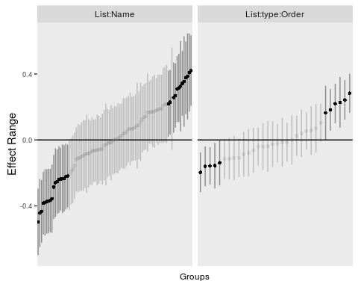

## Loading required package: effects

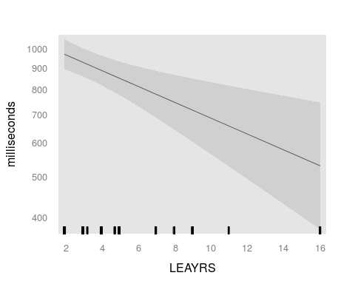!!

## Diagnostic plots

par(mfrow=c(3,2))  
# plot(lm4,which=1:4)  
  
plot(fitted(lmm, type = "response"), residuals(lmm, type = "response"),  
 main = "Conditional residuals", xlab = "Predicted", ylab = "Residuals")  
  
res <- residuals(lmm, type = "response")  
qqnorm(res, main = "Conditional residuals, QQplot")  
qqline(res)  
  
lm.0 <- lm(log(Time) ~ ( type + LEAYRS + LEA + AMSP + HRSD ), data = DLM)  
x <- model.matrix(lm.0)  
pred <- x %*% fixef(lmm)  
res <- DLM$Time - pred  
plot(pred, res, main = "Marginal residuals", xlab = "Predicted", ylab = "Residuals")  
qqnorm(res, main = "Marginal residuals, QQplot")  
qqline(res)

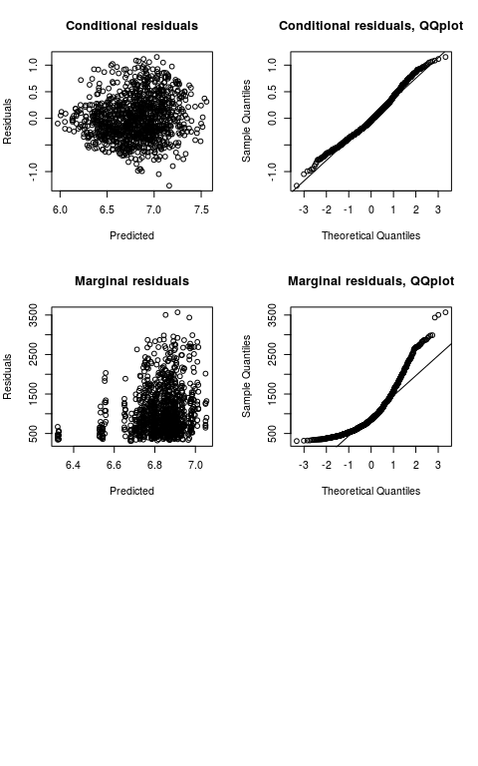

The joint qqplot looks normal. The marginal looks less nice.

## Anova Table with Satterwhite

require(lmerTest)  
lmm <- lmer(log(Time) ~ type + LEAYRS + LEA + AMSP + HRSD + (1 | List:Name) + (1 | List:type:Order), data = DLM, REML=FALSE)  
anova(lmm)

## Analysis of Variance Table of type III with Satterthwaite   
## approximation for degrees of freedom  
## Sum Sq Mean Sq NumDF DenDF F.value Pr(>F)   
## type 0.001 0.001 1 31.9 0.01 0.9324   
## LEAYRS 1.775 1.775 1 85.5 10.57 0.0016 **  
## LEA 0.273 0.273 1 86.1 1.63 0.2055   
## AMSP 0.087 0.087 1 86.4 0.52 0.4726   
## HRSD 0.197 0.197 1 92.3 1.17 0.2817   
## ---  
## Signif. codes: 0 '***' 0.001 '**' 0.01 '*' 0.05 '.' 0.1 ' ' 1

summary(lmm)

## Linear mixed model fit by maximum likelihood t-tests use  
## Satterthwaite approximations to degrees of freedom [lmerMod]  
## Formula:   
## log(Time) ~ type + LEAYRS + LEA + AMSP + HRSD + (1 | List:Name) +   
## (1 | List:type:Order)  
## Data: DLM  
##   
## AIC BIC logLik deviance df.resid   
## 1425.1 1470.5 -703.6 1407.1 1135   
##   
## Scaled residuals:   
## Min 1Q Median 3Q Max   
## -3.090 -0.680 -0.102 0.590 2.817   
##   
## Random effects:  
## Groups Name Variance Std.Dev.  
## List:Name (Intercept) 0.0595 0.244   
## List:type:Order (Intercept) 0.0212 0.145   
## Residual 0.1678 0.410   
## Number of obs: 1144, groups: List:Name, 89; List:type:Order, 32  
##   
## Fixed effects:  
## Estimate Std. Error df t value Pr(>|t|)   
## (Intercept) 6.87740 0.17561 93.20000 39.16 <2e-16 ***  
## typeMISMATCH -0.00491 0.05738 31.90000 -0.09 0.9324   
## LEAYRS -0.04310 0.01325 85.50000 -3.25 0.0016 **   
## LEA -0.01885 0.01478 86.10000 -1.28 0.2055   
## AMSP 0.03145 0.04359 86.40000 0.72 0.4726   
## HRSD 0.01621 0.01497 92.30000 1.08 0.2817   
## ---  
## Signif. codes: 0 '***' 0.001 '**' 0.01 '*' 0.05 '.' 0.1 ' ' 1  
##   
## Correlation of Fixed Effects:  
## (Intr) tMISMA LEAYRS LEA AMSP   
## typMISMATCH -0.164   
## LEAYRS -0.086 0.001   
## LEA -0.277 -0.004 -0.126   
## AMSP -0.895 0.005 -0.086 0.014   
## HRSD 0.239 -0.007 -0.231 0.178 -0.391