Size: L1 vs L2

## Data analysis

We have 34 subjects for L1 and 100 for L2 for a total of 2144 observations.

After removal of entries with missing data due to wrong answers, we have 34 subjects for L1 and 100 subjects for L2 for a total of 1629 observations left.

The situation is the same as in the Orientation L1 vs L2 case.

Our starting model is: lmer(log(Time) ~ type + Lang + (1 | List:Name) + (1 | List:type:Order), data = DLM) In this case, a likelihood ratio test gives as significant also the type. The second order interactions are still not significant. The random effects are significant. This is also supported by the portion of standard deviation of the residuals that is imputable to the two random effects.

lmm<- lmer(log(Time) ~ type + Lang + (1 | List:Name)+ (1 | List:type:Order), data = DLM, REML=FALSE)  
summary(lmm)

## Linear mixed model fit by maximum likelihood ['lmerMod']  
## Formula:   
## log(Time) ~ type + Lang + (1 | List:Name) + (1 | List:type:Order)  
## Data: DLM  
##   
## AIC BIC logLik deviance df.resid   
## 1774.4 1806.8 -881.2 1762.4 1623   
##   
## Scaled residuals:   
## Min 1Q Median 3Q Max   
## -3.555 -0.662 -0.079 0.580 4.625   
##   
## Random effects:  
## Groups Name Variance Std.Dev.  
## List:Name (Intercept) 0.0803 0.283   
## List:type:Order (Intercept) 0.0215 0.147   
## Residual 0.1401 0.374   
## Number of obs: 1629, groups: List:Name, 134; List:type:Order, 32  
##   
## Fixed effects:  
## Estimate Std. Error t value  
## (Intercept) 6.9263 0.0484 143.1  
## typeMISMATCH 0.1206 0.0553 2.2  
## LangL1 -0.2812 0.0601 -4.7  
##   
## Correlation of Fixed Effects:  
## (Intr) tMISMA  
## typMISMATCH -0.561   
## LangL1 -0.319 -0.003

lmm.0 <- lmer(log(Time) ~ (1 | List:Name)+ (1 | List:type:Order), data = DLM)  
lmm.1 <- update(lmm.0, .~. + type)  
anova(lmm.0,lmm.1)

## refitting model(s) with ML (instead of REML)

## Data: DLM  
## Models:  
## lmm.0: log(Time) ~ (1 | List:Name) + (1 | List:type:Order)  
## lmm.1: log(Time) ~ (1 | List:Name) + (1 | List:type:Order) + type  
## Df AIC BIC logLik deviance Chisq Chi Df Pr(>Chisq)   
## lmm.0 4 1795 1817 -894 1787   
## lmm.1 5 1793 1820 -891 1783 4.38 1 0.036 *  
## ---  
## Signif. codes: 0 '***' 0.001 '**' 0.01 '*' 0.05 '.' 0.1 ' ' 1

lmm.2 <- update(lmm.0, .~. + Lang)  
anova(lmm.1,lmm.2)

## refitting model(s) with ML (instead of REML)

## Data: DLM  
## Models:  
## lmm.1: log(Time) ~ (1 | List:Name) + (1 | List:type:Order) + type  
## lmm.2: log(Time) ~ (1 | List:Name) + (1 | List:type:Order) + Lang  
## Df AIC BIC logLik deviance Chisq Chi Df Pr(>Chisq)   
## lmm.1 5 1793 1820 -891 1783   
## lmm.2 5 1777 1804 -883 1767 15.9 0 <2e-16 ***  
## ---  
## Signif. codes: 0 '***' 0.001 '**' 0.01 '*' 0.05 '.' 0.1 ' ' 1

lmm.3 <- update(lmm, .~. + (type+Lang)^2)  
anova(lmm,lmm.3)

## Data: DLM  
## Models:  
## lmm: log(Time) ~ type + Lang + (1 | List:Name) + (1 | List:type:Order)  
## lmm.3: log(Time) ~ type + Lang + (1 | List:Name) + (1 | List:type:Order) +   
## lmm.3: type:Lang  
## Df AIC BIC logLik deviance Chisq Chi Df Pr(>Chisq)  
## lmm 6 1774 1807 -881 1762   
## lmm.3 7 1776 1813 -881 1762 0.78 1 0.38

lmm.4 <- update(lmm,.~.-(1 | List:Name))  
anova(lmm.4,lmm)

## Data: DLM  
## Models:  
## lmm.4: log(Time) ~ type + Lang + (1 | List:type:Order)  
## lmm: log(Time) ~ type + Lang + (1 | List:Name) + (1 | List:type:Order)  
## Df AIC BIC logLik deviance Chisq Chi Df Pr(>Chisq)   
## lmm.4 5 2217 2244 -1103 2207   
## lmm 6 1774 1807 -881 1762 444 1 <2e-16 ***  
## ---  
## Signif. codes: 0 '***' 0.001 '**' 0.01 '*' 0.05 '.' 0.1 ' ' 1

lmm.5 <- update(lmm,.~.-(1 | List:type:Order))  
anova(lmm.5,lmm)

## Data: DLM  
## Models:  
## lmm.5: log(Time) ~ type + Lang + (1 | List:Name)  
## lmm: log(Time) ~ type + Lang + (1 | List:Name) + (1 | List:type:Order)  
## Df AIC BIC logLik deviance Chisq Chi Df Pr(>Chisq)   
## lmm.5 5 1935 1962 -963 1925   
## lmm 6 1774 1807 -881 1762 163 1 <2e-16 ***  
## ---  
## Signif. codes: 0 '***' 0.001 '**' 0.01 '*' 0.05 '.' 0.1 ' ' 1

The figures report the random and fixed effects. As above, fixed effects are tranformed back in the original linear scale of milliseconds. We can conclude that L1 speakers have shorter reaction times than L2 speakers under both experimental conditions of MATCH and MISMATCH questions. In addtion, MISMATCH questions seem slightly more difficult to be answered. This effect was shown to be significant from a bootstrap analysis on the transformed data.

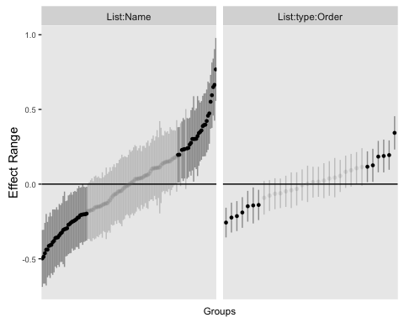

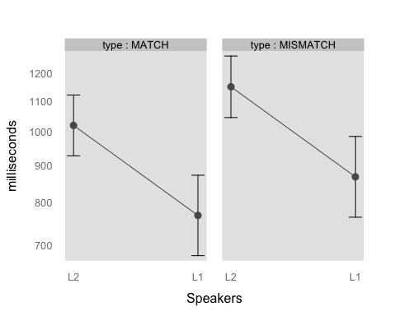

## Diagnostic plots

#lmm<- glmer(Time ~ Lang + type + (1 | Name)+ (1 | type:List:Order), data = DLM,family=Gamma(link = "identity"))  
par(mfrow=c(2,2))  
# plot(lm4,which=1:4)  
  
plot(fitted(lmm, type = "response"), residuals(lmm, type = "response"),  
 main = "Conditional residuals", xlab = "Predicted", ylab = "Residuals")  
  
res <- residuals(lmm, type = "response")  
qqnorm(res, main = "Conditional residuals, QQplot")  
qqline(res)  
  
lm.0 <- lm(log(Time) ~ type + Lang, data = DLM)  
x <- model.matrix(lm.0)  
pred <- x %*% fixef(lmm)  
res <- DLM$Time - pred  
plot(pred, res, main = "Marginal residuals", xlab = "Predicted", ylab = "Residuals")  
qqnorm(res, main = "Marginal residuals, QQplot")  
qqline(res)

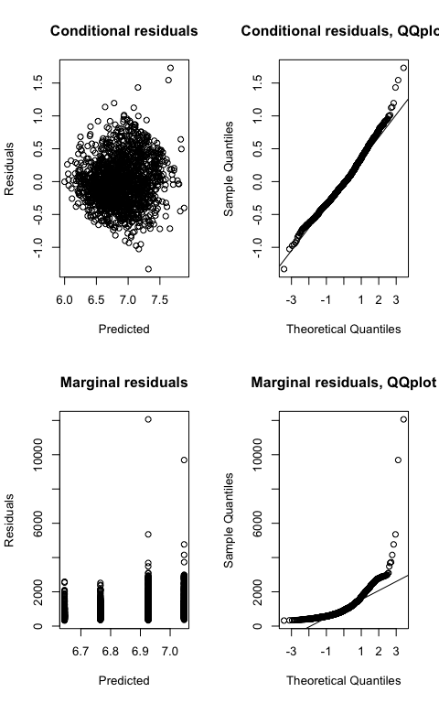

The joint qqplot looks normal. The marginal looks less nice.