**­MLB Pitcher’s Salary Prediction**

**James Colton Behannon**

**December 14, 2020**

Table of Contents

**Introduction1**

**Q01**

Glossary1

**Q13**

**Q25**

**Q37**

**Q49**

**Q59**

**Q611**

**Q712**

**Q813**

**Q915**

**Q1016**

**Q1117**

**Code18**

**Introduction**

MLB players are some of the highest paid athletes of any sport with pitchers bringing home the most per position. Pitchers are expected to dictate the game and are therefore considered deserving of their premium salary. But how much of their salary is actually directly tied to their performance? In this paper I will attempt to predict pitcher salary within three quantiles (low, medium, and high pay) using their performance statistics for that season.

**Q0:**

**The Data Set**

The data sets being used come from Sean Lahman’s baseball database. The database covers pitching, hitting, and fielding performance from 1871 to 2019. It has been integrated into R as a package and is what this paper will be utilizing. The specific data sets drawn from are “Pitching”, “People”, and “Salaries”. Salaries only has salary information until 2016 and will therefore be the most recent year used in the analysis (years 2003 – 2016). The data set obtained from merging Pitching, People, and Salaries, using the selected features, results in 6104 observations (after removing three with NA values) and 28 features. These features will be broken down by the individual data sets they were drawn from.

**Features: Pitching**

From the Pitching data set a total of 28 variables are utilized. playerID and yearID are used to merge the table with People and Salaries. The remaining 26 variables are stint, W, L, G, GS, CG, SHO, SV, IPouts, H, ER, HR, BB, SO, BAOpp, ERA, IBB, WP, HBP, BK, BFP, GF, R, SH, SF, and GIDP.

**Features: People**

From the People data set a total of three variables are obtained. playerID is used as the key to merge with the other tables while weight and height are features.

**Features: Salaries**

From the Salaries data set only three variables are used. The first two, playerID and yearID, are once again used to merge this table with the other two. The remaining variable, salary, is what will be utilized to obtain the target variable of salary bracket.

**Glossary:**

playerID – Unique identifier for each player

yearID – Year the data was collected

weight – The player’s weight in pound

height – The player’s height in inches

debut – The date of the player’s first game

salary – The salary received by the player

stint – Order of appearances within a season

teamID – Team

lgID – The league they are in

W – Wins

L – Losses

G – Games

GS – Games started

CG – Complete games

SHO – Shutouts

SV – Saves

IPouts – Outs pitched

H – Hits

ER – Earned runs

HR – Homeruns

BB – Walks

SO – Strikeouts

BAOpp – Opponent’s batting average (number of hits against / number of at bats)

ERA – Earned run average

IBB – Intentional walks

WP – Wild pitches

HBP – Batters hit by pitch

BK – Balks

BFP – Batters faced by the pitcher

GF – Games finished

R – Runs allowed

SH – Sacrifices by opposing batters

SF – Sacrifice flies by opposing batters

GIDP – Grounded into double plays by batters

**Preparation**

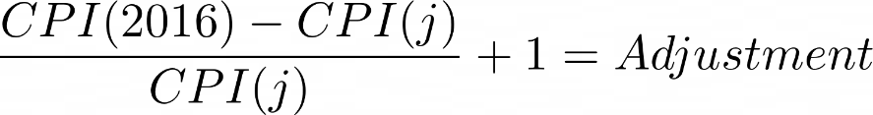 The data set containing all of the previously mentioned features contains salary as a numeric value. For the purposes of this project this must be transformed into three classes (class1, class2, and class3) which represent low, medium, and high salary, respectively. However, before this can be done the salaries must be normalized to account for inflation due to the different years in which the data comes from (2003 – 2016). In order to make this conversion the CPI (Consumer Price Index) values from these years are obtained from the BLS (U.S. Bureau of Labor and Statistics)[1]. The values will be converted to 2016 dollars. The formula used is as follows with CPI(j) referring to the CPI of each year that is referenced in the data set.

The adjustment factor is then multiplied by each salary in order to obtain the inflation adjusted salary, or salary in 2016 dollars. The salaries are then ready to be divided into three quantiles and labeled into their corresponding classes.

**Q1:**

Principle component analysis (PCA) is performed on the standardized features SDATA. PCA is a method of dimensionality-reduction that transfers large data sets into a more practical size with minimal information loss. To examine the results, we can take a look at the plot of proportion of variance explained vs r (number of principle components) and the eigenvalues vs r.

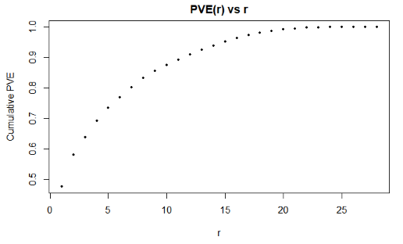

From here we can see that 95% of the variance is explained by the first 15 principle components.

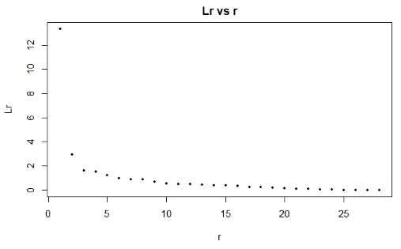

From this plot we can see the decrease in the eigenvalues as they progress. This plot is not cumulative such as the prior one as well.

3D projection of class2(red) and class3(green) 3D projection of class1(black) and class3(green)

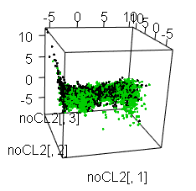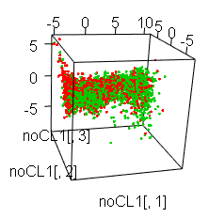

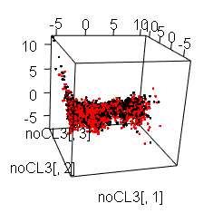3D projection of class1(black) and class2(red)

The pairs of classes are projected into three dimensions on the first three PCA eigenvectors. The resulting 3D plots present no easily distinguishable patterns with which to separate the classes.

**Q2:**

Kmeans clustering is an unsupervised algorithm for separating data into K clusters of “similar” standing. The algorithm identifies K centroids and then sorts the data into its nearest cluster. Kmeans was applied to the standardized data set with K = [1:10]. The following plots were obtained to display the reduction of variance and gini index vs K.

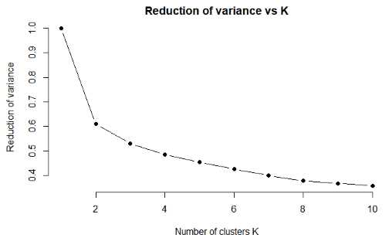

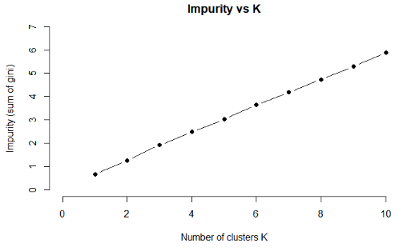

From examining the two plots we arrive at a best K value K* of 8. At K = 8 the impurity continues to increase at a steady rate while the reduction of variance slows down its reduction to a minimal amount.

The computation time for each K was as follows:

K1: 0.521 seconds

K2: 0.669 seconds

K3: 0.846 seconds

K4: 1.028 seconds

K5: 1.331 seconds

K6: 1.563 seconds

K7: 1.873 seconds

K8: 2.574 seconds

K9: 2.381 seconds

K10: 2.578 seconds

**Q3:**

The following is obtained for kmeans with K=8

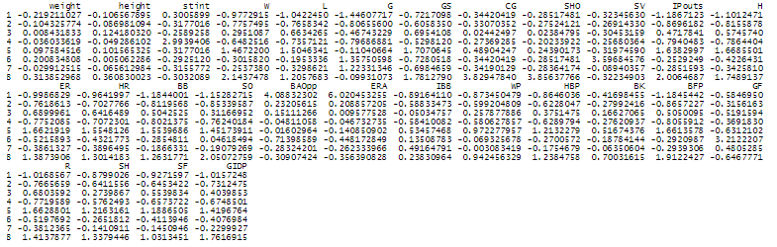Cluster Centers –

|  |  |  |  |
| --- | --- | --- | --- |
| Cluster | Sizes | Dispersion | Gini |
| 1 | 77 | 1976.92 | 0.5377 |
| 2 | 1614 | 11243.80 | 0.6388 |
| 3 | 756 | 8866.34 | 0.6454 |
| 4 | 553 | 4379.70 | 0.6423 |
| 5 | 1013 | 17655.68 | 0.6072 |
| 6 | 378 | 3196.68 | 0.5798 |
| 7 | 1494 | 12014.42 | 0.6319 |
| 8 | 219 | 5345.67 | 0.4453 |

Frequencies –

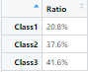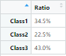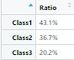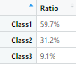Cluster 1: Cluster 2: Cluster 3: Cluster 4:

Cluster 5: Cluster 6: Cluster 7: Cluster 8:

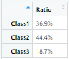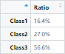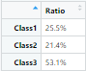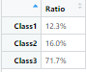



3D Projection of Cluster Centers –

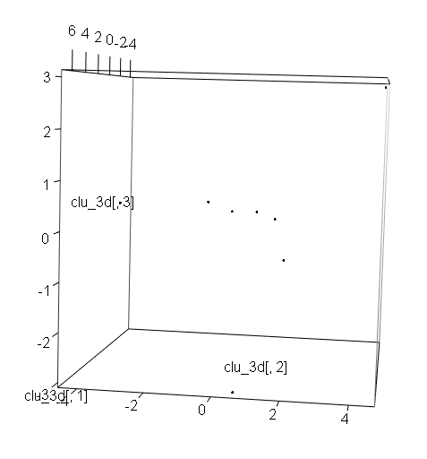

**Q4:**

The classes within the data set were built to be roughly 33% quantile increments and are therefore balanced enough to not require cloning. The train set TRAIN and test set TEST are created using an 80% vs 20% split.

**Q5:**

A decision tree is a predictive modeling algorithm that uses basic “decisions” based on the data to lead to conclusions. A random forest is a supervised learning algorithm that makes uses of several decision trees in order to combat any overfitting that standard decision trees are likely to fall prey to. Random forest is applied to the train set with ntry = 5 (sqrt(29) = 5.385) and ntrees = {100, 200, 300, 400}. The resulting train and test accuracies can be seen in relation to each ntrees values with the plot.

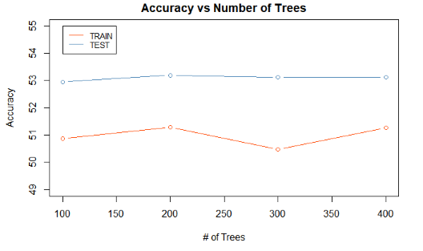

The results within the test sets can be seen within these confusion matrices.

ntrees = 100

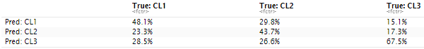

The random forest with ntrees = 100 accurately predicted class1 48.1% of the time, class2 43.7% of the time, and class3 67.5% of the time with an overall classification accuracy of 52.95%. The computation time was 10.629 seconds.

ntrees = 200

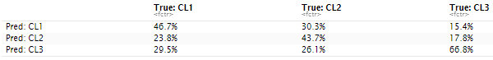

The random forest with ntrees = 200 accurately predicted class1 46.7% of the time, class2 43.7% of the time, and class3 66.8% of the time with an overall classification accuracy of 53.19%. The computation times was 10.452 seconds.

ntrees = 300

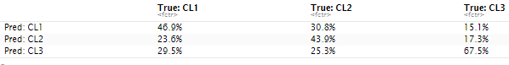

The random forest with ntrees = 300 accurately predicted class1 46.9% of the time, class2 43.9% of the time, and class3 67.5% of the time with an overall classification accuracy of 53.11%. The computation time was 10.759 seconds.

ntrees = 400

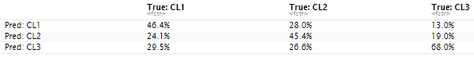

The random forest with ntrees = 400 accurately predicted class1 46.4% of the time, class2 45.4% of the time, and class3 68% of the time with an overall classification accuracy of 53.11%. The computation time was 10.602 seconds.

**Q6:**

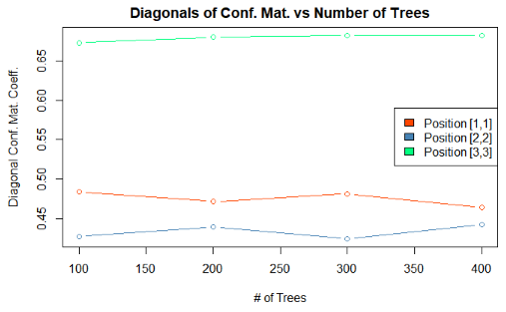

Position[3,3] (class3) consistently performs the best out of the three diagonals. Class3 has the most observations within TRAIN and therefore the model had more information to train off of. However, the difference in observations between class3, the largest class, and class2, the smallest class, is only 65 observations while the difference in accurate classification of the two is around 20%. If this trend held true, any extra observations that could be added might have significant results on the model's performance.

The best ntrees BNT is 200. The performance from position[1,1] and position[2,2] alternate between one increasing and the other decreasing with each new ntrees making it hard to choose the best option. Position[3,3] continues to increase in performance with more ntrees but only slightly. The difference between ntrees = 200 to 400 is minimal in position[3,3]’s performance so the smallest ntrees = 200 is chosen. It should be noted that performance for all of these options were very similar and the selected BNT could have potentially been any of the options with only slightly varied results.

From referencing the off-diagonal terms of the confusion matrices, we can see a similar trend in classification accuracy. When the true class is class1, class3 is incorrectly predicted less than class2 is. The same holds true when looking at predictions of class2. When the true class is class2, class3 is incorrectly predicted less frequently than class1.

**Q7:**

Variable importance is calculated from the mean decrease in gini for each feature from the random forest with ntry = 5 and ntrees = 200. These values were calculated and reordered to display their descending outputs.

Features order by decreasing importance –

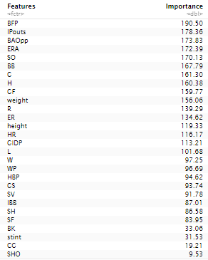

**Q8:**

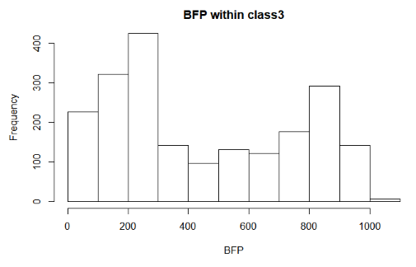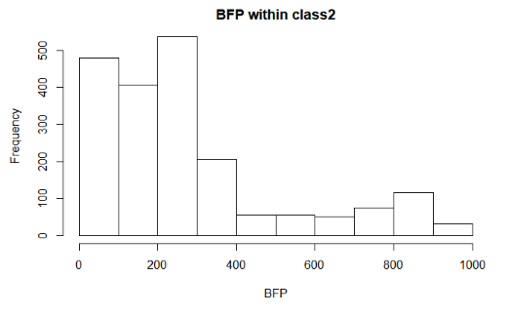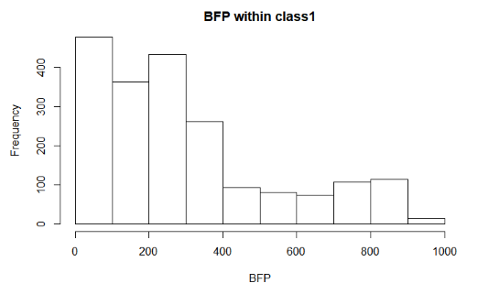BFP (Most important feature) -

BFP represents the amount of batters faced by a pitcher. This is directly related to pitching experience and therefore makes sense that it would be important in determining a pitcher's salary. From looking at the histograms it is difficult to notice a difference between class1 and class2. However, class3 has noticeably more cases within the higher BFP values (specifically greater than 500) than class1 or class2.

The KS test to compare the histograms confirms the variables importance. The comparison of BFP within class1 and class2 received a p-value (P<.001). The comparisons between class1 and class3 as well as class2 and class3 each contained p-values of (P<.001) as well. It should be noted however that the p-value for both comparisons involving class3 were much smaller (P<2.2e-16) than the already small p-value for the comparison of class1 and class2 (P=1.783e-05).

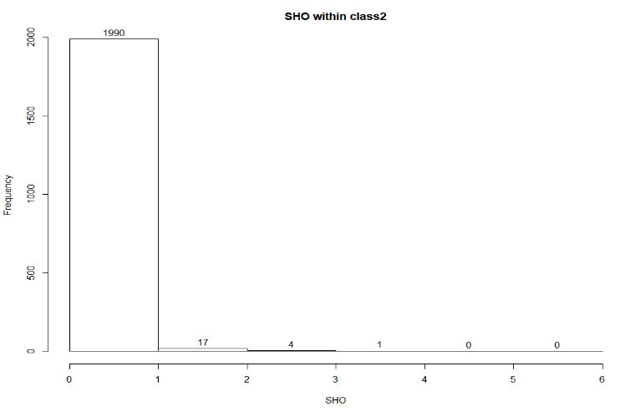SHO (Least important feature) –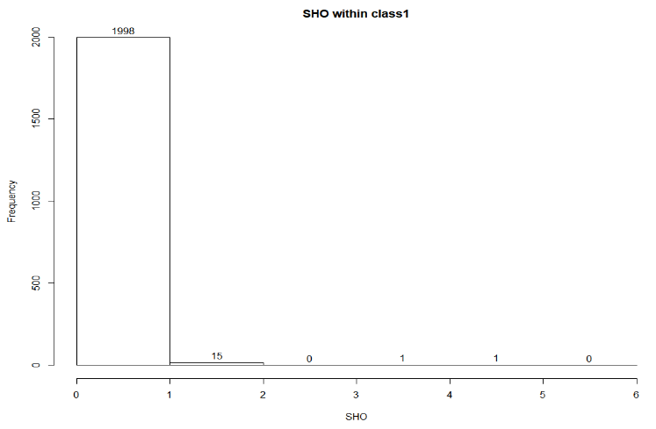

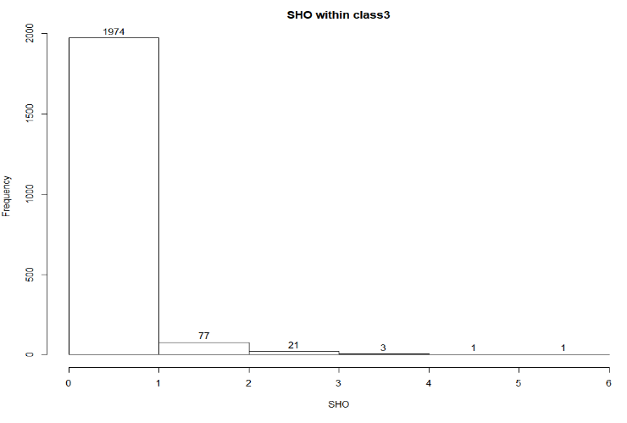

SHO represents the number of shutouts that a pitcher has earned. This would seem like an important statistic for determining the prowess of a pitcher and therefore how much they should be earning. However, the nature of shutouts makes it a hard tool to use. They are extremely rare, and the maximum amount recorded within our data set is 6. From looking at the histograms there is a slight difference in the distributions as pitchers of class2 and then class3 obtain more shutouts than those within the previous class. The difference between class1 and class2 is only five more pitchers that have earned at least one shutout and is pretty insignificant. Class3 shows the most difference among the three with a higher prevalence of at least one shutout than the other two classes (though they are still extremely rare). Class3 contains 103 pitchers with one or more shutouts while class2 contains 22 and class1 contains 17.

The KS test reveals similar findings to what was seen within the histograms. Class1 and class2 are deemed not significantly different with a p-value of P(=.9995). However, the comparison of class1 and class3 as well as class2 and class3 obtained a significant p-value less than .001 (P=4.408e-09 and 3.549e-11, respectively).

**Q9:**

Cluster 8 from question 3 had the minimum gini. A new random forest with ntry = 5 and ntrees = 200 is trained based solely on the occurrences within this cluster. However, before this can be done, we need to clone classes 1 and 2 as there are far fewer cases of these two classes than class 3. There were only 15% as many cases of class1 as class3 so six copies of the class1 observations are made, each with minor perturbations to the feature values, and combined with the original observations. The same is done for class2 as there are only 26% as many cases of class2 as there are for class3. Three duplicates of class2, also with minor perturbations to each feature value, are combined with the original observations. The formula followed to create the perturbations within the feature values is as follows:



Here, runif(1) refers to a random decimal in the range [0, 1].

The final class sizes come out to be 119 observations from class1, 112 observations from class2, and 130 observations from class3. The same process is repeated for the test set and the final sizes come out to be 30 observations from class1, 28 observations from class2, and 27 observations from class3. A random forest can now be trained and tested on these new sets.

**Q10:**

The resulting model had a classification accuracy of 86.05% on the train set and 60% on the test set. The model performed well on the train set as would be expected. The computation time to train the model was 0.598 seconds.

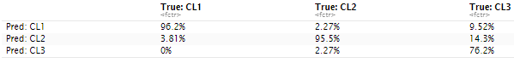

However, the test set had interesting results.

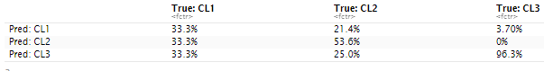

The model accurately predicted class3 96.3% of the time, class2 53.6% of the time, and class1 a mere 33.3% of the time. After repeated sampling and reruns of the random forest the results were all very similar. Class3 maintains a very high classification rate while 2 is smaller but still acceptable and class1 performs terribly. In a few iterations it would even accurately predict class1 less times than 33.3% meaning it performed worse than would be expected given a random selection. These results could potentially be explained by the class density that was originally present in the cluster. Class3 was by far the most prevalent with class1 and class2 requiring extensive cloning. Class1 originally only contained 15% as many cases as class3 and this could help explain its poor classification.

Using the clusters to retrain random forests could potentially obtain better results than one on the whole set. As seen here class3 achieved remarkable results in its predictions. However, class1 did very poorly and class2 did similarly to the original model. Retraining a random forest for each cluster would have differing success depending on the densities within each cluster but could have a positive outcome when taking the amount of classifications per class per cluster into account.

**Q11:**

A linear support vector machine (SVM) is an algorithm that separates data into distinct classes using a line or hyperplane and optimizes by finding the separator that has the largest margin (distance) between the nearest points to create a more robust classifier. A linear SVM was trained on a new training set of just class1 and class3 observations in order to classify between class1 and class3. The SVM obtained a 73.6% classification accuracy on the train set and 69.84% classification accuracy on the test set. The model took 3.862 seconds to train.



The SVM accurately predicted class1 71.7% of the time and class3 75.5% of the time on the train set.



The SVM accurately predicted class1 68.2% of the time and class3 71.4% of the time on the test set.

**Code:**

# install.packages("Lahman")  
  
# Import the dataframes  
data("People", package="Lahman")  
data("Salaries", package="Lahman")  
data("Pitching", package="Lahman")

# Merge the dataframes and filter it for years 2003-2016  
peop <- People[c("playerID", "weight", "height", "debut")]  
sal <- Salaries[c("playerID", "yearID", "salary")]  
yearRange <- c(2003, 2004, 2005, 2006, 2007, 2008, 2009, 2010, 2011, 2012, 2013, 2014, 2015, 2016)  
  
sal1016 <- sal[sal$"yearID" %in% yearRange,]  
  
peopsal <- merge(peop, sal1016, by="playerID")  
all <- merge(peopsal, Pitching, by=c("playerID", "yearID"))

# Normalize the salaries by accounting for inflation between years  
# CPI 1982-84 = 100; data collected from https://data.bls.gov/pdq/SurveyOutputServlet  
# pct_change measures percent change in CPI between each year (2013-2016) and 2016  
cpi = c(184.0, 188.9, 195.3, 201.6, 207.342, 215.303, 214.537, 218.056, 224.939, 229.594, 232.957, 236.736, 237.017, 240.007)  
pct_change = c()  
for (i in 1:length(cpi)) {  
 pct_change = c(pct_change, (cpi[14] - cpi[i])/cpi[i]*100)  
}  
pct_change = (pct_change * 0.01) + 1

# Apply the percent changes in inflation to the player salaries  
for (i in 1:nrow(all)) {  
 if (all$yearID[i] == 2003) {  
 all$salary_adj[i] = all$salary[i] * pct_change[1]  
 }  
 if (all$yearID[i] == 2004) {  
 all$salary_adj[i] = all$salary[i] * pct_change[2]  
 }  
 if (all$yearID[i] == 2005) {  
 all$salary_adj[i] = all$salary[i] * pct_change[3]  
 }  
 if (all$yearID[i] == 2006) {  
 all$salary_adj[i] = all$salary[i] * pct_change[4]  
 }  
 if (all$yearID[i] == 2007) {  
 all$salary_adj[i] = all$salary[i] * pct_change[5]  
 }  
 if (all$yearID[i] == 2008) {  
 all$salary_adj[i] = all$salary[i] * pct_change[6]  
 }  
 if (all$yearID[i] == 2009) {  
 all$salary_adj[i] = all$salary[i] * pct_change[7]  
 }  
 if (all$yearID[i] == 2010) {  
 all$salary_adj[i] = all$salary[i] * pct_change[8]  
 }  
 if (all$yearID[i] == 2011) {  
 all$salary_adj[i] = all$salary[i] * pct_change[9]  
 }  
 if (all$yearID[i] == 2012) {  
 all$salary_adj[i] = all$salary[i] * pct_change[10]  
 }  
 if (all$yearID[i] == 2013) {  
 all$salary_adj[i] = all$salary[i] * pct_change[11]  
 }  
 if (all$yearID[i] == 2014) {  
 all$salary_adj[i] = all$salary[i] * pct_change[12]  
 }  
 if (all$yearID[i] == 2015) {  
 all$salary_adj[i] = all$salary[i] * pct_change[13]  
 }  
 if (all$yearID[i] == 2016) {  
 all$salary_adj[i] = all$salary[i] * pct_change[14]  
 }  
}  
all$salary_adj = as.integer(all$salary_adj)

# Split the adjusted salaries into three quantiles  
quantile(all$salary_adj, probs=c(0, 0.33, 0.66, 1))

## 0% 33% 66% 100%   
## 305781 521496 2999630 33000000

quant33 <- nrow(all[all$salary_adj<=521496,])  
quant66 <- nrow(all[all$salary_adj<=2999630 & all$salary_adj>521496,])  
quant100 <- nrow(all[all$salary_adj<=33000000 & all$salary_adj>2999630,])  
  
# Confirm we did not miss any of the observations  
nrow(all[all$salary_adj<=521496,])+nrow(all[all$salary_adj<=2999630 & all$salary_adj>521496,])+nrow(all[all$salary_adj<=33000000 & all$salary_adj>2999630,])

## [1] 6107

# Create a new dataframe that contains the information classifying each salary into 1, 2, or 3 based on quantity  
data <- as.data.frame(all)  
  
for (i in 1:nrow(data)) {  
 if (data$salary_adj[i] <= 521496) {  
 data$class[i] = 1  
 }  
 if (data$salary_adj[i] <= 2999630 & data$salary_adj[i] > 521496) {  
 data$class[i] = 2  
 }  
 if (data$salary_adj[i] <= 33000000 & data$salary_adj[i] > 2999630) {  
 data$class[i] = 3  
 }  
}

# Check for missing values  
apply(is.na(data), 2, which)

## $playerID  
## integer(0)  
##   
## $yearID  
## integer(0)  
##   
## $weight  
## integer(0)  
##   
## $height  
## integer(0)  
##   
## $debut  
## integer(0)  
##   
## $salary  
## integer(0)  
##   
## $stint  
## integer(0)  
##   
## $teamID  
## integer(0)  
##   
## $lgID  
## integer(0)  
##   
## $W  
## integer(0)  
##   
## $L  
## integer(0)  
##   
## $G  
## integer(0)  
##   
## $GS  
## integer(0)  
##   
## $CG  
## integer(0)  
##   
## $SHO  
## integer(0)  
##   
## $SV  
## integer(0)  
##   
## $IPouts  
## integer(0)  
##   
## $H  
## integer(0)  
##   
## $ER  
## integer(0)  
##   
## $HR  
## integer(0)  
##   
## $BB  
## integer(0)  
##   
## $SO  
## integer(0)  
##   
## $BAOpp  
## [1] 5589  
##   
## $ERA  
## [1] 4225 5494 5589  
##   
## $IBB  
## integer(0)  
##   
## $WP  
## integer(0)  
##   
## $HBP  
## integer(0)  
##   
## $BK  
## integer(0)  
##   
## $BFP  
## integer(0)  
##   
## $GF  
## integer(0)  
##   
## $R  
## integer(0)  
##   
## $SH  
## integer(0)  
##   
## $SF  
## integer(0)  
##   
## $GIDP  
## integer(0)  
##   
## $salary_adj  
## integer(0)  
##   
## $class  
## integer(0)

# Remove the 3 cases that contain missing values  
data = na.omit(data)  
  
# Check for missing values again  
sum(is.na(data))

## [1] 0

# remove the salary and salary_adj variables and just leave the classes  
salary = as.vector(data$salary)  
data$salary = NULL  
salary_adj = as.vector(data$salary_adj)  
data$salary_adj = NULL  
  
# Convert class to a factor  
data$class <- as.factor(data$class)  
class_vec = as.vector(data$class)  
  
# Obtain a vector of playerID  
playerID = as.vector(data$playerID)  
  
# Create a list of the variables we want to use as features  
vars <- c("weight", "height", "stint", "W", "L", "G", "GS", "CG", "SHO", "SV", "IPouts", "H", "ER", "HR", "BB", "SO", "BAOpp", "ERA", "IBB", "WP", "HBP", "BK", "BFP", "GF", "R", "SH", "SF", "GIDP", "class")  
  
# Filter the data to only hold the previously identified features  
data <- data[,vars]  
  
# Confirm we have all of correct vars  
vars %in% colnames(data)

## [1] TRUE TRUE TRUE TRUE TRUE TRUE TRUE TRUE TRUE TRUE TRUE TRUE TRUE TRUE  
## [15] TRUE TRUE TRUE TRUE TRUE TRUE TRUE TRUE TRUE TRUE TRUE TRUE TRUE TRUE  
## [29] TRUE

There are now a total of 6104 observations. Time to standardize the data.

### Q1

SDATA <- data.frame(scale(data[,-29]))  
# SDATA$class <- class_vec

# PCA  
SDATA.cor <- cor(SDATA)  
SDATA.eig <- eigen(SDATA.cor)  
  
# Variance explained  
PVE <- SDATA.eig$values/sum(SDATA.eig$values)  
  
# Plot PVE(r) vs r  
it = 0  
PVE.sum <- c()  
for (i in 1:length(PVE)){  
 PVE.sum <- sum(PVE[1:i])  
 it = it + 1  
 if (PVE.sum >= .95){  
 break  
 }  
}  
  
cumPVE <- plot(cumsum(PVE),pch=19, cex=.6, ylab = "Cumulative PVE", xlab = "r", main = "PVE(r) vs r")

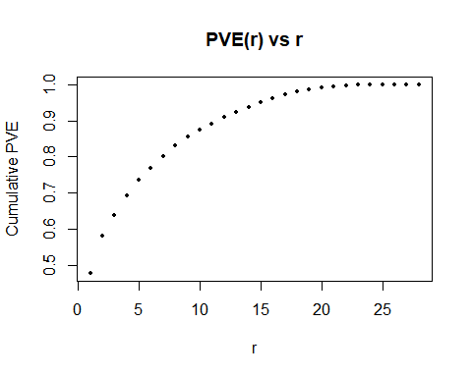 95% of the variance is explained by the first 15 principle componenets.

plot(SDATA.eig$values, pch=20, cex=.75, xlab="r", ylab="Lr", main="Lr vs r")

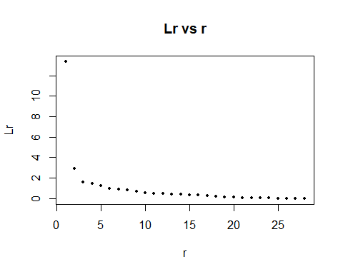

format(SDATA.eig$values[1:3], scientific=FALSE)

## [1] "13.371663" " 2.912144" " 1.594754"

PVE[1:3]

## [1] 0.47755940 0.10400516 0.05695552

The plot of eigenvalues as a function of r. The first three eigenvalues are 13.371663, 2.912144, and 1.594754. They explain 47.8%, 10.4%, and 5.7% of the the total variance respectively.

W <- SDATA.eig$vectors[,1:15]  
PrinComp <- as.data.frame(as.matrix(SDATA) %*% W)  
PrinComp$class <- class_vec  
  
noCL1 <- PrinComp[PrinComp$class==2 | PrinComp$class==3,]  
noCL2 <- PrinComp[PrinComp$class==1 | PrinComp$class==3,]  
noCL3 <- PrinComp[PrinComp$class==1 | PrinComp$class==2,]  
  
library(rgl)

## Warning: package 'rgl' was built under R version 3.6.3

plot3d(noCL1[,1], noCL1[,2], noCL1[,3], col=noCL1$class)  
plot3d(noCL2[,1], noCL2[,2], noCL2[,3], col=noCL2$class)  
plot3d(noCL3[,1], noCL3[,2], noCL3[,3], col=noCL3$class)

The three pairs of classes do not show any distinguishable evidence of seperability.

### Q2

k1_start <- Sys.time()  
k1 <- kmeans(SDATA, centers=1, nstart=50)  
k1_end <- Sys.time()  
k2_start <- Sys.time()  
k2 <- kmeans(SDATA, centers=2, nstart=50)  
k2_end <- Sys.time()  
k3_start <- Sys.time()  
k3 <- kmeans(SDATA, centers=3, nstart=50)  
k3_end <- Sys.time()  
k4_start <- Sys.time()  
k4 <- kmeans(SDATA, centers=4, nstart=50)  
k4_end <- Sys.time()  
k5_start <- Sys.time()  
k5 <- kmeans(SDATA, centers=5, nstart=50)  
k5_end <- Sys.time()  
k6_start <- Sys.time()  
k6 <- kmeans(SDATA, centers=6, nstart=50)  
k6_end <- Sys.time()  
k7_start <- Sys.time()  
k7 <- kmeans(SDATA, centers=7, nstart=50)  
k7_end <- Sys.time()  
k8_start <- Sys.time()  
k8 <- kmeans(SDATA, centers=8, nstart=50)  
k8_end <- Sys.time()  
k9_start <- Sys.time()  
k9 <- kmeans(SDATA, centers=9, nstart=50)  
k9_end <- Sys.time()  
k10_start <- Sys.time()  
k10 <- kmeans(SDATA, centers=10, nstart=50)

## Warning: did not converge in 10 iterations  
  
## Warning: did not converge in 10 iterations  
  
## Warning: did not converge in 10 iterations

k10_end <- Sys.time()  
  
# Compute times  
k1_end - k1_start

## Time difference of 0.1938782 secs

k2_end - k2_start

## Time difference of 0.397753 secs

k3_end - k3_start

## Time difference of 0.6256192 secs

k4_end - k4_start

## Time difference of 0.9484148 secs

k5_end - k5_start

## Time difference of 1.176275 secs

k6_end - k6_start

## Time difference of 1.365161 secs

k7_end - k7_start

## Time difference of 1.639989 secs

k8_end - k8_start

## Time difference of 2.055737 secs

k9_end - k9_start

## Time difference of 2.355561 secs

k10_end - k10_start

## Time difference of 2.593405 secs

var1 <- k1$betweenss/k1$totss  
var2 <- k2$betweenss/k2$totss  
var3 <- k3$betweenss/k3$totss  
var4 <- k4$betweenss/k4$totss  
var5 <- k5$betweenss/k5$totss  
var6 <- k6$betweenss/k6$totss  
var7 <- k7$betweenss/k7$totss  
var8 <- k8$betweenss/k8$totss  
var9 <- k9$betweenss/k9$totss  
var10 <- k10$betweenss/k10$totss  
  
var_values <- c(var1,var2,var3,var4,var5,var6,var7,var8,var9,var10)  
k_values <- 1:10  
plot(k_values, 1-var_values, type="b", pch = 19, frame = FALSE, xlab="Number of clusters K", ylab="Reduction of variance", main = "Reduction of variance vs K")

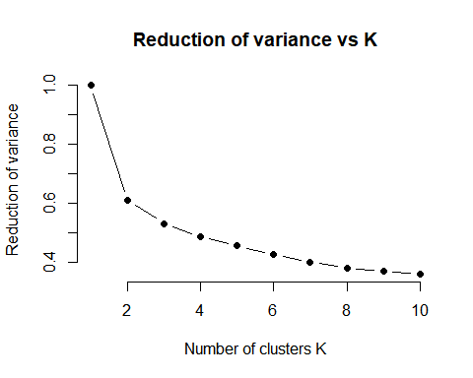 Best K = 8.

### Q3

# Obtain cluster centers  
k8$centers

## weight height stint W L G  
## 1 -0.219211027 -0.106567895 0.3005899 -0.9772915 -1.0422450 -1.44607717  
## 2 0.097584516 0.101565325 -0.3177016 1.4672200 1.5046341 -0.11040664  
## 3 -0.036033619 -0.049286102 2.9939406 -0.6482516 -0.7357121 -0.79686881  
## 4 -0.104325774 -0.086981094 -0.3177016 -0.7757495 -0.7658342 -0.80655600  
## 5 0.008431833 0.124180320 -0.2589258 0.2951087 0.6634265 -0.46743229  
## 6 0.200834808 -0.005062286 -0.2925120 -0.3015820 -0.1953336 1.35750598  
## 7 0.313852968 0.360830023 -0.3032089 2.1437478 1.2057683 -0.09931073  
## 8 -0.029912515 -0.065612984 -0.3155772 -0.2537380 -0.3298621 1.22331346  
## GS CG SHO SV IPouts H  
## 1 -0.7217098 -0.34420419 -0.28517481 -0.32345630 -1.1867123 -1.1012471  
## 2 1.7070645 0.48904247 0.24390173 -0.31974590 1.6382997 1.6685501  
## 3 -0.5298120 -0.27369285 -0.20233922 -0.25680364 -0.7940483 -0.7864404  
## 4 -0.6058350 -0.33070352 -0.27524121 -0.26914330 -0.8696182 -0.8155878  
## 5 0.6954108 0.02442497 0.02384795 -0.30453159 0.4717841 0.5745740  
## 6 -0.7280518 -0.34420419 -0.28517481 3.59684576 -0.2529249 -0.4226431  
## 7 1.7812790 3.82947840 3.85637766 -0.32234903 2.0064687 1.7489137  
## 8 -0.6984659 -0.34190129 -0.28364174 -0.08940357 -0.2851593 -0.3425810  
## ER HR BB SO BAOpp ERA  
## 1 -0.9986829 -0.9641997 -1.1844001 -1.15282715 4.08832302 6.020453255  
## 2 1.6621919 1.5548126 1.5539686 1.45173911 -0.01602964 -0.140850902  
## 3 -0.7752085 -0.7072301 -0.8021375 -0.76240184 -0.04811058 -0.046732735  
## 4 -0.7618613 -0.7027766 -0.8119568 -0.85339587 0.23205615 0.208857205  
## 5 0.6899961 0.6416489 0.5042525 0.31166952 0.15111266 0.009577528  
## 6 -0.5215893 -0.4321773 -0.2854811 0.04618494 -0.71398589 -0.448172849  
## 7 1.3873906 1.3014183 1.2631771 2.05072759 -0.30907424 -0.356390828  
## 8 -0.3861327 -0.3896495 -0.1866331 -0.19079269 -0.28324201 -0.262333966  
## IBB WP HBP BK BFP GF  
## 1 -0.89164110 -0.873450479 -0.8646036 -0.41698455 -1.1845442 -0.5846950  
## 2 0.53457468 0.972277957 1.2132279 0.51674376 1.6613578 -0.6312102  
## 3 -0.58410082 -0.580627857 -0.6289794 -0.27620937 -0.8055912 -0.3691830  
## 4 -0.58833473 -0.599204809 -0.6228047 -0.27992416 -0.8657227 -0.3156163  
## 5 -0.05034757 0.257877886 0.3751475 0.16627065 0.5050095 -0.5191594  
## 6 0.13508783 -0.069325678 -0.2700572 -0.18784144 -0.2920987 3.2122207  
## 7 0.23830964 0.942456329 1.2384758 0.70031615 1.9122427 -0.6467771  
## 8 0.49164791 -0.003083419 -0.1754679 -0.06350604 -0.2939306 0.4805285  
## R SH SF GIDP  
## 1 -1.0168567 -0.8799026 -0.9271597 -1.0157248  
## 2 1.6628801 1.2163161 1.1886505 1.4196764  
## 3 -0.7719589 -0.5762493 -0.6573722 -0.6748501  
## 4 -0.7665659 -0.6411556 -0.6453422 -0.7312475  
## 5 0.6803592 0.2739867 0.5539834 0.4039853  
## 6 -0.5197692 -0.2651812 -0.4113946 -0.4076984  
## 7 1.4137877 1.3379446 1.0313451 1.7616915  
## 8 -0.3812365 -0.1410911 -0.1450946 -0.2299927

# Obtain cluster sizes  
k8$size

## [1] 77 1013 553 1614 756 378 219 1494

# Obtain dispersion  
k8$withinss

## [1] 1976.924 17655.684 4379.702 11243.800 8866.344 3196.681 5345.665  
## [8] 12014.417

# Freqency table of classes within each cluster

# Create a frequency table of all clusters and classes  
library(plyr)  
  
cluster_vals = c()  
for (i in 1:length(k8$cluster)) {  
 cluster_vals <- c(cluster_vals, k8$cluster[[i]])  
}  
  
clust_vs_class = cbind(cluster_vals, class_vec)  
  
FREQ <- count(clust_vs_class, vars = c("cluster_vals", "class_vec"))  
names(FREQ) <- c("Cluster", "Class", "Freq")  
  
gini_per_clust <- c()  
i=1  
while (i <= nrow(FREQ)) {  
 class1 <- FREQ[i, 3]  
 class2 <- FREQ[i+1, 3]  
 class3 <- FREQ[i+2, 3]  
 total <- class1+class2+class3  
 class1_pct <- class1/total  
 class2_pct <- class2/total  
 class3_pct <- class3/total  
 gini <- class1_pct*(1-class1_pct) + class2_pct*(1-class2_pct) + class3_pct*(1 - class3_pct)  
 gini_per_clust <- c(gini_per_clust, gini)  
 i = i+3  
}

# Impurity calculation

gini_impurity <- c()  
  
# k1 cluster values  
cluster_vals = c()  
for (i in 1:length(k1$cluster)) {  
 cluster_vals <- c(cluster_vals, k1$cluster[[i]])  
}  
  
clust_vs_class = cbind(cluster_vals, class_vec)  
  
FREQ <- count(clust_vs_class, vars = c("cluster_vals", "class_vec"))  
names(FREQ) <- c("Cluster", "Class", "Freq")  
  
gini_per_clust <- c()  
i=1  
while (i <= nrow(FREQ)) {  
 class1 <- FREQ[i, 3]  
 class2 <- FREQ[i+1, 3]  
 class3 <- FREQ[i+2, 3]  
 total <- class1+class2+class3  
 class1_pct <- class1/total  
 class2_pct <- class2/total  
 class3_pct <- class3/total  
 gini <- class1_pct*(1-class1_pct) + class2_pct*(1-class2_pct) + class3_pct*(1 - class3_pct)  
 gini_per_clust <- c(gini_per_clust, gini)  
 i = i+3  
}  
gini_impurity <- c(gini_impurity, sum(gini_per_clust))  
  
#k2 cluster values  
cluster_vals = c()  
for (i in 1:length(k2$cluster)) {  
 cluster_vals <- c(cluster_vals, k2$cluster[[i]])  
}  
  
clust_vs_class = cbind(cluster_vals, class_vec)  
  
FREQ <- count(clust_vs_class, vars = c("cluster_vals", "class_vec"))  
names(FREQ) <- c("Cluster", "Class", "Freq")  
  
gini_per_clust <- c()  
i=1  
while (i <= nrow(FREQ)) {  
 class1 <- FREQ[i, 3]  
 class2 <- FREQ[i+1, 3]  
 class3 <- FREQ[i+2, 3]  
 total <- class1+class2+class3  
 class1_pct <- class1/total  
 class2_pct <- class2/total  
 class3_pct <- class3/total  
 gini <- class1_pct*(1-class1_pct) + class2_pct*(1-class2_pct) + class3_pct*(1 - class3_pct)  
 gini_per_clust <- c(gini_per_clust, gini)  
 i = i+3  
}  
gini_impurity <- c(gini_impurity, sum(gini_per_clust))  
  
#k3 cluster values   
cluster_vals = c()  
for (i in 1:length(k3$cluster)) {  
 cluster_vals <- c(cluster_vals, k3$cluster[[i]])  
}  
  
clust_vs_class = cbind(cluster_vals, class_vec)  
  
FREQ <- count(clust_vs_class, vars = c("cluster_vals", "class_vec"))  
names(FREQ) <- c("Cluster", "Class", "Freq")  
  
gini_per_clust <- c()  
i=1  
while (i <= nrow(FREQ)) {  
 class1 <- FREQ[i, 3]  
 class2 <- FREQ[i+1, 3]  
 class3 <- FREQ[i+2, 3]  
 total <- class1+class2+class3  
 class1_pct <- class1/total  
 class2_pct <- class2/total  
 class3_pct <- class3/total  
 gini <- class1_pct*(1-class1_pct) + class2_pct*(1-class2_pct) + class3_pct*(1 - class3_pct)  
 gini_per_clust <- c(gini_per_clust, gini)  
 i = i+3  
}  
gini_impurity <- c(gini_impurity, sum(gini_per_clust))  
  
#k4 cluster values   
cluster_vals = c()  
for (i in 1:length(k4$cluster)) {  
 cluster_vals <- c(cluster_vals, k4$cluster[[i]])  
}  
  
clust_vs_class = cbind(cluster_vals, class_vec)  
  
FREQ <- count(clust_vs_class, vars = c("cluster_vals", "class_vec"))  
names(FREQ) <- c("Cluster", "Class", "Freq")  
  
gini_per_clust <- c()  
i=1  
while (i <= nrow(FREQ)) {  
 class1 <- FREQ[i, 3]  
 class2 <- FREQ[i+1, 3]  
 class3 <- FREQ[i+2, 3]  
 total <- class1+class2+class3  
 class1_pct <- class1/total  
 class2_pct <- class2/total  
 class3_pct <- class3/total  
 gini <- class1_pct*(1-class1_pct) + class2_pct*(1-class2_pct) + class3_pct*(1 - class3_pct)  
 gini_per_clust <- c(gini_per_clust, gini)  
 i = i+3  
}  
gini_impurity <- c(gini_impurity, sum(gini_per_clust))  
  
#k5 cluster values   
cluster_vals = c()  
for (i in 1:length(k5$cluster)) {  
 cluster_vals <- c(cluster_vals, k5$cluster[[i]])  
}  
  
clust_vs_class = cbind(cluster_vals, class_vec)  
  
FREQ <- count(clust_vs_class, vars = c("cluster_vals", "class_vec"))  
names(FREQ) <- c("Cluster", "Class", "Freq")  
  
gini_per_clust <- c()  
i=1  
while (i <= nrow(FREQ)) {  
 class1 <- FREQ[i, 3]  
 class2 <- FREQ[i+1, 3]  
 class3 <- FREQ[i+2, 3]  
 total <- class1+class2+class3  
 class1_pct <- class1/total  
 class2_pct <- class2/total  
 class3_pct <- class3/total  
 gini <- class1_pct*(1-class1_pct) + class2_pct*(1-class2_pct) + class3_pct*(1 - class3_pct)  
 gini_per_clust <- c(gini_per_clust, gini)  
 i = i+3  
}  
gini_impurity <- c(gini_impurity, sum(gini_per_clust))  
  
#k6 cluster values   
cluster_vals = c()  
for (i in 1:length(k6$cluster)) {  
 cluster_vals <- c(cluster_vals, k6$cluster[[i]])  
}  
  
clust_vs_class = cbind(cluster_vals, class_vec)  
  
FREQ <- count(clust_vs_class, vars = c("cluster_vals", "class_vec"))  
names(FREQ) <- c("Cluster", "Class", "Freq")  
gini_per_clust <- c()  
i=1  
while (i <= nrow(FREQ)) {  
 class1 <- FREQ[i, 3]  
 class2 <- FREQ[i+1, 3]  
 class3 <- FREQ[i+2, 3]  
 total <- class1+class2+class3  
 class1_pct <- class1/total  
 class2_pct <- class2/total  
 class3_pct <- class3/total  
 gini <- class1_pct*(1-class1_pct) + class2_pct*(1-class2_pct) + class3_pct*(1 - class3_pct)  
 gini_per_clust <- c(gini_per_clust, gini)  
 i = i+3  
}  
gini_impurity <- c(gini_impurity, sum(gini_per_clust))  
  
#k7 cluster values  
cluster_vals = c()  
for (i in 1:length(k7$cluster)) {  
 cluster_vals <- c(cluster_vals, k7$cluster[[i]])  
}  
  
clust_vs_class = cbind(cluster_vals, class_vec)  
  
FREQ <- count(clust_vs_class, vars = c("cluster_vals", "class_vec"))  
names(FREQ) <- c("Cluster", "Class", "Freq")  
gini_per_clust <- c()  
i=1  
while (i <= nrow(FREQ)) {  
 class1 <- FREQ[i, 3]  
 class2 <- FREQ[i+1, 3]  
 class3 <- FREQ[i+2, 3]  
 total <- class1+class2+class3  
 class1_pct <- class1/total  
 class2_pct <- class2/total  
 class3_pct <- class3/total  
 gini <- class1_pct*(1-class1_pct) + class2_pct*(1-class2_pct) + class3_pct*(1 - class3_pct)  
 gini_per_clust <- c(gini_per_clust, gini)  
 i = i+3  
}  
gini_impurity <- c(gini_impurity, sum(gini_per_clust))  
  
#k8 cluster values  
cluster_vals = c()  
for (i in 1:length(k8$cluster)) {  
 cluster_vals <- c(cluster_vals, k8$cluster[[i]])  
}  
  
clust_vs_class = cbind(cluster_vals, class_vec)  
  
FREQ <- count(clust_vs_class, vars = c("cluster_vals", "class_vec"))  
names(FREQ) <- c("Cluster", "Class", "Freq")  
gini_per_clust <- c()  
i=1  
while (i <= nrow(FREQ)) {  
 class1 <- FREQ[i, 3]  
 class2 <- FREQ[i+1, 3]  
 class3 <- FREQ[i+2, 3]  
 total <- class1+class2+class3  
 class1_pct <- class1/total  
 class2_pct <- class2/total  
 class3_pct <- class3/total  
 gini <- class1_pct*(1-class1_pct) + class2_pct*(1-class2_pct) + class3_pct*(1 - class3_pct)  
 gini_per_clust <- c(gini_per_clust, gini)  
 i = i+3  
}  
gini_impurity <- c(gini_impurity, sum(gini_per_clust))  
  
#k9 cluster values  
cluster_vals = c()  
for (i in 1:length(k9$cluster)) {  
 cluster_vals <- c(cluster_vals, k9$cluster[[i]])  
}  
  
clust_vs_class = cbind(cluster_vals, class_vec)  
  
FREQ <- count(clust_vs_class, vars = c("cluster_vals", "class_vec"))  
names(FREQ) <- c("Cluster", "Class", "Freq")  
gini_per_clust <- c()  
i=1  
while (i <= nrow(FREQ)) {  
 class1 <- FREQ[i, 3]  
 class2 <- FREQ[i+1, 3]  
 class3 <- FREQ[i+2, 3]  
 total <- class1+class2+class3  
 class1_pct <- class1/total  
 class2_pct <- class2/total  
 class3_pct <- class3/total  
 gini <- class1_pct*(1-class1_pct) + class2_pct*(1-class2_pct) + class3_pct*(1 - class3_pct)  
 gini_per_clust <- c(gini_per_clust, gini)  
 i = i+3  
}  
gini_impurity <- c(gini_impurity, sum(gini_per_clust))  
  
#k10 cluster values  
cluster_vals = c()  
for (i in 1:length(k10$cluster)) {  
 cluster_vals <- c(cluster_vals, k10$cluster[[i]])  
}  
  
clust_vs_class = cbind(cluster_vals, class_vec)  
  
FREQ <- count(clust_vs_class, vars = c("cluster_vals", "class_vec"))  
names(FREQ) <- c("Cluster", "Class", "Freq")  
gini_per_clust <- c()  
i=1  
while (i <= nrow(FREQ)) {  
 class1 <- FREQ[i, 3]  
 class2 <- FREQ[i+1, 3]  
 class3 <- FREQ[i+2, 3]  
 total <- class1+class2+class3  
 class1_pct <- class1/total  
 class2_pct <- class2/total  
 class3_pct <- class3/total  
 gini <- class1_pct*(1-class1_pct) + class2_pct*(1-class2_pct) + class3_pct*(1 - class3_pct)  
 gini_per_clust <- c(gini_per_clust, gini)  
 i = i+3  
}  
gini_impurity <- c(gini_impurity, sum(gini_per_clust))

# Plot impurity vs k

plot(k_values, gini_impurity, type="b", pch = 19, frame = FALSE, xlab="Number of clusters K", ylab="Impurity (sum of gini)",xlim = c(0,10), ylim = c(0, 7), main = "Impurity vs K")

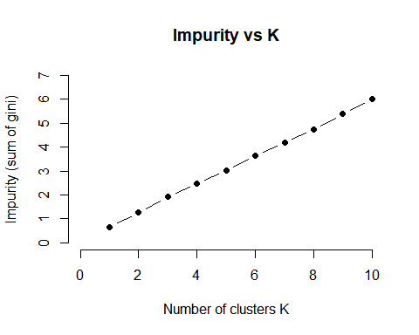

library(scales)  
  
class1 <- FREQ[1, 3]  
class2 <- FREQ[2, 3]  
class3 <- FREQ[3, 3]  
total <- class1+class2+class3  
class1_pct <- class1/total  
class2_pct <- class2/total  
class3_pct <- class3/total  
freq_ratio1 = data.frame(percent(c(class1_pct, class2_pct, class3_pct)), row.names = c("Class1", "Class2", "Class3"))  
names(freq_ratio1) <- "Ratio"  
  
class1 <- FREQ[4, 3]  
class2 <- FREQ[5, 3]  
class3 <- FREQ[6, 3]  
total <- class1+class2+class3  
class1_pct <- class1/total  
class2_pct <- class2/total  
class3_pct <- class3/total  
freq_ratio2 = data.frame(percent(c(class1_pct, class2_pct, class3_pct)), row.names = c("Class1", "Class2", "Class3"))  
names(freq_ratio2) <- "Ratio"  
  
class1 <- FREQ[7, 3]  
class2 <- FREQ[8, 3]  
class3 <- FREQ[9, 3]  
total <- class1+class2+class3  
class1_pct <- class1/total  
class2_pct <- class2/total  
class3_pct <- class3/total  
freq_ratio3 = data.frame(percent(c(class1_pct, class2_pct, class3_pct)), row.names = c("Class1", "Class2", "Class3"))  
names(freq_ratio3) <- "Ratio"  
  
class1 <- FREQ[10, 3]  
class2 <- FREQ[11, 3]  
class3 <- FREQ[12, 3]  
total <- class1+class2+class3  
class1_pct <- class1/total  
class2_pct <- class2/total  
class3_pct <- class3/total  
freq_ratio4 = data.frame(percent(c(class1_pct, class2_pct, class3_pct)), row.names = c("Class1", "Class2", "Class3"))  
names(freq_ratio4) <- "Ratio"  
  
class1 <- FREQ[13, 3]  
class2 <- FREQ[14, 3]  
class3 <- FREQ[15, 3]  
total <- class1+class2+class3  
class1_pct <- class1/total  
class2_pct <- class2/total  
class3_pct <- class3/total  
freq_ratio5 = data.frame(percent(c(class1_pct, class2_pct, class3_pct)), row.names = c("Class1", "Class2", "Class3"))  
names(freq_ratio5) <- "Ratio"  
  
class1 <- FREQ[16, 3]  
class2 <- FREQ[17, 3]  
class3 <- FREQ[18, 3]  
total <- class1+class2+class3  
class1_pct <- class1/total  
class2_pct <- class2/total  
class3_pct <- class3/total  
freq_ratio6 = data.frame(percent(c(class1_pct, class2_pct, class3_pct)), row.names = c("Class1", "Class2", "Class3"))  
names(freq_ratio6) <- "Ratio"  
  
class1 <- FREQ[19, 3]  
class2 <- FREQ[20, 3]  
class3 <- FREQ[21, 3]  
total <- class1+class2+class3  
class1_pct <- class1/total  
class2_pct <- class2/total  
class3_pct <- class3/total  
freq_ratio7 = data.frame(percent(c(class1_pct, class2_pct, class3_pct)), row.names = c("Class1", "Class2", "Class3"))  
names(freq_ratio7) <- "Ratio"  
  
class1 <- FREQ[22, 3]  
class2 <- FREQ[23, 3]  
class3 <- FREQ[24, 3]  
total <- class1+class2+class3  
class1_pct <- class1/total  
class2_pct <- class2/total  
class3_pct <- class3/total  
freq_ratio8 = data.frame(percent(c(class1_pct, class2_pct, class3_pct)), row.names = c("Class1", "Class2", "Class3"))  
names(freq_ratio8) <- "Ratio"

# Create 3D plots of clusters on first 3 eigenvectors

library(rgl)  
clu_3d <- as.data.frame(as.matrix(k8$centers) %*% W)  
plot3d(clu_3d[,1], clu_3d[,2], clu_3d[,3])

### Q4

# Obtain the training and testing data  
  
# First split the data into classes  
CL1 = as.data.frame(data[data$class == 1,])  
CL2 = as.data.frame(data[data$class == 2,])  
CL3 = as.data.frame(data[data$class == 3,])  
  
# Obtain train/test split  
trainCL1.index <- sample(1:nrow(CL1), 0.8 * nrow(CL1))  
testCL1.index <- setdiff(1:nrow(CL1), trainCL1.index)  
trainCL1 <- CL1[trainCL1.index,]  
testCL1 <- CL1[testCL1.index,]  
# train.labels1 <- class_vec[trainCL1.index]  
# test.labels1 <- class_vec[testCL1.index]  
train.labels1 <- rep(1, nrow(trainCL1))  
test.labels1 <- rep(2, nrow(testCL1))  
  
trainCL2.index <- sample(1:nrow(CL2), 0.8 * nrow(CL2))  
testCL2.index <- setdiff(1:nrow(CL2), trainCL2.index)  
trainCL2 <- CL2[trainCL2.index,]  
testCL2 <- CL2[testCL2.index,]  
# train.labels2 <- class_vec[trainCL2.index]  
# test.labels2 <- class_vec[testCL2.index]  
train.labels2 <- rep(2, nrow(trainCL2))  
test.labels2 <- rep(2, nrow(testCL2))  
  
trainCL3.index <- sample(1:nrow(CL3), 0.8 * nrow(CL3))  
testCL3.index <- setdiff(1:nrow(CL3), trainCL3.index)  
trainCL3 <- CL3[trainCL3.index,]  
testCL3 <- CL3[testCL3.index,]  
# train.labels3 <- class_vec[trainCL3.index + nrow(CL2) + nrow(CL1)]  
# test.labels3 <- class_vec[testCL3.index + nrow(CL2) + nrow(CL1)]  
train.labels3 <- rep(3, nrow(trainCL3))  
test.labels3 <- rep(3, nrow(testCL3))  
  
TRAIN <- rbind(trainCL1, trainCL2, trainCL3)  
TEST <- rbind(testCL1, testCL2, testCL3)  
train.labels <- c(train.labels1, train.labels2, train.labels3)  
test.labels <- c(test.labels1, test.labels2, test.labels3)  
  
TRAIN_y <- TRAIN$class  
TEST_y <- TEST$class  
  
TRAIN <- scale(TRAIN[,-29])  
TEST <- scale(TEST[,-29])  
  
TRAIN <- as.data.frame(TRAIN)  
TEST <- as.data.frame(TEST)  
  
TRAIN$class <- TRAIN_y  
TEST$class <- TEST_y

### Q5

library(randomForest)

## Warning: package 'randomForest' was built under R version 3.6.3

## randomForest 4.6-14

## Type rfNews() to see new features/changes/bug fixes.

rf100_start <- Sys.time()  
rf100 <- randomForest(TRAIN[,-29], TRAIN$class, ntry = 5, ntrees = 100)  
rf100_end <- Sys.time()  
rf200_start <- Sys.time()  
rf200 <- randomForest(TRAIN[,-29], TRAIN$class, ntry = 5, ntrees = 200)  
rf200_end <- Sys.time()  
rf300_start <- Sys.time()  
rf300 <- randomForest(TRAIN[,-29], TRAIN$class, ntry = 5, ntrees = 300)  
rf300_end <- Sys.time()  
rf400_start <- Sys.time()  
rf400 <- randomForest(TRAIN[,-29], TRAIN$class, ntry = 5, ntrees = 400)  
rf400_end <- Sys.time()  
  
rf100_end - rf100_start

## Time difference of 11.09518 secs

rf200_end - rf200_start

## Time difference of 10.73739 secs

rf300_end - rf300_start

## Time difference of 10.64945 secs

rf400_end - rf400_start

## Time difference of 10.48955 secs

pred.test100 <- predict(rf100, TEST[,-29])  
pred.test200 <- predict(rf200, TEST[,-29])  
pred.test300 <- predict(rf300, TEST[,-29])  
pred.test400 <- predict(rf400, TEST[,-29])  
  
# Create function to obtain accuracy  
accuracy <- function(x){sum(diag(x)/(sum(rowSums(x)))) * 100}  
  
# Obtain the confusion matrices for predicting the train set using training data  
conf.mat.train100 <- rf100$confusion  
conf.mat.train200 <- rf200$confusion  
conf.mat.train300 <- rf300$confusion  
conf.mat.train400 <- rf400$confusion  
  
# Obtain the confusion matrices for predicting the test set using training data  
conf.mat.test100 <- table(pred.test100, TEST$class)  
conf.mat.test200 <- table(pred.test200, TEST$class)  
conf.mat.test300 <- table(pred.test300, TEST$class)  
conf.mat.test400 <- table(pred.test400, TEST$class)

acc_train <- c(accuracy(conf.mat.train100), accuracy(conf.mat.train200), accuracy(conf.mat.train300), accuracy(conf.mat.train400))  
acc_test <- c(accuracy(conf.mat.test100), accuracy(conf.mat.test200), accuracy(conf.mat.test300), accuracy(conf.mat.test400))  
ntrees <- c(100, 200, 300, 400)  
  
plot(ntrees, acc_train, type = "b", xlab = "# of Trees", ylab = "Accuracy", main = "Accuracy vs Number of Trees", col = "orangered", ylim = c(49, 55))  
lines(ntrees, acc_test, type = "b", col= "steelblue")  
legend(100, 55, legend=c("TRAIN", "TEST"), col=c("orangered", "steelblue"), lty=1:1, cex=0.8)

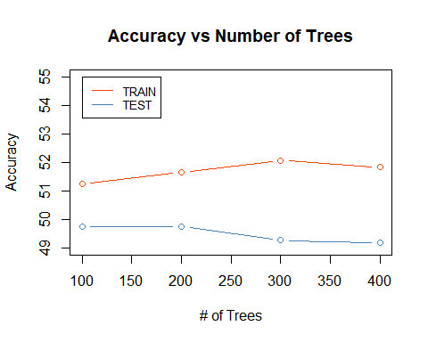

# Display confusion matrices of the test set  
  
# ntrees = 100  
cl1pred1 <- percent(conf.mat.test100[1,1]/sum(conf.mat.test100[,1]))  
cl1pred2 <- percent(conf.mat.test100[2,1]/sum(conf.mat.test100[,1]))  
cl1pred3 <- percent(conf.mat.test100[3,1]/sum(conf.mat.test100[,1]))  
  
cl2pred2 <- percent(conf.mat.test100[2,2]/sum(conf.mat.test100[,2]))  
cl2pred1 <- percent(conf.mat.test100[1,2]/sum(conf.mat.test100[,2]))  
cl2pred3 <- percent(conf.mat.test100[3,2]/sum(conf.mat.test100[,2]))  
  
cl3pred3 <- percent(conf.mat.test100[3,3]/sum(conf.mat.test100[,3]))  
cl3pred1 <- percent(conf.mat.test100[1,3]/sum(conf.mat.test100[,3]))  
cl3pred2 <- percent(conf.mat.test100[2,3]/sum(conf.mat.test100[,3]))  
  
row1 <- c(cl1pred1, cl2pred1, cl3pred1)  
row2 <- c(cl1pred2, cl2pred2, cl3pred2)  
row3 <- c(cl1pred3, cl2pred3, cl3pred3)  
  
  
conf.matrix.percent.test100 <- rbind(row1, row2, row3)  
rownames(conf.matrix.percent.test100) <- c("Pred: CL1", "Pred: CL2", "Pred: CL3")  
colnames(conf.matrix.percent.test100) <- c("True: CL1", "True: CL2", "True: CL3")  
as.data.frame(conf.matrix.percent.test100)

## True: CL1 True: CL2 True: CL3  
## Pred: CL1 37.5% 29.3% 15.9%  
## Pred: CL2 30.3% 42.9% 15.9%  
## Pred: CL3 32.3% 27.8% 68.3%

# ntrees = 200  
cl1pred1 <- percent(conf.mat.test200[1,1]/sum(conf.mat.test200[,1]))  
cl1pred2 <- percent(conf.mat.test200[2,1]/sum(conf.mat.test200[,1]))  
cl1pred3 <- percent(conf.mat.test200[3,1]/sum(conf.mat.test200[,1]))  
  
cl2pred2 <- percent(conf.mat.test200[2,2]/sum(conf.mat.test200[,2]))  
cl2pred1 <- percent(conf.mat.test200[1,2]/sum(conf.mat.test200[,2]))  
cl2pred3 <- percent(conf.mat.test200[3,2]/sum(conf.mat.test200[,2]))  
  
cl3pred3 <- percent(conf.mat.test200[3,3]/sum(conf.mat.test200[,3]))  
cl3pred1 <- percent(conf.mat.test200[1,3]/sum(conf.mat.test200[,3]))  
cl3pred2 <- percent(conf.mat.test200[2,3]/sum(conf.mat.test200[,3]))  
  
row1 <- c(cl1pred1, cl2pred1, cl3pred1)  
row2 <- c(cl1pred2, cl2pred2, cl3pred2)  
row3 <- c(cl1pred3, cl2pred3, cl3pred3)  
  
  
conf.matrix.percent.test200 <- rbind(row1, row2, row3)  
rownames(conf.matrix.percent.test200) <- c("Pred: CL1", "Pred: CL2", "Pred: CL3")  
colnames(conf.matrix.percent.test200) <- c("True: CL1", "True: CL2", "True: CL3")  
as.data.frame(conf.matrix.percent.test200)

## True: CL1 True: CL2 True: CL3  
## Pred: CL1 38.5% 30.0% 16.6%  
## Pred: CL2 30.5% 43.4% 16.6%  
## Pred: CL3 31.0% 26.6% 66.8%

# ntrees = 300  
cl1pred1 <- percent(conf.mat.test300[1,1]/sum(conf.mat.test300[,1]))  
cl1pred2 <- percent(conf.mat.test300[2,1]/sum(conf.mat.test300[,1]))  
cl1pred3 <- percent(conf.mat.test300[3,1]/sum(conf.mat.test300[,1]))  
  
cl2pred2 <- percent(conf.mat.test300[2,2]/sum(conf.mat.test300[,2]))  
cl2pred1 <- percent(conf.mat.test300[1,2]/sum(conf.mat.test300[,2]))  
cl2pred3 <- percent(conf.mat.test300[3,2]/sum(conf.mat.test300[,2]))  
  
cl3pred3 <- percent(conf.mat.test300[3,3]/sum(conf.mat.test300[,3]))  
cl3pred1 <- percent(conf.mat.test300[1,3]/sum(conf.mat.test300[,3]))  
cl3pred2 <- percent(conf.mat.test300[2,3]/sum(conf.mat.test300[,3]))  
  
row1 <- c(cl1pred1, cl2pred1, cl3pred1)  
row2 <- c(cl1pred2, cl2pred2, cl3pred2)  
row3 <- c(cl1pred3, cl2pred3, cl3pred3)  
  
  
conf.matrix.percent.test300 <- rbind(row1, row2, row3)  
rownames(conf.matrix.percent.test300) <- c("Pred: CL1", "Pred: CL2", "Pred: CL3")  
colnames(conf.matrix.percent.test300) <- c("True: CL1", "True: CL2", "True: CL3")  
as.data.frame(conf.matrix.percent.test300)

## True: CL1 True: CL2 True: CL3  
## Pred: CL1 37.5% 30.0% 16.3%  
## Pred: CL2 31.3% 42.4% 16.3%  
## Pred: CL3 31.3% 27.5% 67.3%

# ntrees = 400  
cl1pred1 <- percent(conf.mat.test400[1,1]/sum(conf.mat.test400[,1]))  
cl1pred2 <- percent(conf.mat.test400[2,1]/sum(conf.mat.test400[,1]))  
cl1pred3 <- percent(conf.mat.test400[3,1]/sum(conf.mat.test400[,1]))  
  
cl2pred2 <- percent(conf.mat.test400[2,2]/sum(conf.mat.test400[,2]))  
cl2pred1 <- percent(conf.mat.test400[1,2]/sum(conf.mat.test400[,2]))  
cl2pred3 <- percent(conf.mat.test400[3,2]/sum(conf.mat.test400[,2]))  
  
cl3pred3 <- percent(conf.mat.test400[3,3]/sum(conf.mat.test400[,3]))  
cl3pred1 <- percent(conf.mat.test400[1,3]/sum(conf.mat.test400[,3]))  
cl3pred2 <- percent(conf.mat.test400[2,3]/sum(conf.mat.test400[,3]))  
  
row1 <- c(cl1pred1, cl2pred1, cl3pred1)  
row2 <- c(cl1pred2, cl2pred2, cl3pred2)  
row3 <- c(cl1pred3, cl2pred3, cl3pred3)  
  
  
conf.matrix.percent.test400 <- rbind(row1, row2, row3)  
rownames(conf.matrix.percent.test400) <- c("Pred: CL1", "Pred: CL2", "Pred: CL3")  
colnames(conf.matrix.percent.test400) <- c("True: CL1", "True: CL2", "True: CL3")  
as.data.frame(conf.matrix.percent.test400)

## True: CL1 True: CL2 True: CL3  
## Pred: CL1 38.0% 30.0% 16.6%  
## Pred: CL2 30.0% 41.9% 16.3%  
## Pred: CL3 32.0% 28.0% 67.1%

### Q6

diag1 <- c(conf.mat.test100[1,1]/sum(conf.mat.test100[,1]), conf.mat.test200[1,1]/sum(conf.mat.test200[,1]), conf.mat.test300[1,1]/sum(conf.mat.test300[,1]), conf.mat.test400[1,1]/sum(conf.mat.test400[,1]))  
diag2 <- c(conf.mat.test100[2,2]/sum(conf.mat.test100[,2]), conf.mat.test200[2,2]/sum(conf.mat.test200[,2]), conf.mat.test300[2,2]/sum(conf.mat.test300[,2]), conf.mat.test400[2,2]/sum(conf.mat.test400[,2]))  
diag3 <- c(conf.mat.test100[3,3]/sum(conf.mat.test100[,3]), conf.mat.test200[3,3]/sum(conf.mat.test200[,3]), conf.mat.test300[3,3]/sum(conf.mat.test300[,3]), conf.mat.test400[3,3]/sum(conf.mat.test400[,3]))  
  
  
plot(ntrees, diag1, type = "b", ylim = range(c(diag1, diag2,diag3)), col = "orangered", xlab = "# of Trees", ylab = "Diagonal Conf. Mat. Coeff.", main = "Diagonals of Conf. Mat. vs Number of Trees")  
lines(ntrees, diag2, type = "b", col = "steelblue")  
lines(ntrees, diag3, type="b", col = "springgreen")  
legend("right", c("Position [1,1]", "Position [2,2]", "Position [3,3]"), fill = c("orangered", "steelblue", "springgreen"))

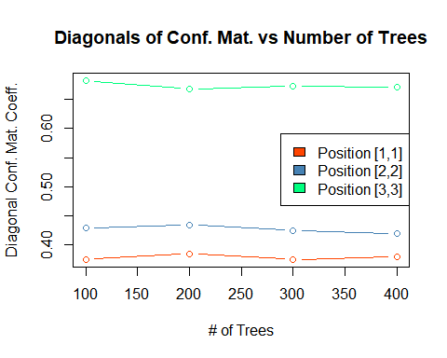 Position[3,3] (class3) consistently performs the best out of the three diagonals. Class3 has the most observations within TRAIN and therefore the model had more information to train off of. However, the difference in observations between class3, the largest class, and class2, the smallest class, is only 65 observations while the difference in accurate classification of the two is around 10%. If this trend held true then any extra observations that could be added might have significant results on the model’s performance.

The best ntrees BNT is 200. The performance from position[1,1] and position[2,2] decreases on the way from ntrees = 200 to 300 while position[3,3] decreases. These changes are minimal as are the changes to ntrees = 400. Therefore ntrees = 200 is selected as the best since there is not a large difference in accuracy but it is the simpler model than those with larger ntrees.

From referencing the confusion matrices we can see a similar trend in classification accuracy for class3. When the true class is class1, class3 is incorrectly predicted less than class2 is. The same holds true when looking at predictions of class2. When the true class is class2, class3 is incorrectly predicted less frequently than class1.

### Q7

# Display feature importances of bestRF (rf200)  
  
imp <- as.data.frame(importance(rf200, type = 2))  
imp <- data.frame(Features = rownames(imp), Importance = round(imp$MeanDecreaseGini,2))  
imp[order(imp$Importance,decreasing = TRUE),]

## Features Importance  
## 23 BFP 183.18  
## 11 IPouts 182.33  
## 17 BAOpp 173.40  
## 18 ERA 172.27  
## 16 SO 171.23  
## 15 BB 168.26  
## 6 G 164.43  
## 24 GF 163.64  
## 12 H 162.26  
## 1 weight 154.52  
## 25 R 141.34  
## 13 ER 136.55  
## 2 height 120.41  
## 14 HR 115.79  
## 28 GIDP 110.48  
## 5 L 104.39  
## 20 WP 97.15  
## 10 SV 94.47  
## 21 HBP 92.61  
## 4 W 92.60  
## 7 GS 91.18  
## 26 SH 88.67  
## 19 IBB 86.70  
## 27 SF 81.32  
## 22 BK 33.86  
## 3 stint 32.60  
## 8 CG 17.19  
## 9 SHO 9.48

### Q8

# Display histogram of most important feature Z (BFP) within each class  
hist(data$BFP[data$class == 1], main = "BFP within class1", xlab = "BFP")

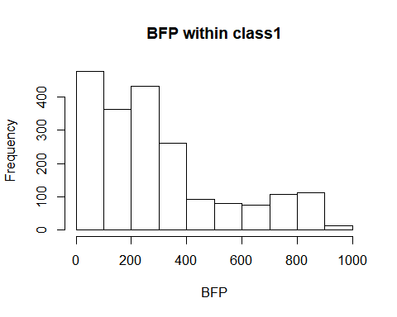

hist(data$BFP[data$class == 2], main = "BFP within class2", xlab = "BFP")

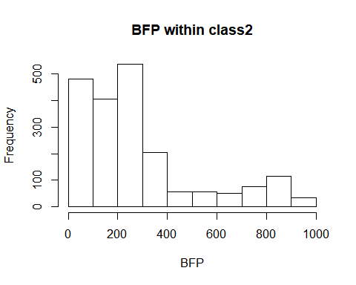

hist(data$BFP[data$class == 3], main = "BFP within class3", xlab = "BFP")

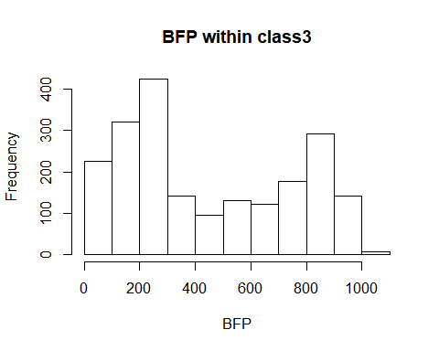

ks.test(data$BFP[data$class==1], data$BFP[data$class==2])

## Warning in ks.test(data$BFP[data$class == 1], data$BFP[data$class == 2]):  
## p-value will be approximate in the presence of ties

##   
## Two-sample Kolmogorov-Smirnov test  
##   
## data: data$BFP[data$class == 1] and data$BFP[data$class == 2]  
## D = 0.075992, p-value = 1.783e-05  
## alternative hypothesis: two-sided

ks.test(data$BFP[data$class==1], data$BFP[data$class==3])

## Warning in ks.test(data$BFP[data$class == 1], data$BFP[data$class == 3]):  
## p-value will be approximate in the presence of ties

##   
## Two-sample Kolmogorov-Smirnov test  
##   
## data: data$BFP[data$class == 1] and data$BFP[data$class == 3]  
## D = 0.23198, p-value < 2.2e-16  
## alternative hypothesis: two-sided

ks.test(data$BFP[data$class==2], data$BFP[data$class==3])

## Warning in ks.test(data$BFP[data$class == 2], data$BFP[data$class == 3]):  
## p-value will be approximate in the presence of ties

##   
## Two-sample Kolmogorov-Smirnov test  
##   
## data: data$BFP[data$class == 2] and data$BFP[data$class == 3]  
## D = 0.27803, p-value < 2.2e-16  
## alternative hypothesis: two-sided

BFP represents the amount of batters faced by a pitcher. This is directly related to pitching experience and therefore makes sense that it would be important in determining a pitcher’s salary. From looking at the histograms it is difficult to notice a difference between class1 and class2. However, class3 has noticably more cases within the higher BFP values (specifically greater than 500) than class1 or class2.

The KS test to compare the histograms confirms the variables importance. The comparison of BFP within class1 and class2 received a p-value (P<.001). The comparisons between class1 and class3 as well as class2 and class3 each contained p-values of (P<.001) as well. It should be noted however that the p-value for both comparisons involving class3 were much smaller (P<2.2e-16) than the already small p-value for the comparison of class1 and class2 (P=1.783e-05).

# Display histogram of least important feature (SHO) within each class  
hist(data$SHO[data$class == 1], breaks = c(0,1,2,3,4,5,6), labels = TRUE, main = "SHO within class1", xlab = "SHO")

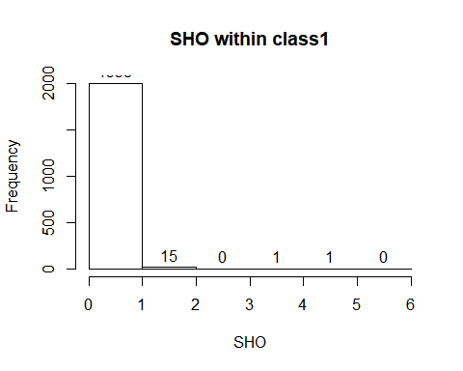

hist(data$SHO[data$class == 2], breaks = c(0,1,2,3,4,5,6), labels = TRUE, main = "SHO within class2", xlab = "SHO")

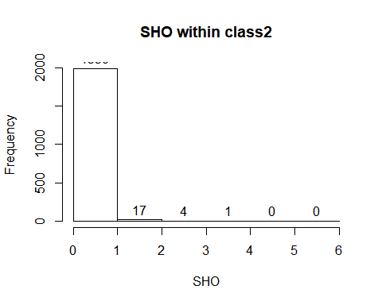

hist(data$SHO[data$class == 3], breaks = c(0,1,2,3,4,5,6), labels = TRUE, main = "SHO within class3", xlab = "SHO")

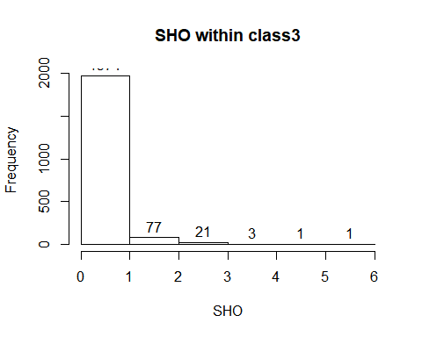

ks.test(data$SHO[data$class==1], data$SHO[data$class==2])

## Warning in ks.test(data$SHO[data$class == 1], data$SHO[data$class == 2]):  
## p-value will be approximate in the presence of ties

##   
## Two-sample Kolmogorov-Smirnov test  
##   
## data: data$SHO[data$class == 1] and data$SHO[data$class == 2]  
## D = 0.011336, p-value = 0.9995  
## alternative hypothesis: two-sided

ks.test(data$SHO[data$class==1], data$SHO[data$class==3])

## Warning in ks.test(data$SHO[data$class == 1], data$SHO[data$class == 3]):  
## p-value will be approximate in the presence of ties

##   
## Two-sample Kolmogorov-Smirnov test  
##   
## data: data$SHO[data$class == 1] and data$SHO[data$class == 3]  
## D = 0.098715, p-value = 4.408e-09  
## alternative hypothesis: two-sided

ks.test(data$SHO[data$class==2], data$SHO[data$class==3])

## Warning in ks.test(data$SHO[data$class == 2], data$SHO[data$class == 3]):  
## p-value will be approximate in the presence of ties

##   
## Two-sample Kolmogorov-Smirnov test  
##   
## data: data$SHO[data$class == 2] and data$SHO[data$class == 3]  
## D = 0.11005, p-value = 3.549e-11  
## alternative hypothesis: two-sided

SHO represents the amount of shutouts that a pitcher has earned. This would seem like an important statistic for determining the prowess of a pitcher and therefore how much they should be earning. However, the nature of shutouts makes it a hard tool to use. They are extremely rare and the maximum amount recorded within our data set is 6. From looking at the histograms there is a slight difference in the distributions as pitchers of class2 and then class3 obtain more shutouts than those within the previous class. The difference between class1 and class2 is only five more pitchers that have earned at least one shutout and is pretty insignificant. Class3 shows the most difference among the three with a higher prevalence of at least one shutout than the other two classes (though they are still extremely rare). Class3 contains 103 pitchers with one or more shutouts while class2 contains 22 and class1 contains 17.

The KS test reveals similar findings to what was seen within the histograms. Class1 and class2 are deemed not significantly different with a p-value of P(=.9995). However, the comparison of class1 and class3 as well as class2 and class3 obtained a significant p-value less than .001 (P=4.408e-09 and 3.549e-11, respectively).

### Q9

Cluster #8 had the lowest gini

# Obtain data from cluster 8  
CLj = SDATA[which(k8$cluster == 8),]  
CLjnonSDATA = data[which(k8$cluster == 8),]  
CLj$class = CLjnonSDATA$class  
  
# Create train/test samples from CLj  
set.seed(42)  
trainCLj.index <- sample(1:nrow(CLj), 0.8 * nrow(CLj))  
testCLj.index <- setdiff(1:nrow(CLj), trainCLj.index)  
trainCLj <- CLj[trainCLj.index,]  
testCLj <- CLj[testCLj.index,]  
train.labels.CLj <- class_vec[trainCLj.index]  
test.labels.CLj <- class_vec[testCLj.index]

# Check class balance in the train set  
nrow(trainCLj[trainCLj['class'] == 1,])

## [1] 436

nrow(trainCLj[trainCLj['class'] == 2,])

## [1] 537

nrow(trainCLj[trainCLj['class'] == 3,])

## [1] 222

# There are far more cases of class 3 than class 1 and 2 so we will use cloning to make them even  
# There are only 15% as many cases of class 1 as class 3 so we will duplicate class 1 by 6  
trainCLj.class1 <- trainCLj[trainCLj['class'] == 1,]  
trainCLj.class1_copy1 <- as.data.frame(trainCLj.class1)  
trainCLj.class1_copy2 <- as.data.frame(trainCLj.class1)  
trainCLj.class1_copy3 <- as.data.frame(trainCLj.class1)  
trainCLj.class1_copy4 <- as.data.frame(trainCLj.class1)  
trainCLj.class1_copy5 <- as.data.frame(trainCLj.class1)  
trainCLj.class1_copy6 <- as.data.frame(trainCLj.class1)  
  
# There are only 26% as many cases of class 2 as class 3 so we will duplicate class 2 by 3  
trainCLj.class2 <- trainCLj[trainCLj['class'] == 2,]  
trainCLj.class2_copy1 <- as.data.frame(trainCLj.class2)  
trainCLj.class2_copy2 <- as.data.frame(trainCLj.class2)  
trainCLj.class2_copy3 <- as.data.frame(trainCLj.class2)

# Create clones of class1 from the training set with small perturbations  
for (i in 1:17) {  
 perturb = 1 + (runif(1) - 0.5)/10000  
 trainCLj.class1_copy1[i,-29] <- trainCLj.class1_copy1[i,-29]*perturb  
}  
for (i in 1:17) {  
 perturb = 1 + (runif(1) - 0.5)/10000  
 trainCLj.class1_copy2[i,-29] <- trainCLj.class1_copy2[i,-29]*perturb  
}  
for (i in 1:17) {  
 perturb = 1 + (runif(1) - 0.5)/10000  
 trainCLj.class1_copy3[i,-29] <- trainCLj.class1_copy3[i,-29]*perturb  
}  
for (i in 1:17) {  
 perturb = 1 + (runif(1) - 0.5)/10000  
 trainCLj.class1_copy4[i,-29] <- trainCLj.class1_copy4[i,-29]*perturb  
}  
for (i in 1:17) {  
 perturb = 1 + (runif(1) - 0.5)/10000  
 trainCLj.class1_copy5[i,-29] <- trainCLj.class1_copy5[i,-29]*perturb  
}  
for (i in 1:17) {  
 perturb = 1 + (runif(1) - 0.5)/10000  
 trainCLj.class1_copy6[i,-29] <- trainCLj.class1_copy6[i,-29]*perturb  
}  
  
# Combine the new clones with the original class1 observations  
newtrainCLj.class1 <- rbind(trainCLj.class1,trainCLj.class1_copy1, trainCLj.class1_copy2, trainCLj.class1_copy3, trainCLj.class1_copy4, trainCLj.class1_copy5, trainCLj.class1_copy6)  
  
# Create clones of class2 from the training set with small perturbations  
for (i in 1:28) {  
 perturb = 1 + (runif(1) - 0.5)/10000  
 trainCLj.class2_copy1[i,-29] <- trainCLj.class2_copy1[i,-29]*perturb  
}  
for (i in 1:28) {  
 perturb = 1 + (runif(1) - 0.5)/10000  
 trainCLj.class2_copy2[i,-29] <- trainCLj.class2_copy2[i,-29]*perturb  
}  
for (i in 1:28) {  
 perturb = 1 + (runif(1) - 0.5)/10000  
 trainCLj.class2_copy3[i,-29] <- trainCLj.class2_copy3[i,-29]*perturb  
}  
  
  
# Combine the new clones with the original class2 observations  
newtrainCLj.class2 <- rbind(trainCLj.class2,trainCLj.class2_copy1, trainCLj.class2_copy2, trainCLj.class2_copy3)  
  
newTRAIN <- rbind(newtrainCLj.class1, newtrainCLj.class2, trainCLj[trainCLj['class'] == 3,])  
  
nrow(newTRAIN[newTRAIN['class'] == 1,])

## [1] 3052

nrow(newTRAIN[newTRAIN['class'] == 2,])

## [1] 2148

nrow(newTRAIN[newTRAIN['class'] == 3,])

## [1] 222

There are now 119 class1 observations, 112 class2, and still 130 class3.

The same process will be repeated for the test set.

# Check class balance in the test set  
nrow(testCLj[testCLj['class'] == 1,])

## [1] 115

nrow(testCLj[testCLj['class'] == 2,])

## [1] 126

nrow(testCLj[testCLj['class'] == 3,])

## [1] 58

# There are still more cases of class 3 than class 1 and 2 so we will use cloning to make them more even  
# There are only 10 class1 cases to the 27 class3 cases so we will triple the size of class1  
testCLj.class1 <- testCLj[testCLj['class'] == 1,]  
testCLj.class1_copy1 <- as.data.frame(testCLj.class1)  
testCLj.class1_copy2 <- as.data.frame(testCLj.class1)  
  
# There are only 7 cases of class2 so we will clone it 3 times  
testCLj.class2 <- testCLj[testCLj['class'] == 2,]  
testCLj.class2_copy1 <- as.data.frame(testCLj.class2)  
testCLj.class2_copy2 <- as.data.frame(testCLj.class2)  
testCLj.class2_copy3 <- as.data.frame(testCLj.class2)

# Create clones of class1 from the test set with small perturbations  
for (i in 1:10) {  
 perturb = 1 + (runif(1) - 0.5)/10000  
 testCLj.class1_copy1[i,-29] <- testCLj.class1_copy1[i,-29]*perturb  
}  
for (i in 1:10) {  
 perturb = 1 + (runif(1) - 0.5)/10000  
 testCLj.class1_copy2[i,-29] <- testCLj.class1_copy2[i,-29]*perturb  
}  
  
# Combine the new clones with the original class1 observations  
newtestCLj.class1 <- rbind(testCLj.class1,testCLj.class1_copy1, testCLj.class1_copy2)  
  
# Create clones of class1 from the test set with small perturbations  
for (i in 1:7) {  
 perturb = 1 + (runif(1) - 0.5)/10000  
 testCLj.class2_copy1[i,-29] <- testCLj.class2_copy1[i,-29]*perturb  
}  
for (i in 1:7) {  
 perturb = 1 + (runif(1) - 0.5)/10000  
 testCLj.class2_copy2[i,-29] <- testCLj.class2_copy2[i,-29]*perturb  
}  
for (i in 1:7) {  
 perturb = 1 + (runif(1) - 0.5)/10000  
 testCLj.class2_copy3[i,-29] <- testCLj.class2_copy3[i,-29]*perturb  
}  
  
  
# Combine the new clones with the original class1 observations  
newtestCLj.class2 <- rbind(testCLj.class2,testCLj.class2_copy1, testCLj.class2_copy2, testCLj.class2_copy3)  
  
newTEST <- rbind(newtestCLj.class1, newtestCLj.class2, testCLj[testCLj['class'] == 3,])  
  
nrow(newTEST[newTEST['class'] == 1,])

## [1] 345

nrow(newTEST[newTEST['class'] == 2,])

## [1] 504

nrow(newTEST[newTEST['class'] == 3,])

## [1] 58

There are now 30 class1 observations, 28 class2, and still 27 class3.

rf.cluster8_start <- Sys.time()  
rf.cluster8 <- randomForest(newTRAIN[,-29], y=newTRAIN$class, ntry=5, ntrees = 200 )  
rf.cluster8_end <- Sys.time()  
rf.cluster8_end - rf.cluster8_start

## Time difference of 9.535136 secs

pred.rf.cluster8 <- predict(rf.cluster8, newTEST[,-29])

### Q10

conf.mat.train.cluster8 <- rf.cluster8$confusion  
conf.mat.test.cluster8 <- table(pred.rf.cluster8, newTEST$class)  
  
conf.mat.test.cluster8

##   
## pred.rf.cluster8 1 2 3  
## 1 150 95 13  
## 2 195 405 43  
## 3 0 4 2

accuracy(conf.mat.train.cluster8)

## [1] 95.92492

accuracy(conf.mat.test.cluster8)

## [1] 61.41125

There appears there would be an advantage to training separate rf’s.

# Train set nice conf matrix  
library(scales)  
cl1pred1 <- percent(conf.mat.train.cluster8[1,1]/sum(conf.mat.train.cluster8[,1]))  
cl1pred2 <- percent(conf.mat.train.cluster8[2,1]/sum(conf.mat.train.cluster8[,1]))  
cl1pred3 <- percent(conf.mat.train.cluster8[3,1]/sum(conf.mat.train.cluster8[,1]))  
  
cl2pred2 <- percent(conf.mat.train.cluster8[2,2]/sum(conf.mat.train.cluster8[,2]))  
cl2pred1 <- percent(conf.mat.train.cluster8[1,2]/sum(conf.mat.train.cluster8[,2]))  
cl2pred3 <- percent(conf.mat.train.cluster8[3,2]/sum(conf.mat.train.cluster8[,2]))  
  
cl3pred3 <- percent(conf.mat.train.cluster8[3,3]/sum(conf.mat.train.cluster8[,3]))  
cl3pred1 <- percent(conf.mat.train.cluster8[1,3]/sum(conf.mat.train.cluster8[,3]))  
cl3pred2 <- percent(conf.mat.train.cluster8[2,3]/sum(conf.mat.train.cluster8[,3]))  
  
row1 <- c(cl1pred1, cl2pred1, cl3pred1)  
row2 <- c(cl1pred2, cl2pred2, cl3pred2)  
row3 <- c(cl1pred3, cl2pred3, cl3pred3)  
  
  
conf.matrix.percent.train.cluster8 <- rbind(row1, row2, row3)  
rownames(conf.matrix.percent.train.cluster8) <- c("Pred: CL1", "Pred: CL2", "Pred: CL3")  
colnames(conf.matrix.percent.train.cluster8) <- c("True: CL1", "True: CL2", "True: CL3")  
as.data.frame(conf.matrix.percent.train.cluster8)

## True: CL1 True: CL2 True: CL3  
## Pred: CL1 98.6% 0% 0%  
## Pred: CL2 0% 92.4% 0%  
## Pred: CL3 1.42% 7.57% 100%

# Test set nice conf matrix  
library(scales)  
cl1pred1 <- percent(conf.mat.test.cluster8[1,1]/sum(conf.mat.test.cluster8[,1]))  
cl1pred2 <- percent(conf.mat.test.cluster8[2,1]/sum(conf.mat.test.cluster8[,1]))  
cl1pred3 <- percent(conf.mat.test.cluster8[3,1]/sum(conf.mat.test.cluster8[,1]))  
  
cl2pred2 <- percent(conf.mat.test.cluster8[2,2]/sum(conf.mat.test.cluster8[,2]))  
cl2pred1 <- percent(conf.mat.test.cluster8[1,2]/sum(conf.mat.test.cluster8[,2]))  
cl2pred3 <- percent(conf.mat.test.cluster8[3,2]/sum(conf.mat.test.cluster8[,2]))  
  
cl3pred3 <- percent(conf.mat.test.cluster8[3,3]/sum(conf.mat.test.cluster8[,3]))  
cl3pred1 <- percent(conf.mat.test.cluster8[1,3]/sum(conf.mat.test.cluster8[,3]))  
cl3pred2 <- percent(conf.mat.test.cluster8[2,3]/sum(conf.mat.test.cluster8[,3]))  
  
row1 <- c(cl1pred1, cl2pred1, cl3pred1)  
row2 <- c(cl1pred2, cl2pred2, cl3pred2)  
row3 <- c(cl1pred3, cl2pred3, cl3pred3)  
  
  
conf.matrix.percent.test.cluster8 <- rbind(row1, row2, row3)  
rownames(conf.matrix.percent.test.cluster8) <- c("Pred: CL1", "Pred: CL2", "Pred: CL3")  
colnames(conf.matrix.percent.test.cluster8) <- c("True: CL1", "True: CL2", "True: CL3")  
as.data.frame(conf.matrix.percent.test.cluster8)

## True: CL1 True: CL2 True: CL3  
## Pred: CL1 43.5% 18.8% 22.4%  
## Pred: CL2 56.5% 80.4% 74.1%  
## Pred: CL3 0% 0.794% 3.45%

### Q11

library(e1071)

## Warning: package 'e1071' was built under R version 3.6.3

# Create train/test samples from for class1 and class3  
newTRAsvm <- rbind(trainCL1, trainCL3)  
newTESTsvm <- rbind(testCL1, testCL3)  
  
svm_start <- Sys.time()  
svm_model <- svm(newTRAsvm[,-29], newTRAsvm$class)  
svm_end <- Sys.time()  
pred_svm <- predict(svm_model, newTESTsvm[,-29])  
svm_end - svm_start

## Time difference of 3.466868 secs

conf.mat.svm.train <- table(svm_model$fitted, newTRAsvm$class)  
conf.mat.svm.test <- table(pred_svm, newTESTsvm$class)  
  
accuracy(conf.mat.svm.train)

## [1] 74.21326

accuracy(conf.mat.svm.test)

## [1] 68.49817

cl1pred1 <- percent(conf.mat.svm.train[1,1]/sum(conf.mat.svm.train[,1]))  
cl1pred3 <- percent(conf.mat.svm.train[3,1]/sum(conf.mat.svm.train[,1]))  
  
cl3pred3 <- percent(conf.mat.svm.train[3,3]/sum(conf.mat.svm.train[,3]))  
cl3pred1 <- percent(conf.mat.svm.train[1,3]/sum(conf.mat.svm.train[,3]))  
  
row1 <- c(cl1pred1, cl3pred1)  
row3 <- c(cl1pred3, cl3pred3)  
  
  
conf.matrix.percent.svm.train <- rbind(row1, row3)  
rownames(conf.matrix.percent.svm.train) <- c("Pred: CL1", "Pred: CL3")  
colnames(conf.matrix.percent.svm.train) <- c("True: CL1", "True: CL3")  
as.data.frame(conf.matrix.percent.svm.train)

## True: CL1 True: CL3  
## Pred: CL1 72.7% 24.3%  
## Pred: CL3 27.3% 75.7%

library(scales)  
cl1pred1 <- percent(conf.mat.svm.test[1,1]/sum(conf.mat.svm.test[,1]))  
cl1pred3 <- percent(conf.mat.svm.test[3,1]/sum(conf.mat.svm.test[,1]))  
  
cl3pred3 <- percent(conf.mat.svm.test[3,3]/sum(conf.mat.svm.test[,3]))  
cl3pred1 <- percent(conf.mat.svm.test[1,3]/sum(conf.mat.svm.test[,3]))  
  
row1 <- c(cl1pred1, cl3pred1)  
row3 <- c(cl1pred3, cl3pred3)  
  
  
conf.matrix.percent.svm.test <- rbind(row1, row3)  
rownames(conf.matrix.percent.svm.test) <- c("Pred: CL1", "Pred: CL3")  
colnames(conf.matrix.percent.svm.test) <- c("True: CL1", "True: CL3")  
as.data.frame(conf.matrix.percent.svm.test)

## True: CL1 True: CL3  
## Pred: CL1 64.0% 27.2%  
## Pred: CL3 36.0% 72.8%

write.csv(data,"C:\\Users\\Melinda B\\Documents\\College\\Graduate\\6350 - Azencott\\Final\\csv's\\data.csv")  
write.csv(TRAIN,"C:\\Users\\Melinda B\\Documents\\College\\Graduate\\6350 - Azencott\\Final\\csv's\\TRAIN.csv")  
write.csv(TEST, "C:\\Users\\Melinda B\\Documents\\College\\Graduate\\6350 - Azencott\\Final\\csv's\\TEST.csv")  
write.csv(newTRAsvm, "C:\\Users\\Melinda B\\Documents\\College\\Graduate\\6350 - Azencott\\Final\\csv's\\newTRAsvm.csv")  
write.csv(newTESTsvm, "C:\\Users\\Melinda B\\Documents\\College\\Graduate\\6350 - Azencott\\Final\\csv's\\newTESTsvm.csv")

1. Bureau of Labor and Statistics CPI data - (<https://data.bls.gov/pdq/SurveyOutputServlet>).