John Bartlett

Renato Cruzalegui

Charles Knight

Becky Matthew-Pease

SCM651

Homework #4 - Group 74

1. Logit and Probit Analysis
   1. Significant variables
      1. **CCAvg** – As the average spending on credit cards per month increases, the likelihood of taking out a loan increases.
      2. **CDAccount** – If the customer has a certificate of deposit with the bank they are more likely to take out a loan.
      3. **CreditCard** – If the customer uses a credit card issued by Universal Bank they are less likely to accept the loan.
      4. **Education** – The greater the education level, the more likely they are to take out a loan.
      5. **Family** – As the family size of the customer increases, the likelihood of taking out a loan increases.
      6. **Income** – As the annual income of the customer increases, the likelihood of taking out a loan increases.
      7. **Online** – If the customer uses Internet banking facilities, they are less likely to accept the loan.
      8. **SecuritiesAccount** – If the customer has a securities account with the bank, they are less likely to accept the loan.

Logit Probit

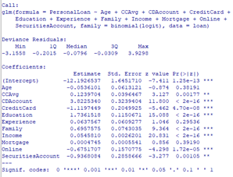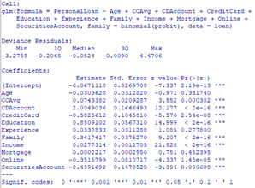

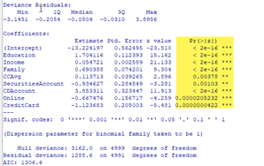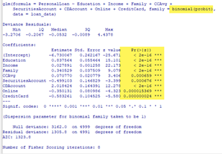

1. Moderating Effects
   1. We tested two combinations: Education Level & Family size and Education & Income Level. These two interactions are familiar to us and based on the data, they are statistically significant. These factors each had the lowest p-values among all of the other variables we tested. This was the same in both the logit and probit analysis.
   2. Statistically significant interaction: education level and family size
      1. **Undergraduate** – As family size increases, the likelihood of taking out a loan increases.
      2. **Graduate** – As family size increases, the likelihood of taking out a loan increases.
      3. **Advanced/Professional** – As family size increases, the likelihood of taking out a loan decreases.
      4. **Beyond advanced/professional** – As family size increases, the likelihood of taking out a loan decreases.
   3. Statistically significant interaction: education level and income level
      1. **Undergraduate** – As income level increases, the likelihood of taking out a loan increases.
      2. **Graduate** – As income level increases, the likelihood of taking out a loan increases.
      3. **Advanced/Professional** – As income level increases, the likelihood of taking out a loan increases.
      4. **Beyond advanced/professional** – As income level increases, the likelihood of taking out a loan increases.

Moderating effect: Education * Family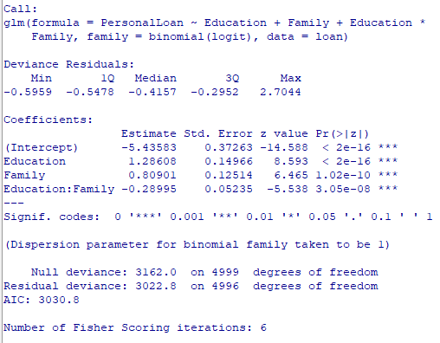

Moderating effect: Education * Income

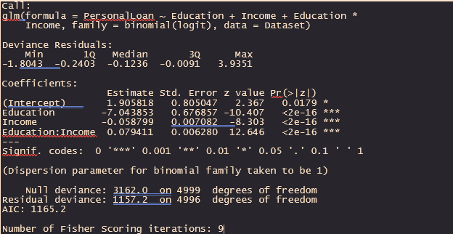

1. Prediction and sensitivity analysis of regression models shown above (both main effects and interaction effects)

Moderating effect: Education * Family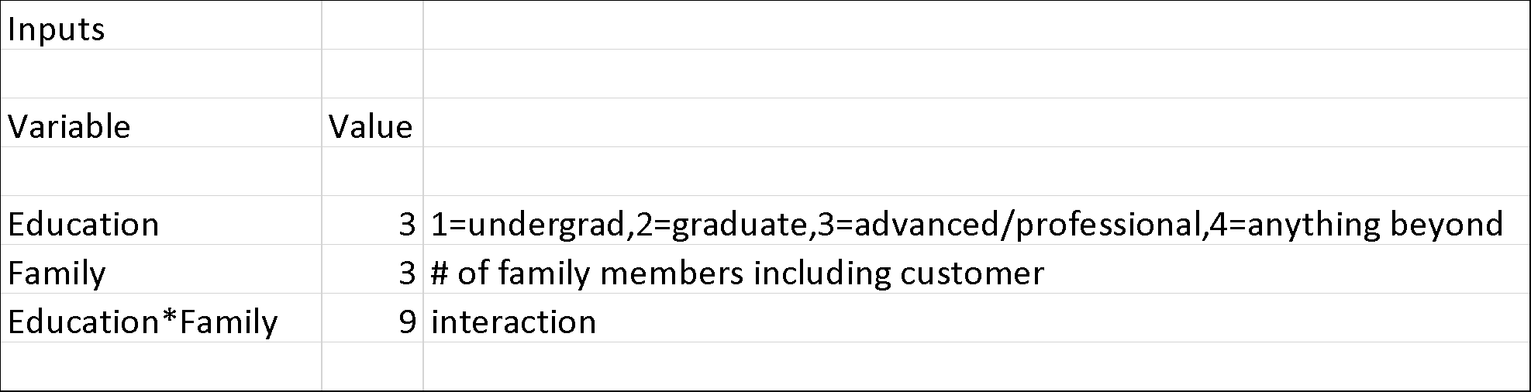

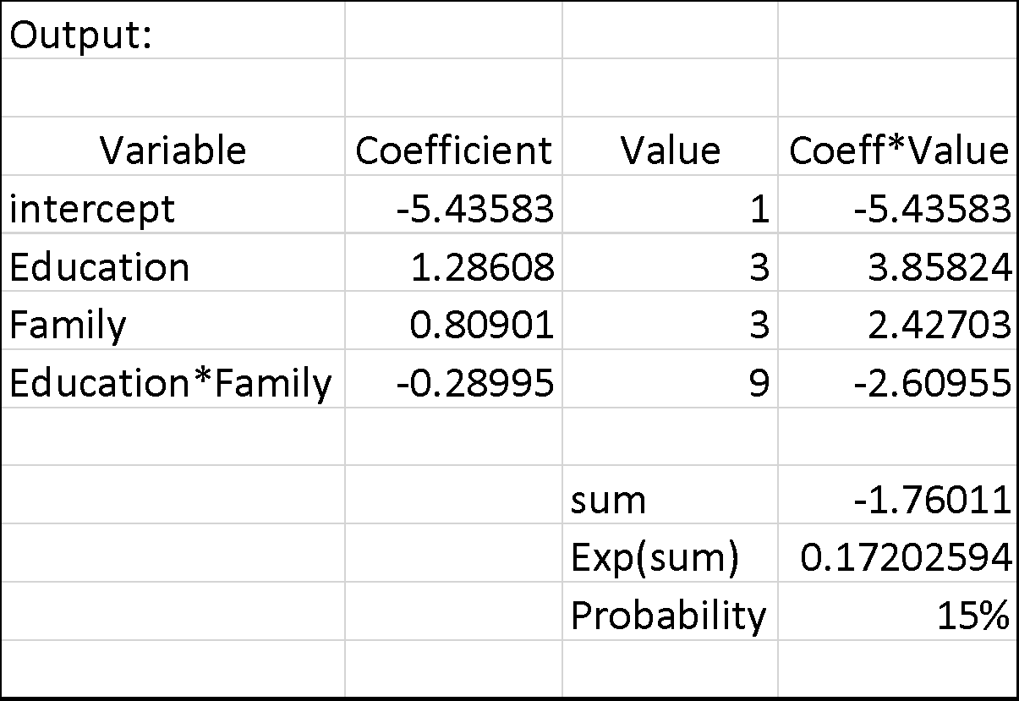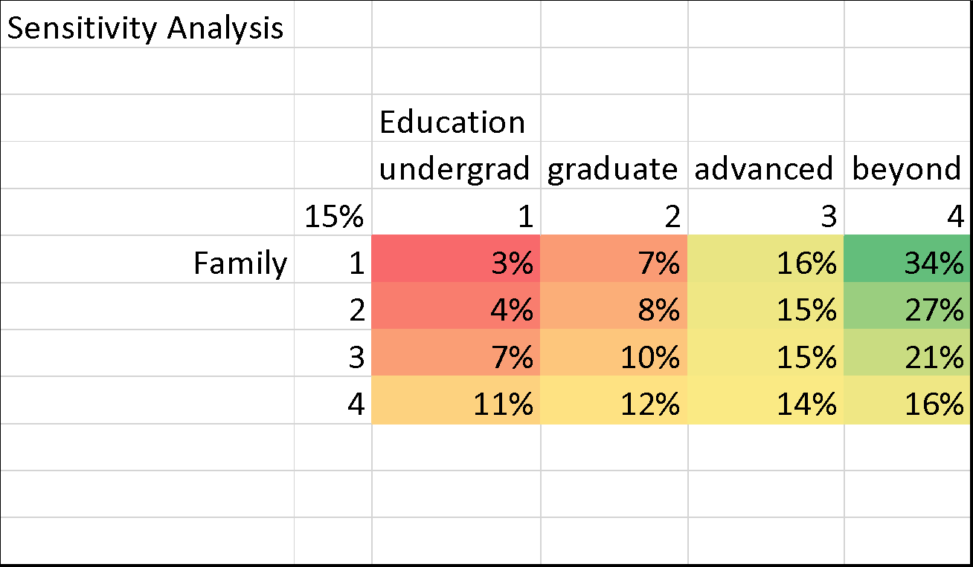

While for those with lower education levels, the probability of accepting a loan increases with family size, for those with higher education, this probability decreases as family size increases. Those with a higher education level, however, still had a higher probability of getting the loan than those with lower education level, regardless of family size. Higher education is often accompanied by a higher income, so these individuals may have had more chances to accumulate savings for future life changes. For those with less education, an increase in family size can account for an increase in loan acceptance as these individuals may require loans for adjustments in housing, tuition for multiple children, etc.

Moderating effect: Education * Income

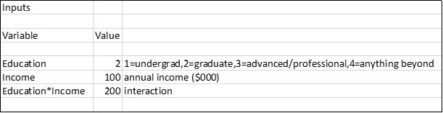

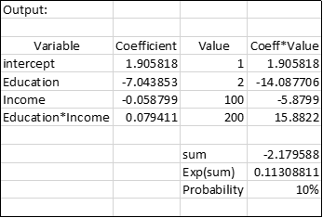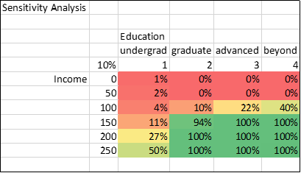

From this analysis, we can see that education and income are both positive indicators on the likelihood of a customer accepting a loan. Higher income and higher education level increase the likelihood of accepting the loan. Individuals with higher education and income have the means for a loan and are more likely to receive a loan given these variables. Those with lower income and lower education levels may have more immediate need for a loan, with less in savings to fall back on thus their probability of receiving a loan decreases.

1. Neural Network analysis of the variables found to be significant in the logit and probit analysis above.

Education * Family

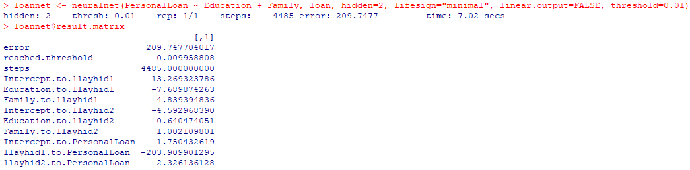

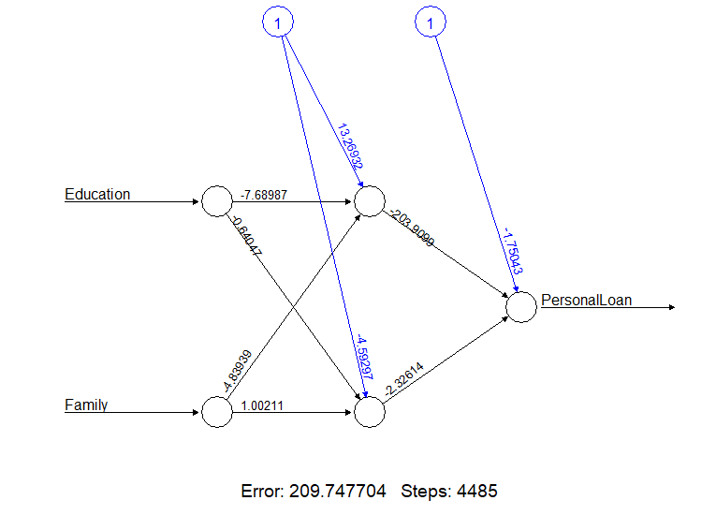

Education * Income

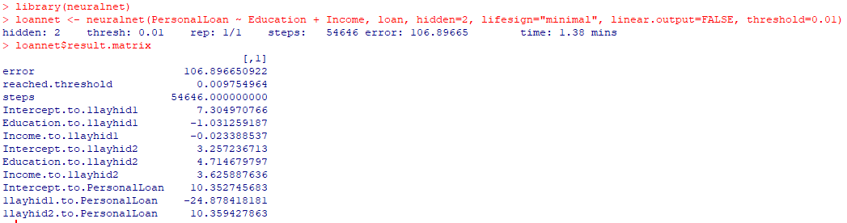

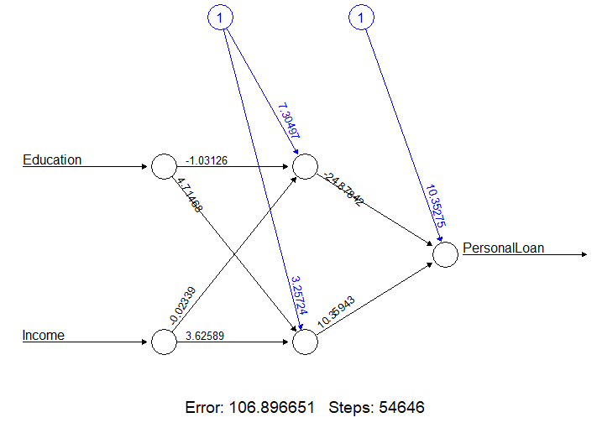

1. Prediction model and sensitivity analysis of the neural network model above.

Education * Family

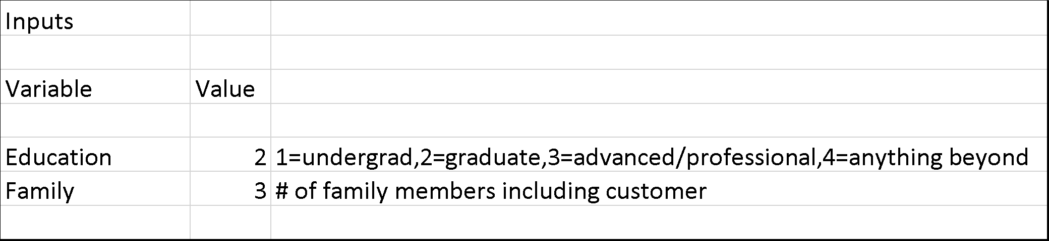

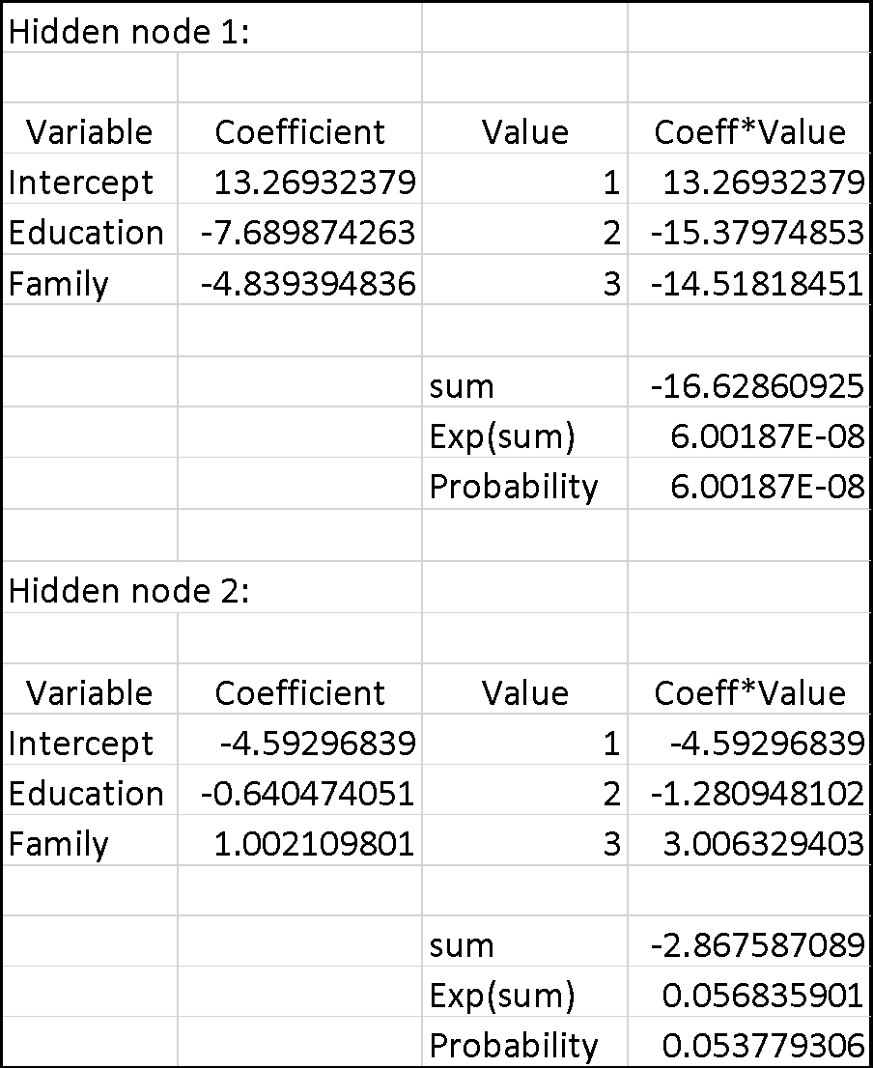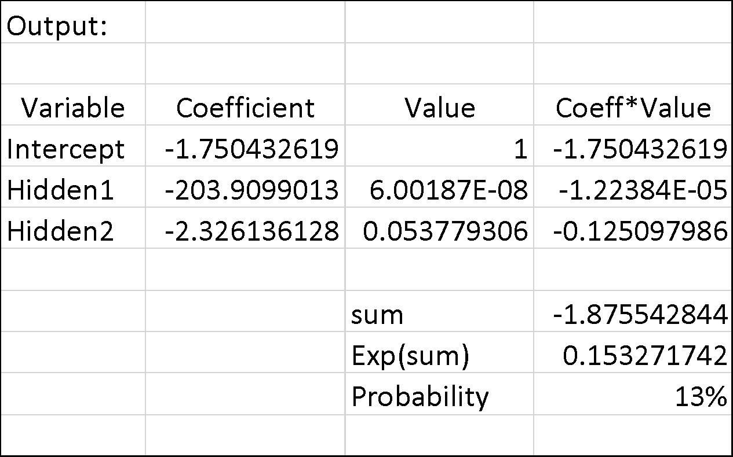

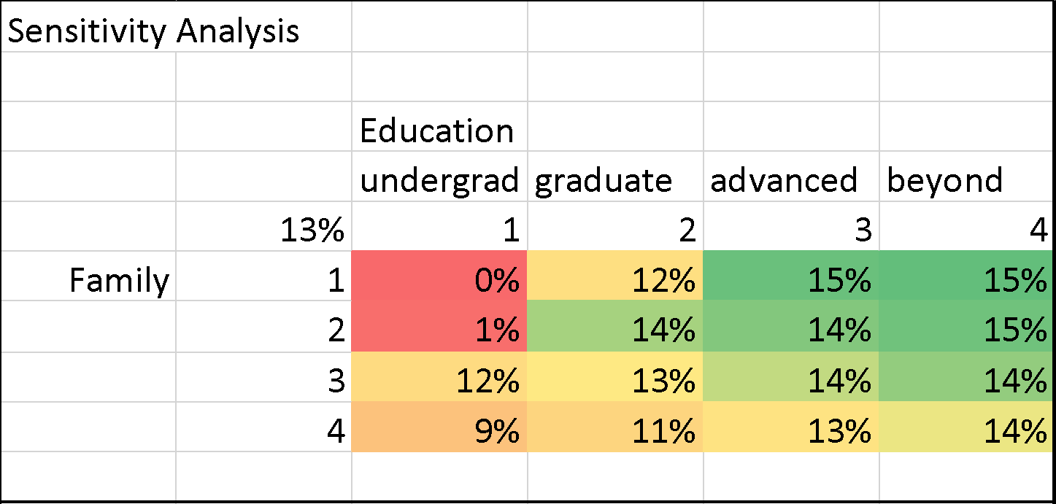

Education * Income

