Becky Matthews-Pease
IST 652: Scripting for Data Analysis
Final Project

Data Source:
Brady Brelinski, Founding Member of the Manhattan Chocolate Society, created a database of chocolate, focusing on dark chocolate bars. Each bar was rated on a scale of 1 to 5, with 5 being the best. Data also collected included the year the bar was tested, the location of the company, the type of bean used, and the source of the bean. While an older version of this dataset is available on Kaggle, the creator of the database has continued to add entries in recent years on his website. This information was combined with the original Kaggle dataset to form a more complete set spanning from 2006 to 2020. Web searches were able to locate information for the few fields that were missing, and in some instances, data was transformed from categorical to continuous data in order to run analysis. In total, 2,346 bars were reviewed, with an average score of 3.1.

Pre-Processing:
This pre-processing was completed in a copy of the original .csv file In addition, fields such as year of harvest, company name, bar name, and other sub-columns were removed due to being irrelevant to this analysis or due to the data being missing for the majority of entries. The data was explored by viewing the number of columns and rows, the number of and names of the different unique fields for each variable, averages for each variable, and histograms of the rankings of each variable. In order to avoid overfitting and see more generalized trends, the categories of company location and bean origin were converted from city/region/state to continent.

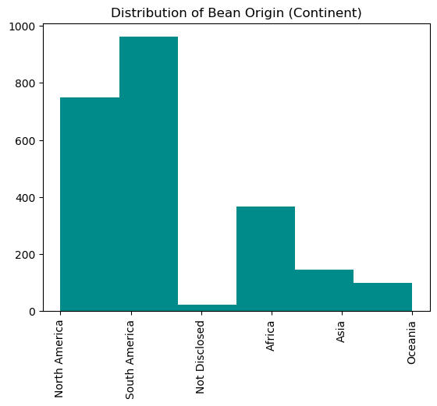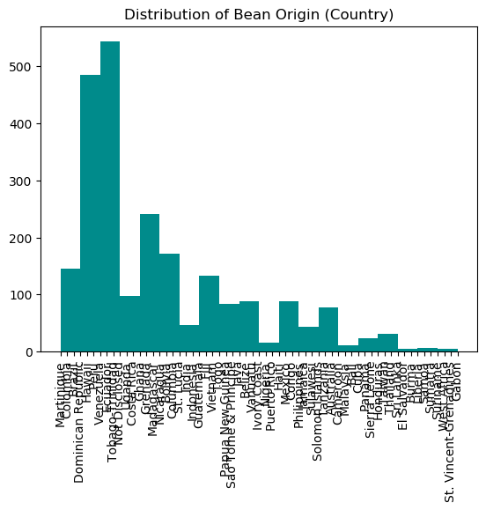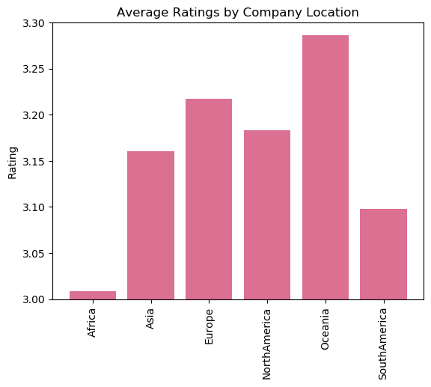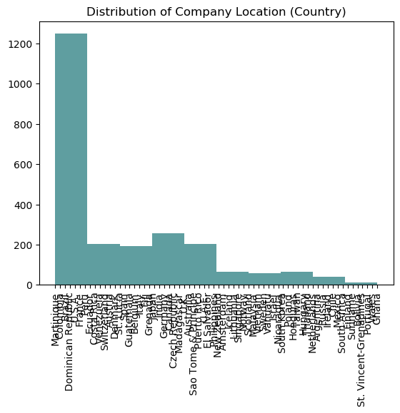

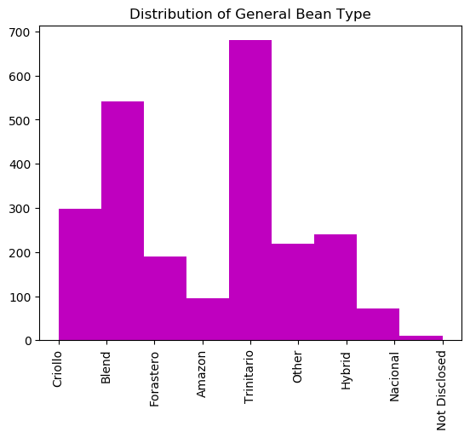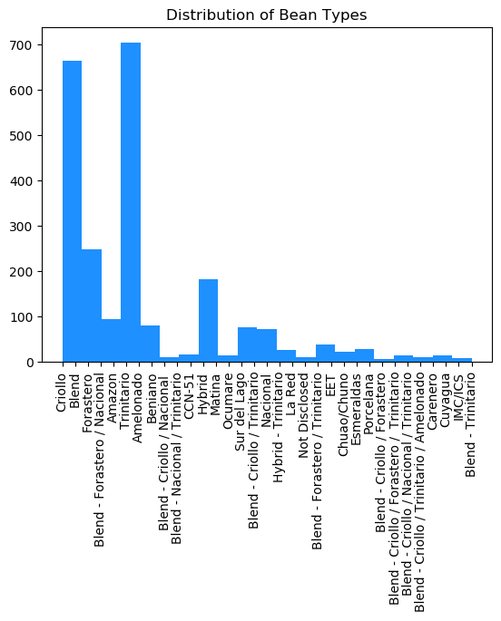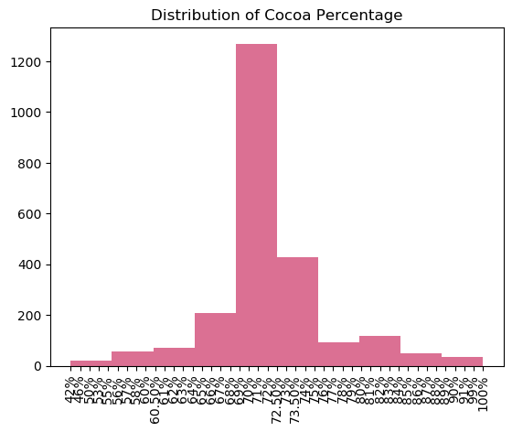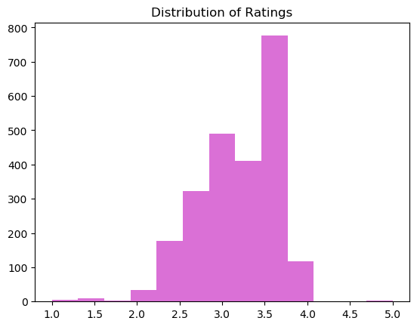
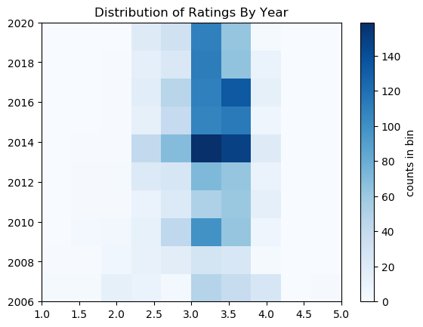

Average Ratings:
Bean Origins:
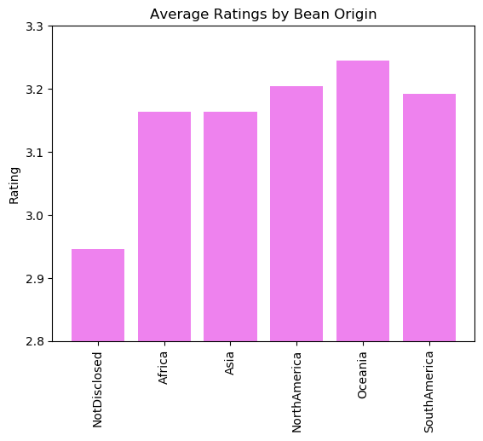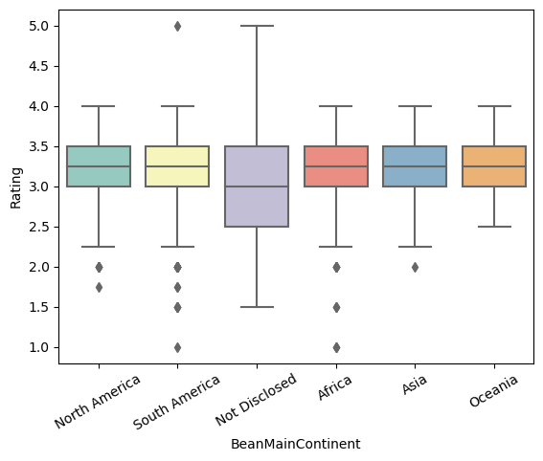
Beans sourced from Oceania had the highest average rating as well as the highest lowest rating. Ratings are focused in a smaller range due to the number of bars from Oceania being the fewest in terms of count. Few companies in this database did not disclose the country/continent(s) of origin, but this group still had the widest range of ratings. This group has the lowest average rating as well, but has one outlier that received a perfect score of 5. North and South America have the second and third highest average rating, followed by Asia and Africa.
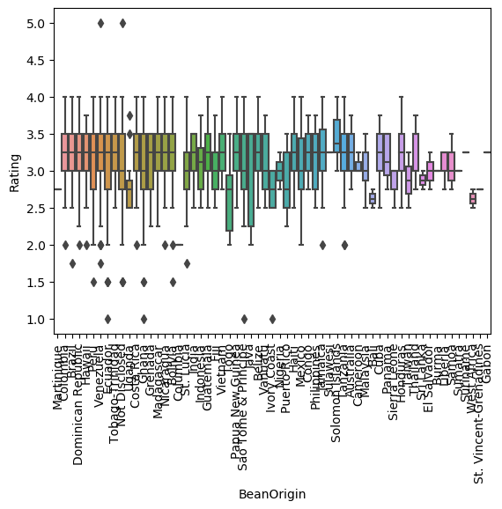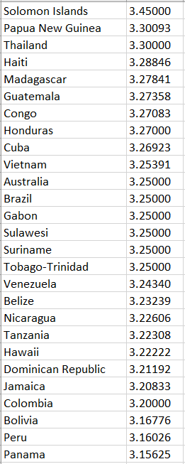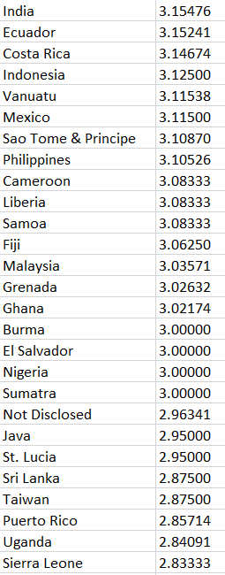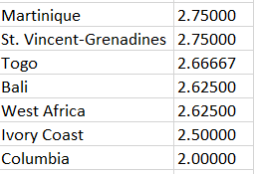

Company Location:
Looking at the company location of these rated bars, bars made in Oceania have the highest average rating, highest lowest rating, and a smaller range. As with bean origin, bars produced in Africa had the lowest average rating (aside from those with an undisclosed source).
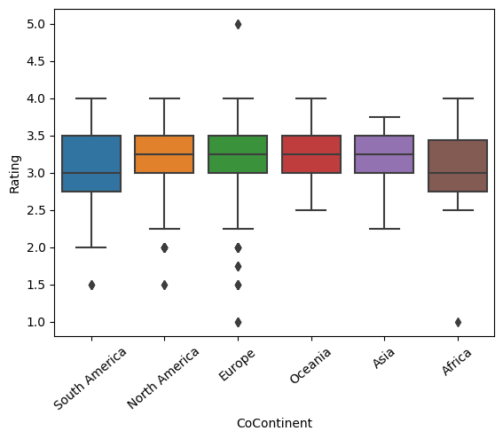
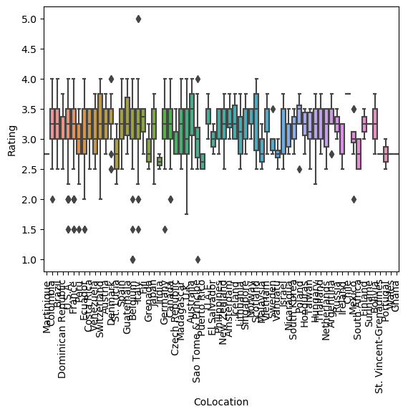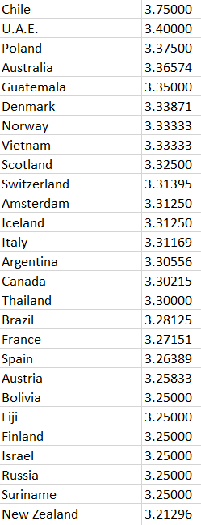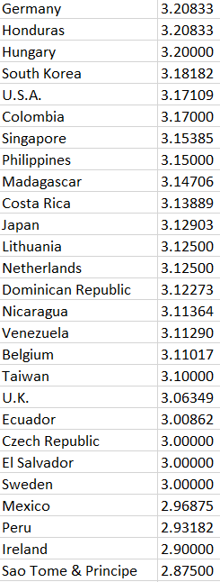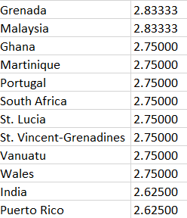
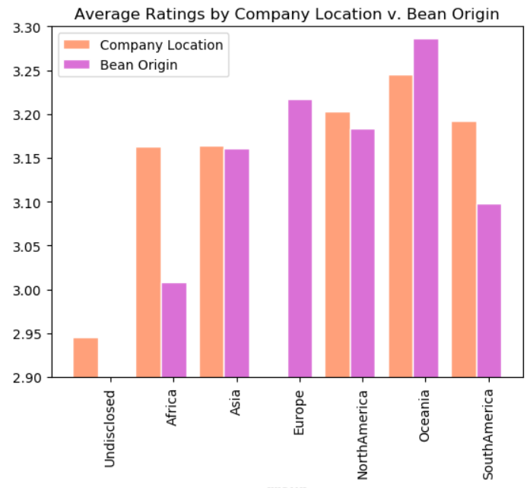

Bean Type:
The most common types of chocolate beans are Trinitario, Forastero and Crillo, however, many chocolate bars use a blend of multiple bean types, and a number of hybrid beans have been created. From this dataset, bars made from Amazon, Nacional, and undisclosed beans have the highest average ratings, but are also the lowest in terms of count.
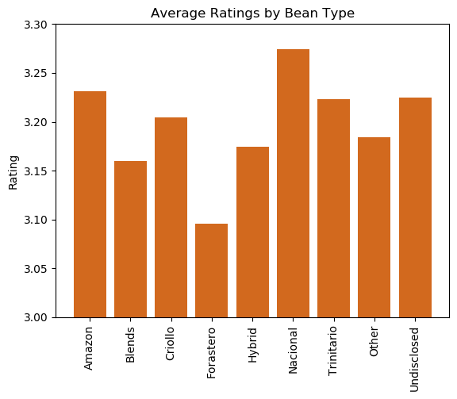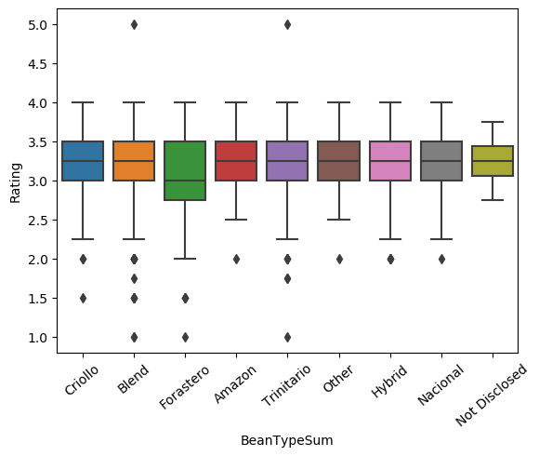

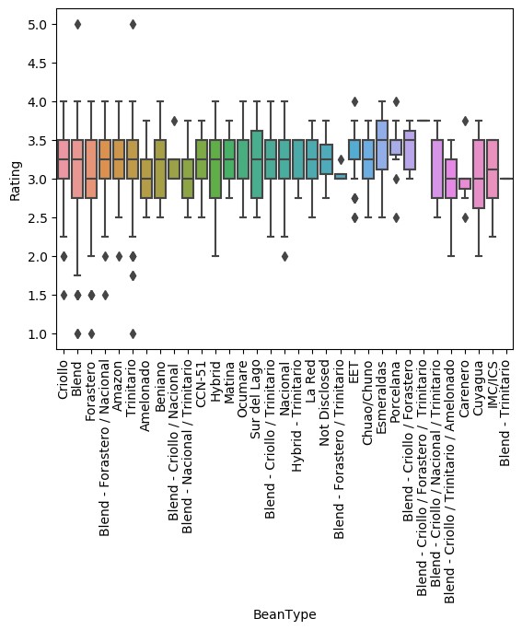
Cocoa Percentage:
There isn’t a direct positive/negative correlation between rating and percentage of cocoa, but the percentage groups with the highest rated bars mostly fell within the 63-78% range. Those between 90%-100% and <42% had the lowest ratings. (Note: few bars were greater than 95% or lower than 50%.)
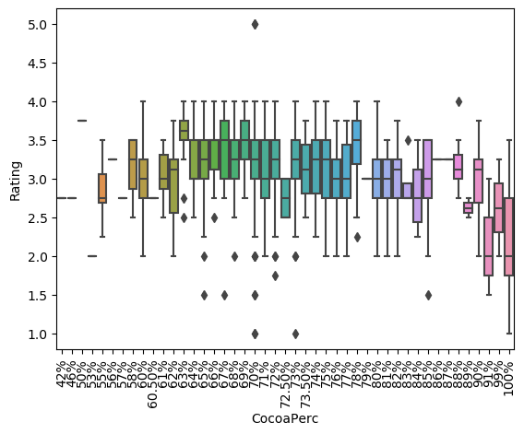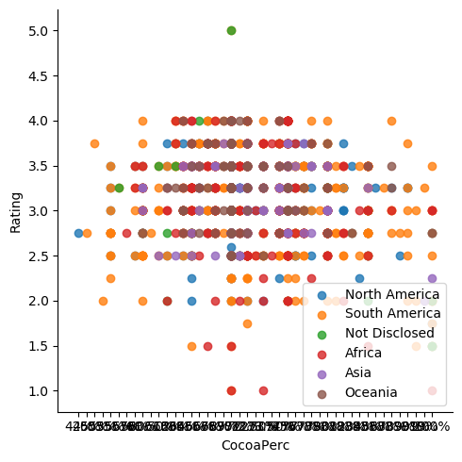

Question for Analysis:
The first question for analysis is what is the most influential predictor of quality score of chocolate bars? And how much influence does the top predictor have? The variables reviewed were percentage of cocoa used in each bar, year, location of company (baking styles can vary based on where the product is being produced), type of bean used (certain types of beans will yield different flavors) and source of the bean used (climate will have an influence over flavor of beans as well). A linear regression model was run using these variables:
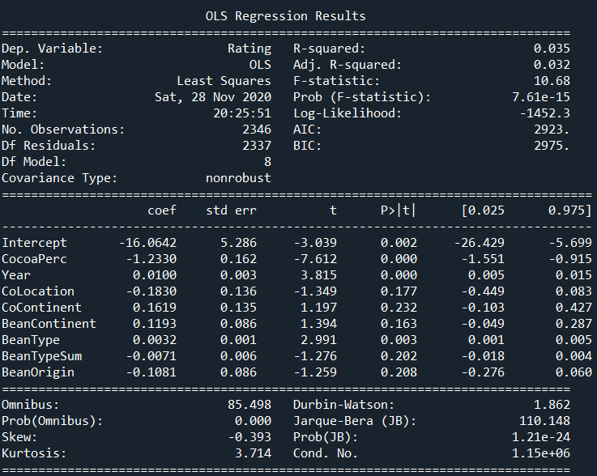

Location and Source:
Based on the analysis of this dataset, the variables that had an impact (with a p-value above .05) were the geographical location where the beans were grown, company location, and type of bean used.
Noting that company location and bean origin are likely to have influence on the rating in addition to there being a trend between companies with the lowest/highest average ratings and the locations of bean origins with the lowest/highest average ratings, exploration was done to see if those bars where the company location was local to the bean source had higher ratings. No trend was found, and the for most, the average rating for those whose company is located in the same continent as the bean source was with about .2% of those from those where the company was located somewhere differently from the bean source.
When only looking at those bars where the company is based in the same area as the bean source the ranking of averages changes slightly. In these cases, bars made by Asian companies with beans sourced from Asia had the highest average rating, followed by South America, Oceania, with North America and Africa having the lowest average. There were no bars where the company was located in the same country as the bean source. Even companies located in cocoa bean growing countries sourced their beans from another.

Source Location and Cocoa Percentage:
Following the analysis that bean origin had the biggest influence between the presented variables, the average variable of each bean origin (by continent) was evaluated. The question that was set up to explore was what is the range of the cocoa content used in those bars made from beans sourced on the continent with the highest average chocolate bar rating, and the content from those bars made from beans sourced on the continent with the lowest average chocolate bar rating.
Those chocolate bars made from beans from the continent that produced the highest average ranking (Oceania) had a large range of cocoa content, ranging from 60% to 100%, with most falling within the 70% range. Since this dataset focuses mainly on dark chocolate, cocoa content of the bars evaluated are all over 40%, so those bars with beans sourced from Oceania have been used in bars that span nearly the full range of cocoa percentage. The ratings of each of these percentages were scattered, with no trend towards higher/lower cocoa content receiving higher/lower ratings. This agrees with the initial linear regression showing cocoa content as not being an influencing variable.
Those chocolate bars made from beans from the continent that produced the lowest average ranking (Africa) had a range similar of 57% -100% with the bulk being at 70%. Also similar to those bars made with beans from Oceania, there wasn’t a clear trend between higher/lower cocoa percentage and rating, but those highest rated were in the lower 60% - lower 70% range

Source Location and Bean Type:
Keeping focus on bars made with beans from Oceania and Africa, bean type used was explored. Both had similar bean types used, with Africa including a slightly wider range of named hybrids and blends. Looking at the grouped categories, each location included Amazon, blends, Criollo, Forastero, hybrid, and Trinitario beans. Africa also had a number of beans summarized as “Other.” These would be specifically named hybrids such as Carenero and Amelonado. Average ratings for each were higher with the beans from Oceania, with the exception of Criollo beans, where Africa had a .6 higher difference.
The more specified list of beans used (which includes those blends and hybrids that are specifically named, rather than all summarized as “blend” or “other” include Amazon, unspecified blends, Criollo/Trinitario blend, Forastero/Trinitario blend, Criollo, Forastero, unspecified hybrids, and Trinitario. In addition to these types, those bars sourced in Africa also included Carenero, Ocumare, Amelonado, and Criollo/Trinitario/Amelonado blend. Again, each type had a higher average rating for those bars sourced from Oceania with the exception of Criollo and Criollo/Trinitario blends.

The Program:
The Python program created begins by exploring the data, getting the column names and unique values and counts of the variables. It further explores the data by creating histograms for different variables to explore the distribution of the data. Bargraphs, boxplots and scatter plots are then generated comparing the different variables and looking at them a bit closer.
It runs the linear regression model looking at variables that might influence chocolate bar rating as well as compiling the averages for each variable, and taking a closer look at some of the characteristics of those bars with the highest and lowest ranking feature of the most influential variable.
The program also produces four output files. The first lists each bean source (country) and the corresponding average rating. The other three list the bean types, company locations, and cocoa percentages respectively, as well as their corresponding average ratings to a .csv file.

Conclusion:
Overall, based on this dataset, the feature most likely to have an impact on the pleasantness of a flavor of chocolate bar is the location from which the beans are sourced. The bars made from the beans sourced from Oceania had the highest average rating, and showed a full variety of cocoa percentage and bean types used in these bars. The bars made from beans sourced in Africa had the lowest average rating, and were used in bars with a similar range of cocoa content, but a wider range of bean types. Location of the company was also a factor, but there were no instances where the company was located in the same country as the bean source, even in the cases where the company was located in a bean-producing country. No correlation was found between those companies located on the same continent as their bean source and those located on a different continent.
One item that was not present in this dataset, and would be difficult to get for all bars listed, is the processing of the beans. Based on readings completed, there can be variations on taste based on if the beans are dried or processed while wet, if they are ground first, etc. This would be a potential area for further research, but likely on a smaller scale due to the difficulty in obtaining these details.

