Becky Matthews-Pease
IST 652: Scripting for Data Analysis
Homework #1

Brady Brelinski, Founding Member of the Manhattan Chocolate Society, created a database of chocolate, focusing on dark chocolate bars. Each bar was rated on a scale of 1 to 5, with 5 being the best. Data also collected included the year the bar was tested, the location of the company, the type of bean used, and the source of the bean. Websearches were able to locate information for the few fields that were missing, and data was transformed from categorical to continuous data in order to run analysis.
This pre-processing was completed in a copy of the original .csv file In addition, fields such as year of harvest, company name, bar name, and other sub-columns were removed due to being irrelevant to this analysis or due to the data being missing for the majority of entries. The data was explored by viewing the number of columns and rows, the number of and names of the different unique fields for each variable, averages for each variable, and histograms of the rankings of each variable. In order to avoid overfitting and see more generalized trends, the categories of company location and bean origin were converted from city/region/state to continent.
The first question for analysis is what is the most influential predictor of quality score of chocolate bars? And how much influence does the top predictor have? The variables reviewed were percentage of cocoa used in each bar, year, location of company (baking styles can vary based on where the product is being produced), type of bean used (certain types of beans will yield different flavors) and source of the bean used (climate will have an influence over flavor of beans as well). A linear regression model was run using these five variables. :

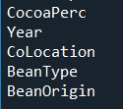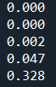

Based on the analysis of this dataset, percentage of Cocoa content, year rated, and company location has little to no influence on the ratings given. Bean type had a slight, but not significant impact. The variable that had an impact (with a p-value above .05) was the geographical location where the beans were grown.
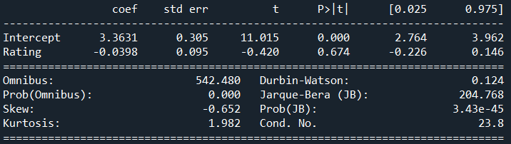

Following the analysis that bean origin had the biggest influence between the five presented variables, the average variable of each bean origin (by continent) was evaluated. The question that was set up to explore was what is the range of the cocoa content used in those bars made from beans sourced on the continent with the highest average chocolate bar rating, and the content from those bars made from beans sourced on the continent with the lowest average chocolate bar rating.
Those chocolate bars made from beans from the continent that produced the highest average ranking (Asia) had a large range of cocoa content, ranging from 56% to 100%, with most falling within the 70% range. Since this dataset focuses mainly on dark chocolate, cocoa content of the bars evaluated are all over 40%, so those bars with beans sourced from Asia have been used in bars that span nearly the full range of cocoa percentage. The rankings of each of these percentages was randomly distributed, with no trend towards higher/lower cocoa content receiving higher/lower ratings. This agrees with the initial linear regression showing cocoa content as not being an influencing variable.
Those chocolate bars made from beans from the continent that produced the lowest average ranking (Australia) had slightly narrower range and leaned towards the lower end of the spectrum, with no bar being over 85%. The full range was between 42% and 85%, but, like with those from Asia, most falling within the 70% range. Also similar to those bars made with beans from Asia, there was no trend of higher/lowing ratings on the basis of cocoa content.
The Python program created explores the data and creates various histograms and barcharts looking at different variables. It runs the linear regression model looking at variables that might influence chocolate bar rating as well as compiling the averages for each variable, and taking a closer look at some of the characteristics of those bars with the highest and lowest ranking feature of the most influential variable.

Histogram of Ratings
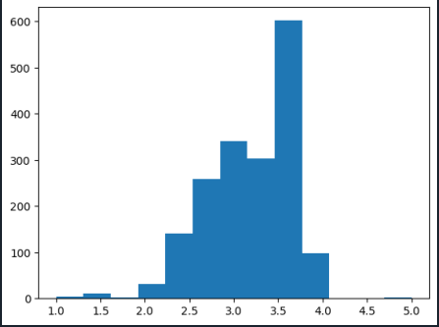

Histogram of Cocoa Percentage
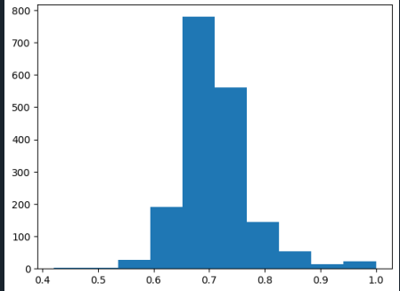

Histogram of Bean Types
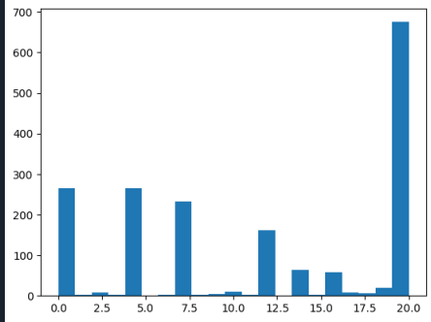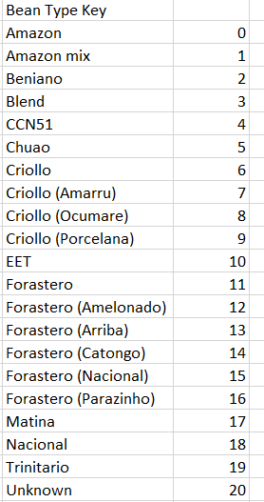

Histogram of Bean Origin (Continent)
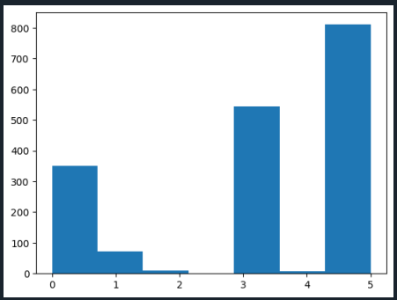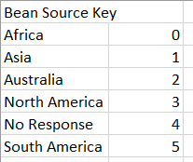

Histogram of Company Location (Continent)
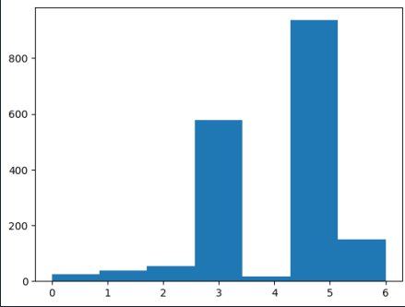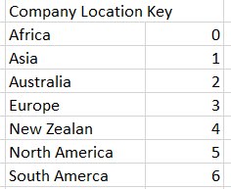

Comparison of Ratings by Year
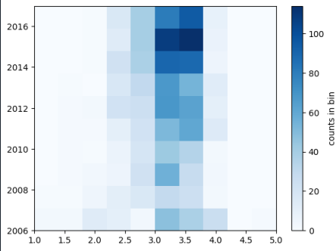

The program also produces two output files. The first lists each unique value for the six factors featured in the dataset: year, cocoa percentage, company location, rating, bean type, and bean origin. The second shows each unique value of the variables bean origin, bean type, year, and cocoa percentage and the average rating for each.

Overall, based on this dataset, the feature most likely to have an impact on the pleasantness of a flavor of chocolate bar is the location from which the beans are sourced. The bars made from the beans sourced from Asia had the highest average rating, and showed a full variety of cocoa percentage used in these bars. The bars made from beans sourced in Australia had the lowest average rating, and were used in bars with a narrower range of cocoa content, which also skewed towards a lower percentage of content than those from Asia.

