

IST736 Text Mining HW5
Becky Matthews-Pease
Classification of Craft Chocolate Bar Reviews



Introduction
In recent years craft chocolate, or bean-to-bar chocolate, has risen in popularity and has been produced by companies of every size. As more customers seek chocolate that is ethically sourced, is not detrimental to the environment and surrounding communities, or even simply an alternative to the chocolate-free Hershey bar, the market for these bars continues to rise. Many of these companies are transparent with the sourcing of their beans, noting what country(s) they come from, and in many cases, the specific farm. Most bars are made with the three most common bean types (trinitario, criollo, and forastero), but blends and hybrids are growing in popularity. With smaller companies becoming more involved in the market, many bars are single batch and only available for a limited time, either due to production restraints, or due to a company closing its doors.
This all results in a wealth of chocolate bars to choose from, and a wealth of different characteristics from which to choose. But it also means that selecting one for a next snack can be daunting. Customer reviews are a great resource to gage if a person might like the bar or not. But reading through reviews can be time consuming. Reviews can go into great details about everything from the packaging, the taste, after taste, the color of the chocolate and even background history about the maker, the bean source/type, and fermentation. While this is all very good information to have and make for an interesting read, an alternative would be needed of someone was just looking for a general idea of if the bar has been well rated or not. Likewise, craft chocolate bar companies could use positive/negative reviews to see if there are trends in certain traits being more well liked. Do bars with longer conch times get better reviews? Do trinitario beans get better reviews than forastero?
There is no shortage of sources to consult when it comes to chocolate bar reviews. Websites such as ChocolateCodex, the C-Spot, Bar and Cocoa, DameCacao, and BeantoBar include reviews from professional reviews, customers, and “armchair” expert bloggers. This program takes segments of reviews from these different websites for 26 different bars. The goal is to see if the positive reviews can be sorted from the negative reviews. Further research and information would yield even bigger trends. It could give insight as to which companies are producing the most well-liked bars, what countries or farms produce the best beans, and what bean types are more popular.
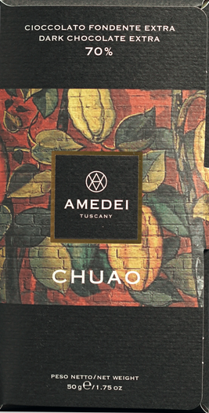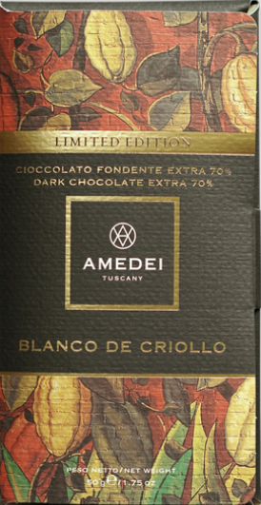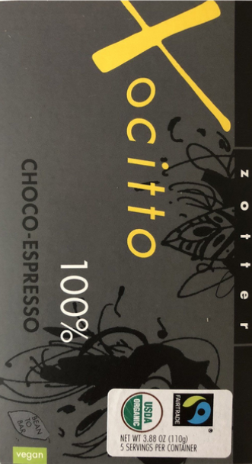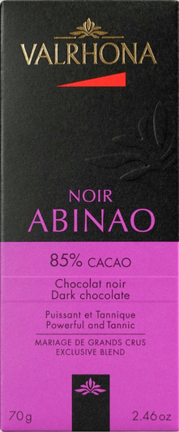
Analysis & Models:
About the Data
The data consists of 7 chocolate bar reviews in a .csv document. Each row of the document is a separate chocolate review under a column titled ‘text.’ Each review contains between 62 and 202 words, totaling to 833 words and 4,472 characters. Reviews were selected at random from a semi-professional chocolate review website, with five being positive reviews (defined as receiving 4-5 star rating out of 5) and two being negative (defined as reviews with a 1-2 star rating out of 5). This particular website is known for reviews that can be sarcastic, sassy, and over the top in nature.
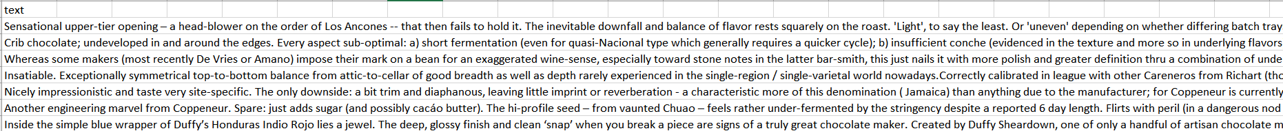
The first step in data cleaning was to run a simple spell check on all documents. Any ampersands were replaced with the word “and” as this was the only special character present that was not compatible with Amazon Mechanical Turk site.
Submissions to AMT were submitted in three batches. The first two times requests only one rater for the labeling, with the third requesting 3 unique raters. A 10 cent incentive was offered to each rater for each label for the first two batches, and a 5 cent incentive for the final batch. Labels were completed within a couple of hours of initial submission. Users were given the rating options of positive, neutral, and negative. The only restriction for rater criteria was knowledge of written English language. Total cost came to $2.45, averaging 7 cents per label. Raters spent and average of 2.66 minutes on each review, totaling to 93 minutes between the 5 unique raters.
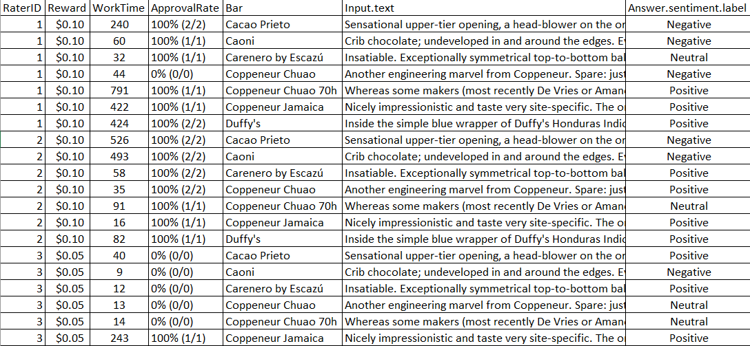
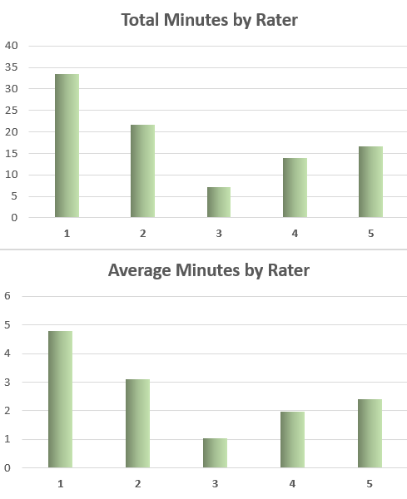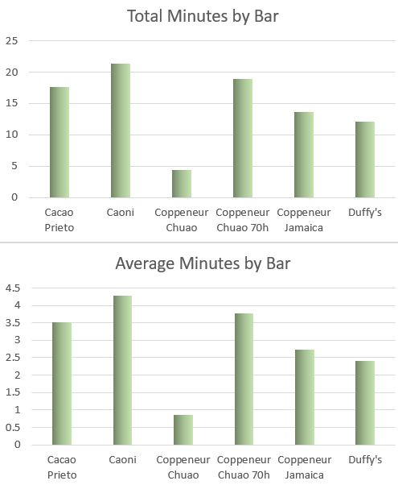
The Models
Amazon Mechanical Turk is a way to crowd-source data related task. Individual researchers and businesses can present volunteers tasks such as taking surveys, data validation, research, and in this case, sentiment labeling. What could be a time-consuming and redundant task for on individual can be split up among multiple volunteers. AMT gives the option to get responses from multiple users, so researches can compare results to ensure greater accuracy. In the case of sentiment analysis, this also has the benefit of getting responses from the general public perspective, rather than one researcher’s perspective. Restrictions can be placed on what users participate, such as demographic details, reviewers with a certain feedback rating, etc. For this project, reviewers were restricted only to those with fluent knowledge of written English.
Labels from each rater were compared to other raters as well as the actual sentiment label for each chocolate bar. From this data, the kappa inter-reliability score was calculated for each rater in comparison to the actual label and other raters.
0 = Negative; 1 = Neutral; 2 = Positive 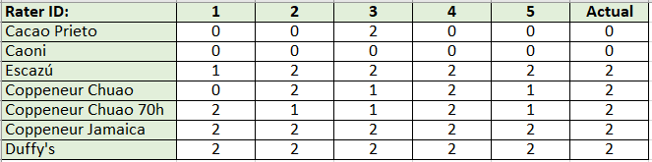
Results
Of the seven chocolate bars, three had a 100% agreement across all raters. The Caoni bar was accurately identified as negative, and the Duffy’s bar and Coopeneur’s Jamaica bar were all accurately identified as positive.
Of those bars where there was not 100% agreement across all raters, most were close in label, with a couple of exceptions. The Escazu bar and Coopeneur’s 70 hour Chuao bar had positive reviews, and all labels were either neutral or positive. The Escazu was correctly labeled positive by all labelers with the exception of rater 1 who rated neutral. Coopeneur’s 70 hour Chuao bar was accurately labeled as positive by raters 1 and 4, but misclassified as neutral by the other three raters. Coopeneur’s Chuao bar and the Cacao Prieto bars were the only two with any significant discrepancy. Cacao Prieto was labeled as positive by rater 3, but accurately identified as positive by all others. Coopeneur’s Chuao bar was labeled as negative by rater 1, but accurately labeled as positive by two labelers, and neutral by the other two.
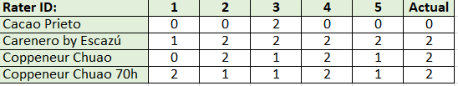
Comparing each rater against every other individual rater (including the actual label) shows an overall inter-reliability score of 60%
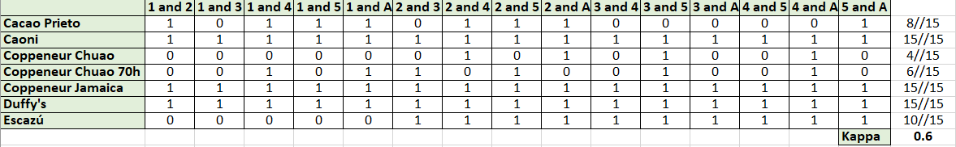
Kappa = ((8/15) + (15/15) + (4/15) + (6/15) + (15/15) + (15/15)) / 7 = 60%
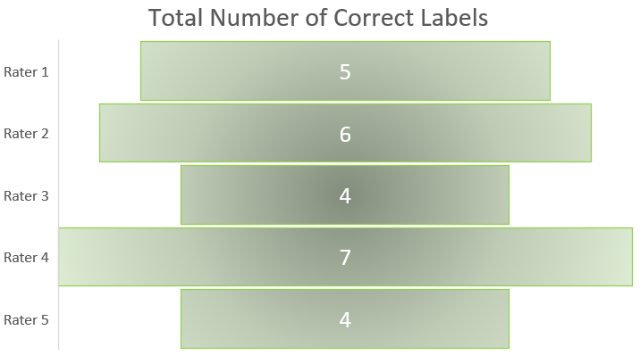

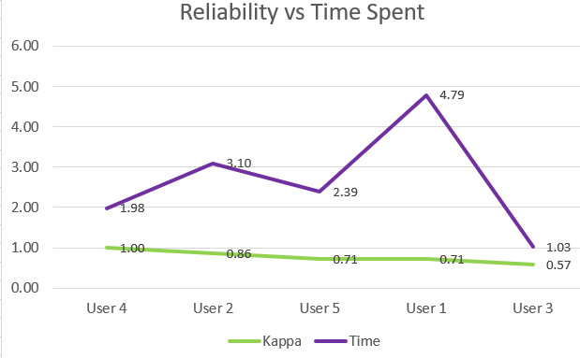
Comparing accuracy level with average time spent on each review does not show any trend; while the rater who spent the least average time on each review has the lowest kappa rating, the other reviews don’t show any correlation between time spent and kappa score. The higher incentive rate for the first two raters may correspond with the having the longest average time spent, but had no impact on overall accuracy.
Looking at the ratings by chocolate bar, both Coppenheur Chuao bars appear to be the most ambiguous, with Cacao Prieto and Escazu being mostly recognizable as positive, and Caoni, Coppeneur Jamica and Duffy’s having no ambiguity.
Number of Accurate Ratings by Bar
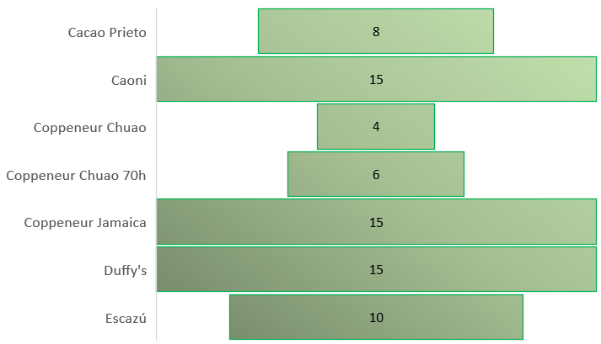

Causes for discrepancy could be related to a number of factors, mainly, knowledge of chocolate characteristics and terminology. While none of the reviews use much in the way of chocolate industry jargon, there are still some instances where extra knowledge of chocolate would be beneficial. For example, one of the Coppeneur Chuao bar reviews mentions the limited number of ingredients. As a general rule among craft dark chocolate fans and makers, a good dark chocolate bar should have few ingredients; more specifically, no more than 3 ingredients should be used. Without knowing this is considered a positive trait, a person could easily misinterpret this as criticism. Phrases used such as “fights for survivial” and “flirts with peril” would typically be seen as negative, but are used in a positive context here, as part of this reviewers signature over-the-top imagery when describing the taste of chocolate bars. In this case, these phrases are describing the complex subtleties in the flavors of this chocolate bar experiment.
Looking at the reviews that were accurately labeled by all reviewers, reviewers demonstrate being able to contextualize negative words used in a positive context such as ‘primitive,’ ‘lacking’ and ‘unrefined.’ One of the universally positive labeled reviews is more narrative, but the few sentiment-related words (great, favorite) were picked up on easily enough.
Conclusion
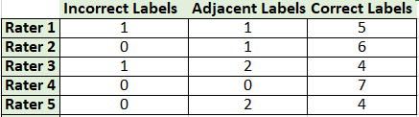
Based on these results, use of Amazon Mechanical Turk would be a viable option for sentiment labeling. Most raters fell above a 70% reliability score, with only one dipping just below 60 percent. With this in mind, it would be a good idea to continue to have multiple unique labelers and taking an aggregate result to mitigate any labelers with lower accuracy. Restrictions could also be added, such as requiring reviewers to have a certain rating from researchers, or requesting reviewers with a small degree of specialized chocolate knowledge.
 | Kappa
User 4 | 100.0%
User 2 | 85.7%
User 5 | 71.4%
User 1 | 71.4%
User 3 | 57.1%
The writing style of the reviewer and use of chocolate-specific terminology may have had the biggest impact on incorrect labeling, as labelers were overall able to correctly identify positive words used in a negative context, and negative words used in a positive context, as well as reviews containing mostly non-sentiment related words. Mis-classification of positive and negative reviews occurred equally, but positive reviews were more likely to be misclassified as positive rather than negative (out of all the negative reviews, only one was mis-labeled by reviewers).

