A: Problem Statement:
HRConnect representatives are spending a lot of time scheduling interviews, explaining how to apply to positions, and giving application updates. These comprise over 20% of case types, and over 50% of a rep’s day.

B: Business Impact
How to fix: By automating certain processes, creating helpful reports, and cutting out unnecessary steps.
Estimated Benefit: HR Connect reps will have more time to work on more complex issues; hold time will go down; Once the team begins to schedule for all of manufacturing, it will speed up the process.
Benefit in dollars: If the team is scheduling for all of the large manufacturing facilities, we would need to double the Front Line head count to keep up with volume.
How to measure: The decrease of inquiries on how to apply/check application statuses; decrease in average time to schedule and interview.
What is key output: Time spent

C. Goals:
What are your improvement objectives: For Front Line reps to spend less time on recruiting related tasks and to pro-actively have more efficient processes in place for when Front Line is scheduling interviews for all manufacturing locations.
Goals or targets: To cut down on the number of recruiting related cases (in the sub-field of “applicant” by 15%, and to cut down on the amount of time spent on scheduling interviews by 25%.

D. Project Scope:
What are your boundaries?
Certain steps of the recruiting process will not be able to be altered based on EEO hiring best practices;
Range of dates applied;
The need to communicate with multiple parties who each only have access to certain systems
What is the first and last step of the process?
The first step would be recruiter review of candidates/sending the request(s) to HRConnect
What is not within your scope?
Potential follow up time such as: candidates calling back/returning an email when we get a voicemail instead of the individual.
Positions where the hiring manager insists on having a dozen or more super busy individuals participate in multiple interviews lasting 2+hours
Reschedules needed
Restrictions on recruiters

E. Team:
Who is the process owner/champion? The Recruiting Specialist
Who do you need to work with or involve to analyze and/or impact this process:
I would involve recruiting to improve communications between plants-recruiters-Front Line reps, trying to find more efficient ways to select candidates and how to distribute requests.
I would work with Scott, Quality and Service Representative to pull reports I may not have access to, and to note any change in quality of service.
I would work primarily with Front Line for process feedback, suggestions, and data.

F. Project Plan 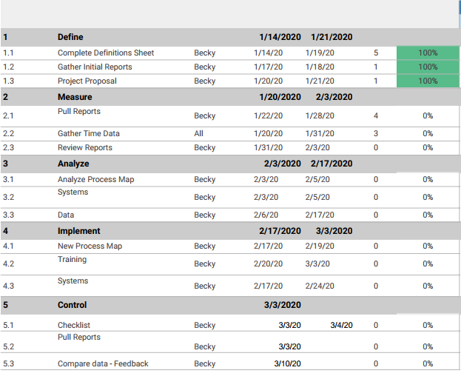

Process Map

