Brenna DeGan

Assignment 6

1. The main difference between the Gouraud shading and the Phong shading models what is interpolated and where. In the Gouraud shading model colors are interpolated for each pixel while in the Phong shading model normal are interpolated. In addition, the Gouraud shading model is implemented in the vertex-shader and the Phong shading model is implemented in the fragment-shader. Phong shading is more realistic because to the approximation of the normal vector at each pixel. This can especially be seen with highlights on shinny objects.

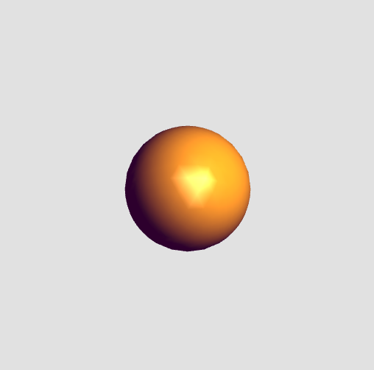Gouraud Shading:

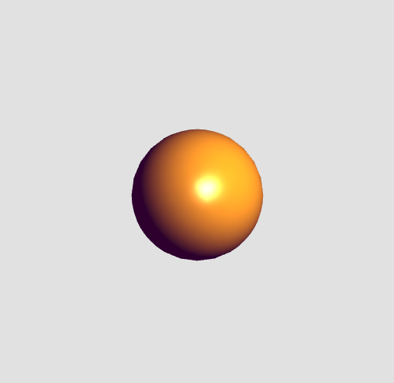Phong Shading:

1. There are non-physical components in the Phong reflection model because it would be too computationally expensive to render an image with that has realistic light reflections. The non-physical components in the Phong reflection model render an image that is close to realistic without being too computationally expensive. An example of the shortcuts used is the assumption that each point source has its own ambient, diffuse and specular components. This assumption isn’t natural but in it can look realistic in real time. Another shortcut used in the Phong reflection model is the use of vectors l, n, v, r, and p. We assume that l is pointing to the light source and we can calculate r (the reflection of l) with n and l. At the point p, the coefficients for the ambient, diffuse and specular material light interactions are used to make the image look more realistic.