Bryan Emer
August 10, 2025
DSC 630 Final Paper

Predicting Employee Attrition Using Machine Learning
Introduction
Employee attrition, the voluntary or involuntary departure of employees, represents a major challenge for organizations. High turnover disrupts teams, adds recruitment and training costs, and erodes institutional knowledge. Researchers note that attrition costs include recruitment expenses, lost productivity and intangible knowledge, which can erode profit margins. Predictive analytics and machine learning offer the potential to identify employees at risk of leaving and allow HR professionals to intervene early with retention strategies. This project applies several classification algorithms to the IBM HR Analytics Employee Attrition & Performance dataset to predict whether an employee will leave the organization.
Overview of Data Used
The IBM HR Analytics Employee Attrition & Performance dataset contains information for 1,470 employees and 35 features. Each observation includes demographic variables (age, marital status, gender), job characteristics (job role, department, business travel, overtime), performance metrics (performance rating, job satisfaction), compensation (monthly income, stock option level) and the target variable Attrition indicating whether the employee left ('Yes') or stayed ('No'). After removing non‑predictive columns such as EmployeeNumber, Over18, StandardHours and EmployeeCount and applying one‑hot encoding to categorical variables, about 50 numeric predictors remained. The target variable is highly imbalanced: approximately 16 % of employees (237 out of 1,470) left the company. Figure 1 shows the distribution of attrition status, and Figure 2 compares monthly income distributions by attrition.
Figure 1. Attrition distribution in the IBM HR dataset.
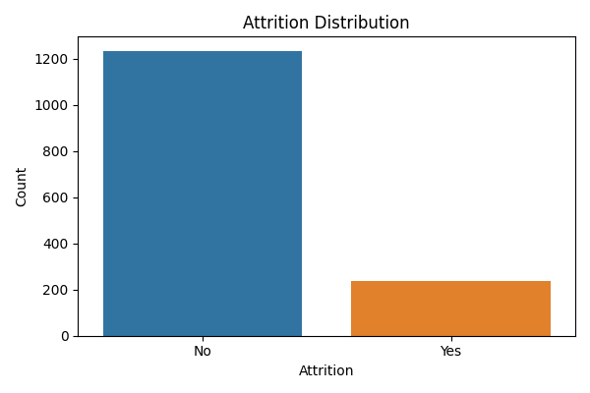

Figure 2. Monthly income distributions by attrition status.
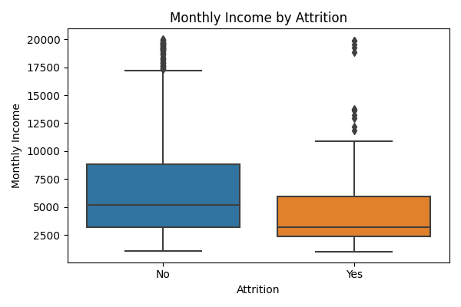
Methods of Analysis
The analysis pipeline was implemented in Python using pandas and scikit‑learn. First, the dataset was cleaned by removing constant identifier columns and converting the categorical target 'Attrition' into a binary variable. Categorical variables were encoded using one‑hot encoding to create a numeric feature matrix. The data were split into training and test sets (80/20) with stratification to preserve the class distribution. To address class imbalance, simple random oversampling duplicated minority class examples so that both classes were equally represented in the training set. (Brownlee, Jason. “Random Oversampling and Undersampling for Imbalanced Classification.” ) More sophisticated methods such as the Synthetic Minority Over‑sampling Technique (SMOTE) generate synthetic minority examples by interpolating between nearest neighbors (Blagus, Rok, and Lara Lusa, “SMOTE for High-Dimensional Class-Imbalanced Data.” ), but they were not used in this environment.
Features were standardized with a StandardScaler before model training. Three classification models were trained: Logistic Regression, Decision Tree and Random Forest. Logistic Regression models the log‑odds of attrition as a linear combination of features and uses the sigmoid function to map predicted probabilities into [0, 1] (www.geeksforgeeks.org/machine-learning/understanding-logistic-regression). Decision trees partition the feature space into regions by learning simple rules. Random forests aggregate predictions from many decision trees grown on random subsets of data and features to reduce overfitting and improve accuracy (www.geeksforgeeks.org/machine-learning/random-forest-algorithm-in-machine-learning). Models were evaluated on the held‑out test set using accuracy, precision, recall, F1 score and the area under the receiver operating characteristic curve (ROC–AUC).
Results & Findings Explained
Table 1 summarizes the performance of each model on the test set. Logistic Regression achieved the highest F1 score (0.50) and recall (0.64), balancing precision and recall effectively. The model correctly identified 64 % of employees who left. Random Forest achieved the highest accuracy (0.83) but at the expense of recall, indicating a preference for predicting employees who stayed. Decision Tree performance was inferior on most metrics. The confusion matrix for Logistic Regression showed that 204 employees who stayed were correctly identified, while 43 were incorrectly predicted to leave. Among employees who left, 30 were correctly identified and 17 were missed. Feature importance analysis from the random forest indicated that age, monthly income, daily rate, total working years and overtime status were strong predictors of attrition. Older employees and those with higher income or more years of service were less likely to leave, whereas working overtime increased attrition risk.
Model | Accuracy | Precision | Recall | F1 Score | ROC AUC
Logistic Regression | 0.80 | 0.41 | 0.64 | 0.50 | 0.81
Decision Tree | 0.74 | 0.20 | 0.21 | 0.21 | 0.53
Random Forest | 0.83 | 0.44 | 0.15 | 0.22 | 0.78
Table 1. Model performance metrics on the test set.

Ethical Considerations
Using machine‑learning models to predict employee attrition raises ethical concerns. Algorithms trained on historical HR data may reflect existing biases and could perpetuate discrimination if sensitive features correlate with attrition. Moreover, employees may perceive predictive systems as intrusive. To address these issues, HR professionals should assess models for fairness across demographic groups and remove sensitive variables when possible. Data should be anonymized and stored securely, and organizations should be transparent about how predictive insights will be used. Ethical guidelines emphasize avoiding bias, protecting privacy and communicating openly with employees (www.hrcloud.com/blog/predictive-analytics-in-hr-forecasting-workforce-needs).
Conclusion
Predicting employee attrition is crucial for organizations seeking to retain talented staff and minimize replacement costs. The IBM HR dataset provided a rich set of demographic, job and performance variables for building predictive models. Among the tested algorithms, logistic regression offered the best balance between identifying employees who leave and avoiding false alarms. Age and income emerged as important predictors: older and better‑paid employees were more likely to stay, while working overtime increased attrition risk. This project demonstrates that a simple and interpretable model can outperform more complex ensemble methods when data are limited and class imbalance is addressed through oversampling. Future work could explore advanced resampling techniques such as SMOTE, incorporate additional behavioral data, and evaluate models using cross‑validation to improve generalizability.
References
Blagus, Rok, and Lara Lusa. “SMOTE for High-Dimensional Class-Imbalanced Data.” BMC Bioinformatics, vol. 14, no. 1, 22 Mar. 2013, https://doi.org/10.1186/1471-2105-14-106
“Predictive Analytics in HR: Forecasting Workforce Needs for 2025.” Hrcloud.com, 2025, www.hrcloud.com/blog/predictive-analytics-in-hr-forecasting-workforce-needs
“Logistic Regression in Machine Learning.” GeeksforGeeks, 9 May 2017, www.geeksforgeeks.org/machine-learning/understanding-logistic-regression
“Random Forest Algorithm in Machine Learning.” GeeksforGeeks, 22 Feb. 2024, www.geeksforgeeks.org/machine-learning/random-forest-algorithm-in-machine-learning
Brownlee, Jason. “Random Oversampling and Undersampling for Imbalanced Classification.” Machine Learning Mastery, 14 Jan. 2020, machinelearningmastery.com/random-oversampling-and-undersampling-for-imbalanced-classification

