**Exercise 1a.**

>> a=1.12

a =

1.1200

>> b=2.34

b =

2.3400

>> c=0.72

c =

0.7200

>> d=0.81

d =

0.8100

>> f=19.83

f =

19.8300

**Exercise 3**

>> array =

Columns 1 through 11

-1.0000 -0.9500 -0.9000 -0.8500 -0.8000 -0.7500 -0.7000 -0.6500 -0.6000 -0.5500 -0.5000

Columns 12 through 22

-0.4500 -0.4000 -0.3500 -0.3000 -0.2500 -0.2000 -0.1500 -0.1000 -0.0500 0 0.0500

Columns 23 through 33

0.1000 0.1500 0.2000 0.2500 0.3000 0.3500 0.4000 0.4500 0.5000 0.5500 0.6000

Columns 34 through 41

0.6500 0.7000 0.7500 0.8000 0.8500 0.9000 0.9500 1.0000

ans =

41

**Exercise 4a**

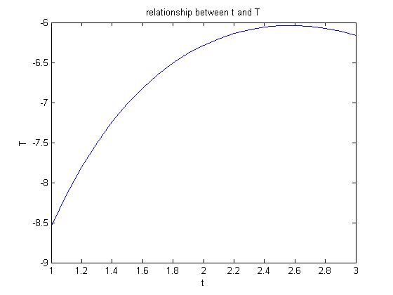

**Exercise 4b**

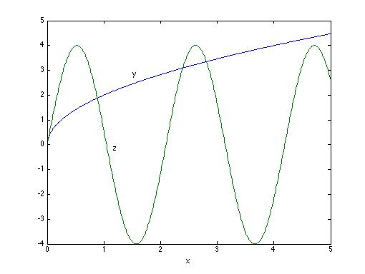

**Exercise 4c**

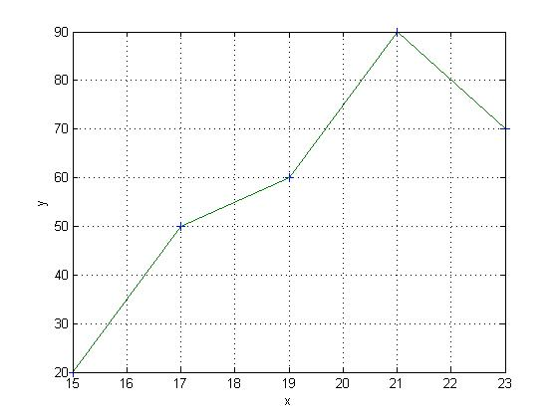

**Exercise 4d**

