Ad Danuvium
A setting for the minimalD6 roleplaying system
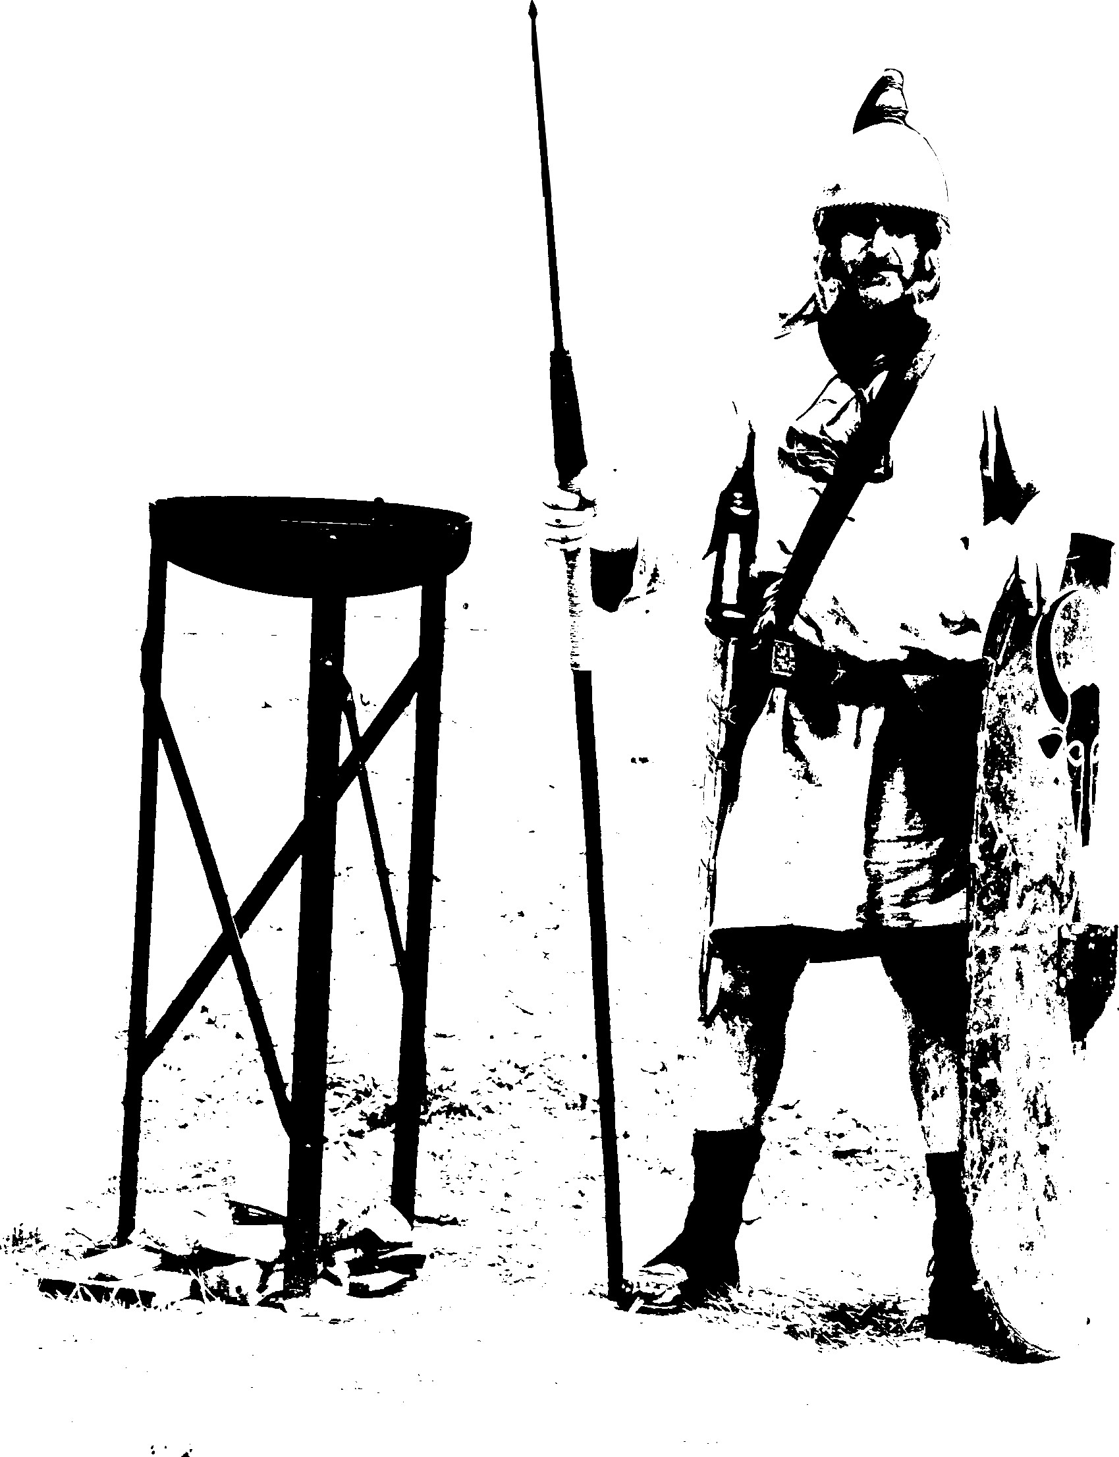

Copyright
Based on minimalD6 v2 by Norbert G. Matausch
minimalD6 is licensed under Creative Commons Attribution-ShareAlike 4.0 International (CC BY-SA 4.0)
https://creativecommons.org/licenses/by-sa/4.0/
Optional rules are inspired by Marcus Burggraf aka Chaosmeister
Text, layout, photos and maps by Peter Kastberger
Additional pictures:
Simurgh by GDJ (https://openclipart.org/detail/222337/simurgh)
Chimera by GDJ (https://openclipart.org/detail/222179/chimera)
Dryad by Firkin (https://openclipart.org/detail/261594/dryad)

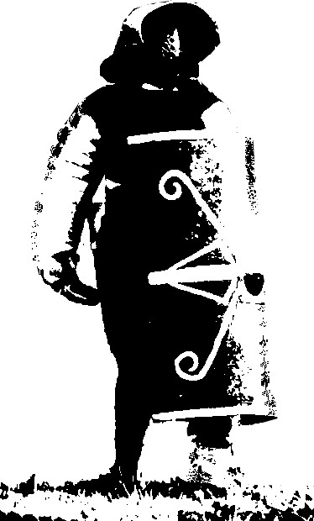
Version 0.1 alpha
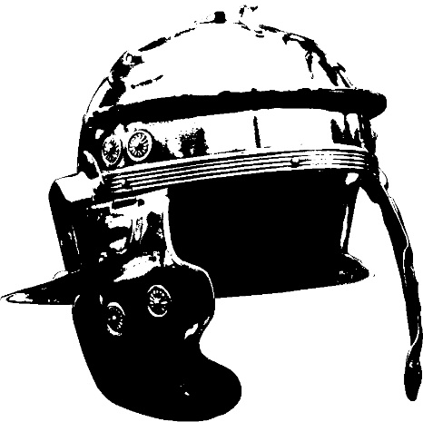
Introduction and a hint
Ad Danuvium is a fantasy setting which takes its ideas from the Roman Empire in the 2nd Century. It is explicitely not historically correct. However existing locations and events are used as a decoration.

Setting
Ad Danuvium is a mixture of historical setting and fantasy. The fantasy elements are taken from the myths of ancient times. The timeframe may be a cold winter in 179/180 A.D.

"We are in Carnuntum. It's the biggest city on the Roman Empire's part of the legendary amber road. Emperor Marcus Aurelius resides here directly at the Limes Pannonicus to lead the war against the approaching barbarian clans from the north. The roman soldiers at the confluence of the March and Danube river are sent into the wildlands for expeditions and patrolling. The water meadows are grim and foggy. The empire also has forts located on the outskirts next to the enemies. Transportation is done by feet or oxcarts, raft or galley. But it's difficult, as the winter is cold and relentless.

Carnuntum is a melting pot for cultures and an important trade center. Amber is brought by brave merchants from the baltic sea all the way trough the wild lands into the empire behind the Limes. From there it is on it's via Scarabantia to the south. It passes Julia Emona and finally reaches Aquileia on the adriatic coast. Aquileia normally is the emperor's sommer location.

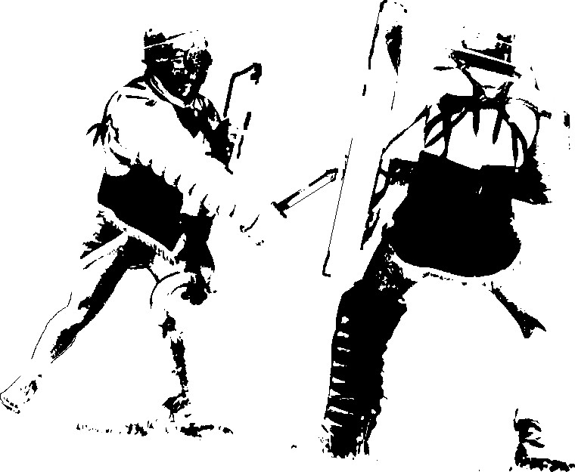
Even though Rome tries to make its citizens believe that empire is stable and secure, life is dangerous! The barbarian clans from the north attack roman citizens whenever the get a chance to and sacrifice their lives to their heathen gods. Highwaymen take the merchants' goods and gold. When get caught, you may end up a slave. Wolves and bears are hungry and roam for food and get quite close to human settlements. The antoninian pestilence has already taken one third of people. And if that wasn't enough, rumours have it that dark creatures, monsters and ghosts are waiting at the woods, shrines and hot springs."

Rules

Character Creation

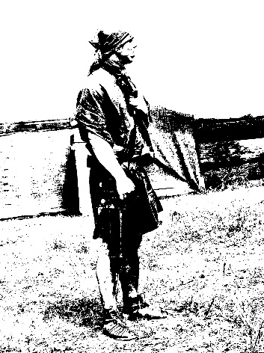
All crazies have 6 Virtutes. Roll 1d6 for each. Alternatively assign the values 1,2,3,3,4,5.

- Auctoritas - authority, experience, leadership
- Firmitas - strength, power, will, perseverance
- Honestas - honesty, reputation, public image
- Humanitas - humanity, humbleness, learning, culture
- Prudentias - courage, foresight, wisdom
- Severitas - severity, austerity, self-control, graveness

1 | 2 | 3 | 4 | 5 | 6
Terrible | Poor | Average | Good | Superb | Legendary

Start
All characters start at level 2. Choose two class properties and one equipment item.
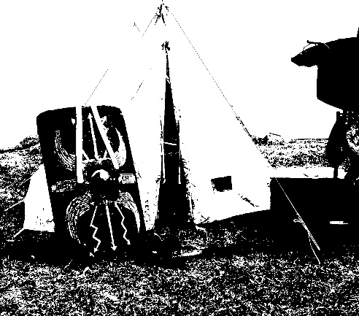

Who are you?

Roll 2D6 or choose:

2: Legionary (miles)
Properties: travelled the world on both sides of the Limes, twenty years of service is a long time, spadework and engineering, basic military education, strategy & tactics
Equipment: short sword (gladius), pillum, pickaxe, salary (gold and salt), helmet and armour, dice

3: Merchant (mercator)
Properties: a little bit is always possible, art & junk - profit and loss, smells a good deal, everyone can be customer, estimating quality/quantity, gibbering
Equipment: slide rule, wax board & pen, amber and shells and gold, hidden pockets with some spare money

4: Mercenary (mercennarius)
Properties: my sword for your money, the witty wins - not the honest, has travelled the whole world, today a friend - tomorrow a foe, flexible with everyone
Equipment: slingshot, dagger, bandages, something to trade, talisman

5: Visionary (aruspex)
Properties: foreshadowing, sees signs in nature and sky, fights on other planes, spellcasting, cursing and banishing, talk to ghosts, make people believe
Equipment: staff, water skin with wine, herbs and roots, chicken bones, wolf skin

6: (free) Slave (servus)
Properties: silent and unsuspicious, economise, straight-faced, knows some secrets, endurance, foreign language and behaviour, own gods
Equipment: hammer & chisel, rope, bread and dry olives, crayon

7: priester (presbyter)
Properties: herald & servant of the gods, loyal to his pantheon, see through fake magic, provide peace
Equipment: incense, small statues, oil lamp and flintstone

8: slave broker (venalcius)
Properties: cold hearted, you can find a commodity anywhere, power of order, daunt, master of fist-fighting, brownnose
Equipment: whip, rope, coins, gold, net

9: doctor (medicus)
Properties: cure injuries and wounds, life's a loop - recognize coherences, I've read about that, brewing potions and poison, overcome fear and loathing
Equipment: bandages, herbs, tools, vinegar

10: actor (actor)
Properties: far travelled, knows stories and fables, bewitch with words, master of disguise, story teller
Equipment: makeup, costumes, parchment & quill, jewellery

11: patrician (patricus)
Properties: can afford it, lineage opens doors, contradiction is not tolerated, is used to command, this is too exhausting, knows bloodlines and dynasties
Equipment: gold coins, harp, barrel of the best wine, good clothes, pet

12: clerk (quaestor)
Properties: the word of the law, accuracy, knows stuff from hearsay, cost versus value, writing and mapping, knowledge from the library, servant to the empire
Equipment: sealing wax and seal, written law, keepsake from home, writing tools

Player
Describe what your character is doing. Roll 2d6. A 5 or 6=successful. +1d6 for advantage of any kind (item, high attribute, superior tactics etc). -1d6 for disadvantage of any kind (low attribute, hinderance). Do NOT ADD dice results. Simply look for Fives and Sixes.
Never roll more than 3d6. Never roll less than 1d6. Roll when you try to hit, to evade, to do stuff, to save your ass. The DM will tell you when and why.
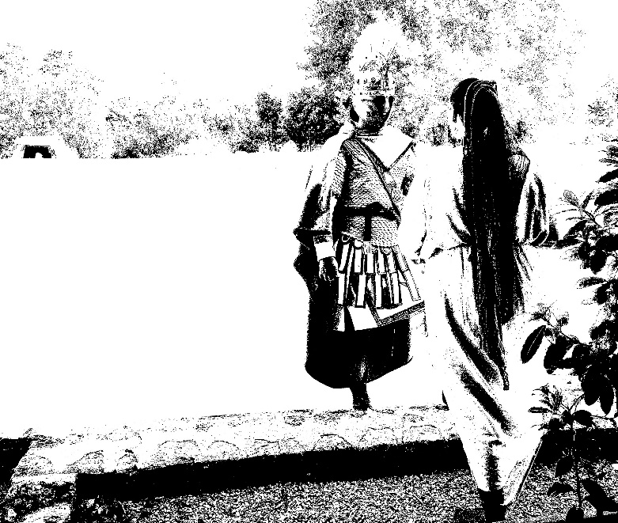

DM
Play the world and everything in it. Roll for it, if necessary. Success in combat=reduce health by 1 point or narrate what happens (high health=they can take a good amount of damage, low health=weak). Major successes are possible (you decide when it happens and what happens). Likely success: don’t roll dice, it happens. Unlikely success: roll dice. Impossible: don’t roll dice, tell the players what happens. Skills are likely, except when impossible. All rolls change the situation.

Optional Rules
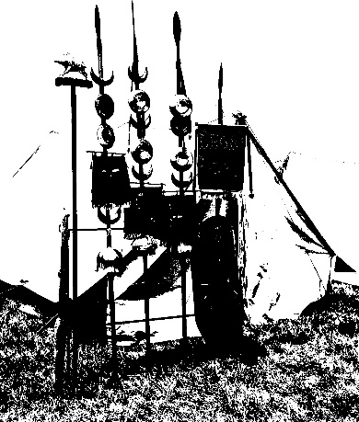
The sum of Firmitas and Severitas is the total amount of stress resistance a character has. Every hit in combat, every wound and every mental damage causes stress for the character. If a character suffers stress, it is reduced from stress resistance. If stress resistance is reduced to 0, the character is out of fight/scene and at the mercy of your opponent/GM. Characters may withdraw from the fight/scene before reaching 0 stress resistance.

At the end of combat regain half the stress suffered during the last fight if you get a break of a few minutes and can catch your breath.

Creatures and Monsters
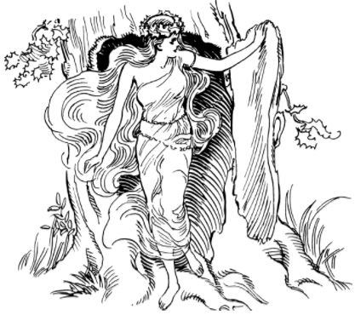
Larvae - restless soul of a murdered victim. Larvae are found near the places of their death and attack the living in madness. They are not able to cause much damage to the real world. However, they are often herald to terrible events.
Mermaids & Aquarii - vicious mixtures of men and fish. They live in the rivers and lakes and can talk and breath air for a short time. Often, they try to sweet-talk people to catch them and drag the down into the cold darkness of their abode.
Silenus - a forest demon. They are half men, half ram goat. The human-like head wears horns, the body has a goat-tail and goat-feet with hides. A Silenus has the firm opinion to be the lord of his land and does not tolerate trespassing. He lures his victims with his lute-playing.

Werboar - a huge boar, possessed by a demon with read glowing eyes. Their teeth are as big as a sword and dangerous. No sane man would try to fight such a thing.
Woodmen - one calls them wizards or druids. Even their own clan expels them, as they are feared. They are mad men and women who bargain with the evil. Covered in fur, dirty and smelling like bait. Deep in the woods and at fountains they beg to their unholy goods to summon dark creatures.
Seirenes - demonic creatures, half bird half human with the upper body of a woman. They come flying at night to fetch their prey.
Skrzat - malevolent gremlins. They are the size of a cat with fur, but feet like a rooster.
Skylla - sea monster. The body has six long throats with heads. There are also six strange feet. With the feet a skylla is able to grab small boats and rafts.
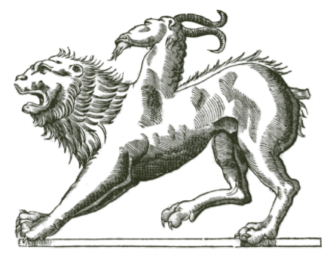
Boginki - demons from the deep dark woods. They hate humans and steal babies and toddlers. Sometimes they exchange the children at night for changelings. Bird-like Boginkis are also called Strigae.
Najadae - Nymphes live in ponds and other waters. They are fascinated by humans and want to have their own humans "as some sort of pet". If dismissed, they quickly get angry and fierce and strive for revenge.
Lamie - almost like a human and light-shunning creature. They tend to drink the blood from throats of their victims.

Map

