Introduction and Problem Definition
In today’s digital environment, businesses receive vast amounts of customer feedback through online platforms such as Amazon, Yelp, and social media. This feedback provides critical insights into customer satisfaction, product quality, and service delivery. However, analyzing such large volumes of unstructured text manually is inefficient and prone to bias.
This project presents a Customer Feedback Analysis Decision Support System (DSS) that uses text mining techniques to automatically analyze customer reviews, identify sentiment trends, and extract key topics that highlight common customer concerns.

Problem Statement
Many businesses lack automated tools that can analyze large-scale textual customer feedback efficiently. This results in slow responses to customer issues and missed opportunities for improvement.

Goal
To design and implement a Text Mining–based Decision Support System capable of:
- Performing sentiment analysis to assess customer satisfaction levels.
- Extracting key topics from feedback to reveal major customer concerns.
- Presenting insights through an interactive analytical dashboard with charts, word clouds, and summaries.
- Providing actionable decision recommendations for business improvement.

2. Data Sources and Preparation

2.1 Data Source
The dataset used consists of Amazon customer product reviews, stored in a CSV file (amazonreviews.csv).
Each record includes:
- Review Text – customer’s written feedback.
- Rating / Date (optional) – used for time-based analysis.

2.2 Data Preprocessing
Data cleaning and transformation were performed to ensure analytical accuracy:

Step | Description
Data Cleaning | Removed duplicates, missing values, and special characters. Converted text to lowercase.
Tokenization & Lemmatization | Split text into tokens (words) and reduced them to their root form (e.g., “running” → “run”).
Stop Word Removal | Eliminated common words such as the, is, and.
Feature Extraction | Represented text numerically using TF-IDF (Term Frequency–Inverse Document Frequency).
Sentiment Labeling | Applied VADER Sentiment Analyzer (from NLTK) to categorize reviews as Positive, Neutral, or Negative.

DATA CLEANING USING PYTHON

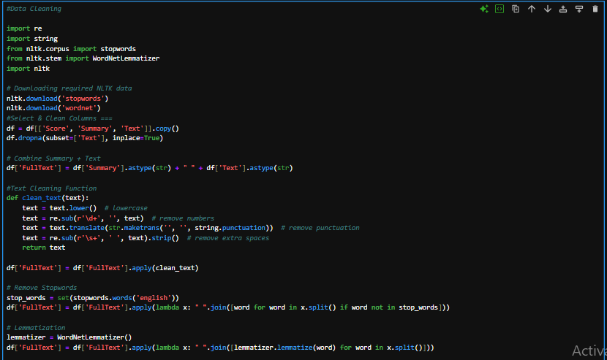

3. Model / Method Used
The DSS was implemented in Python using the Flask web framework. It integrates text mining modules for backend processing and interactive visualizations for frontend presentation.

3.1 System Architecture
Frontend (User Interface):
- Built using HTML, Bootstrap 5, and Plotly.js.
- Enables CSV upload, review column selection, and analysis initiation.
Backend (Flask Application):
- Reads the uploaded file.
- Performs sentiment analysis using VADER.
- Extracts topics using Latent Dirichlet Allocation (LDA).
- Generates visual results (pie charts, bar charts, and Line charts).
Visualization Components:
- Pie Chart: Overall sentiment distribution.
- Bar Chart: Frequency of key positive/negative terms.

A piechart showing overall sentiment distribution
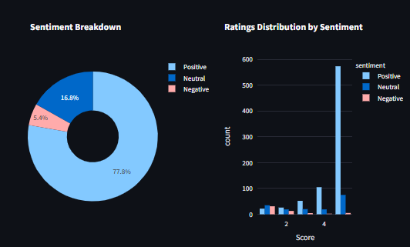
4. System Dashboard and Analysis
After the user uploads the review dataset, the DSS performs automatic text mining and displays the analysis in an interactive dashboard.
4.1 Sentiment Analysis Results

Sentiment | Count | Percentage
Positive | 1 823 | 77.8%
Neutral | 542 | 16.8%
Negative | 766 | 5.4%

A display of the summary metrics

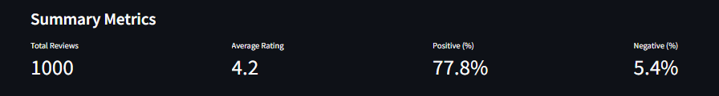

Interpretation:
Most reviews are positive, showing overall customer satisfaction. However, negative feedback highlights potential improvement areas.

4.3 Topic Extraction (LDA Results)
Topic | Keywords | Interpretation
1 | great, br, cup, flavor, cocoa, like, good, taste, hot, chocolate | Customers discussing taste and product satisfaction, particularly hot chocolate and cocoa flavor.
2 | amazon, licorice, like, one, br, product, food, price, good, great | Focus on purchasing experience, product quality, and pricing.
3 | good, use, one, water, tried, dont, like, cocoa, br, hot | Mixed opinions about usability or preparation experience.
4 | perfect, product, br, love, good, like, great, bread, tea, coffee | Positive feedback emphasizing product excellence and taste variety.

Conclusion
Topic extraction revealed that most discussions revolve around product taste, quality, and purchasing experience. This insight helps the system highlight what matters most to customers and supports better product improvement decisions.

4.4 Dashboard Overview
The dashboard displays:
- Interactive Pie and Bar Charts (sentiment proportions, keyword frequency).
- Summary section (total reviews, sentiment ratios).
- Download Report option for exporting analysis results.

A display of the dashboard overview

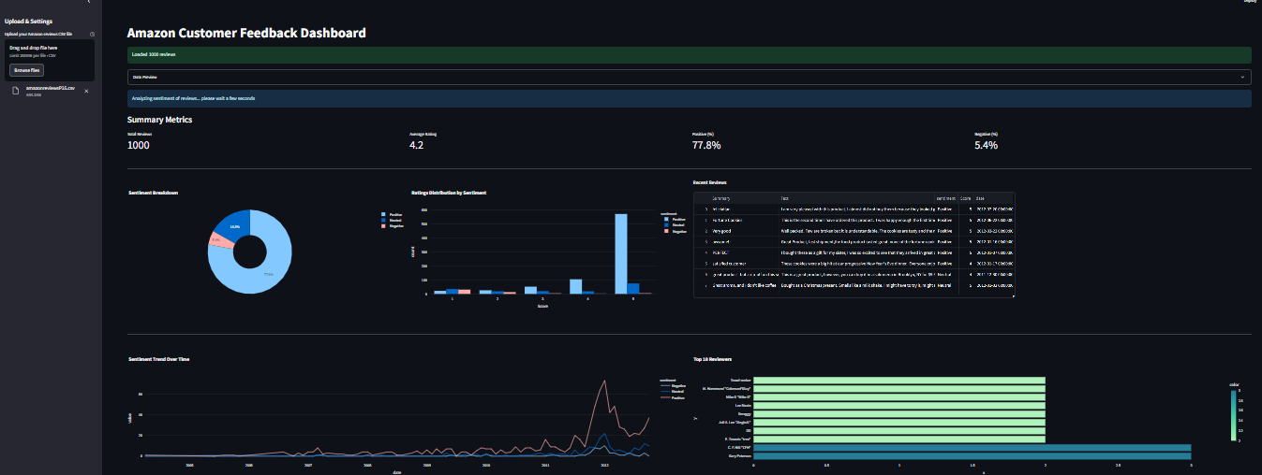

5. Decision Recommendations

Key Finding | Decision Recommendation
High positive sentiment toward product quality | Maintain and emphasize quality in marketing.
Frequent complaints about delivery delays | Improve logistics and introduce delivery tracking.
Price sensitivity among some users | Offer discounts or loyalty programs.
Mixed feedback on customer service | Provide staff training and faster response times
6. Tools and Technologies Used

Category | Tools / Libraries
Programming Language | Python
Visualization | Plotly, Matplotlib
Text Mining | NLTK (VADER), scikit-learn (TF-IDF, LDA)
Frontend | HTML, CSS (Bootstrap 5)
Report Generation | MS WORD 21

7. Conclusion
The Customer Feedback Analysis DSS demonstrates how text mining and sentiment analysis can transform unstructured text into actionable insights. The system efficiently identifies customer sentiment, major topics, and areas requiring improvement through automated analysis and visualization.
Its scalability allows future integration with live data sources (e.g., Amazon or Yelp APIs) for real-time monitoring.
Future enhancements may include:
- Multilingual sentiment analysis.
- Automated recommendation engines.
- Real-time data pipelines.

References
- Hutto, C.J., & Gilbert, E.E. (2014). VADER: A Parsimonious Rule-based Model for Sentiment Analysis of Social Media Text.
- McKinney, W. (2010). Data Structures for Statistical Computing in Python. Proceedings of the 9th Python in Science Conference.
- Blei, D. M., Ng, A. Y., & Jordan, M. I. (2003). Latent Dirichlet Allocation. Journal of Machine Learning Research..

