Homework # 4: Subspace Learning in Image Recognition
Student Name: Ben Blake, Student ID: 14387365

Description:
The objective of this homework is to consolidate and practice the knowledge and skills we learn on component analysis and subspace learning, especially the PCA, LDA and Graph Embedding. We will do an exercise based on a small face data set, which can be downloaded from:
HTTP://umkc.box.com/s/p4levwprgjns5ctg7fne9stwu7twkpza
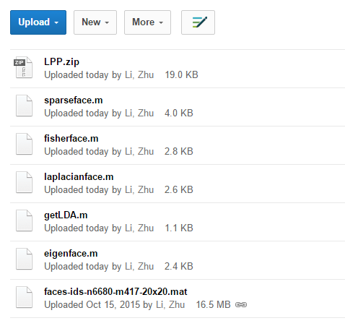
A face data set of 6680 images from 417 subjects, are provided, you should include a special group of 1 subject 10 images from any celebrity on web, to augment the data set.
The basic functions for PCA/LDA/Graph Embedding (LPP) are also provided, as in eigenface.m, fisherface.m, laplacianface.m, and the zipped folder LPP which offers Laplacian embedding solution LPP.m.
The input images are of size 20x20 pels, and students are required to compute the PCA/Eigenface model A₀: 400 x d₀, and LDA/Fisherface model on top of the Eigenface model, A₁: d₀ x d₁, as well as a Laplacian embedding model, A₂: d₀xd₂.
For the following configurations, please compute the face recognition results in different metrics as discussed in class.
Setup
Everything below was run in MATLAB R2025b. The face data set holds 6680 faces of 417 subjects, each a 20 by 20 image stored as a row of 400 values in [0, 1]. The faces of one subject are consecutive, and most subjects were photographed in a single session, so their faces differ in expression but hardly in lighting or framing.
For the celebrity group I used ten photos of Barack Obama from Wikimedia Commons, six public domain and four under Creative Commons licenses; the sources and licenses are listed in celebrity/SOURCES.md. He is appended to the data set as subject 418, which makes 6690 faces of 418 subjects and leaves the first 800 and first 400 faces as they were. I took the 15 photos of myself with my phone. Both sets go through the same function, getFaceCrop: the image is converted to grayscale, the Viola-Jones detector finds the largest face, a square around it is resized to 20 by 20 and stretched to [0, 1].
The detector needed some help on phone photos. Close-ups have a face larger than it expects and a tilted head is missed altogether, so getFaceCrop runs it on copies 800, 500 and 300 pixels high, at two merge thresholds and two detector models, and on the photo rotated by up to 30 degrees, and keeps the largest box. A rotated copy only wins when its box is 1.5 times larger than the best upright one, since rotation slightly enlarges the box even for an upright head. Of my 15 photos, one is cropped from a rotated copy; two had a second person in them and the largest box was me both times. I checked all 25 crops by eye.
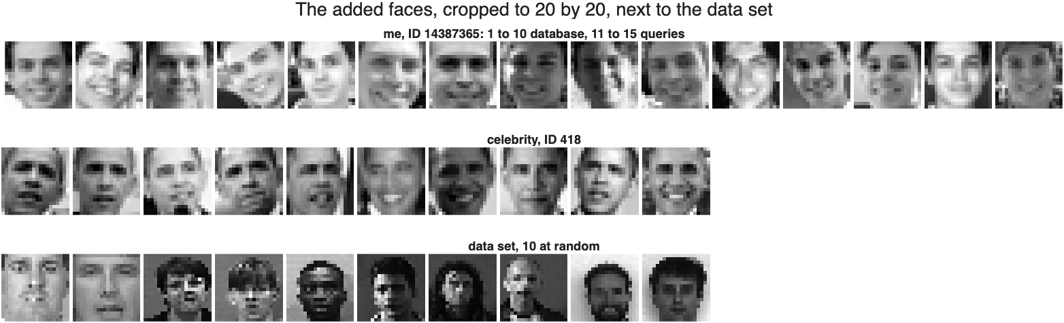
Figure 0.1 My 15 faces, the celebrity's 10 and 10 faces of the data set, all 20 by 20. My first 10 go into the Q3 database and the last 5 are the queries.
The added faces are brighter than the data set, a mean of 0.54 for mine and 0.50 for the celebrity against 0.36, because the assignment asks for each crop to be stretched to [0, 1] while the data set faces were not. This comes back in Q3.
Training and test faces
The test faces of Q2 and Q3 come from the first 800 faces, which end on the last face of subject 110. All three models are trained on the other 5880 faces, the 307 subjects that are not in the first 800 and not the celebrity. So every result in Q2 and Q3 is for people the models have never seen, which is the honest test of a face subspace. Q2 also shows what happens when the models are trained on the test faces instead.

Q1 [30 pts] Show your code for computing Eigenface, Fisherface, and Laplacian face models as A0, A1, A2, for Laplacianface, also compute its affinity W, and visualizing the first 6 face model basis functions as shown in class notes: (Python implementation also ok)
getEigenface.m
function [A0, eigv] = getEigenface(training_data, kd)
arguments
training_data
kd (1,1) double {mustBeInteger, mustBePositive}
end

faces = iFaces(training_data);
if kd > size(faces, 2)
error("getEigenface:kdTooLarge", ...
"kd = %d is more than the %d pixels of a face.", kd, size(faces, 2));
end

% princomp was removed from MATLAB. pca returns the same directions.
[coeff, ~, eigv] = pca(faces);
A0 = coeff(:, 1:kd);
end

function faces = iFaces(training_data)
if isstruct(training_data)
faces = double(training_data.faces);
else
faces = double(training_data);
end
end

getFisherface.m
function [A1, eigv] = getFisherface(training_data, A0, opts)
arguments
training_data (1,1) struct
A0 (:,:) double
opts.Dim double {mustBeScalarOrEmpty, mustBeInteger, mustBePositive} = []
opts.Regularization (1,1) double {mustBeNonnegative} = 0
end

x = double(training_data.faces) * A0; % n-by-d0
y = training_data.ids(:);
[classes, ~, g] = unique(y);
c = numel(classes);
d0 = size(A0, 2);
if c < 2
error("getFisherface:oneClass", "LDA needs at least two subjects.");
end

% Scatter matrices. Each face is taken relative to the mean of its own
% subject for Sw, and each subject mean relative to the overall mean,
% weighted by the subject's number of faces, for Sb.
nk = accumarray(g, 1);
member = sparse(g, 1:numel(y), 1, c, numel(y)); % c-by-n, 1 where face i is subject k
classMean = (member * x) ./ nk; % c-by-d0
within = x - classMean(g, :);
Sw = within' * within;
between = (classMean - mean(x, 1)) .* sqrt(nk);
Sb = between' * between;
Sw = (Sw + Sw') / 2;
Sb = (Sb + Sb') / 2;
Sw = Sw + opts.Regularization * mean(diag(Sw)) * eye(d0);

d1 = min(d0, c - 1);
if ~isempty(opts.Dim)
if opts.Dim > d1
error("getFisherface:dimTooLarge", ...
"Dim = %d, but at most %d directions exist.", opts.Dim, d1);
end
d1 = opts.Dim;
end

% The "chol" algorithm needs Sw positive definite, and it returns
% eigenvectors normalized so that A1'*Sw*A1 = I.
[V, D] = eig(Sb, Sw, "chol");
[eigv, order] = sort(real(diag(D)), "descend");
A1 = V(:, order(1:d1));
eigv = eigv(1:d1);
end

getLaplacianface.m
function [A2, W, eigv, h] = getLaplacianface(training_data, A0, opts)
arguments
training_data (1,1) struct
A0 (:,:) double
opts.Dim double {mustBeScalarOrEmpty, mustBeInteger, mustBePositive} = []
opts.Affinity (1,1) double {mustBeInRange(opts.Affinity, 0, 1, "exclusive")} = 0.15
end

x = double(training_data.faces) * A0; % n-by-d0
y = training_data.ids(:);
n = numel(y);
c = numel(unique(y));
d0 = size(A0, 2);

% The kernel width comes from the mean distance over all pairs, as in the
% course code. The full distance matrix is n-by-n, so it is built a block
% of rows at a time and only its sum is kept.
total = 0;
block = 2000;
for i = 1:block:n
rows = i:min(i + block - 1, n);
total = total + sum(pdist2(x(rows, :), x), "all");
end
h = -log(opts.Affinity) / (total / n^2);

% Supervised affinity: only pairs of the same subject are connected, so
% W is block diagonal and is built one subject at a time.
[I, J, V] = deal(cell(c, 1));
[~, ~, g] = unique(y);
for k = 1:c
idx = find(g == k);
[jj, ii] = meshgrid(idx, idx);
I{k} = ii(:);
J{k} = jj(:);
V{k} = reshape(exp(-h * pdist2(x(idx, :), x(idx, :))), [], 1);
end
W = sparse(vertcat(I{:}), vertcat(J{:}), vertcat(V{:}), n, n);

% The faces are centered first, as the provided LPP.m does. Without it
% the problem has an almost trivial solution, a direction along which
% every face projects to nearly the same value, since L times a constant
% is zero, and that direction would come first while carrying no
% information about who is who.
xc = x - mean(x, 1);
deg = full(sum(W, 2));
XDX = xc' * (deg .* xc);
XLX = XDX - xc' * (W * xc);
XDX = (XDX + XDX') / 2;
XLX = (XLX + XLX') / 2;

d2 = min(d0, c - 1);
if ~isempty(opts.Dim)
if opts.Dim > d0
error("getLaplacianface:dimTooLarge", ...
"Dim = %d, but the Eigenface space has only %d.", opts.Dim, d0);
end
d2 = opts.Dim;
end

[V, D] = eig(XLX, XDX, "chol");
[eigv, order] = sort(real(diag(D)), "ascend");
A2 = V(:, order(1:d2));
eigv = eigv(1:d2);
end
The box above is the code as it is in the repository, with the help text left out to save space. All of the code, the scripts that made every figure and table below, and the checks are at https://github.com/ben-blake/umkc-computer-vision in the folder hw4-subspace-methods.
All three take training_data as a structure with the n by 400 matrix faces and the n by 1 labels ids, since Fisherface and Laplacianface need the labels and the signatures in the assignment have no other place for them. getEigenface also accepts the face matrix alone.
Eigenface
princomp was removed from MATLAB and pca returns the same principal directions. A0 is the first kd of them and a face f is represented by f*A0, without subtracting the mean face, as in the course code; shifting every face by the same amount changes no distance. With kd = d0 = 32 the model keeps 81.4% of the variance of the training faces.
Fisherface
getFisherface projects the faces with A0, builds the between-class scatter Sb and the within-class scatter Sw, and solves Sb a = lambda Sw a with eig(Sb, Sw, "chol"). The result is sorted by lambda, the ratio of between-class to within-class variance, and scaled so that A1'*Sw*A1 = I, which makes distance in the Fisherface space a distance in units of the spread within a subject. Doing PCA first is what keeps Sw invertible: 32 dimensions are far fewer than the number of faces minus the number of subjects. With 307 subjects LDA could give 306 directions, so d1 = d0 = 32. The first eigenvalue is 65.8 and the last 0.51.
The provided getLDA.m solves the same problem with eigs(Sb, Sw). On 1200 faces its six directions come out close to mine but not equal, and the residual of Sb a - lambda Sw a tells which is right: 4.6e-15 for mine against up to 0.18 for eigs, whose first direction also reaches a lower Sb/Sw, 39.67 against 40.06. eigs is an iterative solver and it stopped short.
Laplacianface
The affinity W is the supervised heat kernel of laplacianface.m. Two faces of the same subject get W(i, j) = exp(-h ||x_i - x_j||), and two faces of different subjects get 0. h = -log(0.15) / mean distance, so a pair at the mean distance has an affinity of 0.15; here h = 0.3733. W is 5880 by 5880 but only 119,160 entries, 0.34%, are nonzero, so it is built one subject at a time as a sparse matrix, and the mean distance over all 34.6 million pairs is summed a block of rows at a time. With D the row sums of W and L = D - W, the Laplacianfaces solve X'LX a = lambda X'DX a for the smallest lambda.
My first version did not subtract the mean face before solving, and checking it against the provided LPP.m showed why that matters. LPP.m centers the data. Without centering there is an almost trivial solution, a direction along which every face projects to nearly the same value, since L times a constant vector is zero, and it came first while saying nothing about who is who. With the faces centered my eigenvalues equal one minus those of LPP.m to 1e-8 and the two span the same space.
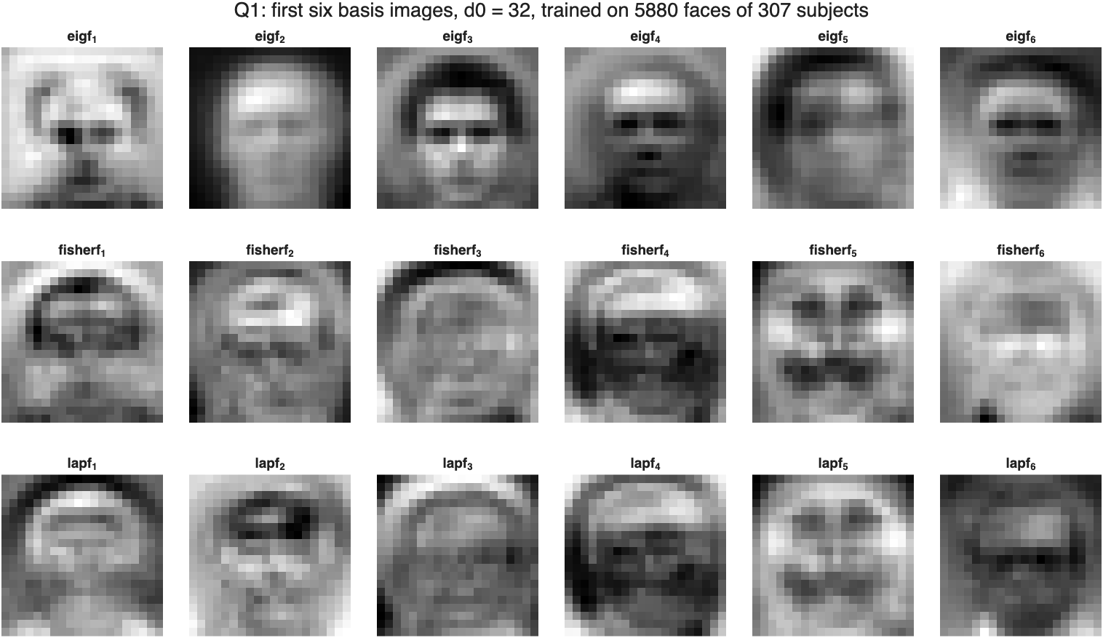
Figure 1.1 The first six basis images of each model, the columns of A0, A0*A1 and A0*A2, drawn as 20 by 20 images.
The Eigenfaces are smooth and look like whole faces under different lighting and framing, which is where most of the variance of the data set is. The Fisherfaces and Laplacianfaces are noisier and concentrate on the eyes, the brows, the mouth and the outline of the head, the parts that differ between people more than within one.
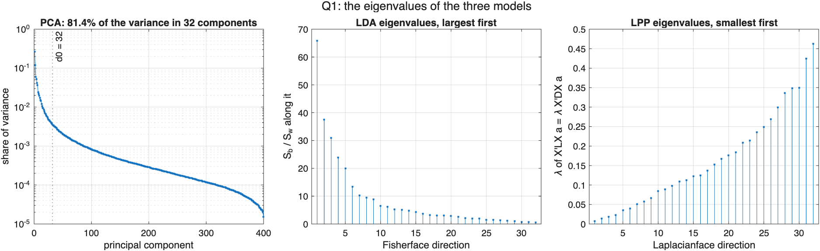
Figure 1.2 Left, the PCA spectrum, each eigenvalue as a share of the total variance. Middle, the LDA eigenvalues. Right, the LPP eigenvalues.
Table 1.1 Variance of the training faces kept by the first d0 Eigenfaces.
d0 | 8 | 16 | 32 | 64 | 128
variance kept | 61.9% | 72.7% | 81.4% | 88.6% | 94.5%
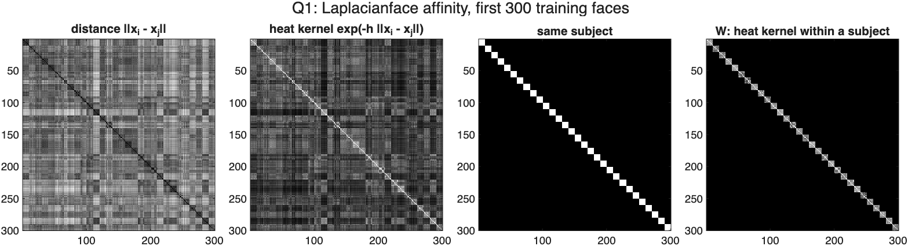
Figure 1.3 The Laplacianface affinity for the first 300 training faces, the four panels of laplacianface.m: distance, heat kernel, same subject, and W, the heat kernel kept only within a subject.
Q2. [30 pts] For the first N=800 face images in the data set, compute the top-1 recognition accuracy as confusion map, for the Eigenface, Fisherface, and Lapalcianface models you trained. Report each one’s accuracy,
(example)
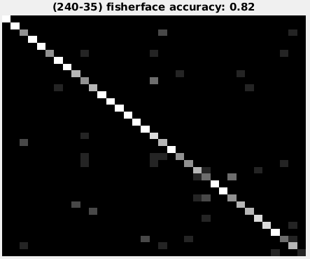
Show your code:
hw4_loo.m
function [acc, cm, pred, labels] = hw4_loo(X, y)
arguments
X (:,:) double
y (:,1) double
end

D = pdist2(X, X);
D(1:size(D, 1) + 1:end) = Inf; % never match a face with itself
[~, nearest] = min(D, [], 2);
pred = y(nearest);
labels = unique(y);
cm = confusionmat(y, pred, Order=labels);
acc = sum(diag(cm)) / sum(cm(:));
end

hw4_q2_recognition.m (excerpt)
names = ["eigenface", "fisherface", "laplacianface"];
proj = {M.A0, M.A0 * M.A1, M.A0 * M.A2};
acc = zeros(1, 3);
cm = cell(1, 3);
pred = cell(1, 3);
for m = 1:3
[acc(m), cm{m}, pred{m}, labels] = hw4_loo(X * proj{m}, y);
fprintf("%-14s top-1 accuracy %.3f\n", names(m), acc(m));
end
hw4_loo recognizes each face as the subject of its nearest other face, which is leave-one-out 1-NN, and confusionmat gives the confusion map. The excerpt is the loop over the three models in hw4_q2_recognition.m.
The test faces are the first 800 plus the celebrity's 10, so 810 faces of 111 subjects. Chance is 1/111, under 1%.
Table 2.1 Top-1 accuracy, d0 = 32, models trained on the other 307 subjects.
model | accuracy | celebrity, of 10
Eigenface | 0.489 | 7
Fisherface | 0.563 | 5
Laplacianface | 0.481 | 3
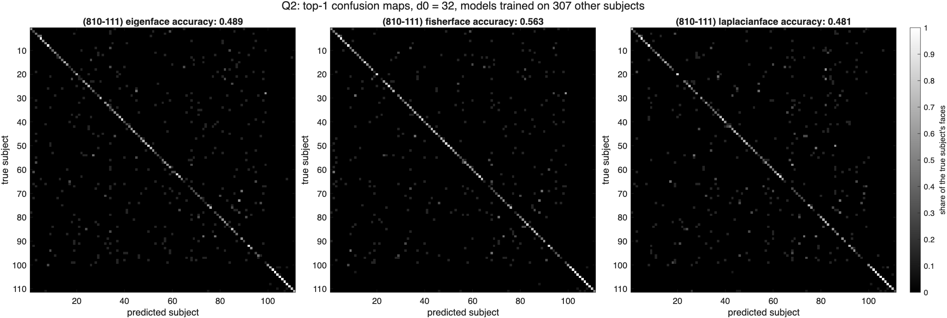
Figure 2.1 Confusion maps, true subject down the rows and predicted subject across, each row normalized. The titles follow the example: (faces-subjects) model accuracy.
Fisherface is the best of the three at 0.563. Eigenface gets 0.489 and Laplacianface 0.481. The maps show the same thing: the diagonal is brightest for Fisherface and the scatter off it is lightest.
Which differences are real
Table 2.2 McNemar's exact test on the faces one model gets right and the other wrong, n = 810.
comparison (A vs B) | A only | B only | p
Eigenface vs Fisherface | 18 | 78 | 4.4e-10
Eigenface vs Laplacianface | 65 | 59 | 0.65
Fisherface vs Laplacianface | 95 | 29 | 2.2e-09
Fisherface is better than both others by a wide margin: of the faces only one of Eigenface and Fisherface gets right, Fisherface has 78 and Eigenface 18. Eigenface and Laplacianface cannot be told apart, p = 0.65.
Trained on the test faces
The example in the assignment reaches 0.82 with Fisherface. Training the three models on the 810 test faces themselves gives 0.435, 0.765 and 0.436. Fisherface jumps by 20 points because it has now seen the label of every face it is tested on: LDA spends its directions on separating exactly these subjects. Eigenface does slightly worse than before, because its PCA now comes from 810 faces instead of 5880. Laplacianface, which also uses the labels, does not gain at all, and the next section shows why. The 0.56 above is the number that says how well a Fisherface model recognizes people it was not built for.
Dimension
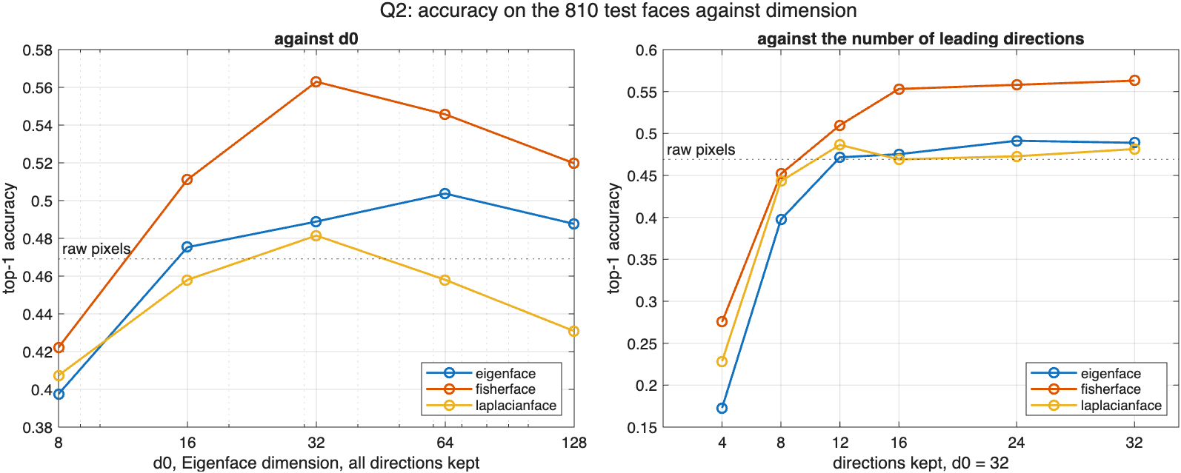
Figure 2.2 Left, accuracy against d0 with all d0 directions of each model kept. Right, at d0 = 32, accuracy with only the leading d directions. The dotted line is 1-NN on the raw 400 pixels.
Table 2.3 Accuracy at d0 = 32 keeping only the leading d directions of each model.
d | Eigenface | Fisherface | Laplacianface
4 | 0.173 | 0.275 | 0.228
8 | 0.398 | 0.452 | 0.443
12 | 0.472 | 0.510 | 0.486
16 | 0.475 | 0.553 | 0.469
24 | 0.491 | 0.558 | 0.473
32 | 0.489 | 0.563 | 0.481
Every model beats raw pixels, 0.469, at d0 = 32, but not by much, and none keeps improving with d0: Fisherface peaks at 32 and Eigenface at 64. Beyond that the extra directions are mostly noise, small differences in lighting and alignment that 1-NN treats as identity. The right panel explains Laplacianface. It reaches 0.486 with 12 directions and then falls back, while Fisherface keeps rising to 32. The leading Laplacianfaces keep each subject together, the later ones mostly keep the noise of each face, and with all 32 kept the result is a reweighted Eigenface space, which is what Table 2.2 shows.
Distance
Comparing the same vectors by cosine distance, which ignores their length, gives 0.567, 0.583 and 0.479. Eigenface gains almost 8 points and comes level with Fisherface. The length of an Eigenface vector is mostly the brightness and contrast of the face, so a lot of what Fisherface adds is that it learns to ignore lighting, and normalizing the vector does much of the same.
The celebrity
Obama is recognized in 7, 5 and 3 of his 10 faces. That he is found at all is notable: his photos come from different years, events and cameras, which is a much harder test than the single session faces of the data set, and the same problem decides Q3.
Q3. [40 pts] Retrieval experiment: take K=15 pictures of yourself, and crop the face images into 20x20 pixels, and normalize the pixel values to [0 1]. Make the face ID as your student ID. Conduct search against the first N=400 images in the data set, plus 10 images of yourself as database, then use 5 images to conduct query, and report your top 5 AP - Average Precision for each query, as well as the mAP overall. Show your retrieval results as a 5x5 data matrix as well:
E.g,
Query ID = 10008372, Retrieved face image ID = [172,10008372, 88, 3, 2 101]
Then this one has AP= 50%
Recall:
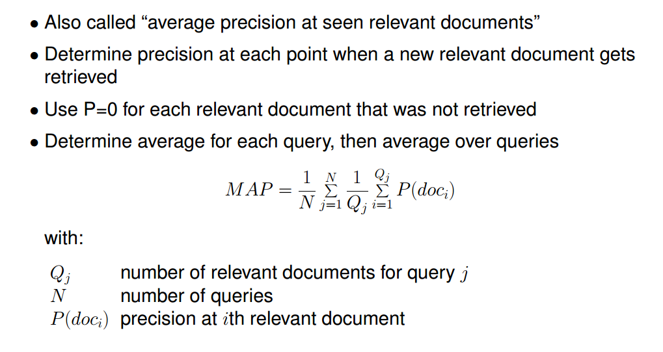
The database is the first 400 faces of the data set, 58 subjects, and my first 10 faces. The queries are my other 5. Each query is ranked against the 410 database faces by Euclidean distance in each model space, and every face of mine is relevant.
The example and the slide above define AP differently. The example divides by the number of hits found, so one hit at rank 2 of 5 is 50%. The slide counts every relevant face that was not retrieved as a precision of 0 and divides by the number of relevant faces, which in the top 5 can be at most 5. I report both. Over the whole ranking with all 10 relevant faces the slide's formula is the usual AP, also reported.
getAveragePrecision.m
function ap = getAveragePrecision(hit, opts)
arguments
hit {mustBeNumericOrLogical, mustBeVector}
opts.NumRelevant double {mustBeScalarOrEmpty, mustBePositive} = []
end

hit = logical(hit(:)');
if ~any(hit)
ap = 0;
return
end
precision = cumsum(hit) ./ (1:numel(hit));
if isempty(opts.NumRelevant)
ap = mean(precision(hit));
else
ap = sum(precision(hit)) / opts.NumRelevant;
end
end
hw4_q3_retrieval.m (excerpt)
for m = 1:3
dist = pdist2(qFaces * proj{m}, dbFaces * proj{m});
[~, order] = sort(dist, 2);
for q = 1:nQ
hit = dbIds(order(q, :)) == cfg.selfId;
retrieved(q, :, m) = dbIds(order(q, 1:K));
apK(q, m) = getAveragePrecision(hit(1:K));
apKSlide(q, m) = getAveragePrecision(hit(1:K), NumRelevant=min(K, nRel));
recallK(q, m) = sum(hit(1:K)) / nRel;
apFull(q, m) = getAveragePrecision(hit);
end
fprintf("\n%s: top-%d face IDs, one row per query\n", names(m), K);
...
end
Table 3.1 The top 5 face IDs of each query, my ID being 14387365, and its AP@5 under the example and under the slide.
model | query | retrieved face IDs, rank 1 to 5 | AP@5 example | AP@5 slide
Eigenface | IMG_1735 | [43, 51, 43, 29, 51] | 0.000 | 0.000
 | IMG_1736 | [17, 14387365, 55, 13, 18] | 0.500 | 0.100
 | IMG_1737 | [16, 33, 31, 31, 3] | 0.000 | 0.000
 | IMG_1738 | [43, 43, 43, 29, 43] | 0.000 | 0.000
 | IMG_1739 | [40, 7, 31, 7, 7] | 0.000 | 0.000
Fisherface | IMG_1735 | [13, 29, 41, 51, 46] | 0.000 | 0.000
 | IMG_1736 | [17, 53, 40, 17, 33] | 0.000 | 0.000
 | IMG_1737 | [33, 31, 31, 31, 13] | 0.000 | 0.000
 | IMG_1738 | [43, 11, 46, 43, 29] | 0.000 | 0.000
 | IMG_1739 | [40, 5, 17, 13, 2] | 0.000 | 0.000
Laplacianface | IMG_1735 | [29, 46, 14387365, 11, 15] | 0.333 | 0.067
 | IMG_1736 | [18, 33, 17, 41, 16] | 0.000 | 0.000
 | IMG_1737 | [54, 33, 45, 16, 45] | 0.000 | 0.000
 | IMG_1738 | [43, 43, 14387365, 29, 41] | 0.333 | 0.067
 | IMG_1739 | [5, 7, 40, 46, 14387365] | 0.200 | 0.040
Table 3.2 Summary over the 5 queries.
model | mAP@5 example | mAP@5 slide | recall@5 | AP, full ranking | mean rank of mine
Eigenface | 0.100 | 0.020 | 0.020 | 0.033 | 252.7
Fisherface | 0.000 | 0.000 | 0.000 | 0.027 | 260.9
Laplacianface | 0.173 | 0.035 | 0.060 | 0.036 | 297.8
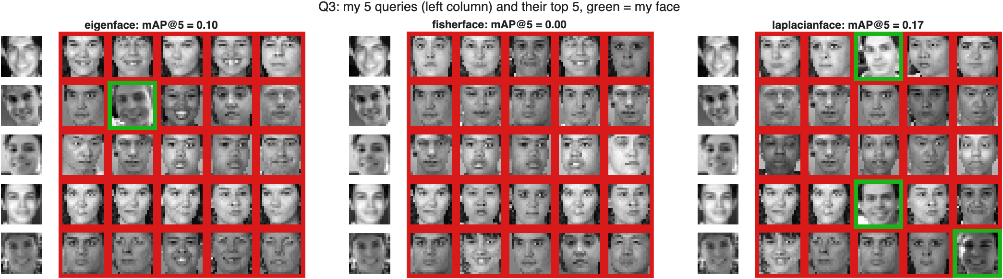
Figure 3.1 Each query on the left and its top 5. A green frame is one of my faces, a red one is someone from the data set.
Retrieval of my faces fails. Over the three models only 4 of the 75 retrieved faces are mine, the best mAP@5 is Laplacianface's 0.173, 0.035 by the slide, and Fisherface finds none at all. The mean rank of my 10 faces among the 410 is 253 to 298, where a random ranking would put them at 205.5. So my queries are not just missing my faces, they are further from them than from the average stranger.
Why
The reason is in the raw pixels. Two faces of one subject in the first 400 are 3.63 apart on average and two faces of different subjects 4.96. Two of my faces are 6.12 apart, further than two strangers in the data set. The data set's subjects were each photographed in one session, in front of one camera, under one light. My photos span years, indoor and outdoor light, sun from the side, different phones, and a smile that varies from photo to photo. At 20 by 20 pixels that variation is larger than the difference between two people, and models trained on single session faces have never learned to ignore it. Fisherface, which learned most precisely what varies within a subject of the data set, is the one that fails worst.
Removing the brightness and contrast of every face, standardizing each to zero mean and unit standard deviation, moves the mean rank to 222, 187 and 220, better than random, and mAP@5 to 0.45, 0.49 and 0.47 by the example's definition, 0.17, 0.14 and 0.13 by the slide's. The gap between the two definitions shows how forgiving the example's is: one hit at rank 1 scores 100% however many of my faces are missing.
Q4. [extra 50 pts] From PCA model, use a kd=16 representation of the data set, and implement a KNN search based local Fisherface and Eigenface model, {hint: both vl_feat and python has kd-tree} for KNN size K = [100 200, 400] and analyze the local Fisherface and Eigenface top-1 recognition accuracy and confusion map.

The query should be randomly selected images from 4000 images:
hw4_q4_local.m (excerpt)
Ag = getEigenface(faces, cfg.kdLocal);
z = faces * Ag;
searcher = KDTreeSearcher(z(1:cfg.nLocal, :));

% The query draw from the assignment, seeded so it can be repeated.
rng(cfg.seed);
q_offs = randperm(cfg.nLocal);
q_offs = q_offs(1:cfg.nQuery);

% iRun, called with queries = q_offs, loops over the queries:
for i = 1:nQ
q = queries(i);
% K + 1 neighbors, then the query itself is removed.
nb = knnsearch(searcher, z(q, :), K=max(cfg.knnList) + 1);
nb = nb(nb ~= q);
predG(i) = ids(nb(1));
for k = 1:nK
idx = nb(1:cfg.knnList(k));
nOwn(i, k) = sum(ids(idx) == ids(q));
local = struct("faces", faces(idx, :), "ids", ids(idx));
A0 = getEigenface(local, cfg.kdLocal);
A1 = getFisherface(local, A0, Regularization=1e-3);
predE(i, k) = iNearest(faces(q, :) * A0, local.faces * A0, local.ids);
predF(i, k) = iNearest(faces(q, :) * A0 * A1, local.faces * A0 * A1, local.ids);
bases.E{i, k} = A0;
bases.F{i, k} = A0 * A1;
end
end

getGrassmannDistance.m
function [d, theta] = getGrassmannDistance(A, B)
arguments
A (:,:) double
B (:,:) double
end

if size(A, 1) ~= size(B, 1)
error("getGrassmannDistance:sizeMismatch", ...
"A and B must have the same number of rows.");
end

Qa = orth(A);
Qb = orth(B);
% The singular values of Qa'*Qb are the cosines of the principal angles.
c = svd(Qa' * Qb);
c = min(c(1:min(size(Qa, 2), size(Qb, 2))), 1);
theta = acos(c);
d = sqrt(max(0, 1 - prod(c.^2)));
end
Every face is represented by a kd = 16 PCA of the whole data set, and the 20 queries are drawn with the code above at seed 0. For each query a kd-tree, KDTreeSearcher and knnsearch, finds its K nearest faces among the first 4000, the query itself excluded. A local Eigenface model, 16 directions, and a local Fisherface model on top of it are trained on those K faces only, and the query is recognized as its nearest neighbor among them in each local space. Many subjects have only one face among the K, which can leave Sw singular, so the local Fisherface adds 0.1% of the mean of its diagonal to Sw.
Table 4.1 Top-1 accuracy of the local models. The global baseline is 1-NN in the kd = 16 space, which is the label of the first neighbor.
queries | model | K = 100 | K = 200 | K = 400
20 | local Eigenface | 0.80 | 0.80 | 0.80
20 | local Fisherface | 0.90 | 0.90 | 0.95
20 | global 1-NN | 0.80
500 | local Eigenface | 0.844 | 0.846 | 0.846
500 | local Fisherface | 0.922 | 0.918 | 0.916
500 | global 1-NN | 0.858
Twenty queries give accuracy in steps of 5 points, so I repeated the experiment with 500 queries, the first twenty being the ones above. The local Fisherface model is right 92% of the time at every K, and the local Eigenface model about 85%. At K = 100, of the queries only one of them gets right, Fisherface has 40 and Eigenface 1, p = 4e-11, and it is the same at the other K. The local Eigenface model is no better than the global 1-NN that chose its neighbors, which makes sense: a PCA of the neighborhood describes how its faces vary but says nothing about who they are. The local Fisherface model does use the labels of the neighbors and gains 6 to 8 points over both.
K hardly matters. The query's own subject is among its neighbors in 98.2% of queries at K = 100 and 99.0% at K = 400, and with a median of 19 of its faces there. Once the right subject is in the neighborhood, more faces add more competitors as well as more data.
These numbers are much higher than in Q2, and the reason is the protocol, not the models. A Q4 query is compared with the other faces of its own session, which are in the 4000, while in Q2 the models had never seen the test subjects. That is the easier test.
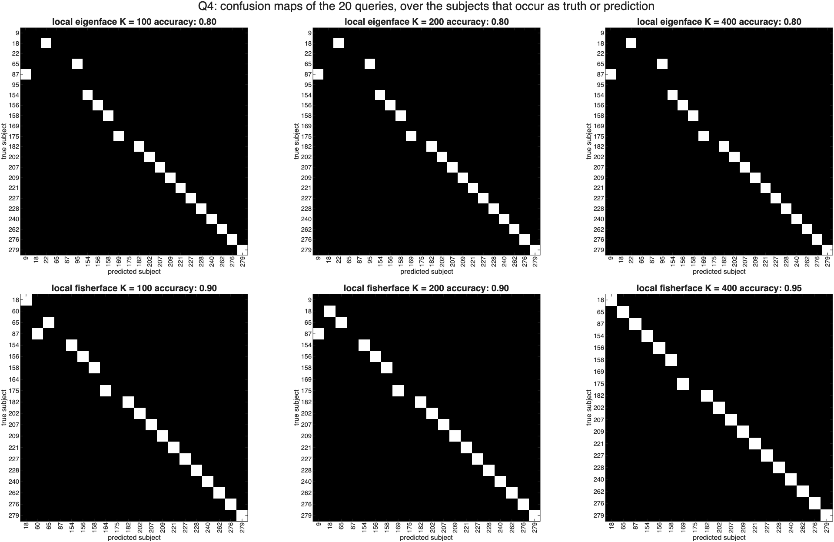
Figure 4.1 Confusion maps of the 20 queries for each K, over the subjects that occur as the true or the predicted subject. White on the diagonal is a correct query.

Also for each query driven model in Eigenface and Fisherface, compute their Cauch-Binet Grassmann Distance.
getGrassmannDistance computes the principal angles between two subspaces from the singular values of Qa'*Qb and returns the Cauchy-Binet distance sqrt(1 - prod(cos(theta).^2)). It is 0 when one subspace contains the other and 1 when any direction of one is orthogonal to all of the other.
With all 16 directions the distance says almost nothing. Every local model is at 1.000 from the global model and from almost every other query's model, because a product of 16 cosines is close to 0 unless every angle is small. And every local Eigenface model is at exactly 0 from its own local Fisherface model, because A0*A1 lies in the span of A0 by construction. So I also computed the distance between the leading 4 directions of each model, which avoids both.
Table 4.2 Cauchy-Binet distance, mean over the 20 queries, between the leading 16 and the leading 4 directions of the local models.
directions | between | K = 100 | K = 200 | K = 400
16 | local Eigenface and local Fisherface | 0.000 | 0.000 | 0.000
16 | local Eigenface and global | 1.000 | 1.000 | 1.000
4 | local Eigenface and local Fisherface | 0.956 | 0.994 | 0.998
4 | two queries, local Eigenface, same subject | 0.657 | 0.604 | 0.377
4 | two queries, local Eigenface, different | 0.999 | 0.996 | 0.989
4 | two queries, local Fisherface, same subject | 0.843 | 0.979 | 0.684
4 | two queries, local Fisherface, different | 1.000 | 0.999 | 0.997
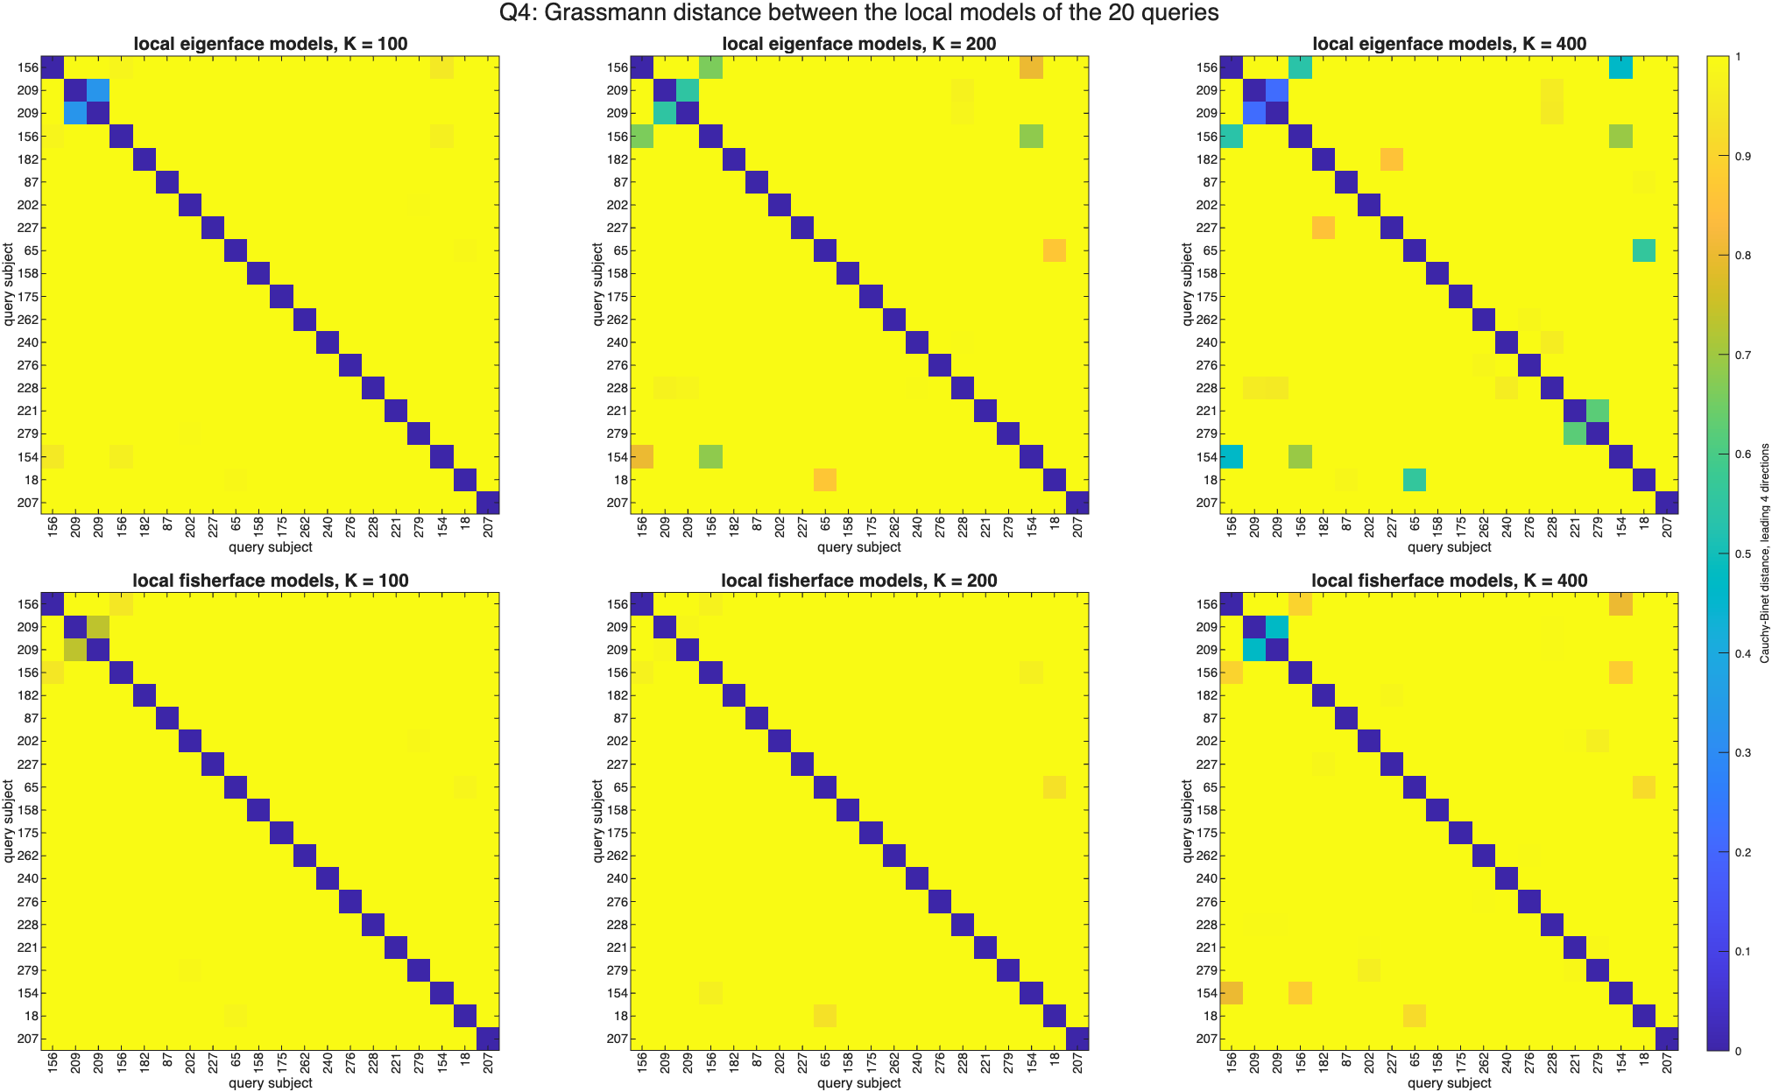
Figure 4.2 Cauchy-Binet distance between the leading 4 directions of the local models of the 20 queries, labeled by subject. The two pairs of queries from subjects 156 and 209 are first.
Two of the 20 random queries share a subject with another, two faces of subject 209 and two of 156, and their local models are the ones that come out close. Between the leading 4 Eigenface directions, the two queries of one subject are 0.66 apart at K = 100 and 0.38 at K = 400, while queries of different subjects stay at 1.00 to 0.99. A local model is a description of the person the query belongs to, and it gets more stable as K grows. The local Fisherface models are further apart even for the same subject, since LDA turns towards whichever subjects happen to be the neighbors. That rests on two pairs, so it is an observation, not a measurement. The mean principal angle between a local and the global Eigenface model falls from 62 to 49 degrees as K goes from 100 to 400: the more faces a local model sees, the more it looks like the global one.
Findings
- Fisherface is the best face model here, and the only one clearly better than Eigenface. On 810 faces of subjects the models never saw it gets 0.563 against 0.489 and 0.481, p < 1e-8. Trained on the test faces themselves it reaches 0.765, which is how much knowing the labels in advance is worth.
- Laplacianface needs fewer directions to be useful. It peaks at 12 directions with 0.486 and then falls back to Eigenface level, while Fisherface keeps improving to 32. My first version also missed the mean subtraction in LPP.m, which put a direction with no information first.
- Much of what Fisherface learns is to ignore lighting. Cosine distance, which drops the length of a face vector, lifts Eigenface from 0.489 to 0.567, level with Fisherface.
- Retrieving my own faces fails, and it is not the code. My photos differ more from each other, 6.12 apart, than two different people of the data set, 4.96. Standardizing every face helps but leaves retrieval weak. Models trained on single session faces do not transfer to phone photos taken over years.
- Local models help when they use the labels. A local Fisherface model reaches 92% against 85% for the local Eigenface model and the global 1-NN, at every K. The 16-direction Cauchy-Binet distance saturates at 1 and is 0 between a local Eigenface model and its Fisherface model by construction; on the leading 4 directions it does show that two queries of one subject get similar local models.

