Homework # 2: Alternative Keypoints Detection with LoG Pyramid
Student Name: Ben Blake, Student ID: 14387365
Description:
The objective of this homework is to reinforce the scale space response extrema concept in key points detection and ask you to compute a LoG pyramid for scale space extrema detection, and compare that with the DoG pyramid based SIFT detection. An example is illustrated below, on the left is an image and its SIFT detection, with vl_sift() and peakStrenthThres=16, on the right is the LoG based detection:
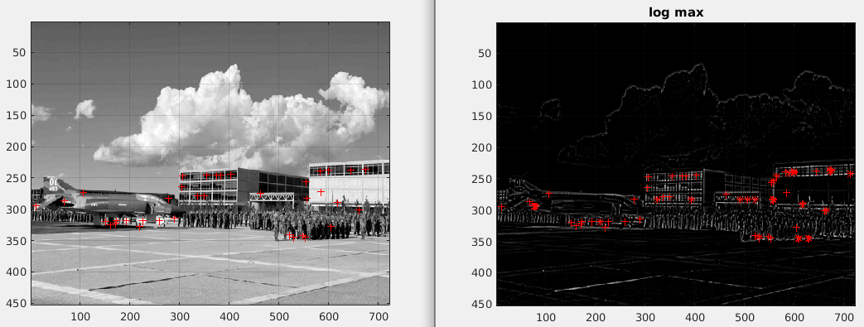
The LoG pyramid is computed for $σ=\{1.200 1.518 1.920 2.429 3.072 3.886 4.915\}$
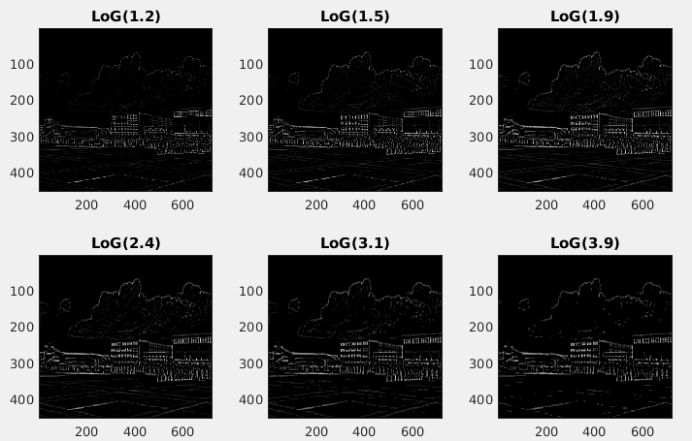
The scale space extrema detection is illustrated in the figure below:
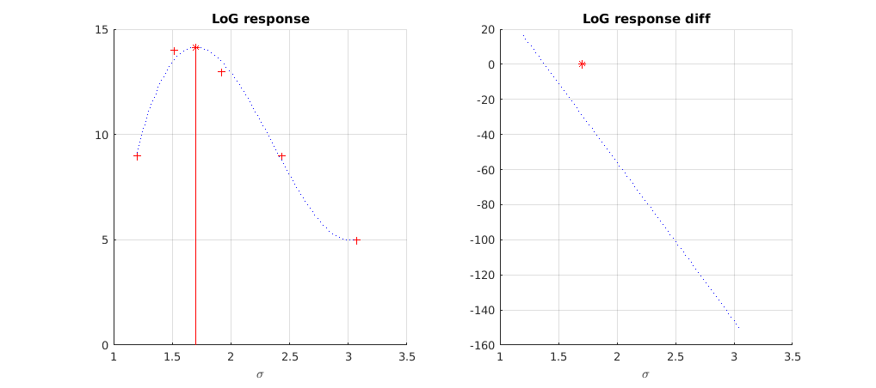
The LoG response is given as $f(σ)$=a$σ$³ + b$σ$² + c$σ$ +d, the fitting can be done with polyfit(x, y, 3), and you can also compute its gradient. An extrema is detected by checking its gradient value.
Q1 [20 pts] Compute LoG Pyramid, show your code
getLoGPyramid.m
function [log_pyramid] = getLoGPyramid(im, scales)
arguments
im {mustBeNumeric, mustBeNonempty}
scales (1,:) double {mustBePositive}
end
gray = 255 * im2double(im2gray(im));
[H, W] = size(gray);
N = numel(scales);
log_pyramid = zeros(H, W, N);
for k = 1:N
sigma = scales(k);
% The kernel reaches 4 sigma each side. At that radius the LoG has
% decayed to under 0.5% of its peak, so truncation does not matter.
halfWidth = ceil(4*sigma);
kernel = fspecial("log", 2*halfWidth + 1, sigma);
response = imfilter(gray, kernel, "replicate", "conv");
log_pyramid(:, :, k) = sigma^2 * response;
end
end
The box above is the function as it is in the repository, with the help text left out to save space. All of the code, the scripts that made every figure and table below, and the checks are at https://github.com/ben-blake/umkc-computer-vision in the folder hw2-log-keypoints.
getLoGPyramid converts the image to grayscale and to double on the 0 to 255 range, then filters it once for each scale with the kernel from fspecial("log", hsize, sigma). The kernel reaches 4 sigma on each side, so hsize = 2*ceil(4*sigma) + 1, which is 11 pixels at the first scale and 41 at the last. At 4 sigma the LoG has decayed to under 0.5% of its peak, so nothing is lost by cutting it there. The border is handled by replicating the edge pixels. The result is an H by W by 7 array with one page for each scale. Every page keeps the size of the input, so this is a stack over scale and not a subsampled pyramid. That keeps a pixel at the same row and column on every level, which is what Q2 needs to read off a response across scale.
I kept the response signed. It is negative at the center of a bright blob and positive at the center of a dark one, and the detector in Q3 takes the absolute value so that both count.
Multiplying by sigma squared
Each page is multiplied by sigma^2. The raw LoG response falls off as 1/sigma^2 because the kernel gets wider and flatter, so without the factor the first level would win every comparison across scale and there would be no extrema to find. Table 1.1 shows the effect on flarsheim-1.jpg. Without the factor the mean magnitude drops from 5.91 on the first level to 0.45 on the last, a factor of 13.1. With it the seven levels stay within a factor of 1.28 of each other.
Table 1.1 The seven levels of the pyramid of flarsheim-1.jpg. Magnitudes are in gray levels.
level | sigma | kernel size | mean |L|, no sigma^2 | mean |L| | 99th pct |L| | max |L|
1 | 1.200 | 11 | 5.91 | 8.50 | 48.6 | 103.9
2 | 1.518 | 15 | 3.92 | 9.04 | 50.8 | 113.9
3 | 1.920 | 17 | 2.57 | 9.47 | 51.2 | 110.2
4 | 2.429 | 21 | 1.66 | 9.81 | 50.3 | 96.0
5 | 3.072 | 27 | 1.07 | 10.11 | 48.8 | 99.7
6 | 3.886 | 33 | 0.69 | 10.42 | 47.4 | 100.0
7 | 4.915 | 41 | 0.45 | 10.87 | 47.0 | 83.2

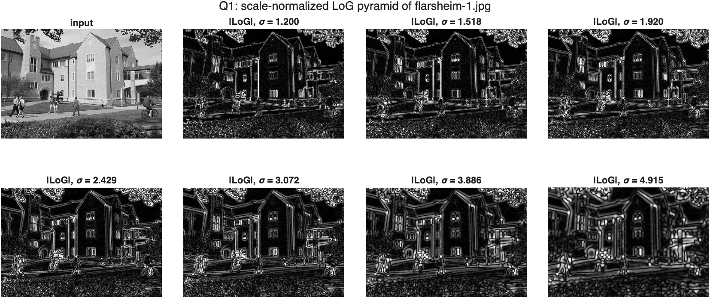
Figure 1.1 The input and the magnitude of the seven pyramid levels, all drawn on one gray scale. Fine levels respond to window frames and leaves, coarse levels to whole windows and tree crowns.
The levels in Figure 1.1 look like the ones in the assignment, with thin lines along every edge at sigma = 1.2 that thicken and merge as sigma grows. What changes from level to level is which structures stand out. The individual panes of the windows are brightest around sigma = 1.5 to 2.4, and by sigma = 4.9 each window has become a single blob.
Checking the pyramid
Three checks in hw2_verify.m are worth describing because they test the function against something I did not get from the function itself.
- I wrote the LoG kernel out from its formula, (x^2 + y^2 - 2 sigma^2) exp(-(x^2 + y^2) / 2 sigma^2) / sigma^4, and convolved with conv2. It matches the pyramid level to 1e-9.
- For a Gaussian blob of standard deviation s and height A, the scale-normalized LoG at its center has the closed form -2 A s^2 sigma^2 / (s^2 + sigma^2)^2. That is largest in magnitude exactly at sigma = s, where it equals -A/2. A synthetic blob with s = 2.429 gave a response that matched the closed form within 2% on all seven levels, peaked on the level with sigma = 2.429, and had magnitude A/2 there. So the sign, the sigma^2 factor and the idea that the peak over scale measures the size of the blob all hold.
- SIFT uses a difference of Gaussians in place of the LoG. Since the derivative of a Gaussian with respect to sigma is sigma times its Laplacian, integrating from sigma to k sigma gives DoG = ln(k) times the scale-normalized LoG at the scale in between. On flarsheim-1.jpg the difference of the Gaussians at the first two scales correlates with my LoG at their geometric mean at r = 1.0000, with a slope of 0.234 against ln(k) = 0.235. This is the reason the comparison in Q3 is a fair one. The two detectors are looking at the same function.
Q2 [30 pts] Compute LoG response extrema
getScaleResponseExtrema.m
function [x0, y_max] = getScaleResponseExtrema(x, y)
arguments
x (1,:) double
y (1,:) double
end
if numel(x) ~= numel(y)
error("getScaleResponseExtrema:sizeMismatch", ...
"x and y must have the same number of elements.");
end
if numel(x) < 4
error("getScaleResponseExtrema:tooFewPoints", ...
"A cubic needs at least 4 points, %d given.", numel(x));
end
x0 = NaN;
y_max = NaN;
% y = a*x^3 + b*x^2 + c*x + d
p = polyfit(x, y, 3);
dp = polyder(p);
ddp = polyder(dp);
% Critical points are where the gradient is zero.
r = roots(dp);
r = r(abs(imag(r)) < 1e-12 * max(1, abs(real(r))));
r = real(r);
isInside = (r > min(x)) & (r < max(x));
isMaximum = polyval(ddp, r) < 0;
r = r(isInside & isMaximum);
% A cubic can turn over once inside the range and still be higher at one
% of the ends. That bump is not the peak of the response, so reject it.
endValues = polyval(p, [min(x) max(x)]);
r = r(polyval(p, r) >= max(endValues));
% A cubic has at most one local maximum, so r is empty or a scalar.
if ~isempty(r)
x0 = r(1);
y_max = polyval(p, x0);
end
end
getScaleResponseExtrema takes the responses y of one pixel at the scales x and fits the cubic f(sigma) = a sigma^3 + b sigma^2 + c sigma + d with polyfit(x, y, 3). The gradient f'(sigma) = 3a sigma^2 + 2b sigma + c is a quadratic, so roots(polyder(p)) gives its zeros directly, and there are at most two of them. A zero is accepted as the extremum when it passes four conditions:
- It is real. If the gradient has no real zero the cubic is monotonic.
- It lies strictly inside the range of x. A peak outside the sampled scales is an extrapolation.
- The second derivative polyval(polyder(dp), r) is negative there, so it is a maximum and not a minimum.
- The fitted value there is at least as high as the fitted curve at both ends of the range. A cubic can turn over once inside the range and still be higher at one end. That bump is not the peak of the response.
When a zero passes, the function returns it as x0 with y_max = f(x0). When none does it returns NaN for both, which tells the caller that the response has no peak inside the pyramid.
How this differs from the reference code
The provided fitLoGReponse.m evaluates the cubic on a grid with a step of 0.02, takes the largest value, and then computes the gradient at that point. I solve f' = 0 instead, which gives the scale exactly and makes the gradient test the thing that finds the extremum. The two agree: over 2000 random responses, both found an interior peak in 1068 and the scales never differed by more than 0.01, half a grid step. They disagreed on whether a peak exists in one case, where the peak sits at 4.908, between the last two grid points, and the grid search reports the end of the range instead.
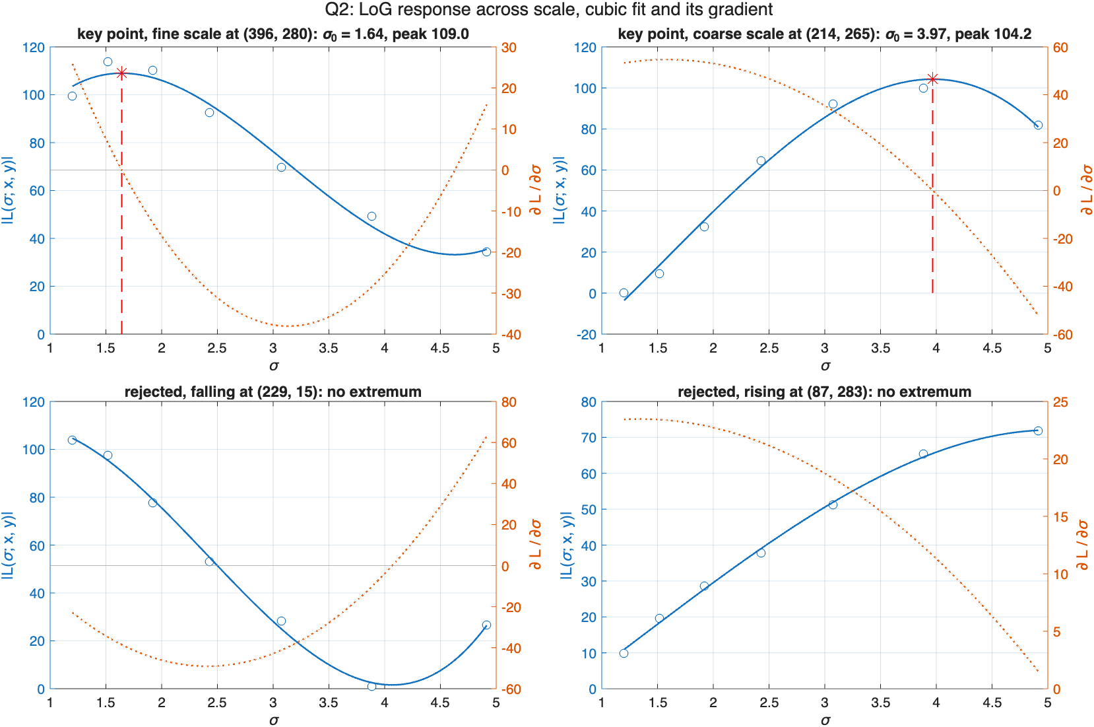
Figure 2.1 Four pixels of flarsheim-1.jpg. Circles are the seven sampled responses, the solid line is the cubic, the dotted line is its gradient on the right axis, and the red star is the extremum. The top two are key points. The bottom two have no extremum and are rejected.
Table 2.1 The four pixels in Figure 2.1.
pixel | (x, y) | response at the seven scales | x0 | y_max
key point, fine scale | (396, 280) | 99, 114, 110, 93, 70, 49, 34 | 1.642 | 109.0
key point, coarse scale | (214, 265) | 0, 9, 32, 65, 92, 100, 82 | 3.968 | 104.2
rejected, falling | (229, 15) | 104, 98, 78, 53, 28, 1, 27 | none | none
rejected, rising | (87, 283) | 10, 20, 29, 38, 51, 65, 72 | none | none

In the first panel the largest sample is at sigma = 1.518 and the fit puts the peak at 1.64, between the second and third levels. In the second the largest sample is at 3.886 and the fit gives 3.97. In both the gradient crosses zero going down, which is the maximum. The third pixel responds most at the finest scale and falls from there. Its cubic does have a zero gradient near sigma = 4, but that is a minimum. The fourth is still rising at the largest scale, so whatever it is responding to is bigger than the pyramid can measure.
Is a cubic a good model of the response
To check, I fitted every pixel of flarsheim-1.jpg that the detector in Q3 would fit, 6068 pixels in total. The median R^2 is 0.989 and the 10th percentile is 0.909, so seven samples are described well by four coefficients. Where there is a peak, the fitted peak value is 0.987 of the largest sample on the median. The cubic slightly rounds off the top instead of overshooting it.
Table 2.2 Pixels fitted, grouped by the level of their largest sample, and how many have an extremum.
level | sigma | pixels fitted | with an extremum | share
1 | 1.200 | 3891 | 74 | 1.9%
2 | 1.518 | 872 | 462 | 53.0%
3 | 1.920 | 530 | 527 | 99.4%
4 | 2.429 | 285 | 285 | 100.0%
5 | 3.072 | 168 | 168 | 100.0%
6 | 3.886 | 116 | 116 | 100.0%
7 | 4.915 | 206 | 133 | 64.6%

Only 1765 of the 6068, 29.1%, have an extremum, and Table 2.2 shows where the rest go. 3891 of the pixels respond most at the first level and only 74 of those have a peak. The others are structures finer than sigma = 1.2 whose response is already falling when the pyramid starts. In the middle of the pyramid almost every pixel has a peak. This is the gradient test doing its job. Without it the detector would report thousands of points at sigma = 1.2 whose real scale it cannot know.
The fitted scale is nearest the level of the largest sample for 1342 pixels and nearest a neighboring level for 386. For 37 it lands five or six levels away. Those are responses with two bumps, where the cubic follows the wider one. I handle them in Q3.
Q3 [50 pts] Give the image level LoG key points detection and visualize and compare with SIFT detection.
getLoGKeyPoints.m
function [x, y, scale, strength] = getLoGKeyPoints(im, log_peak_thres, opts)
arguments
im {mustBeNumeric, mustBeNonempty}
log_peak_thres (1,1) double {mustBeNonnegative}
opts.Scales (1,:) double {mustBePositive} = ...
[1.200 1.518 1.920 2.429 3.072 3.886 4.915]
end

scales = opts.Scales;
N = numel(scales);
% Blobs of either polarity count, so work with the magnitude.
P = abs(getLoGPyramid(im, scales));
[H, W, ~] = size(P);
% Tests 1 and 2: strong enough, and larger than all 26 neighbors in the
% 3-by-3-by-3 block around it. Only the level where the pixel responds
% most is tested, so a pixel can produce at most one key point.
[peakOverScale, level] = max(P, [], 3);
isBlockMax = imregionalmax(P, 26);
[rowGrid, colGrid] = ndgrid(1:H, 1:W);
isCandidate = isBlockMax(sub2ind([H W N], rowGrid, colGrid, level));
isCandidate = isCandidate & (peakOverScale >= log_peak_thres);
% The filter has no real support at the border, so drop a 1 pixel frame.
isCandidate([1 end], :) = false;
isCandidate(:, [1 end]) = false;
[row, col] = find(isCandidate);
candidateLevel = level(isCandidate);
nCandidate = numel(row);
% Test 3: an extremum over scale, located by the cubic fit.
scale = nan(nCandidate, 1);
strength = nan(nCandidate, 1);
for i = 1:nCandidate
response = reshape(P(row(i), col(i), :), 1, N);
[scale(i), strength(i)] = getScaleResponseExtrema(scales, response);
end
% The fit refines the sampled maximum, so it has to agree with it. A
% response with two bumps can put the cubic's peak several levels away
% from the level whose neighborhood was tested, and that is not the same
% extremum.
lowerScale = scales(max(candidateLevel - 1, 1))';
upperScale = scales(min(candidateLevel + 1, N))';
isNearLevel = (scale >= lowerScale) & (scale <= upperScale);
isKeyPoint = isNearLevel & (strength >= log_peak_thres);
[strength, order] = sort(strength(isKeyPoint), "descend");
x = col(isKeyPoint);
y = row(isKeyPoint);
scale = scale(isKeyPoint);
x = x(order);
y = y(order);
scale = scale(order);
end
getLoGKeyPoints builds the pyramid, takes its absolute value, and keeps a pixel as a key point when it passes three tests.
- Strength. The largest of its seven responses is at least log_peak_thres. The threshold is in gray levels on the 0 to 255 range.
- Position. On the level where the pixel responds most, it is larger than all 26 neighbors in the 3 by 3 by 3 block around it, which is the 8 pixels around it on its own level and the 9 on each of the levels above and below. imregionalmax(P, 26) does this for the whole pyramid at once.
- Scale. The cubic from Q2, fitted to its seven responses, has an extremum inside the scale range, the fitted peak is also at least the threshold, and the fitted scale is no more than one level from the level tested in step 2.
The last condition in step 3 is for the two-bump responses from Q2. If the neighborhood was tested on one level and the cubic peaks four levels away, the fit is describing a different extremum from the one that was tested, so I drop it. On flarsheim-1.jpg that removes 53 points, the 37 from Q2 and 16 whose fitted scale is just past the neighboring level. The outputs x, y and scale are sorted from the strongest key point to the weakest, and scale is the x0 of the cubic, so it is continuous and not one of the seven levels.
I used log_peak_thres = 16 for everything below. At that setting flarsheim-1.jpg has 6068 pixels that pass steps 1 and 2 and 1689 that pass step 3.
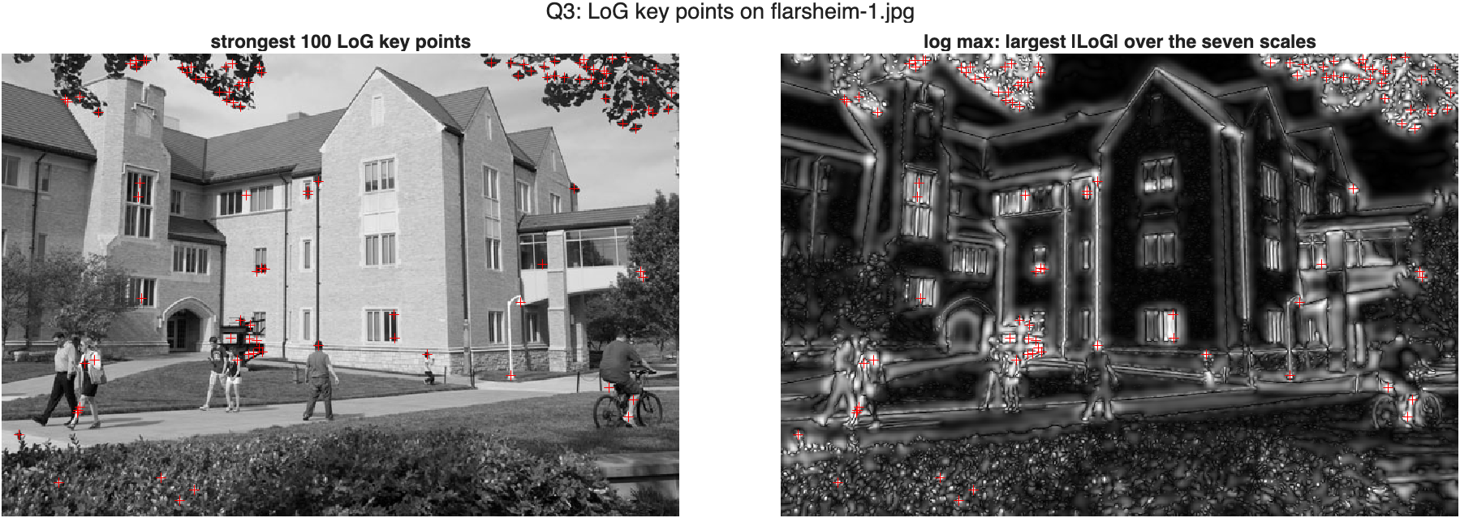
Figure 3.1 The same view as the example in the assignment. Left, the strongest 100 LoG key points on flarsheim-1.jpg. Right, the same points on the log max image, the largest |LoG| over the seven scales at each pixel.
The SIFT side of the comparison
The assignment uses vl_sift. VLFeat is not installed on this machine and its binaries do not run on Apple Silicon MATLAB, so I used detectSIFTFeatures from the Computer Vision Toolbox with its default settings, as I did in Homework 1. Two things have to be handled before the numbers can be compared.
First, the thresholds are not in the same units. detectSIFTFeatures takes a ContrastThreshold on a normalized scale, not a peak threshold in gray levels like vl_sift. So I do not compare the two at matching thresholds. I compare all the points each detector returns, and then the strongest K of each for the same K.
Second, SIFT searches several octaves and my pyramid covers one range, sigma = 1.2 to 4.915. A SIFT point at sigma = 20 has nothing to be compared with. Whenever I count agreement I use only the SIFT points whose scale is inside the pyramid range, which is roughly half of them.
Table 3.1 Key points found. LoG at log_peak_thres = 16, SIFT at its defaults.
image | size | LoG | SIFT | SIFT in scale range | LoG seconds | SIFT seconds
flarsheim-1.jpg | 630 by 430 | 1689 | 2196 | 1165 | 0.80 | 0.04
sift-1.jpg | 1200 by 815 | 3544 | 3172 | 1631 | 2.37 | 0.13
sift-3.png | 660 by 460 | 1361 | 3801 | 1643 | 0.88 | 0.05

The counts are of the same order. The LoG detector is 17 to 19 times slower. It filters the full-size image seven times with kernels up to 41 pixels wide and then calls polyfit once for every candidate pixel in a loop, where SIFT subtracts blurred images it has already computed and works on smaller images at each octave.
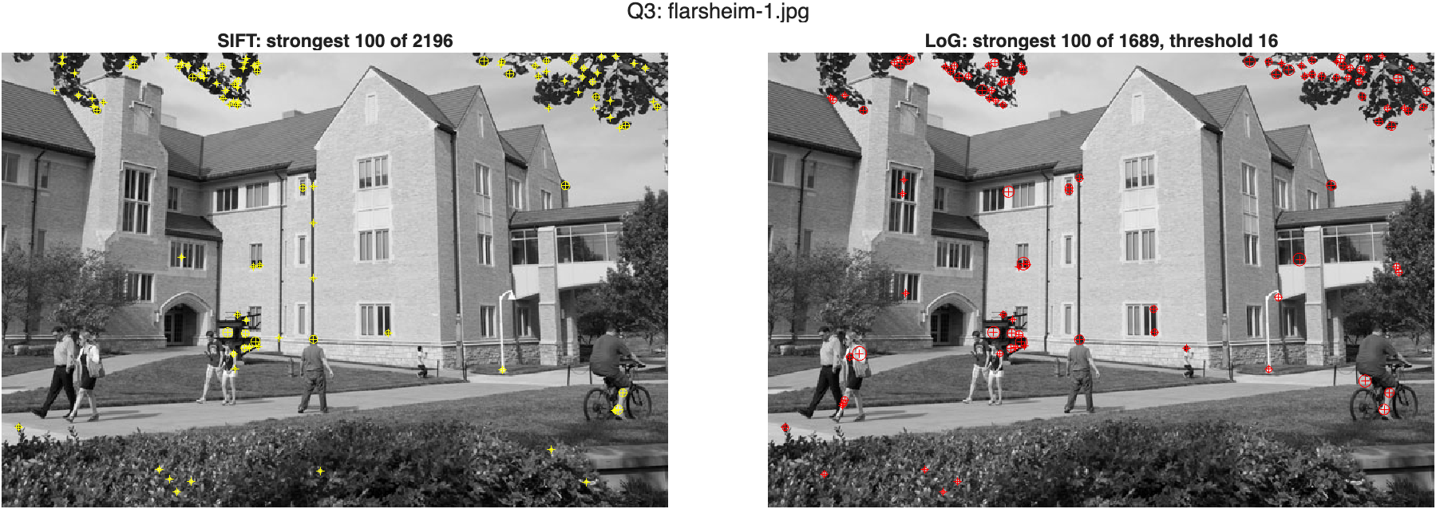
Figure 3.2 flarsheim-1.jpg. The strongest 100 key points of each detector. Circles have radius sqrt(2) times sigma.
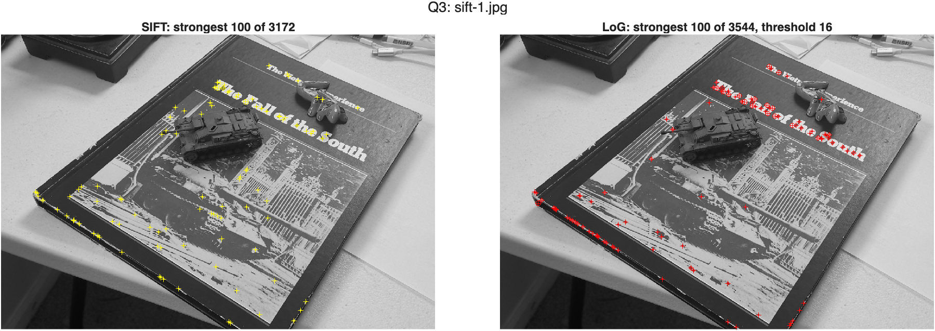
Figure 3.3 sift-1.jpg from Homework 1, same layout. Both detectors go to the lettering. The LoG points also run along the edge of the book.
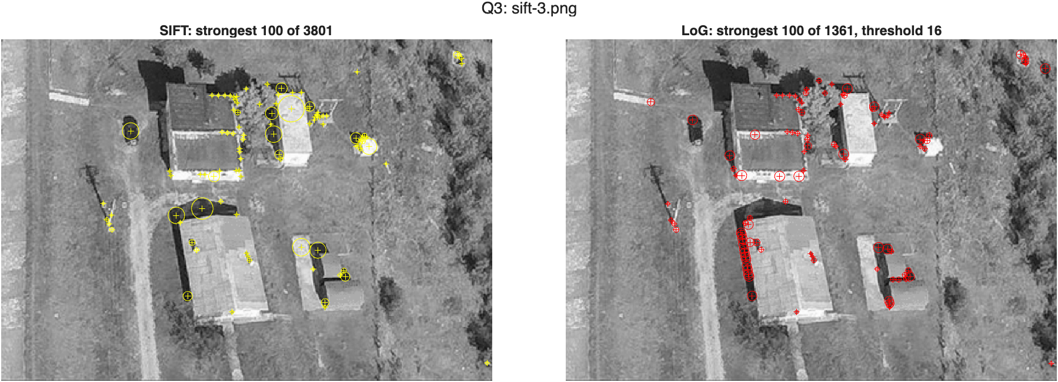
Figure 3.4 sift-3.png from Homework 1, same layout. SIFT returns some large-scale points the LoG pyramid cannot reach. The LoG points line up along the roof edge at lower left.
In all three images the two detectors go to the same parts of the scene: the leaves against the sky and the sign in front of the building, the lettering on the book cover, the corners of the roofs. The differences are visible too. SIFT has circles much larger than any of mine, and the LoG detector puts rows of points along straight edges where SIFT has few or none.
How many key points, as the threshold moves
Table 3.2 LoG key points by log_peak_thres.
image | 8 | 16 | 24 | 32 | 40 | 50 | 60
flarsheim-1.jpg | 2058 | 1689 | 1208 | 879 | 635 | 356 | 194
sift-1.jpg | 4207 | 3544 | 2747 | 1873 | 1049 | 348 | 106
sift-3.png | 2397 | 1361 | 758 | 405 | 206 | 88 | 25

The count falls steadily and there is no natural place to stop. Going from 16 to 40 removes 62.4% of the points on flarsheim-1.jpg and 84.9% on sift-3.png. Because the output is sorted by strength, a higher threshold only ever removes points from the end of the list. I checked that doubling the threshold returns a subset.
Do the two detectors find the same points
I call a LoG key point matched when a SIFT key point lies within 3 pixels of it. A number like that means little without knowing what chance would give, because with a thousand points on each side some will land close together anyway. For the chance figure I mirror the SIFT points left to right and count again. That keeps how many there are and how clustered they are, and removes any real correspondence.
Table 3.3 Agreement in position within 3 pixels, all key points.
image | LoG with a SIFT point | share | chance | SIFT with a LoG point | share
flarsheim-1.jpg | 832 of 1689 | 49.3% | 13.5% | 834 of 1165 | 71.6%
sift-1.jpg | 1288 of 3544 | 36.3% | 7.0% | 1279 of 1631 | 78.4%
sift-3.png | 949 of 1361 | 69.7% | 13.7% | 960 of 1643 | 58.4%

Table 3.4 The same, using only the strongest K of each detector.
image | K = 100 | chance | K = 300 | chance | K = 1000 | chance
flarsheim-1.jpg | 81.0% | 4.0% | 68.3% | 8.0% | 54.8% | 12.3%
sift-1.jpg | 69.0% | 2.0% | 61.3% | 1.7% | 50.2% | 6.4%
sift-3.png | 64.0% | 3.0% | 66.3% | 7.0% | 68.7% | 10.1%

Between 36% and 70% of the LoG key points have a SIFT key point within 3 pixels, against a chance level of 7% to 14%. In the other direction 58% to 78% of the in-range SIFT points have a LoG point. The agreement is strongest at the top of the list. Among the strongest 100 of each it is 64% to 81%, where chance is 2% to 4%. So the detectors agree far more than chance and far less than completely. The rest of this answer is about where the disagreement comes from.
Scale
For the matched pairs I compared the two scales. The rank correlation between the LoG scale and the SIFT scale is 0.91, 0.91 and 0.80 on the three images, so a point that one detector calls large the other calls large as well. The scales are not equal though. The LoG scale is larger by a nearly constant factor, with a median ratio of 1.17, 1.16 and 1.17.
To find out which one is off I ran both on six synthetic Gaussian blobs of known size, from 1.6 to 4.0 pixels. The LoG detector returned 0.98 to 1.06 times the true size and SIFT returned 0.87 to 0.89 times it, a ratio of 1.155 between them. So the factor in the real images is the one the synthetic blobs predict, and the cubic fit recovers the size of a blob to within about 6%. It also recovered the peak strength, which should be half the blob's height, to within 3%.
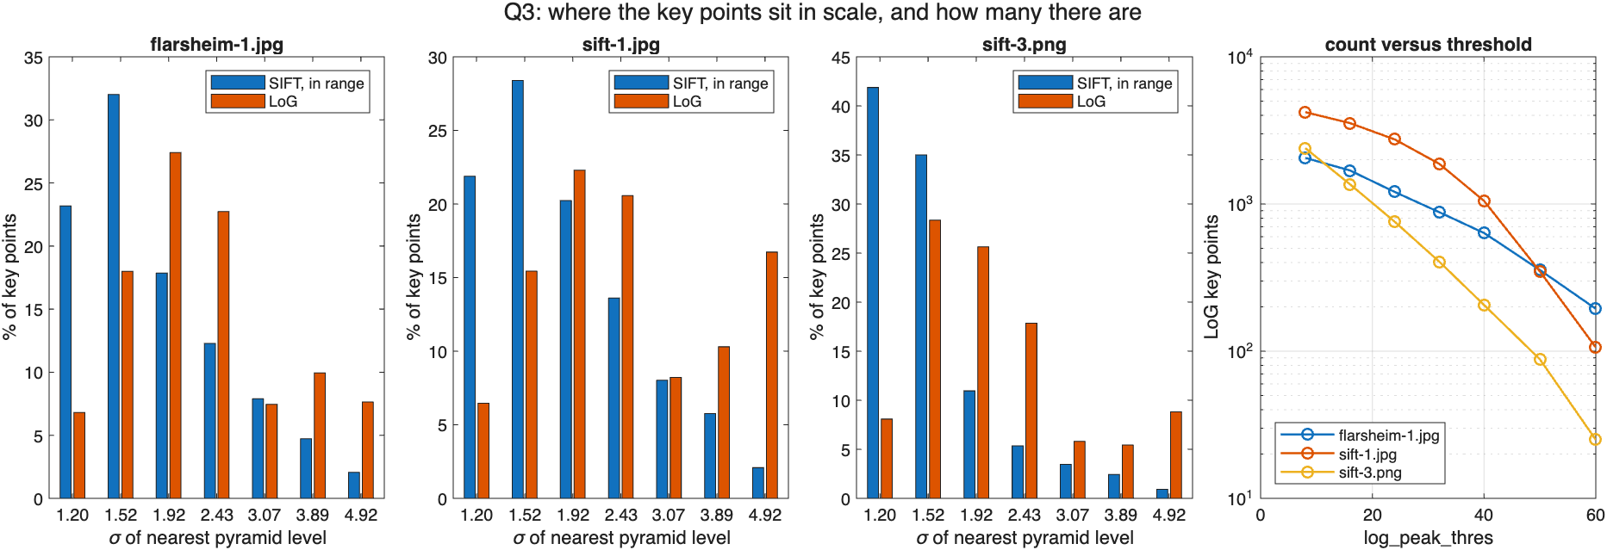
Figure 3.5 Left three panels, the share of key points at each pyramid level, SIFT points in range against LoG points. Right, LoG key point count against threshold on a log axis.
Figure 3.5 shows the same thing as a distribution. SIFT puts most of its in-range points on the first two levels. The LoG detector has few points on the first level, because the extremum test rejects responses that are still falling at sigma = 1.2, and its distribution sits about one level higher, which is what a factor of 1.17 looks like when the levels are a factor of 1.265 apart.
Edges
SIFT has a step the LoG detector does not. After finding an extremum it looks at the two principal curvatures of the response there and drops the point if one is more than 10 times the other, because that shape is a ridge along an edge and not a blob. A point on an edge is well located across the edge and poorly located along it. I applied the same test to my key points after the fact, using the 2 by 2 Hessian of the |LoG| level nearest each point's scale.
Table 3.5 LoG key points that fail the SIFT edge test at r = 10, and how often each group has a SIFT point within 3 pixels.
image | fail the edge test | share | matched, if they fail | matched, if they pass | chance
flarsheim-1.jpg | 487 of 1689 | 28.8% | 12.1% | 64.3% | 13.5%
sift-1.jpg | 1602 of 3544 | 45.2% | 7.2% | 60.4% | 7.0%
sift-3.png | 124 of 1361 | 9.1% | 36.3% | 73.1% | 13.7%

This accounts for most of the disagreement. On flarsheim-1.jpg 29% of the LoG key points fail the edge test, and on sift-1.jpg, with its long straight book edges, 45% do. Those points have a SIFT point nearby 12.1% and 7.2% of the time, which is the chance level of 13.5% and 7.0%. The points that pass the test are matched 64.3%, 60.4% and 73.1% of the time. sift-3.png has few edge points, 9%, and it is the image with the highest agreement overall. Its edge points are the exception to the pattern, matched 36.3% of the time, but there are only 124 of them. The rows of red points along the book edge in Figure 3.3 and the roof edge in Figure 3.4 are these points.
Findings
- The LoG pyramid and SIFT are detecting the same thing. The difference of Gaussians is ln(k) times the scale-normalized LoG, I measured a slope of 0.234 against 0.235, and on the points that are comparable the two detectors agree 60% to 73% of the time where chance is 7% to 14%.
- Checking the gradient is what makes this a scale space detector. Of the pixels that are strong local maxima, only 29.1% have a peak across scale on flarsheim-1.jpg. Most of the rest respond most at the finest level and would have been reported at sigma = 1.2 with no evidence that 1.2 is their size.
- The cubic is a good enough model. Median R^2 is 0.989, the fitted scale of a synthetic blob is within 6% of its true size, and solving f' = 0 agrees with a grid search to half a grid step. It goes wrong on responses with two bumps, and the 53 of 1765 fits that land away from the sampled maximum have to be caught separately.
- What the LoG detector is missing is the edge test. 29% and 45% of its key points on the two images with long straight edges are edge responses, and those are the ones SIFT does not have. Adding the curvature ratio test would be the first thing to do to bring the two detectors together.
- Scales from the two detectors differ by a constant factor of about 1.17. On synthetic blobs most of it comes from SIFT reporting a sigma about 12% below the size of the blob. Anything that mixes key points from both would need to correct for it.
- The LoG detector as written is 17 to 19 times slower than SIFT and covers one range of scales where SIFT covers them all. For blobs larger than about 5 pixels it returns nothing.

