- Compute Histogram for image recognition (50pts)
Data set: the NWPU aerial data set contains approximately 45 categories of 700 images for each category in 256x256 RGB format. The data set RESISC45, can be downloaded from:
https://www.kaggle.com/datasets/aqibrehmanpirzada/nwpuresisc45
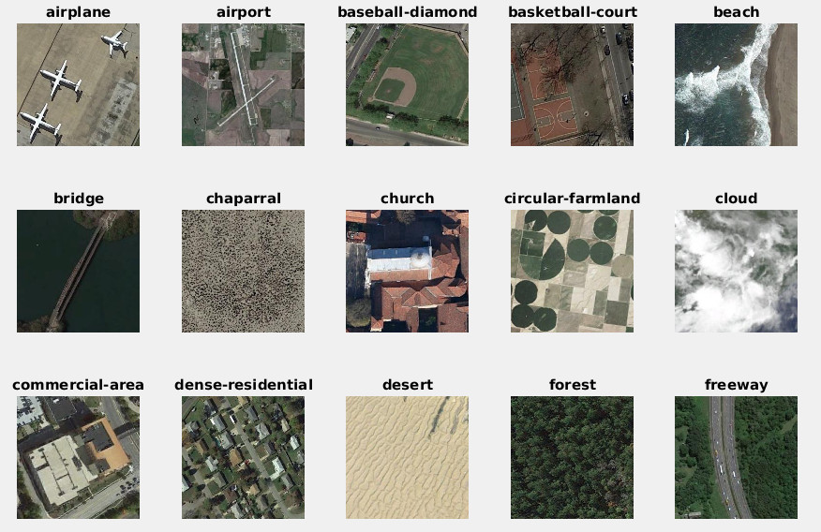
For HW-1, let us just take the first 15 classes (shown above) {airplane, airport, bridge, ..., freeway} from the full data set, and 40 images per class and form a data set of N=600 images with 15 labels. Objectives are:
- compute a HSV Kmeans model with total number of entry K= [64, 128] implementing in MATLAB (or Python) and show your code and results [15pts]
getHSVColorTable.m
function [color_table] = getHSVColorTable(im_path, K, opts)
arguments
im_path
K (1,1) double {mustBeInteger, mustBePositive}
opts.PixelsPerImage (1,1) double {mustBeInteger, mustBePositive} = 500
opts.Replicates (1,1) double {mustBeInteger, mustBePositive} = 3
opts.Seed (1,1) double = 0
end
files = iResolveFiles(im_path);
nFile = numel(files);
if nFile == 0
error("getHSVColorTable:noImages", "No image files found.");
end
rng(opts.Seed);
nPix = opts.PixelsPerImage;
X = zeros(nFile*nPix, 3);
for i = 1:nFile
im = rgb2hsv(imread(files(i)));
[ht, wid, ~] = size(im);
px = reshape(im, [ht*wid, 3]);
sel = randi(ht*wid, [nPix, 1]);
X((i-1)*nPix + (1:nPix), :) = px(sel, :);
end
kmOpts = statset("MaxIter", 300);
[~, C] = kmeans(X, K, Distance="sqeuclidean", Start="plus", ...
Replicates=opts.Replicates, Options=kmOpts, Display="off");
color_table = sortrows(C, [1 2 3]);
end
function files = iResolveFiles(im_path)
if isstring(im_path) || ischar(im_path) || iscellstr(im_path)
im_path = string(im_path);
else
error("getHSVColorTable:badPath", ...
"im_path must be a folder name or a list of file names.");
end
if isscalar(im_path) && isfolder(im_path)
ds = imageDatastore(im_path, IncludeSubfolders=true);
files = string(ds.Files);
else
files = im_path(:);
end
end

hw1_config.m (defines the 600-image, 15-class subset)
function [files, labels, classes] = hw1_config(nImg)
arguments
nImg (1,1) double {mustBeInteger, mustBePositive} = 40
end
dataRoot = fullfile(fileparts(mfilename("fullpath")), "NWPU-RESISC45");
classes = ["airplane"; "airport"; "baseball_diamond"; ...
"basketball_court"; "beach"; "bridge"; "chaparral"; "church"; ...
"circular_farmland"; "cloud"; "commercial_area"; ...
"dense_residential"; "desert"; "forest"; "freeway"];
nClass = numel(classes);
files = strings(nClass*nImg, 1);
labels = zeros(nClass*nImg, 1);
for k = 1:nClass
d = dir(fullfile(dataRoot, classes(k), "*.jpg"));
if numel(d) < nImg
error("hw1_config:tooFewImages", ...
"Class %s has %d images, %d requested.", ...
classes(k), numel(d), nImg);
end
names = sort(string({d.name}')); % airplane_001.jpg first
offs = (k-1)*nImg;
files(offs + (1:nImg)) = fullfile(dataRoot, classes(k), names(1:nImg));
labels(offs + (1:nImg)) = k;
end
end
getHSVColorTable samples 500 random pixels from each of the 600 images, which comes to 300,000 samples, converts them to HSV and clusters them with k-means. I used squared Euclidean distance, k-means++ initialization, 3 replicates and a cap of 300 iterations. Taking the same number of pixels from every image instead of pooling all the pixels together keep each image equally represented in the code book. Everything here was run in MATLAB R2025b.
The function returns the centroids sorted by hue, then saturation, then value. Sorting does not change anything for the classifier, since any consistent permutation of the bins gives the same distances, but it puts similar colors next to each other so the histograms in Question 2 are easier to read.
Table 1.1 Code book coverage of the HSV cube, and training cost.
K | hue range | saturation range | value range | k-means time
64 | 0.00 to 0.93 | 0.01 to 0.96 | 0.04 to 0.92 | 53.7 s
128 | 0.00 to 0.97 | 0.00 to 0.98 | 0.04 to 0.96 | 72.9 s

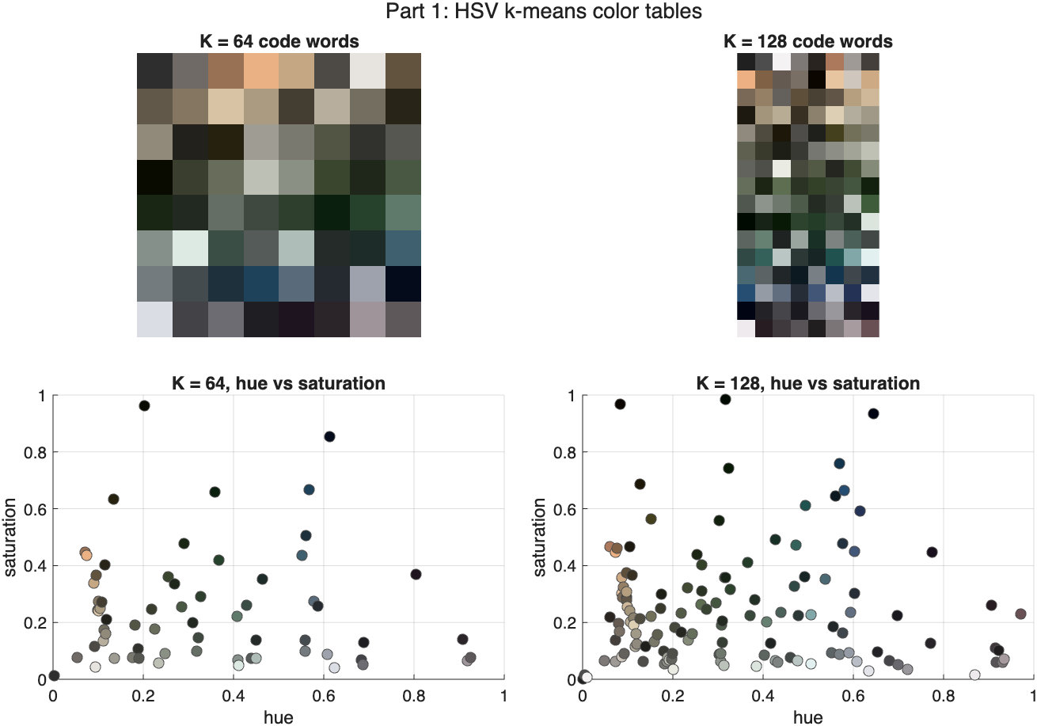
Figure 1.1 The code books for K = 64 and K = 128, shown as color strips and as scatter plots in the hue vs saturation plane.
Both code books are mostly desaturated earth, olive and slate tones, and the scatter plot shows almost every code word below S = 0.5. Aerial photos at this resolution are not very colorful, so I did not expect K = 128 to add much over K = 64. Question 3 confirms that. I also checked that no code word is dead: all 64 and all 128 entries receive pixels from the data set.
One thing I noted with this setup: hue is circular, but squared Euclidean distance treats it as a straight line, so the wrap at H = 0 and H = 1 splits red into two clusters that end up far apart. I left it alone because getHSVHist uses the same distance when it assigns pixels, so at least the code book and the quantizer agree with each other. There is very little red in this data set anyway.
- for each image compute a color histogram, implement the following function in MATLAB or Python with both an Euclidean distance and KL distance (also known as cross entropy) metrics (optional for 10pts extra credits) [15pts]
getHSVHist.m
function [h] = getHSVHist(im, color_table, opt)
arguments
im
color_table (:,3) double
opt (1,1) string {mustBeMember(opt, ["euc", "kld"])} = "euc"
end
im = rgb2hsv(im);
[ht, wid, ~] = size(im);
K = size(color_table, 1);
X = reshape(im, [ht*wid, 3]);
if opt == "euc" % euclidean distance
dist = pdist2(color_table, X);
elseif opt == "kld" % KL distance (cross entropy)
dist = iKLDivergence(color_table, X);
end
[~, idx] = min(dist, [], 1);
h = accumarray(idx(:), 1, [K 1])' / (ht*wid);
end
function D = iKLDivergence(C, X)
a = 1e-6;
P = (X + a) ./ sum(X + a, 2); % M-by-3, pixels
Q = (C + a) ./ sum(C + a, 2); % K-by-3, code words
% KL(p||q) = sum(p.*log(p)) - sum(p.*log(q))
D = (sum(P .* log(P), 2) - P * log(Q)')';
end

getHSVHist converts the image to HSV and reshapes it into a 65,536 by 3 matrix of pixels. Each pixel is assigned to the closest code word, and I divide the counts by the number of pixels, so the result is a K-bin distribution that sums to 1. Normalizing this way means images of different sizes stay comparable. The opt argument picks which distance is used for the assignment.
Euclidean distance
This is plain geometric distance in the HSV cube. I used the pdist2 call from the assignment, which builds the whole K by M distance matrix in one go.
KL distance / cross entropy (extra credit)
For KL I normalize the pixel and the code word so each sum to 1, then treat them as 3-bin distributions over H, S and V. Writing the divergence out splits it into a term that only depends on the pixel and a matrix product:
D(p || q) = sum p log(p/q) = sum p log p - sum p log q
The first term is the negative entropy of the pixel. It is the same for every code word, so it cannot change which code word wins. That means KL and cross entropy pick the same bin, so the note in the assignment is exactly right and not just approximately right. I checked this on all 65,536 pixels of a test image and the two gave identical assignments. Because only the second term matters, the whole thing reduces to one P*log(Q)' matrix product, which is why KL runs about as fast as pdist2 (12.8 s against 11.9 s for all 600 images at K = 64). I add 1e-6 before normalizing so that log(0) never comes up, and so black pixels, whose three channels sum to zero, still get a valid distribution.
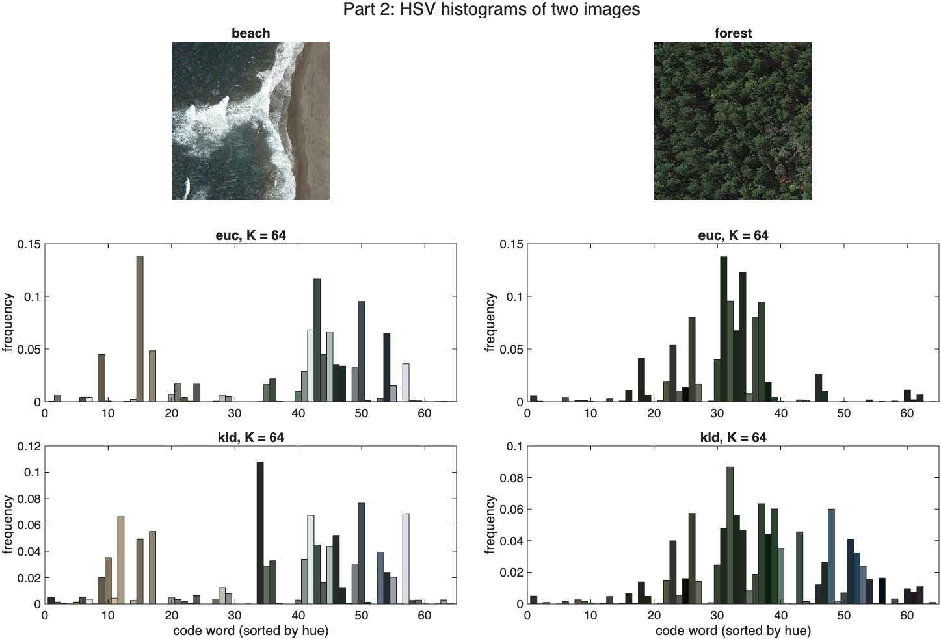
Figure 2.1 A beach image and a forest image with their K = 64 histograms under both metrics. Each bar is painted in the color of its code word.
beach breaks into a sand cluster and a blue-grey water cluster, and forest sits on a narrow band of greens. The same two images spread over more bins under KL.
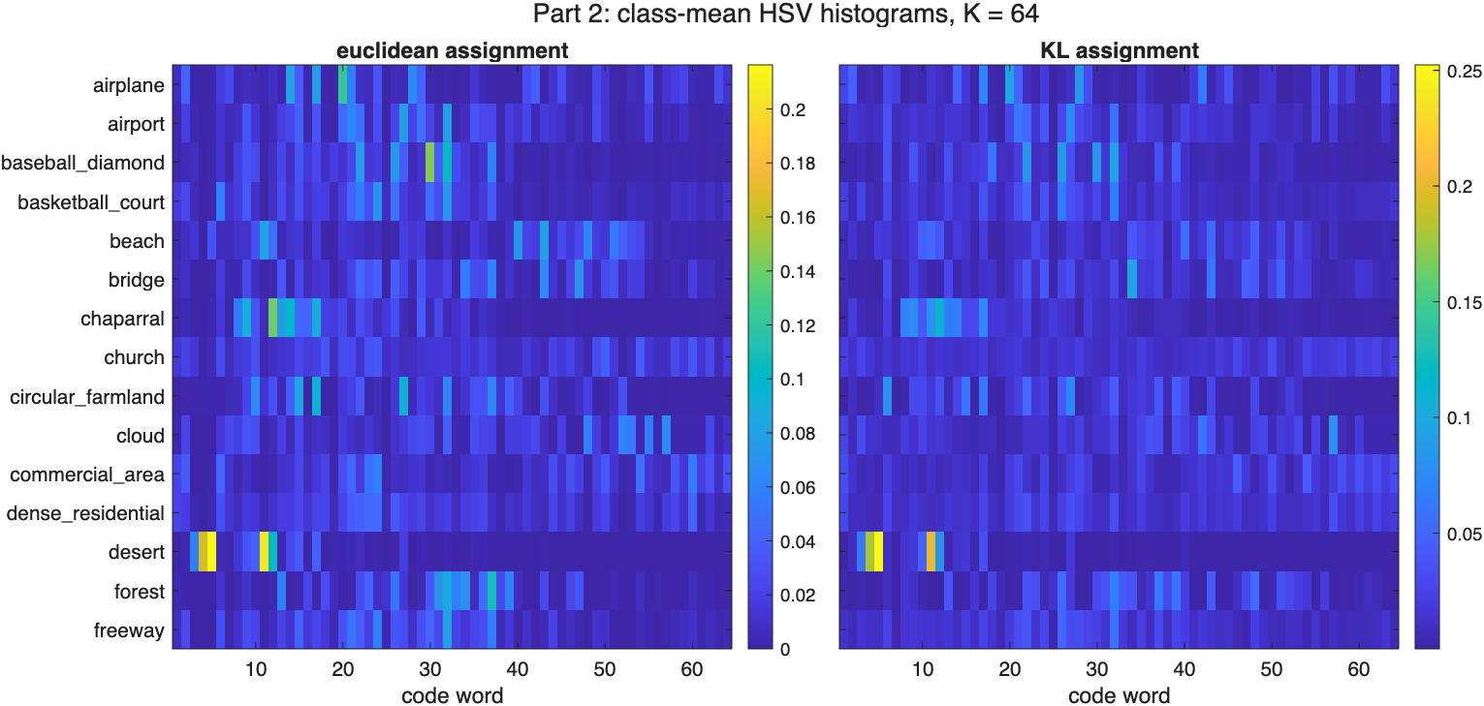
Figure 2.2 Class-mean histograms for all 15 classes under both assignment metrics.
desert puts 42% of its mass in 2 of the 64 bins and 75% in 5. chaparral is also peaked, at 24% and 49%. church is much flatter, 8% and 18%. The peaked classes are the ones that get recognized in Question 3, and classes whose rows look similar, like church and commercial_area, are the ones that get confused.
Comparing the two metrics
The extra spreading shows up in the numbers. Averaged over all 600 images, KL fills 54.0 of the 64 bins while Euclidean fills 46.3, and the KL histograms have higher entropy, 4.11 bits against 3.67.
The reason is that the two distances carve up the space differently, not that KL throws information away. Normalizing each triple makes KL blind to scaling all three channels at once, and I checked this directly: multiplying (H, S, V) by 0.5 leaves the assigned bin unchanged. So, KL's decision regions are cones through the origin, while k-means built the code book out of Euclidean Voronoi cells. Using cone-shaped regions on a code book that was fit with sphere-shaped ones spreads the pixels of an image over more cells than the code book was built for.
I want to be careful here, because the obvious explanation is wrong. KL is not blind to brightness. If I shift V by 0.5 and hold H and S fixed, the assigned bin changes for 99.8% of 4,000 random test pixels, compared to 95.7% under Euclidean. So, KL is more sensitive to value than Euclidean is. The only thing it cannot see is all three channels being scaled together.
- Image Recognition Experiment: Use this HSV histogram feature to represent images, you will have a NxK data matrix, for N=15*40, and K = [64, 128]. Split the data set into training and leave 1 out testing, and conduct classification using knnclassify(). [20pts]
hw1_part3_recog.m
clear; clc;
featSets = ["hsv_hist64" "hsv_hist64_kld" "hsv_hist128" "hsv_hist128_kld"];
kNNList = [1 3 5];
n_class = 15;
n_img = 40;
test_set = 1:10;
train_set = 11:40;
test_idx = reshape(((0:n_class-1)'*n_img + test_set)', [], 1);
train_idx = setdiff(1:n_class*n_img, test_idx)';
accSplit = zeros(numel(featSets), numel(kNNList));
accLoo = zeros(numel(featSets), 1);
perClass = zeros(numel(featSets), n_class);
recAll = cell(numel(featSets), 1);
for f = 1:numel(featSets)
load(featSets(f) + ".mat", "hsv_hist", "labels", "classes");
fprintf("%-18s %d x %d\n", featSets(f), size(hsv_hist, 1), ...
size(hsv_hist, 2));
% Protocol 1: fixed 10 / 30 split, per class as in the skeleton.
for kk = 1:numel(kNNList)
rec = zeros(size(test_idx));
for k = 1:n_class
offs = (k-1)*n_img;
% test: offs + test_set, training: all samples minus test set
rec_label = knnclassify(hsv_hist(offs+test_set, :), ...
hsv_hist(train_idx, :), labels(train_idx), kNNList(kk));
rec((k-1)*numel(test_set) + (1:numel(test_set))) = rec_label;
if kNNList(kk) == 1
perClass(f, k) = mean(rec_label == k);
end
end
accSplit(f, kk) = mean(rec == labels(test_idx));
if kNNList(kk) == 1
recAll{f} = rec;
end
end
% Protocol 2: leave one out over the whole data set.
N = size(hsv_hist, 1);
recLoo = zeros(N, 1);
for i = 1:N
tr = [1:i-1, i+1:N];
recLoo(i) = knnclassify(hsv_hist(i, :), hsv_hist(tr, :), labels(tr));
end
accLoo(f) = mean(recLoo == labels);
end
% Accuracy summary. Chance level is 1/15 = 6.7 percent.
fprintf("\n=== Overall accuracy, 10/30 split (150 test images) ===\n");
disp(array2table(accSplit, RowNames=featSets, ...
VariableNames="k=" + string(kNNList)));
fprintf("=== Overall accuracy, leave one out (600 images) ===\n");
disp(array2table(accLoo, RowNames=featSets, VariableNames="1-NN"));
[bestAcc, best] = max(accSplit(:, 1));
fprintf("Best 1-NN split accuracy: %.1f%% with %s\n", ...
100*bestAcc, featSets(best));
fprintf("\n=== Per-class accuracy, 1-NN, 10/30 split ===\n");
disp(array2table(100*perClass', RowNames=classes, VariableNames=featSets));
metrics = ["euclidean" "cityblock" "chisq"];
accMetric = zeros(numel(featSets), numel(metrics));
for f = 1:numel(featSets)
load(featSets(f) + ".mat", "hsv_hist", "labels");
for m = 1:numel(metrics)
rec = knnclassify(hsv_hist(test_idx, :), hsv_hist(train_idx, :), ...
labels(train_idx), 1, metrics(m));
accMetric(f, m) = mean(rec == labels(test_idx));
end
end
fprintf("\n=== Overall accuracy by k-NN metric, 1-NN, 10/30 split ===\n");
disp(array2table(100*accMetric, RowNames=featSets, VariableNames=metrics));
showClasses = strrep(classes, "_", " ");
fig = figure(Name="Confusion matrix", Position=[100 100 760 640]);
cm = confusionchart(fig, showClasses(labels(test_idx)), ...
showClasses(recAll{best}));
cm.Title = sprintf("Part 3: %s, 1-NN, %.1f%% accuracy", ...
strrep(featSets(best), "_", " "), 100*bestAcc);
cm.RowSummary = "row-normalized";
sortClasses(cm, showClasses);
theme(fig, "light");
drawnow;
exportgraphics(fig, "results/part3_confusion.png", Resolution=150);
save("hw1_part3_results.mat", "accSplit", "accLoo", "accMetric", ...
"perClass", "featSets", "kNNList", "metrics", "classes");
I ran two protocols on all four feature matrices. The split protocol is the one in the assignment: images 1 to 10 of each class are the test set and 11 to 40 are the training set, so 150 test images and 450 training images. The leave-one-out protocol classifies each of the 600 images against the other 599. Chance is 1/15, or 6.7%.
Two corrections I made to the code given in the assignment
1. knnclassify does not exist anymore. It was removed from the Bioinformatics Toolbox after R2013b and exist('knnclassify') returns 0 on R2025b. Rather than rewrite the experiment around fitcknn, I wrote a replacement with the same (Sample, Training, Group, k, distance, rule) signature on top of pdist2, so the calling code from the assignment runs as it is.
2. The index expression in the skeleton did not work. setdiff(offs+test_set, [1:n_class*n_img]) has the arguments in the wrong order and returns empty. It should be setdiff(1:n_class*n_img, offs+test_set). Also, k*ones(1, length(train_set)) labels every training sample as class k, so the classifier would return k for every input and report 100% accuracy. I used the real labels of the training rows instead.
Table 3.1 Overall accuracy (%) by feature set and neighbor count. Chance = 6.7%.
feature set | K | assign | k = 1 | k = 3 | k = 5 | LOO, 1-NN
hsv_hist64 | 64 | euc | 51.3 | 51.3 | 52.0 | 52.5
hsv_hist64_kld | 64 | kld | 48.7 | 54.0 | 52.0 | 49.3
hsv_hist128 | 128 | euc | 53.3 | 48.0 | 46.7 | 52.5
hsv_hist128_kld | 128 | kld | 50.7 | 52.0 | 44.0 | 49.5
Everything lands between 44% and 54%, which is six to eight times chance. The leave-one-out column has four times as much training data but tracks the split column closely, so what limits the result is the feature and not the amount of training data.
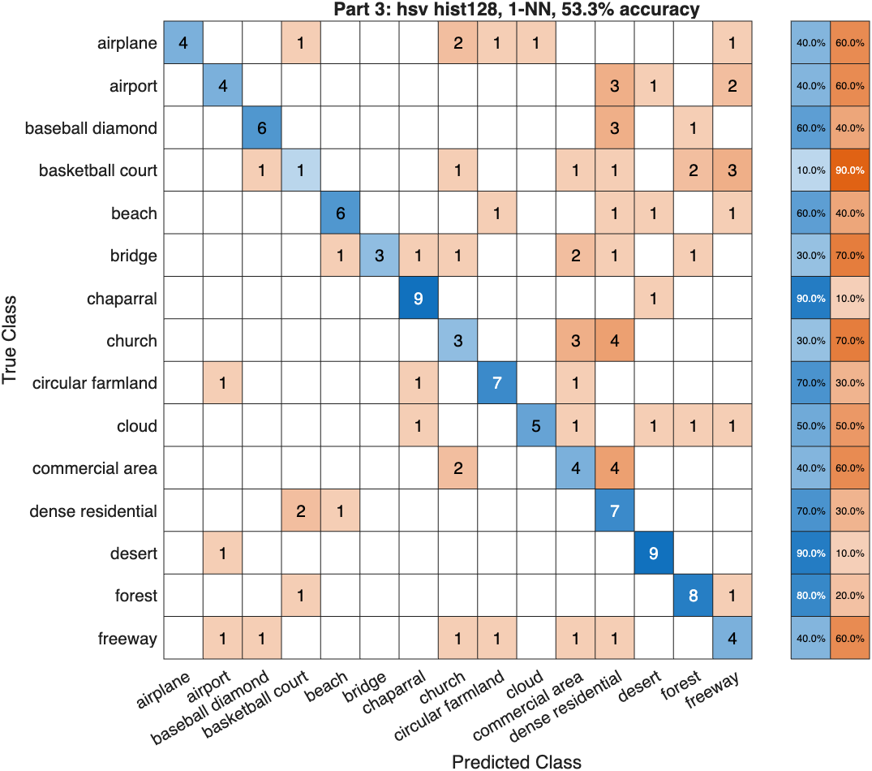
Figure 3.1 Confusion matrix for the best 1-NN split configuration, hsv_hist128 at 53.3% accuracy.
The diagonal is strong for classes with a consistent color and falls apart for the ones defined by their structure. The 10 basketball_court test images end up spread over 7 different predicted classes, and church mostly gets called commercial_area or dense_residential.
Which of these differences are real
With only 150 test images, 51.3% has a 95% Clopper-Pearson interval of [43.0%, 59.6%], which is 16.5 points wide. Every number in Table 3.1 falls inside every other number's interval, so the split protocol on its own cannot rank these configurations. Leave-one-out uses all 600 images as test cases and narrows the interval to 8.1 points. Both conditions also see the same 600 cases, so I can compare them pairwise. Table 3.2 gives McNemar's exact test on the discordant pairs, meaning the images that one setup gets right and the other gets wrong.
Table 3.2 Paired McNemar tests, 1-NN leave-one-out, n = 600.
comparison (A vs B) | A only | B only | exact p | verdict
K = 128 vs K = 64, euclidean | 45 | 45 | 1.000 | no effect
euc vs kld assignment, K = 64 | 68 | 49 | 0.096 | not significant
euc vs kld assignment, K = 128 | 73 | 55 | 0.133 | not significant
chi-square vs euclidean, K = 64 | 64 | 24 | < 0.001 | significant
chi-square vs euclidean, K = 128 | 73 | 27 | < 0.001 | significant
cityblock vs euclidean, K = 64 | 53 | 23 | < 0.001 | significant
cityblock vs euclidean, K = 128 | 50 | 22 | 0.0013 | significant

This is what settles the comparisons. Code book size comes out exactly null, 45 images each way and p = 1.000. Euclidean against KL assignment does not reach significance either. The only thing that separates is which metric the classifier uses to compare the histograms, at p < 0.001.
Table 3.3 Accuracy (%) by the metric the k-NN classifier uses, features unchanged.
feature set | split euc | split city | split chisq | LOO euc | LOO city | LOO chisq
hsv_hist64 | 51.3 | 55.3 | 57.3 | 52.5 | 57.5 | 59.2
hsv_hist64_kld | 48.7 | 56.0 | 58.7 | 49.3 | 57.2 | 59.0
hsv_hist128 | 53.3 | 59.3 | 58.0 | 52.5 | 57.2 | 60.2
hsv_hist128_kld | 50.7 | 58.7 | 59.3 | 49.5 | 57.3 | 60.5

Euclidean distance between two histograms treats a big bin and a small bin the same way, which is not a good model for comparing distributions. Changing only the classifier's metric and leaving the features alone gains 6.7 points under leave-one-out, from 52.5% to 59.2% at K = 64, and the best configuration reaches 60.5%.
Per-class results
The per-class split numbers come from 10 test images each, so one image moves a row by 10 points and the interval on a single row is around 30 points wide. They are too noisy to say much about individual classes. The 0% for basketball_court is a 10-sample artifact and not a real zero. The leave-one-out columns use 40 cases per class, so that is what I base the discussion on.
Table 3.4 Per-class accuracy (%), 1-NN. The last column is hsv_hist128_kld with chi-square, which is the best overall configuration.
class | split 64 euc | split 64 kld | split 128 euc | split 128 kld | LOO 64 euc | LOO best
airplane | 50 | 40 | 40 | 60 | 37.5 | 60.0
airport | 40 | 0 | 40 | 10 | 22.5 | 32.5
baseball_diamond | 50 | 50 | 60 | 70 | 55.0 | 67.5
basketball_court | 0 | 10 | 10 | 10 | 22.5 | 22.5
beach | 50 | 30 | 60 | 10 | 57.5 | 40.0
bridge | 40 | 30 | 30 | 20 | 40.0 | 45.0
chaparral | 100 | 90 | 90 | 90 | 87.5 | 85.0
church | 20 | 20 | 30 | 30 | 45.0 | 52.5
circular_farmland | 50 | 50 | 70 | 60 | 60.0 | 85.0
cloud | 50 | 50 | 50 | 70 | 42.5 | 65.0
commercial_area | 40 | 50 | 40 | 60 | 45.0 | 55.0
dense_residential | 70 | 100 | 70 | 90 | 90.0 | 80.0
desert | 90 | 90 | 90 | 70 | 77.5 | 85.0
forest | 90 | 80 | 80 | 100 | 85.0 | 95.0
freeway | 30 | 40 | 40 | 10 | 20.0 | 37.5

There is a structure here, but it is a gradient and not a clean split. forest (95%), chaparral, desert and circular_farmland (85%) and dense_residential (80%) do fine on color alone, because their color signature barely changes from one image to the next. The weakest are basketball_court (22.5%), airport (32.5%) and freeway (37.5%), which are all defined by geometry sitting on a background that could belong to any built-up class.
Even so, nothing drops to chance. The lowest rate in the table is 22.5%, still 3.4 times the 6.7% chance level, so color carries at least some signal for all 15 classes. Five classes are above 70%, and none are at or below 20%.
Findings
1. K = 128 does not help over K = 64. This is the result I am most confident about, and it is a negative one. Under leave-one-out both sizes get 52.5%, and the paired test splits the discordant images 45 to 45, p = 1.000. There is not much color information in these images, and 64 code words already cover it.
2. The comparison metric is the only thing that makes a real difference. Chi-square adds 6 to 7 points to every feature set under leave-one-out at p < 0.001, topping out at 60.5%, and cityblock is close behind. Neither the code book size nor the pixel assignment metric holds up under the same test.
3. Euclidean and KL assignment cannot be told apart. KL is about 3 points behind under a Euclidean classifier, but p = 0.096 means that is not a real effect, and the gap disappears once the classifier switches to chi-square or cityblock, where the two feature sets land within 0.2 points of each other. The KL histograms are flatter, but flatter did not turn out to be worse.
4. Accuracy varies a lot by class, but nothing sits at chance. Per-class leave-one-out rates run from 22.5% for basketball_court up to 95% for forest, so the mean on its own hides both ends of that range.
What limits the result is the feature and not the classifier. Four times the training data changes accuracy by less than a point and doubling the code book changes nothing at all. Getting basketball_court or airport right would need spatial information, something like texture descriptors, edge statistics or a bag of visual words over SIFT, because a color histogram throws away the geometry that defines those classes.

- (50pts) Homograph estimation: use the SVD to solve the over-fitting Ah=0 as covered in class. Use the sample code as template: http://www.vlfeat.org/applications/sift-mosaic-code.html, compute homograph for the following two images, as well as two images taken by yourself:
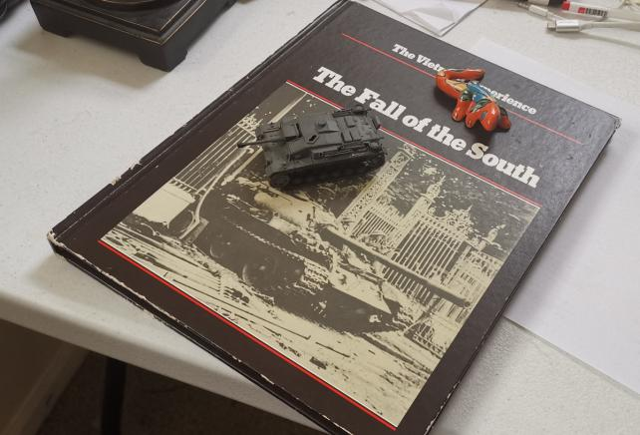 | 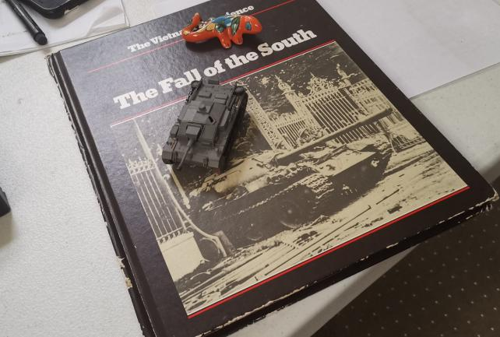
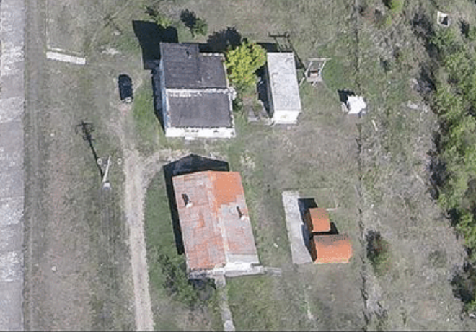 | 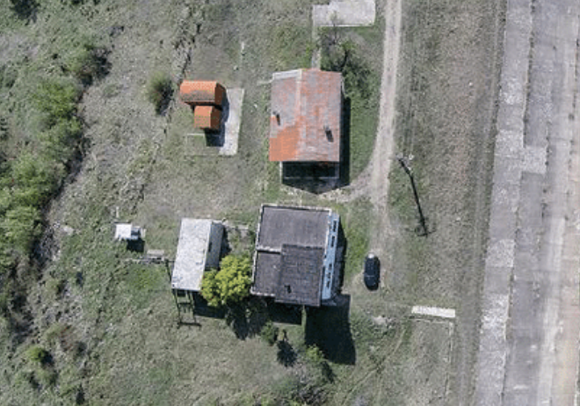

First compute SIFT and SIFT matches, then select good matches to solve homography as an over-determined linear equation via SVD. Show your code and solution details, as well as the final homography matrix. Use MATLAB imtransform to wrap the image according to the homography and verify the accuracy.
Setup
The VLFeat sample code calls vl_sift and vl_ubcmatch. VLFeat is not installed on this machine, so I used the Computer Vision Toolbox versions instead: detectSIFTFeatures, extractFeatures and matchFeatures. They run the same algorithm, and the rest of the pipeline is unchanged. Everything below is MATLAB R2025b.
I raised MatchThreshold from its default of 1.0 to 10. At the default, pair 1 returns 87 matches and pair 2 returns only 13, which is too few to work with. MaxRatio stays at 0.7, which is Lowe's ratio test. RANSAC comes in at one point, to label which matches are geometrically consistent with each other, and it is randomized, so I fix the seed with rng(0) and every number below reproduces exactly.
Setting up Ah = 0
For a correspondence (x, y) in the first image and (x', y') in the second, a homography gives
x' = (h11*x + h12*y + h13) / (h31*x + h32*y + h33)
y' = (h21*x + h22*y + h23) / (h31*x + h32*y + h33)
Multiplying out the denominators turns each correspondence into two equations that are linear in the nine unknowns:
[ x y 1 0 0 0 -x'*x -x'*y -x' ] h = 0
[ 0 0 0 x y 1 -y'*x -y'*y -y' ] h = 0

with h = [h11 h12 h13 h21 h22 h23 h31 h32 h33]'. Stacking two rows for each of the M = 8 correspondences gives a 16 by 9 matrix A, and the homography is the non-trivial solution of Ah = 0. Since h only matters up to scale, the solution is the direction that A annihilates, which is what the SVD gives directly.
getHomographySVD.m
function [H, sv, h, A] = getHomographySVD(p1, p2, opts)
arguments
p1 (:,2) double
p2 (:,2) double
opts.Normalize (1,1) logical = false
end
M = size(p1, 1);
if size(p2, 1) ~= M
error("getHomographySVD:sizeMismatch", ...
"p1 and p2 must have the same number of rows.");
end
if M < 4
error("getHomographySVD:tooFewPoints", ...
"At least 4 correspondences are needed, %d given.", M);
end
if opts.Normalize
[q1, T1] = iNormalize(p1);
[q2, T2] = iNormalize(p2);
else
q1 = p1; q2 = p2;
T1 = eye(3); T2 = eye(3);
end
A = zeros(2*M, 9);
for i = 1:M
x = q1(i,1); y = q1(i,2);
xp = q2(i,1); yp = q2(i,2);
A(2*i-1, :) = [x, y, 1, 0, 0, 0, -xp*x, -xp*y, -xp];
A(2*i, :) = [0, 0, 0, x, y, 1, -yp*x, -yp*y, -yp];
end
[~, S, V] = svd(A);
sv = diag(S);
h = V(:, end);
H = reshape(h, [3 3])';
if opts.Normalize
H = T2 \ H * T1;
end
if H(3,3) ~= 0
H = H / H(3,3);
end
end
function [q, T] = iNormalize(p)
c = mean(p, 1);
d = mean(vecnorm(p - c, 2, 2));
s = sqrt(2) / d;
T = [s 0 -s*c(1); 0 s -s*c(2); 0 0 1];
q = (T * [p, ones(size(p,1), 1)]')';
q = q(:, 1:2);
end

- How many SIFT points pairs you found? Select the best M=8 matching pairs, and use that to compute your Matrix A, for Ah=0 homography solution: [15pts]
Table 4.1 SIFT keypoints and matches. Consistent counts the matches that agree with a homography fitted robustly to all of them.
pair | image 1 | image 2 | keypoints 1 | keypoints 2 | matched pairs | consistent
1 | sift-1.jpg | sift-2.jpg | 3172 | 3860 | 949 | 803 (85%)
2 | sift-3.png | sift-4.png | 3801 | 3794 | 276 | 95 (34%)

Pair 1 gives 949 matched pairs out of 3172 and 3860 keypoints, and pair 2 gives 276 out of 3801 and 3794. The last column is a side check rather than part of the answer: I fitted a homography to all the matches with RANSAC and counted how many of them it explains. That says 85% of the pair 1 matches and 34% of the pair 2 matches are geometrically sensible, so both pairs contain a real homography but pair 2 carries many more bad matches.
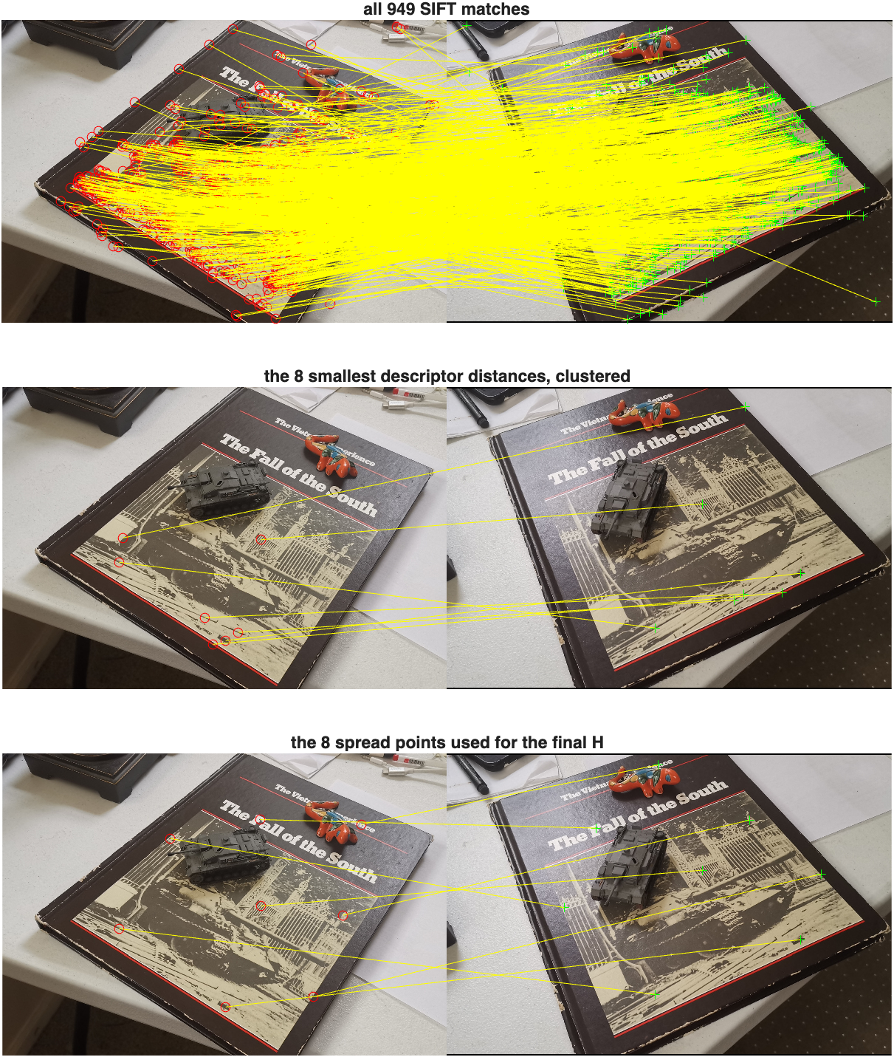
Figure 4.1 Pair 1. All 949 matches, then the 8 with the smallest descriptor distance, then the 8 spread points I ended up using.
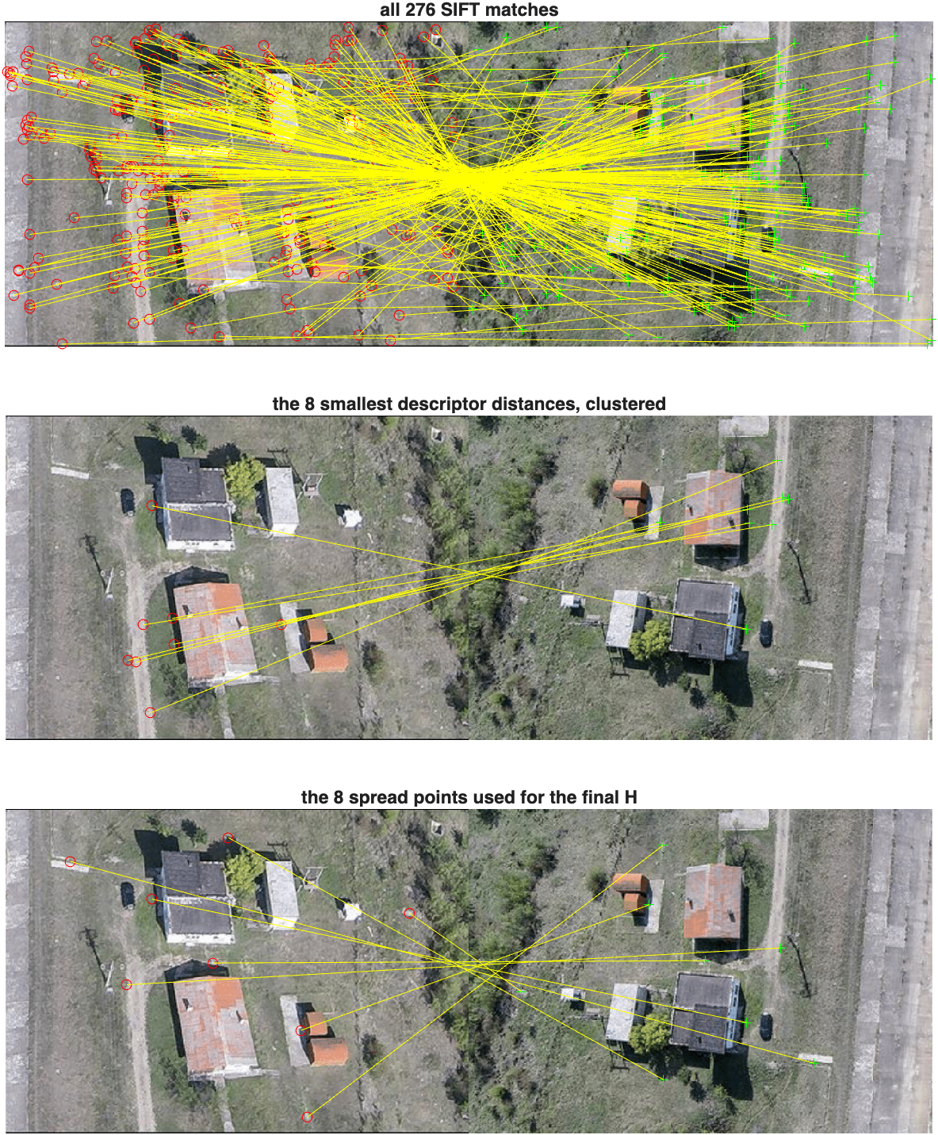
Figure 4.2 Pair 2, same three views. The middle row shows how tightly the lowest-distance matches cluster.
Picking the 8 pairs
The assignment asks for the best M = 8 matching pairs. The obvious reading of best is the 8 with the smallest descriptor distance, so I tried that first, and it does not work. For pair 1 those 8 matches contain only 7 distinct source points, because two SIFT keypoints at different scales sit on the same pixel and both got matched, so one of the eight constraints is a duplicate of another. They are also all sitting inside a box covering 32% of the image width and 35% of its height, near the middle of the frame. On top of that, four of the eight disagree with the homography that the other 941 matches support.
Descriptor distance measures how confidently two patches look alike. It says nothing about whether a match is geometrically correct, and nothing about whether the eight points are spread widely enough to pin down a projective transform. Both of those matter more than descriptor confidence here.
So, I built a second set of eight. It is still ordered by descriptor distance, but it only considers matches that are geometrically consistent, and it refuses any point closer than 15% of the image diagonal to a point already chosen, which forces the set to cover the frame. Everything from Answer B onwards reports both sets side by side so the difference is visible in the algebra and not just in the final picture.
Table 4.2 What the two ways of choosing 8 points select.
pair | selection | distinct source points | spread across frame
1 | 8 smallest descriptor distances | 7 of 8 | 32% x 35%
1 | 8 spread and consistent | 8 of 8 | 54% x 62%
2 | 8 smallest descriptor distances | 8 of 8 | 33% x 64%
2 | 8 spread and consistent | 8 of 8 | 73% x 87%

- Show the SVD of A and what are the zero singular values? [10 pts]
A is 16 by 9. The nine entries of h are only defined up to scale, so eight correspondences are exactly enough to fix the eight remaining degrees of freedom. With perfect coordinates A would have rank 8, its ninth singular value would be exactly zero, and the matching right singular vector would be the null space I am looking for.
That does not happen with measured data. SIFT locations carry noise, so MATLAB reports rank(A) = 9 in all four cases and no singular value is exactly zero. The ninth is small instead of zero, and the question that matters is how small it is next to the eighth.
[~, S, V] = svd(A); % A is 16 x 9
sv = diag(S); % nine singular values, descending
h = V(:, end); % null space direction, unit norm
Table 4.3 The nine singular values of A in each case.
 | pair 1, smallest distance | pair 1, spread | pair 2, smallest distance | pair 2, spread
s1 | 2.1e+06 | 1.976e+06 | 4.734e+05 | 3.93e+05
s2 | 2.69e+05 | 4.195e+05 | 8.421e+04 | 1.087e+05
s3 | 2226 | 2311 | 1096 | 1100
s4 | 488.8 | 714.7 | 282.5 | 617.9
s5 | 376.2 | 555.9 | 208.2 | 472.5
s6 | 263.4 | 305.8 | 41.38 | 139.4
s7 | 32.65 | 172.5 | 31.44 | 106.2
s8 | 0.3507 | 0.2104 | 0.4252 | 1.111
s9 | 0.07479 | 0.003752 | 0.04856 | 0.005556

Table 4.4 How isolated the smallest singular value is.
pair | selection | s9 | s9 / s8 | s9 / s1 | cond(A)
1 | smallest distance | 0.07479 | 2.133e-01 | 3.561e-08 | 2.808e+07
1 | spread | 0.003752 | 1.783e-02 | 1.899e-09 | 5.266e+08
2 | smallest distance | 0.04856 | 1.142e-01 | 1.026e-07 | 9.750e+06
2 | spread | 0.005556 | 4.999e-03 | 1.414e-08 | 7.072e+07

For the two spread sets the ninth singular value is 0.0038 for pair 1 and 0.0056 for pair 2, which is 1.8% and 0.5% of the eighth. That is what a numerical zero looks like here. The last singular value sits several orders below everything above it, the last singular vector is cleanly separated from the rest, and the null space is well defined.
For the two sets built from the smallest descriptor distances the ninth value is 0.075 and 0.049, which is 21% and 11% of the eighth. There is no clean gap. Two singular values are small and of the same order, so A has no single well defined null direction, and the solution is an arbitrary mix of the last two singular vectors. The SVD is reporting the failure before anything gets warped, which is what makes it a useful diagnostic and not just a solver.
So, the answer to what the zero singular values are: there is one of them, s9, and it is only zero to within measurement noise. It comes to 0.0038 for pair 1 and 0.0056 for pair 2 with a good choice of eight points, against s1 of about 2.0e6 and 3.9e5, so it is smaller than the largest singular value by nine and eight orders of magnitude respectively.
- Show the null space solution to Ah=0, i.e., non-zero h that makes Ah=0 [10pts]
The solution is the last column of V, which comes out with unit norm already. Reshaping it row by row into a 3 by 3 matrix and dividing through by h33 gives H in its usual form.
Table 4.5 The null space vector h in each case, before reshaping. Each column has norm 1.
 | pair 1, smallest distance | pair 1, spread | pair 2, smallest distance | pair 2, spread
h11 | -8.34778e-04 | +1.13150e-03 | +1.75470e-03 | +1.34663e-03
h12 | +2.56458e-03 | +2.12396e-03 | -1.89506e-04 | -6.87358e-04
h13 | -9.12186e-01 | -5.54009e-01 | -8.16865e-01 | -7.87545e-01
h21 | -4.64529e-04 | -9.79416e-04 | +4.67411e-04 | +1.06620e-04
h22 | +1.30609e-03 | +8.58082e-04 | +9.71786e-04 | +1.08294e-03
h23 | -4.09764e-01 | +8.32506e-01 | -5.76822e-01 | -6.16252e-01
h31 | -1.29430e-06 | +5.15315e-07 | +2.69794e-06 | +4.99911e-08
h32 | +3.26010e-06 | +3.64528e-07 | -2.57142e-08 | -1.11266e-06
h33 | -1.06582e-03 | +1.09951e-03 | -1.75215e-03 | -1.37109e-03

Reshaped and scaled so that H(3,3) = 1, the two homographies I use for the rest of the answer are these.
Pair 1 maps sift-1.jpg onto sift-2.jpg:
1.029092 1.931730 -503.868205
-0.890774 0.780421 757.159888
0.000469 0.000332 1.000000

and pair 2 maps sift-3.png onto sift-4.png:
-0.982160 0.501323 574.395192
-0.077763 -0.789843 449.462663
-0.000036 0.000812 1.000000

The leading 2 by 2 block of the pair 2 matrix is close to a rotation by 180 degrees with a little skew, which is what the two aerial frames look like, and the third row is nearly [0 0 1] because the two views are close to a pure in-plane motion of a flat scene.
Table 4.6 How well each solution satisfies the system it came from.
pair | selection | norm(A*h) | s9 | max reprojection error on the 8 points
1 | smallest distance | 7.4794e-02 | 7.4794e-02 | 249.22px
1 | spread | 3.7519e-03 | 3.7519e-03 | 1.03px
2 | smallest distance | 4.8555e-02 | 4.8555e-02 | 32.62px
2 | spread | 5.5563e-03 | 5.5563e-03 | 1.59px

Two things in that table are worth pointing out. First, norm(A*h) comes out equal to s9 in every row. That is not a coincidence: h is the unit right singular vector belonging to s9, so A*h has length exactly s9, and it makes a free check that the null vector really is the one the SVD intended.
Second, the last column is the honest test of the two selections. The spread solutions reproduce the eight points that built them to about a pixel, 1.03px for pair 1 and 1.59px for pair 2. The solutions from the smallest descriptor distances miss their own eight points by up to 249px and 32.6px. A homography that cannot fit the data it was derived from is not going to fit anything else, and my answer for question D confirms that.
- For all matched SIFT points, how many are in agreement with this homography? [15pts]
I call a match “in agreement” when its symmetric transfer error is 3 pixels or less. Symmetric means I map the point forward with H, map the matching point back with inv(H), and average the two distances, so neither direction is favored. The threshold is the same 3 pixels used earlier to label consistent matches.
Table 4.7 Matches in agreement with each homography, counted over every matched pair, at four thresholds.
pair | selection | 1px | 3px | 5px | 10px | median error | agreement at 3px
1 | smallest distance | 0 | 1 | 1 | 4 | 403.49px | 1 of 949 (0.1%)
1 | spread | 412 | 796 | 816 | 822 | 1.08px | 796 of 949 (83.9%)
2 | smallest distance | 0 | 6 | 10 | 24 | 140.52px | 6 of 276 (2.2%)
2 | spread | 20 | 89 | 125 | 150 | 8.22px | 89 of 276 (32.2%)

The answer to the question, using the eight spread points: 796 of the 949 matches agree for pair 1, which is 83.9%, with a median error of 1.08px, and 89 of the 276 matches agree for pair 2, which is 32.2%, with a median error of 8.22px.
Those numbers line up with the independent check from Answer A. RANSAC over all the matches said 803 of the pair 1 matches and 95 of the pair 2 matches are geometrically consistent. My eight-point solutions recover 796 of those 803 and 89 of those 95, so 99% and 94% of everything that could have been recovered. Eight well-chosen points are doing nearly as well as a robust fit over hundreds.
The same table for the other selection is 1 of 949 and 6 of 276. Choosing the eight points by descriptor distance alone loses essentially the entire result.
Checking the homography with imtransform
imtransform works on row vectors, so it takes the transpose of H. maketform('projective', H') builds the transform, and passing XData and YData of the second image warps the first one straight into the second one's frame, which makes the two directly comparable.
T = maketform('projective', H');
W = imtransform(I1, T, XData=[1 size(I2,2)], YData=[1 size(I2,1)], FillValues=0);
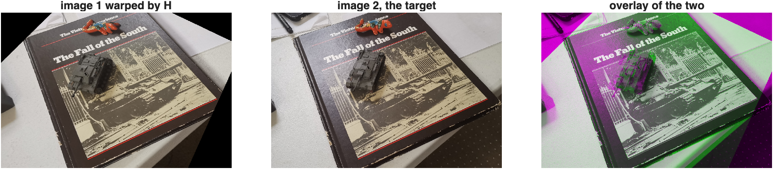
Figure 4.3 Pair 1. sift-1.jpg warped by H, the target sift-2.jpg, and the two overlaid. The book cover lines up; the toy tank on top of it does not.
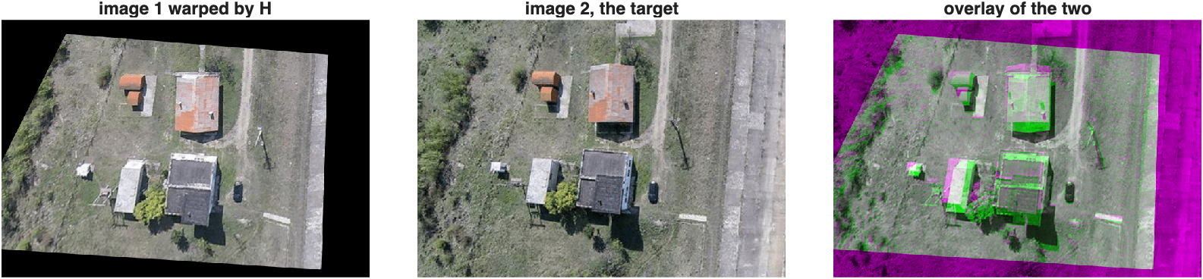
Figure 4.4 Pair 2. sift-3.png warped by H, the target sift-4.png, and the overlay. The ground lines up and the building roofs show colored edges.
Both warps land where they should. In Figure 4.3 the book cover, its border and the lettering sit on top of the target almost exactly. In Figure 4.4 the road, the field boundaries and the tracks line up across the whole frame, and the second image is close to the first turned through 180 degrees, which the matrix in my answer to question C already showed.
Why pair 2 agrees less often than pair 1
84% against 32% looks like one estimate is much worse than the other, but both homographies fit their own eight points to about a pixel and both recover nearly everything RANSAC can find. The difference is in the scenes, not in the algebra.
A homography is only exact for points on a plane. Pair 1 photographs a flat book cover from two angles, so nearly every feature lies on one plane and a single homography covers almost all of them. The exception is the toy tank sitting on the cover, which stands above the plane, and in the Figure 4.3 overlay the tank is the one part that ghosts.
Pair 2 is an aerial pair. The ground is flat, but the buildings stand several meters above it, so roof points do not obey the ground plane's homography and no single H can bring both the ground and the roofs into line at once. That is the colored fringing on the roofs in Figure 4.4 while the ground around them is clean. The parallax is real structure in the scene, so those matches are counted as disagreeing even though nothing went wrong with the estimate. Pair 2 also carries many more bad matches to begin with, 34% consistent against 85%, because grass and scrub produce repetitive descriptors that mismatch easily.
Findings
1. Best matching pairs cannot mean lowest descriptor distance alone. Doing that gave clustered points, a duplicated point in pair 1, and several outliers, and the resulting homography agreed with 1 match out of 949. Requiring the eight points to be spread out and mutually consistent took the same pair to 796 out of 949.
2. The SVD warns you before the picture does. A ratio s9/s8 of 0.21 says there is no clean null direction, and the eight points do not determine H. When the selection is good that ratio drops to 0.018 and 0.005.
3. norm(A*h) equals s9 exactly, so the residual of the solution is readable straight off the singular values.
4. Disagreement is not always error. Most of the pair 2 mismatch is building height, which is a limit of the plane model rather than a fault in the estimate.

