Homework # 3: Gradient Feature Aggregation with Fisher Vectors and VLAD
Student Name: Ben Blake, Student ID: 14387365
Data set: the NWPU aerial data set contains approximately 45 categories of 700 images for each category in 256x256 RGB format. The data set can be downloaded from:
https://umkc.box.com/s/fxvzh5qq2tiob6eklfxfwn89kg3e1io1
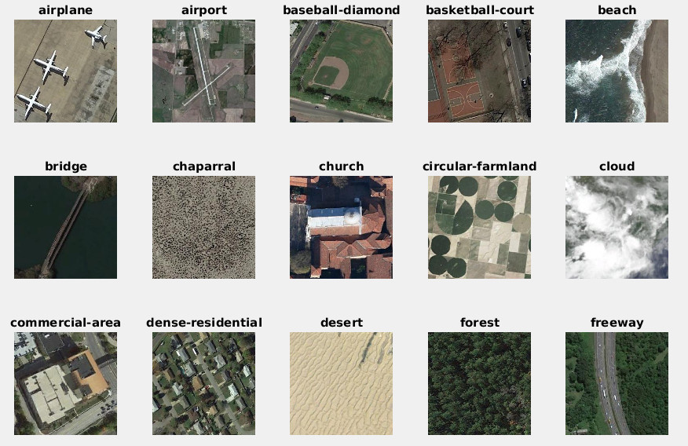
For this homework, let us just take the first 15 classes (shown above) {airplane, airport, bridge, ..., freeway} from the full data set, and 40 images per class and form a data set of N=600 images with 15 labels. Objectives are using the gradient image features (SIFT, Dense SIFT) with aggregation (VLAD, FisherVector) to test which one can give us the best solution.
[1] Gradient Features, for each image, implement the following function in either Matlab and Python, show your implementation [25pts]
getImageFeatures.m
function [f, loc] = getImageFeatures(im, opt)
arguments
im {mustBeNumeric, mustBeNonempty}
opt (1,1) struct = struct("type", "sift")
end

opt = iDefaults(opt);
gray = im2gray(im);

switch opt.type
case "sift"
points = detectSIFTFeatures(gray);
[f, valid] = extractFeatures(gray, points);
f = single(f);
loc = double(valid.Location);
case "dsft"
[f, loc] = iDenseSIFT(im2double(gray), opt.step, opt.binSize);
case "hogf"
[f, loc] = iHOGBlocks(gray, opt.cellSize);
end
end

function opt = iDefaults(opt)
defaults = struct("type", "sift", "step", 8, "binSize", 8, "cellSize", 8);
for name = string(fieldnames(defaults))'
if ~isfield(opt, name)
opt.(name) = defaults.(name);
end
end
opt.type = string(opt.type);
if ~ismember(opt.type, ["sift" "dsft" "hogf"])
error("getImageFeatures:badType", ...
"opt.type must be ""sift"", ""dsft"" or ""hogf"", not ""%s"".", opt.type);
end
end

function [f, loc] = iDenseSIFT(gray, step, binSize)
nOri = 8;
nBin = 4;
[H, W] = size(gray);

% vl_phow smooths by binSize / 6 before taking the gradient.
smoothed = imgaussfilt(gray, binSize / 6);
[gx, gy] = imgradientxy(smoothed, "central");
mag = hypot(gx, gy);
t = mod(atan2(gy, gx), 2*pi) / (2*pi) * nOri;
binLo = floor(t);
w = t - binLo;
binLo = mod(binLo, nOri) + 1;
binHi = mod(binLo, nOri) + 1;

pooled = zeros(H, W, nOri);
tri = [1:binSize, binSize-1:-1:1] / binSize;
for o = 1:nOri
vote = mag .* ((binLo == o) .* (1 - w) + (binHi == o) .* w);
pooled(:, :, o) = conv2(tri, tri, vote, "same");
end

% Bin centers sit 0.5 and 1.5 bins from the grid point, and each pools
% binSize - 1 pixels further out, so the first grid point is 2.5 bins in.
offs = ((1:nBin) - (nBin + 1)/2) * binSize;
margin = max(offs) + binSize - 1;
xs = (1 + margin):step:(W - margin);
ys = (1 + margin):step:(H - margin);
[gx0, gy0] = meshgrid(xs, ys);
loc = [gx0(:) gy0(:)];

% Orientation varies fastest, then x, then y, as in vl_dsift.
f = zeros(numel(gx0), nBin*nBin*nOri);
for iy = 1:nBin
for ix = 1:nBin
block = pooled(ys + offs(iy), xs + offs(ix), :);
col = ((iy-1)*nBin + (ix-1)) * nOri + (1:nOri);
f(:, col) = reshape(block, [], nOri);
end
end

% SIFT normalization: unit length, clip at 0.2 to limit the weight of
% any one large gradient, unit length again, then scale to 0 to 255.
f = f ./ max(vecnorm(f, 2, 2), eps);
f = min(f, 0.2);
f = f ./ max(vecnorm(f, 2, 2), eps);
f = single(min(round(512 * f), 255));
end

function [f, loc] = iHOGBlocks(gray, cellSize)
[h, ~] = extractHOGFeatures(gray, CellSize=[cellSize cellSize], ...
BlockSize=[2 2], BlockOverlap=[1 1], NumBins=9);
d = 2*2*9;
f = single(reshape(h, d, [])');

[H, W] = size(gray);
nY = floor(H / cellSize) - 1;
nX = floor(W / cellSize) - 1;
[bx, by] = meshgrid(1:nX, 1:nY);
loc = [bx(:) by(:)] * cellSize + 0.5; % shared corner of the 4 cells
end
The box above is the function as it is in the repository, with the help text left out to save space. All of the code, the scripts that made every figure and table below, and the checks are at https://github.com/ben-blake/umkc-computer-vision in the folder hw3-gradient-features.
getImageFeatures converts the image to grayscale and returns one feature per row. opt.type picks the feature, and the other fields of opt, the dense SIFT step and bin size and the HoG cell size, take their defaults when they are missing. Everything below was run in MATLAB R2025b.
SIFT
"sift" is detectSIFTFeatures at its default settings followed by extractFeatures, the same SIFT I used in Homeworks 1 and 2. The descriptors are 128-dimensional and their entries are whole numbers from 0 to 255, the same scale vl_sift uses. The number of key points depends on the image, from 7 to 2630, with a median of 510.
Dense SIFT
The assignment points to vl_dsift. VLFeat does not run on Apple Silicon MATLAB, so I had to build dense SIFT some other way. The obvious way, handing extractFeatures a grid of SIFTPoints with orientation 0, does not work: it recomputes the orientation of every point and adds a descriptor for every secondary peak, and on the first image it returned 1069 descriptors for 841 grid points, oriented anywhere from 0 to 2 pi. So I wrote the descriptor out the way vl_dsift computes it.
The image is smoothed with a Gaussian of sigma = binSize / 6, as vl_phow does, and the gradient orientation at every pixel is split between its two nearest of 8 orientation bins. That gives 8 gradient images. Each one is pooled with a triangular window one bin wide, so a pixel votes into the spatial bins around it in proportion to how close it is, and the pooled images are read at the 16 bin centers around every grid point. That is the 4 by 4 by 8 SIFT histogram, without the rotation to a dominant orientation. The descriptor then gets the same treatment as SIFT: unit length, clipped at 0.2, unit length again, and scaled by 512, so dense SIFT and SIFT end up on the same scale. Both come out with a norm of exactly 512.
I used an 8 pixel step and 8 pixel bins, so each descriptor covers 32 by 32 pixels, and the grid stops where the window would leave the image. On a 256 by 256 image that is 28 by 28 = 784 descriptors, the same for every image.
Two checks in hw3_verify.m test it against something with a known answer. A vertical step edge has a gradient in one direction only, and all of its descriptor energy lands in the 0 and 180 degree bins. Rotating an image by 90 degrees has to rotate the 4 by 4 spatial grid and shift every orientation by two bins, and on a 255 by 255 crop, which keeps the grid symmetric, the rotated descriptors match the permuted ones exactly.
HoG
"hogf" uses extractHOGFeatures with 8 pixel cells, 2 by 2 cell blocks and 9 orientation bins, the Dalal-Triggs setup. extractHOGFeatures returns one long vector for the image. I cut it back into its blocks, so each of the 31 by 31 = 961 blocks becomes a 36-dimensional local feature, which is what a Fisher vector needs. I checked that every row equals the block extractHOGFeatures returns when it is asked for that point on its own. 36 dimensions is also enough for kd = 32, which the 31-dimensional vl_hog cell would not have been.
Table 1.1 Features per image over the 600 images, and the time to extract them.
feature | d | min | median | max | total | seconds, 600 images
SIFT | 128 | 7 | 510 | 2630 | 349,672 | 14.6
Dense SIFT | 128 | 784 | 784 | 784 | 470,400 | 6.7
HoG | 36 | 961 | 961 | 961 | 576,600 | 2.9
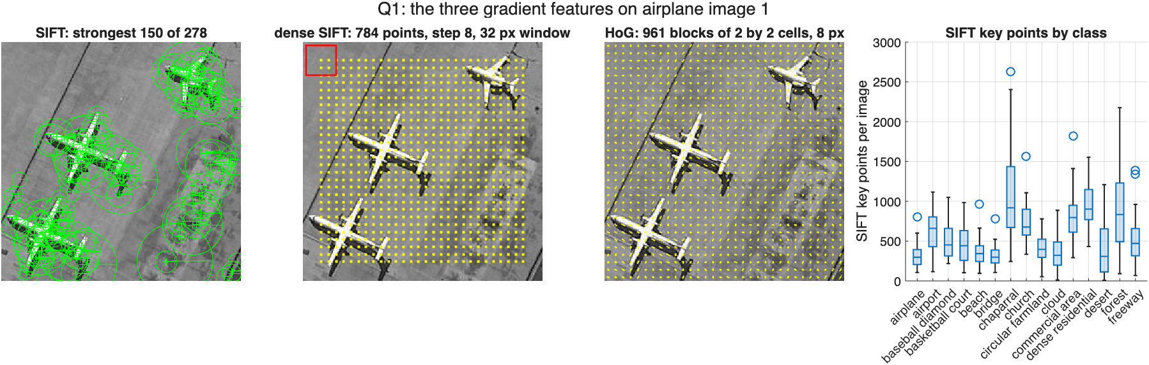
Figure 1.1 The three features on the first airplane image: the strongest 150 SIFT key points, the dense SIFT grid with one 32 pixel window in red, and the HoG cells. Right, the number of SIFT key points per image for each class.
The SIFT counts follow the content. desert and cloud images can have almost nothing to detect, with minimums of 7 and 11 key points, while chaparral and dense_residential have medians of 918 and 903. Dense SIFT and HoG describe every image at the same 784 and 961 places whether there is structure there or not. That difference comes back in Question 3.
Save features as a cell structure, f_sift{}, f_dsift{}, for N images, submit as a gradient_features.mat file. Use cell structure.
hw3_q1_features runs all three on the 600 images and saves gradient_features.mat with the cell arrays f_sift, f_dsift and f_hog, 600 by 1 each, along with labels and classes. SIFT and dense SIFT are stored as uint8, which is exact because their entries are whole numbers from 0 to 255, and HoG as single. The file is 156 MB. That is over GitHub's file size limit, so it is not in the repository, and hw3_q1_features rebuilds it in about 25 seconds.

- Compute the PCA and GMM model for each feature space:[25 pts]
(2a, 10pts), implement the following function that computes various gradient features:
getFisherVectorModel.m
function [gmm, A, lat] = getFisherVectorModel(f, kd, nc, opts)
arguments
f (:,:) {mustBeNumeric}
kd (1,1) double {mustBeInteger, mustBePositive}
nc (1,1) double {mustBeInteger, mustBePositive}
opts.Seed (1,1) double = 0
opts.MaxIter (1,1) double {mustBeInteger, mustBePositive} = 500
opts.Regularization (1,1) double {mustBeNonnegative} = 1e-3
end

f = double(f);
if kd > size(f, 2)
error("getFisherVectorModel:kdTooLarge", ...
"kd = %d is larger than the feature dimension %d.", kd, size(f, 2));
end

% princomp was removed from MATLAB. pca returns the same directions.
[A, ~, lat] = pca(f);
f0 = f * A(:, 1:kd);

rng(opts.Seed);
reg = opts.Regularization * mean(var(f0));
model = fitgmdist(f0, nc, CovarianceType="diagonal", ...
RegularizationValue=reg, Start="plus", Replicates=1, ...
Options=statset(MaxIter=opts.MaxIter));

gmm = struct();
gmm.mean = model.mu';
gmm.var = reshape(model.Sigma, kd, nc);
gmm.prior = model.ComponentProportion;
gmm.converged = model.Converged;
gmm.iterations = model.NumIterations;
gmm.negLogLikelihood = model.NegativeLogLikelihood;
end
The box above is the function as it is in the repository, with the help text left out to save space.
princomp was removed from MATLAB, and pca returns the same principal directions, ordered by decreasing variance. As in the template, f0 = f*A(:,1:kd) without subtracting the mean first. getFisherVector projects the same way, so the offset simply moves the GMM means and the encoding is unchanged. vl_gmm is replaced by fitgmdist with diagonal covariances, k-means++ initialization and a cap of 500 EM iterations. A variance floor of 0.1% of the mean feature variance keeps a component from collapsing onto a handful of identical points, which flat image regions produce. The result is returned in the vl_gmm layout: gmm.mean and gmm.var are kd by nc and gmm.prior is 1 by nc. The third output is the eigenvalues for Question 2b.
Training data
The hint mentions training data that came with the assignment, which I did not have. I sampled 100 features at random from every one of the 600 images, or all of them when an image has fewer, which gives 59,145 SIFT, 60,000 dense SIFT and 60,000 HoG features. An equal share per image keeps images with thousands of key points from dominating the model. The PCA and the GMM never see a label. The image left out in Question 3 contributes 100 of the 60,000 training features but not its class, which is the usual way a codebook is learned.
As a check, I fitted the function to 30,000 points drawn from a mixture of three Gaussians whose means, variances and weights I knew. It recovered the means to within 0.1 and the weights to within 0.02.
(2b, 5pts): Visualize the eigen values for SIFT, and Dense SIFT features here, example of SIFT is shown in lecture notes.
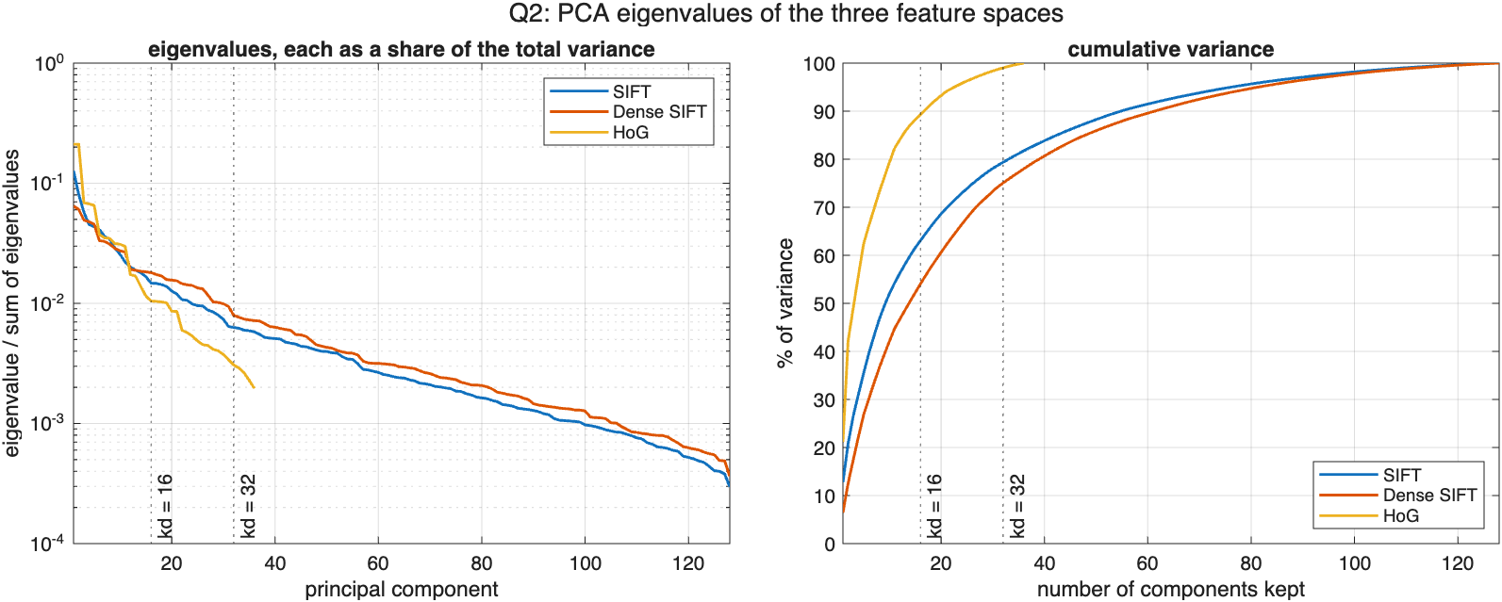
Figure 2.1 Left, the eigenvalues of each feature space as a share of the total variance, on a log axis. Right, the cumulative share. The dotted lines are kd = 16 and 32.
Table 2.1 Variance kept by the first kd principal components.
feature | d | kd = 16 | kd = 32 | 95% needs | 99% needs
SIFT | 128 | 63.1% | 79.4% | 77 | 110
Dense SIFT | 128 | 54.0% | 75.1% | 82 | 113
HoG | 36 | 89.3% | 99.0% | 23 | 32
The SIFT spectrum falls off slowly. The first 16 directions keep 63% of the variance and the first 32 keep 79%, and 95% takes 77 of the 128. Dense SIFT is flatter again, 54% and 75%. Its descriptors are taken everywhere, including smooth ground and water where the gradients are mostly noise, and after normalization those descriptors spread their energy across all bins instead of along a few strong directions. HoG has only 36 dimensions, and 16 of them already keep 89%. At kd = 32 it keeps 99%, so for HoG the reduction is hardly a reduction.
(2c, 10pts): Save the GMM models for SIFT, DenseSIFT features for a combination of PCA dimensions kd=[16, 32], and GMM components nc=[32, 64, 128]. {Hint: example code and training data provided}
hw3_q2_gmm fits all 18 models and saves them to gmm_models.mat: models is a 3 by 2 by 3 cell array indexed by feature, kd and nc, and A and lat hold the PCA of each feature space. All 18 EM runs converged before the 500 iteration cap. Together they took 20 minutes.
Table 2.2 The 18 GMMs. The last two columns show how evenly the components share the data.
feature | kd | nc | EM iterations | seconds | largest prior | 90% of weight in
SIFT | 16 | 32 | 118 | 16.2 | 0.055 | 26 of 32
 | 16 | 64 | 118 | 40.8 | 0.033 | 53 of 64
 | 16 | 128 | 145 | 77.0 | 0.015 | 105 of 128
 | 32 | 32 | 65 | 16.3 | 0.072 | 26 of 32
 | 32 | 64 | 102 | 48.3 | 0.037 | 52 of 64
 | 32 | 128 | 138 | 119.2 | 0.018 | 103 of 128
Dense SIFT | 16 | 32 | 77 | 11.5 | 0.131 | 25 of 32
 | 16 | 64 | 197 | 75.5 | 0.083 | 50 of 64
 | 16 | 128 | 139 | 64.7 | 0.042 | 96 of 128
 | 32 | 32 | 98 | 24.3 | 0.116 | 26 of 32
 | 32 | 64 | 77 | 38.8 | 0.102 | 51 of 64
 | 32 | 128 | 120 | 121.7 | 0.038 | 100 of 128
HoG | 16 | 32 | 154 | 18.6 | 0.147 | 20 of 32
 | 16 | 64 | 269 | 64.6 | 0.110 | 42 of 64
 | 16 | 128 | 204 | 107.2 | 0.048 | 86 of 128
 | 32 | 32 | 91 | 21.1 | 0.153 | 18 of 32
 | 32 | 64 | 199 | 101.2 | 0.105 | 40 of 64
 | 32 | 128 | 255 | 214.8 | 0.079 | 80 of 128
The components are used fairly evenly for SIFT. At nc = 32 the largest prior is 0.055 against 0.031 for a uniform split, and it takes 26 of the 32 components to hold 90% of the weight. HoG is more lopsided: its largest component holds 0.15 and 90% fits in 18 to 20 components. Many HoG blocks come from smooth regions and look alike, and the GMM spends a few heavy components on them. Dense SIFT is in between.
- Compute the gradient feature aggregations and benchmark its recognition accuracy. [50pts]
(3a: 20pts), implement the FisherVector aggregation function here based on vl_feat library:
getFisherVector.m
function [fv] = getFisherVector(f, A, gmm, kd, nc, opts)
arguments
f (:,:) {mustBeNumeric}
A (:,:) double
gmm (1,1) struct
kd (1,1) double {mustBeInteger, mustBePositive}
nc (1,1) double {mustBeInteger, mustBePositive}
opts.Normalization (1,1) string {mustBeMember(opts.Normalization, ...
["improved", "none"])} = "improved"
end

if ~isequal(size(gmm.mean), [kd nc]) || ~isequal(size(gmm.var), [kd nc])
error("getFisherVector:gmmSize", ...
"gmm.mean and gmm.var must be %d-by-%d.", kd, nc);
end

n = size(f, 1);
if n == 0
fv = zeros(1, 2*kd*nc);
return
end
x = double(f) * A(:, 1:kd); % n-by-kd

mu = gmm.mean; % kd-by-nc
s2 = gmm.var;
w = gmm.prior(:)'; % 1-by-nc

% Log of w_k * N(x_i; mu_k, s2_k), expanded so that it is three matrix
% products instead of a loop over components.
logLik = -0.5 * ((x.^2) * (1 ./ s2) - 2 * x * (mu ./ s2) ...
+ sum(mu.^2 ./ s2, 1)) - 0.5 * sum(log(2*pi*s2), 1) + log(w);
% Posteriors, with the largest term taken out so exp cannot underflow.
logLik = logLik - max(logLik, [], 2);
q = exp(logLik);
q = q ./ sum(q, 2); % n-by-nc

% Zeroth, first and second order statistics of each component.
S0 = sum(q, 1); % 1-by-nc
S1 = x' * q; % kd-by-nc
S2 = (x.^2)' * q; % kd-by-nc

u = (S1 - mu .* S0) ./ sqrt(s2) ./ (n * sqrt(w));
v = ((S2 - 2 * mu .* S1 + mu.^2 .* S0) ./ s2 - S0) ./ (n * sqrt(2*w));
fv = reshape([u; v], 1, []);

if opts.Normalization == "improved"
fv = sign(fv) .* sqrt(abs(fv));
fv = fv / max(norm(fv), eps);
end
end
The box above is the function as it is in the repository, with the help text left out to save space.
getFisherVector reduces the features with A, computes the posterior q(i,k) of every component for every feature, and then the two gradients of the log likelihood for each component k with weight w, mean m and standard deviation s:
u_k = sum_i q(i,k) (x_i - m_k) / s_k / (n sqrt(w_k))
v_k = sum_i q(i,k) [ (x_i - m_k)^2 / s_k^2 - 1 ] / (n sqrt(2 w_k))
The posteriors come from three matrix products instead of a loop over components, and the largest log likelihood is subtracted before taking exp so nothing underflows. u_k and v_k are then written out as [u_1 v_1 u_2 v_2 ...], the order vl_fisher uses, and the vector is 2 kd nc long, 1024 to 8192 here. Finally it gets a signed square root of every entry and unit L2 norm, which is the improved Fisher vector and vl_fisher's Improved option.
vl_fisher is not available, so I checked the function two other ways. It matches a version written out one component at a time with mvnpdf to 1e-9. And for 200,000 features drawn from the GMM itself, where the expected gradient is zero, the largest entry of the raw Fisher vector is 0.0069, about what sampling noise gives at that n.
Recognition
Recognition reuses the knnclassify stand-in I wrote for Homework 1, since the original was removed from MATLAB. Each of the 600 images is classified 1-NN against the other 599, and confusionmat gives cm, so the accuracy is sum(diag(cm))/sum(cm(:)) as asked. The vectors have unit length, so Euclidean distance ranks the neighbors the same way cosine distance would. Chance is 1/15 = 0.067.

(3b: 20 pts), compute the knnclassify() based recognition (leave 1 out) results and confusion map, just like in HW-1 here for a combination of features, GMM sizes, fill in the table below, and also show confusion map:
SIFT FV aggregation recognition accuracy: sum(diag(cm))/sum(cm(:))
GMM Size (Kd/nc) | 32 | 64 | 128
16 | 0.537 | 0.527 | 0.518
32 | 0.533 | 0.525 | 0.515
Dense SIFT FV aggregation recognition accuracy: sum(diag(cm))/sum(cm(:))
GMM Size (Kd/nc) | 32 | 64 | 128
16 | 0.525 | 0.527 | 0.523
32 | 0.560 | 0.545 | 0.572

HoG FV aggregation recognition accuracy: sum(diag(cm))/sum(cm(:))
GMM Size (Kd/nc) | 32 | 64 | 128
16 | 0.495 | 0.470 | 0.473
32 | 0.463 | 0.462 | 0.462
The best value in each table is in bold. All 18 land between 0.462 and 0.572, 6.9 to 8.6 times chance. The best configuration of each feature is SIFT at kd = 16, nc = 32 with 0.537, dense SIFT at kd = 32, nc = 128 with 0.572, and HoG at kd = 16, nc = 32 with 0.495.
Which differences are real
Each table cell is one run on the same 600 images, so I compared configurations the way I did in Homework 1, with McNemar's exact test on the images that one gets right and the other gets wrong.
Table 3.1 Paired McNemar tests, leave-one-out over 600 images.
comparison (A vs B) | A only | B only | exact p
SIFT (16, 32) vs Dense SIFT (32, 128) | 81 | 102 | 0.14
SIFT (16, 32) vs HoG (16, 32) | 117 | 92 | 0.097
Dense SIFT (32, 128) vs HoG (16, 32) | 104 | 58 | 0.0004
Dense SIFT, kd 32 vs 16, nc = 128 | 50 | 21 | 0.0008
Dense SIFT, kd 32 vs 16, nc = 32 | 55 | 34 | 0.033
SIFT, nc 32 vs 128, kd = 16 | 61 | 50 | 0.34
HoG, kd 16 vs 32, nc = 32 | 43 | 24 | 0.027
Between features, only dense SIFT over HoG is significant, p = 0.0004. Dense SIFT ahead of SIFT, 102 against 81, is not, p = 0.14. Within a feature, kd matters and nc does not. Going from kd = 16 to 32 helps dense SIFT at both nc = 32 and nc = 128, which fits Table 2.1, where 16 directions keep only 54% of its variance. HoG goes the other way and is better at kd = 16. Its 32 dimensions keep 99% of the variance, so the extra 16 add little but low-variance directions, and the GMM components that have to cover them. Quadrupling nc from 32 to 128 changes SIFT by 61 against 50 images, p = 0.34. More components make the vector longer without giving 1-NN more to work with, at 39 other images per class.
Normalization
Table 3.2 Accuracy at kd = 16, nc = 64, with and without the improved normalization.
feature | raw Fisher vector | signed sqrt and L2
SIFT | 0.358 | 0.527
Dense SIFT | 0.400 | 0.527
HoG | 0.353 | 0.470
The square root and the L2 norm are worth more than anything in the three tables: 11.7 to 16.8 points. Without them a few components that collect most of the features in an image, like the ones the smooth regions fill, dominate the distance between two vectors. The square root evens that out.
Per class, and against the color histograms of Homework 1
In Homework 1 the HSV color histogram reached 52.5% by leave-one-out with Euclidean distance and 60.5% with chi-square, on the same 600 images. So the gradient features are in the same range overall. They get there on different classes though.
Table 3.3 Per-class accuracy (%), leave-one-out, best Fisher vector configuration of each feature, and the best color histogram from Homework 1.
class | SIFT | Dense SIFT | HoG | HW1 color
airplane | 32.5 | 40.0 | 17.5 | 60.0
airport | 32.5 | 30.0 | 22.5 | 32.5
baseball_diamond | 50.0 | 47.5 | 27.5 | 67.5
basketball_court | 22.5 | 27.5 | 15.0 | 22.5
beach | 40.0 | 40.0 | 27.5 | 40.0
bridge | 22.5 | 62.5 | 52.5 | 45.0
chaparral | 95.0 | 97.5 | 80.0 | 85.0
church | 25.0 | 17.5 | 17.5 | 52.5
circular_farmland | 77.5 | 87.5 | 80.0 | 85.0
cloud | 80.0 | 90.0 | 82.5 | 65.0
commercial_area | 52.5 | 30.0 | 42.5 | 55.0
dense_residential | 82.5 | 75.0 | 65.0 | 80.0
desert | 65.0 | 55.0 | 60.0 | 85.0
forest | 97.5 | 92.5 | 95.0 | 95.0
freeway | 30.0 | 65.0 | 57.5 | 37.5
Dense SIFT is much better than color on the classes defined by shape: bridge 62.5% against 45%, and freeway 65% against 37.5%. Those are long straight structures, and a grid of gradient histograms catches them wherever they are, while SIFT, which only looks where its detector fires, gets 22.5% and 30%. Color is better where the class has a color and a texture that shows up everywhere in the image: church 52.5% against 17.5%, commercial_area 55% against 30%, desert 85% against 55%. basketball_court stays near 25% under everything I have tried. Taking the best configuration of each of the three features, 76.3% of the images are right under at least one of them, so the features fail on different images and combining them is the obvious next step.

(3c: 10 pts), Plot the confusion map for 6 combinations for each feature, one example for SIFT, kd=16, nc=64 is shown below: {Hint: confusionmat()}
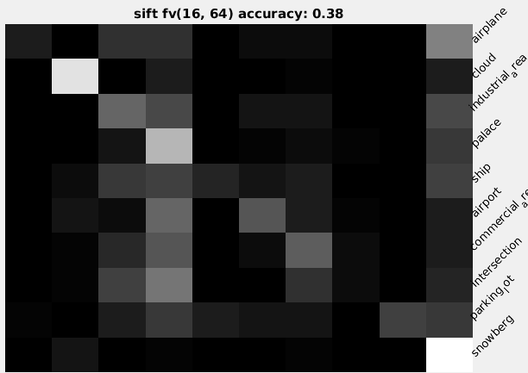
Above is the example from the assignment. My six maps for each feature follow, drawn the same way: row normalized, white for 100%, true class down the rows and predicted class across.
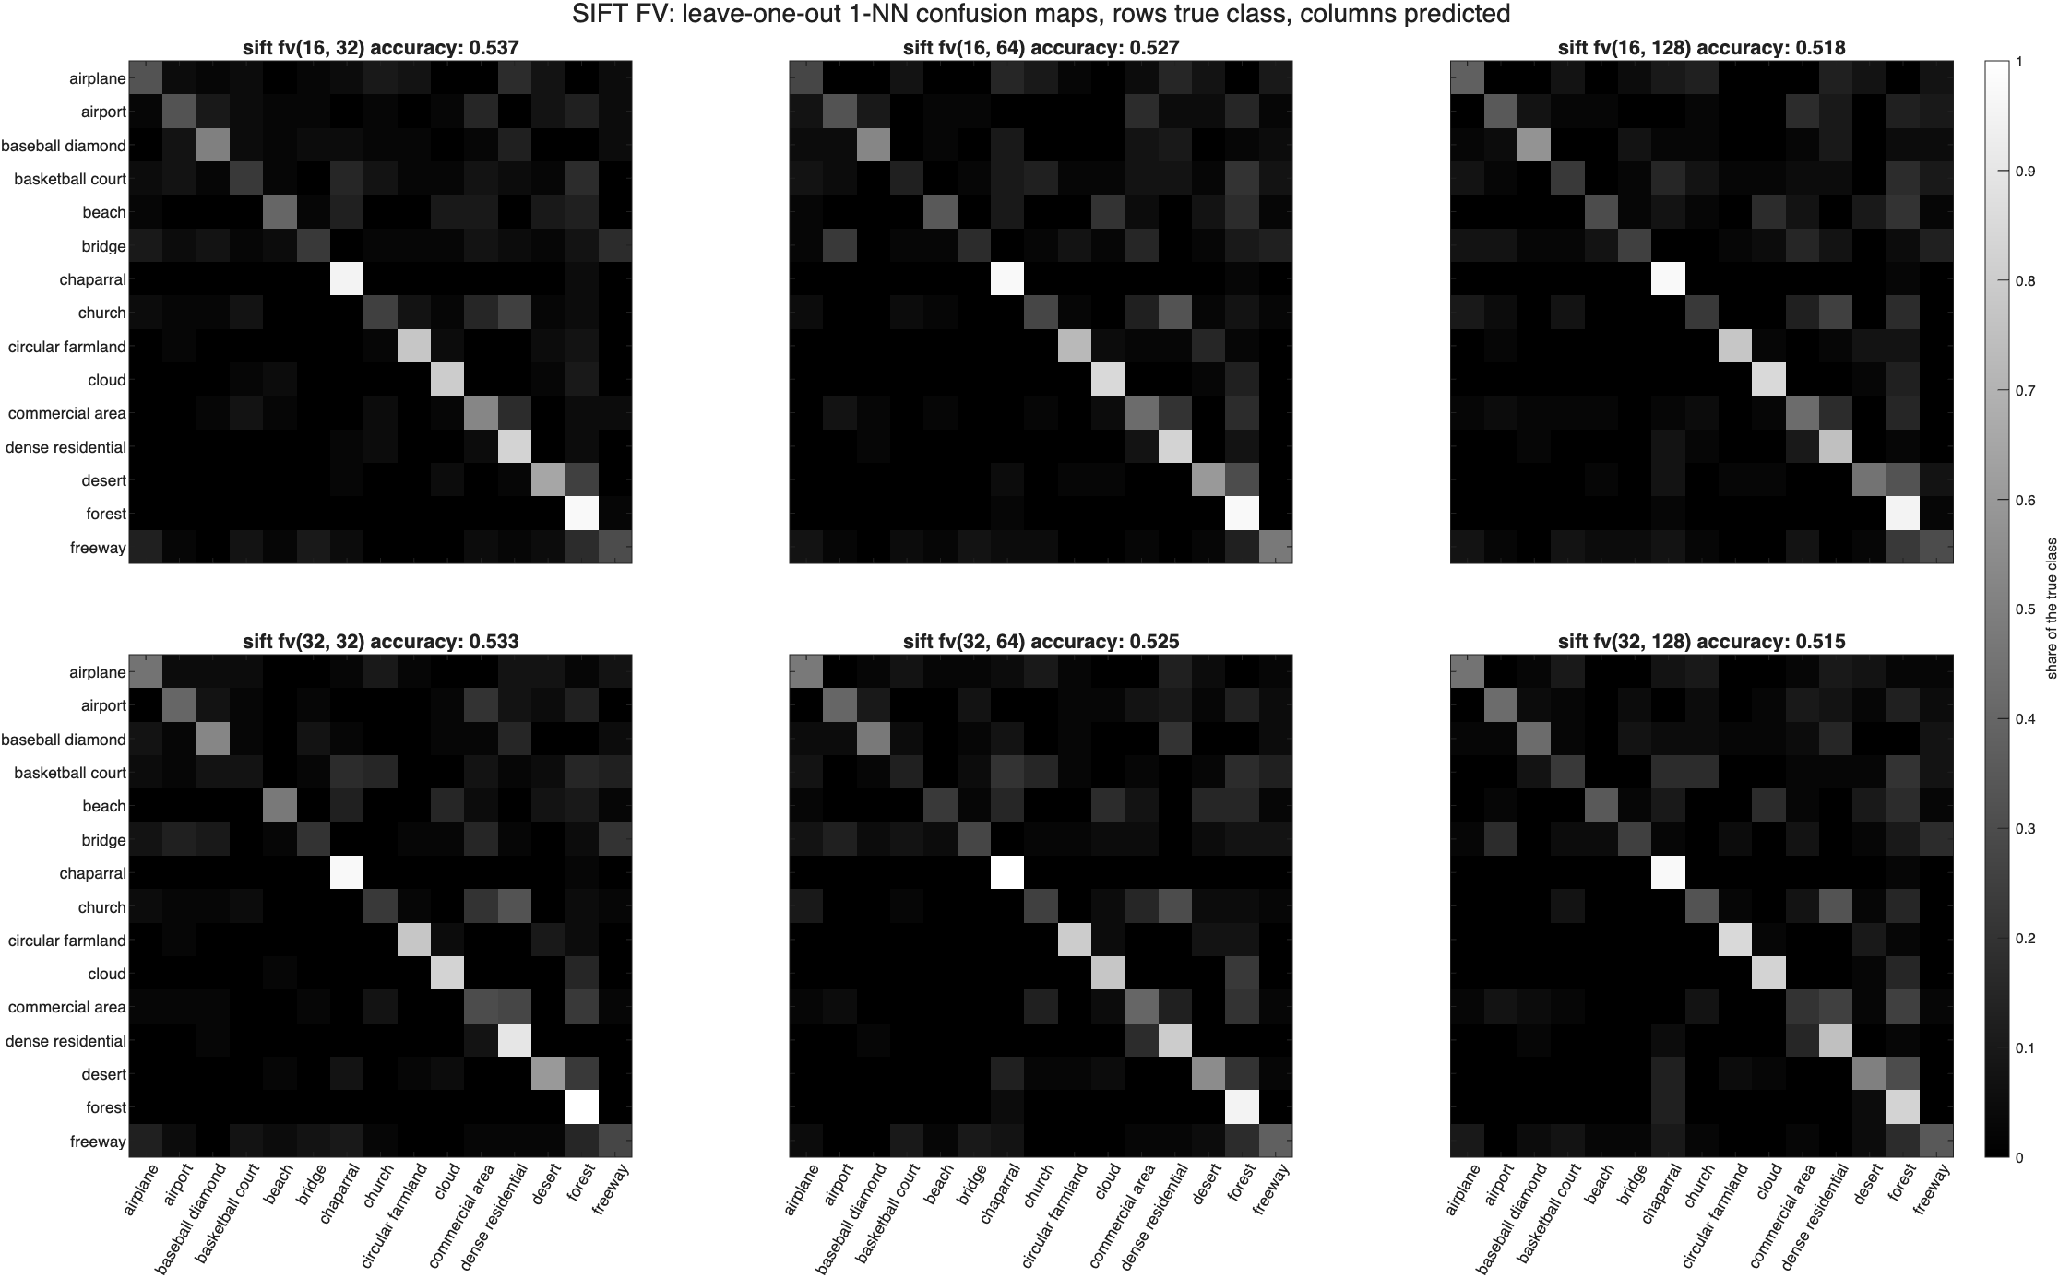
Figure 3.1 SIFT Fisher vectors, all six combinations of kd and nc.
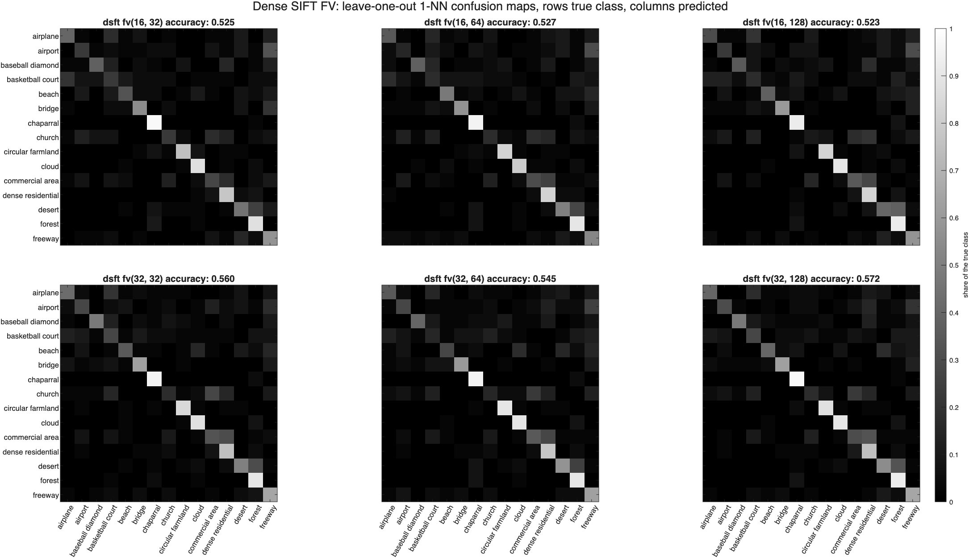
Figure 3.2 Dense SIFT Fisher vectors.
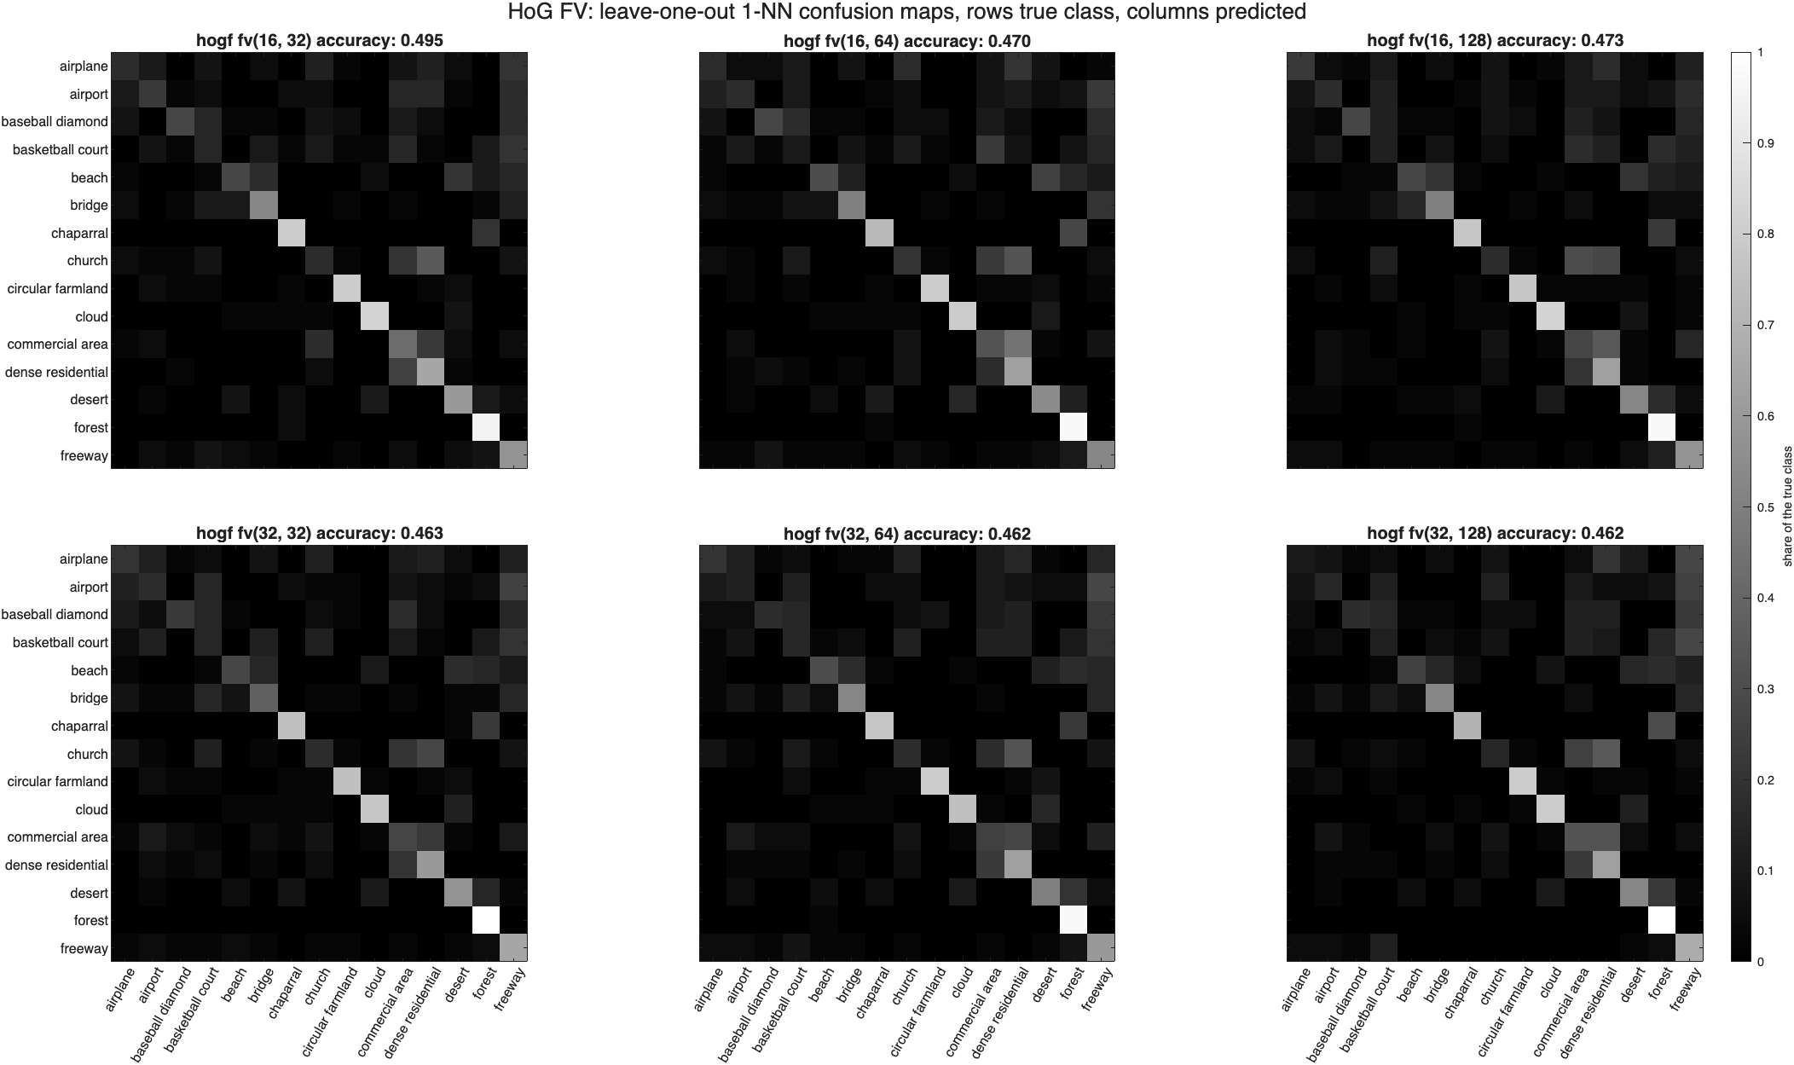
Figure 3.3 HoG Fisher vectors.
The six maps of one feature look almost the same, which is Table 3.1 again: kd and nc move a few images. The structure is in the classes. chaparral, forest, cloud and circular_farmland are near white on the diagonal in every map. Most of the off-diagonal mass sits in a few places. Under all three features commercial_area and church are predicted as dense_residential and desert as forest. airport goes to freeway under dense SIFT and HoG, which both see the runways and roads as the same long straight gradients, and basketball_court is spread across its whole row. Under HoG chaparral also leaks into forest. Without color or the fine texture SIFT keeps, the two kinds of vegetation look alike.

- Extra Credit: Compute the gradient feature VLAD aggregations and benchmark its recognition accuracy. [30pts]
(4a: 15pts), implement the VLAD aggregation function here based on vl_feat library:
getVLAD.m
function [fv] = getVLAD(f, gmm, kd, nc, opts)
arguments
f (:,:) {mustBeNumeric}
gmm (1,1) struct
kd (1,1) double {mustBeInteger, mustBePositive}
nc (1,1) double {mustBeInteger, mustBePositive}
opts.Normalization (1,1) string {mustBeMember(opts.Normalization, ...
["improved", "intra", "none"])} = "improved"
end

if size(f, 2) ~= kd && size(f, 1) > 0
error("getVLAD:notReduced", ...
"f has %d columns, not kd = %d. Reduce it first with f*A(:,1:kd).", ...
size(f, 2), kd);
end
if ~isequal(size(gmm.mean), [kd nc])
error("getVLAD:gmmSize", "gmm.mean must be %d-by-%d.", kd, nc);
end

if size(f, 1) == 0
fv = zeros(1, kd*nc);
return
end
x = double(f);
C = gmm.mean; % kd-by-nc

% Hard assignment to the nearest centroid.
[~, nearest] = min(pdist2(x, C'), [], 2);
assign = sparse(1:size(x, 1), nearest, 1, size(x, 1), nc); % n-by-nc

% For centroid k: sum of x over its features minus count times c_k.
V = x' * assign - C .* full(sum(assign, 1)); % kd-by-nc

switch opts.Normalization
case "improved"
fv = reshape(V, 1, []);
fv = sign(fv) .* sqrt(abs(fv));
case "intra"
V = V ./ max(vecnorm(V, 2, 1), eps);
fv = reshape(V, 1, []);
case "none"
fv = reshape(V, 1, []);
return
end
fv = fv / max(norm(fv), eps);
end
The box above is the function as it is in the repository, with the help text left out to save space.
As the assignment says, the GMM means act as the k-means centroids. Each feature goes to its nearest mean, and for each mean the vector holds the sum of the differences between it and the features assigned to it, so it is kd nc long, half the Fisher vector. The assignment is a sparse matrix, which turns the sum into one matrix product. The signature does not pass A, so f has to be reduced first, f*A(:,1:kd), and the function refuses a feature of the wrong width. The default normalization is the same signed square root and L2 norm as the Fisher vector. Intra-normalization, which normalizes each centroid's block before the whole vector, is an option. vl_vlad is not available, so I checked the function against a loop that assigns and sums one feature at a time.

(4b: 15pts), compute the knnclassify() based recognition (leave 1 out) results and confusion map, just like in HW-1 here for a combination of features, GMM sizes, fill in the table below, and also show confusion map:
SIFT VLAD aggregation recognition accuracy: sum(diag(cm))/sum(cm(:))
GMM Size (Kd/nc) | 32 | 64 | 128
16 | 0.488 | 0.467 | 0.458
32 | 0.502 | 0.487 | 0.463
Dense SIFT VLAD aggregation recognition accuracy: sum(diag(cm))/sum(cm(:))
GMM Size (Kd/nc) | 32 | 64 | 128
16 | 0.462 | 0.475 | 0.452
32 | 0.492 | 0.505 | 0.500

HoG VLAD aggregation recognition accuracy: sum(diag(cm))/sum(cm(:))
GMM Size (Kd/nc) | 32 | 64 | 128
16 | 0.398 | 0.433 | 0.418
32 | 0.398 | 0.432 | 0.428
VLAD ranges from 0.398 to 0.505. The best of each feature is SIFT at kd = 32, nc = 32 with 0.502, dense SIFT at kd = 32, nc = 64 with 0.505, and HoG at kd = 16, nc = 64 with 0.433. The ranking of the features is the same as with Fisher vectors.
The Fisher vector is ahead in all 18 models, by 3.0 to 9.7 points with a mean of 5.4, and McNemar's test calls the difference significant in 14 of the 18. That is the expected order. VLAD keeps only the first order statistics, and it assigns each feature to one centroid, so a feature halfway between two contributes to neither in proportion. The Fisher vector weights every component by its posterior and adds the second order term, how spread out the features around each mean are, which VLAD does not have.
Table 4.1 VLAD at kd = 16, nc = 64 under the three normalizations.
feature | none | intra | signed sqrt and L2
SIFT | 0.248 | 0.447 | 0.467
Dense SIFT | 0.407 | 0.423 | 0.475
HoG | 0.408 | 0.413 | 0.433
The normalization matters here too, most of all for SIFT, which goes from 0.248 raw to 0.467. A few images have thousands of SIFT key points, and without normalization their residual sums are so much larger than everyone else's that they decide the nearest neighbor. Intra-normalization fixes most of that and the square root does slightly better on all three features.
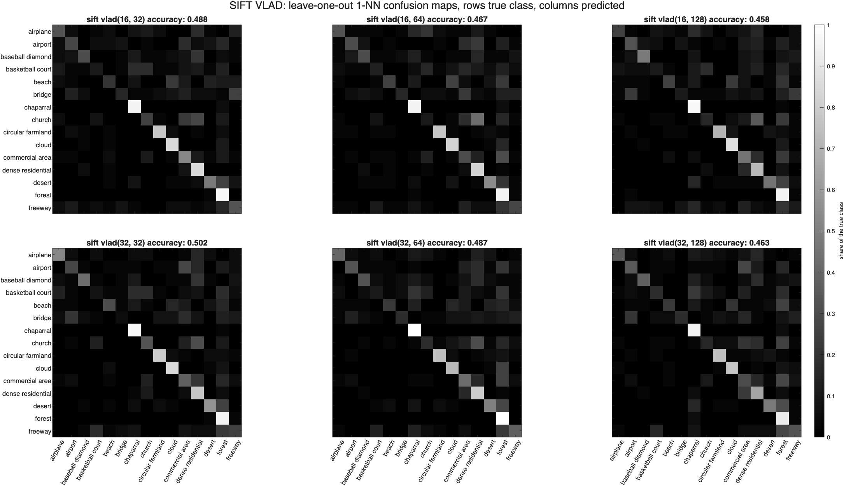
Figure 4.1 SIFT VLAD, all six combinations of kd and nc.
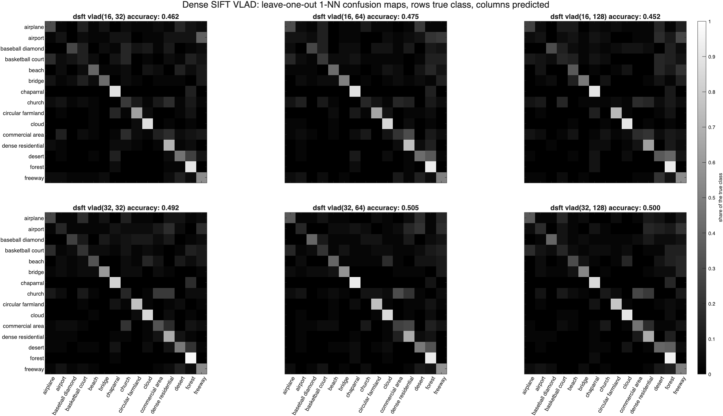
Figure 4.2 Dense SIFT VLAD.
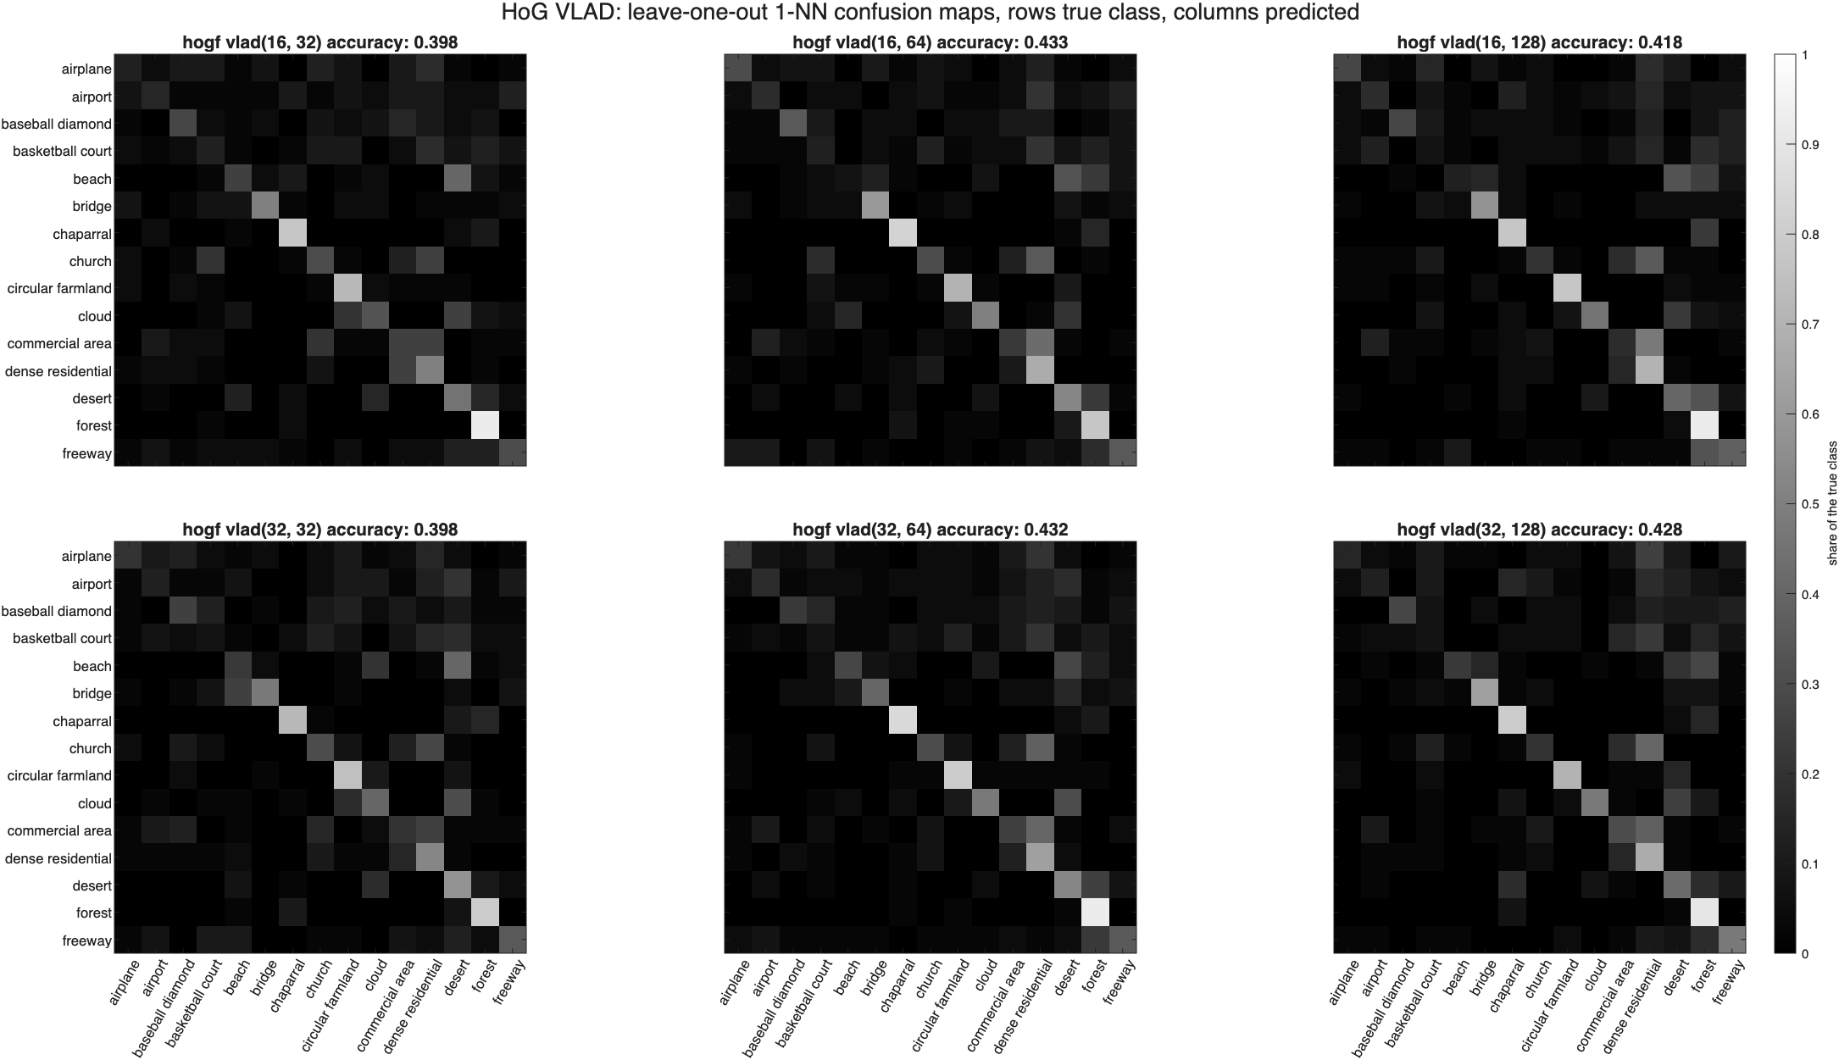
Figure 4.3 HoG VLAD.
The VLAD maps have the same structure as the Fisher vector maps with a darker diagonal. The same classes are easy and the same pairs are confused.
Findings
- Dense SIFT with a Fisher vector is the best combination, at 0.572 for kd = 32 and nc = 128, 8.6 times chance. It is significantly better than HoG, but its lead over SIFT is not significant.
- The normalization is worth more than any other choice. The signed square root and L2 norm add 11.7 to 16.8 points to the Fisher vector and up to 22 points to VLAD, more than any kd, nc or feature in the tables.
- The Fisher vector beats VLAD in all 18 models, by 5.4 points on average, significantly in 14 of them. The second order term and soft assignment are worth having.
- A bigger GMM does not help 1-NN. Going from 32 to 128 components makes no significant difference. kd does matter, in the direction the eigenvalues suggest: up for dense SIFT, whose spectrum is flat, and down for HoG, which has only 36 dimensions to begin with.
- Gradients and color do about equally well overall and fail on different classes. Dense SIFT is 17.5 and 27.5 points better than the Homework 1 color histogram on bridge and freeway and 25 to 35 points worse on church and commercial_area. 76.3% of the images are right under at least one of the three gradient features, so combining features, and a learned classifier instead of 1-NN, are the next things to try.

