Java

18/02/2014
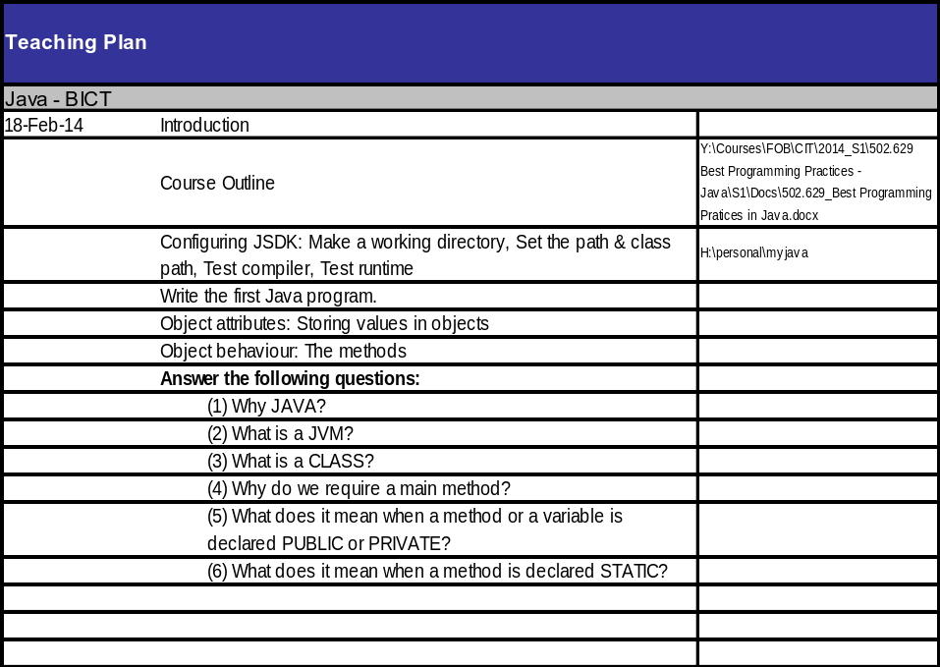

Week 1 Configuration:
- Created a directory in my H: drive to store java code (H:\java_course\java_code).
- Added myconfig.bat into java_code, with the following environment variable configuration lines:
  - set path="C:\Program Files\Java\jdk1.7.0_45\bin"
    - Which adds the java executables to the system path.
  - set classpath=h:\java_course\java_code
    - Which sets my java code directory to the directory where java classes should be created.
- To test:
  - Run: cmd
  - Move to H:drive (by running h:)
  - Move to java_code (by running cd java_course\java_code)
  - Run javac to Confirm it cannot be found
  - Run myconfigb.bat
  - Run javac to confirm usage is displayed, because we didn’t provide a java code file.
javac compiles java source files (.java), and java runs java class files (.class).
javac may encounter compilation errors, java runtime may encounter logic errors.
Java keywords are all lowercase.
Standard: All class names are upper camel case.
No members should be outside a class; no code should be outside of methods.

UML
- Classes are rectangles with names on top; top division containing attributes, and bottom division containing behaviours.
- Attributes contain values or addresses (obj refs)
- Behaviours are methods containing code.

First program
class Employee {
public static void main(String[] args) {
Employee emp = new Employee();
emp.print();
}
public void print() {
System.out.println("Hello World!");
}
}
- Put the code in ben1.java
- Run javac ben1.java to compile the class in the file.
- Then, Employee.class has been created, so we can run java Employee to run the class with the java runtime (which invokes the main() method)
- Explanation:
  - Employee class containing a main method
  - main() must be:
    - public so it can be invoked from outside the class
    - static so that it does not need to be called on an instance
    - void because it returns nothing
    - and it must accept an array of strings (String[] args), which are the command line arguments.
  - We then use the System.out.println() method to print text to the console.
  - Making syntax errors will cause javac to complain (e.g. remove semi-colon)
  - Trying to call a non-static member from a static member will cause a compilation error, because the static member is not associated with an instance to call the non-static member on.
  - Employee emp = new Employee() explained
    - Declare a new variable in the stack (emp) to store a reference (memory address) to an Employee object.
    - Create a new Employee object in the heap, passing nothing to the constructor.
    - Assign (with =) the memory address of the new Employee to the emp variable.
    - The variable emp can now be used to reference the Employee object.

Question answers:
- Java is cross-platform, and strongly typed, which is useful for certain applications.
- JVM = Java Virtual Machine: The runtime environment for compiled java code to run on any OS.
- A class is a template for creating objects.
- A class's main method is invoked when the class is run with java from the command line. Without a main method, a class cannot be run as a program.
- A public member can be accessed from any code, a private member can only be accessed from within the class.
- A static method is stored inside the class itself, not an object. It is callable on the class, and it cannot access instance members, as it is not associated an object instance.

20/02/2014
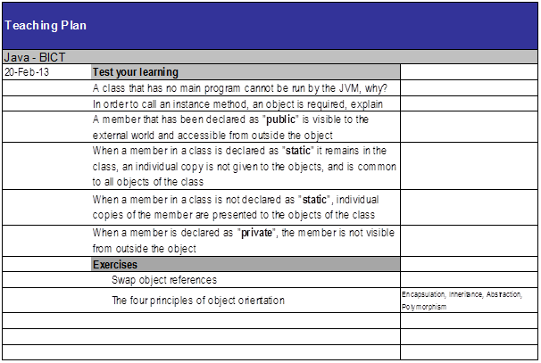

Download Netbeans:
http://www.oracle.com/technetwork/java/javase/downloads/jdk-7-netbeans-download-432126.html

Diagram
Tester
C+main(..)
Employee
+pay()
+work()
-eat()
+workPay()
Staff
+work()
+jobWork()
Manager
Example:
class Tester {
public static void main(String[] args) {
Employee emp1 = new Manager();
// Employee .. work
emp1.work();
// Employee .. pay
emp1.pay();
Employee emp2 = new Staff();
// Employee .. pay
emp2.pay();
// Staff .. work
emp2.work();
// Causes compilation error (Private member not visible outside of
// class).
//emp1.eat();
// Causes compilation error (Not visible from superclass ref).
//emp2.jobWork();
// Causes compilation error (Subclass ref cannot point to superclass
// obj).
// Staff emp3 = Employee();
}
}
class Employee {
public void work() {
System.out.println("Employee .. work");
}
public void pay() {
System.out.println("Employee .. pay");
}
private void eat() {
System.out.println("Employee .. eat");
}
public void workPay() {
System.out.println("Employee .. workPay");
work();
pay();
}
}
class Staff extends Employee {
public void work() {
System.out.println("Staff .. work");
}
public void jobWork() {
System.out.println("Staff .. jobWork");
}
}
class Manager extends Employee {
}
Application Development
Creating an executable class with a main method; makes use of object libraries.
Object Engineering
Creating classes that will be used to create objects in applications and other classes.
When a class is loaded from the disk into memory, only static methods are stored as part of the class. Instance methods are stored with context as part of each instance.
When accessing an instance member from within an instance method, the keyword this can be used to access the current instance. If there is no name conflict, this can even be omitted, and the member accessed directly (as showing in Employee.workPay())

OOP
Inheritance
"Is-a" relationship. Closed, empty arrow pointing toward superclass in UML.
An object-reference of a parent type can point to an instance of child type, but only the parent's members will be accessible. Try to use parent object-references as much as possible.
An object-reference of child type cannot point towards an object of parent type, because it will not be able to fulfil the specialised role.
In an OO-inheritance hierarchy, specialization is downward, generalization is upward.
Even if a child class is empty, it can still be used in the same way as it's parent.
A private member cannot be accessed from outside of the same class (not even in child classes).

25/02/2014
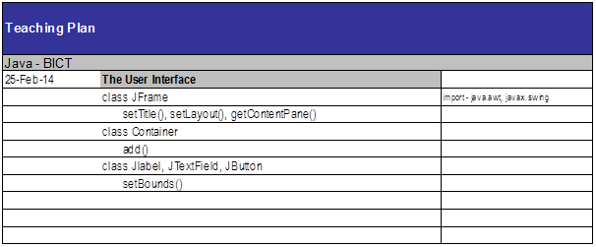
class Employee {
public int ecode;
public String fname;
public String lname;
public double salary;
public Employee(int ecode, String fname, String lname, double salary) {
System.out.println("Employee .. constructor");
this.ecode = ecode;
this.fname = fname;
this.lname = lname;
this.salary = salary;
}
public void pay() {
System.out.println("Employee .. pay");
}
public String work() {
System.out.println("Employee .. work");
return ecode + ": " + fname + " " + lname + "\nSalary: $" + salary;
}
}
class Staff extends Employee {
public Staff(int ecode, String fname, String lname, double salary) {
super(ecode, fname, lname, salary);
System.out.println("Staff .. constructor");
}
// Note how this method overrides work() in Employee for Staff objects.
public String work() {
System.out.println("Staff .. work");
return ecode + ": " + lname + ", " + fname + "\nSalary: $" + salary;
}
}
class Manager extends Employee {
public Manager(int ecode, String fname, String lname, double salary) {
super(ecode, fname, lname, salary);
System.out.println("Manager .. constructor");
}
}
class Tester {
public static void main(String[] args) {
// Prints "Employee .. constructor" and "Staff .. constructor", as the
// constructor is fired.
Employee emp = new Staff(1001, "Ben", "Denham", 120000);
testEmp(emp);
// Prints "Employee .. constructor" and "Manager .. constructor", as
// the constructor is fired.
Employee mgr = new Manager(1001, "Ben", "Denham", 120000);
testEmp(mgr);
}
public static void testEmp(Employee emp) {
// Prints "{Class} .. work" as work() is fired. Also returns the
// employee description, which we store in our local:
// String variable: fullName.
String description = emp.work();
// Prints the description that we stored in the last line.
System.out.println(description);
}
}
In Java, attributes are declared in a class with the following syntax:
[public|private] type attributeName;

Constructors
A special method that is automatically run when an instance of a class is created.
Constructors are useful for initializing variables, and for initializing other required context (e.g. database connections).
The constructor must be public, must have no return value, and must have the same name as the class.
Note how we pass arguments to the constructor when initializing an object with new (see Tester.main()).
If we have a constructor in a child class that does not call the a parent constructor with super, a call to super() seems to be implied.

Method arguments and return values
Note how Employee.work() returns a String instead of void, by declaring the return type and by using the return keyword.
We must return a value that matches the specified return data type (String).
Note how in the constructor of Employee, we accepted arguments by specifying the data type and variable name of each argument.
Note: Because these local variables (fname, lname) conflict with the instance variables of the same names, the local variables take preference when being referenced, and the instance variables must be referenced with this. When there is no conflict, instance variables can be referenced without this.
When an object reference is created of a reference type (E.g. String or another class), the default value is null. (Primitive types have a default value, such as 0 for number types.)

Local and Instance variables
When local variables conflict with instance variables of the same names, the local variables take preference when being referenced, and the instance variables must be referenced with this. When there is no conflict, instance variables can be referenced without this.
- A local variable is allocated when a method runs, and becomes inaccessible when the method finishes.
- An instance variable is allocated when an object is created, and becomes inaccessible when the object becomes inaccessible.
- A static variable is allocated when the class is loaded into memory, and becomes inaccessible when the class becomes inaccessible (usually when the program finishes).

Overriding
When we declare a method in a class that has already been declared in a parent class with the same signature (method name and arguments types and order), then that method is said to override the method in the parent class.
Whenever the method is called for an object of the child type (even when the object reference is of parent type), the overriding definition is used instead of the original one.

27/02/2014
javap class_name inspects a class.

Assignment
- UI
- Vector
- Hashtable

Java UI
Earliest form: AWT. AWT had classes for Frame, Textfield, Button, etc. Problem: the screens were not as good as VB user interfaces. Namespace: java.awt
Swing extends AWT (through inheritance). Swing classes always start with "J" (e.g. JFrame, JButton). Namespace: javax.swing
To create our own form, we create our own class that inherits from JFrame. Our custom form will then contain other controls like buttons and textfields.
Using import java.awt.* will import all class, abstract classes, interfaces, etc. inside java.awt, but not any sub-namespaces.

Action Listening
We must have a class that implements ActionListener by including the method public void actionPerformed(ActionEvent ae). This class can be our Frame.
We must also add the instance of our ActionListener as a listener for a control. For example, if I want the current frame I am constructing to listen to btnOkay, I use: btnOkay.addActionListener(this); // this is my frame that implements ActionListener.
import java.awt.*;
import javax.swing.*;
import java.awt.event.*;
class MainFrame extends JFrame implements ActionListener {
JTextField txtCustomerName;
public MainFrame() {
setTitle("My First UI");
// Don't use any automatic layout. If we used a layout, we wouldn't
// need to specify all of bounds.
setLayout(null);
// Use setBounds(posX, posY, width, height) to position the Frame.
setBounds(10, 10, 400, 600);
// Create our form controls.
JLabel lblCustomerName = new JLabel("Customer Name");
txtCustomerName = new JTextField();
JButton btnOkay = new JButton("Okay");
JButton btnGet = new JButton("Get");
// Use setBounds(posX, posY, width, height) to position the controls.
lblCustomerName.setBounds(20, 20, 100, 20);
txtCustomerName.setBounds(120, 20, 200, 20);
btnOkay.setBounds(20, 60, 80, 20);
btnGet.setBounds(120, 60, 80, 20);
// Subscribe our Frame to the actions of the button.
btnOkay.addActionListener(this);
btnGet.addActionListener(this);
// We add the items to the container instead of this object in order
// to avoid conflicts with the JFrame superclass?
Container con = getContentPane();
con.add(lblCustomerName);
con.add(txtCustomerName);
con.add(btnOkay);
con.add(btnGet);
// Show the frame.
setVisible(true);
}
// Implements the ActionListener interface. Handles actions this Frame is
// listening to.
public void actionPerformed(ActionEvent ae) {
String msg = ae.getActionCommand();
txtCustomerName.setText(msg);
}
}
class Tester {
public static void main(String[] args) {
// Create a new frame object.
JFrame f = new MainFrame();
}
}

Basic ideas of Swing Frame
- Extend javax.swing.JFrame, and implement java.awt.event.ActionListener
- Use instance variables for controls that need to be shared between methods.
- In the constructor:
  - Configure the Frame (Set title, bounds, no layout)
  - Create controls (in local variables, and setting instances of instance variables)
  - Configure controls (Sset bounds, etc.)
  - Set up Frame to listen to controls (control.addActionListener(this);)
  - Add the controls to the Frame's container.
  - Set the Frame to be visible
- In actionPerformed(ActionEvent ae):
  - Handle control actions (events) based on the contents of ae.
  - java.awt.event.ActionEvent stores information about an action that fired.

04/03/2014
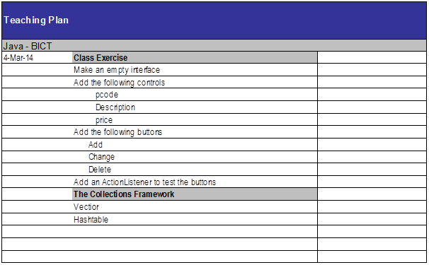
import java.awt.*;
import javax.swing.*;
import java.awt.event.*;
class ProductFrame extends JFrame {
public ProductFrame() {
setTitle("Product");
setLayout(null);
setBounds(10, 10, 400, 220);
JLabel lblPcode = new JLabel("Pcode:");
JLabel lblDescription = new JLabel("Description:");
JLabel lblPrice = new JLabel("Price:");
JTextField txtPcode = new JTextField();
JTextField txtDescription = new JTextField();
JTextField txtPrice = new JTextField();
JButton btnAdd = new JButton("Add");
JButton btnChange = new JButton("Change");
JButton btnDelete = new JButton("Delete");
lblPcode.setBounds(20, 20, 100, 20);
lblDescription.setBounds(20, 60, 100, 20);
lblPrice.setBounds(20, 100, 100, 20);
txtPcode.setBounds(130, 20, 100, 20);
txtDescription.setBounds(130, 60, 230, 20);
txtPrice.setBounds(130, 100, 100, 20);
btnAdd.setBounds(20, 140, 100, 20);
btnChange.setBounds(140, 140, 100, 20);
btnDelete.setBounds(260, 140, 100, 20);
ActionListener listener = new ProductFrameListener();
btnAdd.addActionListener(listener);
btnChange.addActionListener(listener);
btnDelete.addActionListener(listener);
Container container = getContentPane();
container.add(lblPcode);
container.add(txtPcode);
container.add(lblDescription);
container.add(txtDescription);
container.add(lblPrice);
container.add(txtPrice);
container.add(btnAdd);
container.add(btnChange);
container.add(btnDelete);
setVisible(true);
}
}
class ProductFrameListener implements ActionListener {
public void actionPerformed(ActionEvent ae) {
System.out.println("ProductListener: '" + ae.getActionCommand() +
"'button was clicked.");
}
}
class Tester {
public static void main(String[] args) {
JFrame frame = new ProductFrame();
}
}
Above is code similar to last week's, but with more fields and buttons.
Also, we use a separate ProductFrameListener to listen to our button events, rather than making the ProductFrame act as a listener.
HOMEWORK: CREATE UML FROM THE ABOVE CODE:
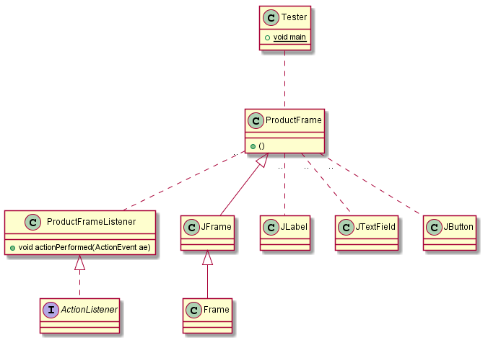

06/03/2014
Don't classify a class (e.g. +String type), use subtyping.
Object a = null;
a.toString();
The above code causes a null pointer exception.
Try to avoid using instanceof and typecasting.

11/03/2014

Collections Framework

Vector
Can have a generic type, but doesn't have to: Vector<E>
Vectors are serial, because their items must be referred to by an index, not by a key.
We do not need to state the size of a vector when we create it; it is dynamic.
Vectors can store any type of object at the same time, by being a vector of objects.
When working with an object reference of parent type, we must typecast to a child type in order to access the public members of the child type:
import java.util.*;
class Tester {
public static void main(String[] args) {
Vector v = new Vector();
v.add("A");
v.add("B");
v.add("C");
int si = v.size();
for (int i=0; i < si; i++) {
String cc = (String) v.elementAt(i);
System.out.println(cc);
}
}
}
When do not need to explicitly typecast a child type to a parent type object reference: the conversion is implicit:
Object myObject = "Hello World";
Try not to use instanceof and typecasting at all costs, by using common parent class (normal or abstract) or interface ojbect references:
import java.util.*;
abstract class Person {
abstract public void prt();
}
class Customer extends Person {
String id;
public Customer(String id) {
this.id = "C" + id;
}
public void prt() {
System.out.println("Customer: " + id);
}
}
class Employee extends Person {
String id;
public Employee(String id) {
this.id = "E" + id;
}
public void prt() {
System.out.println("Employee: " + id);
}
}
class Tester {
public static void main(String[] args) {
Vector v = new Vector();
//Vector<Person> v = new Vector<Person>();
Employee e = new Employee("1001");
v.add(e);
e = new Employee("1002");
v.add(e);
Customer c = new Customer("1001");
v.add(c);
System.out.println("Number of elements: " + v.size());
int si = v.size();
for (int i = 0; i < si; i++) {
/*
Object obj = v.elementAt(i);
if (obj instanceof Employee) {
e = (Employee) obj;
e.prt();
}
else if (obj instanceof Customer) {
c = (Customer) obj;
c.prt();
}
*/
Person p = (Person) v.elementAt(i);
//Person p = v.elementAt(i);
p.prt();
}
}
}

Hashtable
Advantages:
- Can be used as a serial device (like a vector).
- Supports random access (by key, not index).
Hashtable.put(key, value)
Stores a new value.
Hashtable.get(key)
Gets a value stored for a given key.
Hashtable.keys() and Hastable.elements() return Enumerations of the keys and elements respectively. There is no guarantee as to the order of the objects in the enumeration.
We can go through an enumeration using hasMoreElements() and nextElement():
Enumeration en = h.elements();
while (en.hasMoreElements()) {
c = (Customer) en.nextElement();
c.prt();
}
Hashtables can take generics: HashTable<Key, Value>.
Full example:
import java.util.*;
abstract class Person {
abstract public void prt();
}
class Customer extends Person {
String id;
String name;
public Customer(String id, String name) {
this.id = "C" + id;
this.name = name;
}
public void prt() {
System.out.println("Customer: " + id + " - " + name);
}
}
class Employee extends Person {
String id;
public Employee(String id) {
this.id = "E" + id;
}
public void prt() {
System.out.println("Employee: " + id);
}
}
class Tester {
public static void main(String[] args) {
String[] ccode = {"1001", "1002", "1003"};
String[] cname = {"Sam", "Mona", "Mark"};
Customer c = null;
Hashtable h = new Hashtable();
// Hashtable<String, Person> h = new Hashtable<String, Person>();
// Store customers in the Hashtable.
for (int i=0; i < ccode.length; i++) {
c = new Customer(ccode[i], cname[i]);
h.put(ccode[i], c);
}
// Retrieve customers from the Hashtable.
for (int i=0; i < ccode.length; i++) {
c = (Customer) h.get(ccode[i]);
c.prt();
}
System.out.println("-----------------------------");
Enumeration en = h.keys();
String code;
while (en.hasMoreElements()) {
code = (String) en.nextElement();
c = (Customer) h.get(code);
c.prt();
}
System.out.println("-----------------------------");
en = h.elements();
while (en.hasMoreElements()) {
c = (Customer) en.nextElement();
c.prt();
}
}
}

13/03/2014
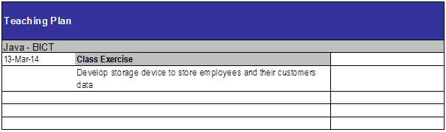
Employee (ecode, fname, lname)
Customer (ccode, name, ecode)
Note: In UML 2, an object can be represented like a class, but with a name like: objectName:ClassName that is underlined (object name is optional, but the colon must be used).
Collection is slower than Enumeration, but safer when multithreading.
Example:
import java.util.*;
class Customer {
String ccode;
String name;
Employee employee;
public Customer(String ccode, String name, Employee employee) {
this.ccode = ccode;
this.name = name;
this.employee = employee;
}
public void print() {
System.out.println("Customer: " + ccode + " - " + name);
}
}
class Employee {
String ecode;
String firstName;
String lastName;
Hashtable<String, Customer> customers;
//Vector<Customer> customers;
public Employee(String ecode, String firstName, String lastName) {
this.ecode = ecode;
this.firstName = firstName;
this.lastName = lastName;
customers = new Hashtable<String, Customer>();
//customers = new Vector<Customer>();
}
public void createCustomer(String ccode, String name) {
customers.put(ccode, new Customer(ccode, name, this));
//customers.add(new Customer(ccode, name, this));
}
public void listCustomers() {
/*
// Collection is slower than Enumeration, but safer when
// multithreading.
for (Customer customer : customers.values()) {
customer.print();
}
*/
Customer customer;
Enumeration<Customer> customersEnum = customers.elements();
while (customersEnum.hasMoreElements()) {
customer = customersEnum.nextElement();
customer.print();
}
/*
// Alternative approach, so that we have access to each key.
String ccode;
Enumeration<String> ccodes = customers.keys();
while (ccodes.hasMoreElements()) {
ccode = ccodes.nextElement();
customer = customers.get(ccode);
customer.print();
}
*/
/*
// For a Vector.
int size = customers.size();
for (int i = 0; i < size; i++) {
customer = customers[i];
customer.print();
}
*/
}
public void print() {
System.out.println("Employee: " + ecode + " - " + firstName + " " +
lastName);
}
}
class Customers extends Hashtable<String, Customer> {
}
class Tester {
public static void main(String[] args) {
// Use of arrays.
String[] ecode = {"E1001", "E1002", "E1003"};
String[] firstName = {"John", "Eric", "Michael"};
String[] lastName = {"Cleese", "Idle", "Palin"};
Employee[] employees = new Employee[3];
for(int i = 0; i < employees.length; i++) {
employees[i] = new Employee(ecode[i], firstName[i], lastName[i]);
}
for(int i = 0; i < employees.length; i++) {
employees[i].print();
}
// Demonstrate customers in employee.
Employee e = new Employee("E1001", "Ben", "Denham");
e.print();
e.createCustomer("C1001", "Datacom");
e.createCustomer("C1002", "Telecom");
e.listCustomers();
// Demonstrate extended Hashtable with set generics.
Customers test = new Customers();
test.put("abc", new Customer("123", "a", e));
Customer c = test.get("abc");
c.print();
}
}
You should extend swing controls. E.g. JTextField <|-- CustomerField.
This means that you can reuse specific components.
Homework: Look up other collections in collections framework.

18/03/2014
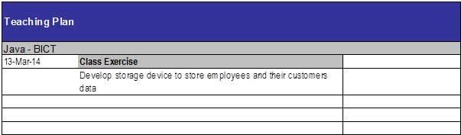

Early binding vs. late binding
Early binding: Add relationship on construction. (must-have relationship)
Late binding: Add relationship at later point. (may-have relationship)
3 HAS-A relationships:
- MUST-HAVE
- MAY-HAVE
- USES
When implementing a design:
- Implement IS-A relationships.
- Implement HAS-A relationships (except USES).
- Attributes.
  - Getters/Setters.
Use super() to call the parent constructor. super() must be the first line in the constructor.
Instead of public attributes, use getters and setters:
private double salary;
public double getSalary() {
return salary;
}
public void setSalary(double salary) {
this.salary = salary;
}
Don't show getters and setters in UML diagrams.
Example:
import java.util.*;
abstract class Employee {
private Customers customers;
public Customers getCustomers() {
return customers;
}
public void setCustomers(Customers customers) {
this.customers = customers;
}
}
class SalesPerson extends Employee {
public SalesPerson(Customers customers) {
setCustomers(customers);
}
}
class OtherStaff extends Employee {}
class Customers extends Hashtable {}
abstract class Customer {}
class CashCustomer extends Customer {}
class CreditCustomer extends Customer {}
class Tester {
public static void main(String[] args) {
}
}

25/03/2014
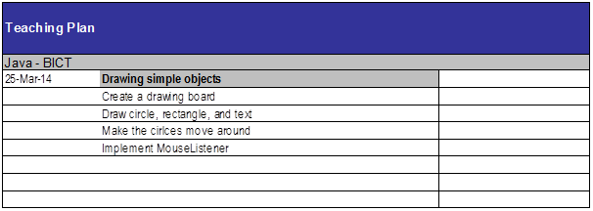
Bouncing ball example:
import java.awt.*;
import javax.swing.*;
class Board extends JPanel {
private JFrame frame;
public Board() {
frame = new JFrame();
frame.setBounds(10, 10, 600, 600);
Container container = frame.getContentPane();
container.add(this);
// Must be done before getting the graphics, otherwise getGraphics()
// will return null.
frame.setVisible(true);
setBackground(Color.white);
Graphics g = getGraphics();
Ball ball = new Ball(g, 50);
ball.setLocation(50, 80);
ball.setVelocity(1, 2);
while (true) {
ball.move();
ball.draw();
}
}
}
class Ball {
private Graphics g;
private int diameter;
private int x;
private int y;
private int xVelocity = 1;
private int yVelocity = 1;
public Ball(Graphics g, int diameter) {
this.g = g;
this.diameter = diameter;
}
public void setLocation(int x, int y) {
this.x = x;
this.y = y;
}
public void setVelocity(int xVelocity, int yVelocity) {
this.xVelocity = xVelocity;
this.yVelocity = yVelocity;
}
public void move() {
x += xVelocity;
y += yVelocity;
if (x > 500 || x < 0) {
xVelocity = -xVelocity;
}
if (y > 500 || y < 0) {
yVelocity = -yVelocity;
}
}
public void draw() {
g.setColor(Color.red);
g.fillOval(x, y, diameter, diameter);
try {
Thread.sleep(20);
}
catch (InterruptedException ex) {}
g.setColor(Color.white);
g.fillOval(x, y, diameter, diameter);
}
}
class Tester {
public static void main(String[] args) {
new Board();
}
}

27/03/2014
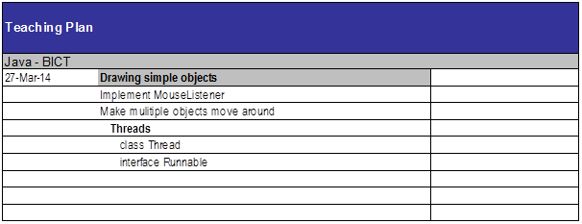
MouseListener works in exactly the same way as ActionListener.

Threads
2 ways to do multithreading:
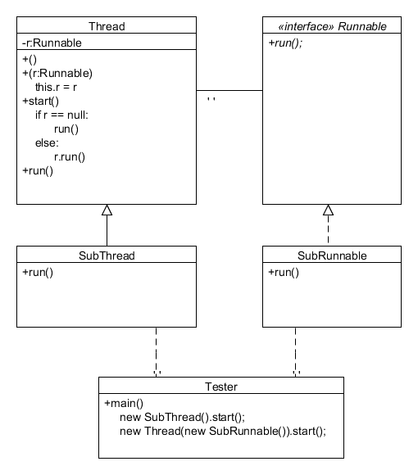
- Class extends Thread:
class Ball extends Thread {
public void run() {
while(true) {
// Do stuff
}
}
}
class Tester {
public static void main() {
Ball ball = new Ball();
ball.start();
}
}
- Class implements Runnable, and we create a new Thread with the Runnable as an argument:
class Ball implements Runnable {
public void run() {
while(true) {
// Do stuff
}
}
}
class Tester {
public static void main() {
Ball ball = new Ball();
Thread thread = new Thread(ball);
thread.start();
}
}
We run start() instead of run(), because start() includes the setup for a thread, and includes running run().
If a thread is constructed with a Runnable, that is run instead of the thread's run() method.
Multiple balls example:
import java.awt.*;
import java.awt.event.*;
import javax.swing.*;
class Board extends JPanel implements MouseListener {
private JFrame frame;
public Board() {
addMouseListener(this);
frame = new JFrame();
frame.setBounds(10, 10, 600, 600);
Container container = frame.getContentPane();
container.add(this);
// Must be done before getting the graphics, otherwise getGraphics()
// will return null.
frame.setVisible(true);
setBackground(Color.white);
Graphics g = getGraphics();
Ball ball;
Thread ballThread;
for (int i = 0; i < 10; i++) {
ball = new Ball(g, i * 10);
ball.setLocation((int)Math.random() * 100,
(int)Math.random() * 100);
ball.setVelocity(i, 10 - i);
// If Ball extended Thread, we could use:
//ball.start();
ballThread = new Thread(ball);
ballThread.start();
}
}
public void mouseClicked(MouseEvent me) {
System.out.println(String.format("%s,%s", me.getX(), me.getY()));
}
public void mousePressed(MouseEvent me) { }
public void mouseReleased(MouseEvent me) { }
public void mouseEntered(MouseEvent me) { }
public void mouseExited(MouseEvent me) { }
}
class Ball implements Runnable {
private Graphics g;
private int diameter;
private int x;
private int y;
private int xVelocity = 1;
private int yVelocity = 1;
public Ball(Graphics g, int diameter) {
this.g = g;
this.diameter = diameter;
}
public void setLocation(int x, int y) {
this.x = x;
this.y = y;
}
public void setVelocity(int xVelocity, int yVelocity) {
this.xVelocity = xVelocity;
this.yVelocity = yVelocity;
}
public void move() {
x += xVelocity;
y += yVelocity;
if (x > 500 || x < 0) {
xVelocity = -xVelocity;
}
if (y > 500 || y < 0) {
yVelocity = -yVelocity;
}
}
public void draw() {
g.setColor(Color.blue);
g.fillOval(x, y, diameter, diameter);
try {
Thread.sleep(20);
}
catch (InterruptedException ex) {}
g.setColor(Color.white);
g.fillOval(x, y, diameter, diameter);
}
public void run() {
while (true) {
move();
draw();
}
}
}

01/04/2014
Thread is basically:
Runnable
+run()
Thread implements Runnable
-r:Runnable
+()
+(r:Runnable)
my.r = r
+start()
if (r == null)
run()
else
r.run()
+run()
So we can either extend thread:
Ball extends Thread
+run()
...
+(s)main(args:String[])
b:Ball = new Ball()
b.start()
or implement runnable:
Ball implements Runnable
+run()
...
+(s)main(args:String[])
b:Ball = new Ball()
t:Thread = new Thread(b)
t.start()
A static method can be called on a class or an instance.
To kill a "ball":
- Stop thread
- Paint white
- Remove listener
Example:
import java.awt.*;
import java.awt.event.*;
import javax.swing.*;
class Board extends JPanel implements MouseListener {
private JFrame frame;
public Board() {
addMouseListener(this);
frame = new JFrame();
frame.setBounds(10, 10, 600, 600);
Container container = frame.getContentPane();
container.add(this);
// Must be done before getting the graphics, otherwise getGraphics()
// will return null.
frame.setVisible(true);
setBackground(Color.white);
Ball ball;
Thread ballThread;
for (int i = 0; i < 10; i++) {
ball = new Ball(this, 30 + i * 10);
ball.setLocation((int)Math.random() * 100,
(int)Math.random() * 100);
ball.setVelocity(i, 10 - i);
// If Ball extended Thread, we could use:
//ball.start();
ballThread = new Thread(ball);
ballThread.start();
}
}
public void mouseClicked(MouseEvent me) {
System.out.println(String.format("%s,%s", me.getX(), me.getY()));
}
public void mousePressed(MouseEvent me) { }
public void mouseReleased(MouseEvent me) { }
public void mouseEntered(MouseEvent me) { }
public void mouseExited(MouseEvent me) { }
}
class Ball implements Runnable, MouseListener {
private static int idCounter;
private int id;
private boolean alive = true;
private JPanel panel;
private Graphics g;
private int diameter;
private int x;
private int y;
private int xVelocity = 1;
private int yVelocity = 1;
public Ball(JPanel panel, int diameter) {
id = idCounter++;
this.panel = panel;
panel.addMouseListener(this);
g = panel.getGraphics();
this.diameter = diameter;
}
public void setLocation(int x, int y) {
this.x = x;
this.y = y;
}
public void setVelocity(int xVelocity, int yVelocity) {
this.xVelocity = xVelocity;
this.yVelocity = yVelocity;
}
public void move() {
x += xVelocity;
y += yVelocity;
if (x > 500 || x < 0) {
xVelocity = -xVelocity;
}
if (y > 500 || y < 0) {
yVelocity = -yVelocity;
}
}
public void draw() {
g.setColor(Color.blue);
g.fillOval(x, y, diameter, diameter);
g.setColor(Color.white);
int radius = diameter/2;
g.drawString(String.format("%d", id), x + radius, y + radius);
try {
Thread.sleep(20);
}
catch (InterruptedException ex) {}
hide();
}
public void run() {
while (alive) {
move();
draw();
}
}
public void hide() {
g.setColor(Color.white);
g.fillOval(x, y, diameter, diameter);
}
public void delete() {
System.out.println(String.format("Deleted ball %d", id));
alive = false;
hide();
panel.removeMouseListener(this);
}
public boolean contains(int xc, int yc) {
return (xc > x && xc < x + diameter &&
yc > y && yc < y + diameter);
}
public void mouseClicked(MouseEvent me) {
if (contains(me.getX(), me.getY())) {
delete();
}
}
public void mousePressed(MouseEvent me) { }
public void mouseReleased(MouseEvent me) { }
public void mouseEntered(MouseEvent me) { }
public void mouseExited(MouseEvent me) { }
}
class Tester {
public static void main(String[] args) {
new Board();
}
}

03/04/2014
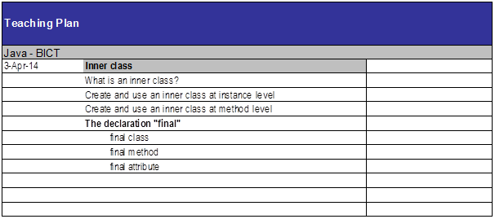
Inner classes are classes that are declared within a class.
Inner classes can be declared at the instance level or method level.
An inner class declared at the instance level is shown in UML by composition (shaded diamond).
An inner class declared at the method level is not included in a UML diagram.
- A private inner class can only be used within the class.
- A public inner class can be used for object references outside of the class (with Outer.Inner), and can be created outside of the class (An instance is needed for creation). It can also access all instance methods of its outer class, even those declared as private.
- A public static inner class can be created and stored outside of the class.
- A class declared within a method can only be accessed within that method, and only in the lines following the declaration of the inner class.
Example:
class Employee {
// Instance-level inner class.
// Can't store an instance outside of the class.
private class Job {
public void m1() {
System.out.println("Inner class of Employee - Job .. m1");
}
}
// Public Instance-level inner class.
// Can create an instance outside of the class.
class Car {
public void m6() {
System.out.println("Inner class of Employee - Car .. m6");
}
}
// Public, static instance-level inner class (can be created from
// outside).
// Can create and store instance outside of the class.
static class Food {
public void m5() {
System.out.println("Inner class of Employee - Food .. m5");
}
}
public void m2() {
Job j = new Job();
j.m1();
}
public void m3() {
Job j = new Job();
j.m1();
}
public Car m4() {
return new Car();
}
public void m7() {
// Note, Pencil mut be declared in the method before creating an
// instance. Otherwise, the operations are out of sequence.
// Can't be accessed at all from outside the method.
class Pencil {
public void m8() {
System.out.println(
"Inner class of Employee m7 - Pencil ..m8");
}
}
Pencil p1 = new Pencil();
p1.m8();
}
}
class Tester {
public static void main(String[] args) {
Employee e1 = new Employee();
e1.m2();
e1.m3();
e1.m7();
Employee.Car c1 = e1.m4();
c1.m6();
Employee.Car c2 = e1.new Car();
c2.m6();
Employee.Food f1 = new Employee.Food();
f1.m5();
}
}

Final access modifier
- The value of a final attribute cannot be changed.
- A final method cannot be overridden.
- A final class cannot be extended.
Public static final attributes can even be declared in an interface.
Example:
class Mathematics {
// The value of a final attribute cannot be changed.
public final float pi = 3.14f;
// If the final value is not set here, it can still be set in the
// cosntructor:
public final String test;
public void m1() {
// Final value cannot be changed.
// pi = 5f;
test = "Setting final value from constructor";
}
// Final method cannot be overridden.
public final int sum(int x, int y) {
return x + y;
}
}
// A final class cannot be extended.
final class Calculus extends Mathematics {
public void m2() {
// Final value cannot be changed.
// pi = 7f;
}
// Final method cannot be overridden.
/*
public int sum(int x, int y) {
return x + y + 1;
}
*/
}
// A final class cannot be extended.
/*
class Algebra extends Calculus {
}
*/
class Tester {
public static void main(String[] args) {
Calculus c = new Calculus();
// Final value cannot be changed.
// c.pi = 4;
System.out.println(c.pi);
System.out.println(c.sum(2, 2));
}
}
A non-GUI component should not use Listeners, but should use observation instead:
import java.util.*;
class Supervisor implements Observer {
public void update(Observable observable, Object object) {
System.out.println(String.format("Observer Supervisor .. update - %s",
observable));
}
}
class Worker extends Observable {
public void call() {
setChanged();
notifyObservers();
}
}
class Tester {
public static void main (String[] args) {
Supervisor s = new Supervisor();
Worker w = new Worker();
w.addObserver(s);
w.call();
}
}

10/04/2014
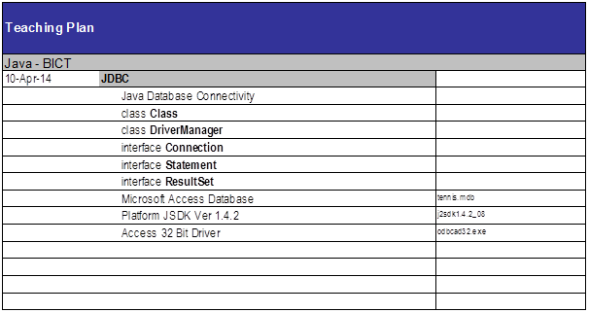
import java.sql.*;
try {
Class.forName("sun.jdbc.odbc.JdbcOdbcDriver");
Connection connect = DriverManager.getConnection("jdbc:odbc:sam","","");
Statement st = connect.createStatement();
ResultSet rs = st.executeQuery("SELECT name, playerno FROM Players”);
while (rs.next()) {
System.out.println(rs.getString(1)+ " " + rs.getString(2));
}
} catch (Exception e) {}
Before any database connection can be made, we must load the driver class by calling the static method forName() on Class.
DriverManager has static getConnection(), which returns an object that implements the Connection interface.
The connection has createStatement(), which returns an object that implements the Statement interface.
The statement has methods like executeQuery(), that will execute the query through the db connection, and returns an object implementing the ResultSet interface.
The result set can be navigated and accessed with methods such as next() and getString().
Example of querying and displaying data in UI:
import java.sql.*;
import java.awt.*;
import javax.swing.*;
import java.awt.event.*;
class Tester {
public static void main(String[] args) {
try {
Class.forName("sun.jdbc.odbc.JdbcOdbcDriver");
Connection connection = DriverManager.getConnection(
"jdbc:odbc:tennis_access","","");
PlayerForm playerForm = new PlayerForm(connection);
// We should really close the connection at some point.
} catch (Exception e) {
System.out.println(e);
}
}
}
class PlayerForm extends JFrame implements ActionListener {
JTextField txtPlayerNo;
JTextField txtName;
JTextField txtInitials;
JTextField txtTown;
Connection connection;
public PlayerForm(Connection connection) {
this.connection = connection;
setTitle("Players");
setBounds(10, 10, 400, 600);
JLabel lblPlayerNo = new JLabel("Player no:");
txtPlayerNo = new JTextField();
JLabel lblName = new JLabel("Name:");
txtName = new JTextField();
JLabel lblInitials = new JLabel("Initials:");
txtInitials = new JTextField();
JLabel lblTown = new JLabel("Town:");
txtTown = new JTextField();
JButton btnSearch = new JButton("Search");
lblPlayerNo.setBounds(10, 10, 100, 20);
txtPlayerNo.setBounds(130, 10, 100, 20);
lblName.setBounds(10, 70, 100, 20);
txtName.setBounds(130, 70, 100, 20);
lblInitials.setBounds(10, 100, 100, 20);
txtInitials.setBounds(130, 100, 100, 20);
lblTown.setBounds(10, 130, 100, 20);
txtTown.setBounds(130, 130, 100, 20);
btnSearch.setBounds(10, 40, 100, 20);
btnSearch.addActionListener(this);
Container container = getContentPane();
// We have to set layout on the container because this is java 1.4.
container.setLayout(null);
container.add(lblPlayerNo);
container.add(txtPlayerNo);
container.add(btnSearch);
container.add(lblName);
container.add(txtName);
container.add(lblInitials);
container.add(txtInitials);
container.add(lblTown);
container.add(txtTown);
setVisible(true);
}
public void actionPerformed(ActionEvent ae) {
Player p = new Player(connection);
int playerno = Integer.parseInt(txtPlayerNo.getText());
String[] player = new String[3];
try {
player = p.getPlayer(playerno);
} catch (Exception e) {
System.out.println(e);
}
txtName.setText(player[0]);
txtInitials.setText(player[1]);
txtTown.setText(player[2]);
}
}
class Player {
private Connection connection;
public Player(Connection connection) {
this.connection = connection;
}
public String[] getPlayer(int playerno) throws SQLException{
Statement statement = connection.createStatement();
String query = "select name, initials, town from players where " +
"playerno = " + playerno;
ResultSet result = statement.executeQuery(query);
if (result.next()) {
return new String[] {result.getString(1), result.getString(2),
result.getString(3)};
}
return null;
}
}

RMI

Task
- User enters player number into screen.
- Presses "Get" button.
- Client calls application server with RMI.
- Server calls DB server with RMI.
- DB server gets name and town from tennis.mdb.
- Data gets passed back through, and Name and Town fields are populated.
- Exit button closes application.

Task completed with
- Aaron
- Edmund

Notes
http://docs.oracle.com/javase/tutorial/rmi/
- Remote Objects get stored in the rmiregistry.
- A remote object must extend UnicastRemoteObject, implement an interface that extends Remote, and must have all its methods throwing RemoteException.
- The interface extending remote must have all its methods throwing RemoteException, and only the methods in the interface will be remotely callable.
- A server will store a remote object in the rmiregistry using Naming.rebind()
- A client will find an object in the rmiregistry using Naming.lookup()
- 2 remote objects exist in the program: PlayerApp and DBServer
- lookup - returns a stub or reference for the remote object with the specified name
- rebind - rebinds the specified name to a new remote object

Misc requirements
- tennis.mdb must be registered at: "jdbc:odbc:tennis_access".

Running steps
javac *.java
rmic myRemoteObject
start rmiregistry
start java myRemoteServer
java myClient

Design
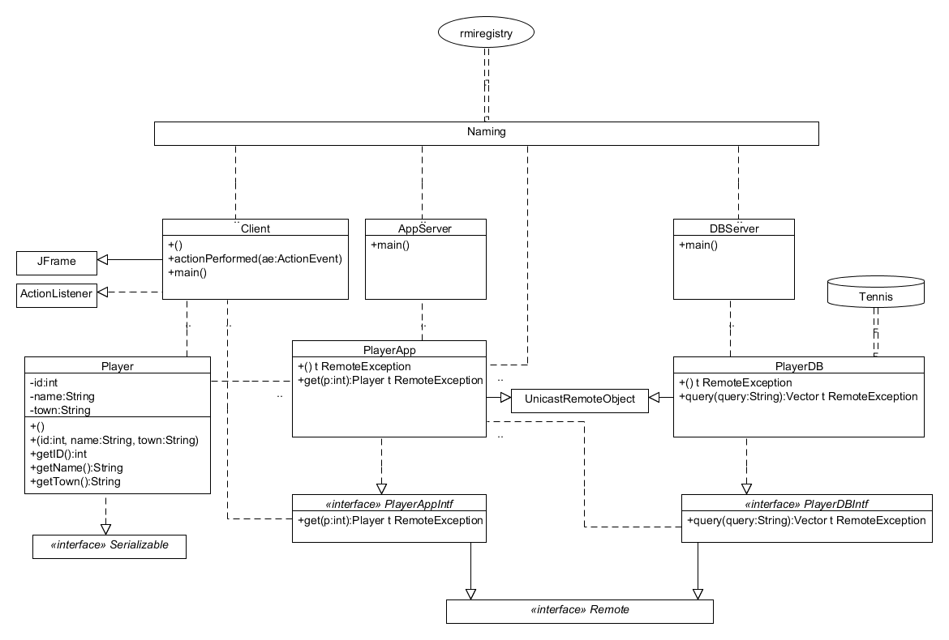

Code
AppServer.java:
import java.rmi.*;
class AppServer {
public static void main(String[] args) {
try {
PlayerApp playerApp = new PlayerApp();
Naming.rebind("PlayerApp", playerApp);
}
catch (Exception ex) {
System.out.println(ex);
}
}
}
Client.java:
import java.rmi.*;
import java.awt.*;
import java.awt.event.*;
import javax.swing.*;
class Client extends JFrame
{
private JTextField txtPlayerNo;
private JTextField txtName;
private JTextField txtInitials;
private JTextField txtBirthDate;
private JTextField txtSex;
private JTextField txtJoined;
private JTextField txtStreet;
private JTextField txtHouseNo;
private JTextField txtPostCode;
private JTextField txtTown;
private JTextField txtPhoneNo;
private JTextField txtLeague;
public static void main(String[] args) {
Client frame = new Client();
}
public Client() {
setTitle("ClientGui");
setBounds(100, 100, 248, 215);
setDefaultCloseOperation(JFrame.EXIT_ON_CLOSE);
JLabel lblPlayerNo = new JLabel("Player No");
lblPlayerNo.setFont(new Font("Tahoma", Font.PLAIN, 15));
lblPlayerNo.setBounds(10, 18, 76, 14);
JLabel lblName = new JLabel("Name");
lblName.setFont(new Font("Tahoma", Font.PLAIN, 15));
lblName.setBounds(10, 55, 76, 14);
JLabel lblTown = new JLabel("Town");
lblTown.setFont(new Font("Tahoma", Font.PLAIN, 15));
lblTown.setBounds(10, 97, 76, 14);
txtPlayerNo = new JTextField();
txtPlayerNo.setBounds(96, 15, 126, 20);
txtPlayerNo.setColumns(10);
txtName = new JTextField();
txtName.setBounds(96, 52, 126, 20);
txtName.setColumns(10);
txtTown = new JTextField();
txtTown.setBounds(96, 94, 126, 20);
txtTown.setColumns(10);
JButton btnGet = new JButton("Get");
btnGet.setFont(new Font("Tahoma", Font.PLAIN, 15));
btnGet.setBounds(133, 140, 89, 23);
btnGet.addActionListener(new ActionListener()
{
public void actionPerformed(ActionEvent arg0)
{
try
{
Remote remote = Naming.lookup("rmi://127.0.0.1/PlayerApp");
PlayerAppIntf playerApp = (PlayerAppIntf) remote;
int p = Integer.parseInt(txtPlayerNo.getText());
Player player = playerApp.get(p);
txtName.setText(player.getName());
txtTown.setText(player.getTown());
}
catch (Exception ex)
{
System.out.println(ex);
}
}
}
);
getContentPane().setLayout(null);
getContentPane().add(lblPlayerNo);
getContentPane().add(txtPlayerNo);
getContentPane().add(lblName);
getContentPane().add(txtName);
getContentPane().add(lblTown);
getContentPane().add(txtTown);
getContentPane().add(btnGet);
setVisible(true);
}
}
DBServer.java:
import java.rmi.*;
class DBServer {
public static void main(String[] args) {
try {
PlayerDB playerDB = new PlayerDB();
Naming.rebind("PlayerDB", playerDB);
}
catch (Exception ex) {
System.out.println(ex);
}
}
}
Player.java:
import java.io.*;
class Player implements Serializable {
private int id;
private String name;
private String town;
public Player() { }
public Player(int id, String name, String town) {
this.id = id;
this.name = name;
this.town = town;
}
public int getID() {
return id;
}
public String getName() {
return name;
}
public String getTown() {
return town;
}
}
PlayerApp.java:
import java.rmi.*;
import java.rmi.server.*;
import java.util.*;
class PlayerApp extends UnicastRemoteObject implements PlayerAppIntf {
public PlayerApp() throws RemoteException {
super();
}
public Player get(int p) throws RemoteException {
try {
Remote remote = Naming.lookup("rmi://127.0.0.1/PlayerDB");
PlayerDBIntf playerApp = (PlayerDBIntf) remote;
Vector result = playerApp.query("select name, town from players where playerno=" + p);
if (result.size() > 0) {
Vector row = (Vector) result.elementAt(0);
Player player = new Player(p, (String) row.elementAt(0), (String) row.elementAt(1));
return player;
}
}
catch (Exception ex) {
System.out.println(ex);
}
return new Player();
}
}
PlayerAppIntf.java:
import java.rmi.*;
interface PlayerAppIntf extends Remote {
public Player get(int p) throws RemoteException;
}
PlayerDB.java:
import java.sql.*;
import java.rmi.*;
import java.rmi.server.*;
import java.util.Vector;
class PlayerDB extends UnicastRemoteObject implements PlayerDBIntf {
public PlayerDB() throws RemoteException {
super();
try {
Class.forName("sun.jdbc.odbc.JdbcOdbcDriver");
}
catch (Exception e) {
System.out.println(e);
}
}
public Vector query(String query) throws RemoteException {
try {
Connection connection = DriverManager.getConnection("jdbc:odbc:tennis_access","","");
Statement statement = connection.createStatement();
ResultSet result = statement.executeQuery(query);
Vector resultVector = new Vector();
ResultSetMetaData rsmd = result.getMetaData();
int columnCount = rsmd.getColumnCount();
while (result.next()) {
Vector row = new Vector();
for (int i = 1; i <= columnCount; i++) {
row.add(result.getString(i));
}
resultVector.add(row);
}
return resultVector;
}
catch (SQLException e) {
System.out.println(e);
}
return null;
}
}
PlayerDBIntf.java:
import java.rmi.*;
import java.util.Vector;
interface PlayerDBIntf extends Remote {
public Vector query(String query) throws RemoteException;
}

Design Patterns

Factory Method with Private Constructor
Class contains a private constructor so a new object cannot be created from outside the class.
A static method will be provided in the class that will create and return a new object.
This is used when initialization of the object is:
- Not safe for just anyone to create an object.
- Involves steps/variables the programmer doesn't need to worry about.
- Factory method reads from some XML configuration file.
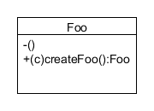
class Foo {
private Foo() { }
public static Foo createFoo() {
return new Foo();
}
}

Factory method with inner class
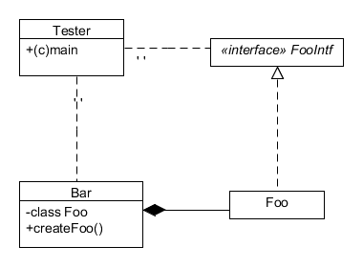
Similar result from making the class an inner class, and by making the outer class include a factory method.
interface FooIntf {
}
class Bar {
private class Foo implements FooIntf {
}
public Foo createFoo() {
return new Foo();
}
}
class Tester {
public static void main(String[] args) {
Bar b = new Bar();
FooIntf = b.createFoo();
}
}

API Design Pattern
A library defines and uses an interface that must be implemented by the client.
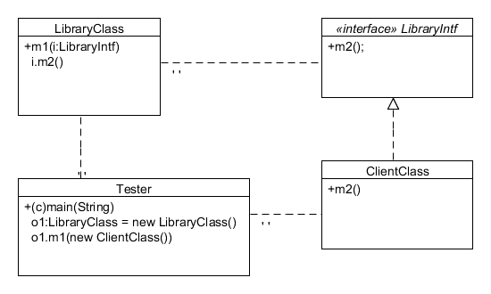

Decoupling Design Patterns
Advantages:
- Neighbourhood.
  - No data is global; everything is local.
- Easy to maintain.
- Safety.
- Uniform distribution of intelligence among classes (no monolithic classes).
  - Modifying monolithic classes are dangerous, because a change in that class could cause more problems in more areas.
- Avoid unwanted classes.
- Some classes "fall out" along the way.
- You will be able to swap out classes more easily, because we program to interfaces, not implementations.
  - Classes don't need to know implementation details of the classes they use.
Static models (class diagrams) are good, but dynamic models (collaboration diagrams) are needed to view interactions, and determine monolithic classes that take the intelligence.

Central Target of Association
CTA-1: A class, where an object of the class is called from many other objects of the same type.
- Use the adapted server pattern to decouple, so that the other objects do not
need to know the implementation details of the CTA-1 class.
- In an example, we have many Button objects that all call methods on a
Dialer. To implement adapted server:
  - Button MUST-HAVE a ButtonServer (abstract class), and will call abstract +ButtonPressed() on it.
  - For each method that needs to be called on dialer, we have an Adapter class that inherits from ButtonServer, and will implemented +ButtonPressed() to call the method in Dialer.
  - This decouples the system so that we can add new types of button (servers) that aggregate ButtonServer, and new types of Dialers (or anything that can be called by a button; clients) that are used by a new kind of Adapter.
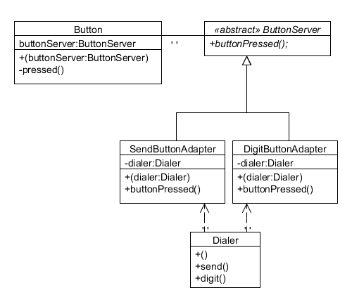
class Button {
private ButtonServer buttonServer;
public Button(ButtonServer buttonServer) {
this.buttonServer = buttonServer;
}
private void pressed() {
buttonServer.buttonPressed();
}
}
abstract class ButtonServer {
public abstract void buttonPressed();
}
class SendButtonAdapter extends ButtonServer {
private Dialer dialer;
public SendButtonAdapter(Dialer dialer) {
this.dialer = dialer;
}
public void buttonPressed() {
dialer.send();
}
}
class DigitButtonAdapter extends ButtonServer {
private Dialer dialer;
public DigitButtonAdapter(Dialer dialer) {
this.dialer = dialer;
}
public void buttonPressed() {
dialer.digit();
}
}
class Dialer {
public Dialer() {
new Button(new DigitButtonAdapter(this));
new Button(new SendButtonAdapter(this));
}
public void send() { }
public void digit() { }
}
CTA-2: A class, where an object of the class is called from many other objects of different types.
- Use interface segregation desin pattern to decouple, so that the other objects do not need to know the implementation details of the CTA-2 class.
- Each type of client should use a separate interface, and each interface should be implemented by the CTA-2 class.
- This way, the CTA-2 class could be replaced for a given client with anything that implements the required interface.
- E.g. Dialer and CellularRadio both call Display.
  - We add (i)DialerDisplay, that is used by Dialer, and implemented by Display.
  - We add (i)CRDisplay, that is used by CellularRadio, and implemented by Display.
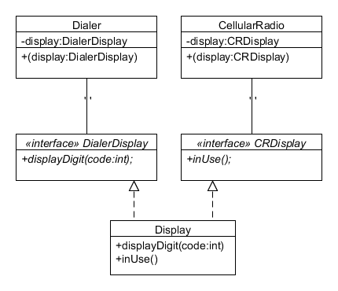
class Dialer {
private DialerDisplay display;
public Dialer(DialerDisplay display) {
this.display = display;
display.displayDigit(5);
}
}
class CellularRadio {
private CRDisplay display;
public CellularRadio(CRDisplay display) {
this.display = display;
display.inUse();
}
}
interface DialerDisplay {
void displayDigit(int code);
}
interface CRDisplay {
void inUse();
}
class Display implements DialerDisplay, CRDisplay {
public void displayDigit(int code) { }
public void inUse() { }
}

GoF Design Patterns

Singleton
The singleton pattern is useful when there only ever needs to be a single, global instance of a given class.
In a singleton class, the constructor(s) are private, and the only way to get an instance is to call a static method of the class, which will only ever create a single object and serve it for every request.
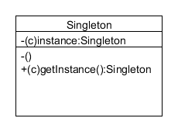
class Singleton {
private static Singleton instance;
private Singleton() {
}
// Any object wishing to get the Singleton object will need to call this.
public static Singleton getInstance() {
if (instance == null) {
instance = new Singleton();
}
return instance;
}
}

Observer
The observer pattern is useful when several objects (observer) need to be notified when a state change occurs for some single object (observable).
In the observer pattern example below, an object wishing to be observed must inherit from the Observable class, and notifyObservers() must be called whenever a change in state occurs. Any object wishing to observe the first object must implement the Observer interface, and must be added to the first object's list of observers with addObserver(). Then, whenever the first object has notifyObservers() invoked, the other objects will have their own notifyObserver() invoked, in which they can react appropriately to the state change.
The observer pattern is commonly used asd part of event-based programming, where objects need to notify other objects of the events that have occurred.
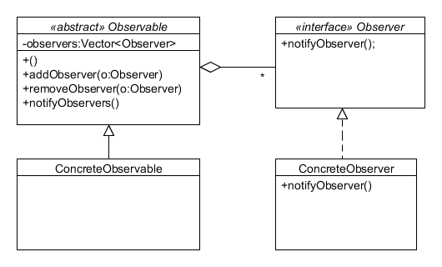
import java.util.Vector;
interface Observer {
void notifyObserver();
}
abstract class Observable {
private Vector<Observer> observers;
public Observable() {
observers = new Vector<Observer>();
}
public void addObserver(Observer o) {
observers.add(o);
}
public void removeObserver(Observer o) {
if (observers.contains(o)) {
observers.remove(o);
}
}
public void notifyObservers() {
for (Observer o : observers) {
o.notifyObserver();
}
}
}
class ConcreteObservable extends Observable {
}
class ConcreteObserver implements Observer {
public void notifyObserver() {
System.out.println("Observation successful!");
}
}
class Tester {
public static void main(String[] args) {
Observable o1 = new ConcreteObservable();
Observer o2 = new ConcreteObserver();
o1.addObserver(o2);
o1.notifyObservers();
o1.removeObserver(o2);
}
}

Memento
The purpose of the memento pattern is for an object to be able to save its state to a "memento" object, and then restore its state from that memento at a later time.
The memento pattern is useful for implementing the ability to "undo" the changes made to an object, such as for a GUI element.
Three main classes are involved in the memento pattern are:
Originator
Objects whose states need to be saveable and restorable.
Memento
Objects that store the state of Originator objects.
Caretaker
An object of Caretaker is responsible for storing the Memento objects.
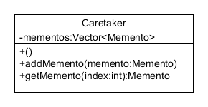
import java.util.Vector;
class Originator {
private String state;
public String getState() {
return state;
}
public void setState(String state) {
this.state = state;
}
public Memento saveState() {
return new Memento(state);
}
public void restoreState(Memento memento) {
state = memento.getState();
}
}
class Memento {
private String state;
public Memento(String state) {
this.state = state;
}
public String getState() {
return state;
}
}
class Caretaker {
private Vector<Memento> mementos;
public Caretaker() {
mementos = new Vector<Memento>();
}
public void addMemento(Memento memento) {
mementos.add(memento);
}
public Memento getMemento(int index) {
return mementos.get(index);
}
}
class Tester {
public static void main(String[] args) {
Originator o = new Originator();
Caretaker c = new Caretaker();
o.setState("A");
c.addMemento(o.saveState());
o.setState("B");
o.restoreState(c.getMemento(0));
System.out.println(o.getState());
}
}

