**Bartoshuk scale README**

**Description:**

The Bartoshuk scale task is a short eprime task where participants are instructed on how to make both intensity and pleasantness/unpleasantness ratings. Then, they are given 20 questions related to different sensory modalities to rate with the two scales. This scale practice allows participants to be familiar and comfortable making ratings using these scales on later constructs (e.g. pain).

**How to run:**

To run this task, you will need Eprime2.0 or later, the main experiment file (ends in .ebs or .ebs2) and all the stimuli files called by the script. The stimuli files are the pictures/scales that are displayed throughout the task. The stimuli files should be in a sub-folder called “stimuli”.

**Instructions**

Slide 1:

We will start with a short questionnaire about how sensitive you are to different types of stimuli.

Each question will appear at the middle of the screen, and rating scale will appear at the bottom of the screen. The questions and your responses will be self-paced.

To respond, move pointer to the appropriate level on the rating scale, and click the left button on the mouse to confirm your response.

Slide 2:

Please answer each question using the following two rating scales.

Intensity rating scale: "How intense is the sensation?"

the scale is a graded line ranging from

1. - No sensation
2. - Barely detectable sensation
3. - Weak sensation
4. - Moderate sensation
5. - Strong sensation
6. - Very strong sensation
7. - Strongest imaginable sensation of any kind

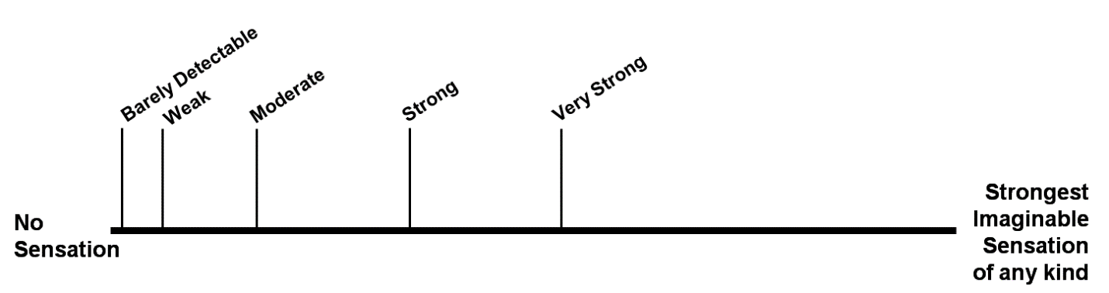

Slide 3:

Please answer each question using the following two rating scales.

2) Pleasantness rating scale: "How pleasant is the sensation?"

The scale is a graded line ranging from

"Strongest imaginable unpleasantness of any kind"

to "Strongest imaginable pleasantness of any kind"

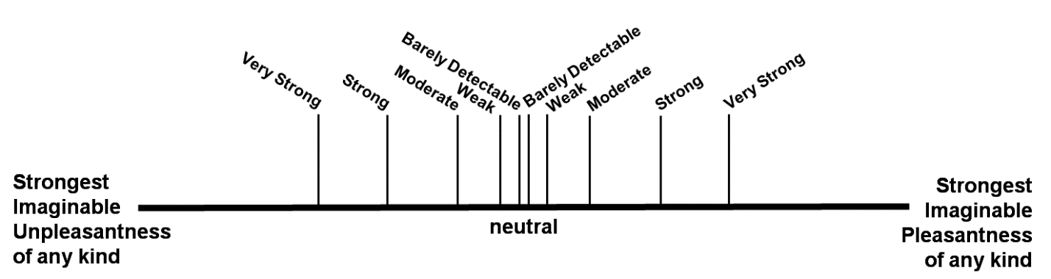

Slide 4:

To give you an idea of the distinction between the two rating scales (i.e., sensation intensity and pleasantness), I'm going to give you an example.

Think of listening to a sound such as a song on the radio. As the volume of the sound increases, you might experience how loud it is or how pleasant or unpleasant it is to you.

The sensation 'intensity' is the loudness of the music, and the sensation 'pleasantness' is how much you like the song.

Slide 5:

Now you will have a chance to practice the rating scales with the following example prompt:

"Brightness of this computer monitor"

If you are ready, please press SPACE.

**Question List:**

Brightness of a dimly lit restaurant

Brightest light you have ever seen

Loudness of a whisper

Loudness of a conversation

Loudest sound you have heard

Strongest smell of a flower

Sweetness of a coca-cola

Bitterness of celery

Strongest saltiness experienced

Strongest sweetness experienced

Sweetness of candy

Strongest sourness experienced

Warmth of warm bread in your mouth

Strongest coldness experienced

Strongest heat experienced

Strongest oral pain experienced (e.g., toothache)

Strongest stomach ache experienced

Strongest headache experienced

Strongest injury-induced pain experienced (e.g. burns, scrapes, broken limbs, etc.)