**Functional Ability Impacted by Combinations of Physical Activity, Sleep Quality and Depression in an Aging Arthritis Population**

**Jimena Perez-Tetuan, Sophia Ladyzhets**

testing

**Abstract**

Arthritis is a disorder that involves swelling and tenderness of joints. In arthritis, functional ability is impacted by the lifestyle factors physical activity (PA), sleep quality (SQ) and depression. In response to the pandemic limiting treatment options, this study aimed to find which combination of PA, SQ and depression most severely impacts functional ability in an aging arthritis population. Data was taken from the National Health and Nutrition Examination Survey from 2011-2018 (n=4969). R packages car, ggpub2, Hmisc and tidyverse were used for analyses. Within each depression severity (DS) group, ANOVA evaluated differences between the subgroups no PA vs PA. Differences between poor SQ vs adequate SQ groups was found within each DS cohort and within every PA group. Significant differences between depression vs no depression subgroups were found in all PA groups. Multiple linear regression was used to assess individual impact of PA, SQ and depression on physical impairment. No PA impacted physical impairment in most DS groups, excluding the severe depression group (p<0.0001, p<0.001, p<0.0001, p<0.0001, p< 0.9). Poor SQ impacted physical impairment in the mild and no depression groups, and in groups with 0-9 occurrences of PA (p<0.0001 all). Mild to severe depression impacted physical impairment in all PA levels (p < 0.0001). Depression explained most variance in functional ability (R^2 = .22). The combination of inactivity and depression had the largest impact on physical impairment. These findings support individualized care and support measures to increase mental health care in individuals with arthritis.

**Introduction**

Arthritis is a disorder that involves swelling and tenderness of joints [1]. A recent report shows that 75% of people with Rheumatoid Arthritis feel unsatisfied with treatment outcomes [2]. An ineffective treatment disproportionately affects people in poorer or rural regions who cannot afford prolonged treatments or cannot sustainably attend physical therapy [3]. An obstacle in achieving remission might be unhealthy lifestyle practices. Recent studies suggest that smoking and BMI are predictors of early treatment outcomes in patients with Rheumatoid Arthritis while depression as a result of impaired physiological responses to stress are indicative of worse long-term outcomes[4-6]. Treatments are solely focused on the physical aspects of arthritis and do not account for a patient's unhealthy lifestyle practices. This could be undermining positive treatment outcomes such as retaining functional ability.

In arthritis, retaining functional ability is essential to maintain work ability, independence, and social interaction [1]. The ability to walk up a flight of stairs or pick up a utensil is crucial to one’s feeling of control and agency over one’s life. Unfortunately, limitations in functional ability are most common in an aging population [7]. According to several preliminary studies, lifestyle factors (LFs) also play a role in the severity of functional limitations that interfere with quality of life [8-9].

Recently, the prevalence of LFs in managing arthritis symptoms has increased. Millions of Americans are confined to their homes and are unable to safely visit hospitals and clinics. Since the aging population has the highest risk of contracting Covid-19 and of having a functional limitation, more research is needed about how LFs can influence functional ability. [10-11]. Prevalent LFs to investigate include physical activity (PA), mental health disorders and non-restorative sleep. In [12], depression and fatigue were found to be increased in patients that report higher disease activity. By contrast, healthy lifestyle practices such as meeting national guidelines for PA can lower risk of disability [9]. The altered lifestyle of someone confined to the home might further reduce physical and mental wellness. Not getting the same amount of daily exercise or having a minimized level of social interaction or having to reestablish a sleep schedule are unwanted changes to one’s life and health. Because of a limited access to hospital and medical professionals, the role that LFs play in managing arthritis symptoms could increase. It is necessary to better understand the role of physical activity, depression and non-restorative sleep on functional ability.

In arthritis, physical limitations were found to be associated with co-occurring depression and emotional distress [13-14]. Additionally, decreased functional capacity and poorer health function were linked to serious mental health disorders in adults with arthritis over 50 years of age [15-16]. Non-restorative sleep has also been linked to higher levels of inflammation in older men resulting in heightened risk of functional disability, with increased risk of incident disability [17-18]. This finding is concerning since arthritis patients have lower sleep quality than the general population [19-20]. Lastly, inactivity and a poor-related health status were found to detrimentally impact functional ability in adults over 75 years of age and were found to be associated with higher rates of disabilities and lower independence [21-22]. Interventions to increase PA can also decrease risk of physical disabilities [23].

The following literature highlights the interrelationships between inactivity, sleep and depression. For example, the relations between sleep and depression were suggested to be mediated by social interaction and result in increased levels of fatigue [24]. Other studies have looked at how exercise can be incorporated into mental health care to effectively treat mental illness [25]. Higher numbers of mentally unhealthy and physically inactive days were also found to affect arthritis burden, lower levels of activity and negatively impact mental health [26].  In [27], researchers found that increased exercise intensity reduced sleep disturbance while increasing daytime dysfunction. However, this study was not conducted with an arthritis sample, which leaves more to be clarified about the relation between physical activity and sleep in a population with arthritis. The overall schematics of the impacts that PA, sleep, depression have on functional ability are shown in Fig 1. 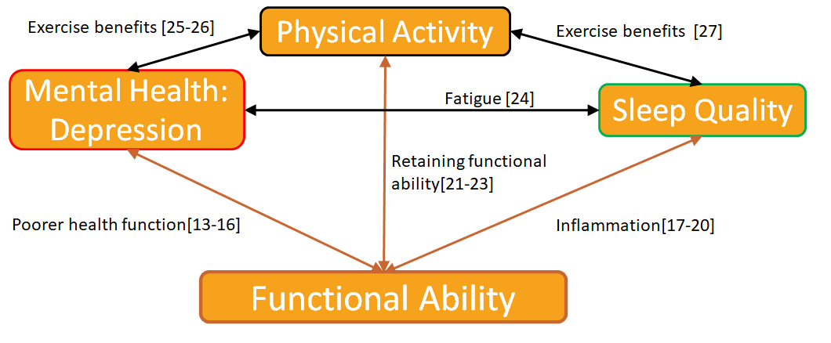

**Fig 1. The direct connections between PA, sleep and depression each have on functional ability**

Also shows the interrelationships between PA, sleep and depression that can have indirect effects on functional ability.

The individual effects of PA, sleep and depression on functional impairments has been established, but research is lacking in how combinations of LFs can impact functional ability. Groups of LFs should be researched more to ensure that findings are reflective of the holistic treatments being advocated for in literature. Therefore, this study aimed to investigate which combinations of PA, sleep quality (SQ), and mild to severe depression are most impactful on functional ability. This study also aimed to find which individual LF is most impactful on functional ability. This will ensure holistic treatments in the future are more effective for the people most severely and commonly harmed by arthritis.

**Methods**

**Data Source:**

The National Health and Nutritional Examination Survey (NHANES)(https://www.cdc.gov/nchs/nhanes/i is a continuous program of the National Center for Health Statistics. Data is released in 2-year cycles and segregated by topic. The NHANES sample is representative of a national civilian, noninstitutionalized population aged 18 years and older. This survey is unique in its combination of interview and physical examinations. Each participant visits the physician when answering certain questions to ensure accuracy of medical and dietary information. People included in the sample are located across the country. Several counties are surveyed annually, indicating that multiple entries could be dedicated to the same person.

**Data Cleaning**

All data was obtained from 4 survey cycles, 2011-2012 (n= 9756), 2013-2014 (n= 10175), 2015-2016 (n= 9971), 2017-2018 (n=9254) to increase sample size. RStudio was used for all data analysis. R package tidyverse was used in mutating and obtaining subsets of data. The package naniar was used to exclude missing values from missing values in the cleaning process. Haven package was used to read data in xpt. files.

**Variables:**

Topics relevant to research objectives included Physical Functioning, Depression Screeners (excluding Youth Depression Screeners), Physical Activity, Sleep Disorders, Medical Conditions and Demographic data. The topics Physical Functioning, Physical Activity, Sleep Disorders, and Depression Screeners are self-reported which is a limitation of this study. Each variable is described in detail in this section.

**Physical Functioning**

To measure functional ability, answers to 19 prompts regarding difficulty completing daily tasks were added up. NHANES variable names were PFQ061B-PFQ061T. Example of prompts used include “ By {yourself/himself/herself} and without using any special equipment, how much difficulty {do you/does SP} have . . .walking from one room to another on the same level?” and “By {yourself/himself/herself} and without using any special equipment, how much difficulty {do you/does SP} have . . .using {your/his/her} fingers to grasp or handle small objects?”.

Each question ranged from 1 to 5  where 1 is “No difficulty” and 5 is “Do not do this activity”.  When adding up answers, “1” was not included in calculations. As a result, scores measuring physical impairment ranged from 0 to 95, where it is not possible to score a 1.

**Depression Severity**

Prompts from the PHQ-9 questioning criteria were used in this study.  The PHQ-9 established as a reliable and valid method of diagnosing depression and includes questions such as “Over the last 2 weeks, how often have you been bothered by the following problems: feeling down, depressed, or hopeless?” [28]. Each question was scored on scale from “0” (not at all) to “3” (nearly every day). Answers to these prompts were added up for a range of 0-27. Columns with missing values were excluded in row totals. NHANES variable names were DPQ010-DPQ090.

To assess depression severity (DS), the continuous scale was cut into bins that were representative of mild (PHQ-9 > 4), moderate (PHQ-9 > 9), moderately severe (PHQ-9 > 14), and severe depression (PHQ-9  > 19) [28].

**Physical Activity**

In this study, PA was defined as participating in at least one occurrence of moderate travel, work or recreational activities that “cause small increases in breathing or heart rate for at least 10 minutes continuously” per week. No PA was defined as engaging in no occurrences of moderate PA. Occurrences of moderate physical activity were chosen in this study as opposed to minutes spent doing an activity to get a more accurate look at PA over a longer period of time [29]. Vigorous activity was also excluded from study to allow for a more probable estimate of PA regarding occurrences of activity. Prompts to measure days of moderate activity included “In a typical week, on how many days {do you/does SP} do moderate-intensity sports, fitness or recreational activities?’’. There were 3 prompts that were added up to get PA (NHANES variable names were PAQ625, PAQ670, PAQ640). The range was from 0-21, where higher numbers indicate higher PA levels. This range represents occurrences of moderate physical activity in a typical week. All prompts about physical activity are originally from the Global Physical Activity Questionnaire (GPAQ). Validity of the GPAQ has been established previously [30-31].

PA was also divided into bins. The categories created were 0, 1-3, 4-6, 7-9,10-12,13-15,16-18,19-21 occurrences of PA. No PA refers to 0 occurrences of PA, while engaging in PA refers to 1-21 occurrences of PA [29].

**Sleep Disorders**

The only prompt taken to measure sleep was the Yes or No question “{Have you/Has SP} ever told a doctor or other health professional that {you have/s/he has} trouble sleeping (TS)?”.  TS was chosen over sleep hours since fatigue and non-restorative sleep have been linked to reduced functional status, depressive symptoms, and lower sleep quality than the general population [32-33]. Variable Name was SLQ050. A yes to this question was defined as poor SQ while a no was defined as adequate SQ.

**Demographics**

Age and gender were also included as variables and possible confounders [34]. Survey cycle number was also included in data to differentiate between years, NHANES variable names are RIDAGEYR, RIAGENDR, and SDDSRVYR, respectively.Other demographic data such as income, race and education level were not included in this study.

**Arthritis**

Information about arthritis diagnosis was taken from the medical conditions files functional ability functional ability. Arthritis was defined as responding ‘Yes’ to prompt “Has a doctor or other health professional ever told {you/SP} that {you/s/he} . . .had arthritis (ar-thry-tis)?” The NHANES variable name was MCQ106A. If the personal identifier number in this arthritis sample matched a personal identifying number (NHANES variable name SEQN) in any previously discussed file, data in those columns was added to the data frame containing all arthritis patients. Data was then filtered to exclude participants under 50. The final data frame included 4964 participants with arthritis Participant characteristics shown in Table 1. This study did not control for severity or duration of arthritis or exclude specific types of arthritis.

**Table 1.  Patient Characteristics for Arthritis group**

|  |  |
| --- | --- |
|  | Arthritis Group (n= 4964) |
| Age |  |
| 50-59 | 1174 |
| 60-69 | 1750 |
| 70-80 | 2040 |
| Gender |  |
| Men | 2010 |
| Women | 2954 |
| Moderate Physical Activity (MPA) |  |
| 0 occurrences/ week | 2127 |
| 1-3 occurrences/ week | 968 |
| 4-6 occurrences/ week | 845 |
| 7-9 occurrences/ week | 629 |
| 10-12 occurrences/ week | 228 |
| 13-15 occurrences/ week | 129 |
| 16-18 occurrences/ week | 32 |
| 19-21 occurrences/ week | 6 |
| Trouble Sleeping |  |
| Yes | 2130 |
| No | 2834 |
| Depression Severity (DS) |  |
| No Depression | 3209 |
| Mild Depression | 919 |
| Moderate Depression | 371 |
| Moderately Severe Depression | 181 |
| Severe Depression | 75 |
| **Note:  209  participants had missing data for depression scores, n= 4755 | |

**Statistical Analysis**

**Overview**

Data was cleaned and filtered using the *Hmisc* and *Tidyverse* packages in R which are recommended for character string manipulation. *Hmisc* was also used to cut continuous scales into bins. Since the aim of this study was not to assess prevalence of a specific condition, sample weights were not used.

**Exploratory Analysis**

For this cross-sectional study, Spearman’s rank correlation was utilized to assess strength and significance of correlations between PA, DS, TS and physical impairment. For this analysis, DS and MPA were reverted to continuous variables. Age and gender were included in analysis to assess if age range or gender would be a strong confounder.  The significance of correlations was found using the Hmisc package in R. The Corrplot package was used to create the correlation matrix.

**Combinations Analysis**

To find which binary combination of LFs is most impactful on physical impairment, the following procedure was used: The arthritis sample was divided into groups based on DS. Each DS group (e.g. mild depression, no depression) was broken up further depending on whether participants met the condition of having poor SQ. Then, statistical analysis would be done between people who have poor SQ vs adequate SQ in the same DS group. If significant differences were found, then that meant having poor SQ significantly increased chance of physical impairments in that DS group. This process was repeated for each DS group using ANOVA. After, the condition would be changed so each DS group would be broken up based on whether participants exhibited PA or no PA. The variable (e.g. SQ or PA) that causes largest number significant differences across DS groups will be deemed most impactful.

The procedure was repeated, and the arthritis sample was divided into PA groups to observe whether the combination of PA and TS, or PA and having depression most severely raised level of physical impairment.

Binary combinations of LFs on physical impairment scores were visualized with the ggpubr R package. This package is often used for data visualization. It is important to note that analyses involving depression had a slightly smaller sample size due to exclusion of participants with missing data (n=4755). The categorical versions of the DS and PA variables were used in this analysis to allow for analysis between behavior and LFs.

**Physical Activity vs Sleep Quality**

The combination of poor SQ and depression was compared with the combination between no PA and depression regarding impact on functional ability. This approach was used to find which combination is most impactful on physical impairment. First, each DS group (e.g. mild depression, no depression) was broken up further depending on whether participants met the condition of having poor SQ. Then, statistical analyses were done between people who have poor SQ vs adequate SQ in the same DS group. If significant differences were found, then that meant having poor SQ significantly increased chance of physical impairments in that DS group.

This process was repeated for each DS group using ANOVA. After, the condition was changed so each DS group was broken up based on whether participants exhibited PA or no PA. The same process of finding significant differences across each DS group would follow to see if no PA significantly impacted physical impairment. The variable (e.g. SQ or PA) that caused the largest number significant differences across DS groups was deemed most impactful in combination with depression.

**Sleep Quality vs Depression Severity**

The combination of poor SQ and no PA was compared with the combination between having depression and no PA. This approach was used to find which combination is most impactful on physical impairment. Participants in the arthritis group were divided based on the number of occurrences of PA in a typical week . Participants in the PA groups were further divided based on whether they met the condition of having poor SQ. ANOVA was used within each activity group to determine if significant differences exist between groups with poor SQ vs adequate SQ. Significant differences meant that poor SQ indicates higher functional impairment.

The condition would later be changed to compare depression vs not having depression. This meant that within each activity group, participants would be further divided if they had depression vs if they do not have depression. A PHQ-9 score of 4 or lower indicates no depression. ANOVA was used to determine if significant differences exist between the depression and no depression groups. This step was repeated for each activity group. The condition (e.g. having depression or poor SQ) that resulted in the highest number of significant differences across activity groups was deemed most impactful in combination with no PA.

**Individual Factors:**

To find how much variance in physical impairment scores can be explained by SQ, DS and MPA individually, a multiple linear regression model was run. The *car* package in R was utilized to execute the regression model. Age and gender controlled for in this model.

**Results**

The goal of this study was to assess which binary combination of PA, SQ and depression was most impactful on physical impairment. The sample population in this study included adults with arthritis over fifty years of age.

**Exploratory Analysis**

Physical impairment was found to have moderate to weak relationships with DS (0.35), occurrences of PA (-0.24), Age ( -0.14), and SQ (-0.19). No collinearity was found in the sample, although DS had a moderate negative correlation with TS (-.029), PA (-0.9), and Age (-0.15). Age also had correlation with PA (-0.14) and SQ (0.13). All correlations had a significance threshold of p< 0.01. Results shown in Fig 2.

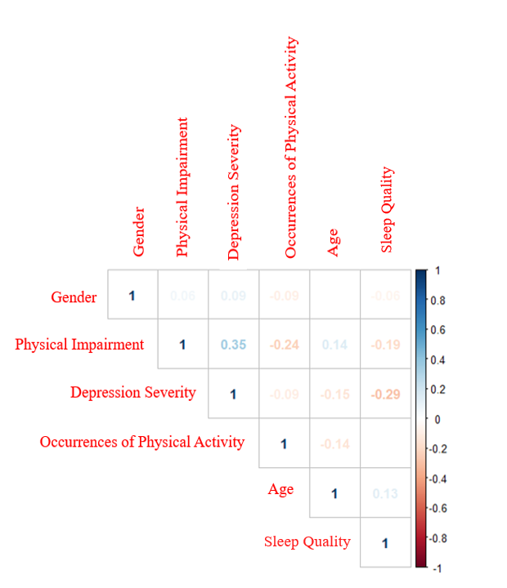

**Fig 2. Correlation matrix between independent**

variables, possible confounding variables and physical impairment.

Made using Spearman’s Rank correlation, p <0.01 for all shown

**Physical Activity vs Sleep Quality**

  To assess if physical impairment was more impacted by the combination of no PA and depression or poor SQ and depression, ANOVA tests were run. To assess SQ’s impact on physical impairment, significant differences were found between groups that had poor SQ vs. adequate SQ within each DS group. Significant differences between physical impairment scores were found only in the mild (p<0.01) and no depression (p< 0.0001) groups (Fig 3). By comparison, in the moderately severe, moderate, mild and no depression groups, significant differences were found between the no PA vs PA groups regarding physical impairment scores (p<0.0001, p<0.001, p<0.0001, p<0.0001). No such differences were found between participants that were active vs. inactive in the severe depression group (p<0.9);(Fig 4). SQ and depression individually each had a significant impact on physical impairment (p<0.0001 all); no interactions between independent variables were significant.

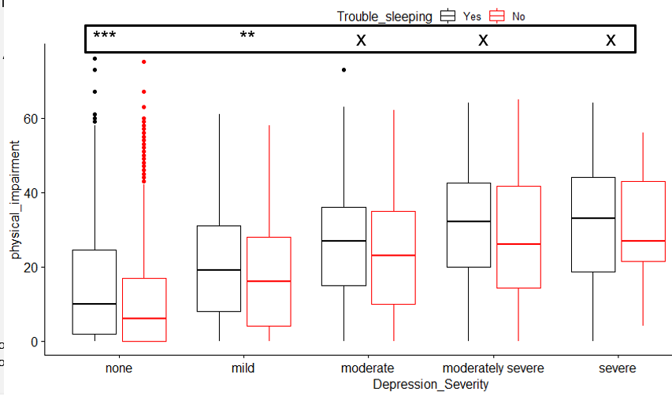

**Fig 3. Distribution of physical impairment scores across depression severities. Subgroups divided based on** whether participants had trouble sleeping in the past week; (p < 0.0001 = ***; p< 0.001= **; insignificant = “ x”)

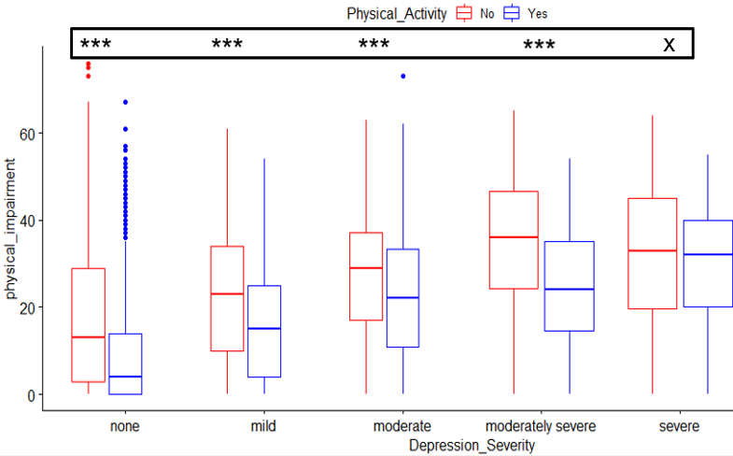

**Fig 4. Distribution of physical impairment scores across depression severities. Subgroups divided on whether** participants had at least one occurrences of moderate PA; (p < 0.0001 = ***; p< 0.001= **; insignificant = “ x”)

**Sleep Quality vs Depression Severity**

To assess if physical impairment was more impacted by the combination of poor SQ and PA or having depression and PA, ANOVA tests were run. The poor SQ group had significantly higher physical impairment in groups that exhibited 0-15 occurrences of PA per week (Activity levels: 0, 1-3, 4-6, 7-9, 13-15);(p < 0.0001, all). There were no significant differences in physical impairment between SQ groups in the bins of 10-12, 16-18 occurrences of PA(p<0.04, p< 0.2); (Fig 5). The 19-21 occurrences of MPA group was excluded due to small sample size ( < 30).

To assess depression’s impact on physical impairment, significant differences were found between groups that had mild to severe depression vs. no depression within each activity group. By comparison, the mild to severe depression group significantly impacted physical impairment scores in all PA groups (0, 1-3, 4-6,7-9,10-12,13-15,16-18,19-21);(p < 0.0001 all). The significance level of TS vs no TS is shown in Fig 6. The 19-21 activity level was excluded due to small sample size.

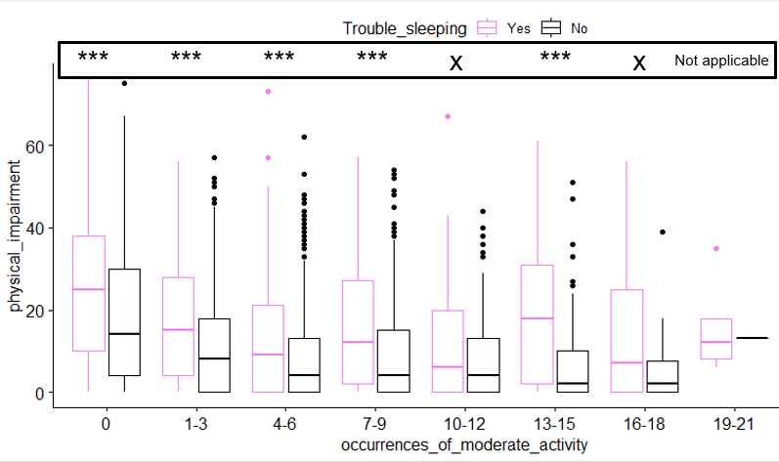

**Fig 5. Distribution of physical impairment scores across occurrences of moderate PA. Subgroups divided on** whether participants had trouble sleeping in the past week; (p < 0.0001 = ***; p< 0.001= **; insignificant = “x ”)

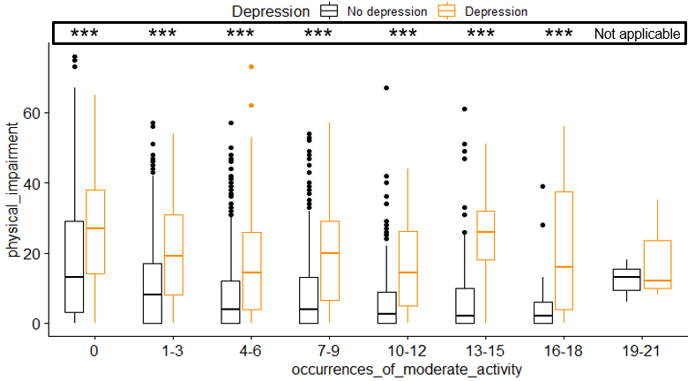

**Fig 6. Distribution of physical impairment scores across occurrences of moderate PA.**  **Subgroups divided on** whether participants had depression; (p < 0.0001 = ***; p< 0.001= **; insignificant = “ x”)

**Individual  Lifestyle Factors**

Multiple linear regression was used to identify how much variance in physical impairment scores is individually attributed to PA, SQ and mild to severe depression within the sample. In the final model, gender and age were controlled for. (R^2 = 0.22). Depression explained most of the variance (0.12), followed by PA (0.06) and SQ (0.04).

**Discussion**

This study aimed to find which combinations of the LFs PA, SQ and depression have the greatest impact on functional ability in individuals with arthritis over fifty. Results from the correlation matrix suggest that age can directly affect functional ability. Age can also have an indirect effect on functional ability through its correlation with PA, SQ and depression. The Spearman’s correlation did find that Depression (0.35),and PA(-0.24) had the strongest correlation to physical impairment, further supporting the Multiple Linear Regression. However, the spearman’s rank correlation found that DS and TS had a moderately strong relation with each other (-0.29) while DS and occurrences of PA had a weak correlation (-0.09). This suggests that interrelations between LFs are not always indicative of LFs having strong associations with functional ability.

This study also determined the combined effects of no PA and depression on physical impairment scores and compared it to the effects of poor SQ with depression. Across all depression severities, excluding the severe depression group, there was a highly significant difference in level of physical impairment between inactive and active people with arthritis over 50 years of age. The significance suggests that PA is associated with lower levels of physical impairment in people with arthritis who also have none to moderately severe depression. This finding supports efforts to increase PA in arthritis patients by as little as 1 day a week. This finding is similar to [29], where researchers found that significant differences among mental wellbeing in participants that were inactive vs those that participated in exercise at least 1 day per week. The positive impact that exercise had on functional ability, even among people with depression was also observed in [35]. This study incorporated exercise into mental health care for people with arthritis and mental illness and observed a decrease in functional limitations. Taken together, these findings suggest that PA may directly impact physical impairment, and indirectly impact physical impairment through depression [36]. The association between depression and PA in impacting physical impairment might be applied to other mental health issues. The role of anxiety in limiting functional ability should be further researched to avoid grouping together mental illnesses that have different responses to similar biological treatments [37].

In comparison, physical impairment was only significantly impacted by SQ in groups with mild and no depression. This suggests that measures to improve SQ might not be as beneficial as efforts to increase PA. Since increasing frequency of PA is an affordable lifestyle change, it should be further emphasized as part of treatment options and regarded as a treatment confounder in people with arthritis and milder forms of depression over fifty. Improving SQ is also an affordable lifestyle change, although it might only be beneficial in people with mild and no depression. Further research should be done to identify how different doses of sleep can impact functional ability in an older arthritis population [38].

Additionally, this study determined the combined effects of poor SQ and PA on physical impairment scores and compared it to the effects of depression and PA. Within most activity levels, physical impairment was higher in the poor SQ groups than the group with adequate SQ. There were two exceptions(10-12, 16-18 PA groups). This suggests that poor SQ impacts physical ability in inactive individuals and individuals with fewer occurrences of moderate physical activity. Interestingly, depression had a consistent significant impact on physical impairment. The combination of no PA with depression was seen to be more impactful on physical impairment than any other combination. It is plausible that higher physical impairment was observed in groups that were inactive because of the positive benefits associated with tolerable exercise including improving functional ability [39-40]. However, the significant difference in PA across depression severities was observed in all depression groups except severe depression. That might indicate that in cases of severe depression in arthritis, more aggressive treatment is needed to improve mental health [41].

  It is unclear if the findings of the Inactivity/Depression combination having the strongest association with physical impairment is due to the indirect effects stemming from the relation between PA and depression. The degree to which a bidirectional relation between PA and depression impacted these results remains unclear because causality could not be established in this study. Future research should compare the degree to which indirect effects can impact functional ability when depression is known to be impacting PA [42-43].

It is important to note that the sample size of adults over fifty might have impacted findings. In [44], researchers saw that the presence of an age-related health issue raised the likelihood of multimorbidity being associated with functional limitations in men over 50 years of age. This suggests that age can impact functional ability through several LFs. Further investigation is needed into mediating effects of age regarding functional ability. Because it is common for older adults to experience comorbidities in both medical and psychiatric fields, examining a younger sample might change distributions regarding PA levels or functional impairment [45]. Treatment outcomes in younger populations of arthritis should be studied separately because of the devastating long term impact arthritis can have on mental health, work ability, medical costs and economic losses [34, 41, 46].

**Conclusions**

These findings have provided insight into how functional ability is impacted by PA, SQ and depression individually and in binary combinations. The inactivity and depression combination being most impactful on physical impairment suggests that adjunctive therapies to maintain stable mental health and increase PA should be incorporated into existing arthritis treatments [47-48]. Interventions to increase PA should also emphasize treatment adherence and take into account patient preferences to optimize treatment effectiveness [49-50]. The role of LFs in achieving remission needs to take into further account the vast array of lifestyles in the nationwide arthritis population. The COVID-19 pandemic has changed lifestyle practices worldwide. The negative implications of the COVID-19 pandemic on functional ability should be investigated to better adjust treatments for patients.

References

[1]   E. Havens *et al.*, “Comorbid arthritis is associated with lower health-related quality of life in older adults with other chronic conditions, United States, 2013-2014,” *Prev. Chronic Dis.*, vol. 14, no. 7, pp. 1–11, 2017. Accessed on: July 13, 2020. [Online]. Available: doi: 10.5888/pcd14.160495.

 [2]  C. Radawski *et al.*, “Patient Perceptions of Unmet Medical Need in Rheumatoid Arthritis: A Cross-Sectional Survey in the USA,” *Rheumatol. Ther.*, vol. 6, no. 3, pp. 461–471, 2019. Accessed on: July 19, 2020. [Online]. Available: doi: 10.1007/s40744-019-00168-5.

[3]   E. J. Soini *et al.*, “Administration costs of intravenous biologic drugs for rheumatoid arthritis,” *Springerplus*, vol. 2, no. 1, pp. 1–11, 2013. Accessed on: July 18, 2020. [Online]. Available: doi: 10.1186/2193-1801-2-531.

[4] E. Schulman *et al.*, “Overweight, Obesity, and the Likelihood of Achieving Sustained Remission in Early Rheumatoid Arthritis: Results From a Multicenter Prospective Cohort Study,” *Arthritis Care Res.*, vol. 70, no. 8, pp. 1185–1191, 2018. Accessed on: Oct 1, 2020. [Online]. Available: doi: 10.1002/acr.23457.

[5] Z. Brown *et al.*, “Modifiable Lifestyle Factors Associated With Response to Treatment in Early Rheumatoid Arthritis,” *ACR Open Rheumatol.*, vol. 2, no. 6, pp. 371–377, 2020. Accessed on: Oct 1, 2020. [Online]. Available: doi: 10.1002/acr.23457. doi: 10.1002/acr2.11132.

[6] M. N. Lwin, L. Serhal, C. Holroyd, and C. J. Edwards, “Rheumatoid Arthritis: The Impact of Mental Health on Disease: A Narrative Review,” *Rheumatol. Ther.*, vol. 7, no. 3, pp.

457–471, 2020. Accessed on: Oct 1, 2020. [Online]. Available: doi: 10.1002/acr.23457. doi: 10.1007/s40744-020-00217-4.

[7]   B. D. James *et al.*, “Relation of late-life social activity with incident disability among community-dwelling older adults,” *Journals Gerontol. - Ser. A Biol. Sci. Med. Sci.*, vol. 66 A, no. 4, pp. 467–473, 2011. Accessed on: July 20, 2020. [Online]. Available:  doi: 10.1093/gerona/glq231.

[8]   M. Ishida *et al.*, “Residual symptoms and disease burden among patients with rheumatoid arthritis in remission or low disease activity: a systematic literature review,” *Mod. Rheumatol.*, vol. 28, no. 5, pp. 789–799, 2018. Accessed on: July 17, 2020. [Online]. Available:  doi: 10.1080/14397595.2017.1416940.

[9]   T. White *et al.*, “Daily walking and the risk of incident functional limitation in knee osteoarthritis: an observational study,” *Arthritis Care* & *Res.*, vol. 66, no. 9, pp. 1328–1336. . Accessed on: July 3, 2020. [Online]. Available:<https://doi.org/10.1002/acr.22362e>.

[10] “National Statistics,” *Centers for Disease Control and Prevention*, 07-Feb-2018. [Online]. Available:<https://www.cdc.gov/arthritis/data_statistics/national-statistics.html#References>. [Accessed: 04-Aug-2020].

[11] “Older Adults and COVID-19,” *Centers for Disease Control and Prevention*. [Online]. Available: https://www.cdc.gov/coronavirus/2019-ncov/need-extra-precautions/older-adults.html#:~:text=Risk for Severe Illness Increases with Age&text=The greatest risk for severe,as having underlying medical conditions. [Accessed: 04-Aug-2020].

[12]   N. Inanc *et al.,*“The role of depression, anxiety, fatigue, and fibromyalgia on the evaluation of the remission status in patients with rheumatoid arthritis,” *J. Rheumatol.*, vol. 41, no. 9, pp. 1755–1760, 2014. Accessed on: July 18, 2020. [Online]. Available:  doi: 10.3899/jrheum.131171.

[13]   S. Zhao *et al.*, “The prevalence of depression in axial spondyloarthritis and its association with disease activity: A systematic review and meta-analysis,” *Arthritis Res. Ther.*, vol. 20, no. 1, pp. 1–9, 2018. Accessed on: July 12, 2020. [Online]. Available: doi: 10.1186/s13075-018-1644-6.

[14]   I. F. Backe *et al.*, “The relationship between physical functional limitations, and psychological distress: Considering a possible mediating role of pain, social support and sense of mastery,” *SSM - Popul. Heal.*, vol. 4, no. 0403, pp. 153–163, 2018. Accessed on: July 16, 2020. [Online]. Available: doi: 10.1016/j.ssmph.2017.12.005.

[15]     J. M. Brooks *et al.,* “Doctor-Diagnosed Arthritis and Self-Reported Physical Health Function Among Middle-Aged and Older Adults With Serious Mental Illness,” *J. of Nerv,. Ment. Dis.,* vol. 207, no. 11, pp. 908-912, Nov 2019*.* Accessed on: July 16, 2020. [Online]. Available: doi:10.1097/nmd.0000000000001078

[16] A. J. Z. Sturgeon  *et al.,* “Affective disturbance in rheumatoid arthritis: psychological and disease-related pathways,” *Physiol. Behav.*, vol. 12, no. 9, pp. 532–542, 2016. Accessed on: July 18, 2020. [Online]. Available: doi: doi:10.1038/nrrheum.2016.112.

[17]      Lee S.  *et al.,* “Sleep Health and its contributions to the mechanisms of functional limitations,” *Innov.Aging,* vol. 2, no. 1, pp. 547-548, 2018.  Accessed on: July 13, 2020. [Online]. Available: <https://doi.org/10.1093/geroni/igy023.2022>

[18]       Stone K. L. *et al.,* “Sleep Health and functional limitations in older adults. *Innov Aging,* vol. 2, no. 1, pp. 547-548, 2018. Accessed on: July 13, 2020. [Online]. Available:   doi: [10.1093/geroni/igy023.2024](https://dx.doi.org/10.1093%2Fgeroni%2Figy023.2024)

[19] F. S. Luyster *et al.*, “Sleep quality and functional disability in patients with rheumatoid arthritis,” *J Clin. Sleep. Med.l,* vol. 7, no. 1, pp. 49-55, 2011. Accessed on: July 17, 2020. [Online].  Available:  10.5664/jcsm.28041.

[20] I. Grabovac *et al.*, “Sleep Quality in Patients with Rheumatoid Arthritis and Associations with Pain, Disability, Disease Duration, and Activity,” *J. Clin. Med.*, vol. 7, no. 10, p. 336, 2018. Accessed on: July 1, 2020. [Online]. Available: doi: 10.3390/jcm7100336.

[21] K. A. Theis *et al.*, “ When You Can’t Walk a Mile: Walking Limitation Prevalence and Associations Among Middle‐Aged and Older US Adults with Arthritis: A Cross‐Sectional, Population‐Based Study ,” *ACR Open Rheumatol.*, vol. 1, no. 6,  pp. 350- 358, 2019. Accessed on: July 13, 2020. [Online]. Available:  doi: 10.1002/acr2.11046.

[22] L. J. Geneen *et al.*, “Physical activity and exercise for chronic pain in adults,” *J. Sociol.,* vol. 1, no. 4, 2017. Accessed on: July 5, 2020. [Online]. Available:doi: 10.1002/14651858.CD011279.pub3.

[23] R. A. Fielding *et al.*, “Dose of physical activity, physical functioning and disability risk in mobility-limited older adults: Results from the LIFE study randomized trial,” *PLoS One*, vol. 12, no. 8, pp. 1–20, 2017. Accessed on July 18, 2020. [Online]. Available: doi: 10.1371/journal.pone.0182155.

[24] S. I. McFarlane, “Depression, obstructive sleep apnea and psychosocial health,” *Sleep Med. Disord. Int. J.*, vol. 1, no. 3, pp. 58–63, 2017. Accessed on: July 2, 2020. [Online]. Available:  doi: 10.15406/smdij.2017.01.00012.

[25] B. Stubbs *et al.*, “EPA guidance on physical activity as a treatment for severe mental illness: a meta-review of the evidence and Position Statement from the European Psychiatric Association (EPA), supported by the International Organization of Physical Therapists in Mental,” *Eur. Psychiatry*, vol. 54, pp. 124–144, 2018. Accessed on: July 14, 2020. [Online]. Available:  doi: 10.1016/j.eurpsy.2018.07.004.

[26] S. E. Furner *et al.*, “Health-related quality of life of us adults with arthritis: Analysis of data from the behavioral risk factor surveillance system, 2003, 2005, and 2007,” *Arthritis Care Res.*, vol. 63, no. 6, pp. 788–799, 2011. Accessed on: July 14, 2020. [Online]. Available: doi: 10.1002/acr.20430.

[27] A. Ali, “Prevalence of Poor Sleep and Relationship of Physical Exercise with Sleep among Male Adult Exercisers,” *J. Accounting and Finance in Emerging Economies,* vol. 6, no. 2, pp. 539–545, 2020.Accessed on: July 15, 2020. [Online]. Available: **DOI:** <https://doi.org/10.26710/jafee.v6i2.1233>

[28] K. Kroenke, R. L. Spitzer, and J. B. W. Williams, “The PHQ-9: Validity of a brief depression severity measure,” *J. Gen. Intern. Med.*, vol. 16, no. 9, pp. 606–613, 2001. Accessed on: July 25, 2020. [Online]. Available:  doi: 10.1046/j.1525-1497.2001.016009606.x.

[29] M. A. Harris, “The relationship between physical inactivity and mental wellbeing: Findings from a gamification-based community-wide physical activity intervention,” *Heal. Psychol. Open*, vol. 5, no. 1, 2018. Accessed on: July 3, 2020. [Online]. Available:  doi: 10.1177/2055102917753853.

[30]     C. L. Cleland *et al.* “Validity of the Global Physical Activity Questionnaire (GPAQ) in assessing levels and change in moderate-vigorous physical activity and sedentary behaviour,” *BMC Public Health*, vol. 14, no. 1, pp. 1–11, 2014.  Accessed on: July 8, 2020. [Online]. Available: https://doi.org/10.1186/1471-2458-14-1255

[31]   A. Singh and B. Purohit, “Evaluation of Global Physical Activity Questionnaire (GPAQ) among Healthy and Obese Health Professionals in Central India,” *Balt. J. Heal. Phys. Act.*, vol. 3, no. 1, pp. 34–43, 2011. Accessed on: July 18, 2020. [Online]. Available: doi: 10.2478/v10131-011-0004-6.

[32] R. Westhovens *et al.,* “Sleep problems in patients with rheumatoid arthritis”, *J. Rheumatol.*, vol. 41, no. 1, pp. 31–40, 2014.  Accessed on: July 18, 2020. [Online]. Available:  DOI: [10.3899/jrheum.130430](https://doi.org/10.3899/jrheum.130430)

[33] K. M. Latocha *et al.*, “Cognitive behavioural therapy for insomnia in patients with rheumatoid arthritis: Protocol for the randomised, single-blinded, parallel-group Sleep-RA trial,” *Trials*, vol. 21, no. 1, pp. 1–17, 2020. Accessed on: July 3, 2020. [Online]. Available: doi: 10.1186/s13063-020-04282-6.

[34] A. Van Schaaijk and K. Nieuwenhuijsen, “Work ability and percentage of hours worked related to limitations in patients with upper extremity musculoskeletal disorders : a cross-sectional cohort study,” *BMC Musculoskelet. Disord.,* vol. 21, no. 389, pp. 1–12,  June 2020. Accessed on: July 18, 2020. [Online]. Available: doi: [10.1186/s12891-020-03387-y](https://dx.doi.org/10.1186%2Fs12891-020-03387-y).

[35] G. A. Kelley *et al.*, “Effects of exercise on depression in adults with arthritis: A systematic review with meta-analysis of randomized controlled trials,” *Arthritis Res. Ther.*, vol. 17, no. 1, 2015. Accessed on: July 18, 2020. [Online]. Available: doi: 10.1186/s13075-015-0533-5.

[36] G. A. Kelley *et al.*, “Community-deliverable exercise and anxiety in adults with arthritis and other rheumatic diseases: A systematic review with meta-analysis of randomised controlled trials,” *BMJ Open*, vol. 8, no. 2, pp. 1–17, 2018. Accessed on: July 15, 2020. [Online]. Available: doi: 10.1136/bmjopen-2017-019138.

[37] M. Ziarko *et al.*, “Mental Health and Rheumatoid Arthritis: Toward Understanding the Emotional Status of People with Chronic Disease,” *Biomed Res. Int.*, vol. 2019, 2019. Accessed on: July 3, 2020. [Online]. Available:  doi: 10.1155/2019/1473925.

 [38] I. Grabovac *et al.*, “Sleep Quality in Patients with Rheumatoid Arthritis and Associations with Pain, Disability, Disease Duration, and Activity,” *J. Clin. Med.*, vol. 7, no. 10, p. 336, 2018, doi: 10.3390/jcm7100336.

 [39] S. M. McDonough *et al.*, “Pedometer-driven Walking for Chronic Low Back Pain

A Feasibility Randomized Controlled Trial,” *Clin J. Pain,* vol. 33, no. 4, pp. 395–401, 2015. Accessed on: July 24, 2020. [Online]. Available:  doi:10.1097/AJP.0b013e31827f9d81.

[40]     M.G. Cisternas *et al., “*Walking and the 2‐year risk of functional decline: an observational study of US adults with arthri-tis”, *Prev Med*., vol. 119, pp. 100–7. Accessed on: July 18, 2020. [Online]. Available: doi: 10.1016/j.ypmed.2018.12.022

[41] A. Deb, *et al.*, “Burden of Depression among Working-Age Adults with Rheumatoid Arthritis,” *Arthritis*, vol. 2018, pp. 1–11, 2018. Accessed on: July 20, 2020. [Online]. Available:  doi: 10.1155/2018/8463632.

 [42] E. Dean and A. Söderlund, “What is the role of lifestyle behaviour change associated with non-communicable disease risk in managing musculoskeletal health conditions with special reference to chronic pain?,” *BMC Musculoskelet. Disord.*, vol. 16, no. 1, pp. 1–7, 2015.Accessed on: June 28, 2020. [Online]. Available:  doi: 10.1186/s12891-015-0545-y.

 [43] H. Jahrami *et al,*, “Assessing dietary and lifestyle risk behaviours and their associations with disease comorbidities among patients with depression: A case-control study from Bahrain,” *Heliyon*, vol. 6, no. 6, p. e04323, 2020. Accessed on: July 15, 2020. [Online]. Available: doi: 10.1016/j.heliyon.2020.e04323.

[44] M. L. Gates *et al.*, “Multimorbidity patterns and associations with functional limitations among an aging population in prison,” *Arch. Gerontol. Geriatr.*, vol. 77, no. June 2017, pp. 115–123, 2018. Accessed on: July 16, 2020. [Online]. Available: doi: 10.1016/j.archger.2018.03.012.

[45] K.E. Barbour  *et al.,* “Vital Signs: Prevalence of Doctor-Diagnosed Arthritis and Arthritis-Attributable Activity Limitation — United States, 2013–2015”. *MMWR Morb Mortal Wkly Rep.* , vol. 66, no. 9, pp. 246–253, 2017. Accessed on: July 15, 2020. [Online]. Available:DOI: http://dx.doi.org/10.15585/mmwr.mm6609e1External.

[46] L. A. C. Machado *et al.*“Prevalence of Pain and Associated Factors in Brazilian Civil Servants: an Introductory Analysis Using Baseline Data From the Elsa-Brasil Cohort,” vol. 4, pp. 550–550, 2019. Accessed on: July 13, 2020. [Online]. Available: doi: 10.5151/sbr2019-550.

[47] C. F. R. Silva *et al.,* “Depression, disability and sleep disturbance are the main explanatory factors of fatigue in rheumatoid arthritis: a path analysis model,” *Clin. Exp. Rheumatol.*, vol. 38, no.2, pp. 314–321, 2020. Accessed on: July 18, 2020. [Online]. Available:<https://www.altmetric.com/details/79060298>

[48] T. Nosratzehi, S. Nosratzehi, M.Nosratzehi, and I. Ghaleb, “Oral health-related quality of life in patients with rheumatoid arthritis,” *Open Access Rheumatol. Res. Rev.*, vol. 11, pp. 309–313, 2019. Accessed on: July 19, 2020. [Online]. Available: doi:10.2147/OARRR.S222607.

[49] S. Austin, H. Qu, and R. M. Shewchuk, “Health care providers’ recommendations for physical activity and adherence to physical activity guidelines among adults with arthritis,” *Prev. Chronic Dis.*, vol. 10, no. 11, pp. 1–10, 2013. Accessed on: July 16, 2020. [Onlin] doi: 10.5888/pcd10.130077.

[50] C. N. Durand *et al.,* “Patient Preferences for Disease-modifying Antirheumatic Drug Treatment in Rheumatoid Arthritis: A Systematic Review,” *J. Rheunatol.*, vol 47, no. 2, pp. 176-187, Apr 2019. Accessed on: July 14, 2020. [Online]. Available: DOI: [10.3899/jrheum.181165](https://doi.org/10.3899/jrheum.181165).