**The Cardiovascular Implications of Racial Discrimination**

**Isabelle John**

The purpose of this study was to evaluate how perceived racial discrimination can be a determinant of cardiovascular health (CVH). The choice to focus specifically on CVH as cardiovascular diseases (CVD) was made because they are some of the main causes of death in the United States; CVD account for 1 out of every 3 deaths in the nation. History has shown that racial minorities, especially black people, are at an extremely high risk to damaging stressors such as lack of housing, poor medical care, hate crimes, unemployment, etc. There is reason to believe that these stressors, brought about by discrimination, put racial minorities at risk for CVD. Similar studies have revealed that racial discrimination drives poor CVH and is linked to CVD like hypertension and obesity. The methodology included a cohort of black and white men and women with an age match of 18-65. Each participant will complete two surveys: The expanded everyday model of the Experiences of Discrimination survey (EOD) and the ABCD CVH questionnaire. The EOD survey evaluated the level and severity of discrimination they face in their lives. The ABCD CVH questionnaire evaluated their cardiovascular health and knowledge of their health. Both surveys were administered digitally. The results of these surveys were compared and grouped with each section of the cohort: white male, white female, black male, and black female. The intention was to give racial minorities the compensation they deserve when it comes to healthcare, housing, education, and treatment. The data revealed that black men and women have higher rates of experienced discrimination and thus have worse overall CVH than their white peers. However white women reported worse cardiovascular outcomes than black women. For future studies, location, ability, language, and education should be considered.

**Introduction**

Racism having an effect on one’s cardiovascular health is not a new concept. For decades, scientists and activist have been pointing out the link between racial oppression and illness (Slopen, 2010). This is due to several factors such as systemic oppression that forces minorities into poverty and leaves them with inadequate resources and healthcare (Krieger, 2008). Additionally, discrimination in the most direct sense, like harassment and hate crimes, can put stress on the body and mind (Gee, 2011). In a more recent observation, discrimination was linked to sedentary behavior, smoking, hypertension, obesity, and heart disease (Udo & Grilo, 2017). It was also found that racism drives poor cardiovascular health (Ferdinand & Nasser, 2017). Therefore, observing the cardiovascular implications of racial discrimination can further support the dismantling of racism and racist institutions (Chae, 2008). With scientific backings, issues like the ones previously mentioned that are endangering minorities can be addressed and hopefully solved in the near future.

When evaluating racism’s effects on cardiovascular health, more often than not, the participants are offered a questionnaire to evaluate their experiences with discrimination. This is the best way to gauge and measure experiences of discrimination as they exist nowhere but in one’s memories and feelings. However, a major issue is that one’s perception of a situation may not be entirely accurate; their accounts might be exaggerated or toned-down dependent on the individual (Nystedt, 2019). A study conducted on the intersectional effects of racial and gender discrimination on cardiovascular health (Bey, 2019), only 5% of white men reported both racial and gender discrimination, and those who did had the worst overall cardiovascular health than any other group. White men do not face any institutional or systemic oppression as the world’s current institutions and systems were built by and for them. However, the questionnaire revealed that their perception of this is inconsistent of this reality. Therefore, a failing of this method of observation is that it is entirely based in an individual’s feelings. There is no hard and fast evidence to rely on.

In this study, the experiences of perceived racial discrimination from the participants were measured and used to indicate a correlation for each participant’s cardiovascular health. Each of participant’s responses were indicative of how much racial discrimination had an effect on their health. It is important to note that all experiences mentioned were scored in the same way and not looked at individually. No two lives are the same, so details must be left out of the analysis. In the

creation of the Experiences of Discrimination (EOD) survey (Kreiger, 2005), each event of discrimination was assigned a point value using a scoring system designed for this questionnaire. The scoring system accounts for both the event actually occurring and the severity of the event. Unlike most perception based questionnaires, the EOD is designed to measure experiences and isolated events. That way, it is less likely for participants to have biased answers. As this is the survey used in this study, the same rules will apply.

As my study is entitled, my intention was to directly observe the effect perceived racial discrimination has on cardiovascular health. Many studies have shown that both the amount and severity of discrimination has some effect on one’s health and wellbeing (Beatty-Moody, 2011). The health factor is typically measured through some kind of physical examination, which is dependent on which aspect of health the study is focused on. In a study centered around the emotional response to perceived racism, nocturnal heart rate was measured to gage this (Bell, 2019). Participants were given an overnight polysomnography and actigraphy. From then on participants were instructed that every night they are to place electrodes across their sternum and ribs before bed to measure their heart rate variability and blood pressure. Medical exams have proven time and time again to be the most effective method in measuring discrimination’s effect on health.

One thing I hope to address in this study that I have not seen addressed thus far is the institutional/systemic side of discrimination. In most studies I have reviewed, the way discrimination is evaluated singles out hate crimes and aggressions between individuals. And although these are still very important, it leaves out something much bigger and more difficult to tackle. Most people reading might depersonalize themselves from racism because they know they would never “do such a thing” which can nullify the impact of studying hate crimes and aggressions. However, when zeroing in on institutional and systemic discrimination like unequal housing, bias in the justice system, and unequal employment, it shows that the world’s institutions are largely at fault, not a few bad people. Many studies have revealed that people of color in America, specifically black Americans, suffer the most when it comes to discrimination on both the institutional and interpersonal level, but only focusing on small encounters leaves out their experiences while also inflating the few experiences of majority groups. Therefore, I hypothesize

that Black people experience worse cardiovascular health due to experiences of racial discrimination.

**Methodology**

There were 40 participants, aged 18-65 in this study: 12 black women, 10 black men, 8 white women, and 4 white men. 6 participants chose “other” when asked to report their race. These individual’s data will not be reported in the results, there for making the final sample size 34. The participants were also evaluated on their average annual income. 3 reported making an average of <$40,000, 32 reported making between $40,000 and $120,000, and 23 reported making >$120,000 annually.

**Experiences of Discrimination Survey**

The first evaluation is the Experiences of Discrimination: Expanded Everyday Model survey (Williams, 2016). In this survey, participants are prompted with the following 9 statements regarding the frequency and severity of everyday acts of discrimination: 1) You are treated with less respect than other people are. 2) You are treated with less respect than other people are. 3) You receive poorer service than other people at restaurants or stores. 4) People act as if they think you are not smart. 5) People act as if they are afraid of you. 6) People act as if they think you are dishonest. 7) People act as if they’re better than you are. 8) You are called names or insulted. 9) You are threatened or harassed. They are given 5 answer choices for each statement: a) almost everyday b) at least once a week c) a few times a month d) less than once a year e) never. Each answer is assigned a point value of 1-5 ending in a score out of 54, “a” being the highest and “e”being the lowest. Those reporting higher scores will be considered as having reported higher levels of experienced discrimination. Finally, there is an open ended follow up question “What do you think is the main reason for these experiences?”. This is to assess how the participants perceive their degree of discrimination. A possible answer could be “my race” or “my age”. The answers to this question will not be included in the results but in the discussion and conclusions.

**ABCD CVH Questionnaire**

The second survey is the ABCD CVH questionnaire. This 85 item questionnaire will assess the participants knowledge and risk of CVD prevention, perceived risk and vulnerability of CVD, perceived susceptibility, perceived severity, perceived benefits, perceived barriers, self-efficacy, and intention to change behavior or cues to action. Each of these categories have anywhere from 4-5 response options or are true or false. The correct answer will earn the participant either 1,4, or 5 points. For the answers with multiple response options, the point value will decrease with the accuracy. Participants with a higher overall score on this questionnaire will be labeled has having better cardiovascular health whereas those with a higher overall score will be labeled as having poorer cardiovascular health.

**Results and Data**

Black female participants reported the highest rates of perceived racial discrimination with an average score of 25.25/54 on the EOD with a standard error of 1.90692518. Black males placed after with an average score of 24.5 and a standard error of 1.78418983, followed by white females with an average score of 17.63 and standard error of 1.90773577 and white males with an average score of 12.75 and standard error of 1.92353841.

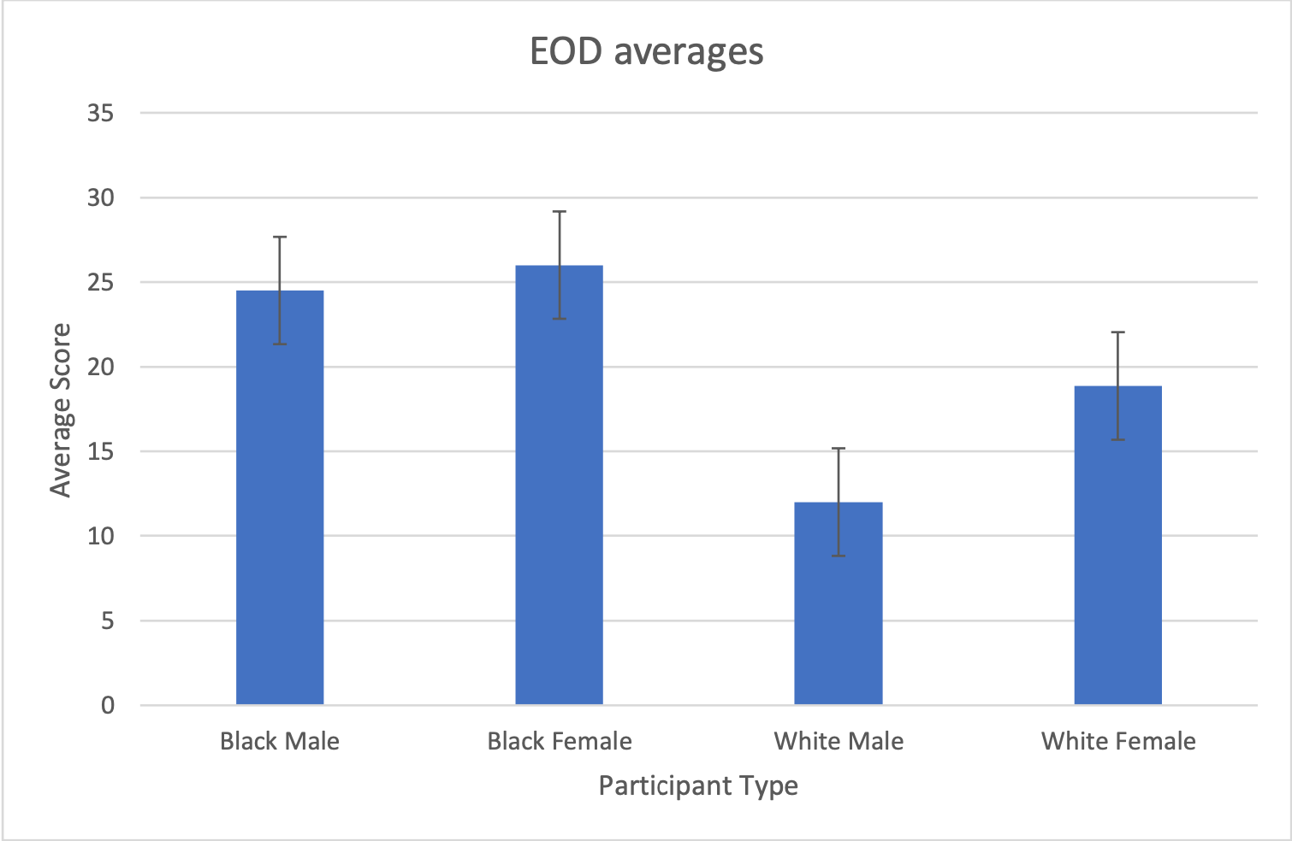

Figure 1: averages from EOD survey

Black males scored the highest on the ABCD CVH questionnaire and therefore had the worst overall cardiovascular health with an average score of 179.5 and a standard error of 2.34402313. White females had the second highest score of 174.13 and a standard error of 8.2705115, then followed by black females with a score of 171.67 and standard error of 5.47353596 and white males with an average score of 162 and a standard error of 5.27636238

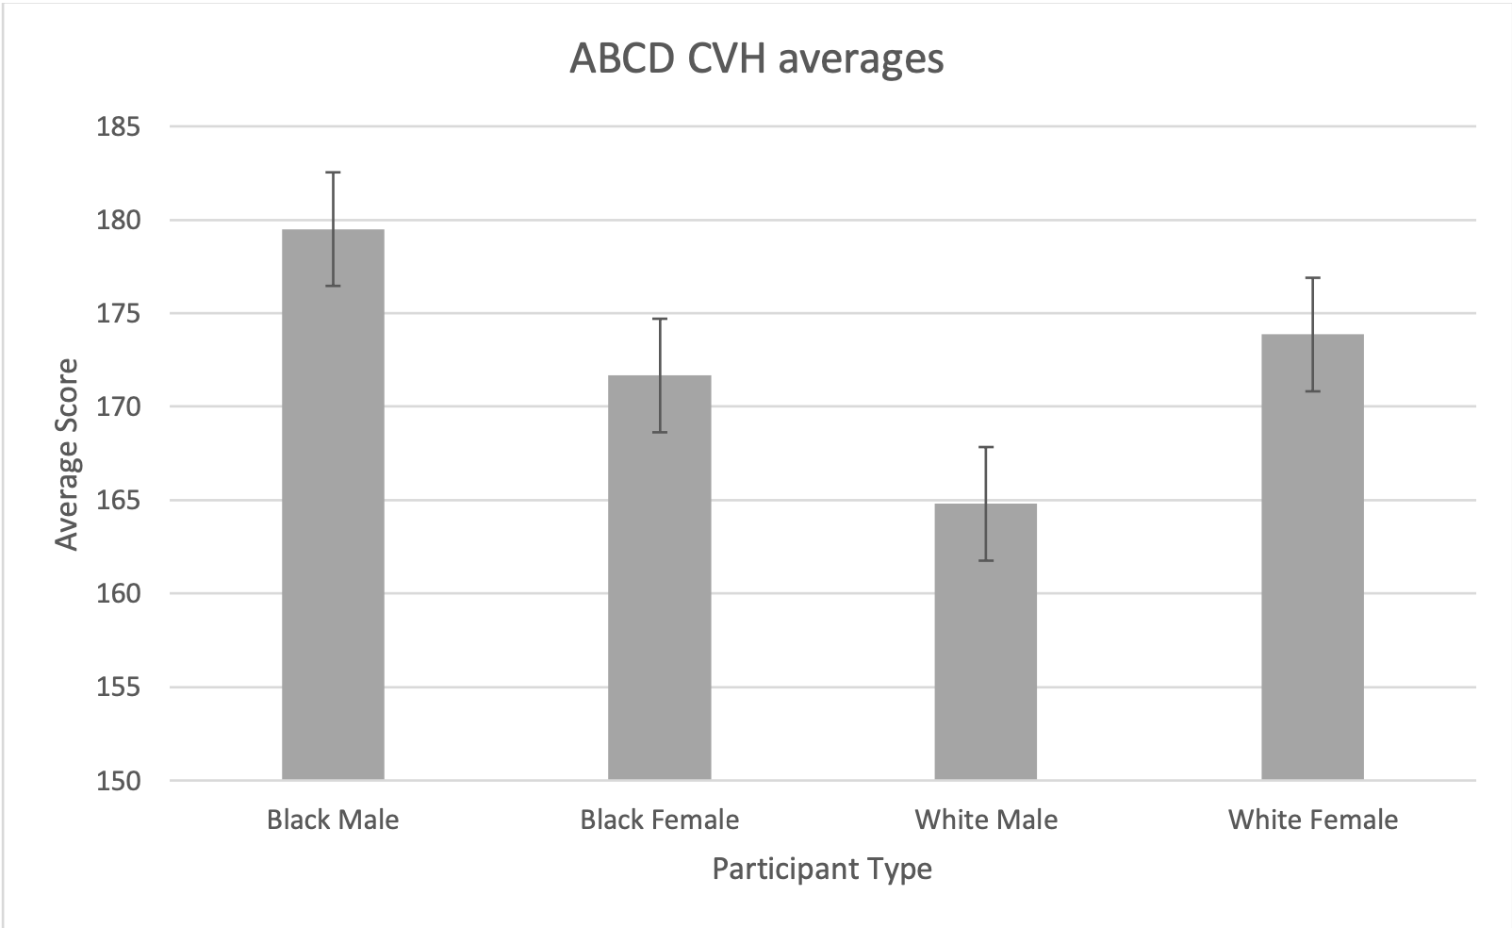

Figure 2: averages from ABCD CVH questionnaire

Black males had consistently high scores in each survey. White males had the lowest scores in each survey. Black females reported discrimination at greater rates than white women but reported better cardiovascular health than white women. Each participant’s scores from the surveys were placed under a correlation analysis.

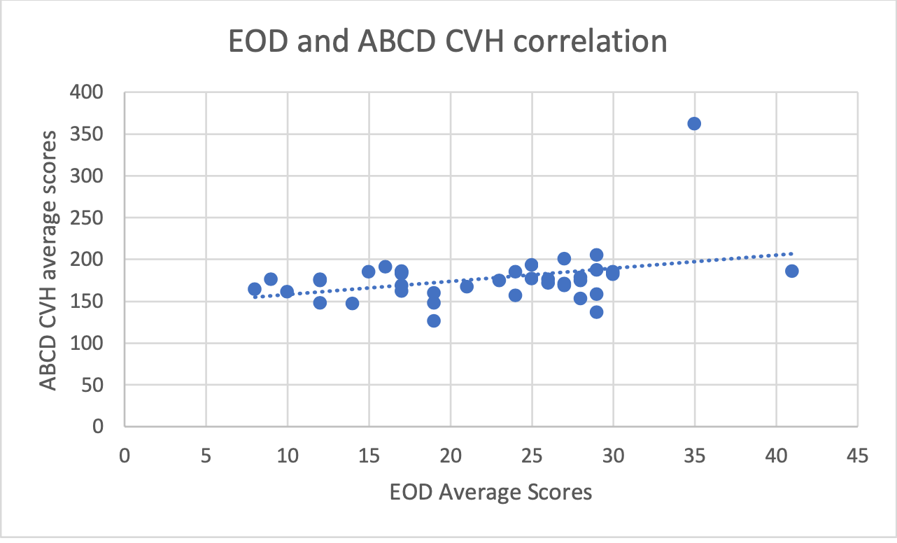

Figure 3: Scatterplot of survey data.

As indicated by the positive slope of the line of best fit in the scatterplot, it can be determined that there is a correlation between higher rates of perceived discrimination and poorer cardiovascular outcomes. Using the correlation coefficient formula 𝑟 = ∑(𝑥𝑖− 𝑥̅)(𝑦𝑖− 𝑦̅) . r was determined to √∑(𝑥𝑖− 𝑥̅)2∑(𝑦𝑖− 𝑦̅)2 be 0.3465. The significance level was set at 0.05 and the resulting p-value from this data was 0.028501. Therefore, the data is statistically significant. The data would completely support my hypothesis however white females reported worse cardiovascular health than that of black women.

**Analysis & Conclusions**

**Follow up questions**

When asked to indicate their reasons for any and all perceived racial discrimination, the vast majority of the black participants referred their race or the color of their skin. White women deferred to their gender as a primary cause. White men either left the question unanswered or provided an answer pertaining to their line of work. One of the two white men to cite their race and gender as a cause reported, “Being a white male affords me privilege. There are assumptions made about me due to my whiteness and maleness that are vastly different compared to other races and genders.”

**Additional demographic analysis**

Those who reported a higher income range, regardless of race or gender, had overall lower rates of perceived racial discrimination. Additionally, participants with an annual income below $40,000 reported scored on the EOD and ABCD CVH questionnaire that was higher than their group’s average. This further supports the relevance of the intersections between race, gender, and class. On the same note of intersectionality, the compounding effects of racism and sexism are exemplified in the black female participant’s high rates of reported discrimination as well as the white female participant’s poor cardiovascular outcomes.

**Limitations**

The primary limitation of this study was the sample size. 40 participants are not enough to determine are true correlation between cardiovascular outcomes and perceived discrimination. A future study should have a much larger sample size preferably within the hundreds. A future study should also consider the variables of location, language, ability, and education as they all work to determine one’s access to healthcare and knowledge of what to do to maintain their health.

In regard to confounding variables, the task of observing perceived discrimination and self- reported health outcome can present its own set of issues. Perception plays a key role in how discrimination impacts health as what is perceived may not always accurate. Human error in memory and recollection is not only anticipated but it is expected. And when considering events that can be traumatizing and elicit high emotional response such as encounters with racism or health history, this issue is only exacerbated.

**References**

Beatty-Moody, Danielle L. “Childhood Socioeconomic Status Is Associated with Psychosocial Resources in African Americans: The Pittsburg Healthy Heart Project.” *Health Psychology*, vol. 30, no. 4, July 2011, pp. 472–480.

Bell, Kimberly A. “Emotional Response to Perceived Racism and Nocturnal Heart Rate Variability in Young Adult African Americans.” *Journal of Psychosomatic Research*, vol. 121, Mar. 2019, pp. 88–92.

Bey, G.S. “Intersectional Effects of Racial and Gender Discrimination on Cardiovascular Health Vary among Black and White Women and Men in the CARDIA Study.” *SSM - Population Health*, vol. 8, 2019.

Ferdinand K.C., Nasser S.A. Disparate cardiovascular disease rates in African Americans: The role of stress related to self-reported racial discrimination. Mayo Clinic Proceedings. 2017;92(5):689–692.

Gee, Gilbert C. “Structural Racism and Health Inequities.” *Du Bois Rev*., vol. 8, no. 1, Apr. 2011, pp. 115–132.

Krieger, Nancy. “Experiences of Discrimination: Validity and Reliability of a Self-Report Measure for Population Health Research on Racism and Health.” *Social Science & Medicine*, vol. 61, 2005, pp. 1576–1596.

Krieger, Nancy. “The Inverse Hazard: Blood Pressure, Sexual Harassment, Racial Discrimination, Workplace Abuse and Occupational Exposures in US Low-Income Black, White, and Latino Workers.” *Social Science & Medicine*, vol. 67, 2008, pp. 1970–1981.

Nystedt, Tanya. “The Association of Self-Reported Discrimination to All-Cause Mortality: A Population-Based Prospective Cohort Study.” *SSM - Population Health*, vol. 7, Apr. 2019.

Slopen, Natalie. “Early Life Adversity and Inflammation in African Americans and Whites in the Midlife in the United States Survey.” *Psychosom Med.*, vol. 72, no. 7, Sept. 2010, pp. 694–701.

Udo T., Grilo C.M. Cardiovascular disease and perceived weight, racial, and gender discrimination in U.S. adults. Journal of Psychosomatic Research. 2017;100:83–88.