How Holistic Chiropractic Care Affects Quality of Life and Pain

Julianna Coppola

White Plains High School

**Table of Contents:**

**Abstract- Page 4**

**Introduction- Page 4**

**Materials and Methods- Page 6**

**Results- Page 9**

**Discussion- Page 11**

**Conclusions- Page 12**

**References- Page 13**

**List of Figures:**

**Figure 1: Page 7**

**Figure 2: Page 10**

**Figure 3: Page 10**

**Figure 4: Page 11**

**Abstract**

In this research study we tested how holistic chiropractic care helped patients who were experiencing pain/discomfort/symptoms. This research demonstrated the effects of holistic healing, including and using lasers, and or vitamins. The hypothesis of this study was if 5-10 people attend weekly holistic chiropractic sessions for 7-10 weeks, their QOL scores and or pain scales would improve. The participants took surveys and questionnaires to evaluate change and pain. 5-10 study participants took an initial questionnaire based on pain and the QOL scale. The QOL scale measures overall wellness, including physical, social and emotional health. The participants then began their treatment sessions (30 minutes each). The QOL questionnaire was taken at the beginning of each treatment session, and the pain scale was taken at the beginning and end of every session. This continued for 7-10 weeks. Once all required sessions had been completed, the patient took the questionnaire one last time; recording their overall change/improvement from the first day. We hoped to see a decrease of pain as well as QOL score increase from the first day of treatments to the last. The results concluded that 100% of participants' QOL score increased, and 77% increased by 12 points or more. Similarly, 100% of the patients’ pain improved, 77% of which recorded their pain completely went away after completing treatment weeks.

**Introduction**

Chiropractic care has improved effects of pain the most, seeing as neck pain is one of the leading causes of disability. Compared to acupuncture, medication, and physical therapy, chiropractic has resolved issues faster and easier (Herman et al., 2018). Holistic health care finds the underlying reasons to a patient's symptoms and or conditions. In doing so, holistic health care goes beyond traditional chiropractic. By releasing the underlying issues and root causes to a patient's problems, the body is able to heal quicker and more extensively. The holistic approach refers to the effect on the whole body, considering all aspects of life (Stuber et al., 2018). Physical and mental wellness is easily affected by pain and common conditions, and chiropractic care offers a safe treatment for low back pain (Gedin et.al., 2019).

Chronic pain was able to be treated with chiropractic care and prevent 62-78% of patients from needing surgeries and or taking medication. These conclusions excluded chiropractors using instrument-assisted practices and were drawn from patients only with chronic lower back and neck pain; excluding other ailments (Herman et al., 2018). These results are consistent with studies that indicate many prescription medication affect women and men differently (Corcoran et al., 2018). Patients attending chiropractors’ offices have reportedly had 25-49% of patients being over the age of 65 and using Medicare benefits (Salsbury et al., 2019). Many instances of chronic pain in adults stem from low back pain in adolescence, also demonstrating decreased quality of life from a young age (Peng et al., 2018). Pain more commonly decreases in acute intensities, while in chronic cases more years of seeing a chiropractor were needed. Patients with chronic back pain reported significant improvements in their self-rated health. (Gedin et al., 2019).

Attending 30-60-minute sessions of chiropractic treatment for a consistent amount of weeks allows for success in healing and pain decrease (Whalen et al., 2019). It is important to analyze how the amount of treatment time effects results. By keeping this period to 30-minute sessions once a week, for 7-10 weeks, results are kept consistent for every patient. Similarly, previous studies have shown that changing survey/questionnaire format influences the answers given. The differing look of the paper can affect patients’ mood and or influence questionnaire answers from the session.

The Quality of Life Scale (QOL) addresses one’s overall wellbeing. This includes both mental and physical aspects of life, as well as satisfaction, improvements, commitments, relationships, and work-life balance. The higher the score, the better overall wellness. Using a similar QOL scale, a study of 2,818 chiropractors displayed QOL score improvements for patients in 4 different domains: self-rated, metal, physical, and emotional (Russell et al., 2016). QOL measures are used to determine the impact doctor sessions have on health; which is also likely to change with age and remaining independent. Chiropractic care establishes a relationship between the mind and body, for which this health care has a positive impact on pain and QOL (Glucina et al., 2019).

All patients were treated using Erchonia Low Light Laser therapy. Low Light Lasers (LLL) were first created and tested in 2002 by the FDA. They took 100 patients with neck and shoulder pain and provided low level light therapy to half, leaving the other half as a control group. They concluded that the treatment group experienced 66% faster tissue regeneration and pain relief. Chiropractic and LLL management were tested in a patient with Bell Palsy, with symptoms of partial left-side facial paralysis. After 8 treatments in 4 days, the patient had a full resolution of symptoms (Rubis et al., 2013). In correlation with non-surgical treatment options, between physical therapy, low light therapy, and shockwave therapy, low light therapy was the only with moderate pain relief (Hawk et al., 2017).

Noticing the differences of holistic health care can provide a change in methods and results. Holistic methods target the root of the problem and aims to prevent it from never returning or coming up again. Assessing QOL using questionnaires and surveys, provide detailed results occurring from holistic chiropractic methods. Holistic chiropractic has displayed improvements for people ranging of all ages, races, class, gender, etc. By using QOL scoring, 95.5% of woman attending holistic chiropractic treatment stated that they would definitely recommend chiropractic care to others (Alcantara et al., 2018).

The aim of this study was to show the effects holistic chiropractic sessions could have on targeted ailments and overall QOL. More specifically, we hypothesized that patients who attended weekly holistic chiropractic sessions for 7-10 weeks would show improvements in their QOL scores and lower pain scale scores​.

**Materials and Methods**

This study researched the cause-and-effect relationship of Holistic Chiropractic care on QOL and pain. The contents on this study were reviewed and approved by White Plains High School Institutional Review Board Regular and Science Research Committee. Patients attending the doctor’s office were presented with a recruitment flier as well as full information and commitments for the study. Patients interested in participating were given a signup sheet for their name, email, and phone number; any questions or concerns were answered at that time or during an email or phone contact with the doctor. Printed Informed Consent Form was provided to patients for which they must sign and return to the doctor before starting treatments. Ages range from 40 to 80. Gender and demographics did not matter for this study but were included in the survey to predict/include for the study analysis, vulnerable populations were not included. 5-10 participants were needed, and participants included current and new patients.

*Questionnaire*

To start, patients took an initial QOL and pain questionnaire to determine baseline/fundamental scores. The QOL scale is a revised World Health Organization (WHO) QOL scale (Herman et al., 2018). The QOL questionnaire asked questions on current physical and emotional wellness and the pain scale is a simple 1-10 pain range scale. This scale was revised to be shorter, more appropriate for the study participants, and analyze patients mental and physical health. This revised questionnaire includes 6 optional background questions and 10 required wellness questions. The 6 optional questions ask based on personal life aspects such as age, gender, highest education, marital status, and current illness/ health issue being addressed in treatments. These were not included in QOL scores but were included for further study analysis. The 10 required questions were using the Likert scale, where the patient answers the appropriate answer choice 0-5, 0 being dissatisfied with that aspect of their life, and 5 being very satisfied. The pain scale is a common Likert, 1-10 pain rating scale which determines the pain level of the patient. The patients chose the icon of facial expression or number that best exemplified their pain level. Figure 1 demonstrates the pain scale, for which, patients were asked to rate their pain level before and after weekly treatments. The QOL questionnaire was taken at the beginning of every treatment session (once a week), while the pain scale was taken before and after each treatment session. This is because the effects of the treatment do not ensure immediate results, yet it was still possible that the patient feels a pain change from before the treatment. When taking the QOL questionnaire, patients were put in a private room, this way they were not pressured to score answers in any particular way. This also upholds confidentiality if there were other patients or people in the office.

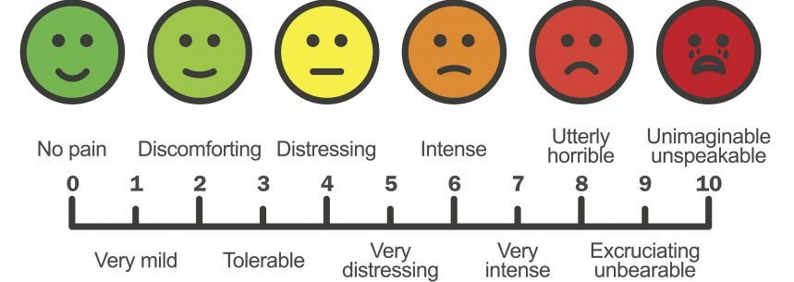

*Figure 1. Common Likert 1-10 pain rating scale used to determine the patients’ pain level.*

*Treatments*

Next, the patients started 30-minute holistic chiropractic treatments. During these sessions, LLL were the main treatment instrument. This laser displays two nonthermal colored beams, one red and the other violet, which expresses the different wavelength frequencies. Different frequencies are used for different symptoms, so when the laser is put in the correct frequency setting it is able to penetrate and restore tissue without causing skin damage. When a person experiences pain or other symptoms it is because their cells and tissue are out of balance, so the lasers reduce inflammation and pain, as well as enhance nerve muscle communication helping to restore balance to the cells and body. The red and violet lasers stimulate the nervous system, allowing the healing process to begin (FDA, 2002). LLL promote the body’s natural healing process by stimulating all types of cells, specifically in the mitochondria, allowing the production of more adenosine triphosphate (ATP). ATP is an organic compound that encourages energy creation and release in cells.

*Data Collection*

This process of treatments and weekly questionnaires continued for 7-10 weeks. Once all required sessions have been completed, the patients took the questionnaire one last time; recording their overall change and improvement from the first day.

*Data Analysis*

Data analysis were performed using an excel worksheet. Weekly, QOL scores were inputted into excel out a possible 50. Each question is out of 5 and there are 10 questions; the higher number the patient answers the question, the better they have evaluated how they have felt from the past week. Once all sessions were completed, data was interpreted by comparing the first week scores with the last week scores, as well as calculating the average deviation, and weekly change average. Pain before and after scores were also inputted into excel. This data was analyzed using paired t-tests, comparing the pretreatment scores to the post treatment scores, then comparing weekly change. Weekly change of pain scores and comparing starting pain score to pain score after 7-10 weeks was interpreted. This way, we can see how each individual week of treatment affected pain and QOL.

**Results**

*Patient characteristics*

A total of 11 people enrolled in this study. They were recruited on their first appointed treatment session and after consent was obtained. One case was unable to continue weekly treatment after five weeks and one case was excluded from study because of the severity of the patients condition. Data from 9 cases was analyzed. Six patients finished the study after seven weeks of treatment, one patients after eight weeks, one patient after nine weeks, and one patients after ten weeks. 33% of participants started treatments with the intent of pain decrease, 56% of participants initialized treatments with alternate symptoms of disease or syndromes, and the remaining 11% had no targeted symptoms or illness that needed to be addressed. The patients’ characteristics are demonstrated as 77% female and 22% male. 4 participants are in the age range of 40-50, 3 were in the 50-60 range, 1 in the 60-70 range, and 1 in the 70-80 range.

*Patient-reported outcomes*

The results of this study concluded that 100% of participants QOL score increased, and 7 (77%) increased by 12 points or more. The participants averaged to improve 2.4 QOL points for each week, and overall improved an average of 13.5 points from the first day (Figure 2). Similarly, 100% of patients’ pain improved, 7 (77%) of which recorded their pain completely went away after completed treatment weeks. The participants pain scores decreased by an average of 7 since the time of the first session and by an average of 1.2 each week (Figure 3). Also included in data analysis were the immediate changes holistic chiropractic treatment had on pain each week. In other words, the pain scale was conducted before and after the treatment sessions each week. The mean pain scores show to have decreased immediately after the treatment sessions, but then slightly increased again by the next week. This demonstrates holistic chiropractic treatments can provide immediate results, but not entirely long lasting. This data concluded to be significant with a p-valuethreshold of < 0.001 (Figure 4).

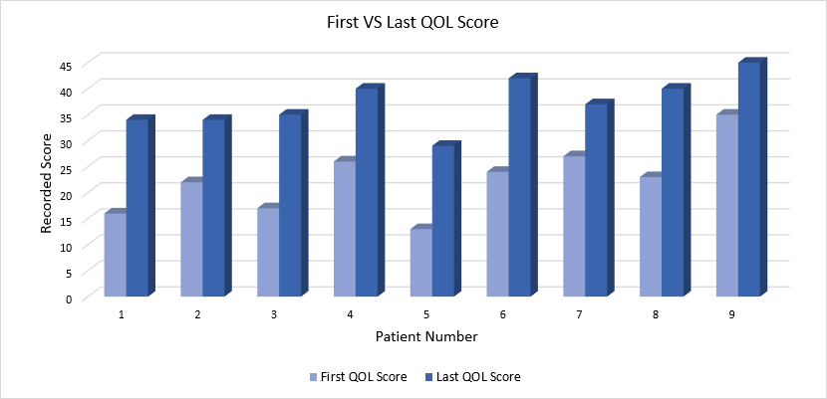

Figure 2. Graph comparing first week QOL scores to last week QOL scores

Figure 3. Graph comparing first week pain scores to last week pain scores

*Figure 4. QOL scores increased significantly (p<0.001). Pain scores decreased significantly (p<0.001). Error bars represent standard error.*

**Discussion**

This study explored the effects of Holistic Chiropractic treatment sessions on pain, discomfort, symptoms, disease, syndromes, and/ or overall quality of life. Patients’ conclusion with this study after 7 weeks dictated this as a result of personal financial interferences. An analysis including age, gender, and highest education degree as between subject variables failed to reveal a relative relationships with pain or QOL score change. We were able to demonstrate that holistic chiropractic care helps to improve QOL and pain.

One patient suffering from a severe case of amyotrophic lateral sclerosis (ALS), began and went through 9 weeks of treatment sessions. Due to the difficulty and severity of the participant’s condition, the doctor explained the process to be very slow-moving and therefore not a normal case study. The patient decided to withdrawal from this case study but continues to receive weekly holistic treatments. Tests are still taken and the patient is showing no to minor improvement each week.

*Limitations and possible sources of error*

The results of the treatment sessions often do show immediate results, yet others present at later times. For this reason, the pain scale survey was taken at the beginning and end of treatment sessions; the before treatment score accounts for both the previous week results and the current week pain score. However, the final data collection week does not account for the effects presenting at a later time. A one or two week follow-up survey sheet could account for final effects of the treatment sessions.

This study does not include the effects or presence of medication supplied by pharmaceutical sources, or of vitamins purchased on site of the doctor’s office. The effects of those materials were accompanied by the treatment sessions and did not distort the usual routine of participants.

Other limitations include people who are financially unable to attend 7-10 weeks of treatment. Also, the patients available for participation are in one geographical region, so many people looking for care can be out of the area but are unable to get to the office for treatments. This study accounts only for a small sample size, so in future studies this topic should be investigated at a larger scale.

**Conclusion**

The holistic approach is different from traditional chiropractic in that it checks the entire body for imbalances associated with the problem. Through specific and natural techniques, the holistic chiropractor eliminates the underlying issues and unbalances in the body.  Every condition is different, and responds differently to care, but all conditions respond to some degree. This study tested holistic treatment through the use of Erchonia LLL, not testing or accounting for possible vitamins or drugs taken by the participant.

After 7-10 weeks of holistic chiropractic treatment patients described large improvements in the reporting of after procedure pain or discomfort. All participants QOL score increased and all patients pain score decreased (Figure 5). There was report of no problems or post-treatment pain. This data concluded to be significant with a p-value < .001. More treatment variety processes are needed to adhere to all people with different types of conditions. Positive results were collected from each variable, but more treatments are needed for all participants to reach maximum score regarding QOL and minimum score regarding pain.

**References**

Alcantara, J. (2018). The Use of the Patient Reported Outcomes Measurement Information System and the RAND VSQ9 to Measure the Quality of Life and Visit-Specific Satisfaction of Pregnant Patients Under Chiropractic Care Utilizing the Webster Technique.

Corcoran, K. (2017). Changes in Female Veterans’ Neck Pain Following Chiropractic Care at a Hospital for Veterans. *Science Direct. Complementary Therapies in Clinical Practice*. 30. 91-95.

Gedin, F. (2019). Patient-reported improvements of pain, disability, and health-related quality of life following chiropractic care for back pain- A national observational study in Sweden*. Science Direct. Journal of Bodywork and Movement Therapies*. 23. 241-246.

Glucina, T. (2019). Chiropractors’ Perspectives on the Meaning and Assessment of Quality of Life Within Their Practice in New Zealand: An Exploratory Qualitative Study. *Science Direct. Journal of Manipulative and Physiological Therapeutics.* 42(7). 480-491.

Hawk, C. (2017). Systematic Review of Nondrug, Nonsurgical Treatment of Shoulder Conditions. Journal of Manipulative and Physiological Therapeutics. 40 (5). 293–319.​

Herman, P. (2018). Characteristics of Chiropractic Patients Being Treated For Chronic Low Back And Neck Pain*. Science Direct. Journal of Manipulative and Phycological Therapeutics.* 41(6). 445-455.

Peng, T. (2018). Utilization of Chiropractic Care in US Children and Adolescents: A Cross- Sectional Study of the 2012 National Health Interview Survey. *Science Direct. Journal of Manipulative and Physiological Therapeutics.* 41(9). 725-733.

Rubis, L. (2013). Chiropractic Management of Bell Palsy with Low Level Laser and Manipulation: A Case Report. Journal of Chiropractic Medicine. 12 (4). 288–291. ​

Russell, D. (2016). Changes in Quality of Life in 7 Older Adult Patients Receiving Activator Methods Chiropractic Technique.

Salsbury, S. (2019). Interprofessional Attitudes And Interdisciplinary Practices For Older Adults With Back Pain Among Doctors Of Chiropractic: A Descriptive Study. *Science Direct. Journal Of Manipulative And Phycological Therapeutics*. 42(4). 295-305.

Stuber, K. (2018). A Pilot Study Assessing Patient-Centred Care in Patients With Chronic Health Conditions Attending Chiropractic Practice. *Science Direct. Complementary Therapies in Medicine.* 39. 1-7.

Whalen, W. (2019). Best Practice Recommendations for Chiropractic Management of Patients With Neck Pain. *Science Direct. Journal Of Manipulative And Phycological Therapeutics.* 1-16.