**The Immune Stimulatory Effect of Bacterial Oligoribonucleotides**

**Marcus Chung**

**Abstract**

Oligoribonucleotides (ORNs) are small chains of ribonucleotides. ORNs are used in research to detect complementary RNA and can change to function of the RNA they bond to. Previous studies recently have demonstrated the anti-viral, anti-bacterial and anti-inflammatory properties of ORNs. However, not enough research has been done to determine the specific interactions between ORNs and the immune system to cause such effects. This study compared previously recorded ORNs released by Lactobacillus casei bacteria 30 minutes after being washed with a nutrient devoid solution to the L. casei, Lactobacillus paracasei, and Streptococcus pyogenes genomes. Each released ORN was aligned to an area of similar sequence in the genome and the number of ORNs that align to each sequence in the genomes was recorded. L. casei, L. paracasei, and S. pyogenes, contained 68, 92, and 39 loci with more than 200 aligned ORNs respectively. The types of RNA transcripts help to formulate a hypothesis on interactions between ORNs and the immune system. In these 68 locations in the L. casei genome, the number of aligned ORNs differed from ORNs collected from L. casei bacteria after 5 and 15 minutes after washing. Most loci increased in the number aligned ORNs from 5 to 30 minutes. Future studies should continue to study the effects of ORNs on the immune system and explore the interactions between them. A future goal of this study would be to create a dietary probiotic or nasal spray using ORNs to reduce infection and symptoms of respiratory diseases.

**Introduction**

Bacterial RNA could one day protect you from viruses. Bacterial oligoribonucleotides (ORNs) are small pieces of bacterial RNA that have been shown to have anti-inflammatory and anti-viral properties (Eigenbrod et. al). One study by Melnichuk et. al showed modified ORNs being able to inhibit hemagglutinin activity of influenza viruses, preventing infection. Bacterial ORNs are released by bacteria when under stressful conditions, such as when being ingested by an animal. In a previous study by Melnichuk et. al, modified ORNs were found effective in causing an immune response and preventing infection by the parainfluenza virus type 3. Patients were given either a common flu medicine or ORNs as treatment and the group given ORNs experienced shorter duration of symptoms and hospital. Another study by Forsbach et. al demonstrated bacterial RNA was able to stimulate an immune response by activating the toll like receptors 7 and 8. Another study by Grigorov et. al found that a methylated ORN was able to inhibit reverse transcription of the HIV DNA. Further research could create new treatments and medicines for increasing innate immunity, which could prevent or reduce the severity of respiratory diseases and other pathogenic diseases.

Figure 1- 


Figure 1- Example of how immune system detects pathogens

When a pathogen infects the human body, it often leaves behind waste materials, such as pieces of RNA. The immune system then detects these waste products and stimulates an immune response to destroy the pathogens. Bacterial ORNs, being small pieces of RNA, mimic the presence of a pathogen. Injecting ORNs causes the immune system to believe a pathogen is present because the ORNs are similar to those released by a pathogen. The immune system then stimulates an immune response, believing it detected a pathogen by the presence of Bacterial ORNs. The immune system becomes stimulated and prepared to destroy invading pathogens, despite none actually being present at the moment. The bacterial ORNs cause the immune system to stimulate and prepare to fight off pathogens.

Previous studies have shown that ORNs are effective in inhibiting pathogenic activity and stimulating an immune response. A study by Eigenbrod et. al found toll like receptors 7 and 8 are stimulated by detection of pathogenic genetic material and then release type 1 IFN which causes an immune response. Kandimalla et. al were able create synthetic oligoribonucleotides that were able to activate toll like receptors 7 and 8. Similarly, research by Lan et. al found a synthetic ORN was able to induce an immune response in mice using toll like receptors 7 and 8. Another study by Forsbach et. al found comparable results in humans, where modified ORNs activated an immune response by stimulating toll like receptors 7 and 8. Forsbach et. al modified a ORN and found it bypassed toll like receptor 7 and instead stimulated toll like receptors 8 and 9 to release type one IFN. Marchyshak et. al used thioacetamide on mice to induce hepatotoxicity, which is drug induced liver damage. They found that a modified ORN, very similar to the ORNs used in Melnichuk’s study, was able to reduce the damage by its anti-inflammatory properties. This shows the wide applications of ORNs to protective effects in animals. Studies even suggest ORNs could help develop improved cancer treatments. Fujita et. al found that ORNs could be used to detect mutations and activate the immune system to fight tumors. Wang et. al found that activating the immune system by synthetic ORNs causes strong immune responses with the ability to fight against tumor growth in mice. Although these studies were able to show ORNs were able to stimulate the immune system, it is not completely known how ORNs are able to interact with innate immune cells to activate them.

Lactobacillus casei is a harmless dietary bacterium that releases RNA fragments (ORNs) when in stressful environments. When L. casei bacteria release ORNs, the ORNs then interact with the immune cells in a way that is unknown as of now. This study will analyze what types of RNA transcripts are being released as ORNs in order to formulate a hypothesis on how ORNs interact with the immune system to cause an immune response. Finding what type of RNA is released by L. casei when under stressful conditions will help determine how future studies can create ORNs that will most effectively stimulate the immune system.

The sequences of ORNs released by L. casei will be compared to the L. casei genome in order to find areas in the genome that match to many of the released ORNs. An area in the genome with many alignments from the RNA fragments could indicate a connection between the specific gene and the RNA fragment released to cause an immune response.

Previous studies have been able to find evidence that ORNs are able to stimulate the immune system and inhibit viral and bacterial activity, however, have not been able to find how ORNs interact with the immune system to do so. This study will analyze RNA sequence data from Lactobacillus casei, a harmless dietary bacterium and other similar bacteria. RNA fragments released by L. casei under stressful conditions have been found to stimulate innate immune response in animals and prevent subsequent infection from pathogens. This study will analyze the ORNs released by L. casei to bacterial genomes in order to determine what types of RNA transcripts are released and how they interact with the immune system.

**Methodology**

Bacterial genome files for Lactobacillus casei, lactobacillus paracasei, and Streptococcus pyogenes were downloaded from the NCBI database. The National Center for Biotechnological Information provides access to biomedical and genomic information. L. casei is a dietary bacterium, L. paracasei is a harmless related bacterium, and S. pyogenes is a more distantly related pathogenic bacterium. Use and viewing of these files was in UGENE, a gene viewing software. UGENE is a software designed to view genomic information files.

A previous study by Hamby et. al incubated L. casei bacteria and collected the ORNs released. To stimulate the release of RNA, the bacteria were washed with a solution devoid of nutrients and of an acidic pH. The released ORNs were collected at 5 minutes, 15 minutes and 30 minutes after washing. The ORNs were then purified and sequenced for data analysis. The ORNs were then incubated with human peripheral blood mononuclear cells (PBMC) and the produced cytokine levels were collected and recorded.  Graphical user interface, application, table, Excel

The ORNs collected from the L. casei bacteria were aligned with the genomes of similarly related bacteria. In figure 2, the ORNs released by L. casei are represented by the colored sequences on the bottom, with the sequences on the top representing a bacterial genome. Each ORN released by L. casei was matched to a similar area in a bacterial genome. Each row on the bottom of figure 2 represents one ORN and is called a read. An area with many aligned ORNs may suggest what types of RNA transcripts bacteria may release. L. paracasei is a related harmless bacterium and S. pyogenes is a more distantly related pathogenic bacterium. The previously collected L. casei ORNs from 5, 15 and 30 minutes after washing the bacteria were aligned to each of the bacterial genomes. The L. casei ORNs were aligned to these bacterial genomes in addition to L. casei to compare the ORNs released to other pathogenic and harmless bacteria. The areas in the genomes with 200 or more matching sequences had their position, number of matches, gene type, and gene name recorded. Collected data aimed to determine the types of RNA transcripts released along with how the number of transcripts at notable locations changed over time. Areas involved with bacterial RNA transcription were observed for notable RNA mapping.

Figure 2 – A screenshot of ORNs aligned to a genome. The upper sequence represents a bacterial genome, the lower sequences represent ORNs released by L. casei that match to an area in genome

Gene sequences from ORNs collected by Dr. Hamby were recorded and then searched for in various bacterial genomes using NCBI BLAST. NCBI BLAST is a tool created by NCBI for searching for gene sequences in genomes of specific organisms. Transfer RNA and ribosomal RNA sequences found to be released by L. casei bacteria were searched for in L. casei, L. paracasei, and S. pyogenes.

**Results**

When L. casei bacteria were previously washed with an acidic solution and deprived of nutrients, they released ORNs. The change in the number of aligned ORNs to 68 locations in the L. casei genome was recorded from 5 minutes to 15 minutes to 30 minutes. From 5-15 minutes, the number of reads (aligned ORNs) decreased in 45 loci, increased in 11 loci, and remained the same in 12 loci. From 15 to 35 minutes, the number of reads increased in 61 loci, decreased in 5 loci, and stayed the same in one locus. Overall, from 5 to 30 minutes, the number of reads decreased in 5 loci, increased in 62 loci, and remained the same in 1 locus.

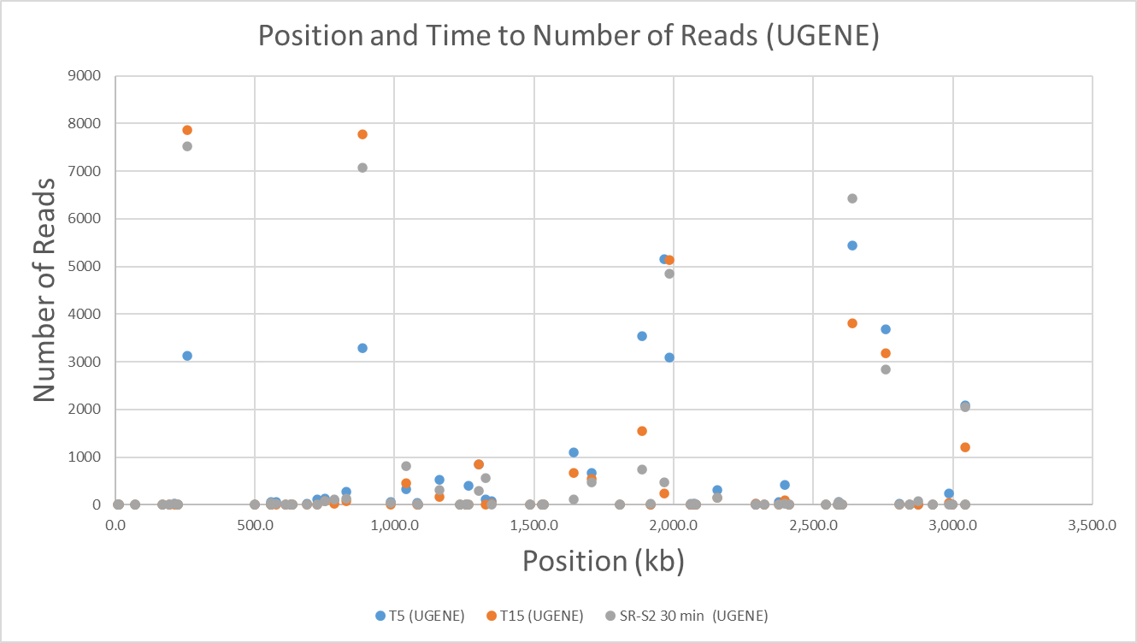

Figure 3 – Graph shows the number of reads (aligned ORNs) at a position over time.

The ORNs released by L. casei bacteria 30 minutes after being washed were aligned to the L. casei, L. paracasei, and S. pyogenes genomes. Shown in table 1, any areas in the genomes with more than 200 reads were recorded. L. casei, L. paracasei, and S. pyogenes, contained 68, 92, and 39 loci with more than 200 reads respectively. L. paracasei has no reads for tRNA and S. pyogenes had no significant (>200) reads for other types of sequences. rRNA in both L. casei and L. paracasei had very few reads.

Table 1- Shows the number of areas with 200 or more reads at a locus in the bacterial genomes

|  |  |  |  |
| --- | --- | --- | --- |
| Read Type | L. casei | L. paracasei | S. pyogenes |
| tRNA | 11 | 0 | 21 |
| rRNA | 3 | 1 | 18 |
| other | 54 | 91 | 0 |

In the L. casei and S. pyogenes alignments, operons in which encoded rRNAs and other various tRNAs were found to have high numbers of ORN alignment at 30 minutes after washing the bacteria. Four operons were identified in the L. casei alignment, and 6 operons were identified in the S. pyogenes alignment. The total number of ORN alignments are shown in the tables below. The alignments in these operons were mostly comprised of alignments to rRNA-16S and rRNA-23S along with some alignment to rRNA-5S and various other tRNAs.

Figures 4 and 5 – These graphs display the total number of reads (aligned ORNs) in each operon

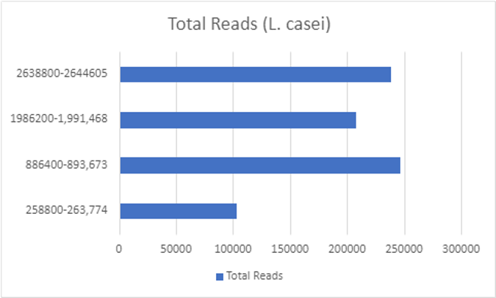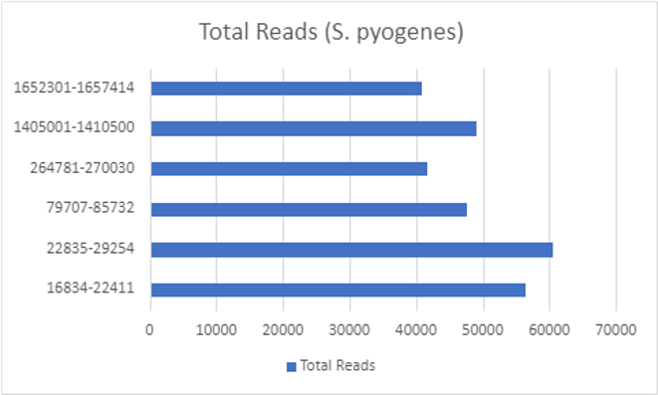

**Discussion and Conclusions**

ORNs have a wide variety of possible applications in research, such as inhibiting pathogenic activity. Bacterial ORNs likely activate toll like receptors 7 and 8 to release cytokines and stimulate the innate immune system. The presence of bacterial ORNs in a human body may mimic the presence of a pathogen and alert the immune system. The immune system then prepares to fight a pathogen, even if there is no such pathogen present. This phenomenon can be used by researchers to create pharmaceuticals that could increase one’s immune system activity and protect from infectious disease.

This study found that most of the aligned ORNs were other types of RNA to the L. casei and L. paracasei genomes. Most tRNA sequences aligned to the L. casei and S. pyogenes genomes, while most rRNA sequences aligned to the S. pyogenes genome. Possible future studies should compare the effectivity of these different RNA types to stimulate the immune system. Finding which types of RNA sequences are most effective at mimicking a pathogen would create opportunities for new treatments to prevent or lessen symptoms of infectious disease.

Future studies should compare the numbers of aligned ORNs to L. paracasei and S. pyogenes collected from L. casei bacteria at 5 and 15 minutes after washing in order to better understand how the released ORNs compare to genomes of other related bacteria over time. Further studies should compare the amount of cytokines human blood cells secrete when given specific types of RNA such as tRNA and rRNA to the original blood cells incubated with ORNs by Hamby et. al.

References

* Eigenbrod, Tatjana. “Bacterial RNA: An Underestimated Stimulus for Innate Immune Responses.” *The Journal of Immunology*, vol. 195, no. 2, July 2015, pp. 411–418., [www.jimmunol.org/content/195/2/411](http://www.jimmunol.org/content/195/2/411).
* Forsbach, Alexandra. “Dual or Triple Activation of TLR7, TLR8, and/or TLR9 by Single-Stranded Oligoribonucleotides.” *Nucleic Acid Therapeutics*, vol. 21, no. 6, Dec. 2011, [www.liebertpub.com/doi/abs/10.1089/nat.2011.0323](http://www.liebertpub.com/doi/abs/10.1089/nat.2011.0323).
* Fujita, T. “Detection of genome-edited cells by oligoribonucleotide interference-PCR". *DNA Res*, vol. 25 , no. 4, Aug. 2018, <https://pubmed.ncbi.nlm.nih.gov/29718217/>
* Grigorov, Boyan. “Identification of a Methylated Oligoribonucleotide as a Potent Inhibitor of HIV-1 Reverse Transcription Complex.” *Nucleic Acids Res.*, vol. 39, no. 13, July 2011, pp. 5586–5596., pubmed.ncbi.nlm.nih.gov/21447560/.
* Carl V. Hamby and William H. Marshall. *Lactobacillus casei* bacteria subjected to nutritional and pH shifts release small RNAs extracellularly that have immune modulating activity. 5th ASM Conference on Beneficial Microbes, September 27-30, 2014, Washington, D.C.
* Kandimalla, Ekamber. “Synthesis and immunological activities of novel Toll-like receptor 7 and 8 agonists”. Cell Immunol, vol. 270, no. 2, April 2011, pp. 126-134., https://pubmed.ncbi.nlm.nih.gov/21570062/
* Lan, Tao. “Synthetic Oligoribonucleotides Containing Arabinonucleotides Act as Agonists of TLR7 and 8.” *Bioorganic & Medicinal Chemistry Letters*, vol. 19, no. 7, Apr. 2009, pp. 2044–2047., [www.sciencedirect.com/science/article/abs/pii/S0960894X09001620](http://www.sciencedirect.com/science/article/abs/pii/S0960894X09001620).
* Marchyshak, Tetiana. “The Potential Protective Effect of Oligoribonucleotides-d-Mannitol Complexes Against Thioacetamide-Induced Hepatotoxicity in Mice.” *Pharmaceuticals (Basel)*, vol. 11, no. 3, Aug. 2018, pubmed.ncbi.nlm.nih.gov/30082619/.
* Melnichuk, Nataliia. “Complexes of Oligoribonucleotides with *D*-Mannitol Inhibit Hemagglutinin–Glycan Interaction and Suppress Influenza A Virus H1N1 (A/FM/1/47) Infectivity In Vitro.” *MDPI,* vol. 10, issue 3, Aug 2017, https://www.ncbi.nlm.nih.gov/pmc/articles/PMC5620615/.
* Melnichuk, Nataliia. “Pre-Clinical and Clinical Efficiency of Complexes of Oligoribonucleotides With D-Mannitol Against Respiratory Viruses.” *Pharmaceutics*, vol. 10, no. 2, May 2018, pubmed.ncbi.nlm.nih.gov/29783756/.
* Wang, Daqing. “Antitumor Activity and Immune Response Induction of a Dual Agonist of Toll-Like Receptors 7 and 8.” *Molecular Cancer Therapeutics*, vol. 9, no. 6, June 2010, pp. 1788–1797., pubmed.ncbi.nlm.nih.gov/20515950/.