**Touch sensitivity during the first year of life in human infants: effects of sex, sleep state, and NICU experience**

Melissa Soto

**Abstract**

Sensory processing in infants can be tested through the flexion reflex to examine spinal cord processes. Sensory thresholds increase with age, however, sex, sleep state, hospitalization, and ICU stay have been shown to affect sensory thresholds in adults. We aimed to examine sensory thresholds in the first year of life and how the factors of sex, sleep state, hospitalization, and NICU stay affect development of sensory processes. This study was conducted with children at 2-, 4-, and 10-month visits. At each visit, stimuli were applied at building intensities to measure sensory thresholds. Reflexes were viewed as hip, knee, ankle, or no responses. Responses were recorded and viewed to see the development of sensory thresholds over the first year of life. Responses showed no variability from normal developmental trends presented in children not exposed to painful procedures in the stimulation. These results were able to assess the abilities of the spinal cord in accordance with sensory processing after painful procedures.

**Introduction**

Children may have involuntary exposure to pain at a very young age as part of necessary medical procedures. It is often difficult for medical professionals to view the amount of pain the child is being exposed to and how the management of that pain should be administered (Fitzgerald 2009). This is due to children not being able to report on the pain due to inability to talk and impairments to cognitive activity. The development of sensory processing of pain in adults and older children has been examined, however little has been examined regarding infants and their development in nervous system pathways that process pain. Concerns have emerged about pain responses when newborns were exposed at a sensitive developmental period.

Sensory processing of the spinal cord has been measured through flexion withdrawal reflexes evoked by touch (Cornelissen 2013). Singular stimulation has been used to find sensory thresholds that could view development through time (Andrews 2007). As seen in figure 1, flexion withdrawal reflexes are important towards the viewing of the spinal cord processes due to the pathway of the pain signal being triggered by a receptor in which it is then sent to a sensory neuron that moves it to the integration center of the spinal cord. The spinal cord has the job of sending the signal towards a motor neuron and impulses the flexion withdrawal reflex. In a healthy adult, these connections are easily transferred, and activity runs smoothly because of the maturity of the nervous system, however infants do not react in the same way when their nervous system is still maturing. Premature infants have been shown to be intensively sensitive to low intensity stimulation and more sensitive than newborns (Andre 2020). Newborns and young infants have been shown to have flexion reflex withdrawals from low intensity stimulation (Hatfield 2014). Their withdrawal reflexes are normally unusually strong when compared to intensity applied and include both legs without much distinction on which leg the stimulation was applied to. As newborns develop into later infancy, their flexion reflex withdrawals come from higher intensity stimulation and begin to develop a distinction between where the stimulation was applied meaning the reflex changes from bilateral to unilateral (Abdulkader 2008). It has been shown that as a human grows older, their nervous system matures, and sensory thresholds increase. As the adult nervous system is mature, touch stimuli are high in intensity to evoke reflex.

Adults have been examined and show that more sensitivity is to be associated with the male sex, those who test asleep, and those who have previous ICU experience (Torsney 2007). Considering the familiarity of the nervoous system, infants need to be viewed for these major factors as well.

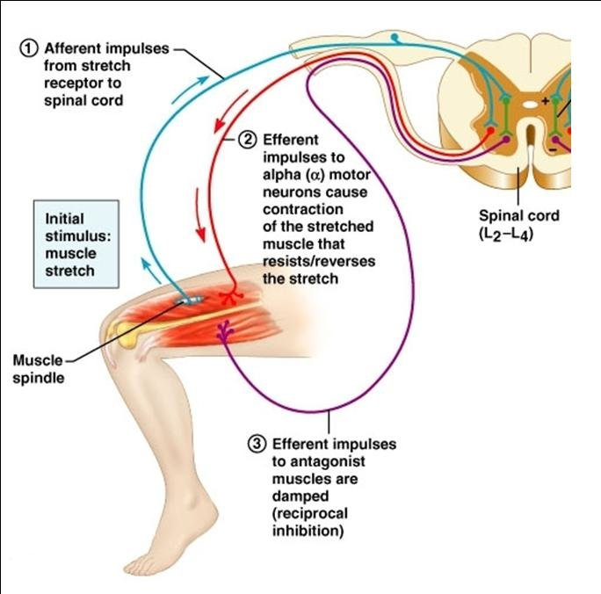**Figure 1.** Flexion withdrawal reflexes involve spinal cord connectivity and muscle contractions

Studies have focused on the flexion reflex from touch stimuli in infants who have been hospitalized and examine the responses when they are admitted, however little studies have examined the progression of reflexes over time specifically the first year of life (Abdulkader 2008). Our study focuses on children who were both hospitalized and not hospitalized. Our study held multiple study visits in the first 12 months of the infants’ lives, where mechanical stimulation was applied with von Frey monofilaments at building intensities.

**Statement of Purpose**

We aimed to investigate infant sensory threshold development in the first year of life in humans. We also used secondary measures of sex, sleep state, and hospitalization or NICU experience to view the effects of these factors on the development of sensory thresholds. We hypothesized that infants would grow less sensitive to touch as they age which would mean that their sensory thresholds would increase. We also hypothesized that males, infants who were asleep, and those with NICU experience would be more sensitive.

**Methods and Materials**

Infants of the ages 2, 4, and 10 months were subject to singular stimulation to view sensory thresholds and sensitization using flexion withdrawal reflexes. The Boston Children’s Hospital Institutional Research Board gave ethical approval. Parents and guardians gave informed written consent through forms before starting any research on participants.

Infants were recruited in Boston Children’s Hospital and around the Boston area. Infants of both genders were accepted into the participant grouping if they complied with inclusion and exclusion criteria. Inclusion criteria included a gestational age of > 32 weeks, native English speakers, and had or would have an exposure to anesthesia for a procedure longer than 45 minutes (not applicable to control group). Exclusion criteria included history of clinical seizures, auditory or visual impairment, genetic disorders involving neurodevelopment, or other medical conditions that would prevent leg movement responses.

Infants were placed in two positions, which included sitting up with free mobility of the legs or laying down on their backs. To find sensory thresholds, von Frey hair stimulators were applied to each participant’s plantar surface of their left foot for 2 seconds before releasing stimulation. Von Frey hair stimulation intensities began at hair number one, 0.008 g, and rose in intensity up to hair number 20, 300 grams as seen in figure 2. Intensity was built until withdrawal reflex was responded for three stimulations of the same intensity. If reflexes did not occur with all three stimulations, intensity of von Frey hair would increase. Once the threshold was found, a second trial repeated the procedures. A Case Report Form was filled out by a Research Assistant present during the procedures to record type of response, which included no response, ankle, knee, or hip, sleep state, and behavior during procedures. Procedures were also recorded by an iPhone or a room camera for quality checks on recorded types of responses.

|  |  |
| --- | --- |
| **Hair number** | **Force (grams)** |
| 1 | 0.008 |
| 2 | 0.02 |
| 3 | 0.04 |
| 4 | 0.07 |
| 5 | 0.16 |
| 6 | 0.4 |
| 7 | 0.6 |
| 8 | 1 |
| 9 | 1.4 |
| 10 | 2 |
| 11 | 4 |
| 12 | 6 |
| 13 | 8 |
| 14 | 10 |
| 15 | 15 |
| 16 | 26 |
| 17 | 60 |
| 18 | 100 |
| 19 | 180 |
| 20 | 300 |

**Figure 2.** Conversion chart of force in grams to the stimulation von Frey hairs

Responses for finding sensory thresholds a were assessed in-person. Reflexes were assessed by grouping them into four classifications which included having no response, having an ankle response, having a knee response, or having a hip response.

Videos were taken of procedures using room cameras or iPhone cameras for quality reviews of responses taken in person. Videos were reviewed and assessed for the four classifications of no response, ankle response, knee response, and hip response. New classifications were recorded, and a percentage of videos were reviewed by a second rater to maintain interrater reliability.

For singular stimulation to find sensory thresholds, descriptive statistics were generated for sex, sleep state, hospitalization, and NICU experience. The means of these groups were used and separated into age groups which were 2 months, 4 months, and 10 months. From here, means were compared using t-tests to view difference in each grouping in the age groups.

**Results**

The development of sensory thresholds was expected to increase in a hill pattern where children were less sensitized through age. As shown in figure 2, sensory thresholds increased through 2 to 4 months however slightly decreased between the 4- and 10-month age gap. The 10-month age gap was supposed to head upwards as does the gap between 2 and 4 months of age, however this could be explained by the small sample size for the 10-month visit.

**Figure 3.** Sensory threshold development trend over age of infants at specific study visit ages

Regarding the categorization of the flexion reflex responses, most of the reflex responses were examined at hair number 9 which is 1.4 grams of force. Throughout age, the type of flexion response changed from being a strong hip flexion response at the 2- month visit to more ankle and knee responses coming from the 4 and 10 month visit infants, however these changes were not considered significant.

There was no significant difference between sex, sleep state, and NICU experience between the children. There were no significant differences between the types of responses in each category. The avergae threshold between ages in each category had no significant difference being that it maintained in the same patterns and remained no more than 2 or 3 hair number differences.

**Figure 4.** Comparison of sensory thresholds to group of ages regarding sex

**Figure 5.** Comparison of sensory thresholds to group of ages regarding sleep state

**Figure 6.** Comparison of sensory thresholds to group of ages regarding NICU experience

**Discussion and Conclusion**

This study shows an overall view of the effect of painful procedures over development of sensory thresholds in singular stimulation settings. It is evident that the children tested fell into the normal pattern of development of increasing thresholds as they grow older. There is a slight decrease for singular stimulation between 4 and 10 months, however it is not considered a significant decrease and should be accounted for by the small sample size in the 10-month group. The average of the sensory thresholds for singular stimulation is heading towards the right direction when it comes to development of sensory thresholds. Research needs to follow these children as they grow older at 2 and 5 years old to make sure that this development continues through normalcy.

Results shown in this study can be used to reassure parents of safety of short duration exposures to painful procedures and bring application to clinical trials testing topical anesthetics as well needle procedures presented in pain management for pediatric patients.

This study has several limitations which surround sample size due to circumstances involving the COVID-19 pandemic. Many children were unable to attend to all three scheduled visits at 2-, 4-, and 10- months because of the pandemic’s restrictions to visit hospital settings, so there are missing points in several of the children’s profile. Throughout the visit, the children were also put through three steps of the larger study and may have been exposed to fatigue, hunger, and other factors that could have affected thresholds and responses. Some children were not able to go through all three steps of the larger study and missing points were also present due to this reason. These missing points made sample sizes small for this study and makes it difficult to generalize data to a larger group.

Although this study enables the assessing of the development of sensory thresholds in the first year of life, a larger sample size should be used for future studies to find conclusions that could easier to generalize to a larger group. Development of sensory thresholds should be assessed into the first 2 and 5 years of life including school aged children. Effects of types of procedures and different risk factors should be assessed in determining the developmental factors of changes.

**References**

Abdulkader, H. M., Freer, Y., Fleetwood-Walker, S. M., & McIntosh, N. (2008). Bodily Progression of Motor Responses to Increasing Mechanical Force Stimulation in the Newborn Infant and the Effect of Heel Prick. *Neonatology*, *94*(1), 38–44. <https://doi.org/10.1159/000112948>

Abdulkader, H. M., Freer, Y., Garry, E. M., Fleetwood-Walker, S. M., & McIntosh, N. (2008). Prematurity and neonatal noxious events exert lasting effects on infant pain behaviour. *Early Human Development*, *84*(6), 351–355. <https://doi.org/10.1016/j.earlhumdev.2007.09.018>

André, V., Durier, V., Beuchée, A., Roué, J.-M., Lemasson, A., Hausberger, M., Sizun, J., & Henry, S. (2020). Higher tactile sensitivity in preterm infants at term-equivalent age: A pilot study. *PLOS ONE*, *15*(3), e0229270. <https://doi.org/10.1371/journal.pone.0229270>

Andrews, K., & Fitzgerald, M. (2007). Cutaneous flexion reflex in human neonates: a quantitative study of threshold and stimulus-response characteristics after single and repeated stimuli. *Developmental Medicine & Child Neurology*, *41*(10), 696–703. <https://doi.org/10.1111/j.1469-8749.1999.tb00525.x>

Cornelissen, L., Fabrizi, L., Patten, D., Worley, A., Meek, J., Boyd, S., Slater, R., & Fitzgerald, M. (2013). Postnatal Temporal, Spatial and Modality Tuning of Nociceptive Cutaneous Flexion Reflexes in Human Infants. *PLoS ONE*, *8*(10), e76470. <https://doi.org/10.1371/journal.pone.0076470>

Fitzgerald, M., & Walker, S. M. (2009). Infant pain management: a developmental neurobiological approach. *Nature Clinical Practice Neurology*, *5*(1), 35–50. <https://doi.org/10.1038/ncpneuro0984>

Hatfield, L. (2014). Neonatal pain: What′s age got to do with it? *Surgical Neurology International*, *5*(14), 479. <https://doi.org/10.4103/2152-7806.144630>

Kühne, B., Stützer, H., Roth, B., & Welzing, L. (2012). The Flexion Withdrawal Reflex Reveals an Increasing Threshold during the First Year of Life and is Influenced by the Infant’s State of Consciousness. *Klinische Pädiatrie*, *224*(05), 291–295. <https://doi.org/10.1055/s-0031-1301328>

Sandrini, G., Serrao, M., Rossi, P., Romaniello, A., Cruccu, G., & Willer, J. C. (2005). The lower limb flexion reflex in humans. *Progress in Neurobiology*, *77*(6), 353–395. <https://doi.org/10.1016/j.pneurobio.2005.11.003>

Torsney, C., & Fitzgerald, M. (2003). Spinal Dorsal Horn Cell Receptive Field Size is Increased in Adult Rats Following Neonatal Hindpaw Skin Injury. *The Journal of Physiology*, *550*(1), 255–261. <https://doi.org/10.1113/jphysiol.2003.043661>

van den Hoogen, N. J., Patijn, J., Tibboel, D., Joosten, B. A., Fitzgerald, M., & Kwok, C. H. T. (2018). Repeated touch and needle-prick stimulation in the neonatal period increases the baseline mechanical sensitivity and postinjury hypersensitivity of adult spinal sensory neurons. *PAIN*, *159*(6), 1166–1175. <https://doi.org/10.1097/j.pain.0000000000001201>

https://images.app.goo.gl/Vo4qnFzV2wUcXjiA6