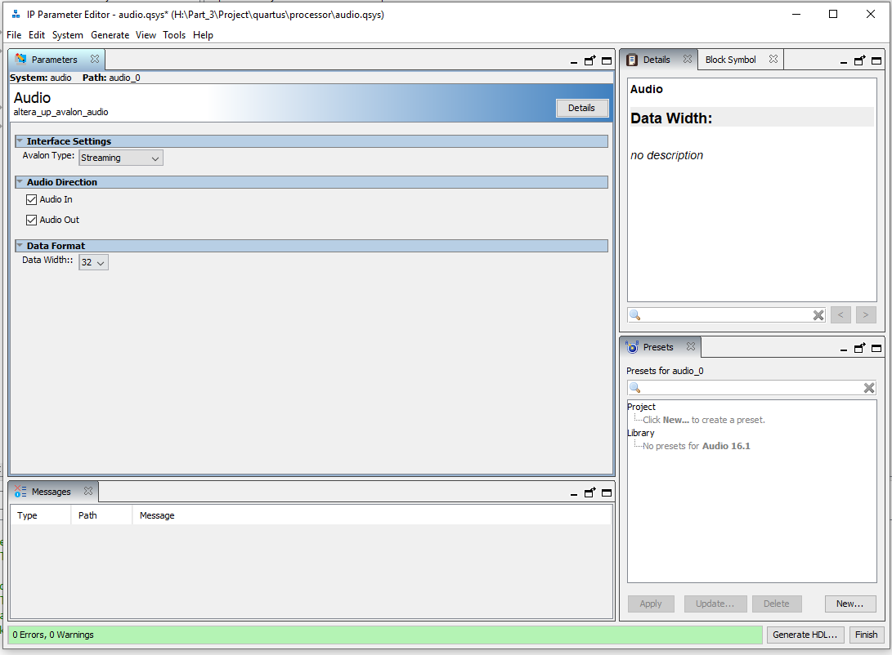

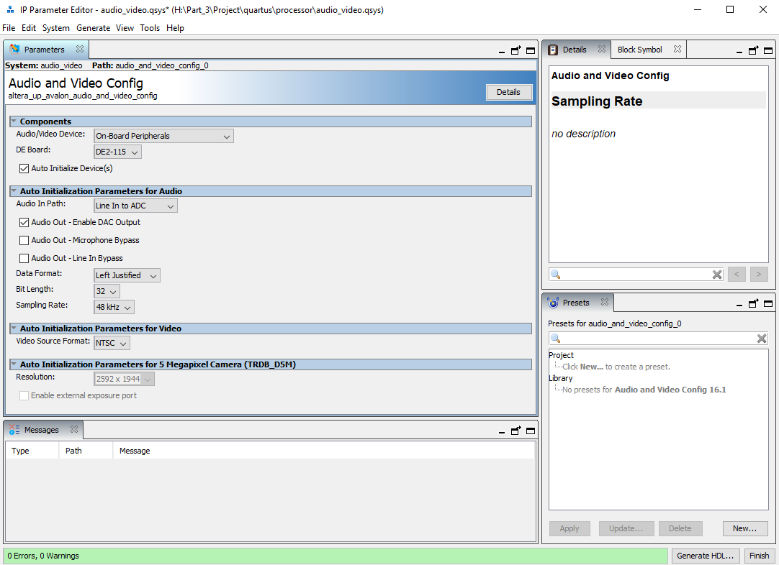

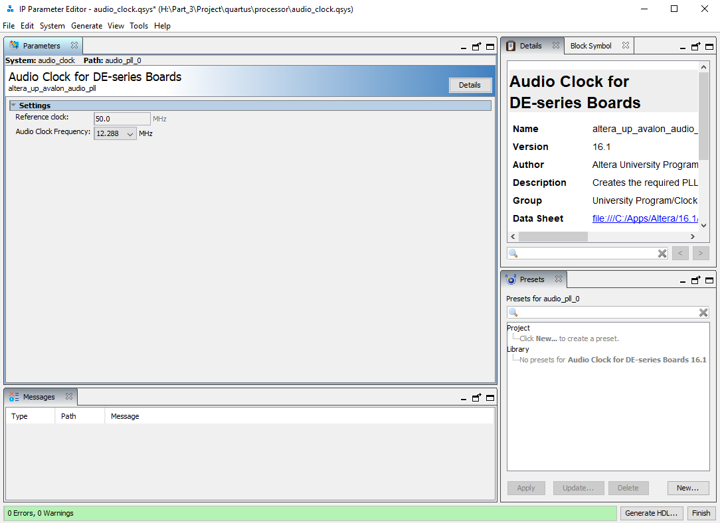

They should be called

|  |  |
| --- | --- |
| IP Core | Module Name |
| Audio Clock | clock_config |
| Audio and Video | audio_video_config |
| Audio | audio_config |