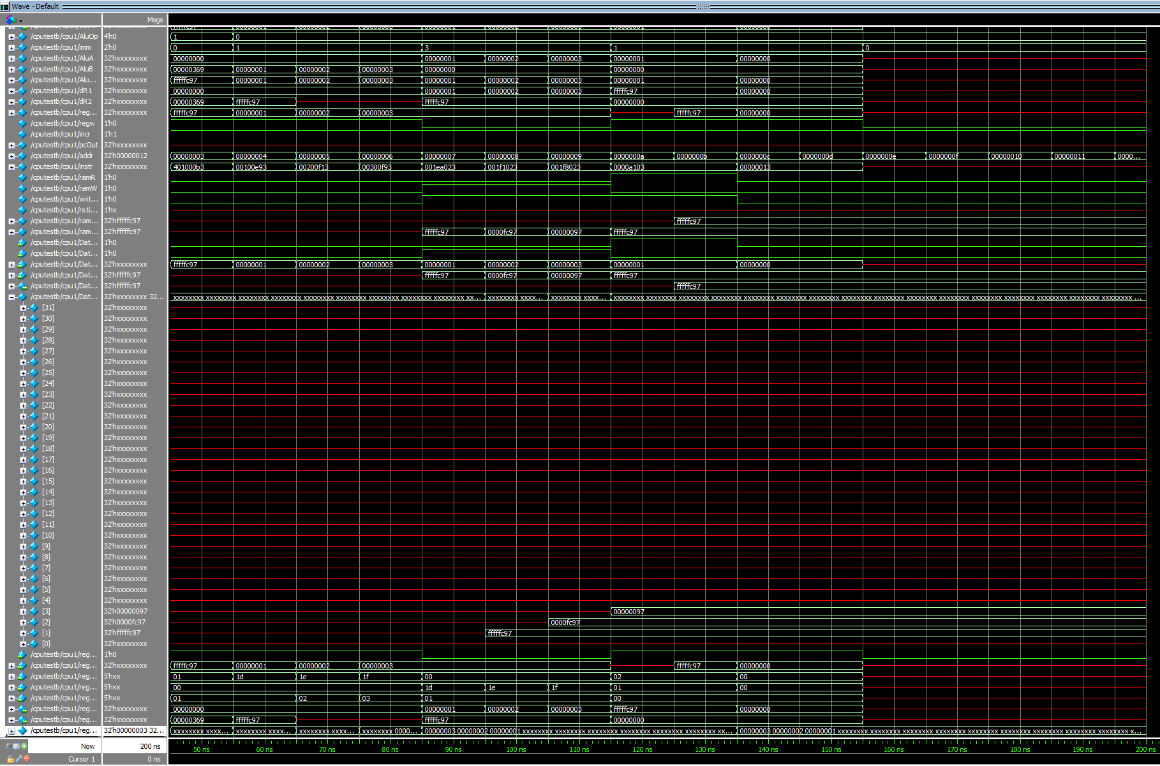

All 3 stores complete

NOP

NOP

addi x1, x0, 873

sub x1, x0, x1

addi x29, x0, 1

addi x30, x0, 2

addi x31, x0, 3

sw x1, 0(x29)

sh x1, 0(x30)

sb x1, 0(x31)

lw x2, 0(x1)

lw x2, 0(x1)

NOP

NOP

Test program