LAB 1: Python Environment Setup and Data Analysis

Objective
To install Python libraries using Anaconda and perform numerical and data analysis using NumPy and Pandas.

Procedure

Step 1:
Environment Setup:
The Anaconda Prompt executes the command ```conda install h5py matplotlib notebook pandas scipy seaborn```.
Installation Details:
The terminal lists packages such as bleach, cycler, h5py, matplotlib, and ipykernel that will be installed into the pyenv1 environment.
Process Insight:
The system resolves dependencies and prepares all required packages before installation.
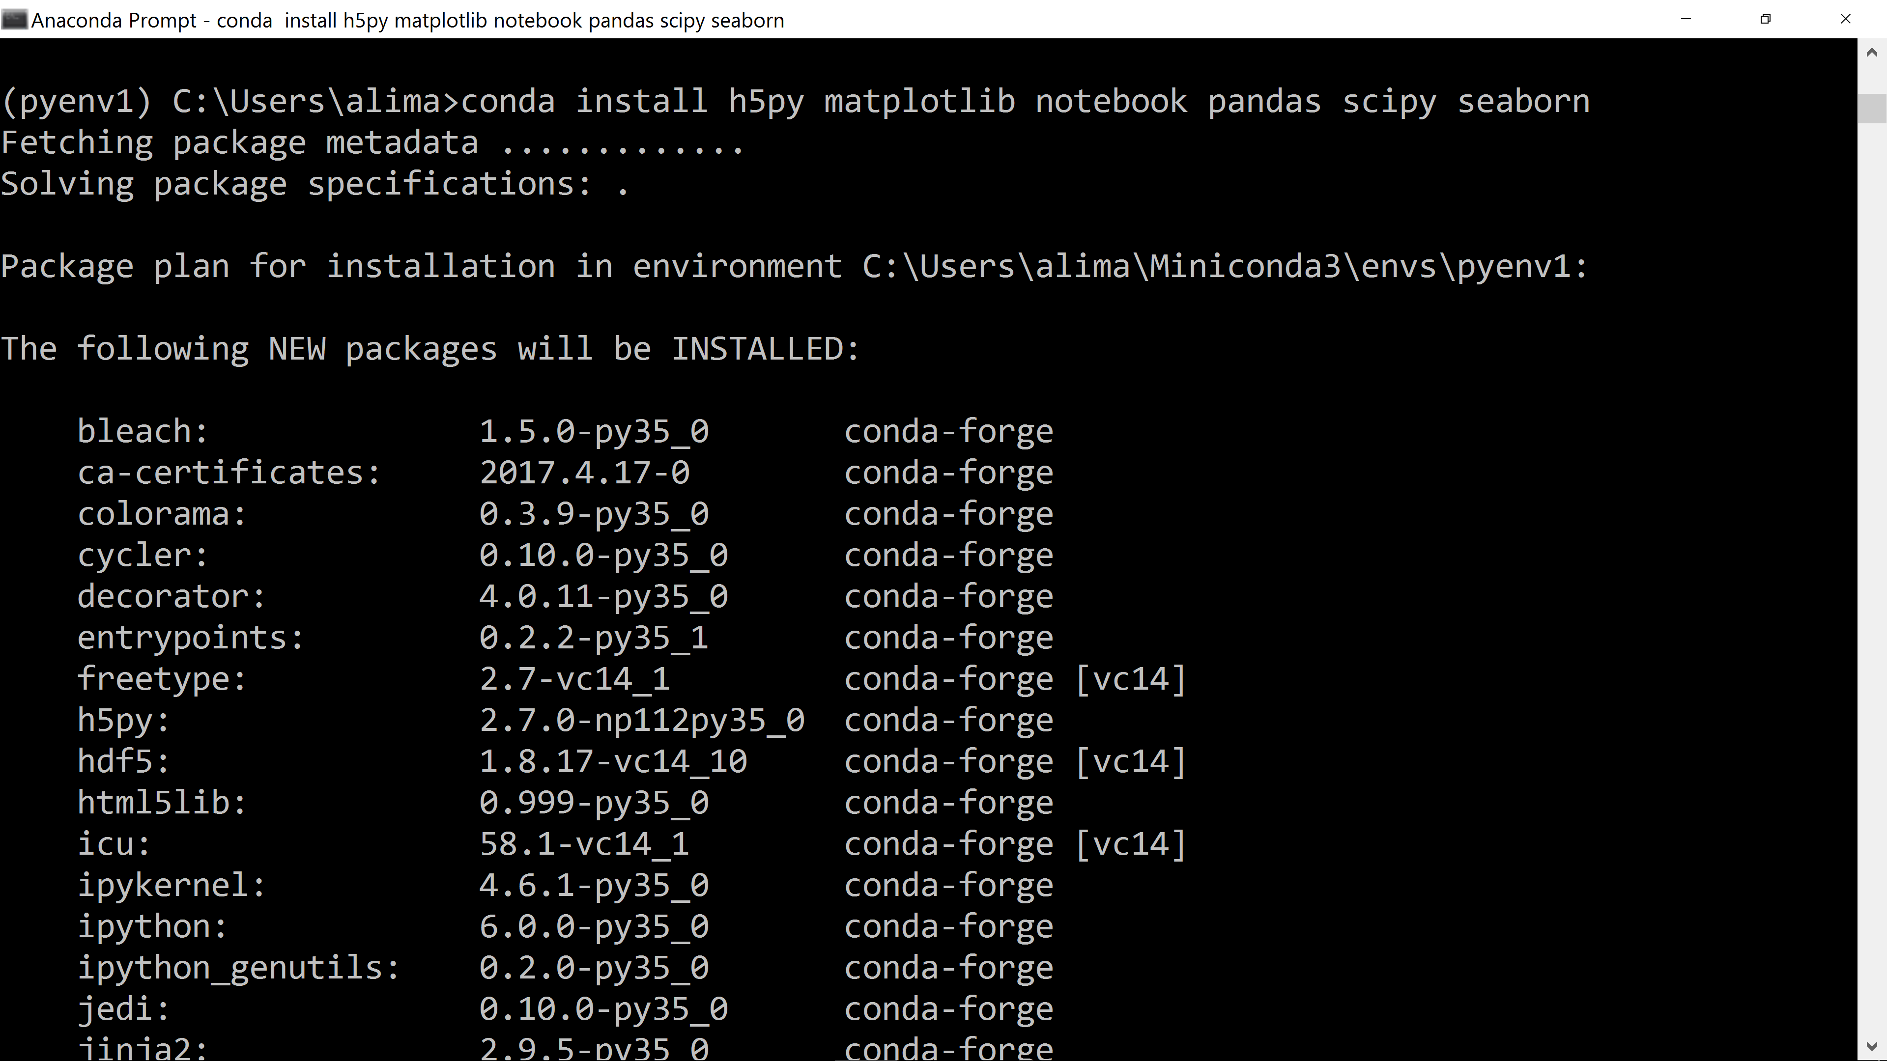
Figure 1.1

Step 2:
Installation Options:
The setup window shows installation options including adding Anaconda to PATH and registering it as default Python 3.9.
System Behavior:
A warning explains that adding Anaconda to PATH may cause conflicts.
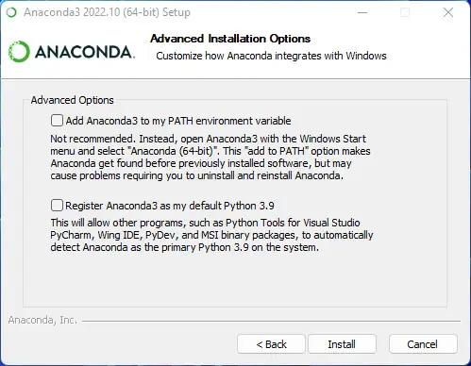
Figure 1.2

Step 3:
Interface Overview:
Anaconda Navigator displays tools including Jupyter Notebook, JupyterLab, Spyder, and VS Code.
Tool Access:
Each tool has a Launch button for direct access.
Purpose:
This dashboard allows managing environments and launching development tools.
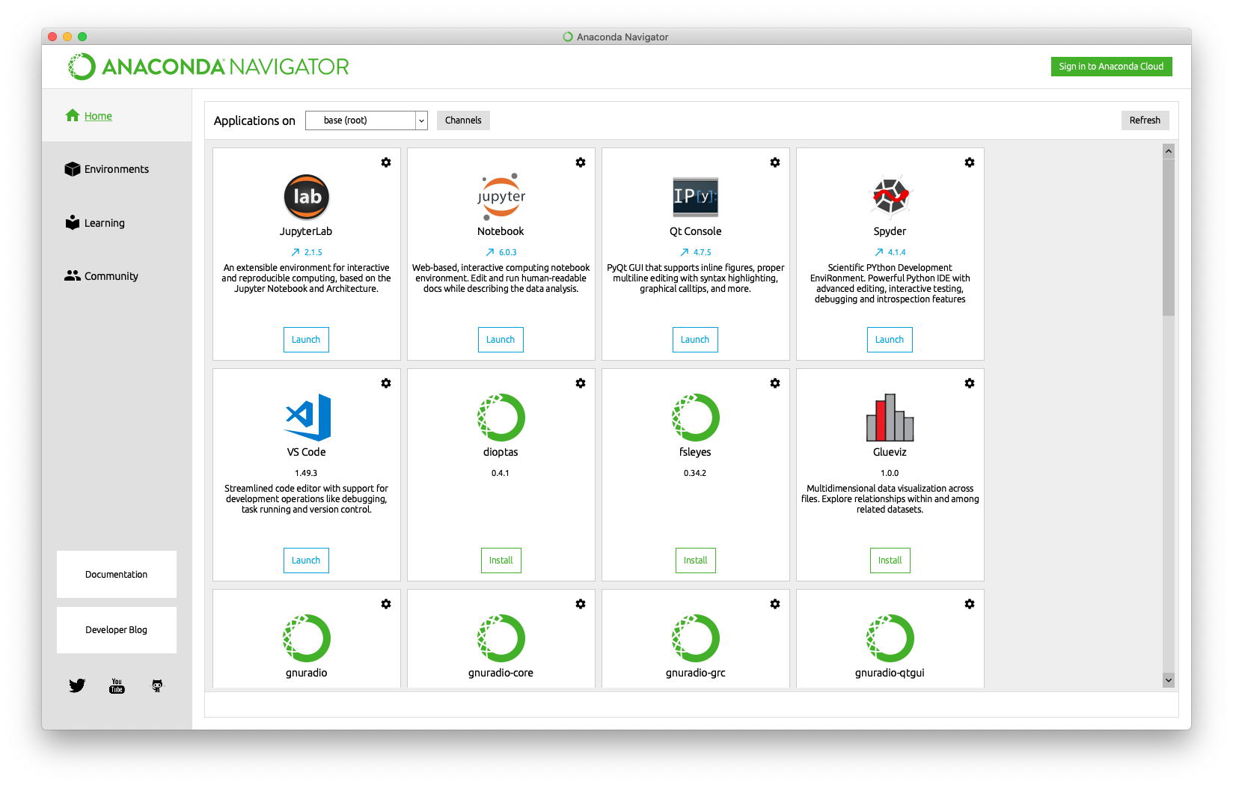
Figure 1.3

Step 4:
Version Check:
The terminal runs 'python --version' showing Python 3.13.5 and 'conda --version' showing conda 25.5.1.
Validation:
This confirms both Python and Conda are installed correctly.
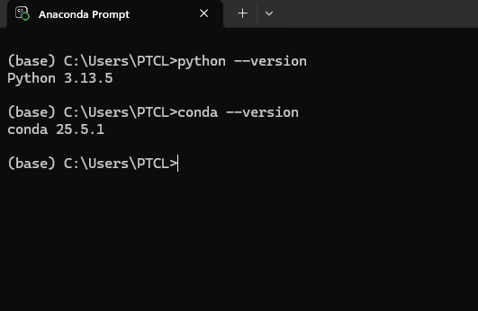
Figure 1.4

Step 5:
Command Execution:
The command 'pip install pandas numpy matplotlib seaborn' is executed.
System Response:
The output shows 'Requirement already satisfied' for all packages.
Interpretation:
All libraries are already installed and ready to use.
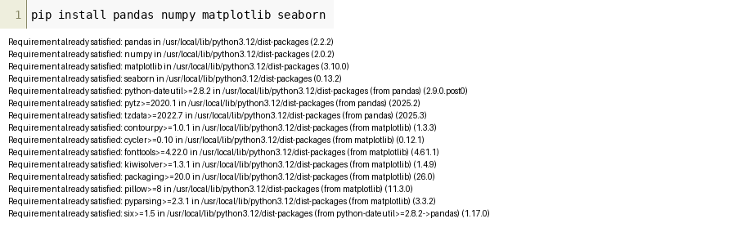
Figure 1.5

Step 6:
Library Installation:
The notebook installs ipdb using 'pip install -Uq ipdb'.
Code Implementation:
A Fibonacci function fib(n) is defined using iteration.
Execution Result:
Calling fib(8) returns 21.
Debug Status:
Automatic pdb calling is turned OFF.
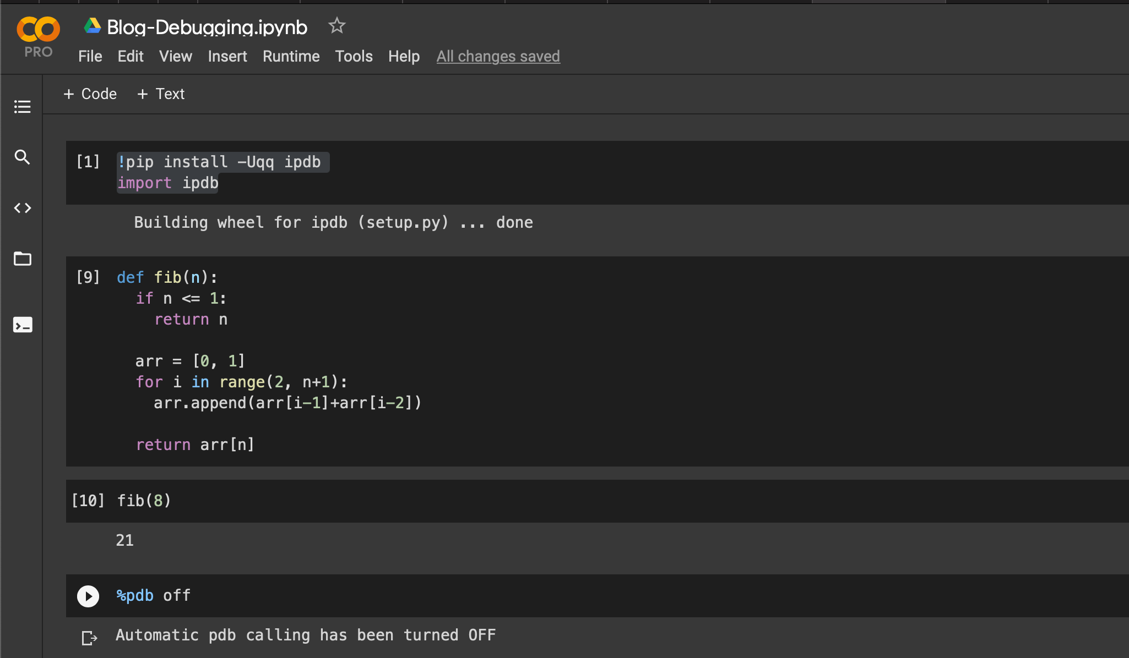
Figure 1.6

Step 7:
Setup:
It imports NumPy and creates an array [10, 20, 30, 40].
Batch Math:
The values are doubled to [20 40 60 80] and square roots are calculated.
Quick Stats:
Mean is 25.0 and maximum value is 40.
Insight:
NumPy processes all values simultaneously.
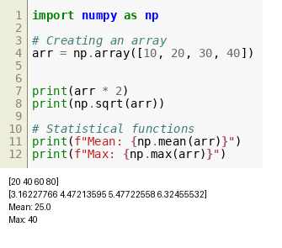
Figure 1.7

Step 8:
Computation Output:
The NumPy operations are displayed again including array doubling and square root results.
Statistics:
Mean remains 25.0 and maximum value is 40.
Verification:
This confirms correct numerical computation.
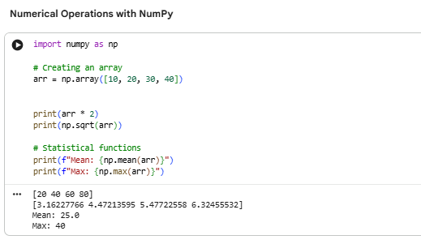
Figure 1.8

Step 9:
Data Setup:
A dataset is created with students Zaid, Riyan, Tahar, Saima and scores 92, 85, 88, 95.
Data Structuring:
A DataFrame is created and a Grade column is added.
Output:
The table displays student names, scores, project status, and grades.
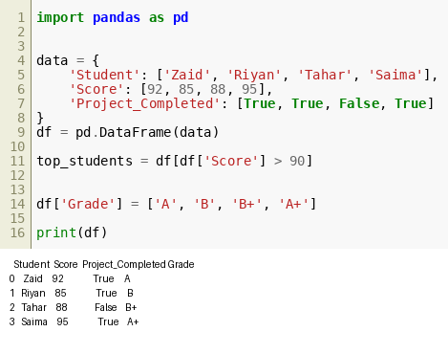
Figure 1.9

Step 10:
Filtering Logic:
Students with score greater than 90 are filtered using df[df['Score'] > 90].
Result:
Only high-scoring students are selected.
Display:
The table shows Student, Score, Project_Completed, and Grade.
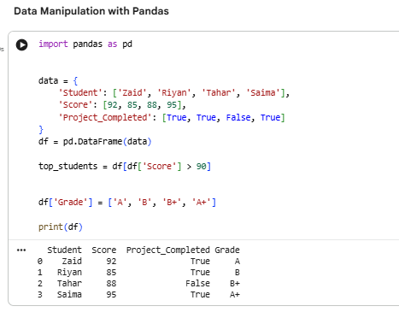
Figure 1.10

Step 11:
Visualization Setup:
Matplotlib and Seaborn are imported.
Graph Creation:
A bar chart is created using sns.barplot with students on x-axis and scores on y-axis.
Styling:
The 'viridis' palette is applied for visualization.
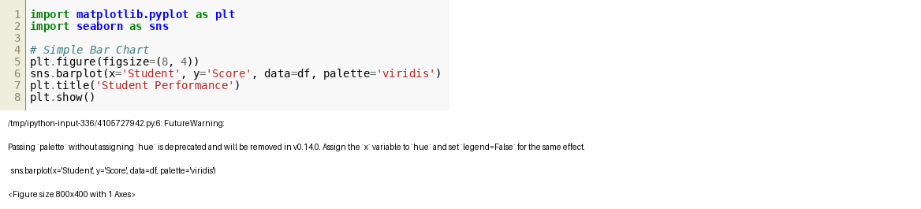
Figure 1.11

