LAB 2: Python Data Structures and File Handling

Procedure

Step 1:
Concept Overview:
The table compares Lists, Tuples, Sets, and Dictionaries based on ordering, indexing, mutability, duplicates, and data types.
Key Detail:
Lists and Tuples are ordered and indexed, while Sets are unordered and do not allow duplicates.
Insight:
Dictionaries store data as key-value pairs instead of index-based access.
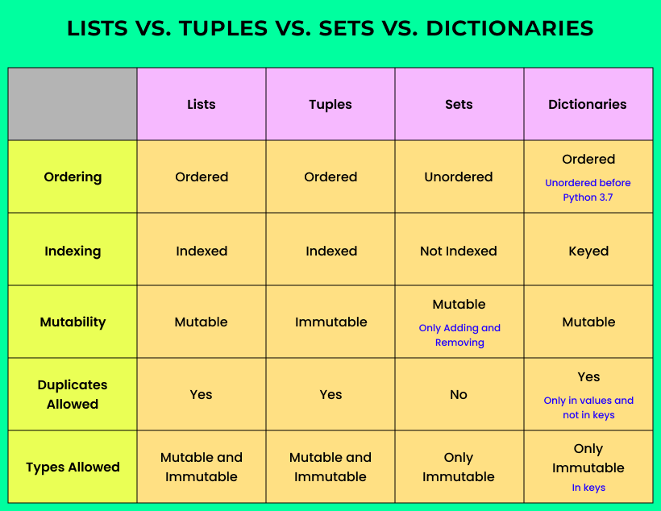
Figure 2.1

Step 2:
Structure Hierarchy:
The diagram shows Python Data Structures divided into built-in and user-defined types.
Built-in Types:
List, Dictionary, Tuple, and Set are shown as core structures.
Extended Structures:
Stack, Queue, Trees, Linked Lists, Graphs, and HashMaps are derived structures.
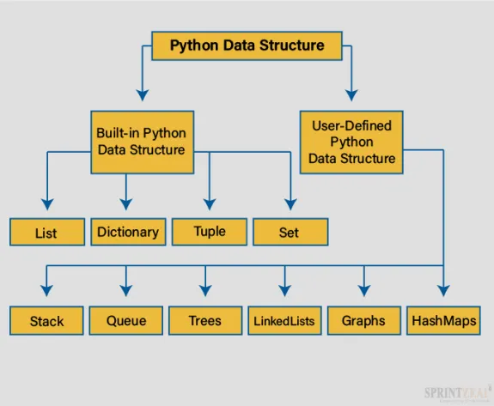
Figure 2.2

Step 3:
List Comprehension:
The syntax [x+1 for x in range(5) if x%2 == 2] is displayed.
Components:
It shows output expression, collection, and condition sections.
Purpose:
This demonstrates creating lists efficiently using a single line of code.
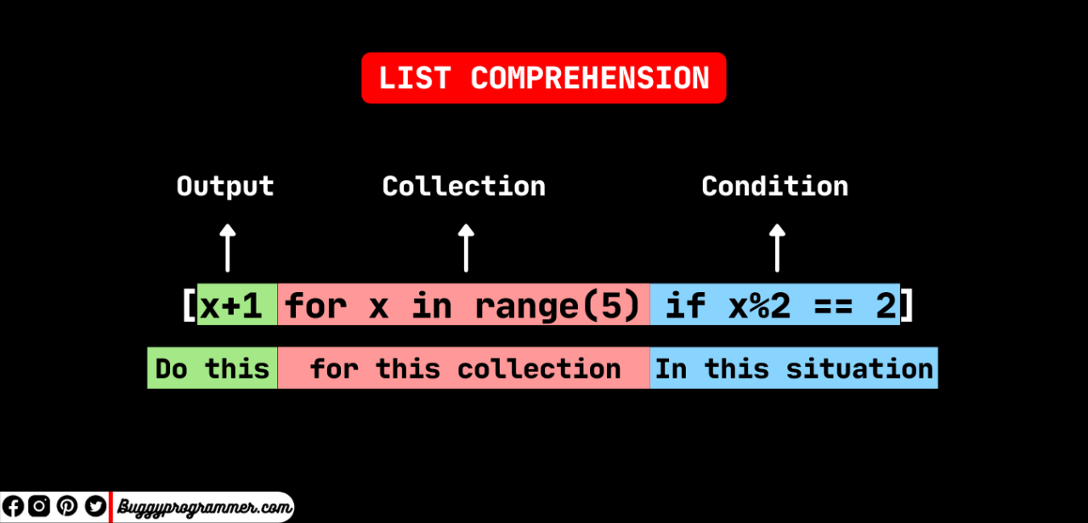
Figure 2.3

Step 4:
Flowchart Logic:
The diagram shows a loop processing numbers from a list.
Condition Check:
Each number is checked and conditionally added to a new list.
Flow:
The process continues until all elements are processed.
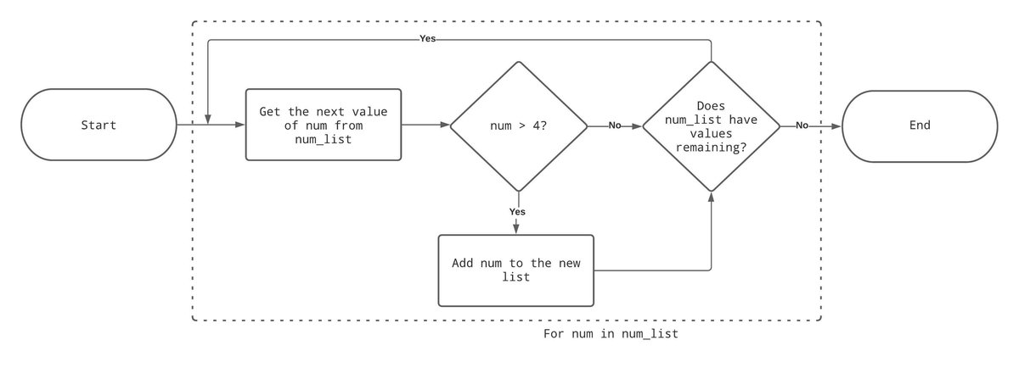
Figure 2.4

Step 5:
Data Structures:
A list of students ['Ali','Sara','Ahmed'], a tuple of grades (85,90,78), a dictionary mapping names to marks, and a set of subjects are created.
Output:
The printed result shows the list and dictionary values.
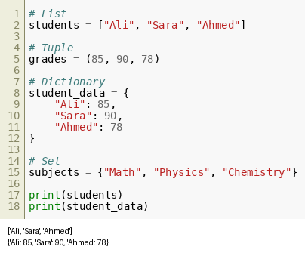
Figure 2.5

Step 6:
Function Definition:
A function calculate_average computes sum(grades)/len(grades).
Execution:
Grades [85,90,78] produce average 84.33.
Result:
The output displays 'Average grade: 84.33'.
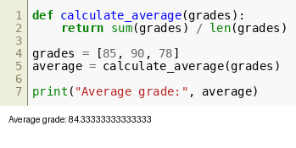
Figure 2.6

Step 7:
CSV Reading:
The csv module reads 'students.csv'.
Loop:
Each row prints Name and Marks.
Output:
Ali 85, Sara 90, Ahmed 78 are displayed.
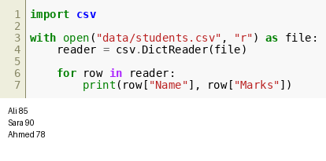
Figure 2.7

Step 8:
JSON Writing:
A dictionary of student marks is written to 'students.json' using json.dump().
Purpose:
This converts Python data into JSON format.
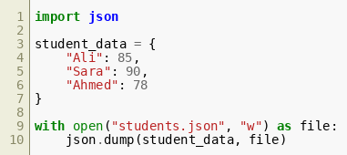
Figure 2.8

Step 9:
File Reading:
A text file 'notes.txt' is opened and its content is printed.
Output:
The displayed string confirms file reading operation.
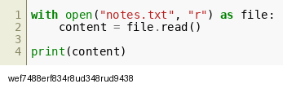
Figure 2.9

Step 10:
List Comprehension Execution:
Numbers [1,2,3,4,5] are squared using [n**2 for n in numbers].
Result:
Output is [1,4,9,16,25].
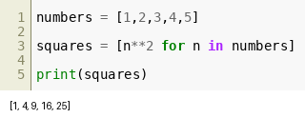
Figure 2.10

Step 11:
Exception Handling:
User input is divided into 10.
Errors:
ZeroDivisionError and ValueError are handled.
Final:
'Program finished' is always printed.
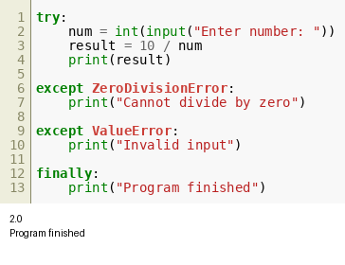
Figure 2.11

Step 12:
CSV Calculation:
Sales data is read and total calculated using Price * Quantity.
Result:
Total Sales is printed as 7200.
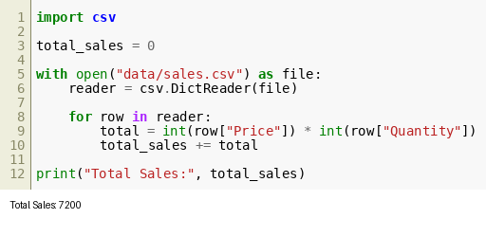
Figure 2.12

