LAB 3: NumPy Advanced Operations and Data Analysis

Procedure

Step 1:
Data Loading:
NumPy, Pandas, and Matplotlib are imported.
Dataset:
A CSV file 'AAPL_stock_data.csv' is loaded with 'Date' as index.
Extraction:
The 'Close' column is converted into a NumPy array.
Output:
The shape (1258,) and sample values of closing prices are displayed.
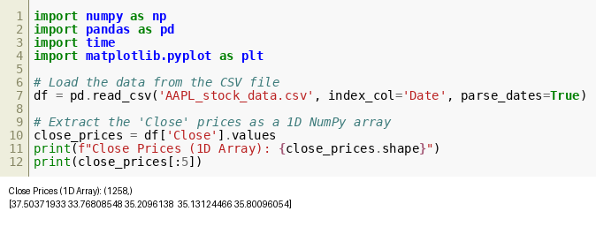
Figure 3.1

Step 2:
Array Transformation:
The 1D array is reshaped into a 2D array where each row represents 5 trading days.
Further Structuring:
A 3D array is created representing months, weeks, and days.
Output:
Shapes of 2D (251,5) and 3D arrays are printed.
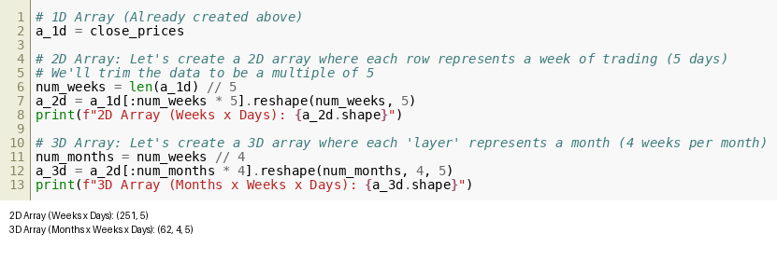
Figure 3.2

Step 3:
Indexing:
Accesses the price of day 1 in week 2 using a_2d[1,0].
Slicing:
Extracts first 4 weeks of data.
Reshaping:
Flattens 3D array back to 1D.
Output:
Displays selected value and shapes.
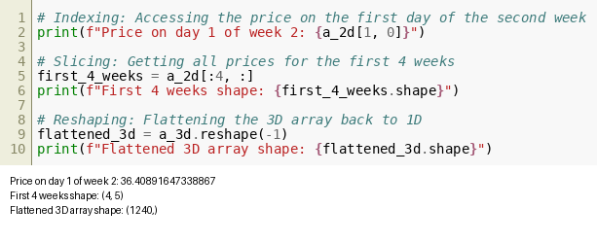
Figure 3.3

Step 4:
Log Returns:
Calculates logarithmic returns using np.log.
Normalization:
Divides prices by mean price.
Broadcasting:
Subtracts weekly mean from daily prices.
Output:
Displays first values and resulting shapes.
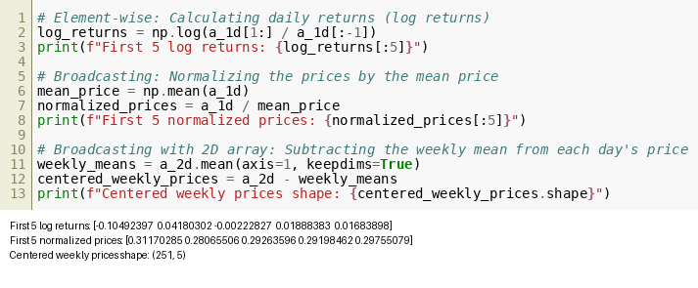
Figure 3.4

Step 5:
Statistical Analysis:
Calculates mean, median, standard deviation, and percentiles.
Output:
Mean 120.32, Median 131.29, Std Dev 46.32, Percentiles shown.
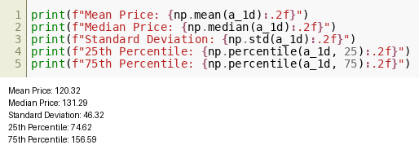
Figure 3.5

Step 6:
Linear Algebra:
Computes weighted sum using dot product.
Matrix Operation:
Projects data using matrix multiplication.
Output:
Shows weighted values and projected shape (251,3).
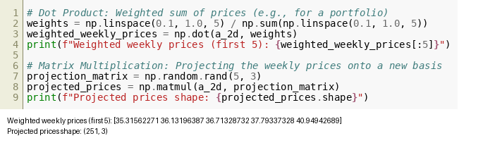
Figure 3.6

Step 7:
Random Simulation:
Generates normal distributed returns.
Sampling:
Randomly samples from computed log returns.
Output:
Displays mean values of simulated and sampled data.
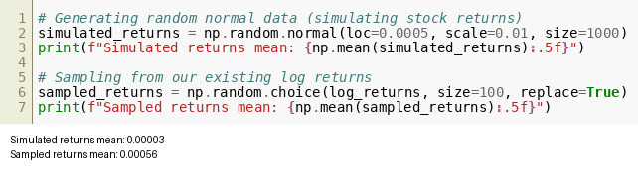
Figure 3.7

Step 8:
Performance Comparison:
Adds two large lists using Python loops and NumPy arrays.
Timing:
Measures execution time for both methods.
Result:
NumPy operation is significantly faster than Python lists.
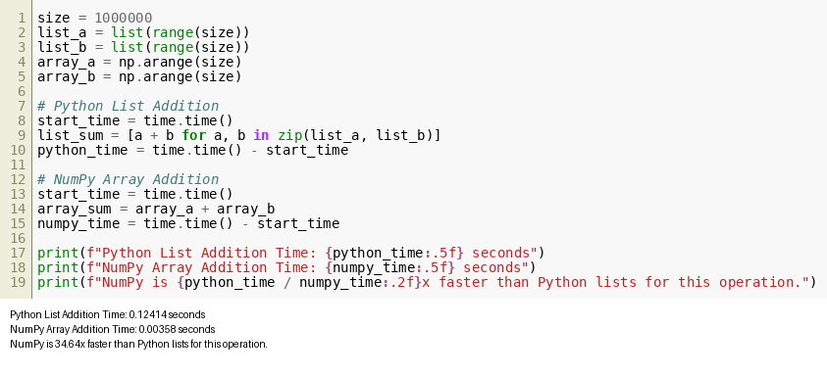
Figure 3.8

