LAB 4: Data Cleaning and Transformation using Pandas

Procedure

Step 1:
Library Setup:
Pandas and NumPy libraries are imported.
Verification:
The versions are printed showing Pandas 2.3.3 and NumPy 2.3.5.
Purpose:
This confirms the environment is correctly configured.
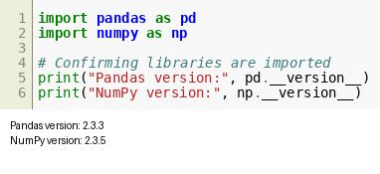
Figure 4.1

Step 2:
Dataset Loading:
The dataset 'data.csv' is loaded using pd.read_csv().
Confirmation:
A message 'Dataset loaded successfully' is printed.
Preview:
The first 5 rows are displayed showing columns like house age, distance to MRT, and house price.
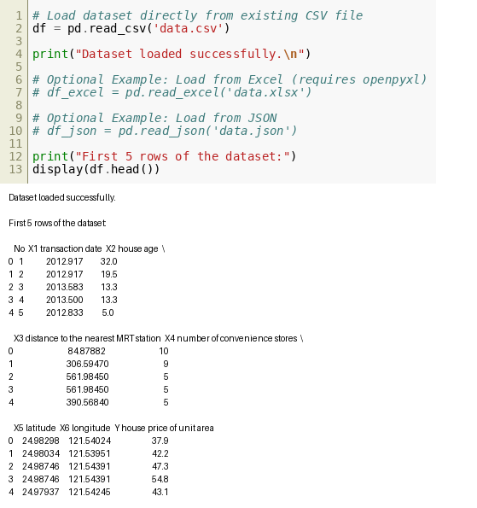
Figure 4.2

Step 3:
Data Inspection:
The dataset structure and values are displayed in detail.
Observation:
Multiple rows and columns are visible for analysis.
Purpose:
This step helps understand the dataset before processing.
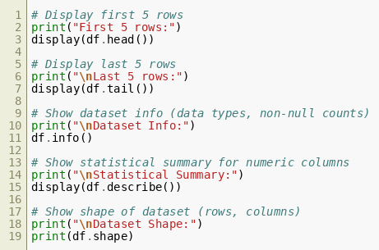
Figure 4.3

Step 4:
Column Selection:
Single and multiple columns such as house age and distance to MRT are selected.
Filtering:
Rows are filtered where house age > 20.
Conditional Filtering:
Additional conditions include price > 40 and distance < 500.
Output:
Filtered dataset is displayed.
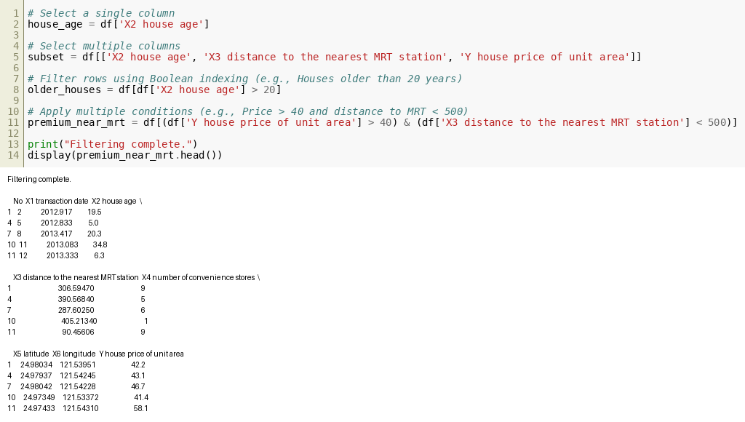
Figure 4.4

Step 5:
Sorting Data:
The dataset is sorted by house price in ascending order.
Multiple Sorting:
It also sorts by house age and price together.
Output:
Sorted data is displayed.
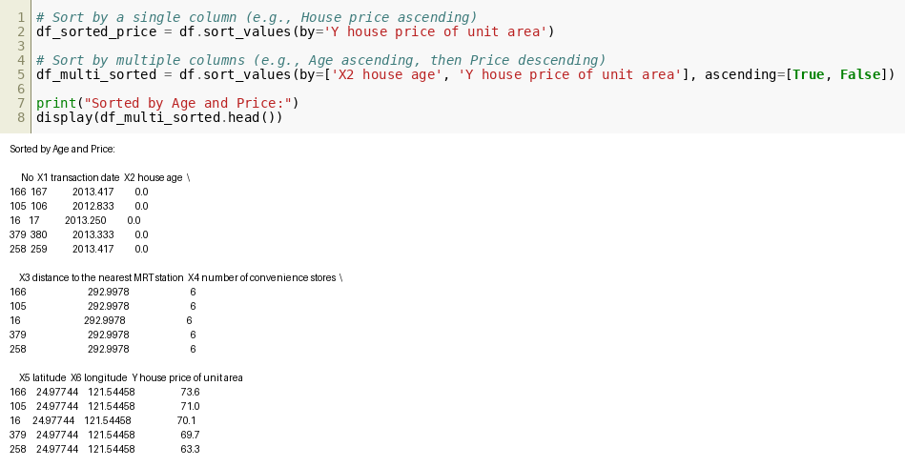
Figure 4.5

Step 6:
Missing Values Handling:
Missing values are identified using isnull().sum().
Filling Data:
Missing values are replaced using mean values of respective columns.
Result:
Clean dataset is confirmed.
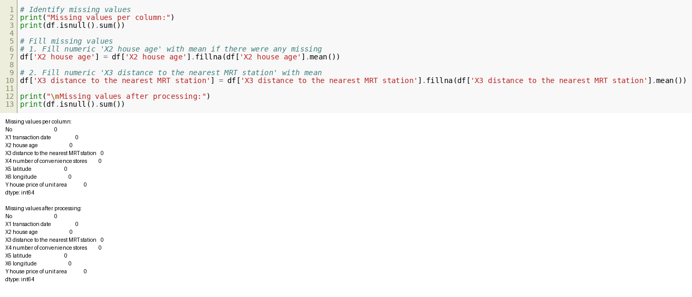
Figure 4.6

Step 7:
Feature Engineering:
A new column PricePerYear is created using price divided by house age.
Column Cleanup:
Unnecessary column No is removed.
Renaming:
Columns are renamed to more readable names like TransactionDate and DistanceToMRT.
Output:
Transformed dataset is displayed.
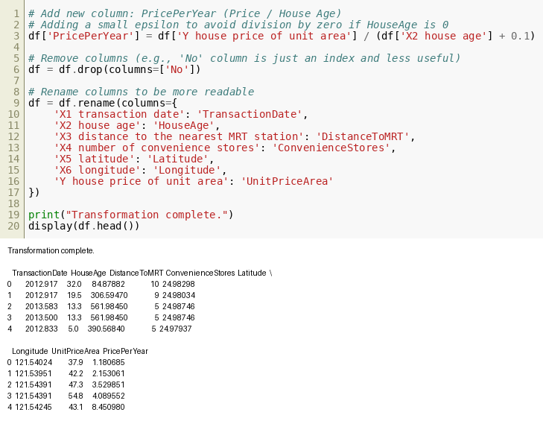
Figure 4.7

Step 8:
Exporting Data:
The cleaned dataset is saved as 'real_estate_cleaned.csv'.
Confirmation:
A message confirms successful file saving.
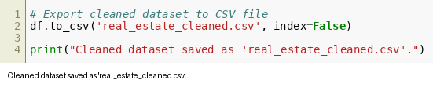
Figure 4.8

