LAB 5: Data Visualization and Analysis using Pandas & Seaborn

Procedure

Step 1:
Library Setup:
Pandas, NumPy, Matplotlib, and Seaborn are imported.
Visualization Style:
Seaborn theme 'whitegrid' and matplotlib style 'ggplot' are applied.
Confirmation:
The message 'Libraries imported successfully.' is printed.
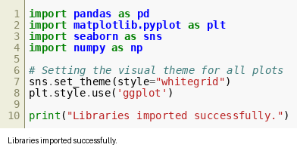
Figure 5.1

Step 2:
Correlation Analysis:
A heatmap displays correlation between Cases, Recovered, Deaths, and Tests.
Observation:
Strong correlation between Cases, Recovered, and Deaths.
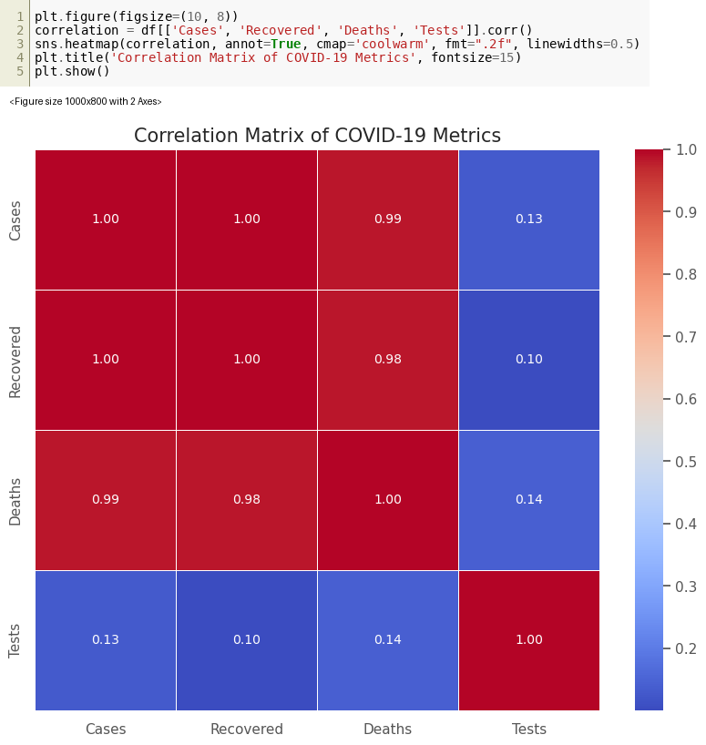
Figure 5.2

Step 3:
Regression Analysis:
Regression plots show relationships between Cases vs Recovered and Cases vs Deaths.
Insight:
Positive linear trends are observed.
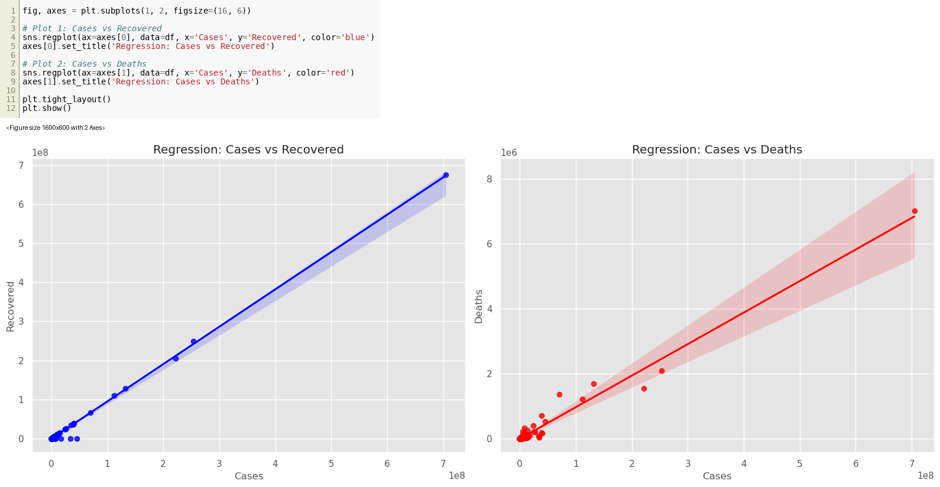
Figure 5.3

Step 4:
Pie Chart:
A pie chart shows proportion of COVID-19 cases by continent.
Observation:
Asia and Europe have the largest shares.
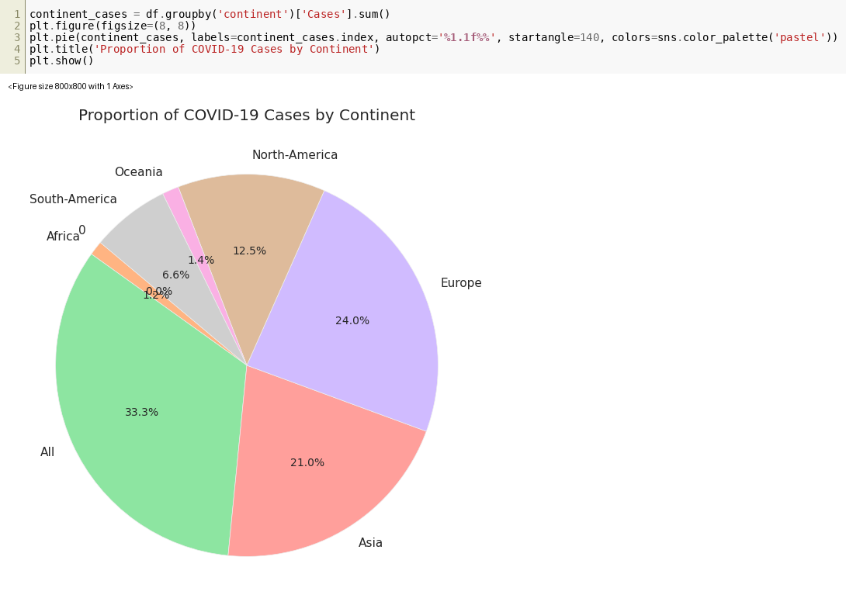
Figure 5.4

Step 5:
Time Series Aggregation:
A pivot table groups cases by continent over time.
Visualization:
Line plot shows cumulative cases progression.
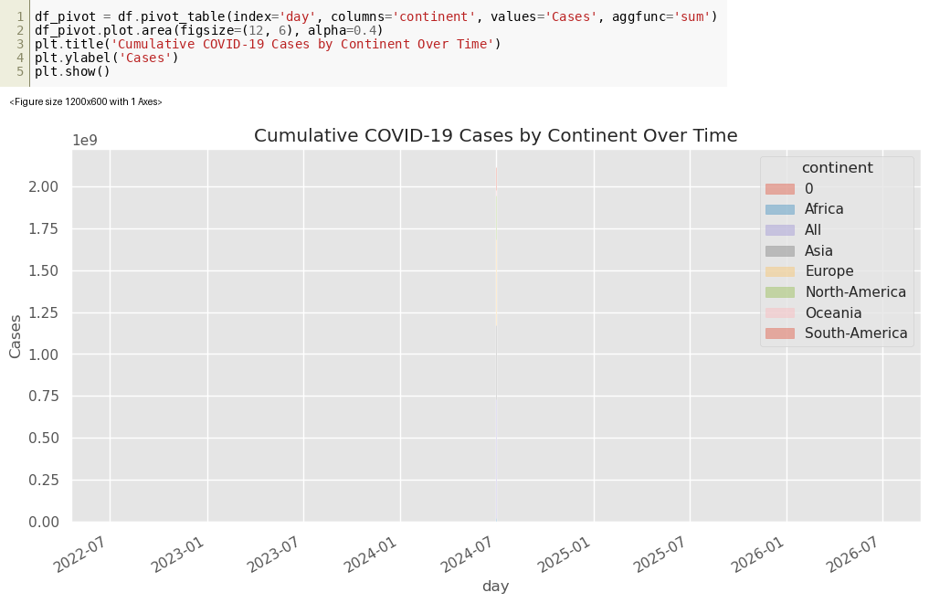
Figure 5.5

Step 6:
Country Count Analysis:
A bar chart shows number of countries represented per continent.
Insight:
Africa and Asia have higher counts compared to others.
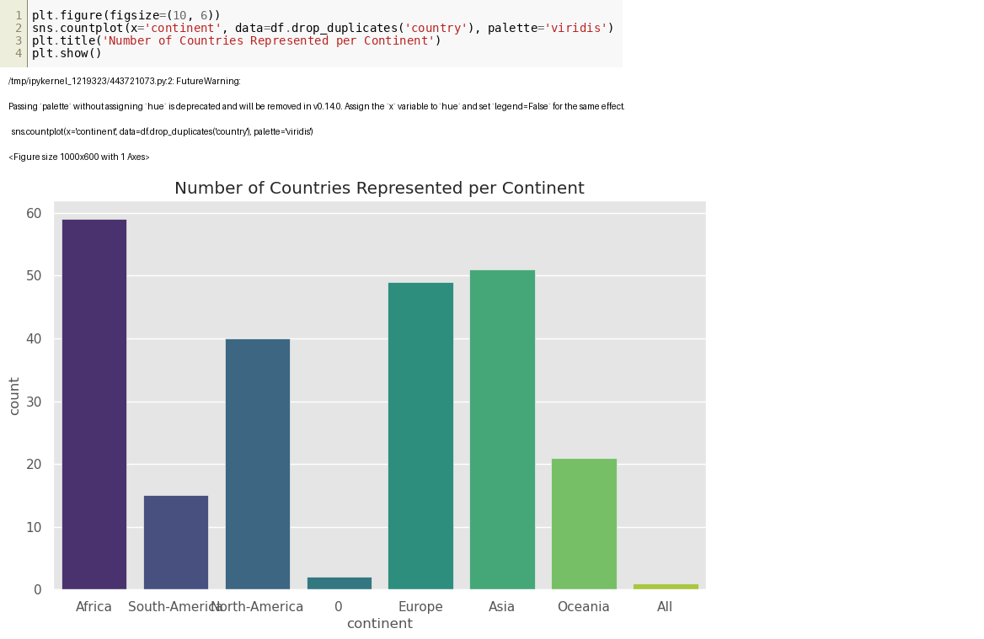
Figure 5.6

Step 7:
Dataset Loading:
The dataset 'data.csv' is loaded.
Preview:
The first 5 rows display columns such as country, continent, population, cases, recovered, deaths, and tests.
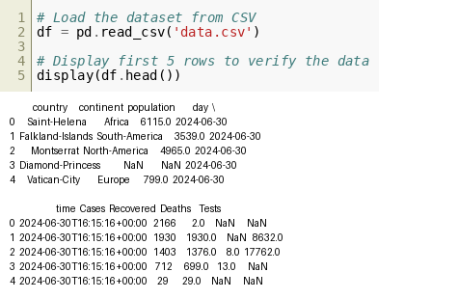
Figure 5.7

Step 8:
Data Preprocessing:
The 'day' column is converted to datetime.
Cleaning:
Missing values are filled with 0.
Conversion:
Columns like Cases, Recovered, Deaths, Tests, and population are converted to numeric types.
Output:
Dataset info is printed showing structure and types.
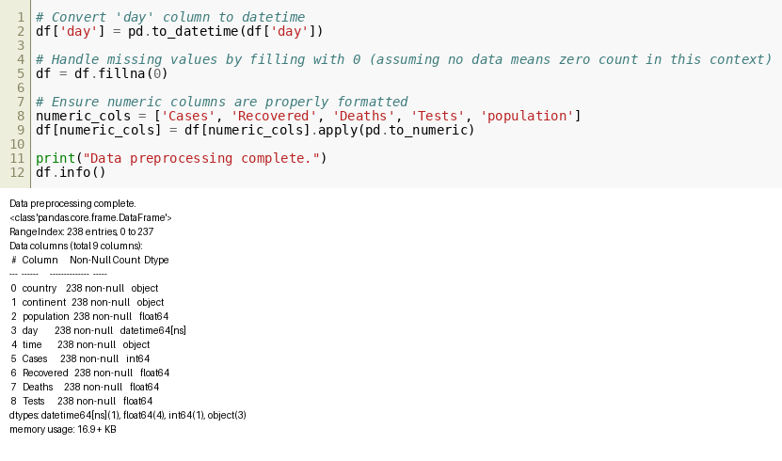
Figure 5.8

Step 9:
Trend Visualization:
A line plot shows COVID-19 cases over time for selected countries.
Details:
Countries include Saint-Helena, Falkland-Islands, Montserrat, Diamond-Princess, and Vatican-City.
Output:
Trend lines with markers are displayed.
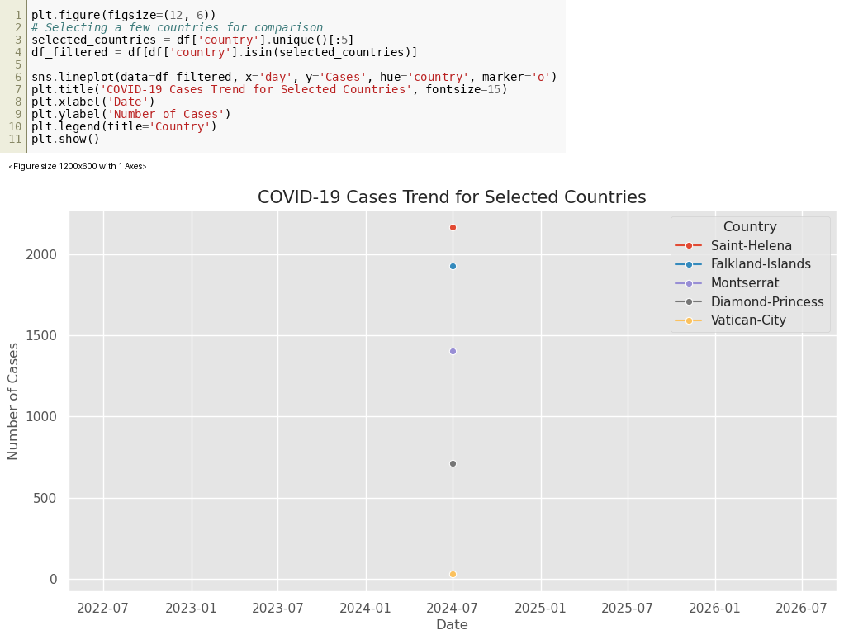
Figure 5.9

Step 10:
Top Countries Analysis:
Top 10 countries are selected based on total cases.
Visualization:
A horizontal bar chart displays countries and their case counts.
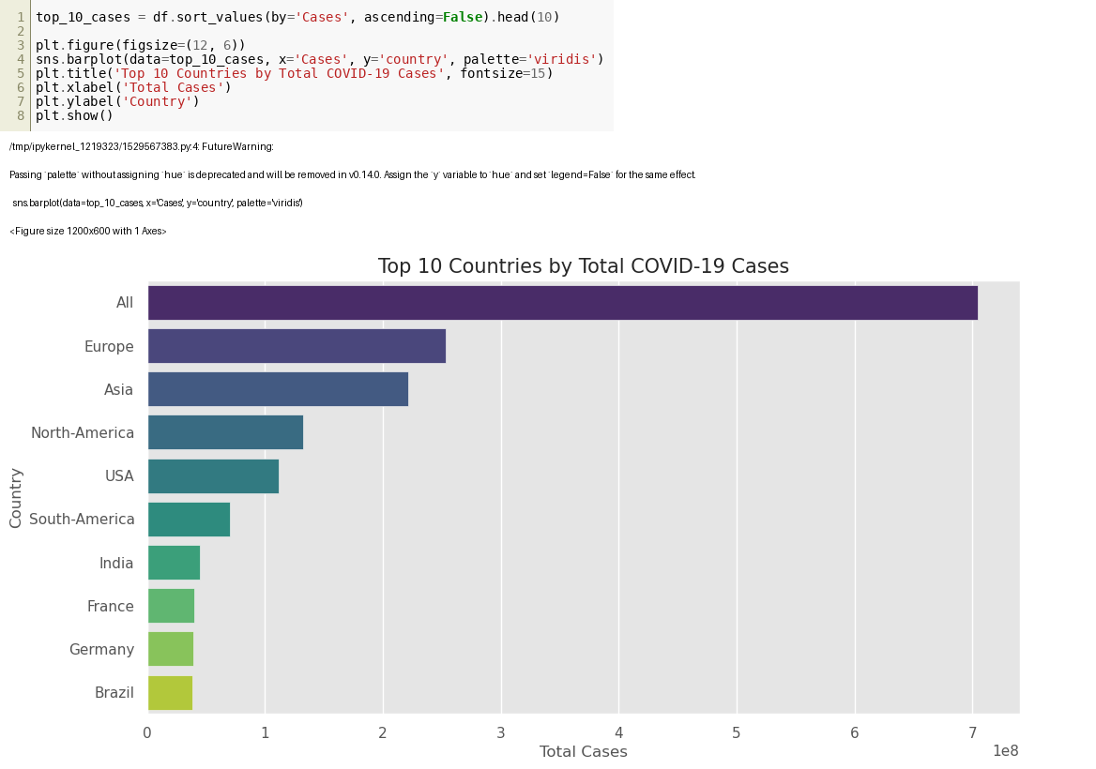
Figure 5.10

Step 11:
Distribution Analysis:
A histogram with KDE shows distribution of global COVID-19 cases.
Insight:
Most values are concentrated at lower ranges with a long tail.
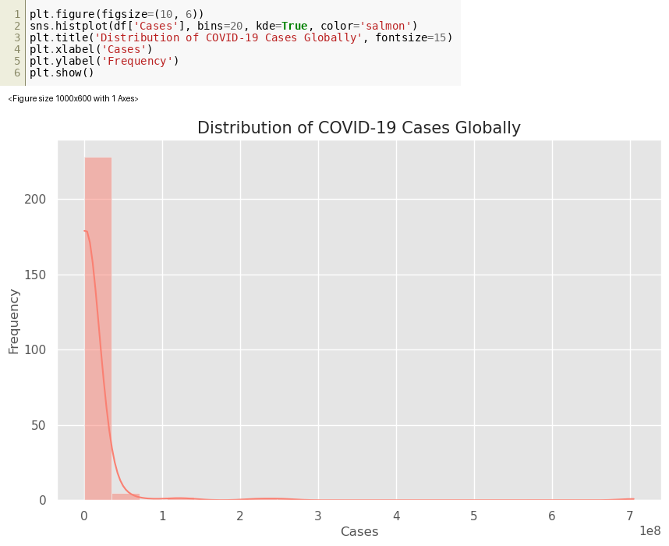
Figure 5.11

Step 12:
Scatter Analysis:
A scatter plot shows relationship between cases and deaths.
Details:
Points are colored by continent and sized by population.
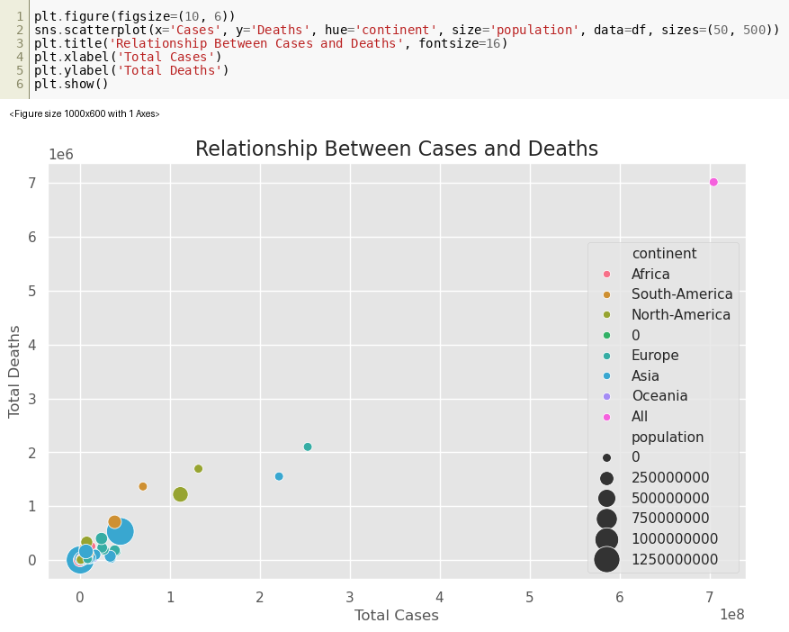
Figure 5.12

Step 13:
Box Plot:
Distribution of cases across continents is shown using a box plot.
Scale:
Log scale is used for better visualization.
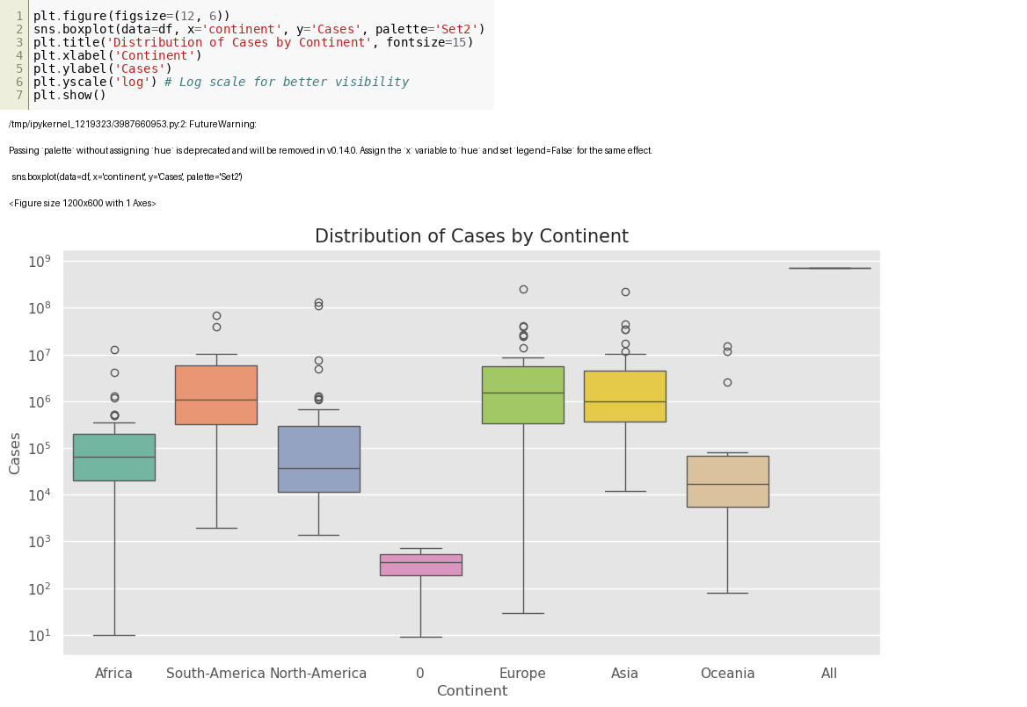
Figure 5.13

Step 14:
Violin Plot:
Distribution density of deaths across continents is visualized.
Insight:
Shows spread and concentration of death counts.
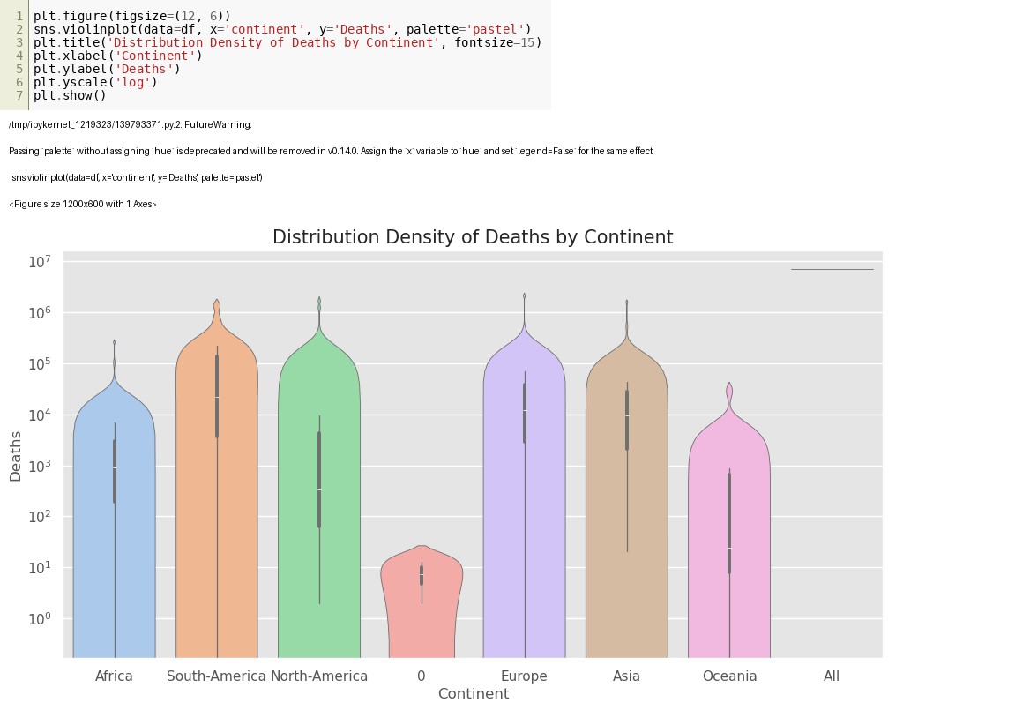
Figure 5.14

