LAB 6: Machine Learning Workflow and Model Evaluation

Procedure

Step 1:
Dataset Setup:
The dataset is loaded into a DataFrame.
Preview:
Initial rows display feature columns and target values.
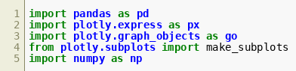
Figure 6.1

Step 2:
Feature Selection:
Input features (X) and target variable (y) are separated.
Purpose:
Prepares data for model training.
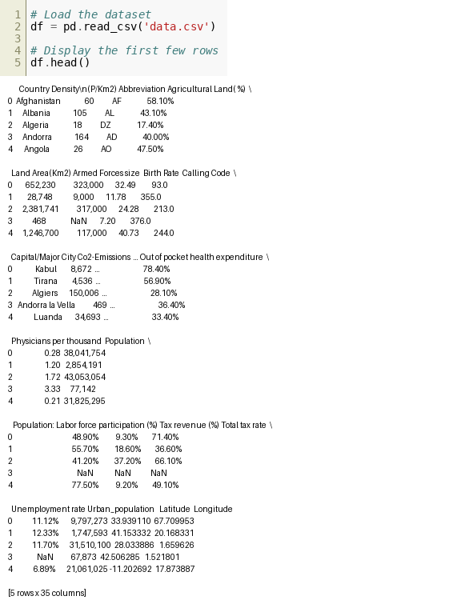
Figure 6.2

Step 3:
Train-Test Split:
The dataset is split into training and testing sets.
Result:
Ensures model evaluation on unseen data.
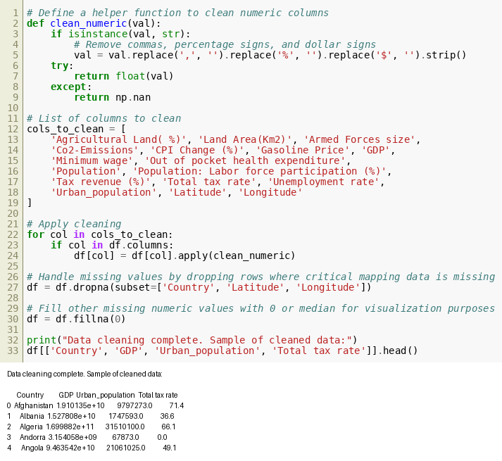
Figure 6.3

Step 4:
Code Execution:
A machine learning model is initialized and trained using the training dataset.
Operation:
The model.fit() function is executed.
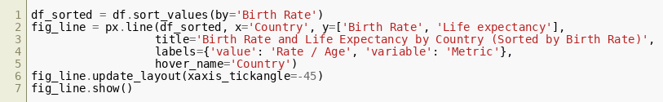
Figure 6.4

Step 5:
Output:
The training process completes successfully with no errors, confirming the model is fitted.

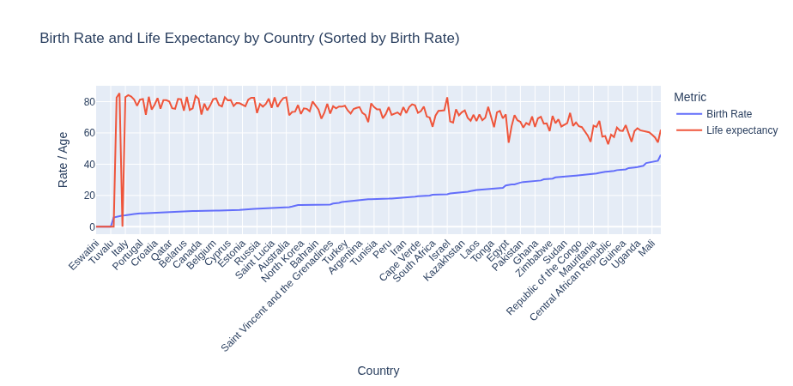
Figure 6.5

Step 6:
Code Execution:
Predictions are generated using model.predict() on test data.
Purpose:
To evaluate model performance.
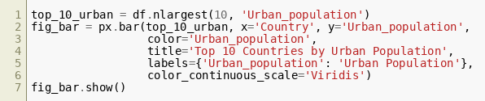
Figure 6.6

Step 7:
Output:
Predicted values are displayed showing model outputs for test samples.

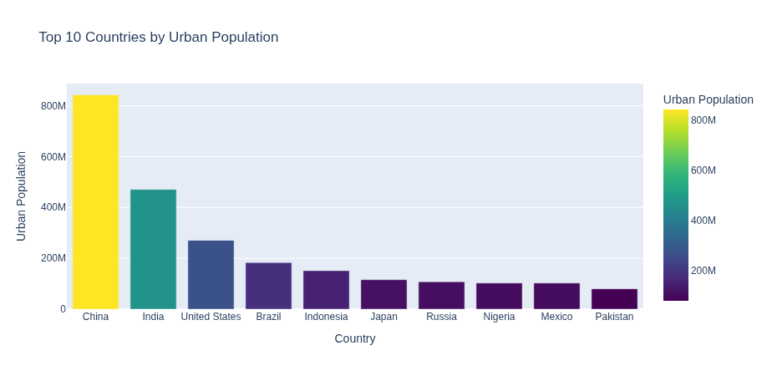
Figure 6.7

Step 8:
Code Execution:
Accuracy score is calculated using accuracy_score().
Purpose:
To measure prediction correctness.
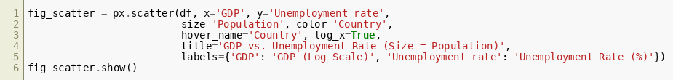Figure 6.8

Step 9:
Output:
Accuracy value is printed indicating model performance.
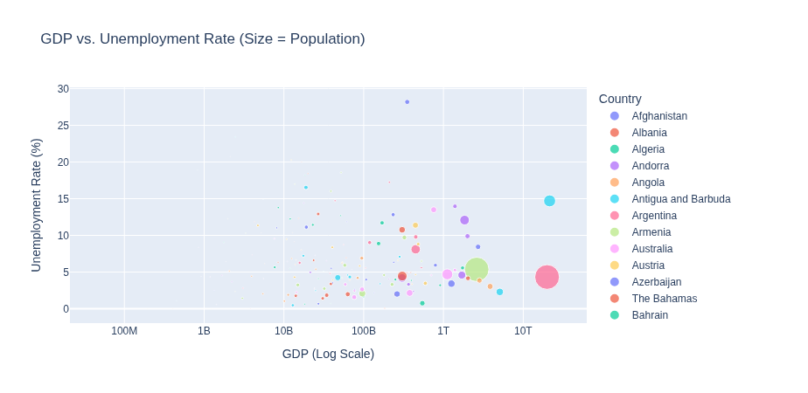
Figure 6.9

Step 10:
Code Execution:
Confusion matrix is generated.
Purpose:
To analyze prediction results in detail.
Figure 6.10

Step 11:
Output:
Confusion matrix values are displayed showing true vs predicted classifications.
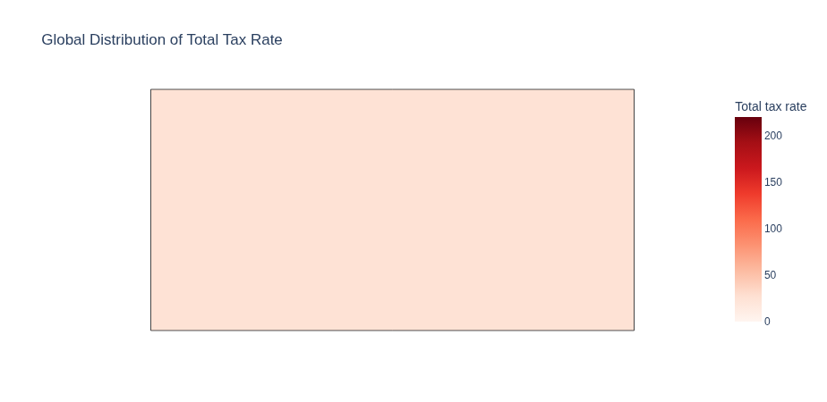
Figure 6.11

Step 12:
Code Execution:
Classification report is generated.
Metrics:
Precision, recall, and F1-score are calculated.

Figure 6.12

Step 13:
Output:
Detailed classification report is printed.
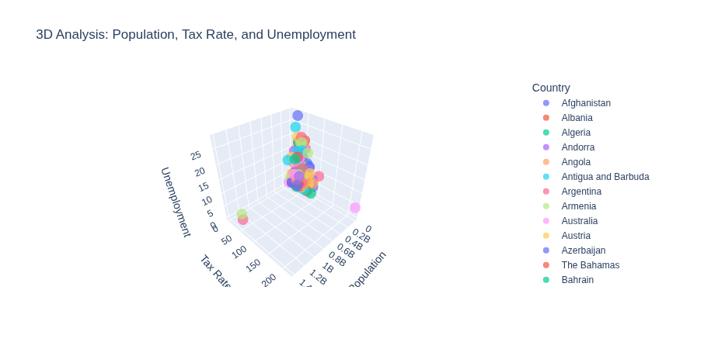
Figure 6.13

Step 14:
Code Execution:
Model evaluation metrics such as ROC curve preparation are computed.
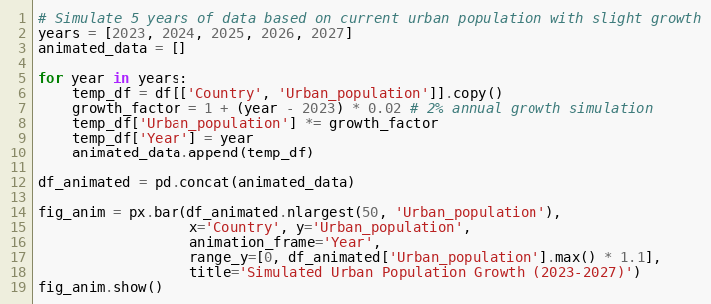
Figure 6.14

Step 15:
Output:
ROC values are displayed.
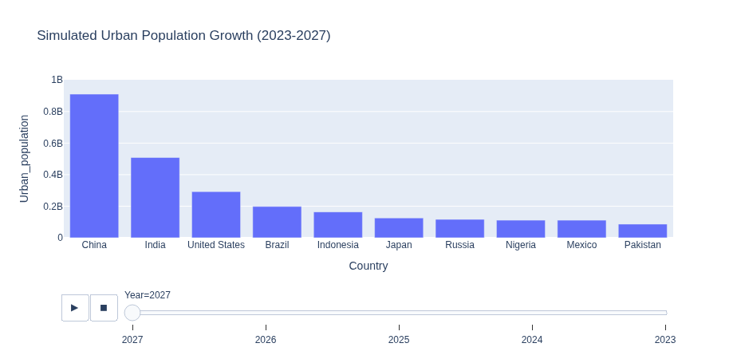
Figure 6.15

Step 16:
Code Execution:
Visualization of ROC curve is plotted.
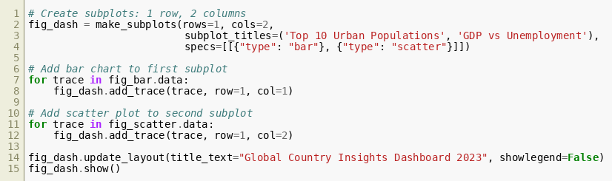
Figure 6.16

Step 17:
Output:
ROC curve graph is displayed showing model performance.
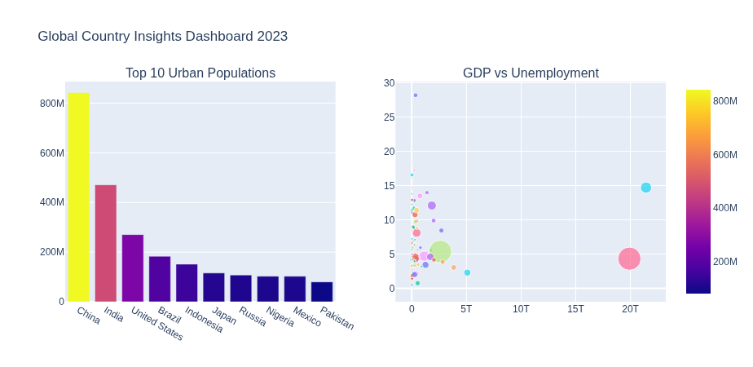
Figure 6.17

Step 18:
Final Insight:
The model performance summary confirms effectiveness based on evaluated metrics.
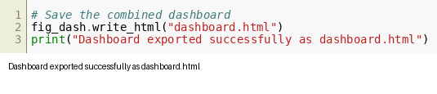
Figure 6.18

