



CERTIFICATE
OF COMPLETION
THIS CERTIFICATE IS PRESENTED TO
{name}
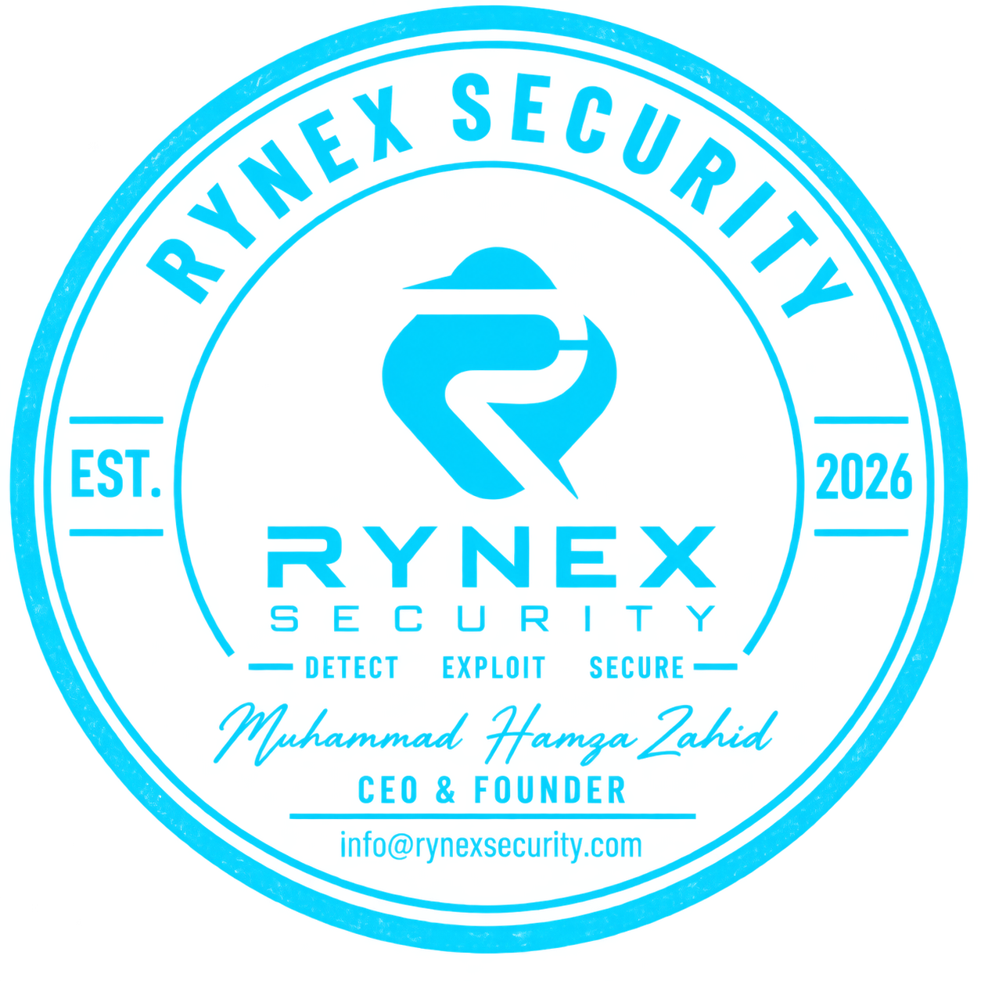
This is to certify that {name_small} has successfully completed the 6 Weeks Cybersecurity Internship & Learning Program At RYNEX SECURITY held from 13 July to 24 August 2026.
{team}
Awarded this on 30th day of August, 2026
Founder And CEO

