



CERTIFICATE
OF COMPLETION
THIS CERTIFICATE IS PRESENTED TO
{name}
This certificate, bearing Certificate ID: {uuid}, is proudly awarded to {name_small} in recognition of successfully completing the 6 Weeks Cybersecurity Internship & Learning Program at RYNEX SECURITY, held from 13 July to 24 August 2026.
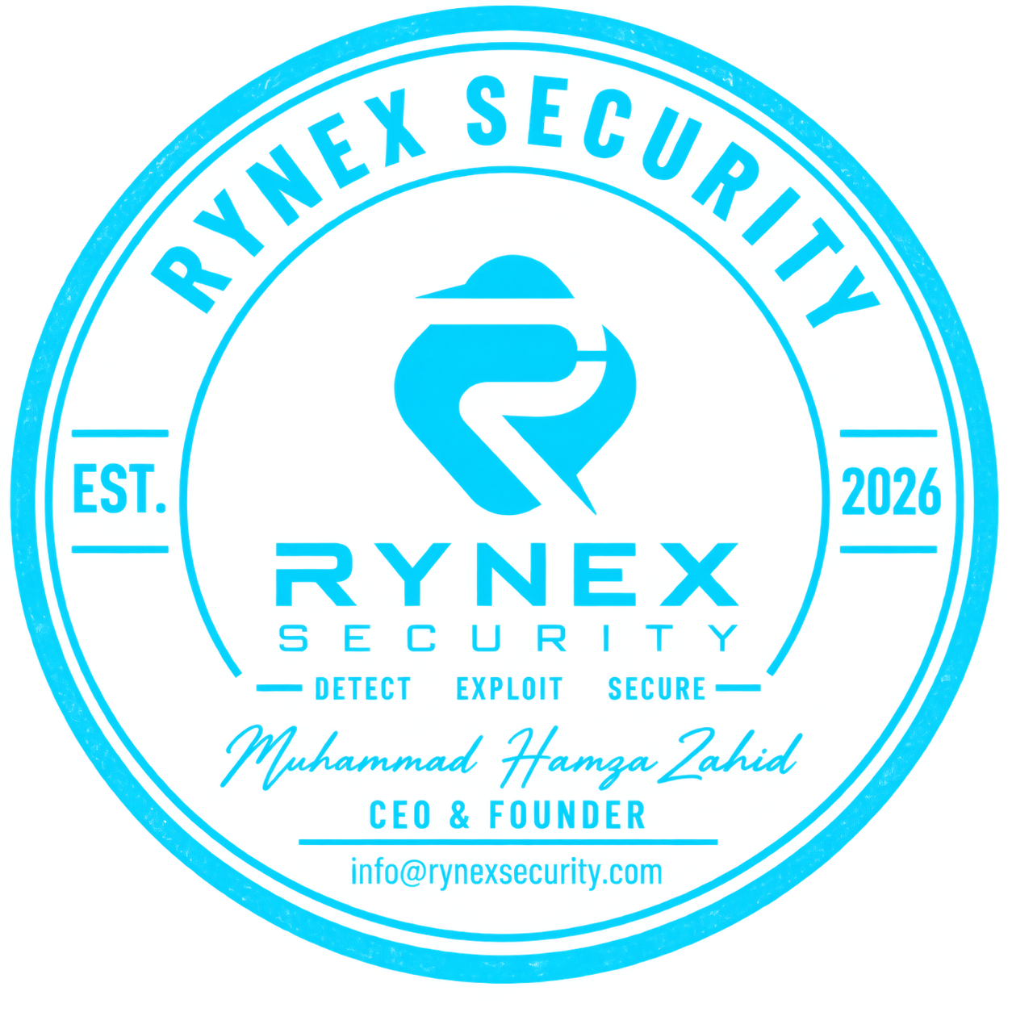
{team}
Awarded this on 30th day of August, 2026
Founder And CEO

