IATracker

for

Star Wars Imperial Assault

Kevin Smith

CS 449

Spring ‘17

**Vision Statement**

For players of Star Wars Imperial Assault who want a digital solution to track their progress of one or more campaigns, IATracker is an Android app that will keep record of all progress components unique to each user campaign. Unlike the competition, this app will not only track the progress, but also provide a systematic walkthrough when a campaign needs to be set up.

IATracker will include all components for the base game and all boxed expansions. Users can select which expansions they have and which story campaign they will play through. All irrelevant or incompatible items (such as side missions) will be filtered out to provide a streamlined look and feel.

**Requirements**

|  |  |
| --- | --- |
| **Actor** | **Goal** |
| Imperial Player | Start a new campaign to track |
|  | Load previously saved campaigns |
|  | Save campaign selections at any point |
|  | Select which expansions are purchased and being used (if any) |
|  | Select the campaign book that will be used |
|  | Build the non-static decks |
|  | View currencies (XP and Threat points) |
|  | Review previously purchased cards |
|  | View campaign mission progress |
| Rebel Player(s) | Review previously purchased cards |
|  | View currencies (XP and Credits) |
|  | View campaign mission progress |

**Product Backlog**

|  |  |  |  |  |
| --- | --- | --- | --- | --- |
| **Story ID** | **Story** | **Story Points** | **Priority** | **Status** |
| S1 | Select which expansions he/she owns | 3 | 5 | done |
| S2 | Pick which story campaign to play | 3 | 4 | done |
| S3 | Select Imperial Player class deck | 3 | 4 | done |
| S4 | Select 2 to 4 heroes of the Rebel players’ choosing | 3 | 5 | done |
| S5 | Select and build the side missions deck | 2 | 4 | done |
| S6 | Select and build the Agenda deck | 2 | 4 | done |
| S7 | View current XP amount | 1 | 2 |  |
| S8 | View previously purchased abilities from the class deck | 5 | 3 |  |
| S9 | View which mission(s) have already been played | 3 | 1 |  |
| S10 | View which mission(s) are upcoming | 2 | 3 | not needed |
| S11 | View which Conditions to omit | 1 | 1 | not needed |
| S12 | View which Item cards to omit | 2 | 1 | not needed |
| S13 | Select newly purchased Item cards by the Rebels | 2 | 2 |  |
| S14 | Select newly purchased Rebel hero class deck cards | 2 | 2 |  |
| S15 | Select newly purchased Imperial Player class deck cards | 2 | 2 |  |
| S16 | View current Credits value | 1 | 1 |  |
| S17 | View current XP value for each hero | 1 | 2 |  |
| S18 | View previously purchased abilities from each hero’s class deck | 4 | 2 |  |
| S19 | View previously purchased Item cards | 2 | 2 |  |

* These hour estimates are very rough estimations and probably understated *

**Sprint 1 Backlog**

|  |  |  |  |
| --- | --- | --- | --- |
| **Story ID** | **Story / Task** | **Estimated Hours** | **Actual Hours** |
| n/a | Design home UI | 5 | 3 |
| S1 | Design expansion selection UI | 3 | 1 |
| S2 | Design story campaign selection UI | 3 | 1 |
| S3,S4,S6 | Design Imperial Player and Hero selection UIs | 3 | 5 |
| S5 | Design Side Missions deck creation UI | 3 | 2 |
| n/a | Compile and add the data to each above item (not selectable yet) | 8 | 8 |

**Sprint Review**

Home screen “New” Selected “Next” Selected

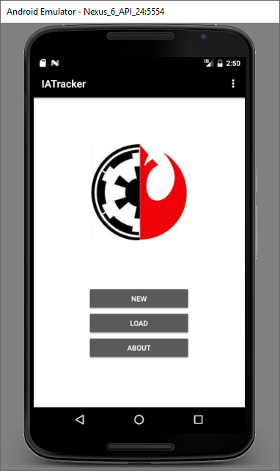 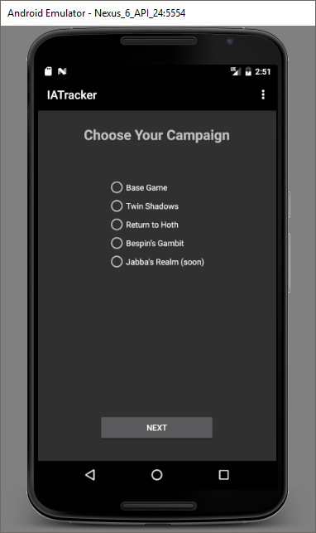 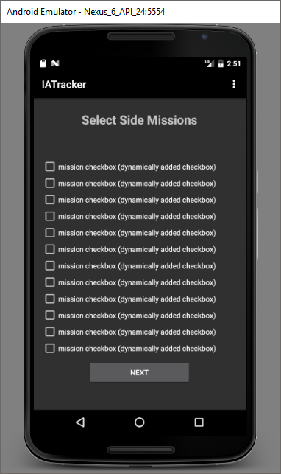

“Next” Selected “Next” Selected “Next” Selected

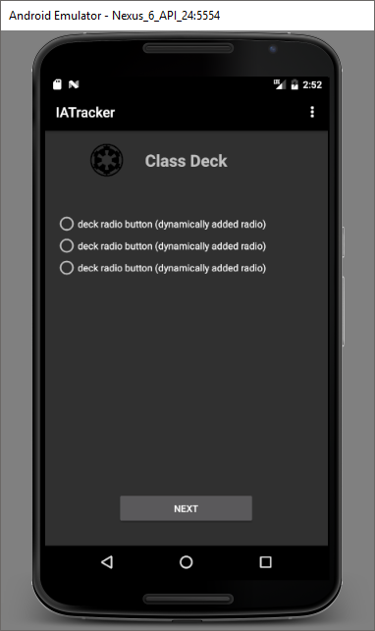 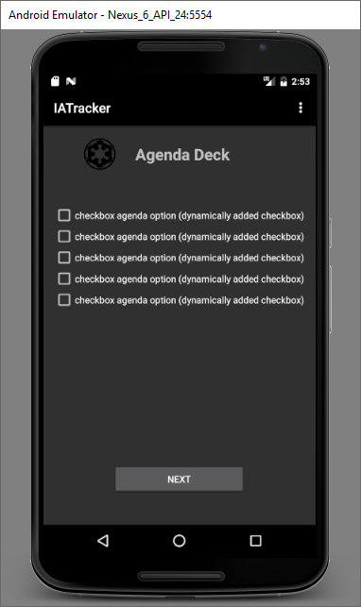 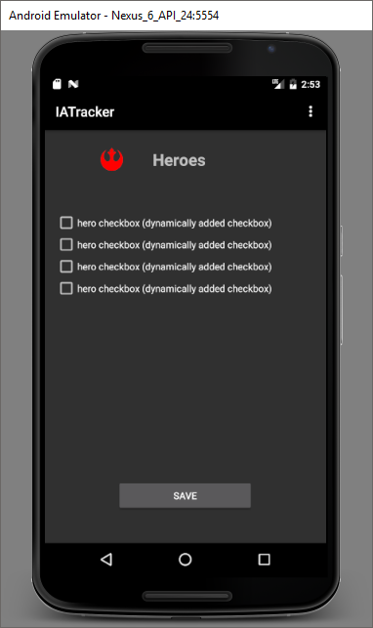

Menu: “About” Option Displays

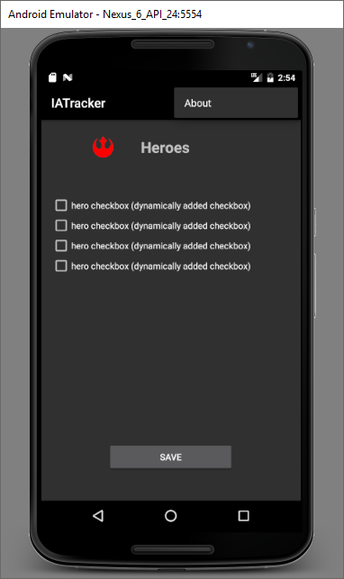

Currently, the UI progression for starting a new campaign exists. The data for these screens will soon be stored in a database and will be queried to populate each view. There will be minimums and maximums for each, which varies by the game component. At the end of the progression, users will be able to save their campaign specifications.

**Retrospective**

Once becoming better acclimated with adding and tweaking views, the process for each subsequent view was faster. Planning and time estimations could have gone better, which is something that normally challenges me. I waffled on how the new campaign progression would look and a major change was made after some work was done. However, the progression is cleaner than I had originally planned. I now have a better sense of time estimations for creating new views and switching between them. There isn’t anything I will do differently for the next iteration, since future features will involve more aspects of Android development that I have zero experience with.

**Sprint 2 Backlog**

|  |  |  |  |
| --- | --- | --- | --- |
| **Story ID** | **Story / Task** | **Estimated Hours** | **Actual Hours** |
| n/a | Design the Load Campaign UI | 5 | 11 |
| n/a | Design the Load Campaign navigation menu | 4 | 4 |
| n/a | Import all data into the database | 8 | omitted |
| n/a | Learn how to query the database and display results on one screen in the New Campaign UI | 4 | omitted |

**Screenshots**

Main Screen “Load” was selected “Next” was selected “Missions” was selected

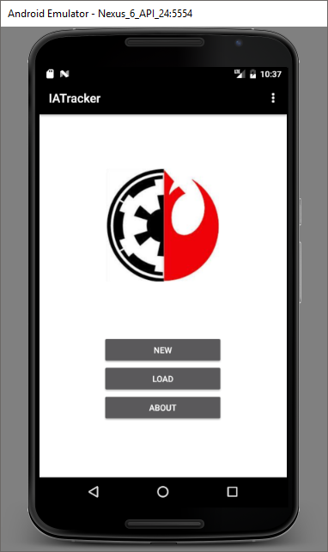 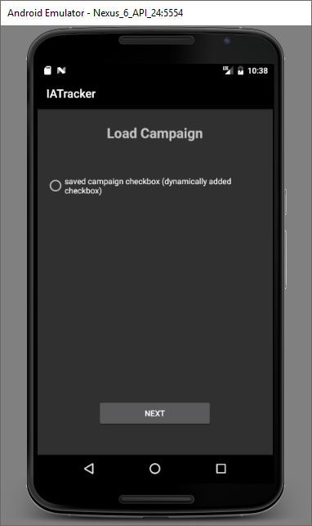 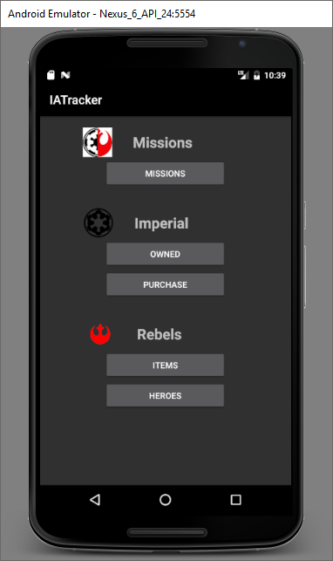 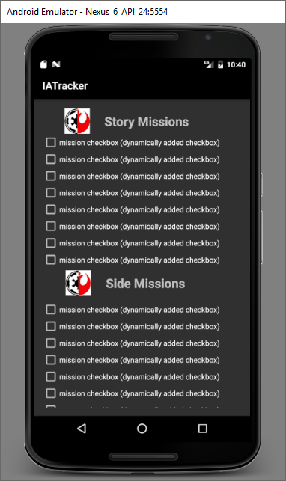

“Owned” “Purchased” “Items” “Heroes”

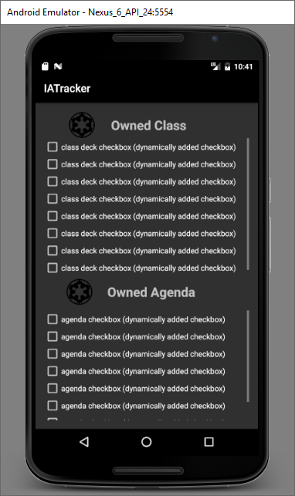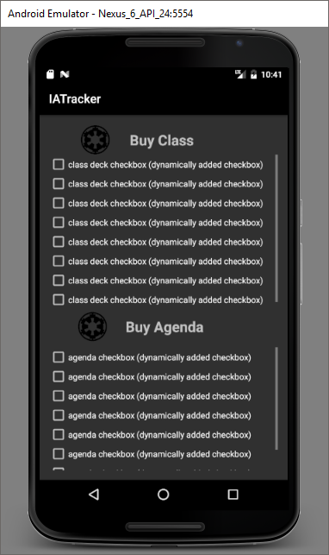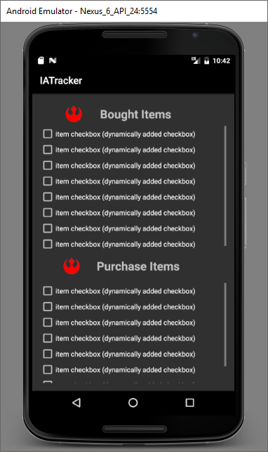

**Retrospective**

After much time spent, the decision was made to store all card data in text files instead of a database. A preliminary list of tables was derived and there were no necessary relationships between them. Additionally, the entire set of card data remains static until more expansions are released. Lastly, all card data specific to a saved campaign is small and can be stored in a single text file. Those were the main factors involved. This is one example of overcomplicating the application, which is something I am working to avoid for future iterations.

**Sprint 3 Backlog**

|  |  |  |  |
| --- | --- | --- | --- |
| **Story ID** | **Story / Task** | **Estimated Hours** | **Actual Hours** |
| n/a | Populate side missions in New Campaign view | 2 | 2 |
| n/a | Populate Imperial class and agenda data in New Campaign views | 4 | 3 |
| n/a | Populate Rebel hero data in New Campaign view | 2 | 1 |
| n/a | Derive system allowing campaign details to one text file | 4 | 4 |
| n/a | Save campaign details to a text file | 3 | not complete |

**Screenshots**

Campaign options from text file Side missions (file) Imperial class deck (file)

(scrollable)

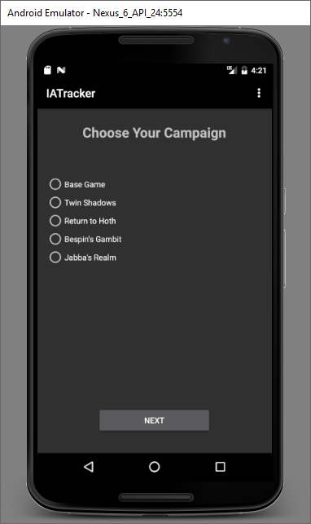 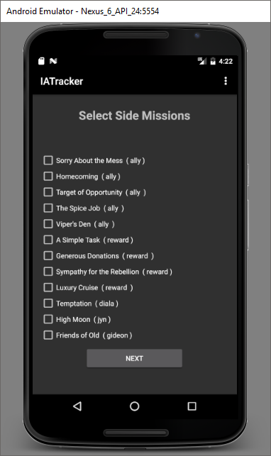 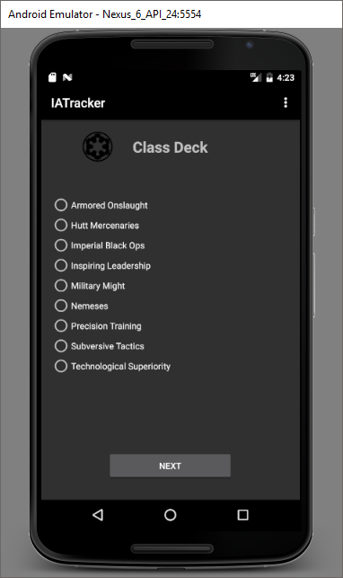

Agenda decks (file) Heroes (file)

(scrollable) (scrollable)

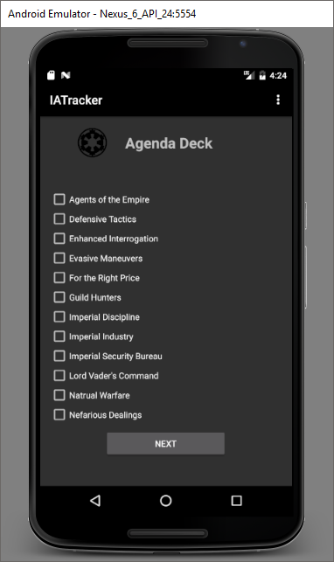 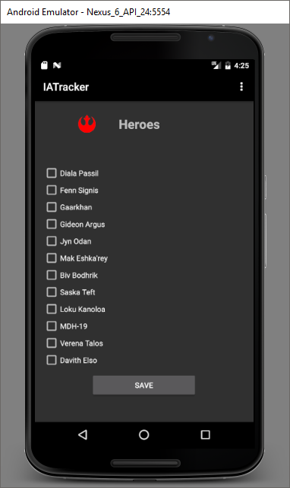

**Retrospective**

The lack of 100% completion on Iteration 3 will not hinder the plan for the Iteration 4. I will keep striving for accurate time estimates for story points and improving my conceptual design process, both of which have improved a little since Iteration 1. My plan is to continue pushing for better time management skills overall. The problem I keep running into is the lack of large chunks of time (a few hours at least) to work on this project, because less than that tends to yield little to no progress on the code or even my understanding of the solutions. Iteration 3 was less like that than 1 and 2, but given the amount of work ahead of me, I need to find some workaround. Also, I need to start adding the Velocity section, because I realized this has been missing.