Composition and Distribution of Phytoplankton in a Subtropical Coastal Shelf Region in the East Coast of Florida near Cape Canaveral

By

Mary C. Tate, Edward J. Phlips*, Susan Badylak, M. Hamazaki, Leslie Landauer, Anne West-Valle and Ben Stelling

Fisheries and Aquatic Sciences Program, S.F.R.C, University of Florida, Gainesville, Florida, USA 32653

*Corresponding author, phlips@ufl.edu

**ACKNOWLEDGMENTS**

We thank the Department of Interior, Bureau of Ocean Energy Management (BOEM), who partially funded this project (CFDA No. 15.424).

**ABSTRACT**

The structure of the phytoplankton community was observed off the coast of Cape Canaveral, Florida, from the fall of 2013 to the summer of 2015. Water samples were collected at 24 sites on a seasonal basis from the surface and bottom of the water column. Temperature and nutrient concentrations were collected also. Cyanobacteria were consistently the most important phytoplankton group in terms of numerical abundance and biomass throughout the study. Among the cyanobacteria, picoplanktonic species were the dominant group, but a significant surface bloom of the nitrogen-fixing filamentous species *Trichodesmium* was observed in the fall of 2013. Nanoplanktonic eukaryotic algae were the next most abundant group in terms of biomass, led by the prasinophytes (Chlorophyta). Dinoflagellates were periodically important in terms of biomass, including obligate photoautotrophic, mixotrophic and heterotrophic species.

Spatial, depth, and temporal differences in the distribution of phytoplankton composition and biomass were examined within the context of possible abiotic and biological driving factors. No consistent and reoccurring spatial patterns were observed, likely due to the dynamic water circulation in the open Cape Canaveral shelf environment. Depth-related differences in biomass were observed for dinoflagellates and diatoms. Dinoflagellate biomass was on average higher in surface samples, perhaps related to their inherent motility. Conversely, diatom biomass was on average higher in bottom waters, reflecting two possible factors: the negative buoyancy of most species and the potential for re-suspension at the benthic–pelagic interface. Inter-annual variability in dominant taxa and the seasons of maximum biomass demonstrate the lack of well-defined temporal patterns often observed in subtropical/tropical environments. The strong increase in picocyanobacteria biomass observed in Year 2 of the study may reflect the influence of high rainfall resulting from El Niño conditions on nutrient loads from the adjacent land mass, as indicated by large increases in phosphorus concentrations. Understanding how abiotic and biological factors influence phytoplankton in the Cape Canaveral shelf environment will help to predict how these important primary producing microscopic organisms will respond to future changes in the environment.

**Keywords:**

**INTRODUCTION**

Marine phytoplankton represent about 50% of global primary production (Veldhuis & Kraay, 2004; Flombaum *et al.*, 2013), it is therefore important to understand their composition, biomass and dynamics, given the growing influences of anthropogenically-driven eutrophication and climate change (Nixon 1995, refs). From a historical perspective, a majority of phytoplankton studies have focused on temperate and boreal ecosystems. For example, in a comparative study of phytoplankton dynamics in 165 marine ecosystems around the world, only 25 were located below 30 $°$ latitude (Cloern & Jassby, 2010). However, the large spatial extent of subtropical/tropical waters, and rapid growth of human development in these regions warrants greater emphasis on tropical/sub-tropical phytoplankton (Geider *et al.*, 1997). The composition, biomass and dynamics of phytoplankton communities in different climatic regimes in part reflect differences in key physical factors, such as temperature and incident irradiance, which exhibit larger seasonal variability at higher latitudes. Boreal latitudes experience strong seasonal changes in both factors, often resulting in summer peaks in phytoplankton growth rates and biomass (Sakshaug & Slagstad, 1991). Temperate latitudes often display multiple seasonal peaks in phytoplankton biomass, including a spring bloom due to elevated irradiance levels and a nutrient-enriched and stratified water column, lower levels of phytoplankton in early summer due to nutrient limitation and grazing pressure, and a secondary bloom in late summer/fall due to regeneration of nutrients or upwelling (Alvain *et al.*, 2008; Li *et al.*, 2006; Mahadevan *et al.*, 2012; Siegel *et al.*, 2002). By contrast, tropical latitudes exhibit less seasonal variation in solar irradiance and temperature, which translates into less distinct or consistent seasonal patterns of phytoplankton biomass than boreal or temperate ecosystems (Bienfang *et al.*, 1984). In many tropical systems, intra-annual variability can be more closely linked to wet and dry periods or tropical storm activity, which can correlate to changes in nutrient loads (Bienfang *et al.*, 1984).

The focus of this study was spatial and temporal variability in the composition and biomass of the phytoplankton community off the coast of Cape Canaveral, located off the east-central coast of Florida. The region is a continental shelf environment ranging in depth from 5-50 m, extending to approximately 50 km off the Florida coast (Atkinson *et al.*, 1983). While some refer to this region as tropical, it is more appropriately designated as subtropical, as its latitude (28°N) and typical water temperature range (i.e. 17.5-30oC) falls between the tropical environment of the Florida Keys and the more temperate conditions in the coastal waters of the Carolinas. The shallow shelf environment of Cape Canaveral is part of the South Atlantic Bight (SAB) and can be impacted by Gulf Stream loop currents (Atkinson, 1977). Previous research has shown that biological production in the SAB is affected “by interaction between the Gulf Stream and adjacent shelf waters” (Lee *et al.*, 1991), as well as by land influences from the Florida peninsula, and upwelling of deep water from the edge of the shelf (Yoder *et al.*, 1981; Lee *et al.*, 1992) . One study found that these interactions are amplified in areas between 27° and 30°N (Lee *et al.*, 1991), which includes the Cape Canaveral region, in part because of the protrusion of the land feature (Fig. 1). The Gulf Stream and wind-driven currents influence the movement of the water and, therefore, the distribution of phytoplankton within the water column (Xie *et al.*, 2001; Winder & Hunter, 2008).

The results of this study reveal similarities to phytoplankton communities of other sub-tropical/tropical ocean systems, such as the importance of picoplanktonic species, blooms of the nitrogen-fixing cyanobacteria *Trichodesmium* spp., and significant presence of mixotrophic taxa (e.g. prasinophytes, dinoflagellates). The climatic regime of the region is reflected in the absence of a re-occurring period of peak phytoplankton biomass, but rather episodic blooms in all seasons of the year, involving a wide range of algal groups. The results also reflect the influence of shallow depths and strong wind-driven currents and vertical mixing, resulting in enhanced potential for blooms of large centric chain-forming diatoms and re-suspension of meroplanktonic species.

**MET****HODS**

**Site Descrip****tion**

The water samples and associated field data used in this project were collected on a quarterly basis, from the fall of 2013 through the summer of 2015. The sampling area was located approximately five miles off the coast (Fig. 1). The area was divided into four regions, i.e. Chester, Bull, North Canaveral Shoal (North Shoal), and South Canaveral Shoal (South Shoal) (Fig. 1). Water samples and associated field data were collected at six sites in each region. The bottom topography in the sampling area was characterized by ridges and swales. The ridges typically ranged in depth from 4-6 m, while the swale locations typically ranged from 8-12 m. Samples from two of the six sites in each region were collected from ridge locations and samples from the other four sites from swale locations.

**Sampling Pro****tocols**

For each site, water temperatures were recorded using a YSI multi-parameter field probe at 0.5 m from the surface and 1 m off the bottom. Surface water was collected at each sampling site using a vertical integrating sampling tube that collects water evenly from the surface to 2.5 m depth. Bottom water samples were collected from 1 m off the benthos with a 5 L Niskin bottle. Three subsamples of the water samples were preserved on site; one with 1% Lugol’s solution and one with glutaraldehyde in 0.1-M sodium cacodylate buffer. The third subsample was frozen for subsequent analysis of total phosphorus and total nitrogen concentrations.

**Nutrient Analyses**

Total nitrogen (TN) and total phosphorus (TP) concentrations were determined using the frozen subsamples mentioned above, via the Standard Methods APHA (1998), with some modifications from U.S.E.P.A. methods (1983).

**Phytoplankton Analysis**

The subsamples that were preserved with Lugol’s solution were analyzed using the Utermöhl method (Utermöhl, 1958; Rott *et al.*, 2007; Phlips *et al.*, 1999). Samples were settled in a chamber for approximately 24 hours to allow cells to settle at the bottom for counting. The phytoplankton were identified and counted at both a 400X and 100X magnification using an inverted microscope. A minimum of 30 and a maximum of 100 grids were counted for each 400X count. At this magnification, the count was complete once 100 cells of a single taxon and at least 30 grids were observed (Phlips *et al.*, 1999). If 100 individuals of a single species were not observed, the count continued until 100 grids were completed. Only species smaller than 30 µm in size were recorded at this magnification. A total bottom count of the settling chamber was completed for each 100X count; all species larger than 30 µm in size were recorded at this magnification (Phlips *et al.*, 1999). Subsamples of seawater were filtered onto 0.2 µm Nuclepore filters and mounted between a microscope slide and cover slip with immersion oil. If not analyzed immediately, slides were stored in a freezer and counted within 72 hours. In addition, picoplanktonic cyanobacteria were identified and enumerated at a 1000X magnification using a fluorescent microscope (Blanchot *et al.*, 1992; Phlips *et al.*, 1999).

Cell biovolumes were estimated by assigning combinations of geometric shapes to fit the characteristics of individual taxa (Smayda, 1978). Specific phytoplankton dimensions were measured for at least 30 randomly selected cells of each species. Species which vary in size, such as many diatom species, were placed into size categories. The number of cells of a species observed in a sample (cells/mL) was multiplied by the individual biovolume of that species, yielding the total biovolume of the respective species in the sample. Phytoplankton carbon values, or biomass (as µg carbon mL-1), were estimated by using conversion factors for different taxonomic groups applied to biovolume estimates (expressed as 106 µm3 mL-1), i.e., 0.065 x biovolume of diatoms, 0.22 x biovolume of cyanobacteria or small nanoplanktonic eukaryotes (‘other’), and 0.16 x biovolume of dinoflagellates (Ahlgren, 1983; Sicko-Goad *et al.*, 1984; Verity *et al.*, 1992; Strathmann, 1967; Work *et al.*, 2005).

The phytoplankton species observed were divided into four categories for general comparisons of compositional differences at spatial and temporal scales, i.e. diatoms, dinoflagellates, cyanobacteria, and all other taxa (i.e. ‘other’). The ‘other’ category included species that did not fit into the first three categories, and was dominantly made up of eukaryotic flagellates, such as cryptophytes, haptophytes, euglenophytes, and prasinophytes.

The 50 taxa with the highest total biomass within each region, depth (per year), or season (per depth) were ranked. To examine differences in the character of dominant phytoplankton species in surface and bottom water samples, the Top-50 individual biomass observations were compared for each sample set. The data for Years 1 and 2 of the study were examined separately to reveal several noteworthy differences between years.

**Statistical Analyses**

Basic statistical procedures (i.e., determination of mean values, standard deviations, Duncan’s Multiple Range Test) were carried out using statistical programs R and PRIMER (R Core Team, 2013; Clarke & Gorley, 2015). A Log10 transformation was used to normalize the carbon biomass data for the comparison of means.

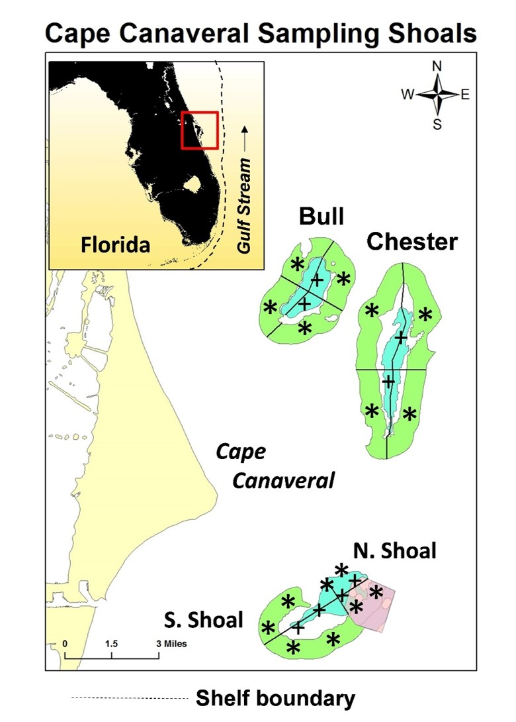

Figure 1. East coast of Florida showing the location of the ridge-swale systems of the study. For each shoal, the ridge area is outlined in blue, the swale area in green, with the buffer zone between the ridge and swale areas. Each shoal system was quartered for stratified random sampling. The ‘+’ represents sampling locations within the ridge area; the ‘*’ represents those within the swale area. The pink area represents the N. Shoal region, and is located within the S. Shoal region.

**RESULTS**

**Physical-Chemical Data**

Mean surface water temperatures ranged from near 20°C in the winter of 2013/14 to near 28°C in the summer of 2014 at both ridge and swale sites, as illustrated by results for the South Shoal region (Fig. 2). All four regions had similar temporal patterns in water temperature. Water temperatures were uncharacteristically low in the summer of 2015, possibly because of cooler upwelled water from deep waters of the Florida Straits (Valle-Levinson, Civil and Coastal Engineering Department, University of Florida, personal communication). In general, bottom water temperatures were no more than 1-2°C lower than surface water temperatures, reflecting the shallow depths and strong vertical mixing energy in the study area (Fig. 2).

Mean total phosphorus concentrations in the four regions of the study ranged from below 10 µg L-1 in the first year of the study to up to 50-70 µg L-1 in the second year (Fig. 3). Overall, mean total phosphorus concentrations were higher from the fall through the spring of the second year of the study than they were during the same months in the first year. There were differences between mean values at ridge and swale sites, but there was no consistent pattern.

Mean total nitrogen concentrations ranged from less than 100 µg L-1 in the summer of 2014 to greater than 300 µg L-1 in the fall of 2013 (Fig. 4). Most seasonal mean nitrogen values were between 100 to 200 µg L-1.

**Variability of Phytoplankton Biomass and Composition**

Mean total surface water phytoplankton biomass ranged from less than 50 µg carbon L-1 to a maximum of 550 µg carbon L-1 in the North Shoal region during the Fall 2013 sampling event (Fig. 2). In Year 1 of the study, the highest mean biomass was observed in the Fall sampling of 2013, and all four groupings of phytoplankton (i.e. cyanobacteria, diatoms, dinoflagellates and “other” taxa) were significantly represented in one or more of the four sampling events. In Year 2, mean biomass levels were highest in the summer sampling event in three of four regions, and cyanobacteria took on a more important role among the four groups in most of the events, compared to Year 1.

Mean total bottom water phytoplankton biomass ranged from less than 50 µg carbon L-1

to a maximum of 300 µg carbon L-1 in the South Shoal region during the Fall 2013 sampling event (Fig. 3). In contrast with surface water samples, diatoms were more consistently significant contributors to total phytoplankton biomass in the bottom samples (Fig. 3, Table 1). Conversely, mean dinoflagellate biomass levels tended to be lower in bottom water samples, although the overall difference was not statistically significant (Table 1). Similar to surface water samples, bottom water samples showed significant representation of all four groupings of phytoplankton in Year 1, while in Year 2 the relative importance of cyanobacteria increased (Fig. 3).

For the two year study period, mean total phytoplankton biomass was higher in bottom than surface water samples in all four regions, but there were no significant differences between regions within each depth category (Table 2). A seasonal comparison of mean total phytoplankton biomass in surface and bottom water samples showed only one significant difference, i.e. mean surface water biomass in the fall season was higher than the other three seasons (Table 3). The latter difference was primarily driven by the surface blooms of the cyanobacterium *Trichodesmium erythraeum*, dinoflagellates and “other” taxa in the Fall sampling of 2013.

Text for Year 1 and 2 comparison in Tables 4 and 5

The dominant phytoplankton taxa, in terms of biomass, in surface and bottom water samples in Years 1 and 2 are shown in the Top-100 list of individual observations (Table 4).

In Year 1, prasinophyte species were most frequently encountered on the Top-100 list, appearing 31 times in the surface water sample list (Table 6). Picoplanktonic cyanobacteria were the next most common entries on the Top-100 list, with 19 entries in the surface water list. Among the cyanobacteria, another major player on the surface water list in Year 1 was the filamentous nitrogen-fixing species *Trichodesmium erythraeum,* which was observed as surface scums of clustered filaments. Dinoflagellates were also strongly represented in the list, most of which were mixotrophic or heterotrophic species. Diatom taxa on the list were mostly large centric forms (i.e. >100 µm). In bottom water samples, prasinophyte species and picocyanobacteria were both strongly represented, with 34 and 33 entries on the Top-100 list, respectively. A wide range of centric diatom species were also present on the list, reflecting the greater contribution of diatom biomass in bottom water compared to surface samples. Conversely, dinoflagellates were less prominent on the list for bottom water samples, although the species present were also observed in the surface samples. Prasinophytes, which were major elements in Year 1, did not make the Top-100 list in Year 2.

In Year 2 of the study, picoplanktonic cyanobacteria dominated the Top-100 list in terms of biomass in surface water samples, with 85 entries. The latter observation reflected the greater contribution of picoplanktonic cyanobacteria to total phytoplankton biomass in the second versus the first year of the study. Centric diatom and mixotrophic/heterotrophic dinoflagellate species filled out the rest of the Top-100 list. Bottom water samples exhibited the same dominance in the Top-100 list, with 82 entries. The rest of the list was taken by a range of centric diatom species. Dinoflagellates did not make the list.

. Figure 2. Surface and bottom water temperatures in the four sampling regions.

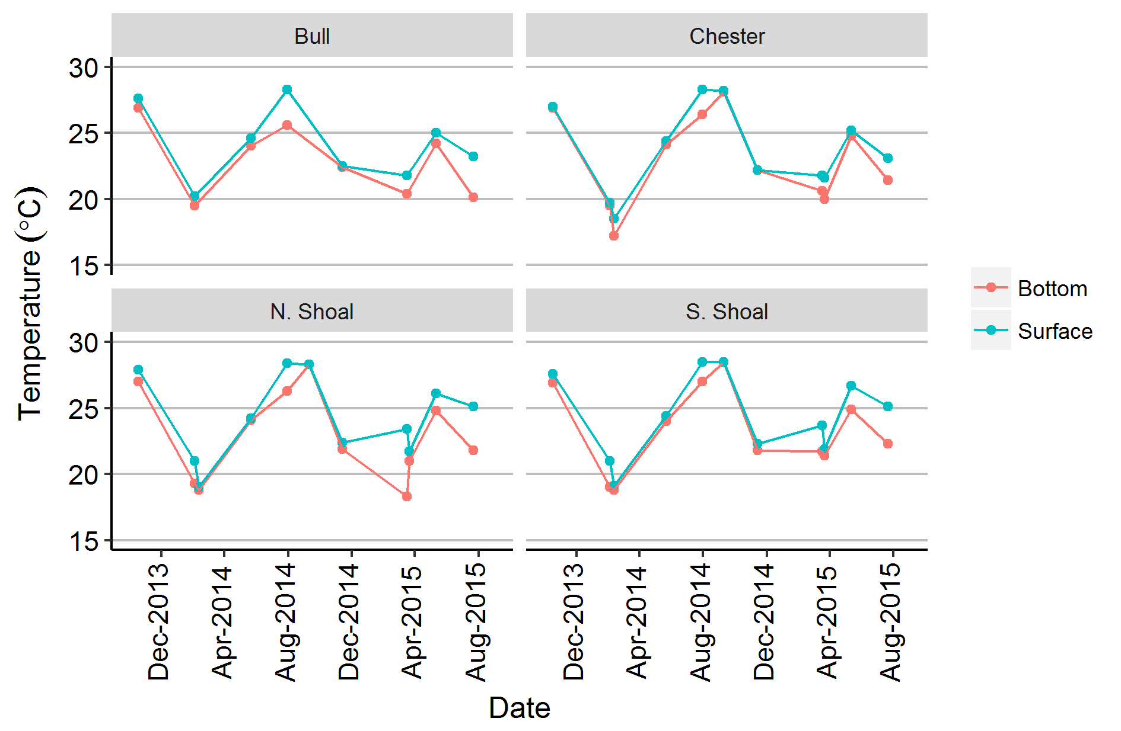

Figure 2. Surface and bottom water total nitrogen concentrations (TN) in the four sampling regions.

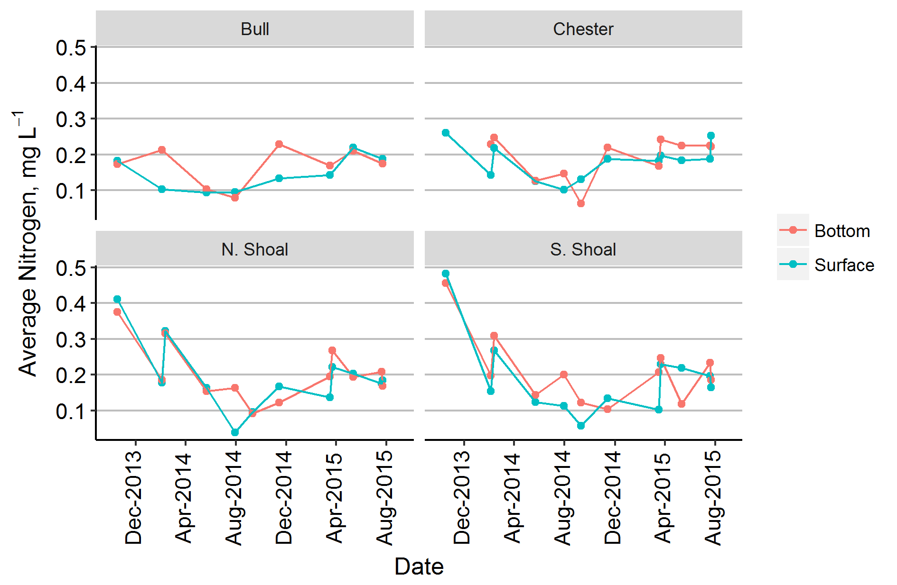

Figure 3. Surface and bottom water total phosphorus concentrations (TP) in the four sampling regions.

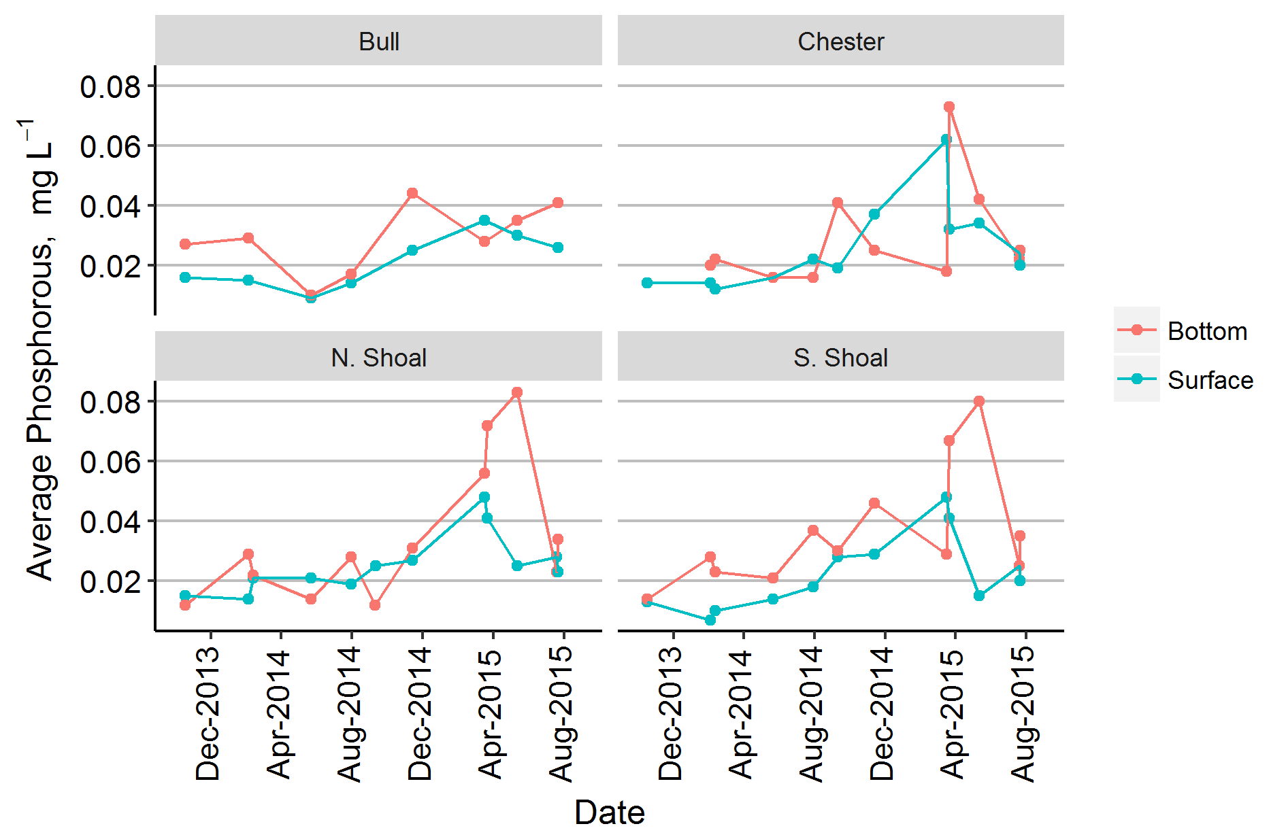

Figure 4. Surface water phytoplankton biomass (µg carbon L-1), sub-divided into four major groups, i.e. cyanobacteria, diatoms, dinoflagellates and all “other” groups.

A screenshot of a video game

Description generated with high confidence

Figure 5. Bottom water phytoplankton biomass (µg carbon L-1), sub-divided into four major groups, i.e. cyanobacteria, diatoms, dinoflagellates and all “other” groups.

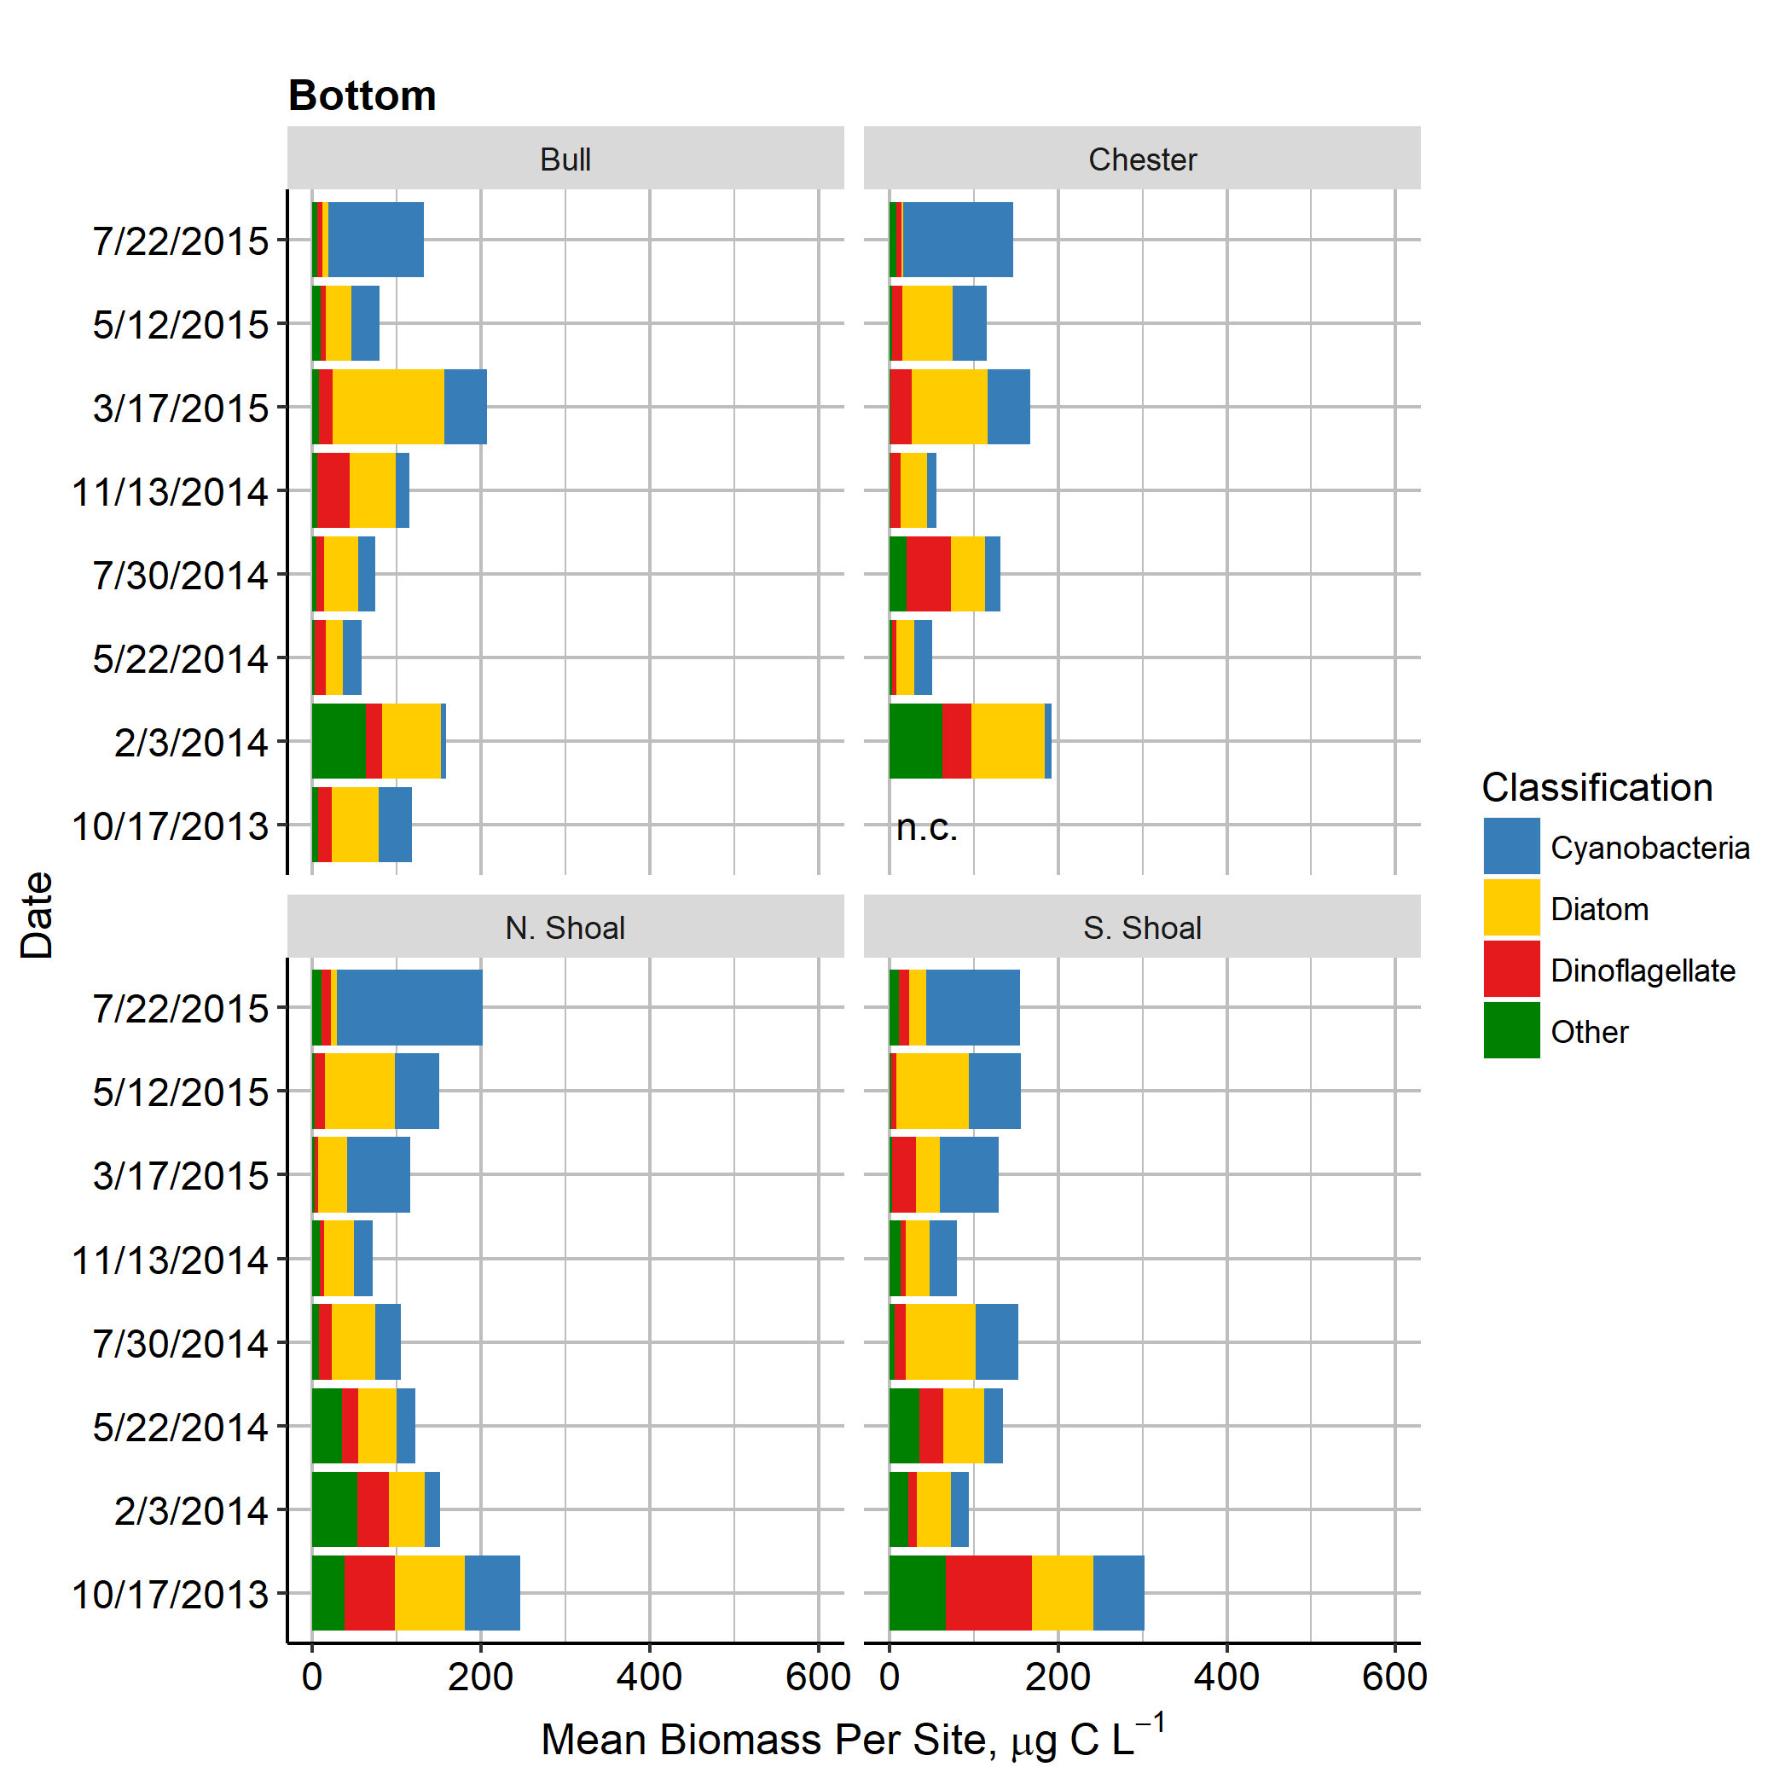

Table 1. Comparison of mean biomass for surface and bottom water samples of four major groups of phytoplankton, i.e. cyanobacteria, diatoms, dinoflagellates and “other”, for all regions. Results of Duncan’s comparison of means shown, i.e. mean values which share letter designations are not significantly different (p of 0.05).

Group Surface/Bottom Log Biomass Duncan result

Cyanobacteria Surface 1.46 AB

Bottom 1.56 A

Diatom Surface 1.03 DE

Bottom 1.51 A

Dinoflagellates Surface 1.30 BC

Bottom 1.23 CD

Other Surface 0.94 E

Bottom 0.96 E

Total Surface 1.18 B

Bottom 1.32 A

Table 2. Comparison of mean total phytoplankton biomass between the four regions of the study, i.e. Bull, Chester, North Shoal and South Shoal. Results of Duncan’s comparison of means shown, i.e. mean values which share letter designations are not significantly different (p of 0.05).

Region Surface/Bottom Log Biomass Duncan result

Bull Surface 1.17 BC

Bottom 1.26 ABC

Chester Surface 1.13 C

Bottom 1.20 BC

North Shoal Surface 1.20 BC

Bottom 1.35 AB

South Shoal Surface 1.23 ABC

Bottom 1.43 A

Table 3. Comparison of mean surface and bottom water total phytoplankton biomass between the four seasons of the year. Results of Duncan’s comparison of means shown, i.e. mean values which share letter designations are not significantly different (p of 0.01).

Group Surface/Bottom Log Biomass Duncan result

Fall Surface 1.51 A

Bottom 1.37 ABC

Winter Surface 1.12 BC

Bottom 1.38 AB

Summer Surface 1.14 BC

Bottom 1.27 ABC

Spring Surface 1.11 C

Bottom 1.24 BC

Table 4. Comparison of mean biomass for Year 1 and Year 2 surface water samples of four major groups of phytoplankton, i.e. cyanobacteria, diatoms, dinoflagellates and “other”, for all regions. Results of Duncan’s comparison of means shown, i.e. mean values which share letter designations are not significantly different (p of 0.01).

Group Year Log Biomass Duncan result

Cyanobacteria Year 1 1.28 BC

Year 2 1.60 A

Diatom Year 1 1.20 C

Year 2 0.90 DE

Dinoflagellates Year 1 1.51 AB

Year 2 1.15 CD

Other Year 1 1.28 BC

Year 2 0.68 E

Total Year 1 1.32 A

Year 2 1.08 B

Table 5. Comparison of mean biomass for Year 1 and Year 2 bottom water samples of four major groups of phytoplankton, i.e. cyanobacteria, diatoms, dinoflagellates and “other”, for all regions. Results of Duncan’s comparison of means shown, i.e. mean values which share letter designations are not significantly different (p of 0.05).

Group Year Log Biomass Duncan result

Cyanobacteria Year 1 1.36 BC

Year 2 1.70 A

Diatom Year 1 1.70 A

Year 2 1.38 B

Dinoflagellates Year 1 1.38 B

Year 2 1.12 C

Other Year 1 1.30 BC

Year 2 0.72 D

Total Year 1 1.43 A

Year 2 1.23 B

Table 6. Top-100 individual biomass observations for surface and bottom water samples in Years 1 and 2. Number of observations for each phytoplankton group and highest value for each group are shown.



**DISCUSSION**

**Phytoplankton Biomass**

Phytoplankton biomass levels in the ocean are often represented as chlorophyll *a* concentrations, in part due to the use of satellite imagery in estimating chlorophyll distribution over large areas of the world’s oceans (Huot et al. 2007). Typical average values range from less than 1 µg L-1 in open ocean regions to 1-5 µg L-1 in many coastal environments (Wernand et al. 2013). Chlorophyll *a* levels can also exceed 10 µg L-1 in areas subject to elevated nutrient loads, such as upwelling regions or regions associated with land runoff from nutrient-rich watersheds.

This study of the Cape Canaveral shelf used an uncommon measure of biomass, i.e. carbon L-1. Most mean values for the shelf region ranged from 50-150 µg carbon L-1. Based on the Redfield ratio and typical chlorophyll *a*/carbon/dry weight ratios for phytoplankton (Reynolds 2006), the latter range in carbon values equate to approximately 1-4 µg L-1, within the range observed for many coastal environments around the world (Wernand et al. 2013). The range also comports with satellite-based estimates for chlorophyll *a* in the Canaveral shelf region (coastwatch.chesapeakebay.noaa.gov/region_fg.php#k490). Based on satellite imagery, surface chlorophyll *a* concentrations in the near shore fringe of the central and northeast shores of Florida commonly fall within a range of 0.3-3 µg L-1, but can periodically exceed these levels during localized near shore bloom events, such as the 2007 red tide (Hart et al. 2015). In the Cape Canaveral region, one exception to the average range was observed in the Fall 2013 sampling event, when mean surface water carbon values reached up to 550 µg carbon L-1, or roughly 15 µg chlorophyll *a* L-1, during a bloom event of the nitrogen fixing cyanobacterium *Trichodesmium* and a group of mixotrophic dinoflagellates (i.e. *Cochlodinium, Prorocentrum, Protoperidimium, Torodinium, Katodinium, Scrippsiella,* and *Gyrodinium* species).

Spatial variability in total phytoplankton biomass among the four regions of the Cape Canaveral Shelf study was limited. However, a higher mean value was observed in bottom water samples from the South Shoal region, compared to the other three regions. This difference may be related to higher sediment surface chlorophyll *a* levels in the south Shoal region (Murie et al. 2018), resulting in higher re-suspension of benthic associated microalgae. The lack of consistent spatial variability of total phytoplankton biomass among the study regions is attributable to the high levels of current and wind-driven circulation in the Cape Canaveral shelf environment. A combination of long-shore currents, loop current influences associated with the Gulf Stream, and strong wave energy due to the shallow ridge/swale topography of the shelf mix the water masses within the study region (Assaf et al. 1971, Atkinson 1977). Previous research shows that biological production in the SAB is “influenced by interaction between the Gulf Stream and adjacent shelf waters” (Lee *et al.*, 1991). And, that these interactions are amplified in areas between 27° and 30°N (Lee *et al.*, 1991), which includes the Cape Canaveral region, in part because of the protrusion of the land feature (Fig. 2-1). In the past, large abundances of phytoplankton biomass occurred within “nutrient-enriched subsurface layers” (Yoder *et al.*, 1981), caused by upwelling and eddies stemming from interactions between the Gulf Stream and the coastal shelf waters (Lee *et al.*, 1992). These currents result in oceanic mixing, which changes the availability of light and nutrients and alters phytoplankton dispersal in the water (Winder & Hunter, 2008).

Contrasting the relatively homogeneous spatial distribution of total phytoplankton biomass among the four regions, there were differences between surface and bottom water samples. Overall, bottom water samples had higher total phytoplankton biomass than surface water samples. The primary reason for the latter pattern was consistently higher presence of diatom biomass in bottom water samples, likely related to resuspension of benthic, meroplanktonic, and sedimented pelagic species. The importance of sediment resuspension is also indicated by the frequently higher total phosphorus concentrations in bottom versus surface waters. There were exceptions to this overall pattern during periods of surface blooms (Fall 2013).

**Phytoplankton Composition**

this study reveals several major features of the phytoplankton community of the Cape Canaveral shelf region. Prokaryotic picoplanktonic (i.e. ≈ 0.5-2 µm) phytoplankton (including cyanobacteria and prochlorophytes), dinoflagellates, and diatoms were all major contributors to total phytoplankton biomass throughout the two-year study period, and some nanoplanktonic (i.e. ≈ 2-20 µm) eukaryotic phytoplankton taxa were prominent for more restricted periods of time. The importance of picoplanktonic prokaryotes on the Cape Canaveral shelf is consistent with the importance of these groups in marine environments around the world (Jochem, 1988; Tarran *et al.*, 2006; Vaulot *et al.*, 2008; Flombaum *et al.*, 2013; Caroppo, 2015). By themselves picoplankton (cells <2 μm) have been shown to account for approximately 20-80% of the total primary production in the tropical Eastern Pacific, and for approximately 60% in the tropical Western Atlantic (Blanchot *et al.*, 1992). In the Canaveral shelf environment picoplanktonic prokaryotes were consistently the dominant taxa in terms of cell abundance, with peak densities near or exceeding 109 cells L-1. The peak densities for picoplanktonic prokaryotes in this study were generally higher than typically found in the open ocean (Flombaum *et al.*, 2013), although not uncharacteristic of values observed in some other nearshore habitats, where nutrients from both upwelling and anthropogenic runoff provide the potential for higher biomass levels (Paerl *et al.*, 2010; Scanlon, 2012; Caroppo, 2015). The fact that picoplanktonic prokaryotes shared the dominant role in terms of biomass with dinoflagellates and diatoms comports with studies of the west-central North Atlantic coast of the United States, showing an increasing relative importance of micro-phytoplankton (i.e. >20 µm) with proximity to land and terrestrial watershed inputs (O’Reilly and Zetlin 1998).

Inter-annual differences were observed in the prominence of picoplanktonic prokaryotes in the Cape Canaveral region, with overall higher relative biomass in Year 2 of the study. Year 2 was also associated with high regional rainfall levels due to a strong El Niño period. The peak period of enhanced rainfall occurred from the fall of 2014 through the spring of 2015. During this period, there was a pronounced increase in TP concentrations in the study region, and moderate increases in TN levels. In the Cape Canaveral area, the wet season tends to be associated with warmer months (Lascody, 2002), but during El Niño periods, the Southeastern U.S. can experience high rainfall levels from late fall through early spring as well (Murrell & Lores, 2004). It may be that increased phosphorus concentrations beginning in Year 2 reflected the added surface water runoff and inlet discharges to the shelf region. A number of studies have shown that there is often a correlation between the amount of rainfall and nutrient concentrations in coastal ecosystems, as a consequence of surface runoff and riverine inputs from adjacent terrestrial environments (Lapointe & Matzie, 1996; Lipp *et al.*, 2001). Nitrogen and phosphorus both play key roles in the amount of primary production (Smith, 2006; Lv *et al.*, 2011). The amount and character of nutrient levels also have an impact on community structure (Tilman *et al.*, 1982). Davis *et al.* (2009) report that an increase in phosphorus can result in cyanobacterial dominance. Combined, the latter two observations may help to explain the surge in picoplanktonic prokaryote biomass in the second year of the study.

Beyond the persistent importance of picoplanktonic prokaryotes in the Cape Canaveral shelf, other cyanobacteria taxa periodically formed blooms in the region. For example, the filamentous nitrogen-fixing species *Trichodesmium erythraeum* was observed as a major surface bloom in the fall of 2013. *T. erythraeum* is a common bloom-forming species in subtropical and tropical ecosystems around the world and can contribute significantly to the nitrogen budgets of the ecosystems in which it occurs (Bergman *et al.*, 2013), which may help explain the peak in total nitrogen concentrations observed at the Cape Canaveral sites during the *Trichodesmium* bloom. It has been linked to the production of toxins, categorizing it as apotentially harmful algae bloom (HAB) taxa (Detoni *et al.*, 2016). It has been hypothesized that blooms of *T. erythraeum* in Florida’s coastal waters are in part linked to external loading of iron emanating from pulses of Saharan dust, which fuels its high demand for the micronutrient, a common feature of nitrogen-fixing cyanobacteria (Walsh & Steidinger, 2001; Lenes *et al.*, 2001). The resultant blooms of *T. erythraeum* have also been linked to the supply of nitrogen that drives blooms of the important toxic red tide species *Karenia brevis* in the Gulf of Mexico (Lenes *et al.*, 2001).

In terms of mean biomass, dinoflagellates were important phytoplankton group in this Cape Canaveral study. Dinoflagellate taxa spanned a wide diversity of functional attributes and were periodically the dominant group. The diversity is illustrated by the list of dinoflagellate taxa appearing on the Top-100 list of individual biomass observations during the study period. For example, *Azadinium caudatum* is considered to be an obligate photoautotrophic (i.e. strictly photosynthetic), while *Cochlodinium*, *Prorocentrum*, and *Scrippsiella* species are mixotrophic and therefore are both primary producers and consumers (Jeong *et al.*, 2010). By contrast, the *Protoperidinium* and *Gyrodinium* species observed in the study are strictly heterotrophic (Jeong *et al.*, 2010) and, from a trophic dynamic perspective, more appropriately belong in the grazer community. Some of the dinoflagellate species observed at significant levels of biomassproduce toxins, including *Azadinium* and *Cochlodinium* (Kudela & Gobler, 2012; Tillman *et al.*, 2014).

Mixotrophic and heterotrophic dinoflagellates were larger biomass contributors in Year 1 than Year 2 of the study. The lower levels of phosphorus in Year 1 could favor mixotrophs, which benefit from their ability to gain nutrition from phagotropic uptake of small cells and particulate organic matter (Joeng et al. 2010). Further evidence of the importance of nutrient limitation in guiding community structure in the Cape Canaveral shelf may be the coincidental bloom of *Trichodesmium* and the mixotrophic dinoflagellates observed in the fall of 2013. A similar relationship has been reported in the coincidental blooms of *Trichodesmium* and the toxic mixotrophic dinoflagellate *Karenia brevis* in the Gulf of Mexico (Lenes and Heil 2010). Lenes and Heil (2010) concluded that one of the sources of nitrogen for the *Karenia brevis* red tide events is nitrogen produced through nitrogen-fixation by *Trichodesmium*. The strong peaks in TN observed during the *Trichodesmium* bloom in the Cape Canaveral shelf in 2013, suggest that a similar relationship may be occurring with a different group of dinoflagellates.

Another ecologically important aspect of dinoflagellate physiology is motility. While many planktonic species move through aquatic habitats “passively by turbulent diffusion and sinking”, others can adjust their position in the water column “actively by means of flagellae or buoyancy regulation” (Huisman *et al.*, 1999). Dinoflagellates have even been observed swimming vertically within the ocean to obtain optimal light for photosynthesis nearer the surface (Ross & Sharples, 2008). This functional attribute helps to explain why dinoflagellates biomass was higher in surface water samples. Another group of phytoplankton which showed a strong bias in distribution toward surface water was the filamentous nitrogen-fixing cyanobacterium *Trichodesmium*. It is commonly observed as surface scums in subtropical and tropical waters (Bergman *et al.*, 2013), including the Gulf of Mexico (Walsh & Steidinger, 2001; Lenes *et al.*, 2001). It maintains position in the water column by regulating buoyancy using intra-cellular gas vesicles.

From a global perspective, diatoms are major contributors to primary production in the ocean (Field *et al.*, 1998; Armbrust, 2009; Buchan *et al.*, 2014), and form major blooms in many coastal ecosystems subject to significant terrestrial nutrient loads or coastal upwelling of nutrient-rich water (Bruland *et al.*, 2001; Carstensen *et al.*, 2015). Diatoms were an important phytoplankton group in the Cape Canaveral shelf. The taxa most often observed in the Top-50 list included: *Cerataulina*, *Odontella*, *Rhizosolenia*, *Coscinodiscus* *Skeletonema*, *Leptocylindrus*, and *Guinardia*. All of these genera have been identified as prominent features in blooms in shallow coastal shelf ecosystems around the world (Reynolds, 2006: Carstensen *et al.*, 2015).

Among the nanoplanktonic eukaryotes, the green algal (Chlorophyta) group Prasinophyceae was particularly prominent in the first year of the study. The importance of prasinophytes in coastal ecosystems has been reported in studies from around the world (Bird & Karl, 1991; Treusch *et al.*, 2012; Santos *et al.*, 2017). From a trophic dynamic perspective, prasinophytes are not only important primary producers, but many species are mixotrophic and are known to also feed on small-celled phytoplankton and bacterioplankton (McKie-Krisberg & Sanders, 2014). Previous evidence shows that small green algal cells (i.e. prasinophytes) can dominate low nutrient environments (Litchman *et al.*, 2007). The below-average rainfall conditions associated with Year 1 of the study may have increased the potential for nutrient limitation by reducing the inputs of nutrients to the shelf from the land. The importance of this ability in the Canaveral shelf region is further indicated by the strong representation of mixotrophic dinoflagellates in the phytoplankton community in Year 1 of the study.

**REFERENCES**

Agawin N.S., Duarte C.M. & Agustí S. (2000) Nutrient and temperature control of the contribution of picoplankton to phytoplankton biomass and production. *Limnology and Oceanography,* 45, 591-600.

Ahlgren G. (1983) Comparison of methods for estimation of phytoplankton carbon. Archives *Hydrobiologia,* 98, 489-508.

Alvain S., Moulin C., Dandonneau Y. & Loisel H. (2008) Seasonal distribution and succession of dominant phytoplankton groups in the global ocean: a satellite view. *Global Biogeochemical Cycles,* 22, 1-15.

Alves-de-Souza C.A., González M.T. & Iriarte J.L. (2008) Functional groups in marine phytoplankton assemblages dominated by diatoms in fjords of southern Chile. *Journal of Plankton Research,* 30, 1233-1243.

Atkinson L.P. (1977) Modes of Gulf Stream intrusion into the South Atlantic Bight shelf waters. *Geophysical Research Letters,* 4, 583-586.

Atkinson L.P, Lee T.N., Blanton J.O. & Chandler W.S. (1983) Climatology of the southeastern United States continental shelf waters. *Journal of Geophysical Research,* 88, 4705-4718.

Anderson D.M., Glibert P.M. & Burkholder J.M. (2002) Harmful algal blooms and eutrophication: nutrient sources, composition, and consequences. *Estuaries,* 25, 704-726.

Andersson A., Haecky P. & Hagström A. (1994) Effect of temperature and light on the growth of micro- and pico-plankton: impact on algal succession. *Marine Biology,* 120, 511-520.

APHA (American Public Health Association). (1998) Standard methods for the analysis of water and wastewater, 20th ed. Washington, DC: APHA.

Armbrust E.V. (2009) The life of diatoms in the world’s oceans. *Nature,* 459, 185-192.

Assaf G., Gerard R. & Gordon A.L. (1971) Some mechanisms of oceanic mixing revealed in aerial photographs. *Journal of Geophysical Research,* 76, 6550-6572.

Badylak S. & Phlips E.J. (2004) Spatial and temporal patterns of phytoplankton composition in a subtropical coastal lagoon, the Indian River Lagoon, Florida, USA. *Journal of Plankton Research,* 26, 1229-1247.

Behrenfeld M.J. (2014) Climate-mediated dance of the plankton. *Nature Climate Change,* 6, 167-194.

Bergman B., Sandh G., Lin S., Larsson J. & Carpenter E.J. (2013) *Trichodesmium* – a widespread marine cyanobacterium with unusual nitrogen fixation properties. *FEMS Microbiology Reviews,* 37, 286-302.

Bienfang P.K. & Harrison P.J. (1984) Co-variation of sinking rate and cell quota among nutrient replete marine phytoplankton. *Marine Ecology Progress Series,* 14, 297-300.

Bienfang P.K., Szyper J.P., Okamoto M.Y. & Noda E.K. (1984) Temporal and spatial variability of phytoplankton in a subtropical ecosystem. *Limnology and Oceanography,* 29, 527-539.

Bird D.F. & Karl D.M. (1991) Microbial biomass and population diversity in the upper water column of the Black Sea. *Deep Sea Research Part A. Oceanographic Research Papers,* 38, 1069-1082.

Blanchot J., Rodier, M. & Bouteiller A.L. (1992) Effect of El Niño Southern Oscillation events on the distribution and abundance of phytoplankton in the Western Pacific Tropical Ocean along 165°E. *Journal of Plankton Research*, 14, 137-156.

Boyd C.M. & Gradmann D. (2002) Impact of osmolytes on buoyancy of marine phytoplankton. *Marine Biology,* 141, 605-618.

Buchan A., LeCleir G.R., Gulvik C.A. & González J.M. (2014) Master recyclers: features and functions of bacteria associated with phytoplankton blooms. *Nature Reviews: Microbiology,* 12, 686-698.

Bruland K.W., Rue E.L. & Smith G.J. (2001) Iron and macronutrients in California coastal upwelling regimes: implications for diatom blooms. *Limnology and Oceanography,* 46, 1661-1674.

Caroppo C. (2015) Ecology and biodiversity of picoplanktonic cyanobacteria in coastal and brackish environments. *Biodiversity and Conservation,* 24, 949-971.

Carstensen J., Klais R. & Cloern J.E. (2015) Phytoplankton blooms in estuarine and coastal waters: seasonal patterns and key species. *Estuarine, Coastal and Shelf Science,* 162, 98-109.

Chiswell S.M., Calil P.H.R. & Boyd P.W. (2015) Spring blooms and annual cycles of phytoplankton: a unified perspective. *Journal of Plankton Research,* 37, 500-508.

Clarke K.R. & Gorley R.N. (2015) PRIMER v7: User Manual/Tutorial. PRIMER-E, Plymouth, 296pp.

Cloern J.E. (2001) Our evolving conceptual model of the coastal eutrophication problem. *Marine Ecology Progress Series,* 210, 223-253.

Cloern J.E. & Jassby A.D. (2010) Patterns and scales of phytoplankton variability in estuarine-coastal ecosystems. *Estuaries and Coasts,* 33, 230-241.

Davis T.W., Berry D.L., Boyer G.L. & Gobler C.J. (2009) The effects of temperature and nutrients on the growth and dynamics of toxic and non-toxic strains of *Microcystis* during cyanobacteria blooms. *Harmful Algae,* 8, 715-725.

Detoni A.M.S., Costa L.D.F., Pacheco L.A. & Yunes J.S. (2016) Toxic *Trichodesmium* bloom occurrence in the southwestern South Atlantic Ocean. *Toxicon,* 110, 51-55.

Dix N., Phlips, E. & Suscy P. (2013) Factors controlling phytoplankton biomass in a subtropical coastal lagoon: relative scales of influence. *Estuaries and Coasts*, 36, 981-996.

Faith D.P., Minchin P.R. & Belbin L. (1987) Compositional dissimilarity as a robust measure of ecological distance. *Vegetatio,* 69, 57-68.

Falkowski P.G., Barber R.T. & Smetacek V. (1998) Biogeochemical controls and feedbacks on ocean primary production. *Science*, 281, 200-206.

Field C.B., Behrenfeld M.J., Randerson J.T. & Falkowski P. (1998) Primary production of the biosphere: integrating terrestrial and oceanic components. *Science,* 281, 237-240.

Flombaum P., Gallegos J.L., Gordillo R.A., Rincón J., Zabala L.L., Jiao N., Karl D.M., Li W.K.W., Lomas M.W., Veneziano D., Vera C.S., Vrugt J.A. & Martiny A.C. (2013) Present and future global distributions of the marine Cyanobacteria *Prochlorococcus* and *Synechococcus*. *Proceedings of the National Academy of Sciences,* 110, 9824-9829.

Fonseca B.M. & Bicudo C.E.D.M. (2008) Phytoplankton seasonal variation in a shallow stratified eutrophic reservoir (Garças Pond, Brazil). Hydrobiologia, 600, 267-282.

Geider R.J., MacIntyre H.L. & Kana T.M. (1997) Dynamic model of phytoplankton growth and acclimation: responses of the balanced growth rate and the chlorophyll *a*:carbon ratio to light, nutrient-limitation and temperature. *Marine Ecology Progress Series,* 148, 187-200.

Hallegraeff G.M. (1993) A review of harmful algal blooms and their apparent global increase. *Phycologia*, 32, 79-99.

Hanisak M.D. & Blair S.M. (1988) The deep-water macroalgal community of the East Florida continental shelf (USA). *Helgoland Marine Research,* 42, 133-163.

Huisman J., Arrayás M., Ebert U. & Sommeijer B. (2002) How do sinking phytoplankton species manage to persist? *The American Naturalist,* 159, 245-254.

Huisman J., Oostveen P.v. & Weissing F.J. (1999) Species dynamics in phytoplankton blooms: incomplete mixing and competition for light. *The American Naturalist,* 154, 46-68.

Jeong H.J., Yoo Y.D., Kim J.S., Seong K.A, Kang N.S. & Kim T.H. (2010) Growth, feeding and ecological roles of the mixotrophic and heterotrophic dinoflagellates in marine planktonic food webs. *Ocean Science Journal,* 45, 65-91.

Jochem F. (1988) On the distribution and importance of picocyanobacteria in a boreal inshore area (Kiel Bight, Western Baltic). *Journal of Plankton Research*, 10, 1009-1022.

Kenkel N.C. & Orlóci L. (1986) Applying metric and nonmetric multidimensional scaling to ecological studies: some new results. *Ecology,* 67, 919-928.

Klausmeier C.A. & Litchman E. (2001) Algal games: the vertical distribution of phytoplankton in poorly mixed water columns. *Limnology and Oceanography,* 46, 1998-2007.

Kooistra W.H.C.F., Gersonde R., Medlin L.K. & Mann D.G. (2007) The origin and evolution of diatoms: their adaptation to a planktonic existence. *Evolution of Primary Producers in the Sea,* 11, 207-249.

Kudela R.M. & Gobler C.J. (2012) Harmful dinoflagellate blooms caused by *Cochlodinium* sp.: global expansion and ecological strategies facilitating bloom formation. *Harmful Algae,* 14, 71-86.

Lapointe B.E. & Matzie W.R. (1996) Effects of stormwater nutrient discharges on eutrophication processes in nearshore waters of the Florida Keys. *Estuaries,* 19, 422-435.

Lascody R. (2002) The onset of the wet and dry seasons in East Central Florida- a subtropical wet-dry climate? *National Weather Service Weather Forecast Office Melbourne, FL*.

Laws E.A. (1975) The importance of respiration losses in controlling the size distribution of marine phytoplankton. *Ecology*, 56*,* 419-426.

Lee T.N. & Atkinson L.P. (1983) Low-frequency current and temperature variability from Gulf Stream frontal eddies and atmospheric forcing along the southeast U.S. outer continental shelf. *Journal of Geophysical Research,* 88, 4541-4567.

Lee T.N., Rooth C., Williams E., McGowan M., Szmant, A.F. & Clarke M.E. (1992) Influence of Florida Current, gyres, and wind-driven circulation on transport of larvae and recruitment in the Florida Keys coral reefs. *Continental Shelf Research,* 12, 971-1002.

Lee T.N., Yoder J.A. & Atkinson L.P. (1991) Gulf Stream frontal eddy influence on productivity of the southeast U.S. continental shelf. *Journal of Geophysical Research,* 96, 191-205.

Lenes J.M., Darrow B.P., Cattrall C., Heil C.A., Callahan M., Vargo G.A. & Byrne R.H. (2001) Iron fertilization and the *Trichodesmium* response on the West Florida shelf. *Limnology and Oceanography,* 46, 1261-1277.

Li W.K.W., Harrison W.G. & Head E.J.H. (2006) Coherent assembly of phytoplankton communities in diverse temperate ocean ecosystems. *Proceedings of the Royal Society of London B: Biological Sciences,* 273, 1953-1960.

Lipp E.K., Schmidt N., Luther M.E. & Rose J.B. (2001) Determining the effects of El Niño-Southern Oscillation events on coastal water quality. *Estuaries,* 24, 491-497.

Litchman E., Klausmeier C.A., Schofield O.M. & Falkowski P.G. (2007) The role of functional traits and trade-offs in structuring phytoplankton communities: scaling from cellular to ecosystem level. *Ecology Letters,* 10, 1170-1181.

Lv J., Wu H. & Chen M. (2011) Effects of nitrogen and phosphorus on phytoplankton composition and biomass in 15 subtropical, urban shallow lakes in Wuhan, China. *Limnologica,* 41, 48-56.

Mackas D.L. (1984) Spatial autocorrelation of plankton community composition in a continental shelf ecosystem. *Limnology and Oceanography,* 29, 451-471.

Mahadevan A., D’Asaro E., Lee C. & Perry M.J. (2012) Eddy-driven stratification indicates North Atlantic spring phytoplankton blooms. *Science,* 337, 54-58.

McKie-Krisberg Z.M. & Sanders R.W. (2014) Phagotrophy by the picoeukaryotic green alga *Micromonas*: implications for Artic Oceans. *International Society for Microbial Ecology,* 8, 1953-1961.

Murrell M.C. & Lores E.M. (2004) Phytoplankton and zooplankton seasonal dynamics in a subtropical estuary: importance of cyanobacteria. *Journal of Plankton Research,* 26, 371-382.

Nixon S.W. (1995) Coastal marine eutrophication: a definition, social causes, and future concerns. *Ophelia,* 41, 199-219.

O’Reilly, J. E. and Zetlin, C. (1998) Seasonal, horizontal and vertical distribution of phytoplankton chlorophyll *a* in the northeast U.S> continental shelf ecosystem. *NOAA Technical Report NMFS* 139, 120 pp.

Pearl H.W. and Paul V.J. (2012) Climate change: links to global expansion of harmful cyanobacteria. *Water Research*, 46, 1349-1363.

Pearl H.W., Rossignol K.L., Hall, S.N., Peierls B.L. & Wetz M.S. (2010) Phytoplankton community indicators of short- and long-term ecological change in the anthropogenically and climatically impacted Neuse River Estuary, North Carolina, USA. *Estuaries and Coasts*, 33, 485-497.

Phlips E.J., Badylak S. & Lynch T.C. (1999) Blooms of the picoplanktonic cyanobacterium *Synechococcus* in Florida Bay, a subtropical inner-shelf lagoon. *Limnology and Oceanography,* 44, 1166-1175.

Phlips E.J., Badylak S., Christman M. & Lasi M. (2010) Climatic trends and temporal patterns of phytoplankton composition, abundance and succession in the Indian River Lagoon, Florida, USA. *Estuaries and Coasts,* 33, 498-513.

R Core Team. (2013) R: a language and environment for statistical computing. R Foundation for Statistical Computing, Vienna, Austria. URL <http://www.R-project.org/>.

Reynolds C.S. (2006) Ecology of Phytoplankton. *Ecology, Biodiversity, and Conservation*. Cambridge University Press.

Roman M., Zhang X., McGilliard C. & Boicourt W. (2005) Seasonal and annual variability in the spatial patterns of plankton biomass in Chesapeake Bay. *Limnology and Oceanography,* 50, 480-492.

Ross O.N. & Sharples J. (2008) Swimming for survival: a role of phytoplankton motility in a stratified turbulent environment. *Journal of Marine Systems,* 70, 248-262.

Rott E., Salmaso N. & Hoehn E. (2007) Quality control of Utermöhl-based phytoplankton counting and biovolume estimates- an easy task or a Gordian knot? *Hydrobiologia,* 578, 141-146.

Sakshaug E. & Slagstad D. (1991) Light and productivity of phytoplankton in polar marine ecosystems: a physiological view. *Polar Research,* 10, 69-86.

Salmaso N., Naselli-Flores L. & Padisák J. (2015) Functional classifications and their application in phytoplankton ecology. *Freshwater Biology,* 60, 603-619.

Santos A.L., Gourvil P., Tragin M., Noël M-H., Docelle J., Romac S. & Vaulot D. (2017) Diversity and oceanic distribution of prasinophytes clade VII, the dominant group of green algae in oceanic waters. *International Society for Microbial Ecology,* 11, 512-528.

Scanlon D.J. (2012) Marine picocyanobacteria. *Ecology of Cyanobacteria II: Their Diversity in Space and Time,* 503-533.

Siegel D.A., Doney S.C. & Yoder J.A. (2002) The North Atlantic spring phytoplankton bloom and Sverdrup’s critical depth hypothesis. *Science,* 296, 730-733.

Sicko-Goad L.M., Schelske C.L. & Stoermer E.F. (1984) Estimation of intracellular carbon and silica content of diatoms from natural assemblages using morphometric techniques. *Limnology and Oceanography,* 29, 1170-1178.

Smayda T.J. (1978) From phytoplankters to biomass. In: Sournia A. (ed.), Phytoplankton Manual. UNESCO, Paris: pp. 273-279.

Smith V.H. (2006) Responses of estuarine and coastal marine phytoplankton to nitrogen and phosphorus enrichment. *Limnology and Oceanography,* 51, 377-384.

Strathmann R.R. (1967) Estimating the organic carbon content of phytoplankton from cell volume or plasma volume. *Limnology and Oceanography,* 12, 411-418.

Stenseth N.C., Llope M., Anadόn R., Ciannelli L., Chan K-S., Hjermann D., Bagøien E. & Ottersen G. (2006) Seasonal plankton dynamics along a cross-shelf gradient. *Proceedings of the Royal Society,* 273, 2831-2838.

Suikkanen S., Laamanen M. & Huttunen M. (2006) Long-term changes in summer phytoplankton communities of the open northern Baltic Sea. *Estuarine Coastal and Shelf Science,* 71, 580-592.

Sverdrup H. (1953) On conditions for the vernal blooming of phytoplankton. *Journal du Conseil,* 18, 287-295.

Tarran G.A., Heywood J.L. & Zubkov M.V. (2006) Latitudinal changes in the standing stocks of nano- and picoeukaryotic phytoplankton in the Atlantic Ocean. *Deep-Sea Research II,* 53, 1516-1529.

Taylor F.J., Taylor N.J. & Walsby J.R. (1985) A bloom of the planktonic diatom, *Cerataulina pelagica*, off the coast of northeastern New Zealand in 1983, and its contribution to an associated mortality of fish and benthic fauna. *Internationale Revue der gesamten Hydrobiologie,* 70, 773-795.

Tillman U., Krock B. & Taylor B.B. (2014) *Azadinium caudatum* var. *margalefii*, a poorly known member of the toxigenic genus *Azadinium* (Dinophyceae). *Marine Biology Research,* 10, 941-956.

Tilman D., Kilham S.S. & Kilham P. (1982) Phytoplankton community ecology: the role of limiting nutrients. *Annual Review of Ecology and Systematics,* 13, 349-372.

Treusch A.H., Demir-Hilton E., Vergin K.L., Worden A.Z., Carlson C.A., Donatz M.G., Burton R.M. & Giovannoni S.J. (2012) Phytoplankton distribution patterns in the northwestern Sargasso Sea revealed by small subunit rRNA genes from plastids. *International Society for Microbial Ecology,* 6, 481-492.

U.S.E.P.A. (1983) Methods of chemical analysis of water and waste. U.S.E.P.A., Cincinnati, Ohio.

Utermöhl H. (1958) Zur vervollkomnung der quantitativen phytoplankton methodik. *Mitt. Int. Limnol,* 9, 1-38.

Vaulot D., Eikrem W., Viprey M. & Moreau H. (2008) The diversity of small eukaryotic phytoplankton (≤3 µm) in marine ecosystems. *FEMS Microbiology Reviews,* 32, 795-820.

Veldhuis M.J.W. & Kraay G.W. (2004) Phytoplankton in the subtropical Atlantic Ocean: towards a better assessment of biomass and composition. *Deep-Sea Research,* 51, 507-530.

Verity P.G., Robertson C.Y., Tronzo C.R., Andrews M.G., Nelson J.R. & Sieracki M.E. (1992) Relationships between cell volume and the carbon and nitrogen content of marine photosynthetic nanoplankton. *Limnology and Oceanography,* 37, 1434-1446.

Walsby A.E., Hayes P.K., Boje R. & Stal L.J. (1997) The selective advantage of buoyancy provided by gas vesicles for planktonic cyanobacteria in the Baltic Sea. *New Phytologist,* 136, 407-417.

Walsh J.J. & Steidinger K.A. (2001) Saharan dust and Florida red tides: the cyanophyte connection. *Journal of Geophysical Research,* 106, 597-612.

Winder M. & Hunter D.A. (2008) Temporal organization of phytoplankton communities linked to physical forcing. *Oceologia,* 156, 179-192.

Winder M. & Cloern J.E. (2010) The annual cycles of phytoplankton biomass. *Philosophical Transactions of the Royal Society,* 365, 3215-3226.

Work K., Havens K., Sharfstein B. & East T. (2005) How important is carbon to planktonic grazers in a turbid, subtropical lake? *Journal of Plankton Research,* 27, 357-372.

Xie L., Wu K., Pietrafesa L. & Zhang C. (2001) A numerical study of wave-current interaction through surface and bottom stresses: wind-driven circulation in the South Atlantic Bight under uniform winds. *Journal of Geophysical Research,* 106, 16841-16855.

Yoder J.A., Atkinson L.P., Lee T.N., Kim H.H. & McClain C.R. (1981) Role of Gulf Stream frontal eddies in forming phytoplankton patches on the outer southeastern shelf. *Limnology and Oceanography,* 26, 1103-1110.

Yoder J.A., Schollaert S.E. & O’Rielly J.E. (2002) Climatological phytoplankton chlorophyll and sea surface temperature patterns in continental shelf and slope waters off the northeast U.S. coast. *Limnology and Oceanography,* 47, 672-682.