# Exercise 4

## 1) SSH key-based authentication

1a) used command: ssh username@servername

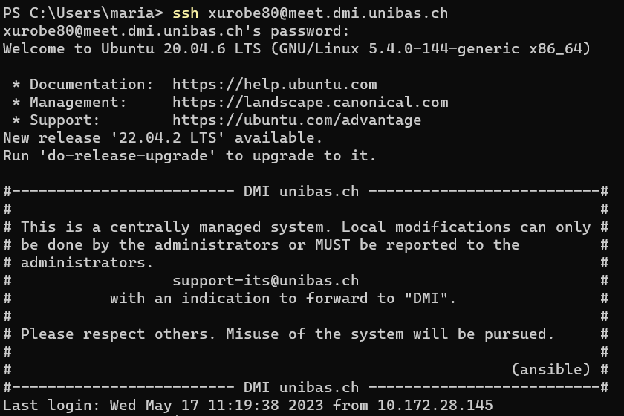

1b) creating key: ssh-keygen

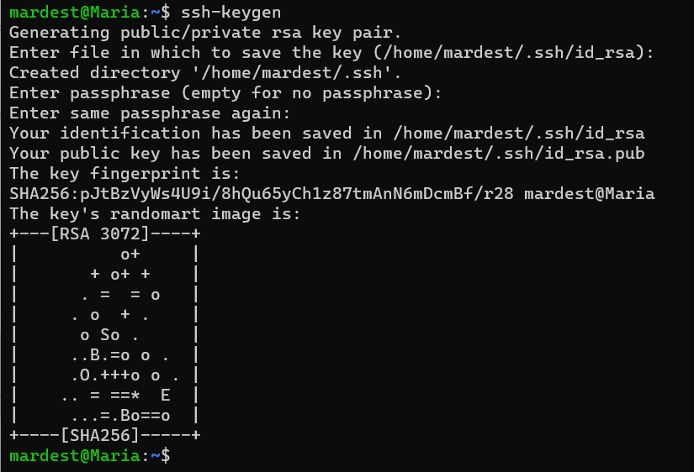

Adding key to server: ssh-copy-id -i path username@servername

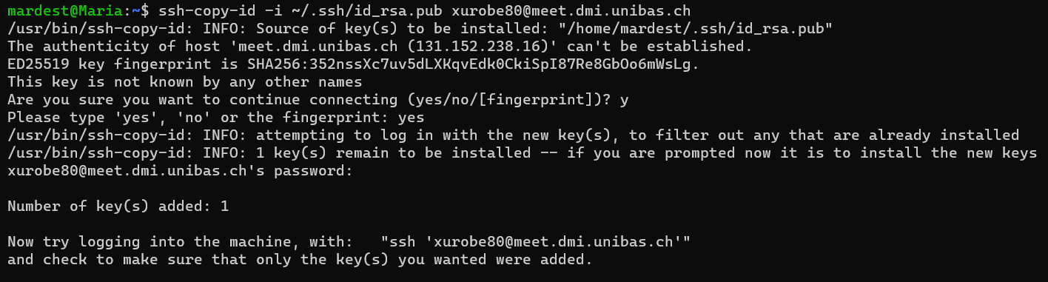

1c) transfer a textfile: scp path username@servername:path



Rename file: ssh username@servername ‘mv filename.txt newFilename.txt’



Edit file:

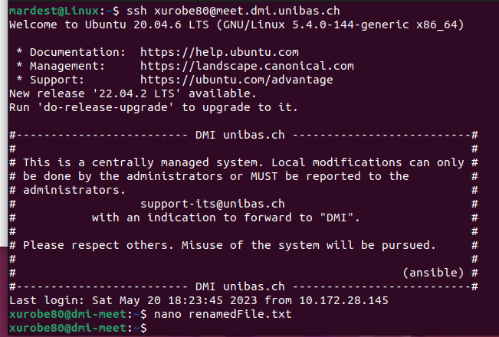

Transfer file back: scp username@servername:remotePath ownPath

