Correlation Coefficient Formula

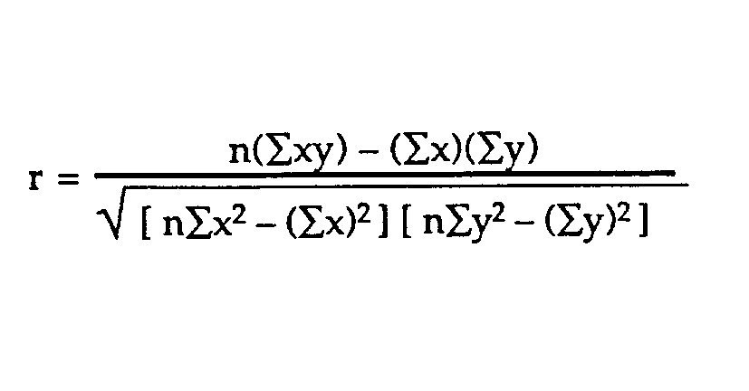

|  |  |  |  |  |
| --- | --- | --- | --- | --- |
| X | Y | X*Y | X2 | Y2 |
| 8 | 98 | 784 | 64 | 9604 |
| 2 | 74 | 148 | 4 | 5476 |
| 6 | 87 | 522 | 36 | 7569 |
| 4 | 82 | 325 | 16 | 6724 |
| 2 | 72 | 144 | 4 | 5184 |
| 22 | 413 | 1926 | 124 | 34557 | Sum |

∑x=22

∑y=413

∑xy=1926

∑x2=124

∑y2=34557

corelation=0.9