How Can We Combat Climate Change Due to Carbon Emissions?

Benjamin Lauze   
*Data Science Fundementals (COMP3125)*

# Introduction (*Heading 1*)

Carbon Emissions have carved out an absurdly large role in world politics. It has become an increasingly prevalent part of the daily lives of every being on Earth. Whether it be the temperature increasing over time, water levels rising, or the ever-increasing number of natural disasters, all these problems can be equated to an increase of Carbon Emissions. This report will go in depth in search of answers to several questions. How do different sectors or regions contribute to carbon emissions (those being to separate questions)? What are some ways we could change our energy consumption? How have governmental policies change/will change emissions in the future? How is the world being affected by climate change (due to carbon emissions) currently? These questions can determine the outlook of our world, and how we need to change ourselves to continue our survival as a species and a world.

# Datasets

## Source of dataset (Heading 2)

The datasets used were found on two different resources, being: Our World in Data, and Statista. Both are generally considered credible. All the data has been published between 2020 and the current day. Our World in Data uses official international resources, whereas Statista tends to conduct a lot of its own research. None of the used data was generated by me.

## Character of the datasets

The data from [1] and [2] are exceedingly large, due to them being about global sectors and regions. Having ten years’ worth of data for every country leads to high row counts. Luckily, it was chosen to downsize to the 5 largest countries for each, though an extra section was added in [2]. The Statista sets [3-6] are far smaller in comparison, as they are used for more specialized questions. The datasets were not converted or combined.

# Methodology

The main tools used in this project were pandas and matplotlib. Pandas provided the data manipulation tools I needed and allowed for me to contain each dataset in its own data frame. This allowed for easy cleaning of the data. Matplotlib allowed for the creation of the graphs. Most of these being time series analyses, as years were a large factor in this project.

A multiple regression model was used for [2]. When preprocessing, one-hot encoding was utilized to transform the categorical 'Entity' variable into binary dummy variables, creating separate binary columns for each country. As for the feature selection, it was constructed using the 'Year' variable and the newly created country dummy variables. The target variable was defined as 'Annual CO₂ emissions'. For **Feature Scaling**, StandardScaler was applied to normalize the features, transforming them to have zero mean and unit variance. For **Data Splitting**, the dataset was partitioned into training and testing sets using an 80-20 split, with a fixed random seed (42) to ensure reproducibility.

# Results

Question 1: How do different sectors contribute to carbon emissions?

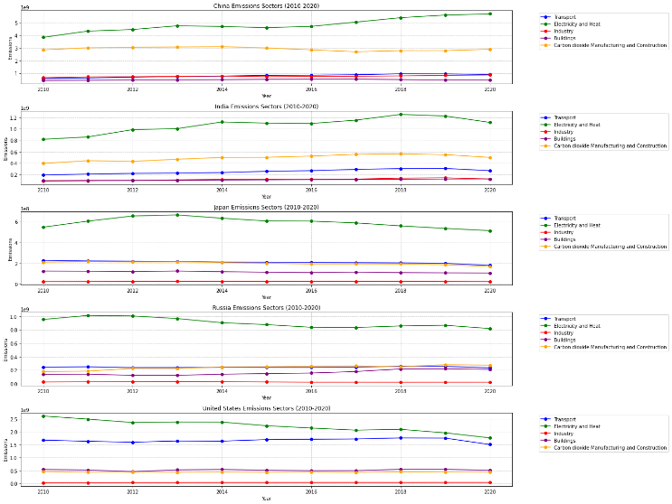

These countries are the top producers of carbon emissions in the world. The different sectors that they harbor have the answers to what contributes the most to the carbon emission crisis. That being Electricity and Heat.

Question Two: Which world regions produce the most emissions?

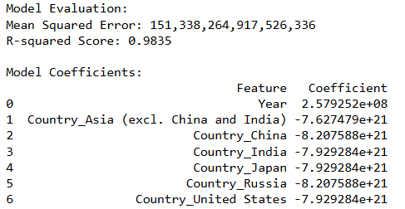

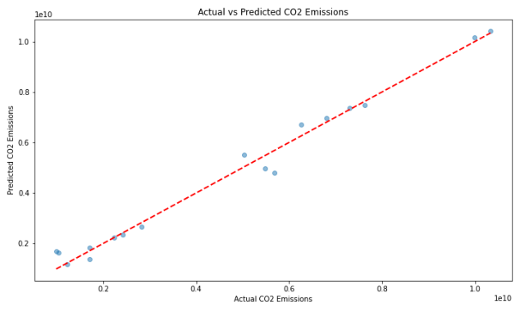

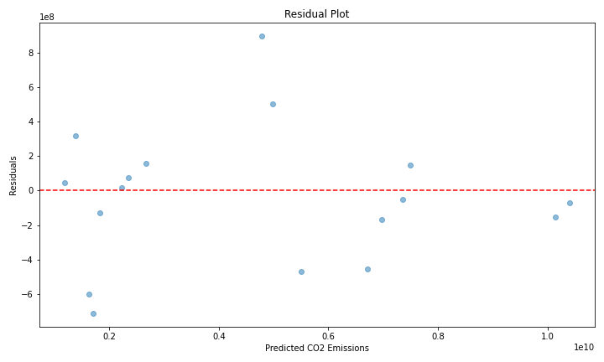

This is the multiple regression model as previously described in the methods. It suggests a steady increase in emissions overtime. This data also answers which countries/regions produce the most, being the ones used.

Question Three: What are some ways we could change our energy consumption to limit carbon emissions?

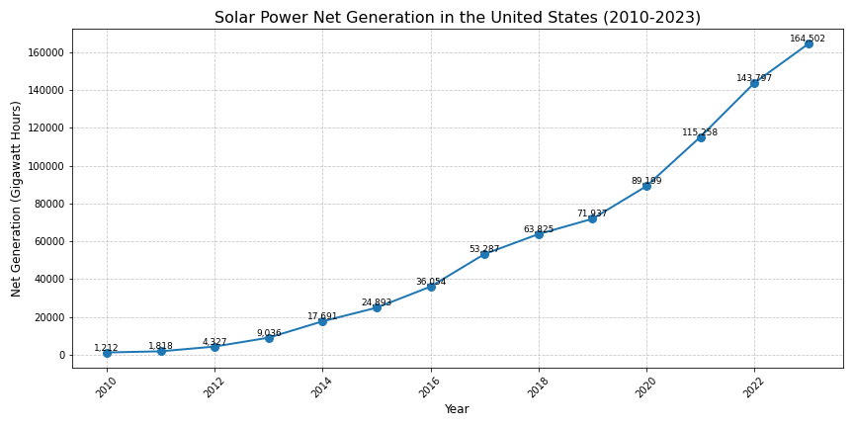

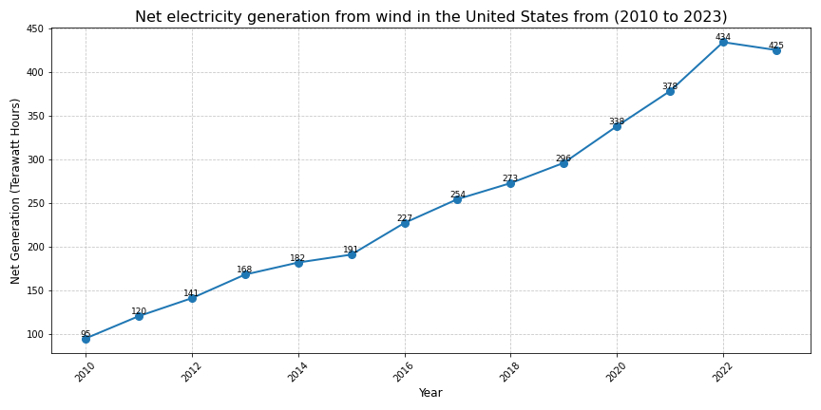

Two of the most prevalent forms of alternative energy are solar and wind. These statistics show that wind is more useful currently.

Question Four: What government policies (across the world, or in the United States specifically) have correlated to changes in emissions?

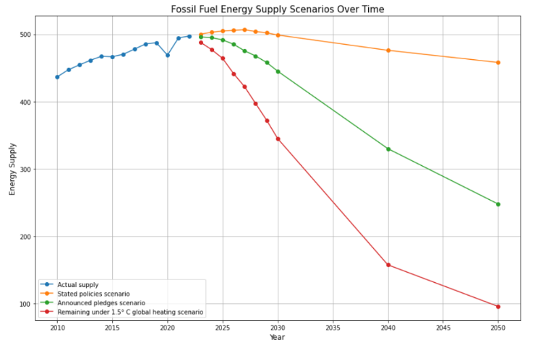

This graph shows the potential carbon dioxide production in the future. This is given stated policies, ones that have slight traction, and ones that will need to be implemented give drastic global temperature change, respectively.

Question Five: How is the world currently being affected by climate change (temperature increases, an excess of natural disasters, etc.)?

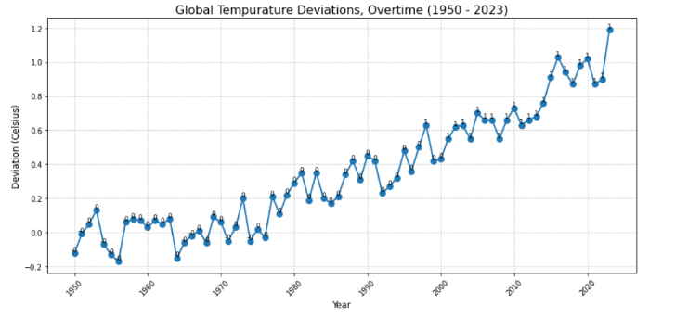

This graph shows the increase in global temperature overtime. It does this by using a given mean value, that it compares the year to. An increase above that given value is bad. We have consistently been having years that are greater than the value.

# Discussion

I was hopeful to use all countries within my first two questions. This was not feasible, but in a future project, I would like to try using all data points. The graphs I produced were not to the quality I would’ve desired before starting this project, so given more time, I would choose to revise them. In the future, I would also seek out different ways of looking into question four, as I felt like my answer was not specific to what was asked.

# Conclusion

Global warming is something that will be an important part of life on Earth moving forward. We must do everything we can moving forward to curb the production of greenhouse gasses. We can do this by relying on clean energy sources, like the ones stated in [3]. I would recommend we rely more heavily on solar, as it is currently not being used to its fullest extent. This should be implemented in the countries I have talked about, as well as countries around the world. The widespread downsides of global warming due to carbon emissions will be something the world will suffer from, so we must use the data collected in this report to fundamentally change the way we live.

##### References

1. Hannah Ritchie, Pablo Rosado and Max Roser (2020) - “Breakdown of carbon dioxide, methane and nitrous oxide emissions by sector” Published online at OurWorldinData.org. Retrieved from: 'https://ourworldindata.org/emissions-by-sector' [Online Resource]
2. Hannah Ritchie and Max Roser (2020) - “CO₂ emissions” Published online at OurWorldinData.org. Retrieved from: 'https://ourworldindata.org/co2-emissions' [Online Resource]
3. EIA. (March 28, 2024). Solar power net generation in the United States from 2000 to 2023 (in gigawatt hours) [Graph]. In *Statista*. Retrieved December 07, 2024, from <https://www.statista.com/statistics/183447/us-energy-generation-from-solar-sources-from-2000/>
4. EIA. (March 28, 2024). Net electricity generation from wind in the United States from 2000 to 2023 (in terawatt hours) [Graph]. In *Statista*. Retrieved December 07, 2024, from https://www.statista.com/statistics/189412/us-electricity-generation-from-wind-energy-since-2005/
5. Energy Post. (November 3, 2022). Fossil fuel demand worldwide from 1965 to 2020, with a forecast until 2050 by scenario (in exajoules) [Graph]. In *Statista*. Retrieved December 07, 2024, from https://www.statista.com/statistics/1275666/fossil-fuel-supply-worldwide/
6. National Oceanic and Atmospheric Administration. (February 16, 2024). Annual anomalies in global land and ocean surface temperature from 1880 to 2023, based on temperature departure (in degrees Celsius) [Graph]. In *Statista*. Retrieved December 07, 2024, from https://www.statista.com/statistics/224893/land-and-ocean-temperature-anomalies-based-on-temperature-departure/