**Wiggofy Press Release:**

Bradley Wiggins deserves to win Sports Personality of the Year 2012, he is one of the most decorated medallists Britain has ever seen, winning Gold medals at 3 olympic games and the ONLY British winner of the Tour De France. He is a ‘Tour de Force’ and a style icon...However, the competition this year is intense, seeing as there were so many stella performances from all the athletes at the Olympics. I want to help Bradley win through my social media campaign:

<http://www.facebook.com/BradleyWigginsForSportsPersonality2012>

<http://twitter.com/wiggofy>

And by getting people to post pictures of themselves from my iPhone app “Wiggofy”

<INSERT LINK HERE>

The idea came to me from seeing how much Wig-Mania swept the country during the Olympics, everyone from TV presenters to Sir Steve Redgrave were sporting sideburns in his honour. My app adds Bradley’s distinctive Ginger sideburns and hair to your face and then allows the user to post to Facebook and Twitter, as shown below:

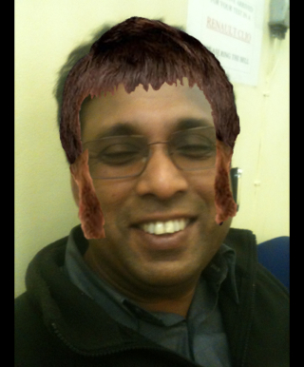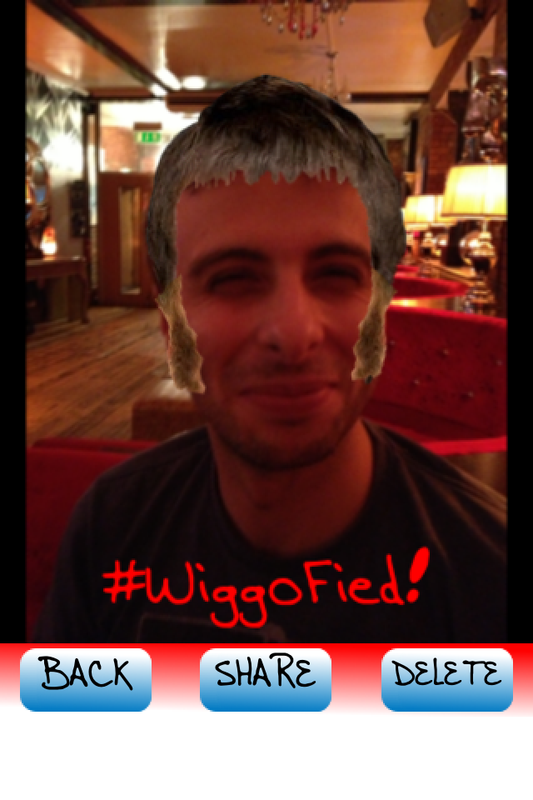

I would massively appreciate if you could help raise awareness of the “Wiggofy” iPhone app and Facebook and Twitter campaign to get Bradley in his rightful place of SPOTY 2012.

Mobile: 07729529863

Email: benjaminsmith1981@googlemail.com