**Architecture Description**

**Team 404 Error**

**Project Briar**

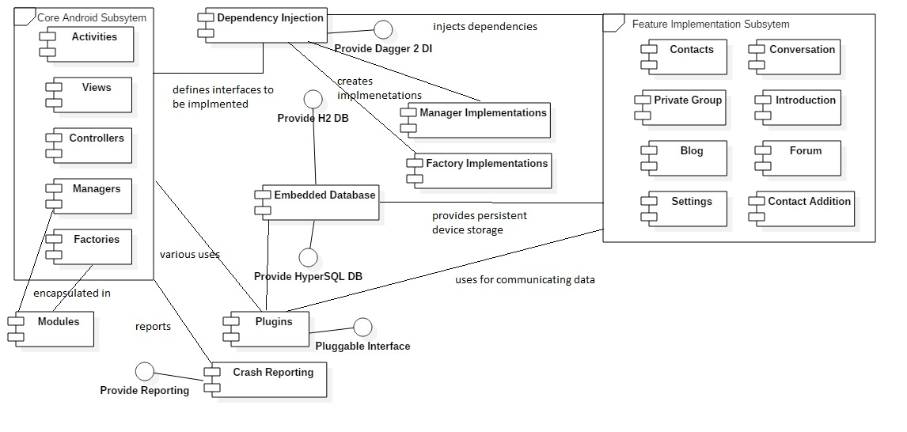

Fig. 1 Component Diagram

Our main application is in the briar-android module which requires briar-core, bramble-core, bramble-android modules as dependencies. The data and business logic for the application is grouped together and features include contact management, blogging, creating private groups, having conversations, creating forums, adding contacts via QR code and managing the application through settings. Since the application is an android application, the activity classes deal with the implementation of these features. The views are defined in xml and can be fragmented and extended with new features promoting reuse. The controllers are used by the activities to manage interactions with the underlying data model. The side menu is defined as an android navbar. Bramble is included as an android library to facilitate and enable secure communication. Classes required for core functionality for both briar and bramble are packaged into separate modules to improve organization.

The dagger dependency injection system is used to inject required dependencies injection and to decouple the structure. The briar and bramble core packages hence contain generated source code which ads greatly to the number of classes.

And embedded H2 database is used as persistence devices storage in the sense that the derver and client are on the same device. The option for hyperSQL also exists.

Virtual device testing is replaced with the use of the roboelectric library with Jmock and Mockito to simplify testing along with hamcrest argument matchers.

Third party plugins are used which include the following:

1. Droidtooth file sharing (seems to be included but not used)
2. Jtor java Tor plugin (for secure messaging over WiFi or data plans)
3. Identicon plugin (created hash based pictorial representations for user profile images)
4. Thoughtcrime (part of the signal application and used to add features to the messaging interface)
5. Panic plugin (that allows a panic button to be used for things such as wiping user data)
6. H2 Plugin
7. HyperSQL Plugin

The following tools and frameworks are used for unit testing

1. Junit
2. Roboelectric
3. Jmock
4. Mockito
5. hamcrest