**PHOTOCHEMICAL ANALYSIS AND APPROXIMATE COMPOSITION OF WATERMELON (CITRULLUS LANATUS) IN KISII TOWN**

**BY**

**OMARIBA FRED SEKA**

**PS18/70129/17**

**A RESEARCH PROPOSAL SUBMITTED TO THE SCHOOL OF PURE AND APPLIED SCIENCES, DEPARTMENT OF BIOLOGICAL SCIENCE IN PARTIAL FULFILLMENT OF THE REQUIREMENTS FOR THE AWARD OF A BACHELOR OF SCIENCE DEGREE IN BIOCHEMISTRY, KISII UNIVERSITY.**

**NOVEMBER, 2020.**

# DECLARATION

"This is my original work and has not been submitted in this or any other institution for any form of awards."

Sign……………………………………..………...… Date ………………………………….........

Name………………………………………….………Reg no…………………………………….....

"I confirmed the work in this proposal was done by the candidate under my supervision."

Sign………………………………………………………Date…………………………………

Name……………………………………………………

# DEDICATION

I will dedicate my work to my parents (Mr. and Mrs. Seka) for providing guidance and financial help to allow me to go through this process.

# ACKNOWLEDGEMENT

My sincere gratitude to Mr. Rotich Joseph of Kisii University for guiding and helping me go through the proposal writing under his supervision. Without him I couldn't be able to accomplish it.

I would also like to thank my parents, friends, course mates for the support, advice and encouragement that they gave me to go through this hard journey. Thanks to my parents for the financial support and the pieces of advice that you gave me during this process.

TABLE OF CONTENTS

DECLARATION ii

DEDICATION iii

ACKNOWLEDGEMENT iv

ABBREVIATIONS vii

DEFINITION OF TERMS viii

ABSTRUCT ix

CHAPTER ONE 1

1.0 INTRODUCTION 1

1.1 Background of the study. 1

1.2 Statement of the problem. 2

1.3 Objectives of study. 2

1.3.1 General objectives 2

1.3.2 Specific objectives 3

1.4 Significance of the study 3

1.5 Scope and justification of the study 3

1.5.1 Scope of the study 3

1.5.2 Justification of the study 3

1.6 Limitations of the study 4

1.7 Assumption of the study 4

CHAPTER TWO 5

2.0 LITERATURE REVIEW 5

2.1 Introduction and Significance of watermelon. 5

2.2 Nature and classification of watermelon 6

2.3 Varieties of watermelon 7

2.4 Composition of watermelon. 9

CHAPTER THREE 11

3.0 METHODOLOGY 11

3.1 Extraction of juice sample 11

3.2 Determination of lycopene and beta-carotene 12

3.2.1 Determination of lycopene 12

3.2.2 Determination of beta-carotene 12

3.3 Determination of saponin content 13

3.4 Determination of flavonoids 13

3.5 Determination of total polyphenols 13

3.6 Determination of tannins 14

REFERENCES 15

APPENDICES 17

# ABBREVIATIONS

Std soln....Standard solution

App.....Approximately

g.....Grams

Ml....Millimeter

nm.....Nanometer

Min....Minutes

hr.....Hour

NaOH.......Sodium hydroxide

# 

# DEFINITION OF TERMS

**Photochemical:** These are bioactive nutrient plant chemicals found in fruits, vegetables, grains and other plant foods that provides desirable health benefits.

**Flowering plant:** It is a plant that produces flowers**.**

**Supplementation:** It is the addition of an extra element or amount to something.

**Diet:** The sum of food consumed by a person or an organism.

**Juice:** Is the liquid obtained from or present in fruits or vegetables

# ABSTRUCT

Watermelon (C. lanatus) is a flowering plant that is vine-like and whose fruits are not vegetables but berries.It originated from Kalahari Desert in Africa and used as water source by those who were walking through the desert.

In several studies, it has been revealed that watermelon contains several photochemicals and bioactive compounds such as saponin, flavonoids, tannins, lycopene, vitamins, and minerals among others. I shall determine the presence of these bioactive chemicals in my research. The phytochemicals such as carotenoids and phenolic compounds have been associated with reduced risk of certain types of cancer, inflammation, cardiovascular and neurodegenerative disease.

The solvents that will be used are ethanol, methanol and/or acetone to extract the juice for analysis. Different methods will be used for screening different phytochemicals present**.**

# CHAPTER ONE

# 1.0 INTRODUCTION

## 1.1 Background information.

Watermelon is a flowering plant that is vine-like and whose fruits are not fruits or vegetables but berries (so-called "pepos").They are scientifically called Citrullus lanatus. Berries have an interior which is sweet, juicy and full of water, hence the name, watermelon and exterior in form of smooth hard rind which is green with dark green stripes or yellow spots. Interior can be of different colors (red, pink, orange, yellow or white) and it contains many seeds (although there are seedless variants).

The watermelon is believed to have originated from the deserts of Kalahari in Africa. Even today, it grows abundantly in this region. The ancestors of the watermelon are called Tsamma melon, which are still found in the Kalahari Desert even today. European colonist and slaves from Africa introduced the watermelon to the New World. Later on it was introduced to China and America .In today's world China is the world's biggest producer or watermelon. Captain James Cook and other explorers introduced watermelon to Hawaii and other Pacific Islands. Watermelon have different variants like in Japan they grow cube watermelons.

In Kenya watermelon growing is considered as the most profitable agricultural activity since it is consumed every day in all major towns on a daily basis. All places with loamy soil and constant high temperatures and humidity are suitable for watermelon cultivation. All coastal areas cultivate watermelon. Other places include Isiolo, Kirinyaga, Meru and Machakos. There are several variants of watermelon cultivated in Kenya such as Sugar baby, Asali F1, Charleston Grey, Crimson sweet among others. The most commonly grown variety is sugar baby which is red flesh inside and has many seeds. They are spherical in shape and dark green in colour take up to two and half months to mature. They are considered to contain water, sugars and vitamins in large quantities. Important phytochemicals such as lycopene and beta-carotene are also present in large quantities.

## 1.2 Statement of the problem.

Watermelon fruits yields 55.3% juice,31.5% rind and 10.4% pomace.Carotenoids such as lycopene and beta-carotene are responsible for the red and orange colour of watermelon respectively.The sweetness of watermelon is main due to a combination of sucrose,glucose and fructose.Sucrose and glucose account for 20-40% and fructose for 30-50% of total sugars in a ripe watermelon(Oberio and Sogi,2019).

These phytochemicals are helpful in human body hence the need for consumption of watermelon especially in high temperature areas. All the components are present in their moat beneficial form.Adedeji and Oluwalana(2017) indicated that watermelon is a good source of minerals and vitamins.Owing to these properties, watermelon consumption can be useful in maintaining acid-base balance in the body.(Bailey et al,2015) found that supplementation with watermelon juice improves aspects of vascular health in individuals with hypertension.

In my research I will determine the presence of water,vitamins,sugars,minerals and other phytochemicals with their proximate composition.These biochemicals are believed to be present in the watermelon and after the project i will be able to recommend on the health benefit of watermelon on humans.

## 1.3 Objectives

### 1.3.1 General objectives

The following will be my objectives of study in my project:

1. To analyze the phytochemicals present in watermelon.

2. To determine the proximate composition of the watermelon

### Specific objectives

### To find out the presence of water, saponin, tannins, total phenols, flavonoids, lycopene and beta-carotene in a watermelon.

### To find out the proximate compositions of these photo chemicals.

## 1.4 Significance of the study

The finding of this research will help the society and the whole population on the importance of taking watermelon as a snack or as a component of their diet. They will also be of help to the government of Kenya through the Ministry of Agriculture on plantation and importance of watermelon in their daily activities.

The results will also be of importance to the Ministry of Health in the manufacture of drugs on people with hypertension and diabetes. It will also help the food processing industries to incorporate the right amounts of watermelon into their processed foods.

It will also help future researchers as this will be the basis of their research.

## 1.5 Scope and justification

### 1.5.1 Scope

The study will deal with identification of the phytochemicals present in watermelon expressing and their role on human health. The research will be carried out at Kisii University Laboratory for a period of up to six months. The watermelon will be obtain from Daraja market located in Kisii town, 2 Km from Kisii University, which is located at Kisii Central ward, 1Km from Kisii County offices.

### 1.5.2 Justification

It is expected that the results of this research will help in different aspects like in food processing industries; pharmaceutical companies for drug making and for dietitians who will give dietary guidelines to patients with diabetes and hypertension. Presence of vitamins and minerals in watermelon will helps in maintaining the immune system of an individual and water prevents body dehydration.

## 

## 1.6 Limitations of the study

In my research I expect to encounter the following challenges;

1. There will be limited time and low resources to conduct the project. 2. There will be lack of equipments and reagents to finish all the objectives of the research.

## 1.7 Hypotheses

I assume that the information i will get from the farmer is correct and they will be honest. I assume that the experiments will have minimum or no errors.

Processing raw watermelon by heat will affect the concentration of the phytochemicals present in it.

# CHAPTER TWO

# 2.0 LITERATURE REVIEW

## 2.1 Introduction and Significance of watermelon.

Watermelon originated from Kalahari desert in Africa where it is grown even today. During colonization watermelon was exported to European countries, where China is now the leading producers in the whole World. The plant has large hairy leaves and white or yellow flower. The watermelon has a hard smooth rind that is green and in some types have dark-green stripes or yellow spots. It is eaten as a fruit and as a snack also since every part of it is edible, even the rind and seeds. Fruits are concentrated source of natural components. These natural components are plant derived materials performing a key role in maintaining human health, especially in disease prevention, growth and development.

In recent era, phyto-nutrients, particularly from fruits and vegetables are becoming popular due to consumer awareness regarding their health enhancing potential (Naz et al, 2013). Plants and plant-based compounds are basis of many of the modern pharmaceutical used today for treatment of various dreadful diseases.

Vitamin C and beta-carotene are antioxidants which destroy free radicals. This way they prevent heart disease, cancer and other chronic conditions

Lycopene reduces the risk of cancer in prostate, breast, lung and colon. It also has low energy density and therefore it is recommended for weight management.

Total polyphenols are used for biological activities such as gene expression, cell signaling and adhesion. Watermelon lowers inflammation and oxidative stress due to composition of lycopene and vitamin C. It also contains low levels of fibres which help in digestion process.

## 2.2 Nature and classification of watermelon

Watermelon (C.lanatus) is botanically considered as the fruit since it belongs to the family Cucurbitaceae (Edward et al,2013). Cucurbitaceae family ranks among the highest of plant families for number of percentage of species used as human food.

Phytochemicals screening of the various parts of watermelon shows that saponin, flavonoids, terpenoids, and some basic cardiac glycosides are present as tannins and steroids were present (Oseni en,2013). Saponin has been reported to show medicinal as well as exhibiting physiological activities. Majority of these phytochemicals are also present in many fruits.

**Scientific classification of watermelon:**

**Kingdom:** Plantae

**Division:** Magnoliophyta

**Class:** Magnoliopsida

**Order:** Cucurbitales

**Family:** Cucurbitaceae

**Scientific name:**  Citrullus lanatus

**Synonyms:** Citrullus vulgaris

**Genus:**  Citrullus

**Species:** lanatus

**Common names associated with watermelon include;**

**English:**  Watermelon

**Chinese:**  Xi gua( Cantonese Si koa), Shi yong xi gua, Choeikoa,Ts’ingtengkoa, Han koa,

**French:**  Melon d’eau, Pastèque

**German:** Wassemelone (East Germany), Wassermelone, GewöhnlicheWassermelone, Wasserzitrulle, Wasser-melone

**Hindi:** Kharbuza (kharmuja), Tarabuuza (Tarbooz, Tarbuj, Tarbuz, Tarmuj)

**Italian:** Anguria, Cocomero, Meloned’acqua, Pastecca

**Japanese:** Suika, Suika

**Spanish:** Sandía (Spain), Melón de agua (Cuba), Albudeca

**Swahili:** Mtango, Mtikiti

## 2.3 Varieties of watermelon

There are more than 1,200 varieties across the globe but mostly grown variety in Kenya is Sugar baby is spherical in shape and green in color with dark green stripes on the exterior and has a red interior with many seeds. Sugar baby watermelon takes up to two and half months to mature. It is grown on loamy soils which include all the coastal areas with high temperatures and other places like Isiolo, Meru and Machakos. Other varieties grown in Kenya include Asali F1, Charleston Grey, Crimson sweet and others.

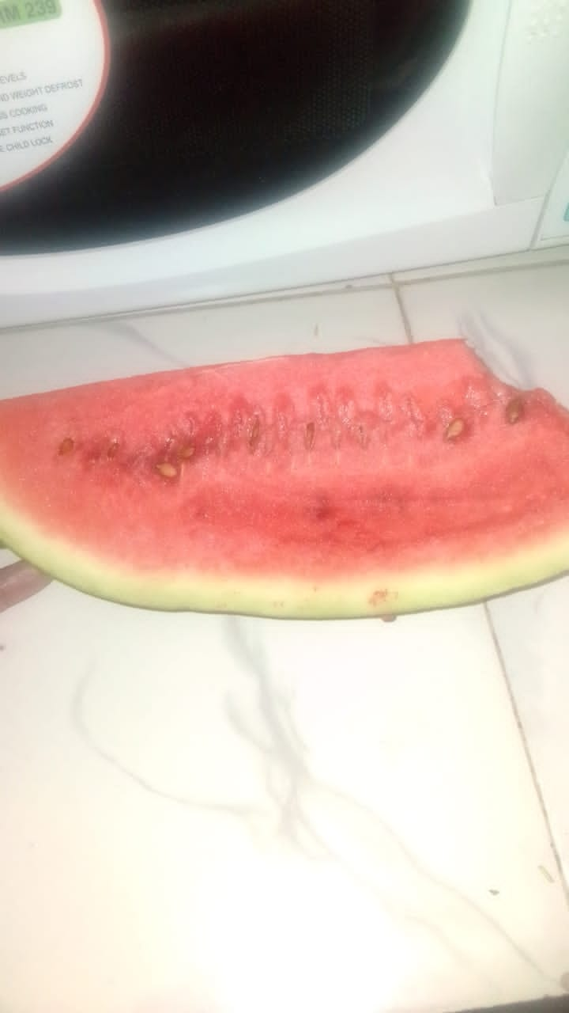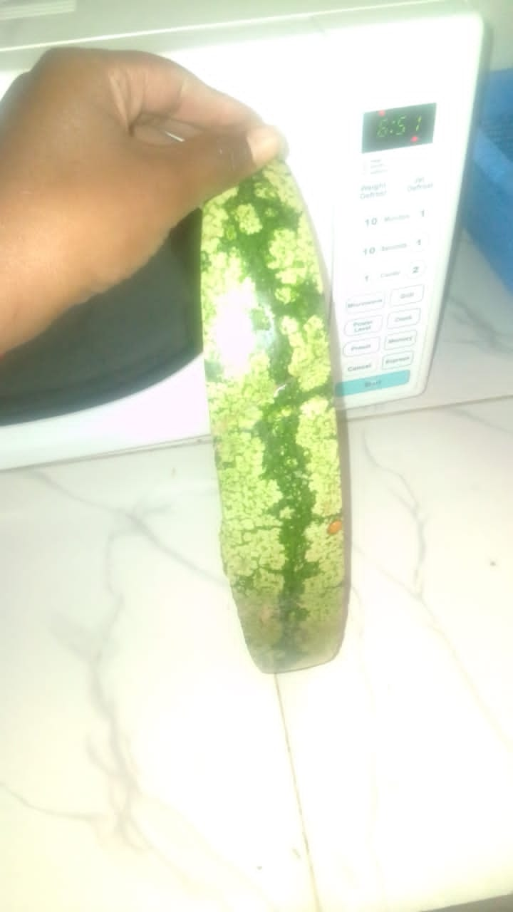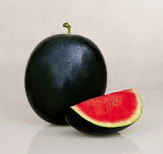

**The figures above show the interior and exterior part of Sugar Baby watermelon and Asali F1 respectively.**

## 2.4 Composition of watermelon.

The analysis of watermelon bioactive components has shown that it yields 46 calories, 1g protein, 2mg of sodium, 11g of carbohydrates,1g niacin, vitamin C and lycopene.(Oberio and Sogi,2019) analyzed that watermelon yields 55.3% juice, 31.5% rind and 10.4% ponace. The sweetness of watermelon is due to a combination of sugars which include sucrose, fructose and glucose. Diets rich in phytochemicals such as carotenoids and phenolic compounds have been associated with a reduced risk of certain types of cancer, cataracts, inflammation, cardiovascular and neurodegenerative diseases (Bueno et al, 2012, Sergeant et al, 2010, Snyder et al, 2011, and Tanaka et al, 2012).

Other phytochemicals that are associated with watermelon are lycopene, beta-carotene, total phenols, vitamins, tannins, saponin, and all these have their role to play in maintaining human health system. The water present in watermelon caries sugars in it that helps to boost sugar levels in the body. It also has low levels of fats hence it prevents weight gain and maintaining normal processes. Flavonoids, steroids and alkaloids are also present in the watermelon and all these are boosting the human health systems like normal functioning of the heart, preventing inflammation and cancer growths.

# CHAPTER THREE

# 3.0 METHODOLOGY

**3.1. Area of study**

The watermelon fruit will be purchased from Daraja market in Kisii Town during its season so as to obtain a good quality sample and stored in a good condition prior to the experimental day. The rinds will be peeled off and seeds removed, juice and red part will be used as a sample to determine the phytochemicals present and analyze them. The following methods will be used;

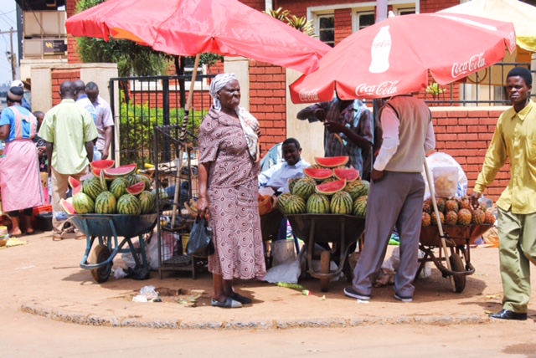

## 3.2. Extraction of juice sample

The watermelon fruit will be divided into three different parts; the seeds, mesocarp, juice and a mixture of the whole fruit. The seeds and the whole fruit will be kept aside. Juice will be filtered using a filter paper to remove traces of the mesocarp. The mesocarp will be grinded into a viscous liquid. On extraction, clear filtrate will be obtained by filtering through Whatman's No 1 filter paper.

Phytochemical screening of the watermelon juice and mesocarp will be carried out to ascertain the qualitative composition.

## 3.3 Determination of lycopene and beta-carotene

Charoensiri et al, 2009 method will be used to determine lycopene and beta-carotene content in watermelon.

### 3.3.1 Determination of lycopene

Weigh 1g of fresh watermelon into a 250 ml beaker and crush it with a glass rod.25 ml of HPLC grade acetone will be added and shaken for 10 min. 25ml of methanolic NAOH solution will be added and a reflex condenser attached. Then the mixture will be heated in boiling water bath for 1 hr, shaking frequently. The moisture will be cooled rapidly and 50 ml of distilled water added. The hydrolysate will be obtained and then transfer it into a separating funnel. The solution will be extracted 3 times with 50 ml of HPLC acetone; 1g of K2SO4 will be added to remove any traces of water. The organic layer will be removed carefully into 250 ml beaker and filtered into 100 ml volumetric flask and then make it up to the mark with HPLC acetone.

Standard solution of lycopene of range 0-50 micrograms/ml will be prepared from 100 ppm stock lycopene solution. The different concentrations of lycopene std soln will be treated similarly like the sample. The absorbance of lycopene will be taken on a spectrophotometer of wavelength 340nm.

­­­­­­­­­­­­­­­­­­­­­­­­­­­­­­­­­­­­­­­­­­­­­­­­­­­­­­­­­­­­­­­­­­­­­­­­­­­­­­­­­­­­­­­­­­­­­­­­­ Absorbance of sample × gradient factor × Dil. Factor/ Amount of lycopen (mg/100g) =

Wt. Of the sample taken in g

### 

### 3.3.2. Determination of beta-carotene

2g of the watermelon will be weighed into a flat button reflux add 10 ml of distilled water added and mixed carefully to form a paste. 25 ml of alcoholic KOH solution will be added. The mixture will be heated for 1 hr while shaking frequently and then add 30 ml of water. Retract the solution 3 times with 25 ml quantities of chloroform, 2g anhydrous sodium sulphate (Na2SO4) will be added to the extract to remove any traces of water, filter the mixture into 100 ml volumetric flask and make it up to the mark with chloroform.

Standard solution of beta-carotene will be made by dissolving 0.003g of std beta-carotene in 100ml chloroform. Absorbance of sample and standard solution will be read using the spectrophotometer at a wavelength of 328nm.

Absorbance of sample ×gradient factor /

Carotene (micrograms/100g) =

Wt. of the sample× 1000

## 

## 3.4 Determination of saponin content

The saponin content will be determined using spectrophotometric method described by (Brunner, 1984). About 2g of dry watermelon will be weighed into a beaker and isobutyl alcohol (but-2-ol) added. The mixture will be filtered through No 1 Whatman filter paper into a beaker containing 40% Magnesium Carbonate (MgCO3) solution. App. 1ml of the solution will be transferred into volumetric flask; 2ml iron three chloride (FeCl3) solution will be added and made up to the mark with distilled water. This will be allowed to stand for 30 min for the color development and absorbance will be read at 380nm.

## 3.5 Determination of flavonoids

Approximately 0.25g of watermelon will be dissolved in 1ml distilled water,5g sodium nitrate solution,0.150ml of freshly prepared aluminiumchloride(AlCl3) and 1ml NaOH solution will be added. The mixture will be allowed to stand for 5 min and absorbance will be measured at 510nm. The results will also be expressed as Quercetin Equivalent (QE) (Makker, 1999).

## 3.6 Determination of total polyphenols

This will be determined using the Folin-Ciocalteu method (Singleton et al, 1999). Distilled water and Folin-Ciocalteu's reagent will be added to a 125 microlitre watermelon extract. Te mixture will be filtered and the extract will be concentrated on a water bath to one quarter of the original volume. Ammonium hydroxide solution will be added drop wise to the extract untilprecipitation is complete. The ppt will be collected, washed with dilute ammonium hydroxide and then filtered. The residue will be dried and weighed (Harbone, 1973).

## 3.7 Determination of tannins

50 mg of extracts will be boiled in 20 ml of distilled water separately and filtered. The filtrates will be used to test the presence of tannins.

Dichromate test: 2 ml solution of the extract will be taken in a test tube. Then 0.5 ml of 10% potassium dichromate solution will be added. A yellow precipitate will be formed which will indicate the presence of tannins.

# REFERENCES

Oberio, D.S, Sogi, S, (2017). Utilization of watermelon pulp for lycopene extraction by response surface methodology. Food chem 233, 1-7. Citation time(s); 2

Adedeji,T.O $ Oluwalana, I.B,(2017). Development and quality evaluation of jam watermelon(Citrullus lanatus). Citation time(s); 1

Naz, A, Butt, M.S, Sultan, M.T, Qayyum, M.M.N, Niaz, R.J,(2013). Watermelon lycopene and Allied Health claims.Excli J. 2014, 13, 650-666.Citation time(s):1

Edward A.J, Vinyard, B.T, Wiley, E.R, Brown, E.D, Collins,J.K, Perkins-Veazie, P, Baker, R.A, Clevidence, B.A (2003). Consumption of watermelon juice increase plasma concentration.J. Nutri 133, 1043-1050. Citation time(s): 1

Oseni,O.A, Okoye, V.I(2013). Journal of Pharmaceutical and Biomedical sciences.

Bueno,J.M, Saez-Plaza, P, Ramos-Escudero, F, Jimenez, A.M, Fett,R and Asuero,A.G,(2012). Analysis and Antioxidant capacity of anthocyanin pigments. Part 2. Chemical structure,colour and intake of anthocyanins.Critical Reviews in Analytical Chemistry 42;126-151. Citation time(s): 1

Sergent, T, Piront, N, Meurice, J, Toussaint, O and Scheinder, Y.J,(2010). Anti-inflammatory effects of dietary phenolic compounds in an in vitro model of inflamed human intestinal epithelium. ChemicoBiologicalinteractions 188: 659-667. Citation time(s):1

Snyder,S.M, Reber, J.D, Freeman, B.L, Orgad, K, Eggett, D.L, and Parker, T.L,(2011).Controlling fir sugar and ascorbic acid, a mixture of flavonoids matching navel oranges significantly increases human postprandial serum antioxidant capacity. Nutrition Research 31:519-526.Citation time(s):1

Tanaka, T, Shnimizu, M, and Mariwaki, H (2012). Cancer Chemoprevention by carotenoids.Molecules 17:3202-3242.Citation time(s):1

Charoensiri, R, Kongkachuichui,R, Suknizum,S and Sungpuag, P, (2009). Beta carotene, lycopene and alpha-to-copherol contents of selected Thai fruits. Food Chemistry, 113, 202-207. Citation time(s):1

Brunner, J.H(1984). Direct spectrophotometer Determination of Saponin. Analytical Chemistry, 34, 1314-1326. Citation time(s):1

Makker,H.P.S(1999). Quantification of Tannin in tree foliage. A laboratory Manual for the FAO/AIEA co-ordinated Research Project on use of Nuclear and related Techniques to develop simple Tannin Assay for predicting and improving the safety and efficacy of feeding ruminants on Tanniferous tree foliage. Joint FAO/IAEA division of Nuclear Techniques in food and agriculture, Vienna. Citation time(s):1

Herbone J.B (1973). Phenolic compounds in phytochemical methods. A guide to medium techniques of plant analysis. London. Chapman and Hall ltd. 33-88. Citation time(s):1

Singleton, V.L, Orthofer, R, Lamuela-Raventus, R.M (1999). Analysis of total phenols and other oxidation substrate and antioxidants by means of Folin-Ciacalteu reagent in: Methods in enzymology (edited by Lester Packer). San Diego, CA, USA Academic press,pp 152-178.Citation time(s):1

# APPENDICES

**Appendix 1**: Work plan

**Appendix 2**: Budget plan

**APPENDIX 1: A RESEARCH PROPOSAL WORK PLAN**

|  |  |  |  |  |
| --- | --- | --- | --- | --- |
| DATE | October -December | January - February | February - April | April 10 - May |
| ACTIVITY | Proposal development | Proposal presentation | Sample collection and Laboratory work | Data analysis and report writing and submission |

APPENDIX 2: A RESEARCH PROPOSAL BUDGET

|  |  |  |  |
| --- | --- | --- | --- |
| ITEM | MINI-ITEM | QUANTITY | AMOUNT(sh) |
| MATERIALS | Watermelon | 50g | 50 |
|  | Reagents |  |  |
| SERVICES | Typing | 60 pages | 1200 |
|  | Printing | 60 pages | 600 |
|  | Photocopying and binding | 60 pages | 500 |
| **TRAVEL** | Field work |  | 300 |
|  | Transportation | To and fro field work | 500 |
| **MISCELLANEOUS** | Lunch and others like credits |  | 1000 |
| **TOTAL** |  |  | = 4150 |

**QUESTIONNAIRE ABOUT WATERMELON**

1. What is a watermelon and why do you think it is called like that (your own opinion)?

………………………………………………………………………………………………………………………………………………………………………………………………………………………………………………………………………………………………………………………………………………………………………………………………………………………………………………………………………………………………………………………

2. What is its local name (Ekegusii)?

………………………………………………………………………………………………………………………………………………………………………

3. How long does it take to mature?

………………………………………………………………………………………………………………………………………………………………………

4. How many kilograms (kg) does a mature watermelon have?

………………………………………………………………………………………………………………………………………………………………………

5. What is the importance of cultivating watermelon and what health benefits does it have?

………………………………………………………………………………………………………………………………………………………………………………………………………………………………………………………………………………………………………………………………………………………………………………………………………………………………………………………………………………………………………………………………………………………………………………………………………………………………………………………………………………………………

6. What are the main challenges faced by watermelon farmer?

………………………………………………………………………………………………………………………………………………………………………………………………………………………………………………………………………………………………………………………………………………………………………………………………………………………………………………………………………………………………………………………

7. What advice can you give to people who are eating watermelon and your fellow farmers?

………………………………………………………………………………………………………………………………………………………………………………………………………………………………………………………………………………………………………………………………………………………………………………………………………………………………………………………………………………………………………………………