

**NAME : BENARD ONDIEKI TUTI**

**ADM. NO : BSCS/2017/41939**

**COURSE: BACHELOR OF SCIENCE COMPUTER SCIENCE.**

**UNIT : EVENT DRIVEN PROGRAMMING**

**UNIT CODE: CSC341.**

**TASK : ASSIGNMENT**

**LECTURER: MASILA KYENGE**

***Question 1***

Program capturing 10 numbers from user, display 8th number,display all nubers,display them in reverse and calculate sum and average of the numbers.

The following is the code of the program;

Public Class Form1

Dim numbers(9) As Integer

Dim searchvalue As Integer

Private Sub Button2_Click(ByVal sender As System.Object, ByVal e As System.EventArgs) Handles Button2.Click

Dim generate As Integer

Randomize()

generate = (Int(100 * Rnd()))

TextBox1.Text = generate

If TextBox1.Text = "0" Then

TextBox1.Text += 1

End If

End Sub

Private Sub Form1_Load(ByVal sender As System.Object, ByVal e As System.EventArgs) Handles MyBase.Load

searchvalue = -1

End Sub

Private Sub Button1_Click(ByVal sender As System.Object, ByVal e As System.EventArgs) Handles Button1.Click

Dim number As Integer

number = TextBox1.Text

If searchvalue = 9 Then

MsgBox("Array full", MsgBoxStyle.Information)

TextBox1.Text = ""

TextBox1.Enabled = False

Button2.Enabled = False

Button1.Enabled = False

Else

searchvalue = searchvalue + 1

numbers(searchvalue) = number

TextBox1.Text = ""

TextBox1.Focus()

End If

End Sub

Private Sub Button4_Click(ByVal sender As System.Object, ByVal e As System.EventArgs) Handles Button4.Click

Dim AddText As Integer

If numbers(4) = "0" Then

MsgBox("you must add nmbers")

Else

ListBox1.Items.Clear()

For AddText = 0 To searchvalue

ListBox1.Items.Add(numbers(AddText))

Next AddText

ListBox1.Sorted = True

End If

End Sub

Private Sub Button3_Click(ByVal sender As System.Object, ByVal e As System.EventArgs) Handles Button3.Click

'display of the 8th number from numbers provided.

MessageBox.Show(numbers(7))

End Sub

Private Sub Button6_Click(ByVal sender As System.Object, ByVal e As System.EventArgs) Handles Button6.Click

'sum of all the numbers provided

Dim sum As Integer

sum = numbers(0) + numbers(1) + numbers(2) + numbers(3) + numbers(4) + numbers(5) + numbers(6) + numbers(7) + numbers(8) + numbers(9)

MessageBox.Show(sum)

End Sub

Private Sub Button5_Click(ByVal sender As System.Object, ByVal e As System.EventArgs) Handles Button5.Click

'average of number display'

Dim average As Double

Dim total As Double

total = numbers(0) + numbers(1) + numbers(2) + numbers(3) + numbers(4) + numbers(5) + numbers(6) + numbers(7) + numbers(8) + numbers(9)

average = total / 10

MessageBox.Show(average)

End Sub

End Class

**Output**

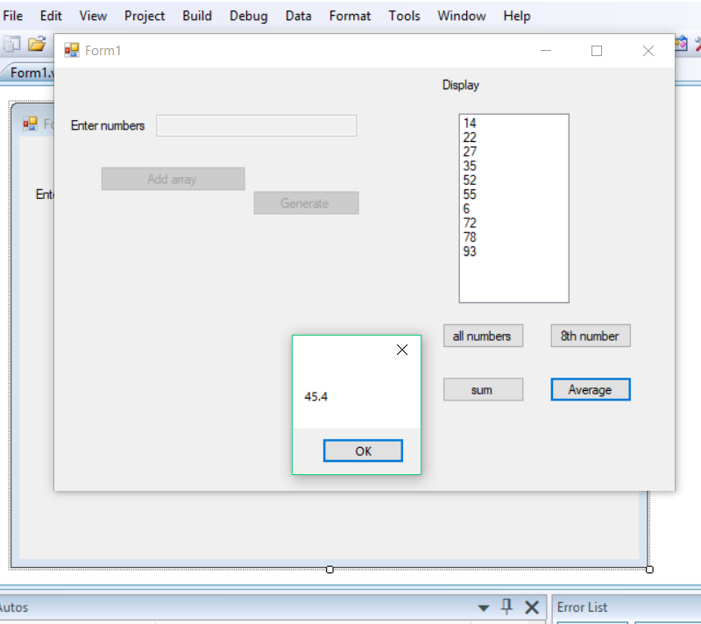

***Question 2***

The program uses 2d array to produce a multiplication table as;

***1 2 3 4 5***

***1*** 1 2 3 4 5

***2*** 2 4 6 8 10

***3*** 3 6 9 12 15

***4 . . . . . . . . ……..***

***The code for the program is as below;***

Module main

Dim table(,) As Integer

Dim input_row As Integer

Dim input_columns As Integer

Dim row() As Integer

Dim sum() As Integer

Dim columns() As Integer

Dim multiplier As Integer

Dim multiplicand As Integer

Sub main()

inputvalue()

other()

Console.ReadLine()

End Sub

Sub inputvalue()

Console.Write("enter row: ")

input_row = Console.ReadLine

Console.Write("Enter columns: ")

input_columns = Console.ReadLine

End Sub

Sub other()

For x As Integer = 1 To input_columns

For y As Integer = 0 To input_row

If y > 0 And x > 0 Then

Console.Write(x * y & vbTab)

End If

Next

Console.WriteLine()

Next

End Sub

End Module

The user offers the row and columns to view the multiplication table generated.

**Output**

