CHAPTER 1
INTRODUCTION
Most educational institutions administrators are concerned about student irregular attendance. Truancies can affect student overall academic performance. The conventional method of taking attendance by calling names or signing on paper is very time consuming and insecure, hence inefficient. Radio Frequency Identification (RFID) is an interesting solution in such cases. RFID based attendance system is one of the solutions to address this problem.
IoT is a dynamic global network organization with self-configuring capabilities based on standard and interoperable communication protocols In the IoT, physical and virtual things have identities, physical attributes, and virtual personalities and use intelligent interfaces The physical and virtual things are seamlessly integrated into the information network RFID is shaping up to be an important building block for the Internet of Things (IoT). RFID (Radio Frequency Identification) devices are wireless microchips used for tagging objects for automated identification RFID systems consist of a reading device called a reader, and one or many tags the reader is a powerful device with ample memory and computational resources RFID can identify objects wirelessly without line-of-sight. . Attendance system will produces an automatic system which give better routine and efficiency than the traditional method of observing student. Furthermore, RFID technology can help to identify and to monitor items (products, people, student etc.) wirelessly. The proposed RFID system is for recognizing and monitoring attendance. In this system, the RFID tags enable the college management people to supervise the student movement in and out of the campus. When RFID tags swiped through the RFID reader, then system will record the data from the RFID tags to the database systems.

  - Preamble
RFID (radio frequency identification) is a new technology that incorporates the use of electromagnetic or electrostatic coupling in the radio frequency (RF) portion of the electromagnetic spectrum to uniquely identify an object, animal, or person. RFID tags are not an "improved bar code" as the proponents of the technology would like you to believe.
An RFID system consists of three components: an antenna and transceiver (often combined into one reader) and a transponder (the tag). The antenna uses radio frequency waves to transmit a signal that activates the transponder. When activated, the tag transmits data back to the antenna. RFID technology differs from bar codes. RFID can read the tag using RF, meaning that the RFID reader can be read from a distance, right through your clothes, wallet, backpack or purse. Besides the RFID tag consist of unique ID for each tag. The technology used in RFID has been around since the early 1920s. In our country, this technology already been used for several years in certain place such as in Highway using card ‘Touch N Go’ and our government also apply this technology by using RFID as I.C (identification card). Some places, they prefer to used Barcode which is cheaper than RFID. Technology spread very fast. Nowadays, there are lots of universities/colleges around our country and each of the university consists of student up to 10 thousand. To handle a large amount of student may be problem especially to get the attendance. Now, process to get attendance in majority universities still used the manual process. The manual process means that when start the class/lecture, lecturer will call out the names of all students and mark their attendance in the register. Lecturer has to keep it as a record. Normally, the attendance register need much time to call and mark all students especially for class with a lot of student. Students also forget to answer their attendance while talking and chit chatting and are assumed to be absent that class. The problem also will happen when lecturer forget to bring the attendance register to class. Students sometimes will take chance to cheat in process getting the attendance by ding proxy for their friends. The suitable solution for this problem is by design a system that will record attendance automatically. In this project, RFID system used to record student attendance automatically. This project will used RFID card or RFID tag and a RFID reader. This RFID system will be integrate with software which is an app to view and modify attendance. This method is more effective to prevent problem in process getting attendance manually.

  - Objectives
This system can be used to take attendance for student in college and university. Its ability to uniquely identify each person based on their RFID tag type of ID card make the process of taking the attendance easier, faster and secure as compared to conventional method.
1. To study on data transfer between RFID system and the mobile application
The data that is read by RFID reader will communicate with interface on mobile application for display and to compare with database.

2. To develop graphical user interface (GUI) using android studio
It will integrate with RFID system to capture and record student attendance. The main objective is to developed student attendance with RFID system. We need to build interface that will integrate with RFID system and will show the card code. Another interface also need to capture and record student attendance.

  - Project Scope
The main goal of this project is develop a student attendance using RFID technology. There is 2 scope will be cover in this project. Firstly is to use appropriate RFID Tag & Reader for this application. Secondly is to design GUI to integrate with RFID technology.
- Use appropriate RFID Tag & Reader for this application.
There are lots of RFID reader and tag sold at market. Not only brand, but also frequencies of the RFID itself need to be considered. Since this system will be applied to a university/college, the RFID reader must use same frequencies as university student ID card.
- Design and implement a system in student attendance using RFID.
The RFID reader will use to detect the student RFID ID card code. The code will use to compare with Access database and the information in database will be display and store by using interface on mobile application using android studio and firebase.

  - Organisation of the report
This “Student Attendance Using RFID System (Iot)” organization is a combination of 6 chapters that contains and elaborates specific topics such as the Introduction, Literature survey, Hardware Design, Software Development, Result, Discussion, Conclusion and Further scope that can be applied in this project.
Chapter 1 basically is an introduction of the project. In this chapter, the discussion is all about the background and objectives of the project. The overall overview of the entire project is also discussed in this chapter.
Chapter 2 will be discussed about the literature review and survey for the development of the Student Attendance Using RFID System. Everything related to the project will be describe generally in this chapter.
Chapter 3 will be focused on hardware design of the Student Attendance Using RFID System. This chapter included four subtopics. The entire hardware used in this project will be discussed briefly.
Chapter 4 will be discussed about the software development of the Graphical User Interface (GUI) and Access. In this section, all basic programming for the system working with system design and architecture.
Chapter 5 discusses the implementation of the project and discussion of the project. The main flow chart for this project implementation will be explained briefly under this topic.
Chapter 6 discusses the results obtained and analysis of the project. It discusses about the advantages and disadvantages of the system.
Chapter 7 discusses the conclusion and further scope and development of the project. This chapter also discusses about total costing involved and potential of this project for commercialization.

CHAPTER 2
LITERATURE SURVEY

  - Literature review
Before the RFID IOT system smart-card and barcode are more popular for all purpose like supervision, attendance or for monitoring student, employees etc. In this we are going to implement the RFID system in our project for improvement of old attendance system and checking system for better result and security of the student. An RFID tag is an object that can be applied to or inserted into a product, person, or animal for the purpose of identification and tracking using radio waves. Some identifiers can be read from several centimeters or meters away and beyond the line of sight of the reader. A number of related works exist in works, application of RFID Technology to different areas and specifically to the area of academic attendance monitoring problem. It was designed and employed as a model of a secured and portable embedded reader system to read the biometric data from the electronic passport. The authors attempted to solve problems of trustworthiness, security and confidentiality in E-passports by authenticating holder online .using Global System of Mobile Communications (GSM) network. The GSM network is the main edge between identification centre and the e-passport reader. The communication data is protected between server and e-passport reader by using AES to translate data for protection while transferring through GSM network.
Most schools today use some system software to collect and maintain school and student information to help manage the ongoing functions of a typical school: attendance, enrolment, grades and communication between teachers, parents and students. The traditional School Management System no longer can be limited to just tracking student information but must provide a means of using data to help drive better, evidence-based decisions on the part of the school and family regarding the educational goals of students.
2.2 RFID Based Attendance System (Hasan U. Zaman, Jannatul Siffat Hossain, Tasnim Tamanna Anika, Deboshree Choudhury)
The applications using Radio Frequency Identification (RFID) are increasing nowadays and are seen being applied in various fields such as transportation, agriculture, industries etc. A major problem faced in educational institutions is the time consuming manual attendance. The goal is to solve this problem using RFID technology. RFID, which stands for Radio Frequency Identification, is an automatic identification technology used for retrieving from or storing data on to RFID Tags without any physical contact.

2.2.1 Methodology
The RFID cards have a unique identification number and that is one of the main benefits of the system as this makes the system very reliable. The card saves the personal details of the used saved across its identification number. Since the card saves all the personal details of the user, there has to be very high security system to secure the information. This privacy issue resulted in standard specifications development that addresses privacy and security issues. ISO/IEC 18000 and ISO/IEC 29167 use on-chip cryptography methods for intractability, tag and reader authentication, and over-the-air privacy; hence the system is very much reliable and secured.
The system consists of the Arduino Mega, SD card Shield, RFID Reader, Wi-Fi module and a LCD Display Shield as shown in figure 2.1. Also consist of a Real Time Clock to get the details of time when the user gave the attendance. This feature helps to know whether any student/employee was late in class/office. The ARDUINO MEGA has 54 input and output pins which leaves with an advantage of adding quite a few devices or modules with it. It is suitable for complex systems. After the electrical and software components are completely done, put a card close to the RFID reader, it reads the unique identification number and the personal data saved across it and compares this data with its backend database that already has all the registered students/employees information beforehand. The controller compares this two information and if they match, it takes the attendance and saves that time and also shows it in the LCD display that attendance was taken in order to inform the user. However, if this two information do not match it shows that the user is not registered in the LCD display.
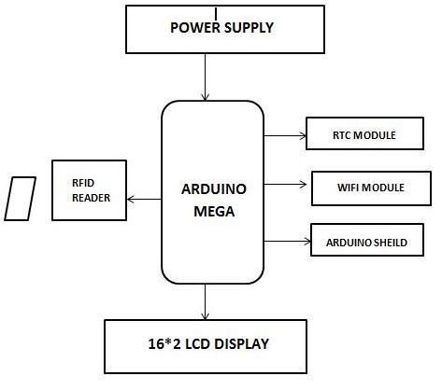
Figure 2.1 Block diagram of system

Now the part where our system meets the internet. To access internet, WI-FI module is implemented to the system. The module used in the system is the ESP8266 WI-FI module. It is a very powerful module and provides storage capability for integration with sensors and other application. It is extremely cost effective and it requires minimum circuitry due to its high on chip integration. Using this module, the device can be connected to a secure internet network. Later on, an account is opened in Thingspeak, an API application, and the device is directly connected to the Thingspeak channel with the help of this WI-FI module. Whenever an entry is recorded, along with saving it in SD card, the entry is also updated in Thingspeak account from where the data can be retrieved anytime. Thingspeak offers real time data collection hence we do not have to worry about late entries as the time will also be duly noted.

2.2.2 Advantages
The API allows for very easy visualization of collected data through using spline charts. Therefore, it is visually appealing and is much easier when examining collected data compared to other open source APIs.
ThingSpeak uses Phusion Passenger Enterprise, a web and application server. Therefore, the API provides additional support for the programming languages Ruby, Python and Node.js.

2.2.3 Drawbacks
There are some aspects of the ThingSpeak API that can be called its weaknesses. For example, when uploading data to the API there is a limit up one update per channel every fifteen seconds. We postulate that the reason for this limit in uploads is due to the excess bandwidth that could be used, and therefore would end up costing ThingSpeak additional funds for a non-profit service. This limit can be removed by taking the whole API to another web host provider to run the API.

2.3 RFID-Based Attendance Management System (H. K. Nguyen, M. T. Chew)
Organizing large professional gatherings such as international technical exhibitions, conferences, competitions, training events, etc., is a challenging task where a number of participants/delegates can be at the range of hundreds or even thousands. The event organizing committee has to correctly estimate an interest to sessions among the delegates, and to allocate premises, facilities and equipment to different topic sessions, presentations, demonstrations, etc.
To keep track of the major aspects, indicators and statistics of the current year gathering as well as to help the organisers of the future events, an automated attendance management system can be put in place. For example, it could help to collect inflow and outflow delegate numbers attending particular sessions or tutorials. To achieve it, the system has to be equipped with a capability to sense delegates passing an entrance in both the directions, as well as to transfer the data to some database where the information is stored, processed and presented in a meaningful form (for example, as an MS Excel files, texts, graphs, etc) thus helping to prepare the relevant reports and carry out planning of the future events of similar types.

2.3.1 Methodology
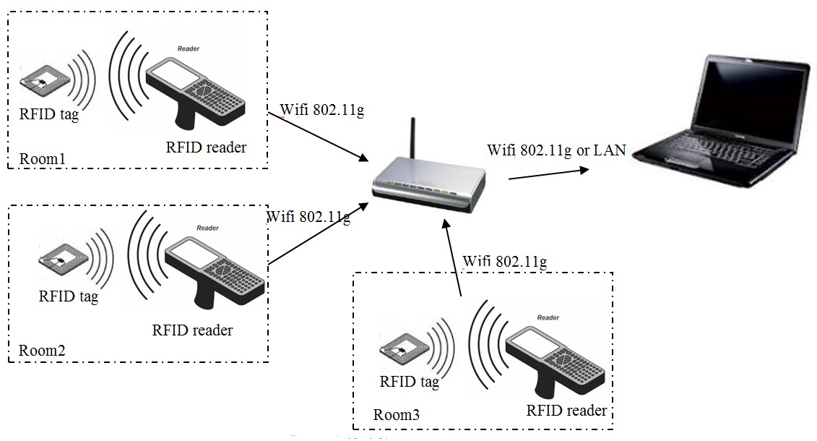
This approach is often based on the inductance coupling principle where a receiver can be supplied with information wirelessly through the electromagnetic field generated by a transmitter. Recently, extensive research and development activities have been carried out to improve the performance of RFID systems. Among them are: an automatic tuning method to maximize read range, performance improvement of RFID tags when attaching them onto a metallic surface, optimization of modulation techniques for passive RFID tags in an absence of resonant conditions, etc. Due to these and numerous other improvements, the RFID solution is now significantly more widely accepted, and implemented for the object identification in many areas such as libraries, supermarkets, logistics warehouses, and so on. Moreover, the cost of implementation of RFID-based systems is relatively low. They are also often less complicated to setup and maintain than some other solutions. At the same time, RFID-based systems have to satisfy the relevant electromagnetic emission, frequency and security regulations. Yet, these restrictions do not affect any significantly a possibility of implementing an event automatic attendance and tracking system based on RFID technology.

Figure 2.2 Block architecture of the system

The system consists of a number of RFID readers installed at every room of a large professional event and a server application on a laptop to collect and process the information sent from all the readers. The system architecture is illustrated in Figure 2.2.

    - Advantages
These tags can store data up to 2 KB, whereas, a barcode has the ability to read just 10 - 12 digits. This allows one to store a stronger encoded identification series within it.

2.3.3 Drawbacks
RFID proves to be too expensive for many applications as compared to other tracking and identification methods, such as the simple barcode.

2.4 RFID Based Attendance Management System using LABVIEW (Garry W. Johnson, Richard Jennings)
Recently, number of application of RFID technology has increased. Today RFID is applied to agriculture, retail industry, manufacturing industry, keeping track of vehicle etc. RFID works wirelessly. It automatically identifies using wireless technology. In my project, I have tried to solve the problem of rigorous and monotonic attendance procedure followed today. Manually attendance is taken of every student or employee. But in this method lot of time is wasted. Moreover, it is erroneous. So, this electronics based product will not only make the attendance procedure flexible, but also will keep the records error free. In my design the students will be provided with the low-cost passive tags. These tags will be used in the identifying the student. Once the tag is detected by the reader the data is sent to the ARM processor for further processing. Processor displays the received data on LCD and then sends it to the PC/Laptop for database management. The database management is done using LabVIEW. It is a low-cost method for attendance management. Further the use of LabVIEW made the real time data acquisition fast.
RFID is a technology which wirelessly identifies the chip or tag of interest and captures the data. It is otherwise known as AIDC. AIDC consists of card technology, barcodes used on products technology, biometric systems optical photo recognition systems etc. (see figure 2.3). RFID perfectly identifies the tags or the
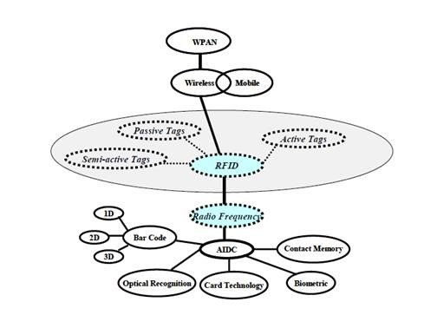

Figure 2.3: Position of RFID technology in the AIDC landscape

products attached with it provided they are present within the range. As a result, it finds lot of applications in manufacturing or retail industries Any RFID system comprises of three components: (i) RFID tags, (ii) RFID reader (iii) RFID middleware application that is integrated into a host system. RFID Tags contain the information unique to each product/person (depending on application). This information is transferred to reader wirelessly and further processing is done.

2.4.1 Methodology
The methodology involves the following implementation and work flow.
2.4.1.1 Implementation
The below figure 2.3 shows the algorithm for the hardware interface. At first the LCD and the Serial port are initialized. Then the processor waits for the Reader data to arrive serially. Once the Reader data is present in ASCII format in the buffer of the processor, the processor forwards the data to the LCD. LCD displays the data and then sends the data to the PC where there is the GUI and Database management done.

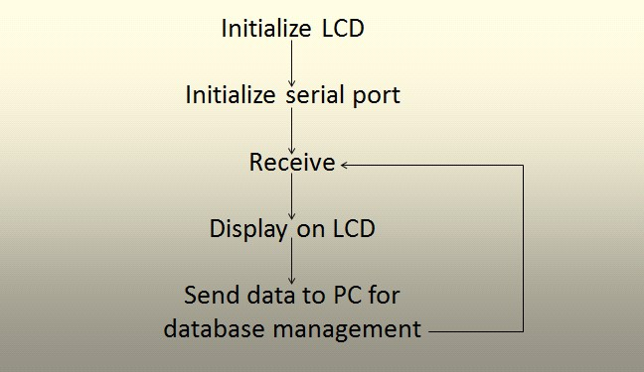
Figure 2.3: Algorithm for the hardware interface

Data sent by the processor is received by the serial module of LabVIEW2013. After receiving the data serially, LabVIEW access the already present data in the database and converts them into LabVIEW compatible formats. Then check if the data received at the USB terminal matches with any of the present data. If the match is successful then the database is updated to the new value. If unsuccessful then LabVIEW simply does not change the database (see figure 2.4).

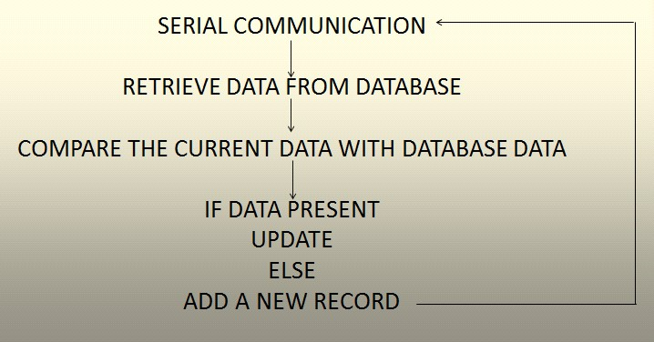
Figure 2.4: Algorithm for database management
2.4.2 Advantages
- Graphical interface is flexible and simple to use. Most engineers and scientists can learn to use it quickly.
- LabVIEW provides a universal platform for numerous applications in diverse fields.
- LabVIEW can be used with 3rd party hardware: it can be interfaced with C/C++, VB, Fortran etc.
- Easy to interface too many hardware items like data acquisition and test equipment products.
- It has excellent customer support and a large active community forum.
    - Drawbacks
- LabVIEW is single sourced and some companies may not like to use a product that is single sourced and not standardised by the industry.
- Cost of ownership – although in line with many other industry products of a similar nature, its cost should be considered before it is introduced.
- For those more accustomed to text programming, graphical programming can take a little familiarisation time.
  - Summary of Literature Survey
AUTHOR | TITLE | YEAR | MERITS | DEMERITS
Hasan U. Zaman, Jannatul Siffat Hossain, Tasnim Tamanna Anika, Deboshree Choudhury | RFID Based Attendance System | 2017 | Easy visualization of collected data through using spline charts.  Support for the programming languages Ruby, Python and Node.js. | Additional funds for a non-profit service.
H. K. Nguyen,  M. T. Chew | RFID-Based Attendance Management System | 2017 | Tags can store data up to 2 KB, whereas, a barcode has the ability to read just 10 - 12 digits. | RFID proves to be too expensive for many applications
Garry W. Johnson, Richard Jennings | RFID Based Attendance Management System using LABVIEW | 2006 | Graphical interface is flexible and simple to use. | Single sourced

  - Motivation
In most universities, teachers take attendance by calling out the names and surnames of students, and then marking them, while, in others, teachers pass around a sheet of paper, asking students to sign in attendance sheet just next to their surnames. Both practices have their drawbacks. In the first case, if numerous groups attend the lesson, checking all of these students by name and surname might take about 10 minutes out of each lesson; in the second case, friends of absent students may write down their names and surnames. These practices place university teachers and their institutions at considerable disadvantages when it comes to taking attendance. To rectify these systematic failings, we have decided to put the RFID-card into service. Each card has a unique ID, precluding the duplication of a card. These RFID-cards are given to students, and while entering classrooms, RFID readers will read these cards, identify the students from their respective RFID-cards and send the data to a PC. The PC, in turn, sends all the data it has collected to the server by the end of lesson, or at the end of this day according to the preference of lecturer. This means no class time will be wasted.

2.7 Problem Statement
As it stands, the process for taking attendance at college is inconsistent and annoying. It can change year to year and requires professors to take head counts of their students. Most students show up to class on time, but if someone is late to class, they will miss the head count. If the professor didn’t notice a student who was in class, they will be marked absent. The professor has to keep track of these occurrences. This traditional method of attendance taking places unnecessary responsibility on the professor.

2.8 Objectives
The aim of the project is to utilize RFID system in a different and developmental side. We all know that RFID is used in each and every industrial and manufacturing field. Our focus is to make a system that will take the attendance of authorized individuals, record the data along with time and date and store in an internal SD card file, and finally send the data to ThingSpeak channel (an API application) at the end of the day using Wi-Fi connection. Each user will be given an individual RFID tags and its record will be maintained.

2.9 Summary
The use of RFID technology in attendance system is not very complex as it sounds. Any individual can purchase the electronic components which we will see in the Chapter 3. As we are using Raspberry Pi, we may require the knowledge of Python.

CHAPTER 3
HARDWARE AND SOFTWARE REQUIREMENTS
The hardware, software and all the apps required for the project are listed below
- Raspberry pi Zero W
- RFID card reader
- RFID card/tags
- Rapsbian
- Android studio
- Jump wires
- USB connectors
- An android phone
- VNC Viewer
- Fing app
- firebase
3.1 Hardware
Two main hardware components are Raspberry pi and RFID. Some of the hardware components are listed below.
3.1.1 Raspberry pi Zero W
The ultra-small and ultra-slim Raspberry Pi Zero W (Wireless) is the smallest form factor Raspberry Pi on the market now incorporating WiFi and Bluetooth connectivity on board. It is 40% faster than the original Raspberry Pi but measures only 65mm long by 30mm wide and 5mm deep. The Raspberry Pi Zero W supports mini connectors to save on space and the 40 pin GPIO is unpopulated providing the flexibility to use only the connections your project requires.
Specifications:
- Dimensions: 65mm × 30mm × 5mm
- SoC: Broadcom BCM2835
- CPU: ARM11 running at 1GHz
- RAM: 512MB
- Wireless: 2.4GHz 802.11n wireless LAN
- Bluetooth: Bluetooth Classic 4.1 and Bluetooth LE
- Power: 5V, supplied via micro USB connector
- Video & Audio: 1080P HD video & stereo audio via mini-HDMI connector
- Storage: MicroSD card
- Output: Micro USB
- GPIO: 40-pin GPIO, unpopulated
- Pins: Run mode, unpopulated; RCA composite, unpopulated
- Camera Serial Interface (CSI)
It’s almost identical to the previous Raspberry Pi Zero v1.3 (the one that added the camera connector) – importantly, all the chips and components are still only on the top side of the board.
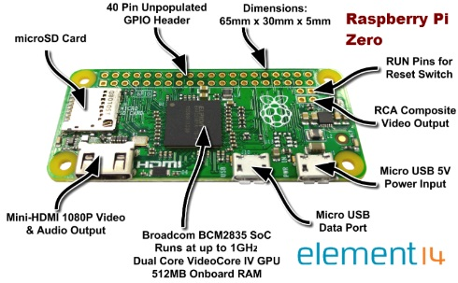

Figure 3.1 Raspberry pi
3.1.2 RC522 - RFID Reader / Writer Package
RC522 - RFID Reader / Writer 13.56MHz with Cards Kit includes a 13.56MHz RF reader cum writer module that uses an RC522 IC and two S50 RFID cards. The MF RC522 is a highly integrated transmission module for contact-less communication at 13.56 MHz. RC522 supports ISO 14443A/MIFARE mode.
RC522 - RFID Reader features an outstanding modulation and demodulation algorithm to serve effortless RF communication at 13.56 MHz. The S50 RFID Cards will ease up the process helping you to learn and add the 13.56 MHz RF transition to your project.
The module uses SPI to communicate with microcontrollers. The open-hardware community already has a lot of projects exploiting the RC522 – RFID Communication, using Raspberry pi.
Features:
- Integrated MF RC522
- 13.56MHz contactless communication card chip.
- Low-voltage, low-cost, small size of the non-contact card chip to read and write.
- Suitable for Smart meters and portable handheld devices.
- Advanced modulation and demodulation concept completely integrated in all types of 13.56MHz passive contactless communication methods and protocols.
- 14443A compatible transponder signals.
- ISO14443A frames and error detection.
- Supports rapid CRYPTO1 encryption algorithm, terminology validation MIFARE products.
- MFRC522 support MIFARE series of high-speed non-contact communication, two-way data transmission rate up to 424kbit/s.
- Low cost, and ideal for user equipment development.
- The reader and RF card terminal design meets advanced applications development and production needs.
- Can be directly loaded into the various reader molds, very convenient.
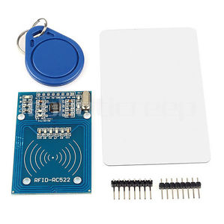
Figure 3.2 RFID Reader/Writer Package
Specifications:
- Operating Current :13-26mA / DC 3.3V
- Idle Current :10-13mA / DC 3.3V
- Sleep Current: < 80uA
- Peak Current: < 30mA
- Operating Frequency: 13.56MHz
- Supported card types: mifare1 S50, mifare1 S70 MIFARE Ultralight, mifare Pro, MIFARE DESFire
- Environmental Operating Temperature: -20 - 80 degrees Celsius
- Environmental Storage Temperature: -40 - 85 degrees Celsius
- Relative humidity: relative humidity 5% - 95%
- Reader Distance: ≥ 50mm / 1.95" (mifare 1)
- Module Size: 40mm × 60mm
- Module interface: SPI
- Data transfer rate: Maximum 10Mbit/s
RC522 - RFID Reader / Writer Package:
- 1x A RFID-RC522 Module
- 1x The Standard S50 Blank Card
- 1x S50 special-shaped card (as shown by the key ring shape)
- 1x Straight Pin
- 1x Curved Pin
3.1.3 Micro SD Card
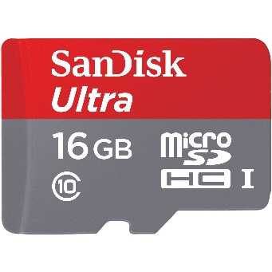
Figure 3.3 Micro SD Card
Features
- 16GB capacity
- Upto 48MB/s read speed
- Dependable high speed for shooting Full HD (1080p) video and high-quality photos
- Compatible with all microSDHC, microSDXC supporting host devices
- Dimensions (L*B*H in mm):15*11*1
3.1.4 Jump Wires
A jump wire (also known as jumper, jumper wire, jumper cable, DuPont wire, or DuPont cable – named for one manufacturer of them) is an electrical wire, or group of them in a cable, with a connector or pin at each end (or sometimes without them – simply "tinned"), which is normally used to interconnect the components of a breadboard or other prototype or test circuit, internally or with other equipment or components, without soldering.
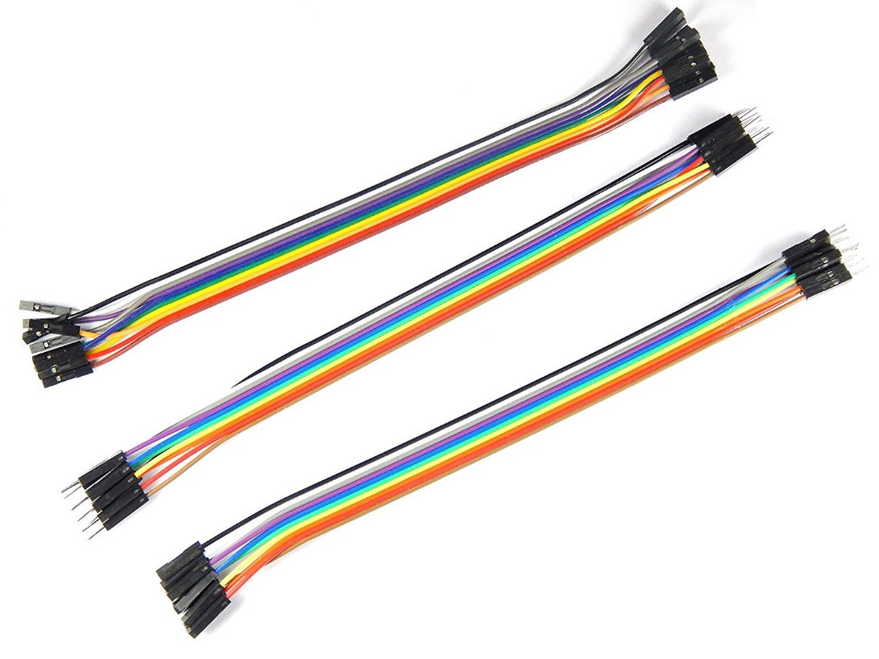
Individual jump wires are fitted by inserting their "end connectors" into the slots provided in a breadboard, the header connector of a circuit board, or a piece of test equipment.

Figure 3.4 Jump Wires: female to female, male to male and female to male
3.1.5 USB Cable
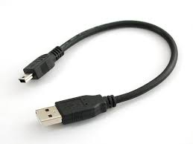
USB, short for Universal Serial Bus, is an industry standard that was developed to define cables, connectors and protocols for connection, communication, and power supply between personal computers and their peripheral devices.

Figure 3.5 USB Cable
3.2 Software
Two main software used are Rasbian Stretch OS and the Android Studio.Some of the softwares are listed below.
3.2.1 Raspbian Stretch OS
Raspbian is a free operating system based on Debian optimized for the Raspberry Pi hardware. An operating system is the set of basic programs and utilities that make your Raspberry Pi run. However, Raspbian provides more than a pure OS: it comes with over 35,000 packages, pre-compiled software bundled in a nice format for easy installation on your Raspberry Pi.
The initial build of over 35,000 Raspbian packages, optimized for best performance on the Raspberry Pi, was completed in June of 2012. However, Raspbian is still under active development with an emphasis on improving the stability and performance of as many Debian packages as possible.
Debian 9 (Stretch) was released on June 17, 2017, contained more than 51,000 packages. Major upgrades include the Linux kernel going from version 3.16 to 4.9, GNOME desktop version going from 3.14 to 3.22, KDE upgraded from KDE 4 to Plasma 5, LibreOffice 4.3 upgraded to 5.2 and Qt upgraded from 4.8 to 5.7.LXQt has been added as well.The Intel 586 (Pentium), Intel 586/686 hybrid (Pentium with MMX) and PowerPC architectures are no longer supported as of Stretch
Note: Raspbian is not affiliated with the Raspberry Pi Foundation. Raspbian was created by a small, dedicated team of developers that are fans of the Raspberry Pi hardware, the educational goals of the Raspberry Pi Foundation and, of course, the Debian Project.
3.2.2 Android Studio
Android Studio is the official integrated development environment (IDE) for Google's Android operating system, built on JetBrains' IntelliJ IDEA software and designed specifically for development. It is available for download on Windows, macOS and Linux based operating systems. It is a replacement for the Eclipse Android Development Tools (ADT) as primary IDE for native Android application development.

3.3 Web or mobile apps
The main web app development application used is firebase which stores information in form of tree structure. Some of the apps are as follows
3.3.1 Firebase
Firebase is a mobile and web application development platform developed by Firebase, Inc. It provides developers with a plethora of tools and services to help them develop high-quality apps, grow their user base, and earn more profit.
3.3.2 VNC Viewer
VNC stands for Virtual Network Computing. It is, in essence, a remote display system which allows you to view a computing `desktop' environment not only on the machine where it is running, but from anywhere on the Internet and from a wide variety of machine architectures.
In computing, Virtual Network Computing (VNC) is a graphical desktop sharing system that uses the Remote Frame Buffer protocol (RFB) to remotely control another computer. It transmits the keyboard and mouse events from one computer to another, relaying the graphical screen updates back in the other direction, over a network.
3.3.3 Fing
It discovers which devices are connected to any Wi-Fi network, map devices, detect intruders, assess network security risks, troubleshoot network problems and achieve best network performance, with the world’s most popular network toolkit.
Fing network utilities include:
- Wi-Fi/LAN scanner: discover all devices connected to any network.
- Full device details including IP address, MAC address, Device Name, Vendor, Device Manufacturer and more
3.4 Summary
Languages like python is used in Raspberry pi. JAVA is used in android studio. Firebase is used as database to store all the information required.
CHAPTER 4
SYSTEM DESIGN
Systems design is the process of defining the architecture, modules, interfaces, and data for a system to satisfy specified requirements. Systems design could be seen as the application of systems theory to product development. There is some overlap with the disciplines of systems analysis, systems architecture and systems engineering.
4.1 System Architecture
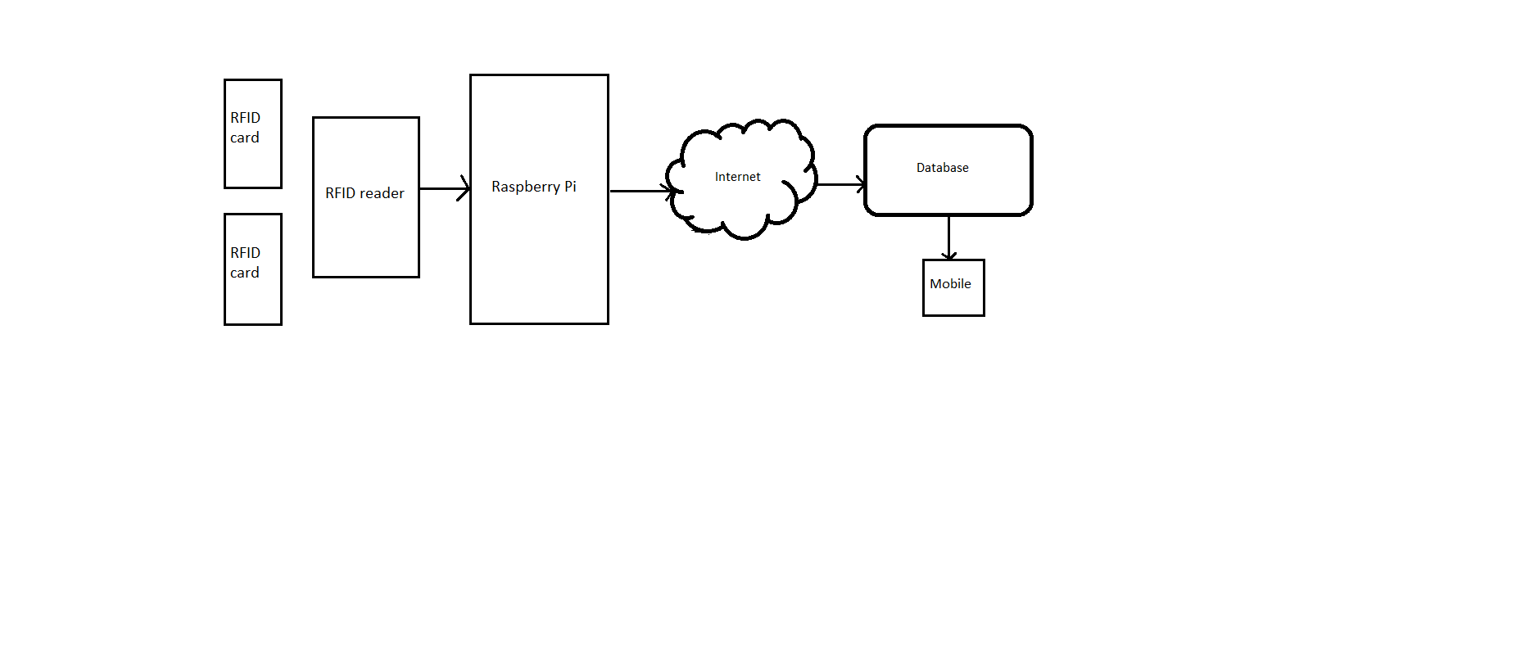
Figure 4.1: System Architecture
The figure 4.1 shows the block diagram of system architecture the consist of different modules: Admin module,Faculty Module and student module.
4.1.1 Admin module
The admin is responsible of registering faculties and students, providing RFID tags for the students, updating/editing the timetable. The admin should login with his/her email id and password. Once he/she enters their email and password that will be matched with the data present in database. If the match is found then the admin can see the database thus providing security.

4.1.2 Faculty module
Each faculty should get register with their email and password. Once the faculty is registered, then he/she can be able to view the attendance of the students by providing department, semester, section. The date-wise attendance can also be viewed.
4.1.2 Student module
Students can view their attendance by entering the University Serial Number. Each students will be having RFID tags that contains unique EPC code.

4.2 E-R Diagram
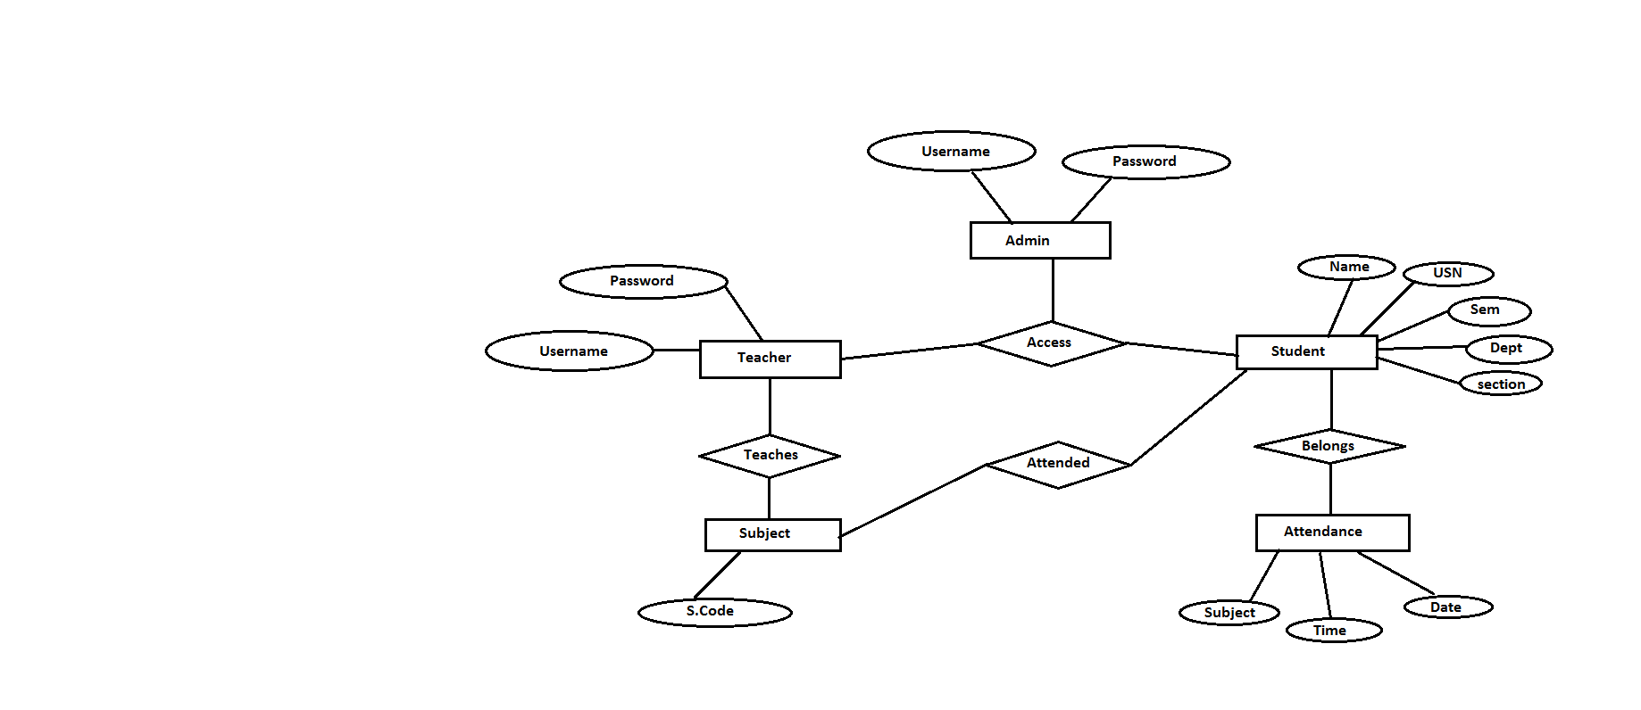
Figure 4.2: ER Diagram
The above figure 4.2 shows the ER diagram of the system. The rectangular box represents the entity:Teacher, Admin, Student, Attendance, Subject.The circle represents the attributes of of the entity.The diamond represents the relationship betweem the entities.From the figure 4.2 ,username and password are the attributes of admin and teacher entities.Name,USN, sem, section, dept are the attributes of the student entity.Subject, time, date are the attributes of the attendance entity.S.code is the attribute of the subject entity.
4.3 Schema of the system
A database schema is the skeleton structure that represents the logical view of the entire database. It defines how the data is organized and how the relations among them are associated. It formulates all the constraints that are to be applied on the data (see figure 4.2)
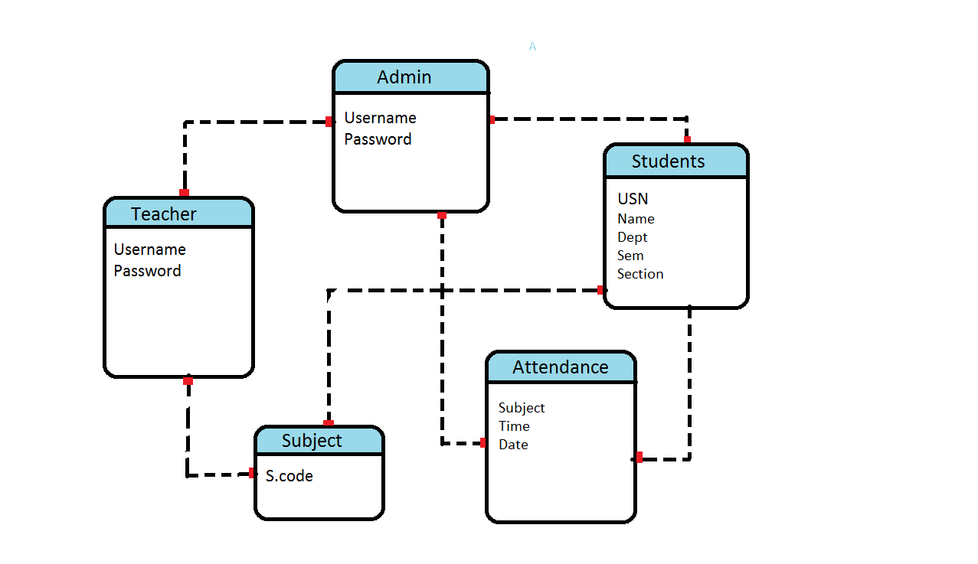
Figure 4.3: Schema of the system

4.4 Summary
To overcome the limitations of conventional system, we have developed this system. The proposed system is user friendly, easy. Due to use of IOT the android page can be easily managed by the automated by the authorized person.

CHAPTER 5
IMPLEMENTATION
In this chapter, we are going to give a brief description about the design and implementation of our project. The RFID system was successfully integrated with graphic user interface on the host system. The system consists of login for admin, faculty and student. The system performs two main functions which are class attendance system and students evaluation for eligibility to sit for examination based on percentage attendance. It contains following blocks:
5.1 Graphical User Interface
The graphical user interface is created with android studio 3.0.1 and it consists of the database system used to store all the student, faculty and admin details, date and time of entry and exit for each class. There are 3 modules built in Android studio 3.0.1 and firebase to store and access the RFID based automatic attendance system’s information. There are six fragments designed in android studio in admin login which has home fragment to view the student attendance either date wise or USN wise, add faculty to add faculty details for authorization, add student to add authenticated students, time-table to view class time tables of entire class going on in the college, percentage calculation, to check percent attendance, report generation to generate the attendance status of all the students of a particular sem.
5.2 Splash screen
A splash screen is a graphical control element consisting of a window containing an image, a logo, and the current version of the software. A splash screen appears while program is launching consisting of Student Attendance System in the background as text. After few seconds it moves to the next login window. Figure 5.1 shows the splash screen.
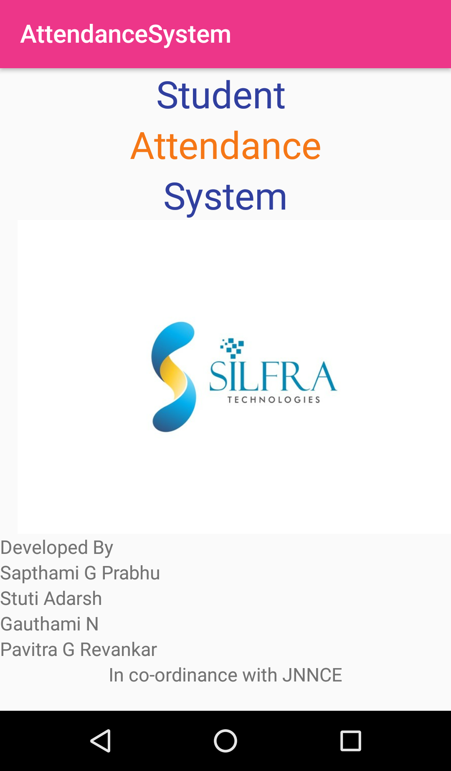
Figure 5.1: Splash screen
5.3 Login Screen
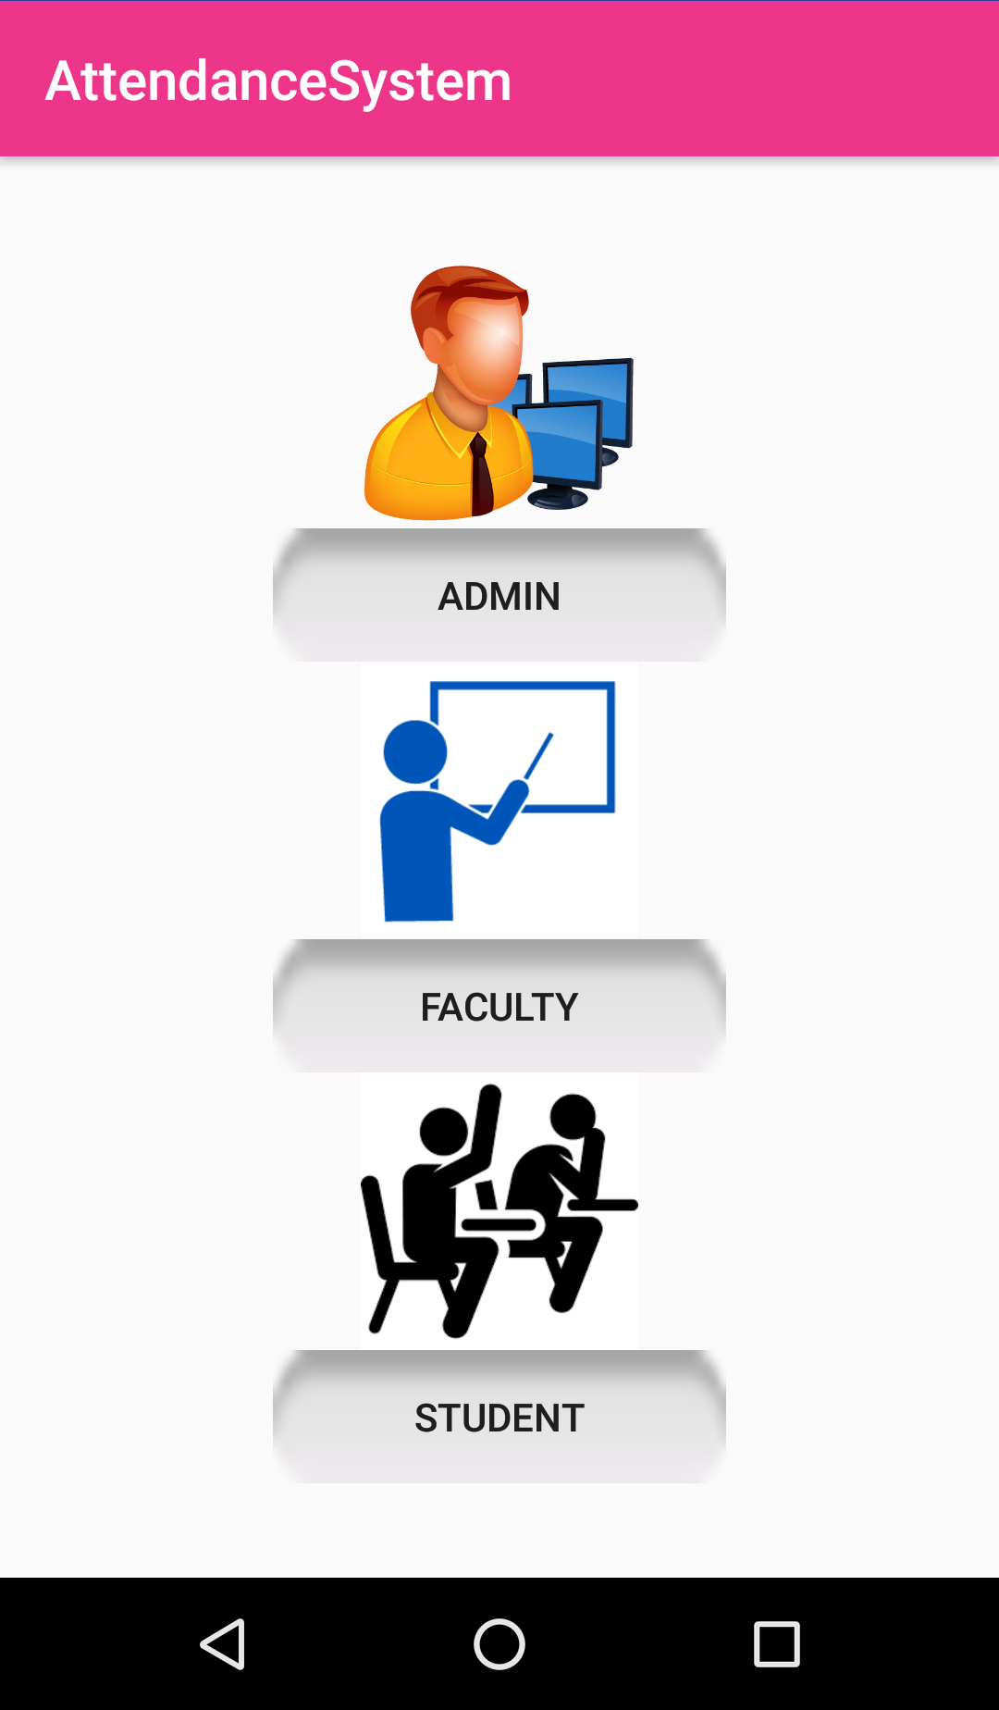
The login window in the mobile application is built with tightened security which allows only authenticated person to access this system. Figure 5.2 shows the login screen.
Figure 5.2: Login screen
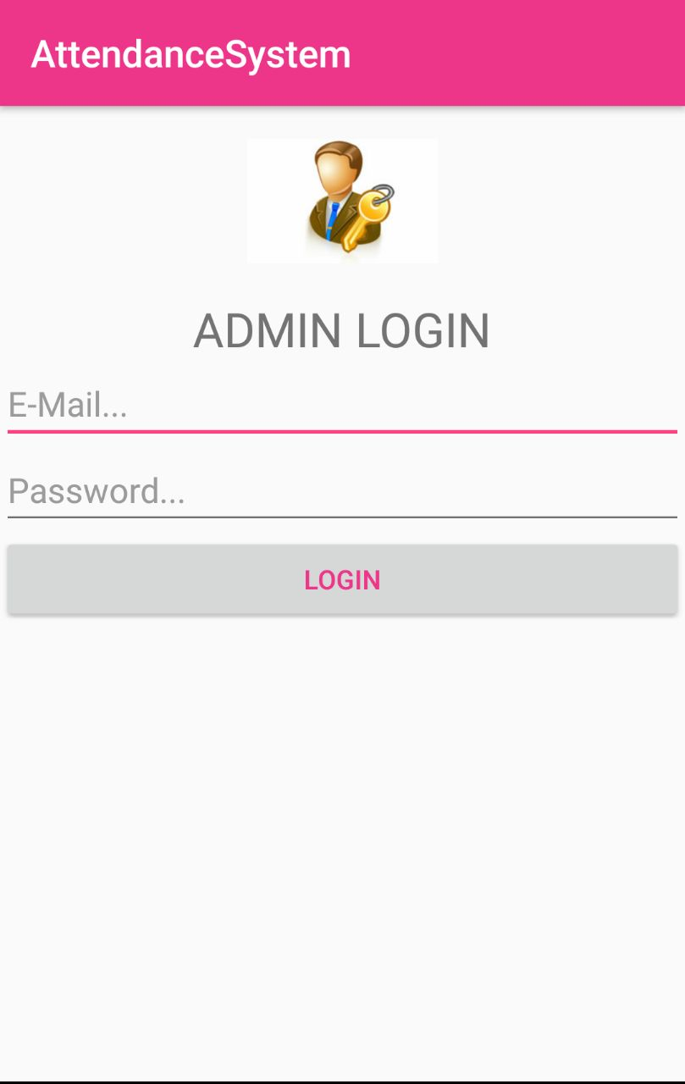
The administrator needs to create his user name and password to log in this system. Therefore, the administrator needs to key in the correct username and password to access this system (Figure 5.3) and can quit this system by clicking the logout button to turn off the administration login of the system. The administrator can make selection either to login to the admin page or has authorization to even access faculty and student login page.
Figure 5.3: Admin login page
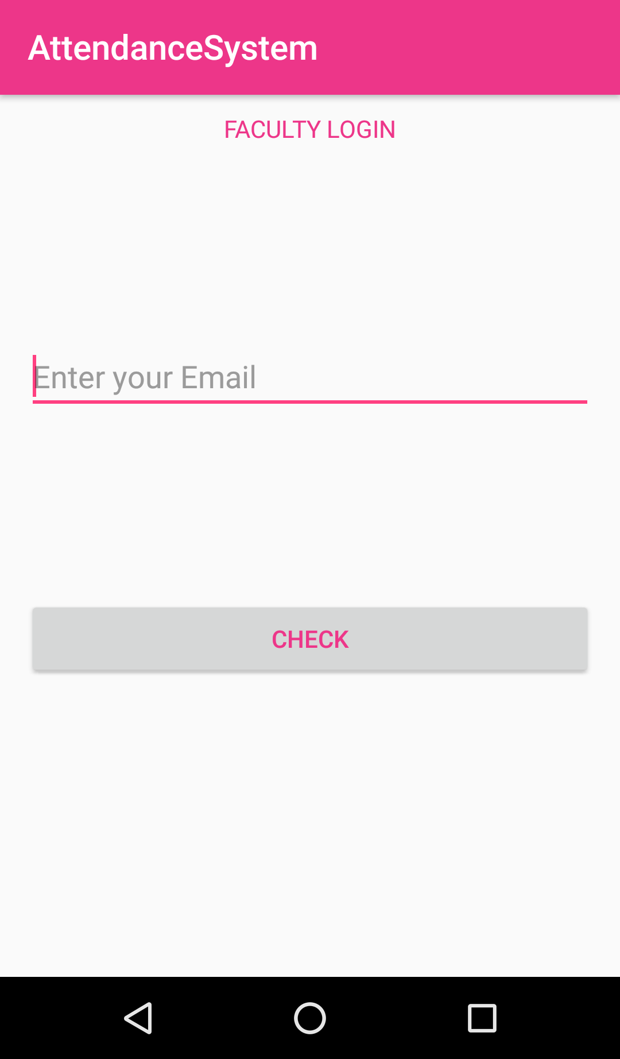

Figure 5.4: faculty login page
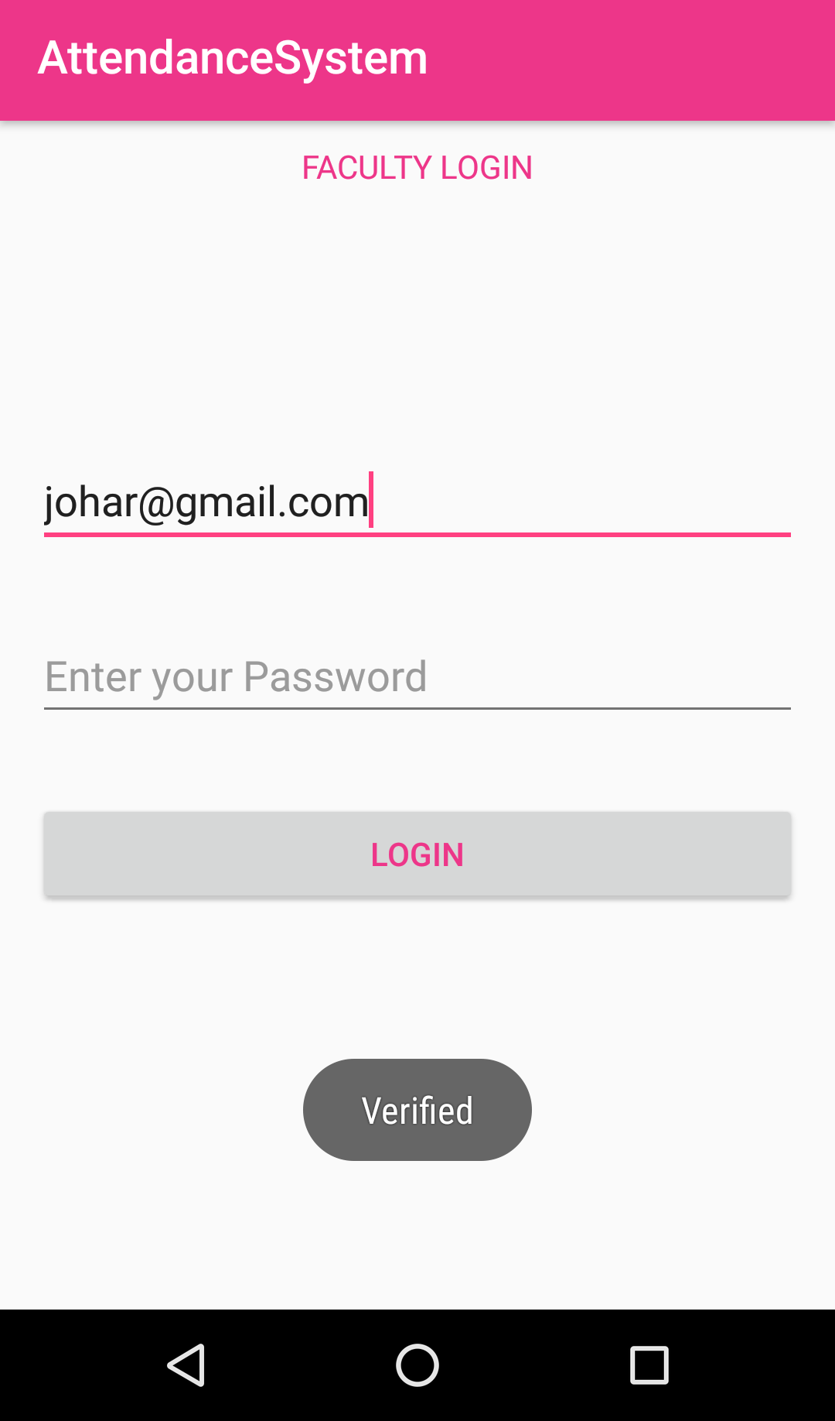
Faculty needs to login by using the email-id (Figure 5.4) provided by the administrator. The faculty then registers by creating a password which gets stored in authentication portion of the firebase (Figure 5.5). After the faculty is successfully registered, they can use email and password to login. Only valid credentials are accepted to start the new screen.
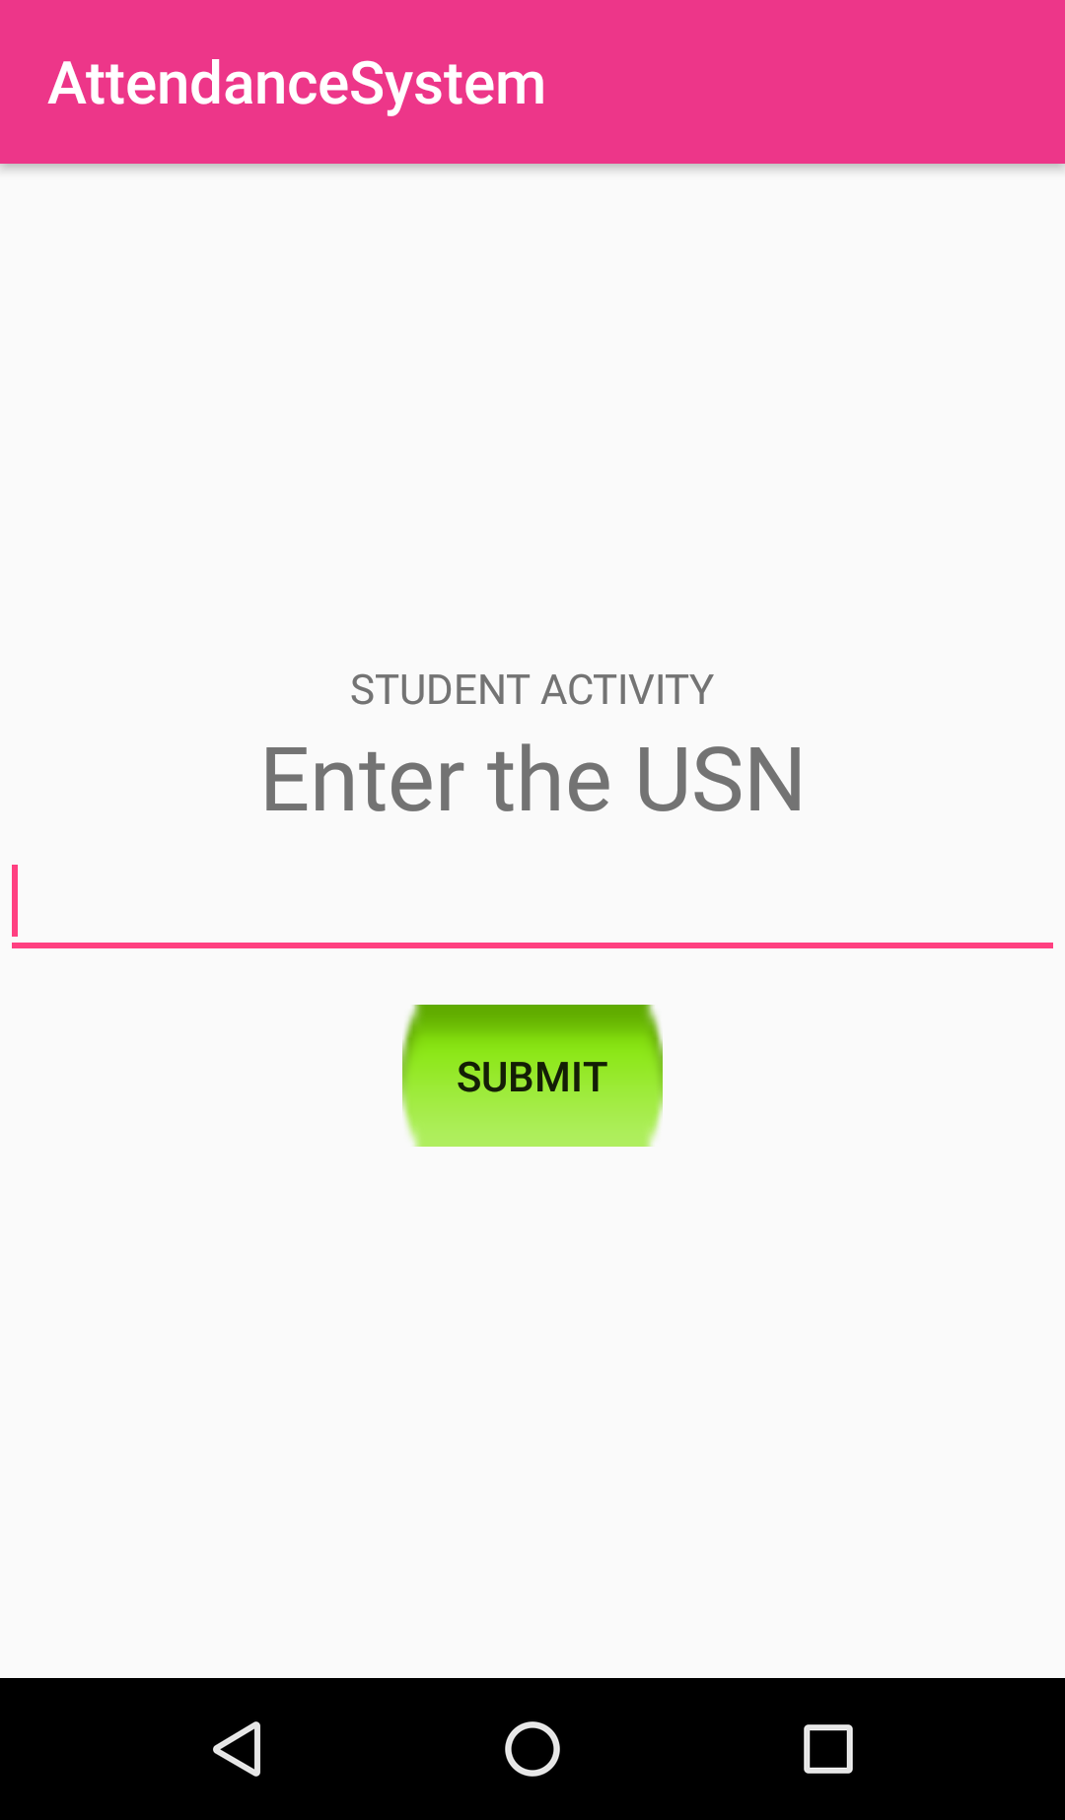
Figure 5.5: Faculty authentication
Figure 5.6: Student login using USN

Student’s needs to login by using their USN (as shown figure 5.6 above) which a unique roll number assigned to each student by the VTU. Only valid USN which is already there in firebase tree structure of the database is considered for successful login and moved to new screen.
  - Admin module
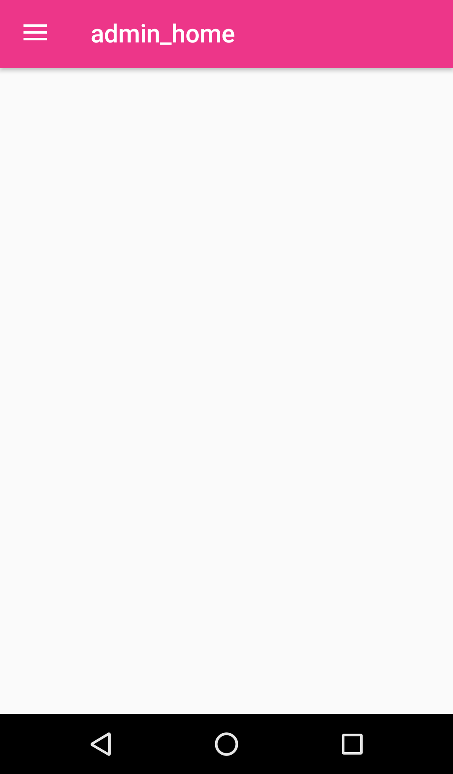
The admin module screen opens after the admin is successfully logged in (Figure 5.7). The admin module consists of the navigation drawer which has –home fragment, add faculty, add student, time-table fragment, percentage calculation fragment, report generation fragment, and logout option as shown in figure 5.8 below. The figure clearly displays various options.
Figure 5.7: Admin dashboard
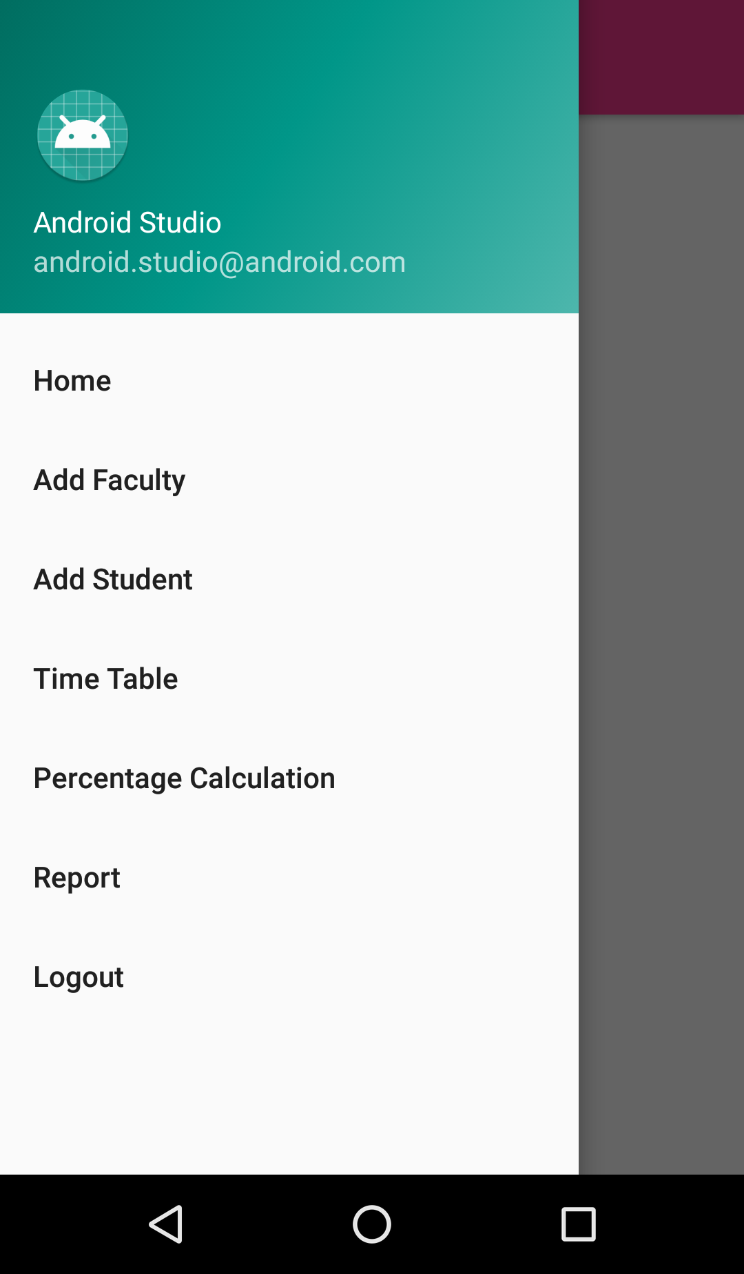
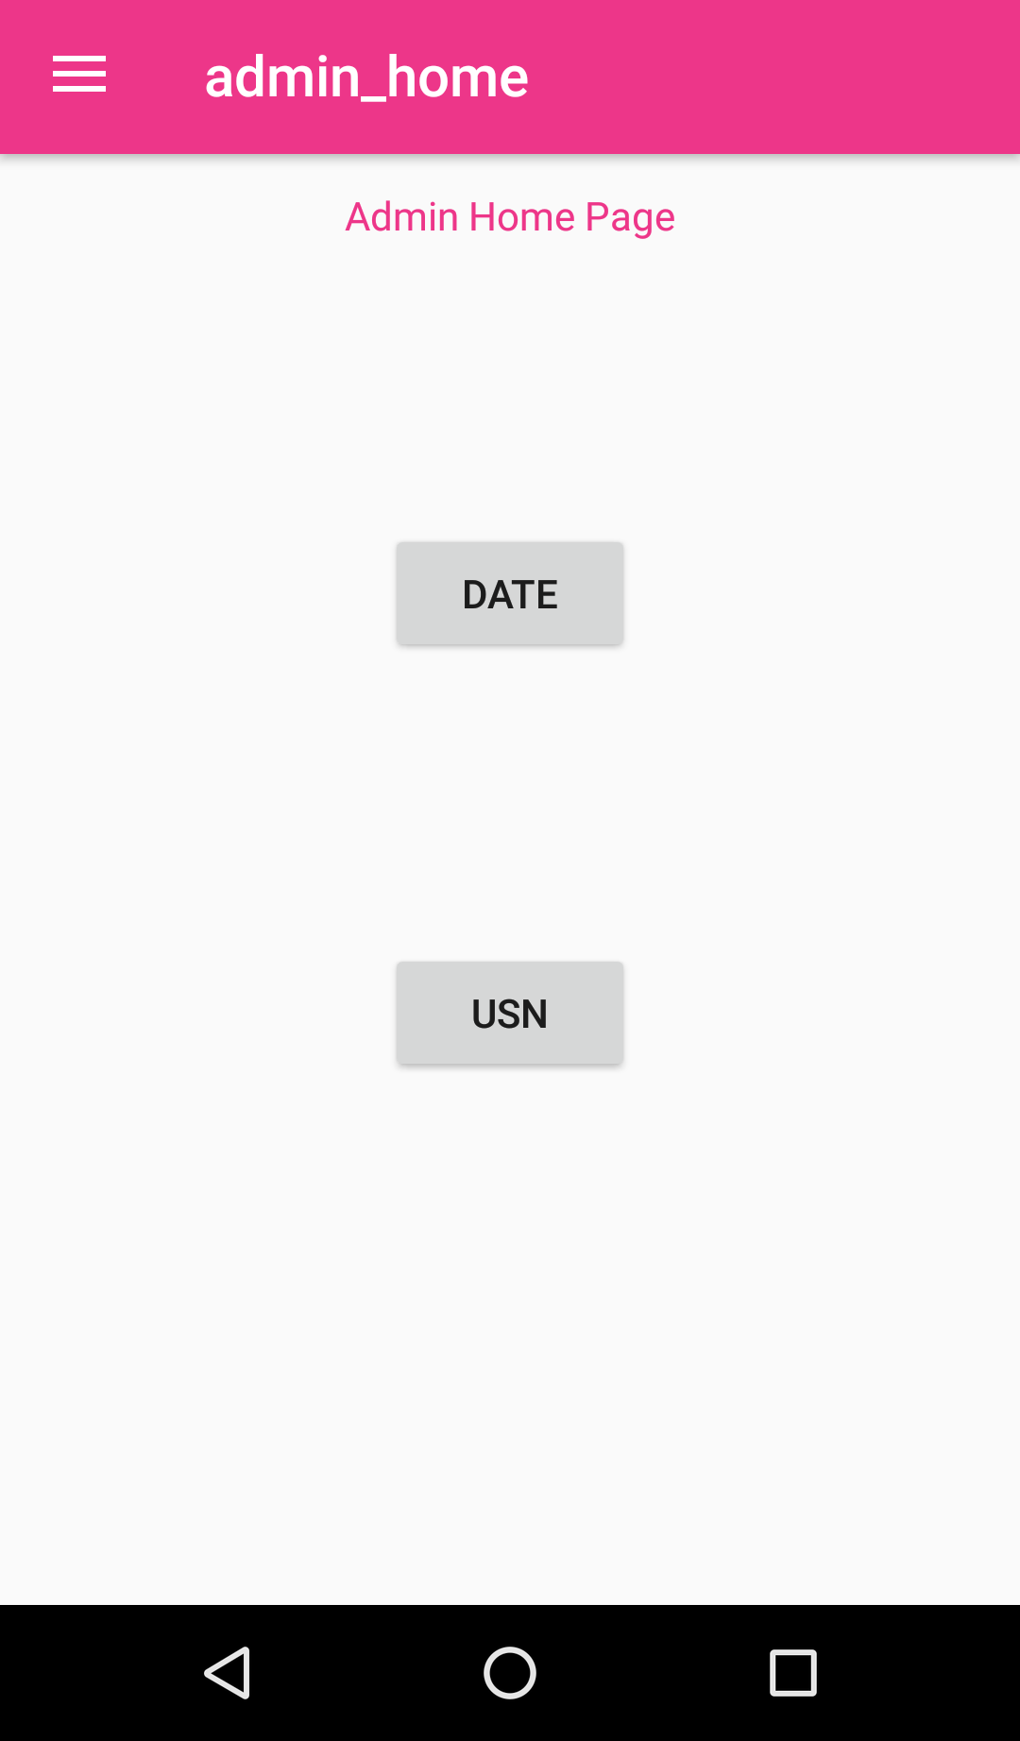
Figure 5.8: Navigation drawer in admin dashboard containing various options
Figure 5.9: Home fragment options
  - Home- The home option displays the 2 button as options – Date and USN as shown in figure 5.9 above.
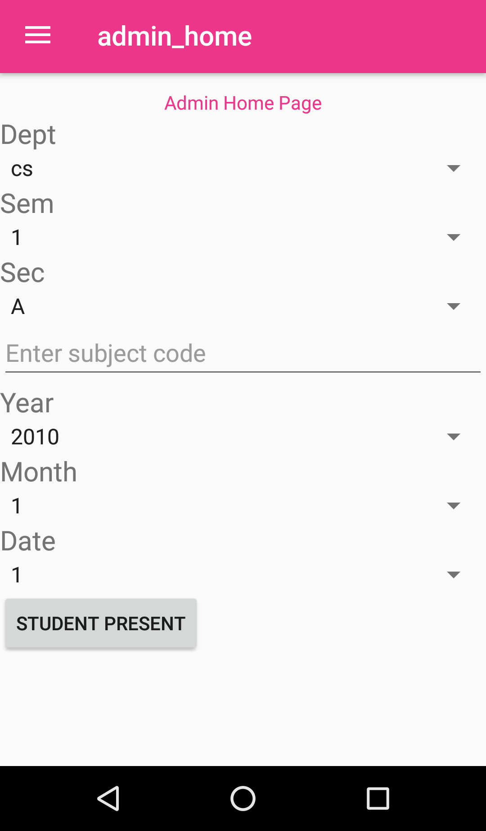
  - Date- When admin goes on to date option, new screen activity opens. Page consists of Department, Semester, and Section to be selected from drop-down menu. It also consists of subject code entry and date selection from various drop-down options as year, month and day for the specific date for which admin wants to view the attendance of all the students of a particular semester and section who were present. After the details have been entered, Student present button is pressed to view the attendance status of a particular on that date. Figure 5.10 gives the snapshot of the details in date wise attendance.
Figure 5.10: Date wise attendance details
  - USN- When admin goes on to USN option, new screen activity opens. In this screen admin needs to enter a particular student USN for which he/she wants to view the status of that student for all classes that he has attended. On entering the USN of the student, new page opens consisting two columns for the subjects of his semester and the attendance status for each of the class attended. Figure 5.11 is the snapshot of the USN wise page in the admin dashboard to view the specific student attendance for all the classes that he/she attended.
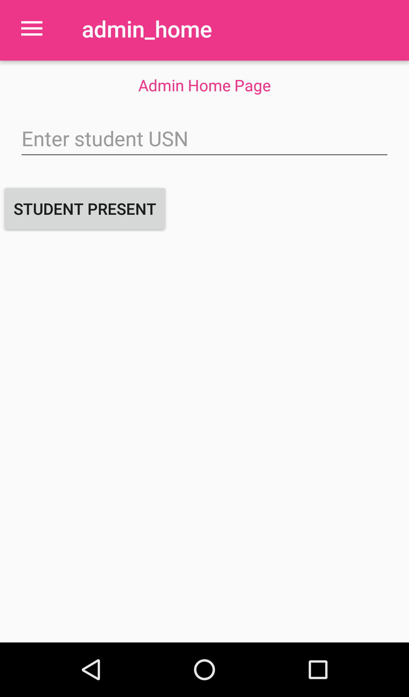
Figure 5.11: USN wise attendance
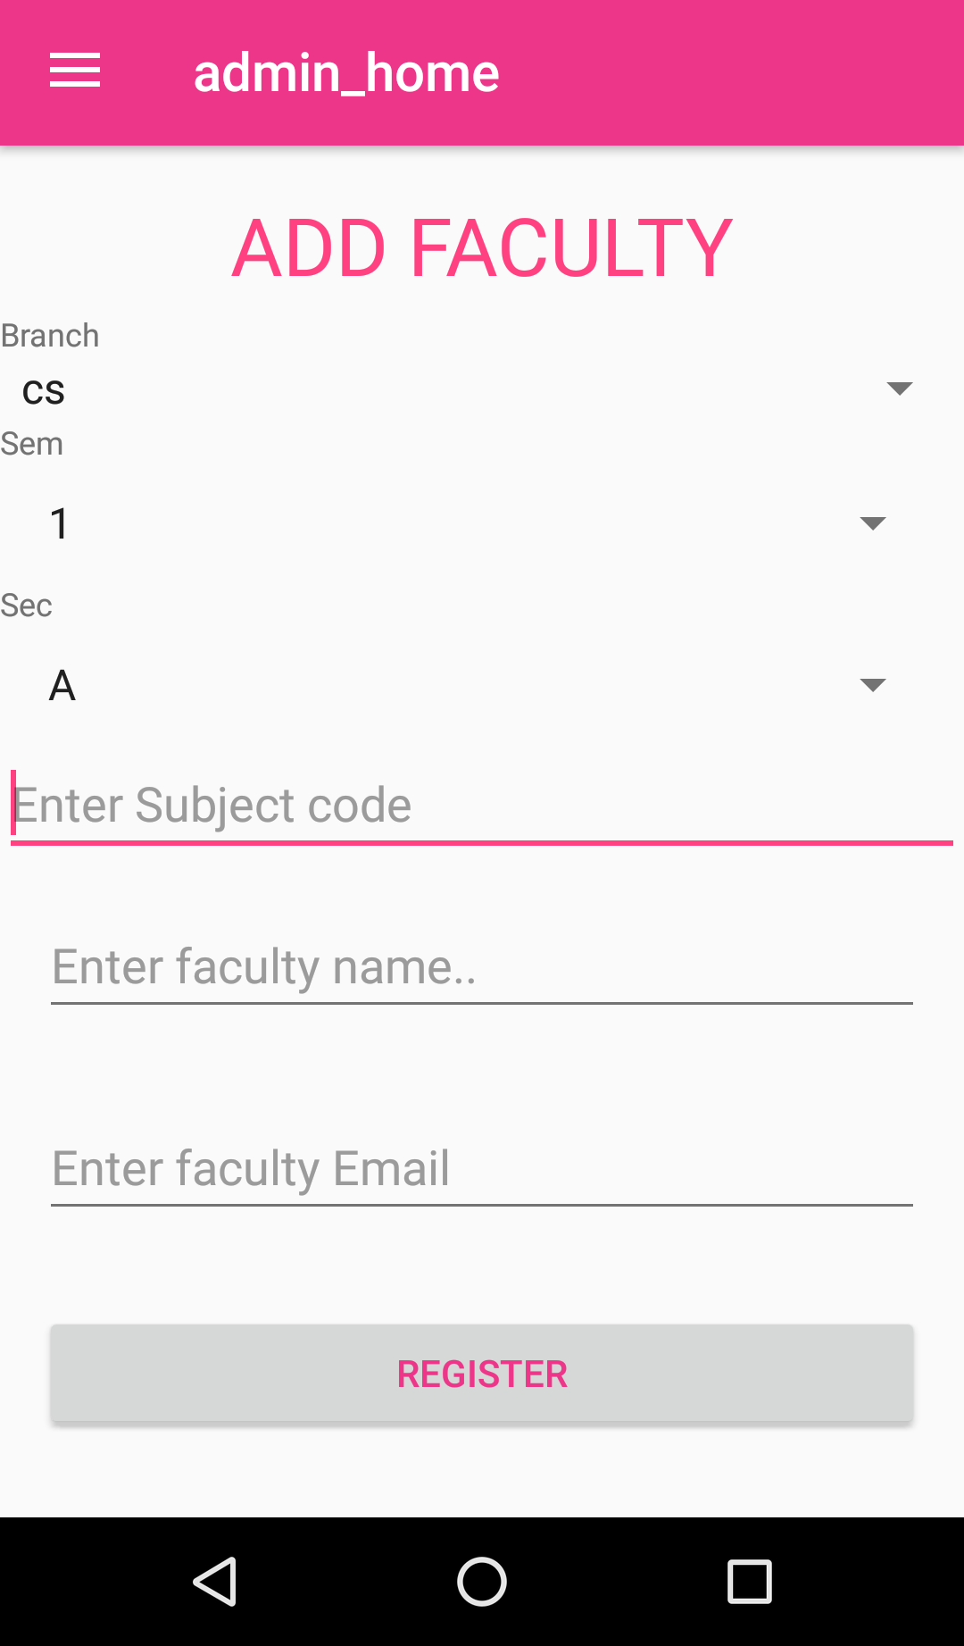
- Add faculty-
Figure 5.12: Add faculty fragment
Admin registers a particular faculty for the authentication and security purpose. When admin goes for adding faculty option, he/she is granting him the access authorization. The add faculty fragment consists of Branch, semester, section subject code entry of which faculty will teach, the faculty name entry and the faculty email-id entry as shown in the above figure 5.12. After the details have been entered, registered button can be pressed with all the fields entered properly for registering that faculty. All details are stored in a separate firebase tree structure called facultyQueue and facultyDetails.
- Add student-
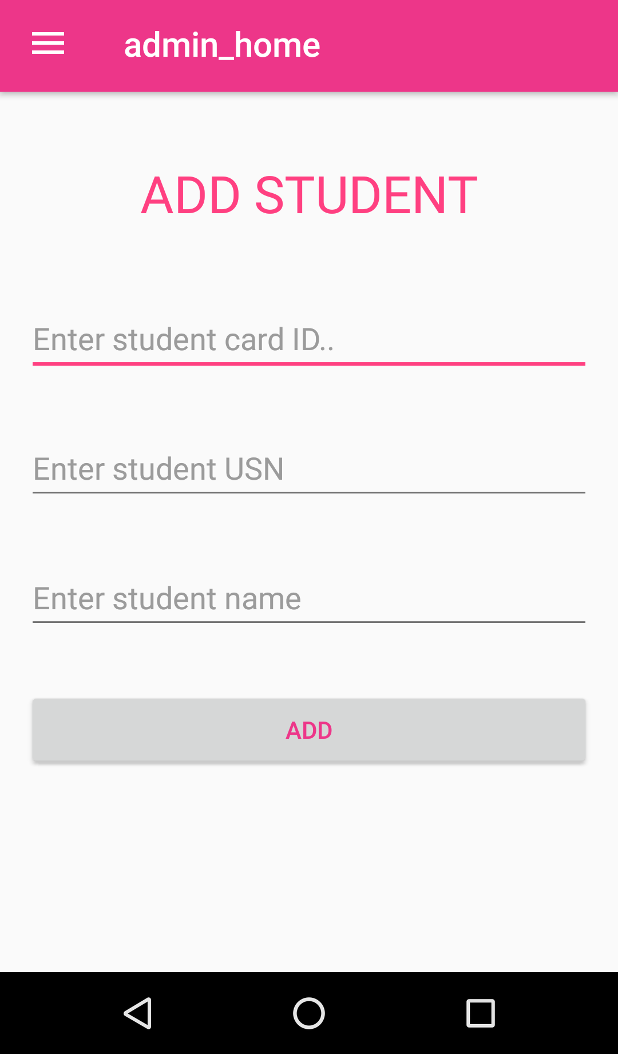
Admin registers the student by entering his/her details for authorizing and granting him the access to view the attendance. In this fragment there are following -student RFID card number entry, student USN entry and student name entry as shown in figure 5.13. After entering the above details, add button is clicked with all the fields entered properly and the details will be stored in the firebase tree structure StudentQueue. After adding in the database by clicking on add, automatically branch, semester and section option with drop-down appears which needs to be selected for that particular student. After all the details are entered for the student, admin can click on register button to register the student successfully as shown in figure 5.14 below. The details will be stored in a separate tree structure in firebase called Students.

Figure 5.13: Student details
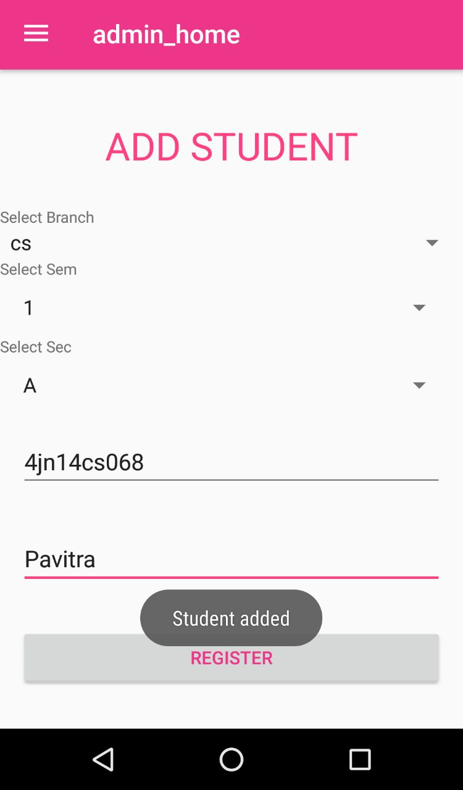
Figure 5.14: Student registration
- Time Table-
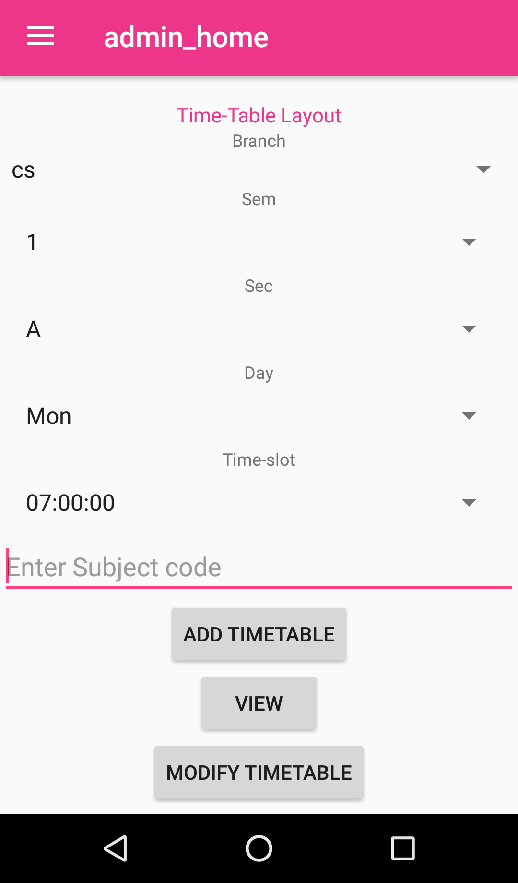
Admin has to add the time table for each class, view the time table and also modify the time table for each class semester wise for each department in the college. Following functions are as shown in figure 5.15 below-

Figure 5.15: Time table layout

4.1 Adding the time-
Here admin can add the time table of a particular class. This option contains fields like branch, semester, section, day, time-slot options which needs to be selected from the drop down list for the particular class and subject code entry for each time of the day for the class must be added as shown in the figure above 5.14. The details are stored in firebase tree structure called Timetable.
4.2 View time-table
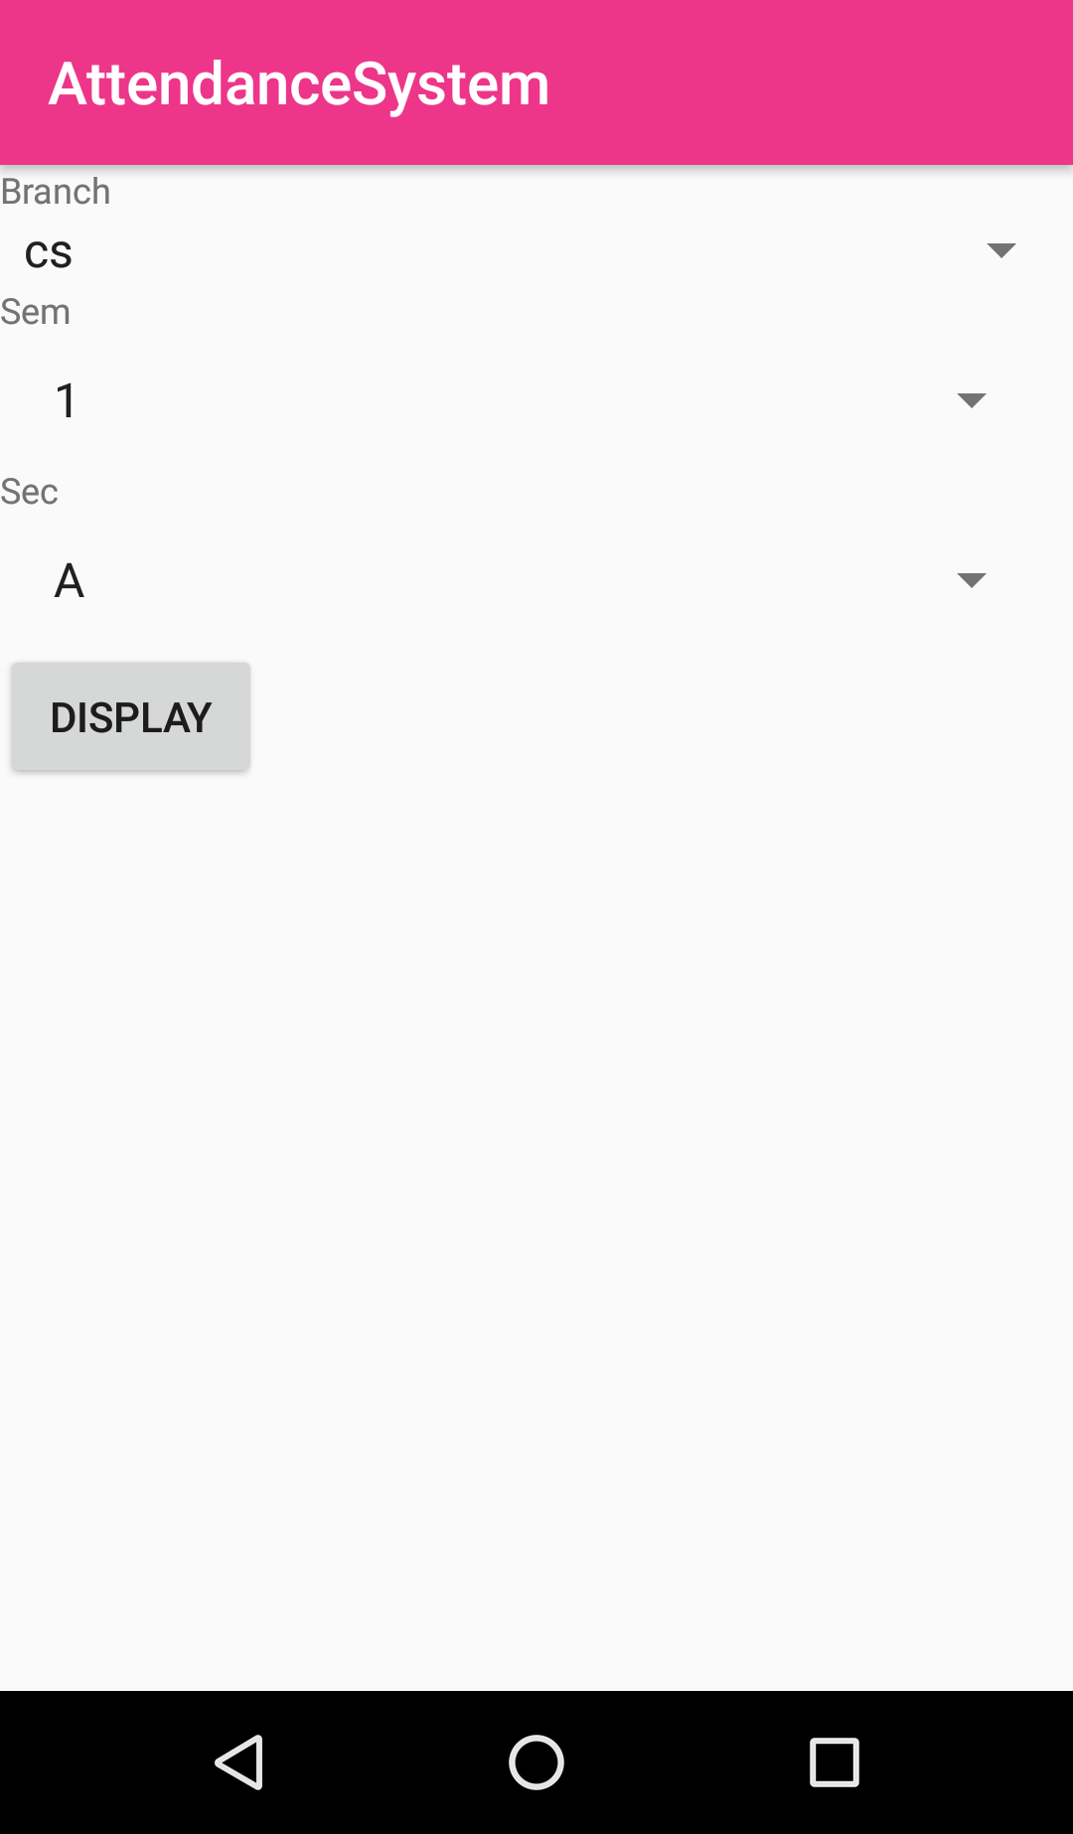
Here admin can view the time table of a class. On clicking the view button new activity opens. It contains fields that needs to be selected from the drop-down list of the class for which time-table must be viewed(Figure 5.16). On selecting branch, semester, section, there is a display button which on clicking displays the added time-table from the tree structure of the firebase database. A new page opens on click of display button. It displays the entire time table of that class in table form with rows containing various times of the day and the column containing the days of the week except Sunday as shown in Figure 5.17. The inner rows and columns are fields are filled by the subjects which are scheduled at that time of that day.
Figure 5.16: Entry of details to view time-table
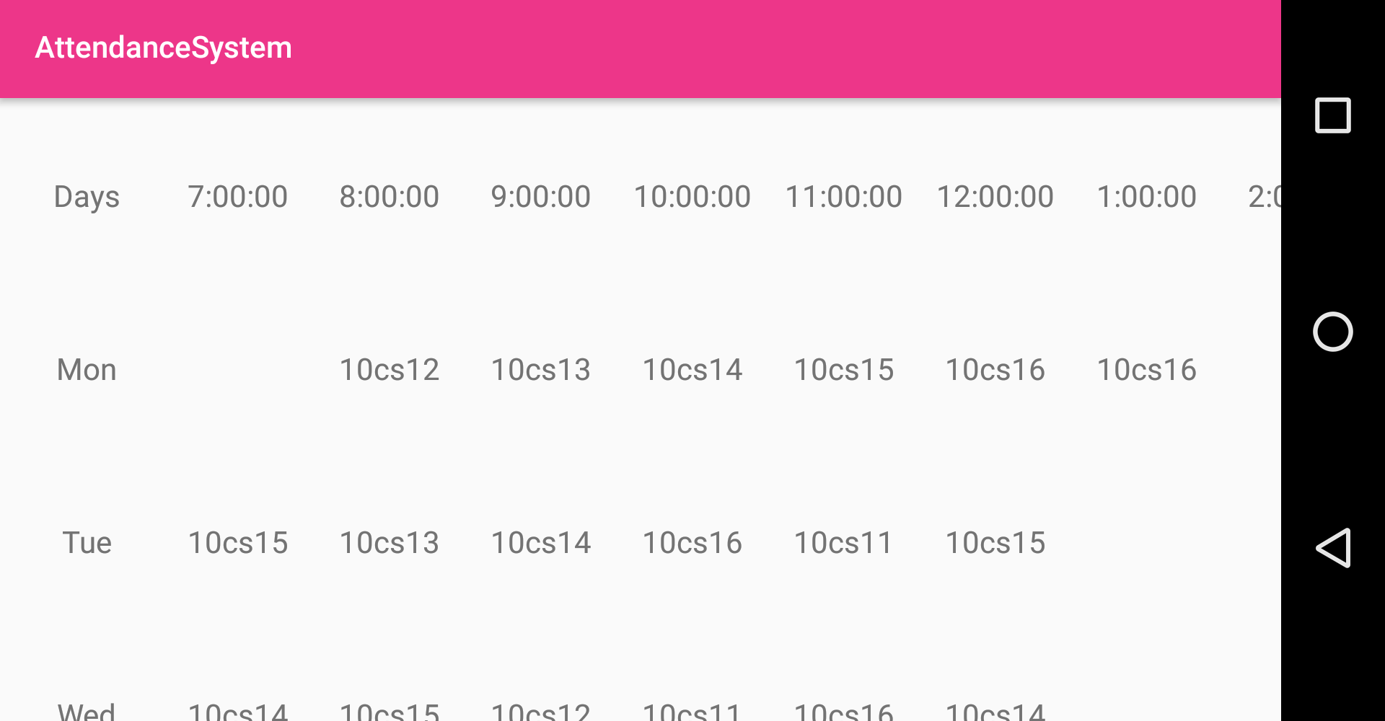
Figure 5.17: Time-table view
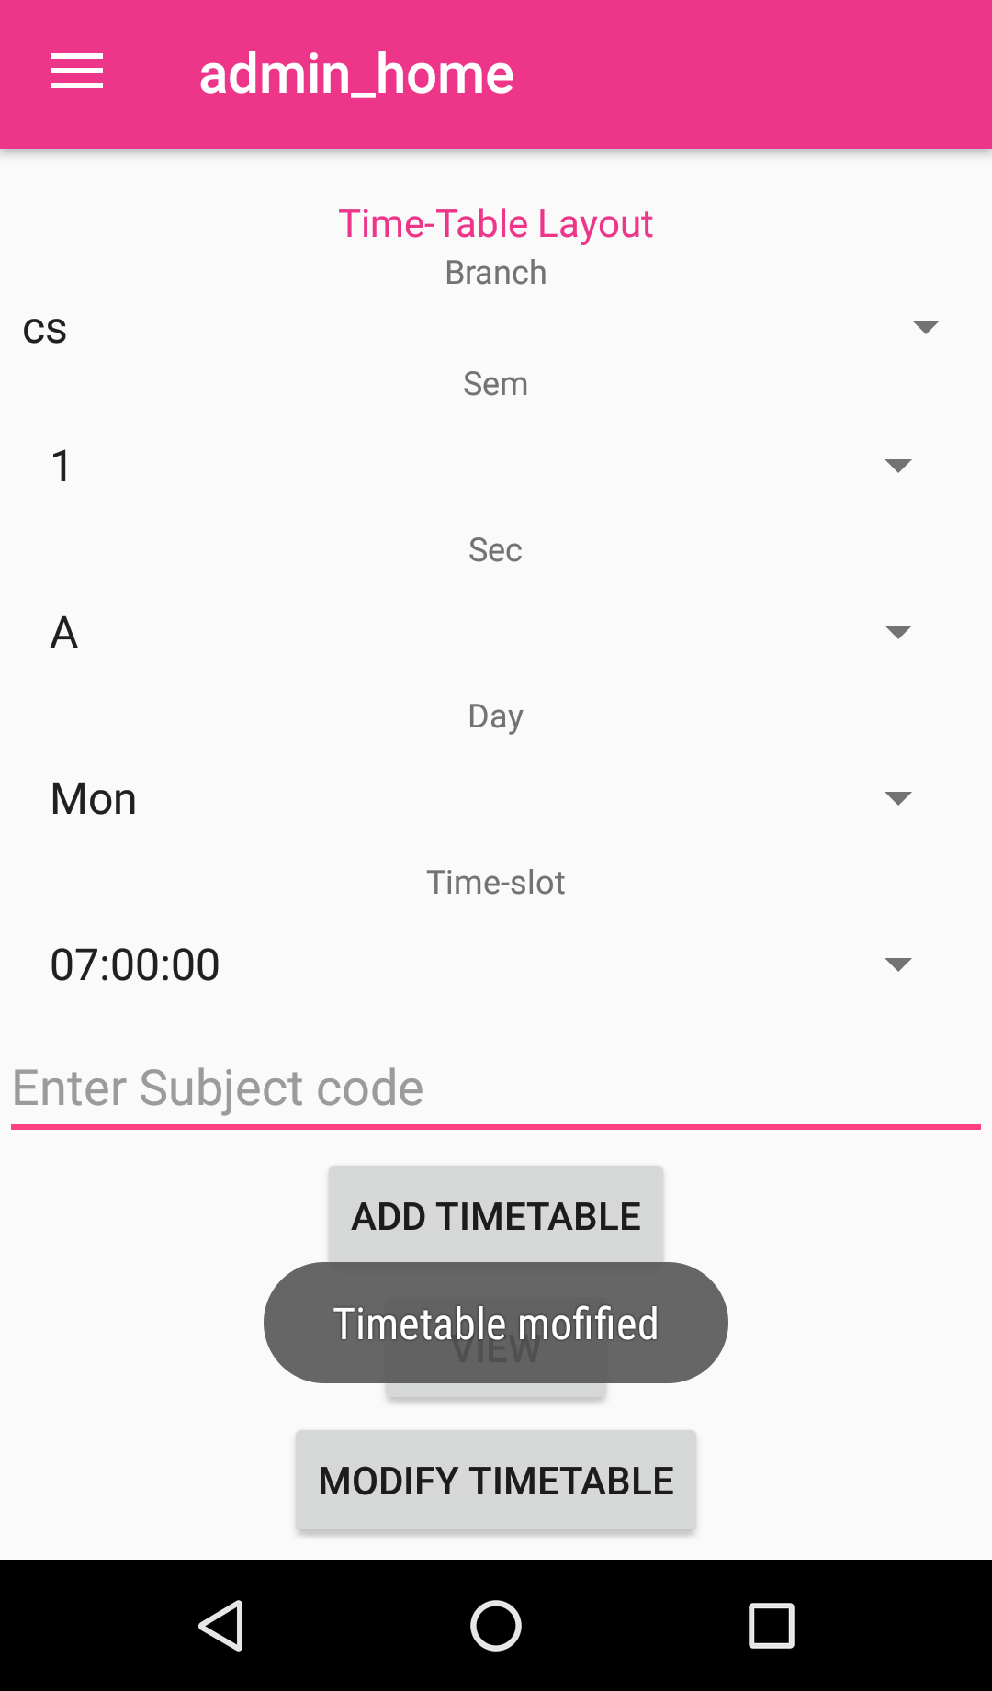
4.3 Modify time-table
Figure 5.18: Time – table modify option
It is same as add time-table (figure 5.18), only the difference is that admin can modify the time table by changing the subject of particular time slot scheduled for the particular day for that class. After clicking on modify button, time-table is updated with new values and can be viewed as per interest.
- Percentage calculation-
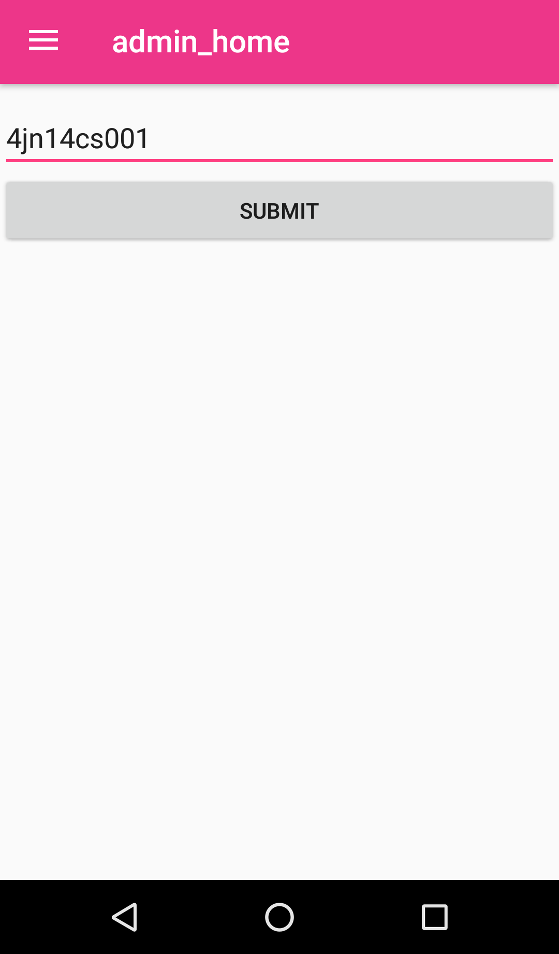
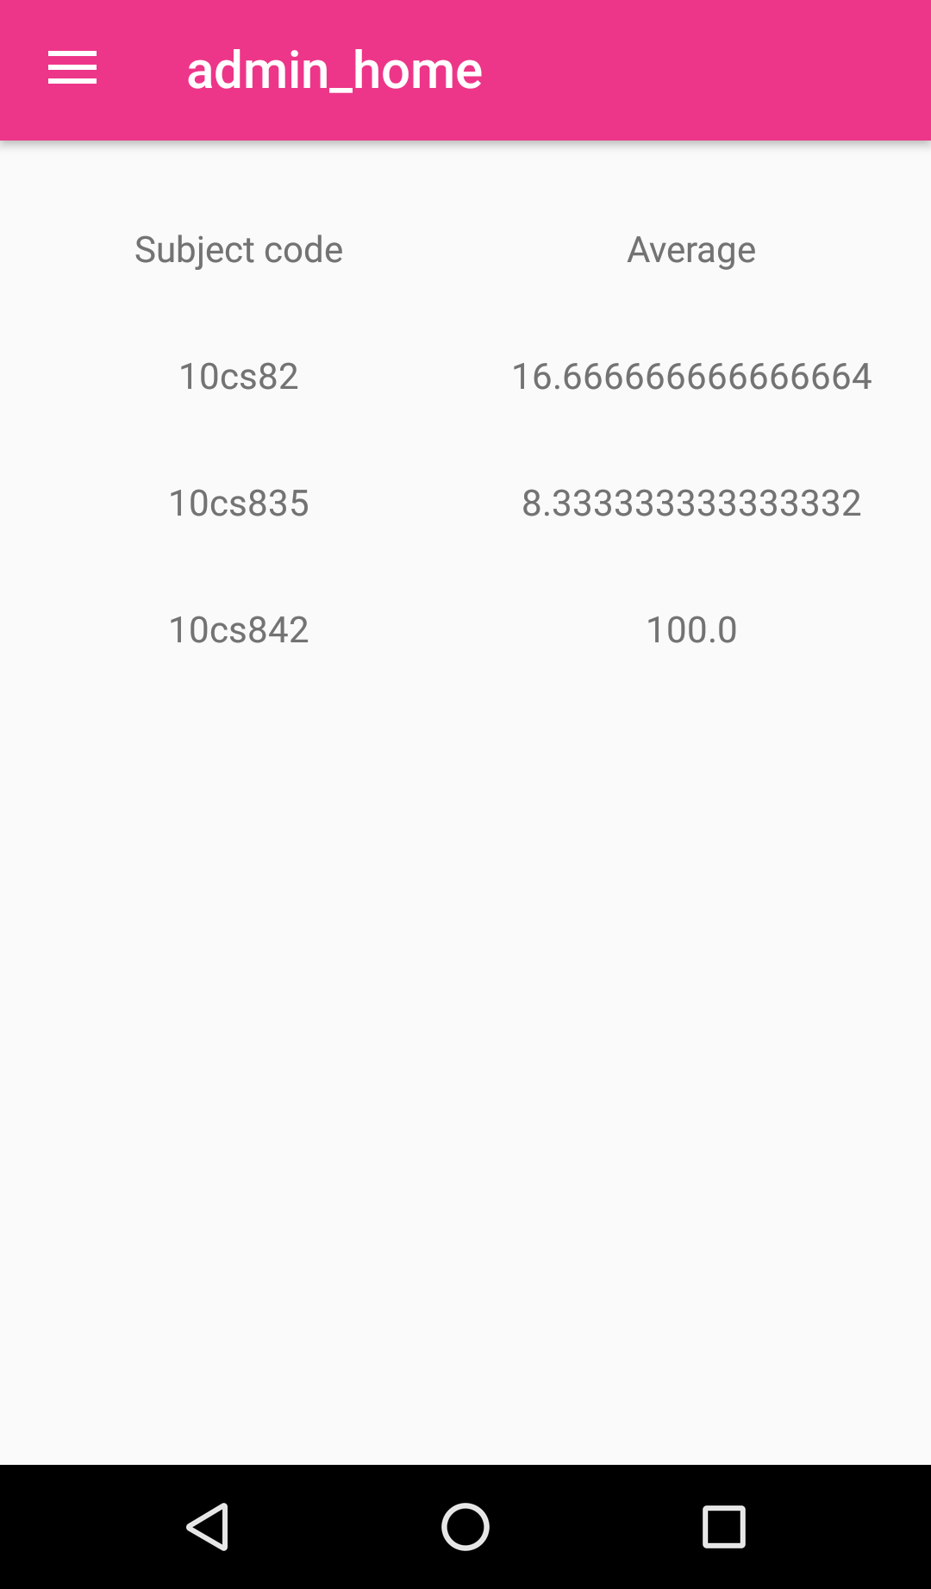
If the admin wants to see the percentage attendance of each student, he/she can go for this option. Here average attendance can be viewed for a particular student by entering student’s USN (Figure 5.19). After entering the USN, it opens a new page which has table displaying columns containing each subject code of that student for his/her class and in front of it in the next row, it displays the average attendance for that subject for that student as shown in the figure 5.20 below.
Figure 5.19: Percent calculation details
Figure 5.20: Percentage attendance
- Report generation-
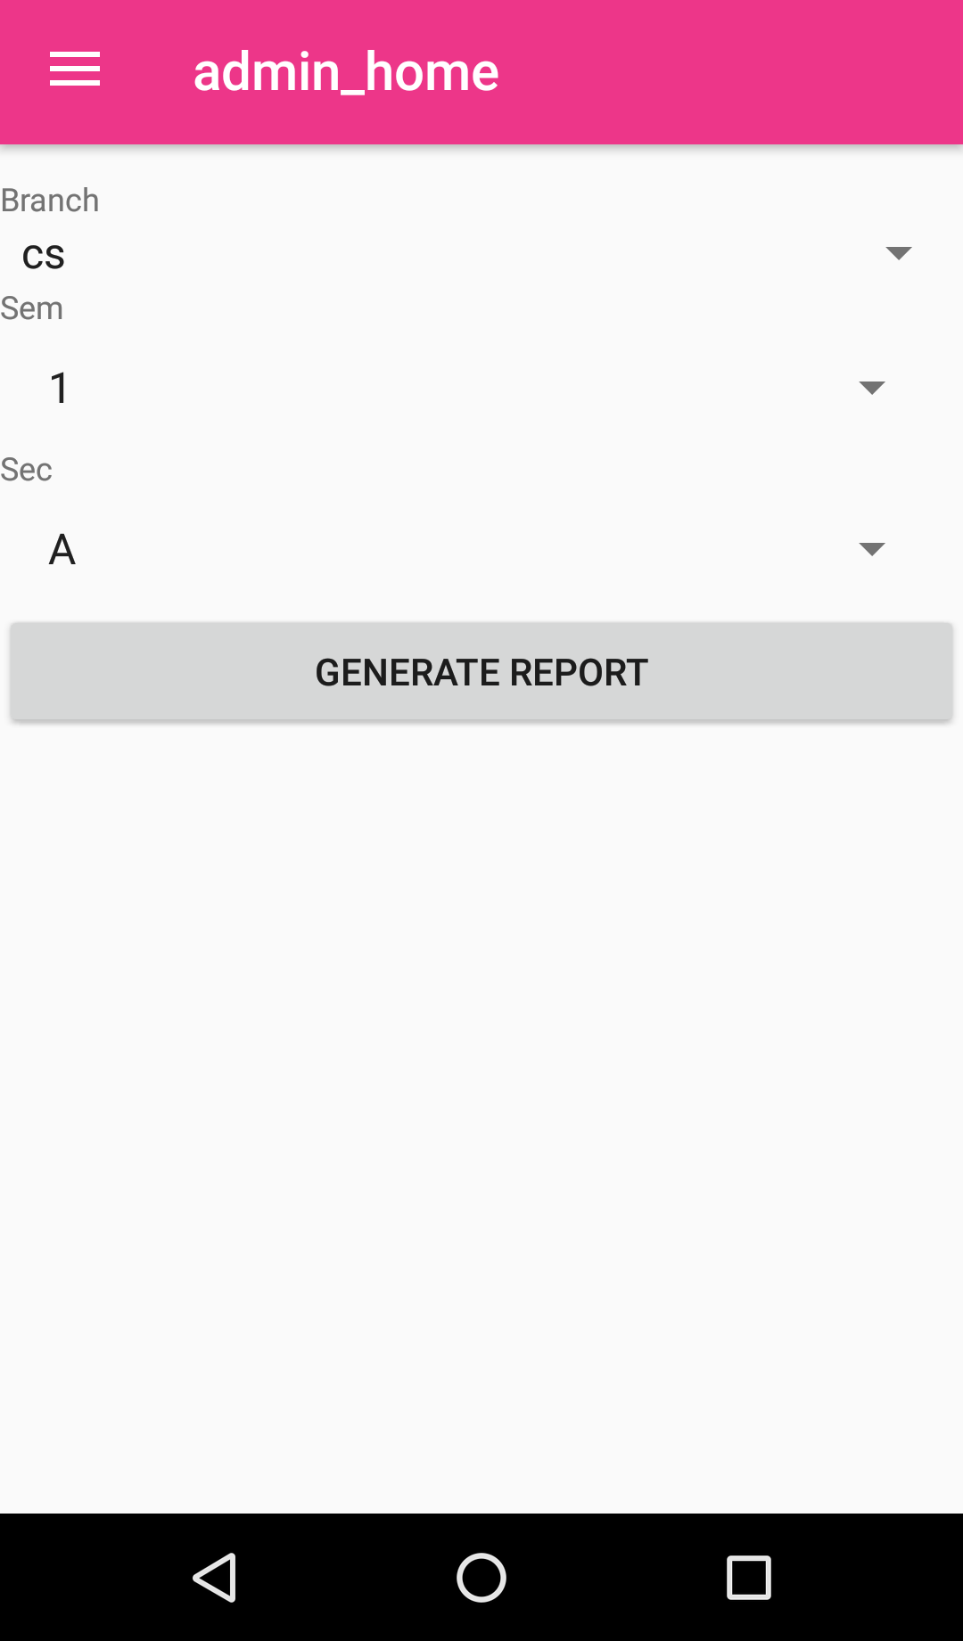
The admin can generate attendance report for a class by using this option. On going for this field there are option like branch, semester, section which must be selected from the drop-down menu and a generate report button which must be clicked after all the selections are made as shown in the figure 5.21. A new which displays a formatted view containing row and columns which displays all USN in the leftmost column for a class and the subjects in topmost row which 2 split containing total class of that subject taken by lecturer and the no. of classes the student attended for that subject (Figure 5.22).
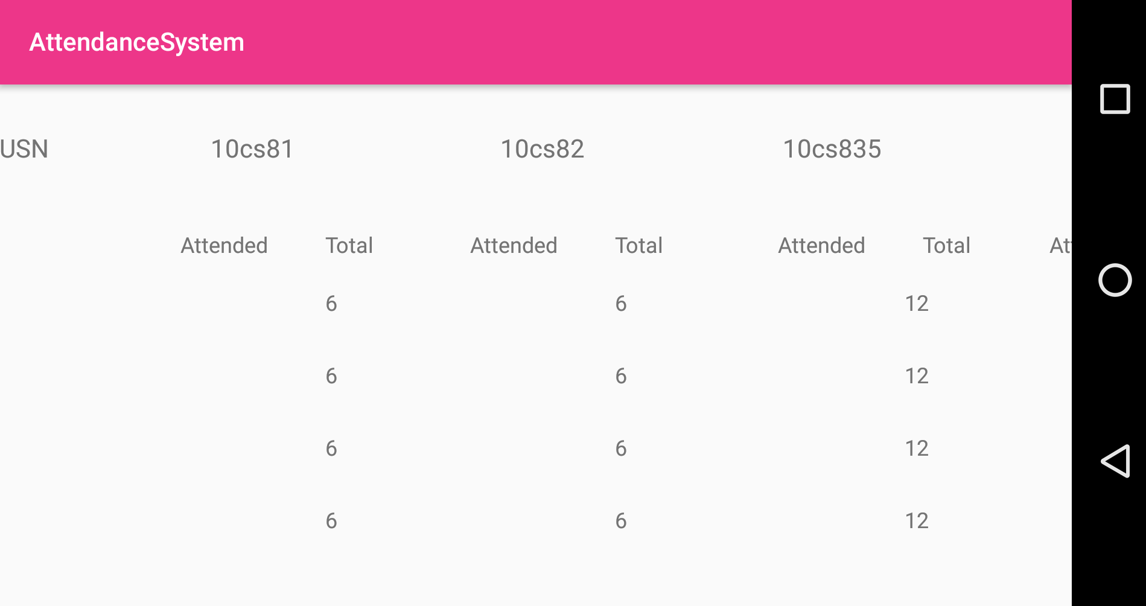
Figure 5.21: Generate report details
Figure 5.22: Generated report
- Logout
Admin can exit the login by clicking the logout option and hence logout from the session as shown in figure 5.8 above.
  - Faculty module
The faculty module screen opens after the faculty is successfully logged in, using the valid credentials. There are to options-
  - View date wise attendance-
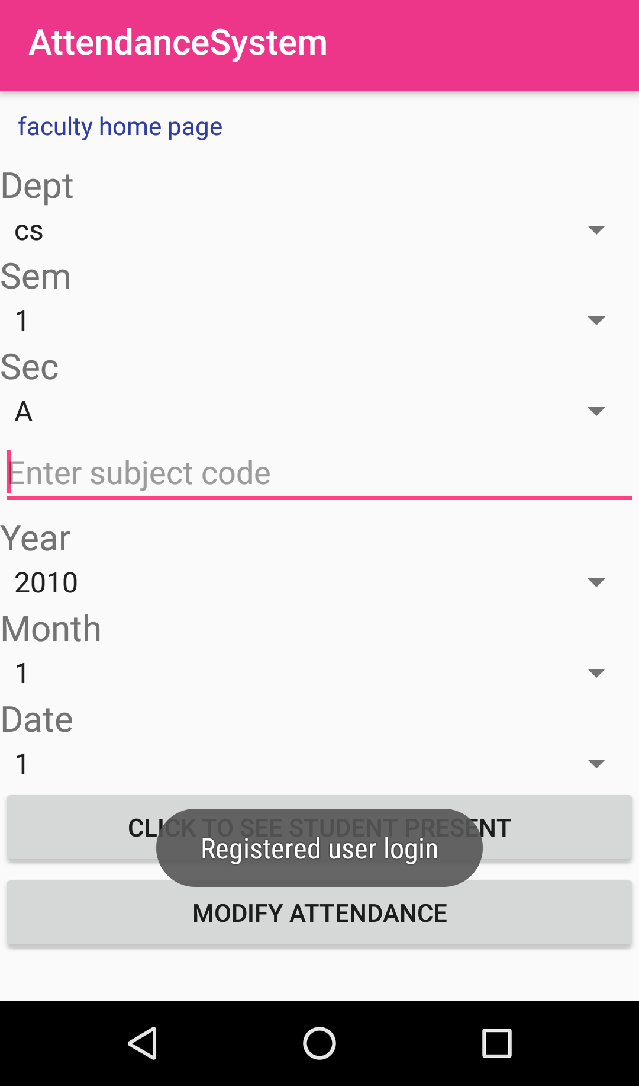
The faculty module has option for each department faculty to view the attendance of student for the subject he takes class for, for a particular day. There are options in drop down to be selected from list of department, semester, section, subject code entry and the date using year, month and day from the drop down list. After the fields are selected, click to see student present button must be selected as shown in below figure 5.23. New page opens displaying the list of student USN who attended the class as shown in figure 5.24
Figure 5.23: Faculty home page
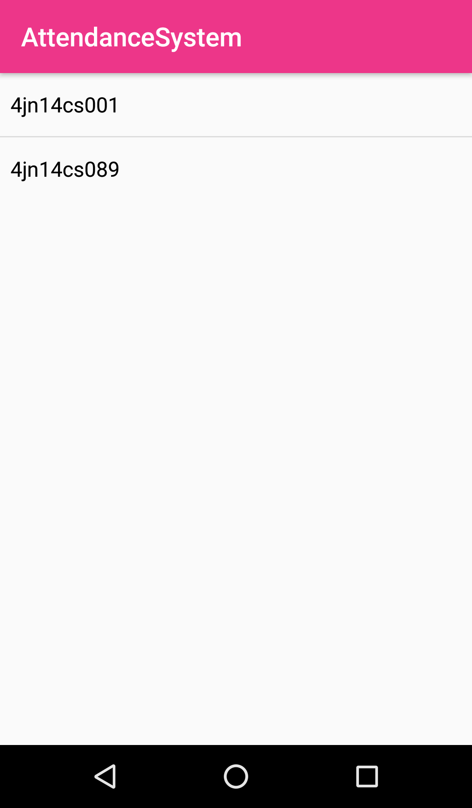
Figure 5.24: Students present
  - Modify the attendance-
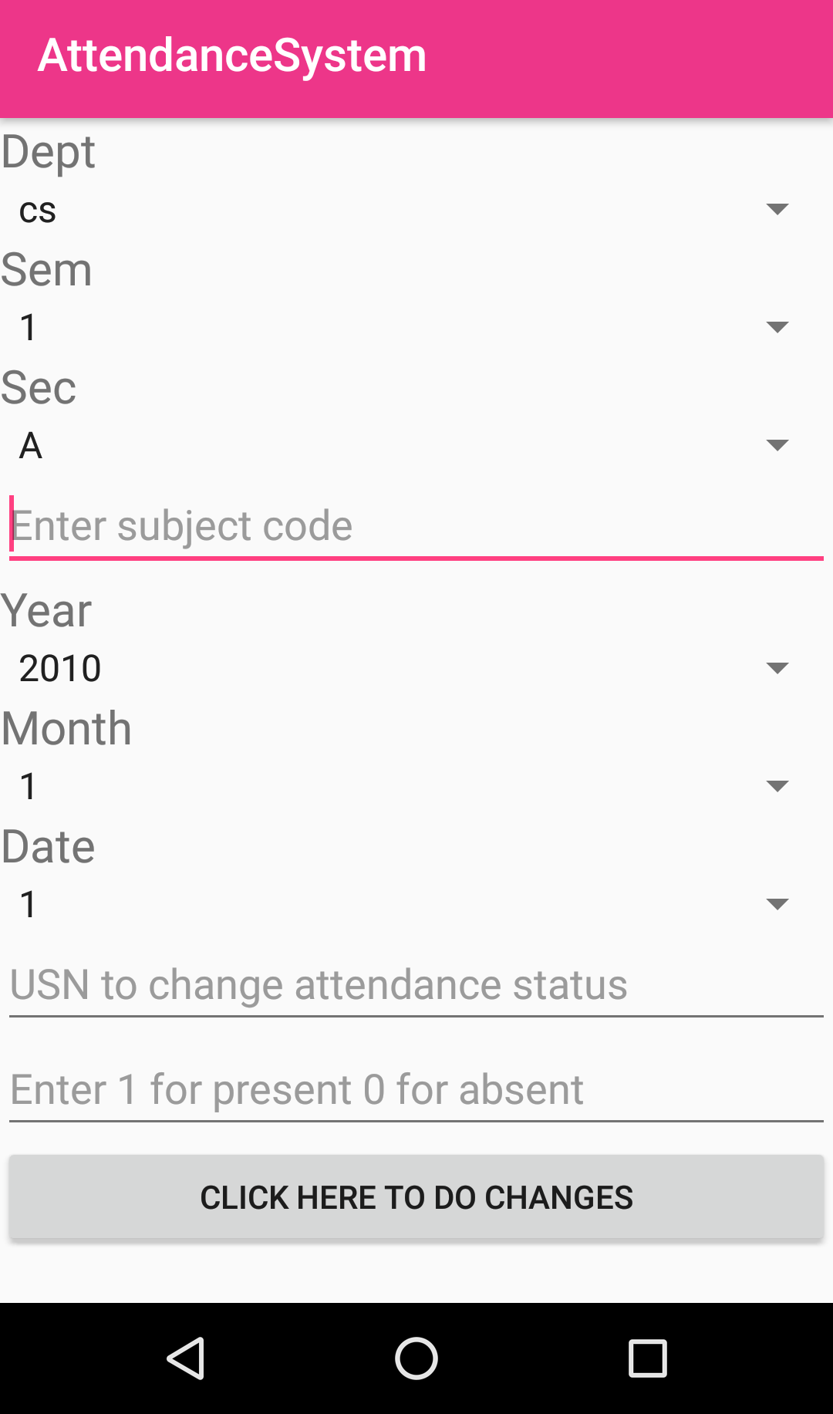
Figure 5.25: Modify attendance
The faculty has the access to modify the student attendance in case of valid reasons of fault or mishappening that may have occurred unintentionally or if faculty wants to update the attendance for shortage kind of cases. There are option for department, semester, section, subject entry and date selection same as view attendance except that two more fields are added: firstly, to enter the USN for which the attendance needs to be modified. Secondly, entry containing 0 for absent and 1 for present as shown in above figure 5.25. After the entry, the attendance is update for the student for that subject.
  - Student module
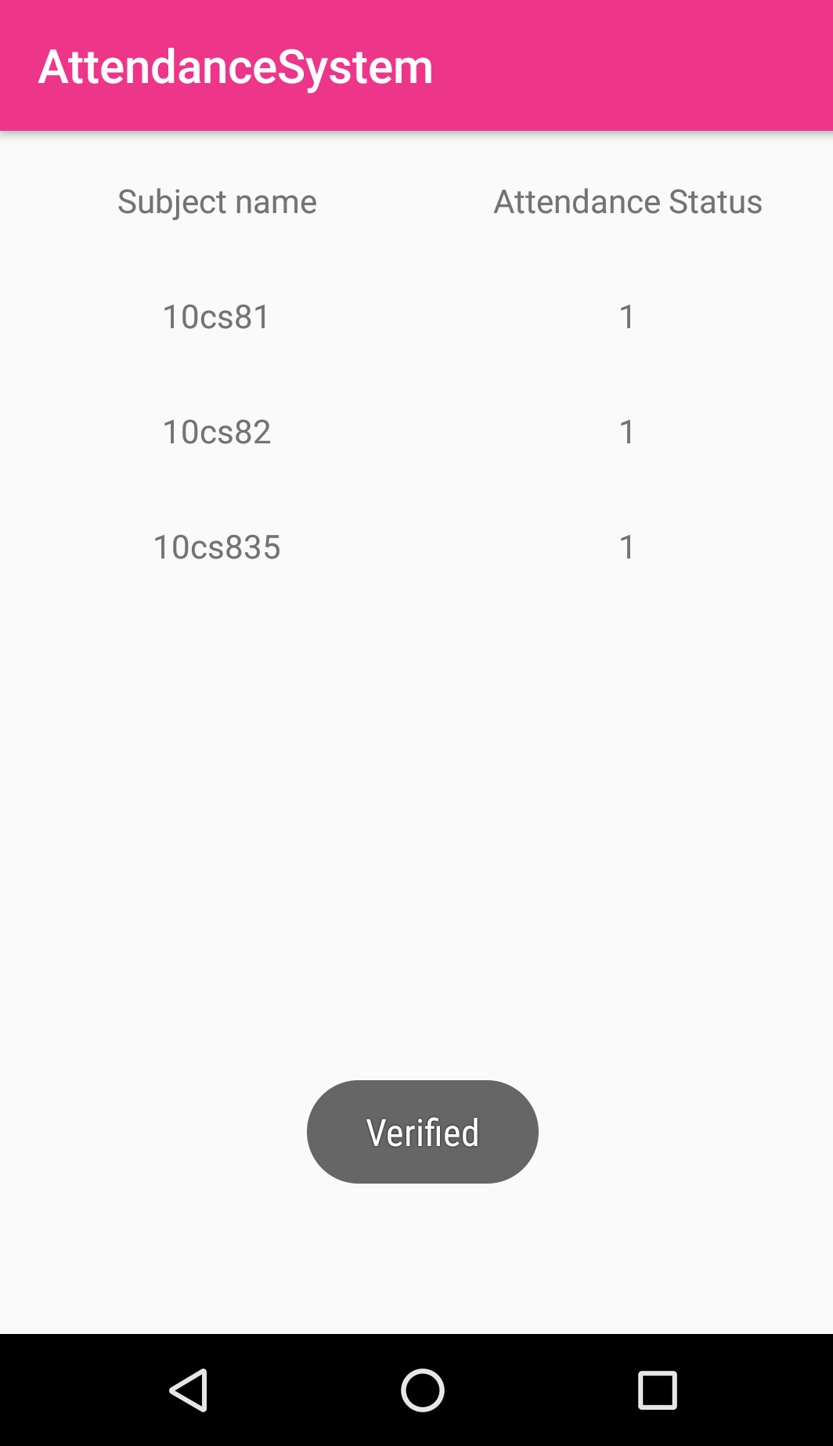
Student’s needs to login by using their USN which a unique roll number assigned to each student by the VTU. Only valid USN which is already there in firebase tree structure of the database is considered for successful login and moved to new screen as shown below in figure 5.26. When the new screen opens, which is table view containing subject codes in the row for that student for his class, and attendance status in the next column containing details of the number of the classes attended.
Figure 5.26: Student attendance status

CHAPTER 6
RESULTS AND ANALYSIS
A careful observation of the trend of usage of RFID tags leads one to consider the possibility of its utilization for monitoring the attendance of students in educational institutions, with the aid of program driven computers. While every student given a specific RFID tag attends the lecture through entrance door, a serial number (related to each student‘s matriculation number) of tag is associated with the student database entry. So every time a student uses his/her card, the entries will be entered into the database with the time stamp.
The use of webcam might be optionally necessary to take a snap of the person using the card. Webcam reduces proxy attendance attempts. This is used to cross-verify in the event of an undesirable event or dispute. Consequently, the attendance data then can be used to create many types of reports like daily attendance details, monthly, weekly and real time feedback to parents. The attendance score calculation can be automated using the collected data. After setting up the student attendance RFID system from the mode of operation. The tag is activated when it is swiped through a radiofrequency (RF) field, which is generated by the antenna embedded within the reader box. The program checks whether the tag is valid or not. If the tag is valid, it will continue to the database program and registers the student‘s attendance for the course. If the tag is invalid, the program gives a notification that the tag has not been registered to any student and requires the user to either supply a valid tag. In our proposed system, we improve the student attendance system. The Radio Frequency Identification (RFID) technology is one of an automation technology that is beneficial in improving current traditional way of monitoring. As every tag has its own unique ID, it is easy to differentiate every tag holder. In addition, a Graphical User Interface (GUI) provides more efficient way to review the monitor. Thus, the integration of RFID technology and the GUI in an monitoring system will produces an automatic view of attendance in the mobile. To view the attendance first administrative person or the user operating this project has to login. Data is sent to the application as soon as it is shown on LCD display. At that time attendance monitoring on LCD becomes very time consuming and is not easy. However, data for all employees can be viewed on mobile at a faster rate and very easily.

6.1 Advantages
- This system is fully automated and it does not require any human interaction.
- LCD and PC interface both are provided with RFID based attendance system. This gives benefit of viewing attendance on the spot on LCD or remotely from computer.
- This system is accurate and can avoid proxy or false attendance.
- RFID tag and reader should not be in LOS to make the system work.
- Unlike barcodes, tags can store more information. Moreover, it follows instructions/commands of reader.
- RFID technology is versatile in nature and hence smaller and larger RFID devices are available as per application.
- Tags can be read only as well as read/write unlike barcodes.
- The technology is used for security and attendance purpose in schools, colleges as well as office establishments. The time-in and time-out is recorded it the database of the server.
6.2 Disadvantages
- Active RFID is bit costly.
- Privacy is a concern with the use of RFID on products as it can be easily tapped or intercepted.
- RFID devices need to be programmed which requires enough amount of time.
- Use of RFID technology at inventory control and for other such applications lead to loss of jobs for unskilled labourer.
- The external electromagnetic interference can limit the RFID remote reading.
- The coverage range of RFID is limited which is about 3 meters.

CHAPTER 7
CONCLUSION AND FUTURE SCOPE
In conclusion, the objective to build an RFID based attendance system was successfully achieved. In terms of performance and efficiency, this project has provided a convenient method of attendance marking compared to the traditional method of attendance system. By using databases, the data is more organized. This system is also a user friendly system as data manipulation and retrieval can be done via the interface, making it a universal attendance system. Thus, it can be implemented in either an academic institution or in organizations.
Alerts could be sent to the professor or student via email. Maybe a student has missed 5 classes in a row, which triggers an alert. It could email the student and professor notifying them of this pattern, helping facilitate better communication between professor and students as well as better class attendance. Interfacing the system with a GSM so that data can be transmitted through messages. Integrating finger print module to avoid students cheat. Including camera and n number of other devices taking security to a whole new level. Including voice announcement system to this project. So, whenever user logs in, an announcement can be made like, “Your attendance has been logged in” or “Your card is invalid”.

REFERENCES

[1] Herdawatiebinti Abdul Kadir, Siti Nurul Aqmariahbinti Mohd Kanafiah, Mohd Helmy bin Abd. Wahab, Zarina Tukiran and Zulidabte Abdul Kadir―Online students ISSN: 2278 – 1323 International Journal of Advanced Research in Computer Engineering & Technology (IJARCET) Volume 5, Issue 4, April 2016 1159 www.ijarcet.org supervision (OSS ) systems using passive RFID 2008 IEEE paper.
[2] HerdawatieBt Abdul Kadir, Mohd HelmyAbd. Wahab and Siti Nurul Aqmariah Bt Mohd Kanafiah ―Boarding School Students Monitoring Systems (EID) UsingRadio Frequency Identification ―Faculty of Electrical and Electronic Engineering,University Tun Hussein Onn Malaysia, 86400 Parit Raja, BatuPahat, Johor, Malaysia, Journal of Social Sciences 5(3):206- 211 2009
[3] Abdul Kadir1, Mohd Helmy Abd Wah Ab2, Zarina Tukiran3, Ariffin AbdulMutalib4 ―Tracking Student Movement using Active RFIDHERDAWATIE 1,2,3Faculty of Electrical and Electronic Engineering Universiti Tun Hussein Onn Malaysia P.O. Box 101, Pt. Raja, Batu Pahat, Johor,ISSN: 1790-5117,ISBN: 978-960-474-166-3MALAYSIA
[4] Amin A. Al-Zarouni, Nassar H. Fakhro ―Mobile RFID Tracking System Computer Engineering Department American University of Sharjah, UAE
[5] Z. Chalhoub and S. EI Dahdaah, ―An RFID Attendance and Monitoring System for University Applications Department of Electrical and computer and communication Engineering Notre Dame University Louaize Zouk Mosbeh, 978-1-4244-8157- 6/102010.
[6] Dawes A.T. (2004),Is RFID Right for Your Library, Journal of Access Services, Volume 2(4), pp 7-13.

