Overview
This report evaluates the Milestone 2 face verification pipeline on the real LFW dataset already referenced by the repository. The baseline system uses deterministic grayscale-flattened features with cosine similarity. Thresholds are selected on the validation split by maximizing balanced accuracy, then locked for final reporting on the test split.

Tracked Runs And Threshold Rule
Five real tracked runs were completed to satisfy the milestone requirement, but the fairest baseline-versus-improved comparison is baseline_32 versus improved_32, because both use the same image size and scoring code while only the pair policy changes.
Run | Threshold | Val Balanced Acc. | Test Balanced Acc. | Test Acc. | Note
baseline_32 | 0.80 | 0.6210 | 0.5648 | 0.5648 | Baseline reporting run
improved_32 | 0.77 | 0.6100 | 0.5852 | 0.5852 | prefer_unique pair policy
improved_48 | 0.77 | 0.6112 | 0.5886 | 0.5886 | Exploratory improved run
The threshold rule was fixed before final evaluation: choose the threshold on the validation split that maximizes balanced accuracy. For baseline_32, the selected threshold is 0.80. For improved_32, the selected threshold is 0.77.

Baseline Versus Improved Result
At the same 32x32 feature resolution, the improved pair policy raises test balanced accuracy from 0.5648 to 0.5852, an absolute gain of 0.0204. The main gain comes from recall: baseline recall is 0.4904, while improved recall is 0.6504. This comes with a tradeoff, because false positives increase from 902 to 1200.

ROC And Confusion Matrix
The improved 32x32 run is the clearest run to visualize because it is the real data-centric comparison target.
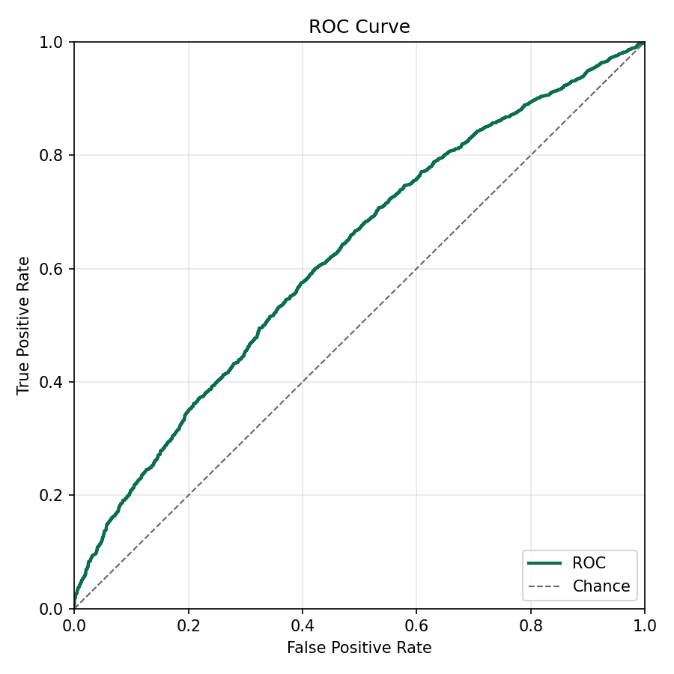
Improved 32x32 ROC plot
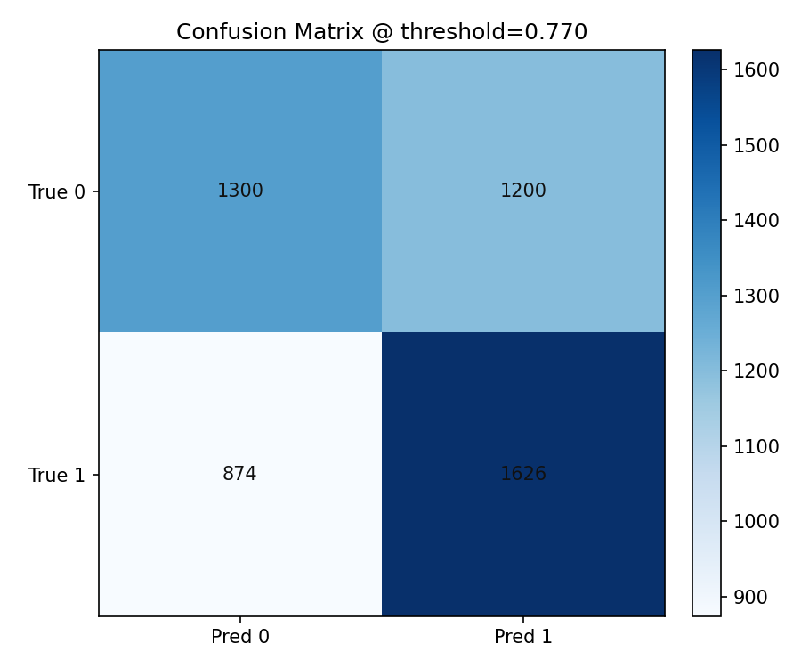
Improved 32x32 confusion matrix

Error Slice 1: High-Similarity False Positives
Slice definition: different-identity pairs scoring above the selected threshold. In the baseline 32x32 run, high_similarity_false_positives has count 1728. Representative examples are shown below.
Hypothesis: Faces undergoing different expressions can contort in just the right way so that they are falsely positive more often than when expressions are similar.
Future improvement: When facial expression is very different, require a sub-routine where a small selection of the face that is less affected by facial expression. This would be a parallel model.
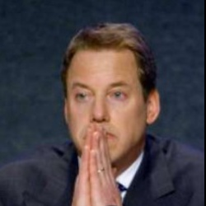
Baseline false-positive example A
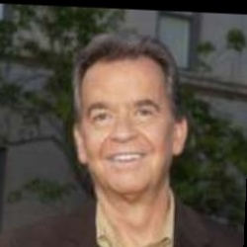
Baseline false-positive example B

Error Slice 2: Low-Similarity False Negatives
Slice definition: same-identity pairs scoring below the selected threshold. In the improved 32x32 run, low_similarity_false_negatives has count 1686. Representative examples are shown below.
Hypothesis: faces at different angles are hard to score high in similarity.
Future improvement: Find a angle resilient identifiable part of the face and train a parallel model to run in parallel alongside the main face model. It can be a helper to help judge faces at different angles.
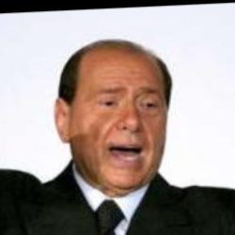
Improved false-negative example A

Improved false-negative example B

