**DIABETES MELLITUS**

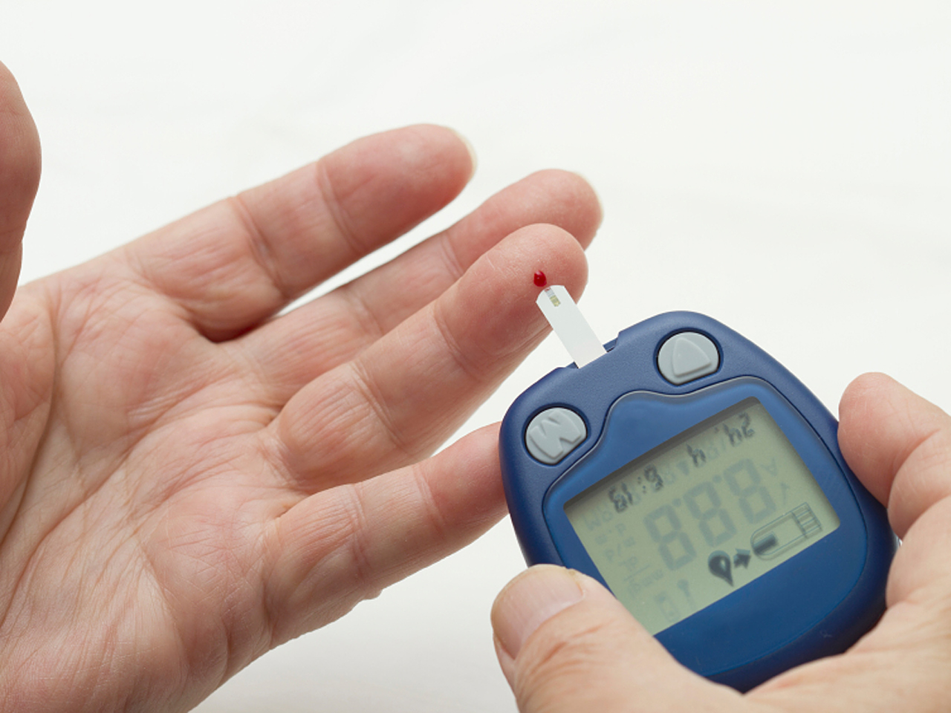

In this section, the caregiver will understand:

* Types of diabetes
* Risk factors for diabetes
* Health problems associated with diabetes and their management.

**Definition:**

* Diabetes is a disease that occurs when the blood glucose, also called blood sugar, is too high. Blood glucose is the main source of energy and comes from the food we eat.
* Insulin, a hormone made by the pancreas helps glucose from food get into the cells to be used for energy. Sometimes the body does not make enough—or any—insulin or does not use insulin well. Glucose then stays in blood and does not reach the cells.
* Over time, having too much glucose in the blood can cause health problems health problems. Although diabetes has no cure, it can be managed and stay.

**Causes**

To understand diabetes, first you must understand how glucose is normally processed in the body.

**How insulin works:**

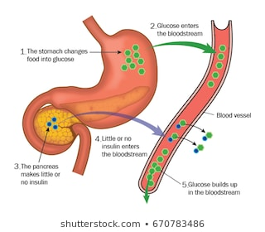

* Insulin is a hormone that comes from a gland situated behind and below the stomach (pancreas).
* The pancreas secretes insulin into the bloodstream.
* The insulin circulates, enabling sugar to enter your cells.
* Insulin lowers the amount of sugar in the bloodstream.
* As your blood sugar level drops, so does the secretion of insulin from the pancreas.

**The role of glucose**

* Glucose — a sugar — is a source of energy for the cells that make up muscles and other tissues.
* Glucose comes from two major sources: food and the liver.
* Sugar is absorbed into the bloodstream, where it enters cells with the help of insulin.
* The liver stores and makes glucose.
* When the glucose levels are low, such as when the person hasn't eaten in a while, the liver breaks down stored glycogen into glucose to keep the glucose level within a normal range.

**Types of diabetes**

* There are 2 main types of diabetes – type 1 and type 2 diabetes

**1.Causes of type 1 diabetes**

* The exact cause of type 1 diabetes is unknown. What is known is that the immune system — which normally fights harmful bacteria or viruses — attacks and destroys the insulin-producing cells in the pancreas.
* This leaves the person with little or no insulin. Instead of being transported into the cells, sugar builds up in the bloodstream.
* Type 1 is thought to be caused by a combination of genetic susceptibility and environmental factors, though exactly what those factors are is still unclear. Weight is not believed to be a factor in type 1 diabetes.

**2. Causes of type 2 diabetes**

* More than 90% people with diabetes have type 2
* The cells become resistant to the action of insulin, and the pancreas is unable to make enough insulin to overcome this resistance. Instead of moving into the cells where it's needed for energy, sugar builds up in the bloodstream.
* Exactly why this happens is uncertain, although it's believed that genetic and environmental factors play a role in the development of type 2 diabetes too.
* Being overweight is strongly linked to the development of type 2 diabetes, but not everyone with type 2 is overweight.

**Type 1 vs. type 2 diabetes**

* Type 1 diabetes is the result of the body not producing insulin on its own. Taking insulin is necessary for survival, to move glucose from the bloodstream into the body’s cells.
* For people with type 2 diabetes, the cells have stopped responding well to insulin. The body struggles to move glucose from the blood into the cells, despite adequate levels of the hormone. Eventually, their bodies may stop making adequate insulin entirely.
* Type 1 diabetes develops very quickly, and symptoms are obvious. For people with type 2 diabetes, the condition can develop over many years. In fact, a person with type 2 diabetes may not know they have it until they have a complication.
* The two types of diabetes have different causes. They also have unique risk factors.

**3. Causes of gestational (pregnancy induced) diabetes.**

* During pregnancy, the placenta produces hormones to sustain the pregnancy. These hormones make the cells more resistant to insulin.
* Normally, the pancreas responds by producing enough extra insulin to overcome this resistance. But sometimes the pancreas can't keep up. When this happens, too little glucose gets into the cells and too much stays in your blood, resulting in gestational diabetes.

**Risk factors for diabetes**

Researchers don't fully understand why some people develop diabetes and others don't. It's clear that certain factors increase the risk, however, including:

* **Weight.** The fattier tissue the person has, the more resistant the cells become to insulin.
* **Inactivity.** The less active the person is, the greater your risk. Physical activity helps control weight, uses up glucose as energy and makes the cells more sensitive to insulin.
* **Family history.**  Risk increases if a parent or sibling has diabetes.
* **Race or ethnicity.** Although it's unclear why, certain people — including Black, Hispanic, American Indian and Asian American people — are at higher risk.
* **Age.** Risk increases as the person get older. This may be because of less exercise, lose muscle mass and gaining weight as the person ages. But type 2 diabetes is also increasing among children, adolescents, and younger adults.
* **Gestational diabetes.** If the person developed gestational diabetes when pregnant, the risk of developing diabetes increases. If the person gives birth to a baby weighing more than 9 pounds (4 kilograms), they are also at risk of diabetes.
* **High blood pressure.** Having blood pressure over 140/90 millimetres of mercury (mm Hg) is linked to an increased risk of type 2 diabetes.
* **Abnormal cholesterol levels.**  People with high levels of cholesterol levels have an increased risk of type 2 diabetes.

**Symptoms of diabetes**

Diabetes symptoms vary depending on how much your blood sugar is elevated. Some people, especially those with prediabetes or type 2 diabetes, may sometimes not experience symptoms. In type 1 diabetes, symptoms tend to come on quickly and be more severe.

Some of the signs and symptoms of type 1 diabetes and type 2 diabetes are:

* Increased thirst
* Frequent urination
* Extreme hunger
* Unexplained weight loss
* Fatigue
* Irritability
* Blurred vision
* Slow-healing sores
* Frequent infections, such as gums or skin infections and vaginal infections

**Prevention**

Type 1 diabetes can't be prevented. However, the same healthy lifestyle choices that help treat prediabetes, type 2 diabetes and gestational diabetes can also help prevent them:

* **Healthy foods**. Choose foods lower in fat and calories and higher in fiber. Focus on fruits, vegetables and whole grains. Strive for variety to prevent boredom.
* **Physical activity.** Aim for about 30 minutes of moderate aerobic activity on most days of the week, or at least 150 minutes of moderate aerobic activity a week.
* **Weight loss**.  Can reduce the risk of diabetes. Talk to the doctor about how much weight is healthy to gain during pregnancy.
* **Keep weight in a healthy range:** focus on permanent changes to the eating and exercise habits. Motivate the person by remembering the benefits of losing weight, such as a healthier heart, more energy and improved self-esteem.
* Sometimes medication is an option as well. Oral diabetes drugs such as metformin (Glumetza, Fortamet, others) may reduce the risk of diabetes — but healthy lifestyle choices remain essential.
* blood sugar to be checked at least once a year to check that the person at risk haven't developed type 2 diabetes.

**Health problems people with diabetes, how to prevent and manage.**

* **Kidney damage (nephropathy).** The kidneys contain millions of tiny blood vessel clusters (glomeruli) that filter waste from the blood. Diabetes can damage this delicate filtering system. Severe damage can lead to kidney failure or irreversible end-stage kidney disease, which may require dialysis or a kidney transplant.

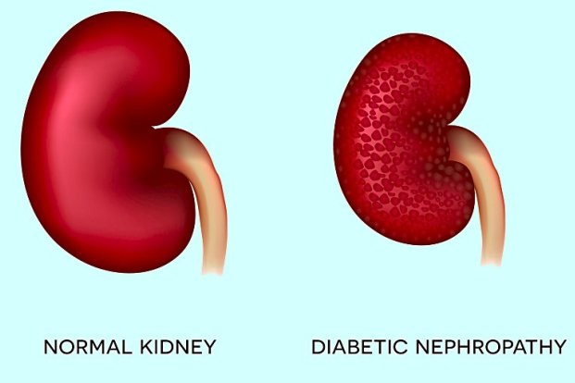

* **Eye damage (retinopathy).** Diabetes can damage the blood vessels of the retina (diabetic retinopathy), potentially leading to blindness. Diabetes also increases the risk of other serious vision conditions, such as cataracts and glaucoma.

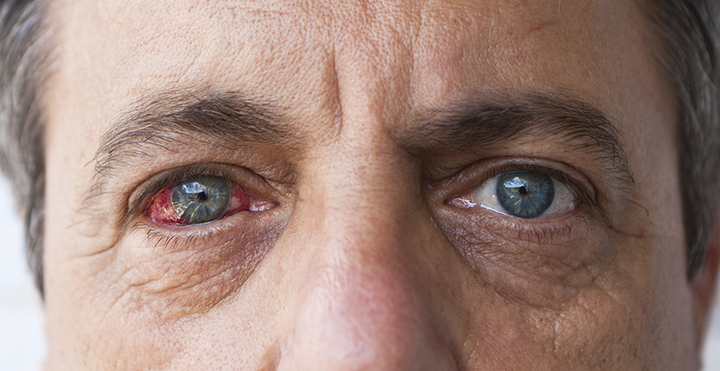

* **Foot damage.** Nerve damage in the feet or poor blood flow to the feet increases the risk of various foot complications. Left untreated, cuts and blisters can develop serious infections, which often heal poorly. These infections may ultimately require toe, foot or leg amputation.

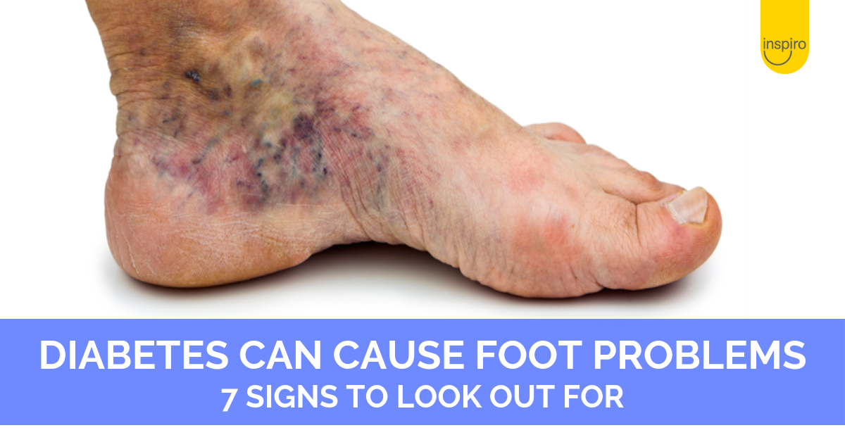

* **Skin conditions.** Diabetes may leave you more susceptible to skin problems, including bacterial and fungal infections.

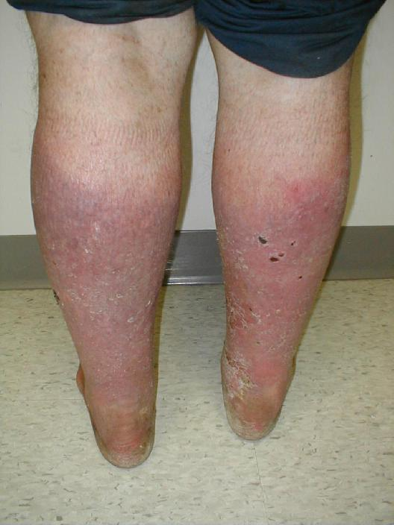

* **Hearing impairment.** Hearing problems are more common in people with diabetes.
* **Diabetic neuropathy (Nerve damage)** Diabetic neuropathy is nerve damage that can result from diabetes. Different types of nerve damage affect different parts of your body. Managing diabetes can help prevent nerve damage that affects the feet and limbs, and organs such as the heart.
* **Gum disease and other dental problems.** Diabetes can lead to problems in the mouth, such as infection, gum disease, or dry mouth. To help keep the mouth healthy, manage blood glucose, brush teeth twice a day, see the dentist at least once a year, and not smoking.
* **Sexual and bladder problems**. Sexual and bladder problems are more common in people with diabetes. Problems like erectile dysfunction, loss of interest in sex, bladder leaks, and retained urine can happen if diabetes damages your blood vessels and nerves. Treatments are available to help control symptoms and restore intimacy.
* **Depression and Diabetes**. Depression   is common among people with a chronic, or long-term, illness such as diabetes. Depression can be treated through expressing feelings of sadness, hopeless, or anxious.

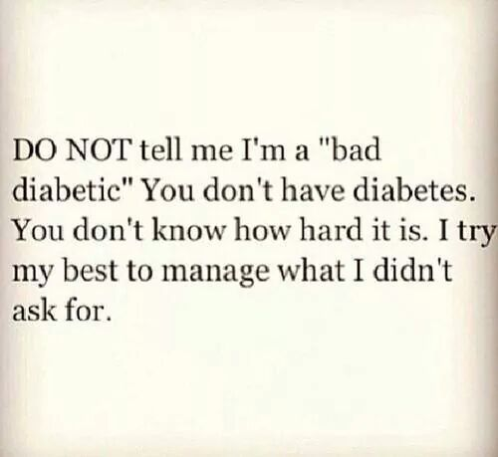

* **Dementia and Diabetes**. High blood glucose increases the chance of developing dementia making it hard to self-manage diabetes.
* **Short breaths and Diabetes**. Breathing for short periods during sleep is more likely to develop in type 2 diabetes.

**Diabetes and wound healing**

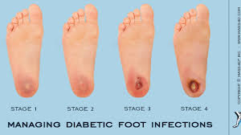

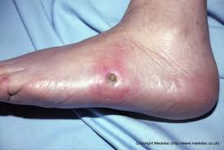

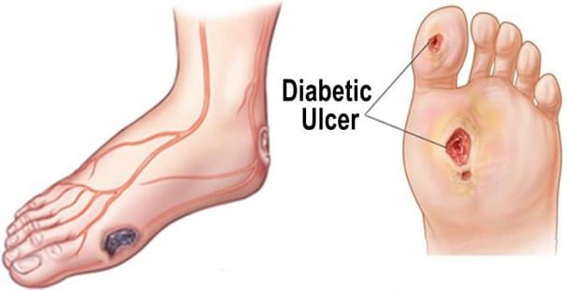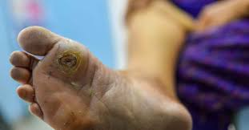

**Diabetes and wound healing Causes**

* Diabetes causes impairment in the body’s production of insulin, a hormone that allows the cells to take and use glucose from the bloodstream for energy. This disruption to insulin makes it more difficult for the body to manage blood glucose levels.
* When blood glucose remains permanently high, it impairs the function of white blood cells. White blood cells are central to the role of the immune system. When white blood cells are unable to function correctly, the body is less able to fight bacteria and close wounds.
* People with uncontrolled diabetes may develop poor circulation. As circulation slows down, blood moves more slowly, which makes it more difficult for the body to deliver nutrients to wounds. As a result, the injuries heal slowly, or may not heal at all.
* Diabetes can also cause neuropathy (nerve damage), which can also affect wound healing. Uncontrolled blood glucose can damage the nerves, numbing sensations in the area. This may mean that people with diabetes who sustain trauma to their feet might not be aware of the injury.
* If a person is not aware of an injury, they might not receive treatment, which might allow the wound to worsen. A combination of slow healing and reduced sensation in the area significantly increases the risk of infection.

**Factors that may increase this risk include:**

* Impaired sweating
* Dry and cracked skin
* Toenail infections
* Foot abnormalities

**Complications**

* People who experience poor wound healing because of diabetes on the nerves and blood vessels might also experience other complications. These include heart disease, kidney disease, and eye problems.
* If an untreated wound becomes infected, the infection may spread locally to muscle and bone. A condition called osteomyelitis.
* If an infection develops in the wound and is left untreated, it can progress to the stage of gangrene (death of body tissue due to either a lack of blood flow or a serious bacterial infection. Gangrene is a common cause of amputations in people who lose limbs as a result of diabetes.
* Sometimes, people with uncontrolled infections develop sepsis, which occurs when an infection spreads into the bloodstream. Sepsis can be life-threatening.

**Diabetic wound Prevention**

People with diabetes can use specific strategies to improve the time it takes for a wound to heal. These include managing blood glucose, thorough foot care, and treating wounds as they occur.

**Foot care for diabetes**

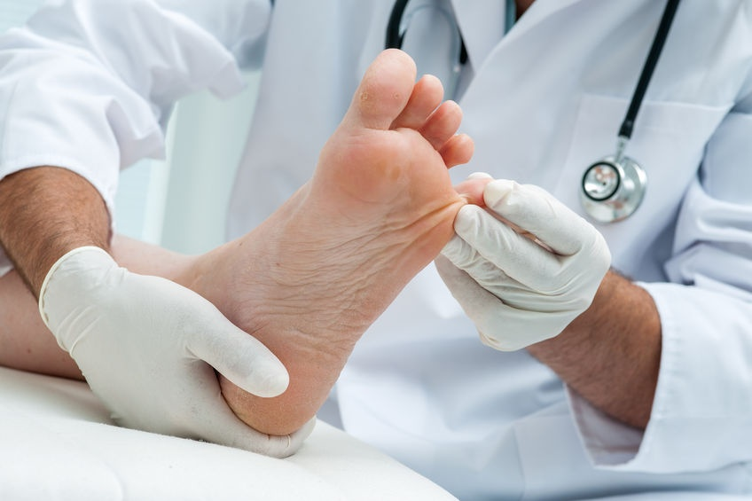

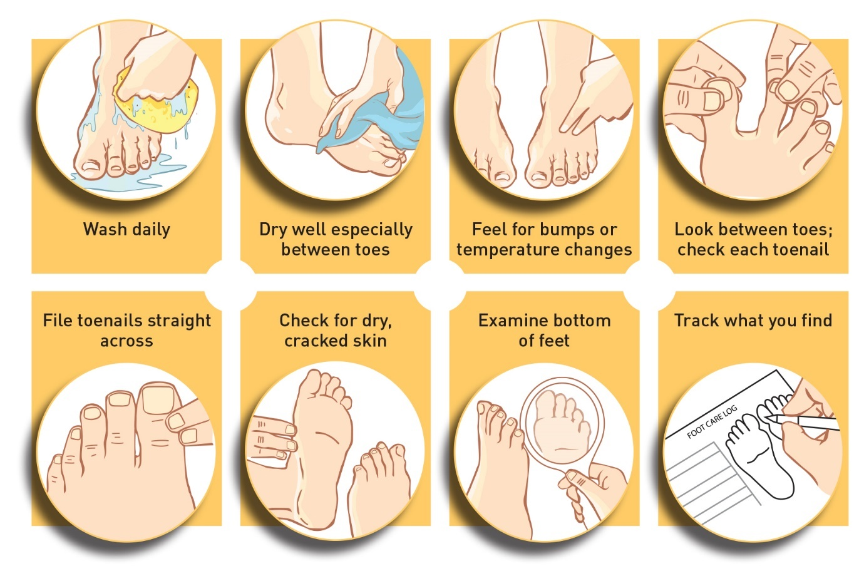

Appropriate foot care includes:

* Washing feet daily
* Patting the skin dry before applying moisturizer
* Avoiding walking barefoot
* Carefully trimming toenails
* Wearing comfortable shoes
* Inspecting feet and looking inside shoes daily.
* Having a doctor check the feet at each visit.

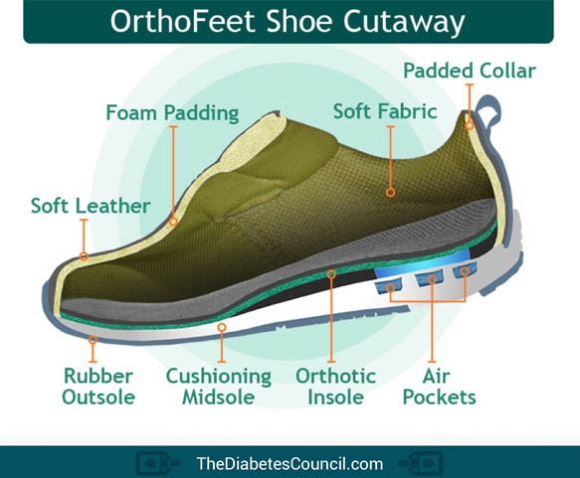

**Wound treatment**

* It is essential that people with diabetes carefully monitor their wounds. While wounds might heal slowly, it is not normal for them to remain open for several weeks, to spread, ooze, or become extremely painful.
* While an infection might not develop in every ulcer or wound, the first step to preventing it is to clean the wound and cover it with a clean bandage. Repeat this daily.
* It might be a good idea for people with diabetes to wear shoes and socks when walking around, especially if a wound has developed. Being barefoot increases the risk of infection.
* People who have any type of diabetes should seek treatment if a wound develops on their foot and does not heal. A person will often need to take antibiotics to combat any infections and might require hospitalization if the wound is severe.

**Glucose control**



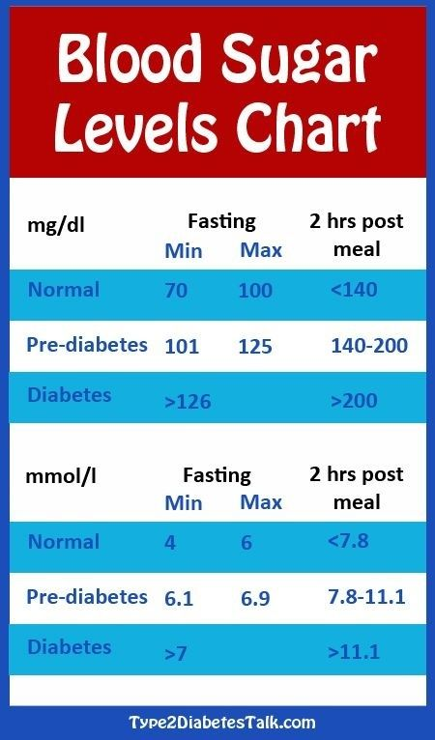

* Glucose control is essential for preventing slow wound healing.
* People who manage their blood glucose levels are less likely to experience severe wounds that do not heal.
* People with type 1 diabetes will need to take insulin for life to control blood sugar. People with type 2 diabetes have more options — as well as taking insulin and other medications, making some lifestyle adjustments, such as a healthful diet, regular exercise, and weight management may substantially improve a person’s blood sugar levels.
* These lifestyle changes may even allow a person to manage diabetes without medication.
* People with both type 1 and type 2 diabetes can benefit from a carbohydrate-controlled diet. Talk to a doctor who will individualize a meal plan that includes a specific amount of carbs that a person should eat each day.

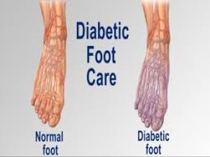

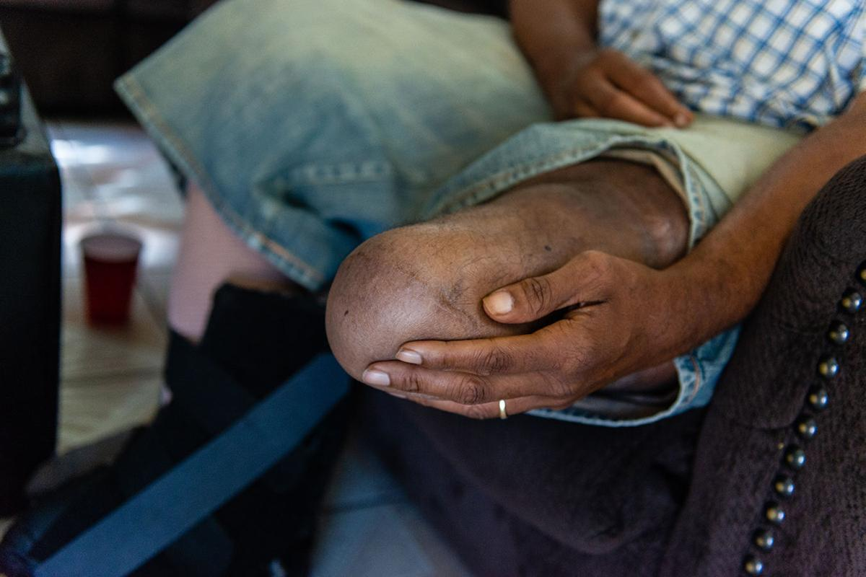

Fig: Diabetic amputations a ‘shameful metric’ of inadequate care

**Conclusion**

* When a person has diabetes, a wound that does not heal can quickly become life-threatening. A positive outlook for slow-healing wounds depends on prompt treatment and effective glucose management.
* People with diabetes should immediately contact a doctor when they develop serious or painful wounds that do not heal after several days, or if an infection seems to have developed.
* A combination of aggressive antibiotic treatment, wound cleaning, surgical removal of dead tissue, and more effective glucose control may help. If the wound does not respond to treatment, amputation may be necessary.
* People should take preventive steps before wounds develop to reduce the risk of wound healing complications.

**Diabetes: Test Your Knowledge**

1. **Diabetes happens because of which of these?**

1. The liver doesn’t make enough blood sugar
2. The muscles use too much blood sugar
3. The body can’t use blood sugar the way it should
4. The body makes more insulin than it needs.

**2. Two of the main types of diabetes are type 1 and type 2. How many people with diabetes have type 2?**

1. 10% to 15%
2. 30% to 35%
3. 45% to 50%
4. More than 90%

**3. A certain gland or organ doesn't work right in a person who has type 1 diabetes. Which gland or organ is it?**

1. Pituitary gland
2. Pancreas
3. Adrenal glands
4. Kidneys

**4. Why is insulin important for the body to use blood sugar?**

1. It helps blood sugar enter the cells.
2. It lowers the blood pressure.
3. It raises the cholesterol levels.
4. It keeps the sucrose levels normal.

**5**. **Keeping diabetes under control early on will help prevent more health problems later. People with diabetes are at higher risk for which of these?**

1. Heart disease
2. Cancer
3. Nerve damage
4. Both A and C

6. **Why are a healthy diet and regular exercise so important if for a person with diabetes?**

1. They keep depression at bay.
2. Eating raises blood sugar, exercise lowers it.
3. Being overweight can be dangerous for people with diabetes.
4. B and C

7**. Type 1 diabetes is primarily treated with:**

1. Diet and exercise
2. Stress management
3. Insulin injection
4. Sleep and exercise
5. Insulin capsules

8. **The risk factors for type 1 diabetes include all of the following except:**

1. Diet
2. Genetic
3. Autoimmune
4. Environmental

9. **Diabetics are at increased risk of heart disease if they also:**

1. Smoke
2. Have low cholesterol levels.
3. Take aspirin.
4. Consume a high-fiber diet.

10. Nerve damage caused by high blood sugar is called:

1. Retinopathy
2. Nephropathy
3. Diabetic neuropathy

11. People with diabetes may not feel pain when a small cut or blister occurs on the foot.

1. True
2. False

12. Diabetes affects the feet mainly in two ways. These are:

1. Can cause nerve damage
2. Can cause hardening of the blood vessels
3. both A and B are correct

13. How do you know if the nerves in a diabetic patient’s feet are damaged?

1. There are no symptoms
2. Feet may feel pale and cold
3. Feet may feel tingle of feel numb
4. All of the above are correct

14. The most important way you can prevent diabetic foot problems is:

1. Keep blood sugar within target ranges
2. Wearing well-fitting shoes
3. Never go bare foot

**Answers**

**1. Diabetes happens because of which of these?**

C. The correct answer is C. The body can't use blood sugar the way it should.

**2. Two of the main types of diabetes are type 1 and type 2. How many people with diabetes have type 2?**

The correct answer is D. More than 90%.

Many people with the disease don't know they have it. Most often develops in middle-aged, obese adults, although younger people, even children, can develop it. This is especially true if it runs in the family.

**3. A certain gland or organ doesn't work right in a person who has type 1 diabetes. Which gland or organ is it?**

The correct answer is B. Pancreas.

The pancreas makes insulin.

**4. Why is insulin important for your body to use blood sugar?**

The correct answer is A. It helps blood sugar enter your cells.

Insulin is a hormone made by the pancreas. Insulin circulates in the bloodstream. Insulin unlocks the "cell door," allowing blood sugar to move from the bloodstream into the cells. The cells use the blood sugar for energy production.

**5. Keeping diabetes under control early on will help prevent more health problems later. People with diabetes are at higher risk for which of these?**

The correct answer is D. A and C .

People with diabetes are more likely to develop heart disease and nerve damage than people who don't have diabetes.

**6. Why are a healthy diet and regular exercise so important a diabetic person ?**

The correct answer is D. B and C .

For daily management of diabetes, eating raises the blood sugar and exercising lowers it. Each must be done carefully to balance blood sugar levels. Over the years, a balance between eating and exercise keeps a person from gaining weight. Extra weight can make it more difficult to keep diabetes under control.

**7. Type 1 diabetes happens when the body cells that make insulin (beta cells) in the pancreas are destroyed. What destroys them?**

The correct answer is A. The immune system .

The immune system works to fight off infections. In type 1 diabetes, the immune system destroys the insulin-producing cells in the pancreas. Doctors do not know why this happens. A person's genes are one of many possible factors.

8. **The risk factors for type 1 diabetes include all of the following except:**

The correct answer is A. Diet.

9. **Diabetics are at increased risk of heart disease if they also:**

The correct answer is  E. Smoke