[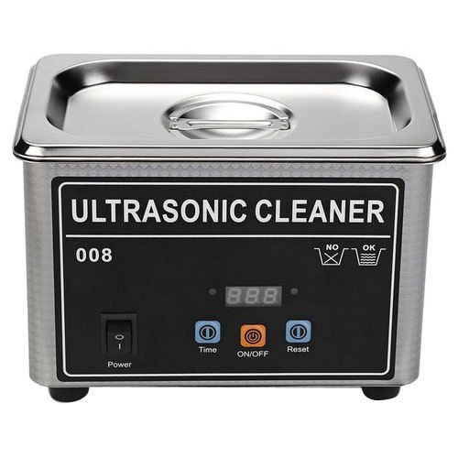](https://www.google.co.ke/url?sa=i&url=https%3A%2F%2Fwww.indiamart.com%2Fproddetail%2Fultrasonic-cleaning-machine-21555036197.html&psig=AOvVaw3gK0NgcrN1CN5pyn5ZzxJq&ust=1586694439451000&source=images&cd=vfe&ved=0CAIQjRxqFwoTCLDUqMav4OgCFQAAAAAdAAAAABAD) 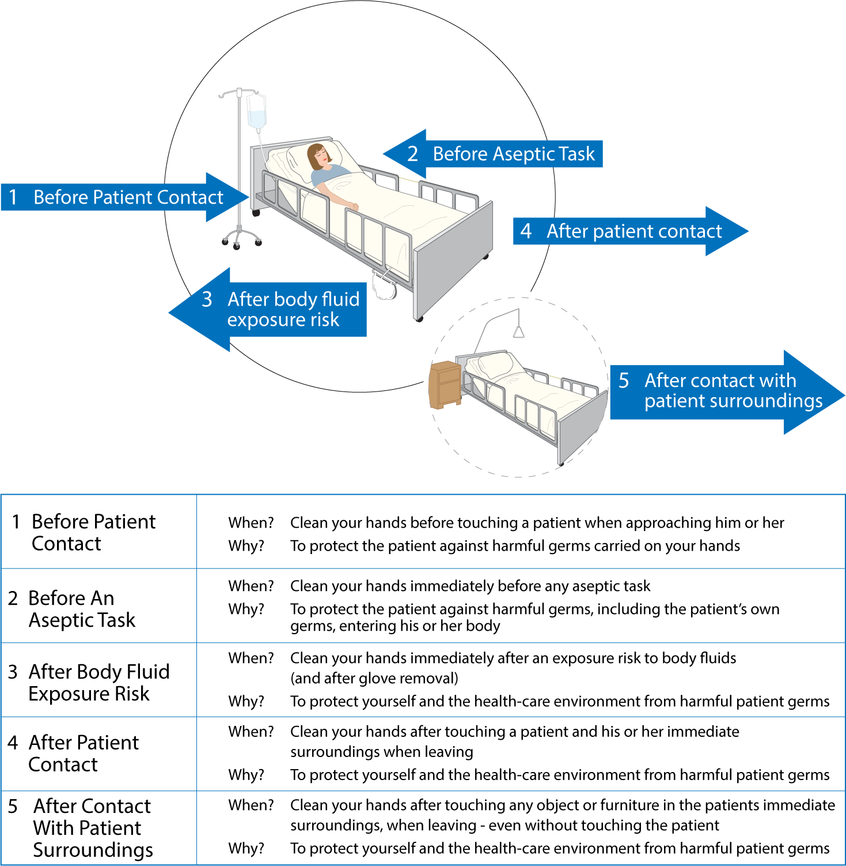



Partnering with patients for hand hygiene

