Kettle Architecture Plan
ChatGPT plugin and server side product design | October 2026

Purpose and recommendation
Kettle helps a user turn a product brief into source-backed short-form video ideas, editable scripts, and a saved filming plan. Build one Kettle backend with a public MCP endpoint for ChatGPT, a worker for longer research tasks, and a small website for accounts and Stripe billing. Kettle owns the saved work; reference providers supply candidates only.
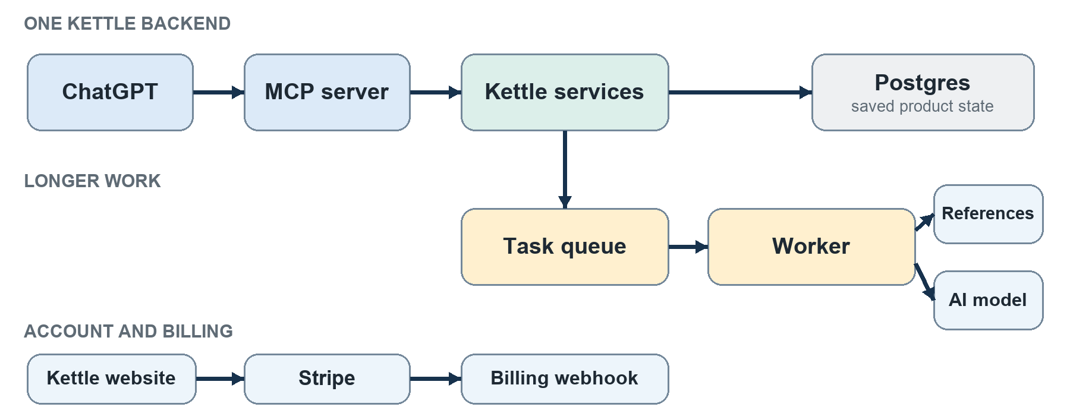
Figure 1 ChatGPT, research work, and billing enter Kettle through separate paths.

Why these boundaries
Choice | Reason
ChatGPT plus MCP | ChatGPT handles conversation; Kettle tools perform controlled reads and writes.
One product backend | Projects, recommendations, Studio, and Vault share the same rules and saved data.
Background worker | Reference research can take minutes; jobs preserve progress and allow retries.
Postgres | Related projects, references, ideas, versions, and access rights need a durable source of truth.
Separate billing website | Subscriptions and plan management stay outside the ChatGPT plugin.

MCP tools and user journey
The MCP server is Kettle’s doorway into ChatGPT. It verifies the connected account, checks project access and paid entitlements, and returns concise structured results. The model chooses a tool; Kettle decides whether the request is authorized and how it is executed.
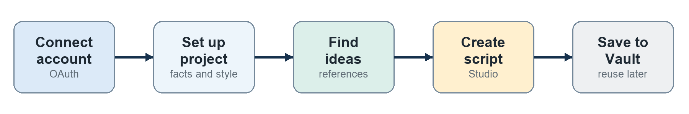
Figure 2 The user can resume the same project and script in later conversations.
User goal | MCP tools | Kettle service
Connect and inspect account | get_account | Identity and entitlements
Set up a project | create_project, list_projects, get_project, update_project | Project profile
Browse examples | search_references, get_reference | Reference catalog
Get ideas | start_idea_run, get_job_status, list_ideas, get_idea | Research and ranking
Write and revise | create_script, get_script, revise_script | Studio generation and versions
Keep work | save_to_vault, list_vault, set_vault_status | Vault

How an idea request works
When a user asks for ideas, start_idea_run saves a job and returns its ID. A worker retrieves permitted references, checks their provenance, ranks them against the project, and saves a set of ideas. ChatGPT uses get_job_status while the job runs and list_ideas when it finishes. If the source cannot support a performance claim, Kettle shows the idea without that claim.

Implementation choices
Use the official TypeScript MCP SDK with explicit tool schemas, a TypeScript service on Cloud Run, OAuth through an established identity provider such as Auth0, Cloud Tasks for queued work, and Supabase Postgres for product data. These are proposed starting choices; a working OAuth connection and reference-source pilot should be validated before committing to them.

Reference data and idea selection
A useful Kettle library can begin small. Keep user-added links private to their projects. Build the shared catalog from creator, brand, or agency submissions that Kettle is permitted to show. Store Kettle’s original analysis of each example and a link to the creator’s post; do not assume that access to a video permits copying or re-hosting it.
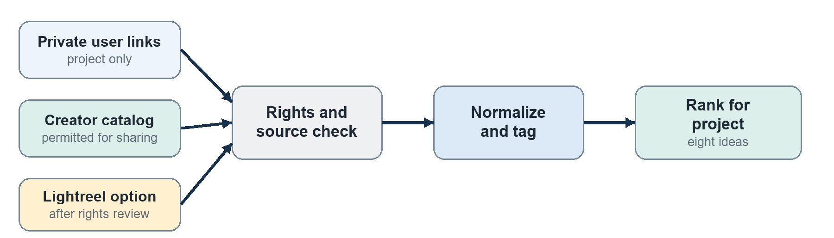
Figure 3 Every source passes the same check before it can influence a recommendation.

Lightreel as an option
A worker may call Lightreel’s server-side API to ask for video candidates and hooks. Lightreel documents a question-answer endpoint and structured fields, and says requests may take several minutes. Kettle must normalize and verify returned links and metrics. Use Lightreel as a primary source only after testing output quality, latency, cost, and the rights to store and display its results to paying users.

Reference record
Field group | Store in Kettle
Identity | Original URL, platform, creator, source provider, submitted by
Analysis | Hook type, format, audience, shots, filming difficulty, Kettle notes
Evidence | Metric value, metric type, observation date, evidence source
Rights | Permission scope, visibility, expiry, withdrawal and deletion state

Search the catalog with tags and Postgres full-text search first. Add semantic search only when the catalog is large enough that ordinary search and ranking fail to find suitable examples.

Script generation and versioning
Kettle should generate the canonical script on its server. ChatGPT carries the conversation, while Kettle keeps a stable record of the user’s facts, chosen idea, revisions, and filming plan.
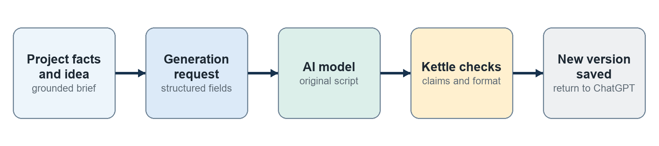
Figure 4 The backend grounds, checks, and saves each generated script.

What the backend does
- Load the project profile, selected idea, reference pattern, current script version, and any specific edit instruction.
- Build a brief with product facts, audience, tone, target length, and desired sections. Treat outside reference text as untrusted input.
- Call a server-side model for structured hook, showcase, CTA, spoken lines, and timed shot directions.
- Check that required sections exist, timecodes fit, claims are supported by the project, and the result is distinct from the source video.
- Save an immutable script version and return it to ChatGPT. A revision creates a new version rather than overwriting the old one.

Why the model runs here
Kettle can apply the same facts and checks whether the request comes from ChatGPT or a future Kettle interface. The server can also measure generation cost, enforce usage limits, retry failures, and recover the latest version without relying on chat history. The model creates language and structure; Kettle’s code controls authorization, data selection, validation, and persistence.

Data that remains under Kettle control
Postgres stores users, projects, reference records, idea runs, ideas, script versions, Vault items, jobs, usage events, Stripe event IDs, and entitlements. Store only task-specific inputs rather than entire ChatGPT conversations. Use object storage only for user assets that Kettle has a reason and permission to retain.

Accounts payments and launch
The user connects an existing Kettle account through OAuth. The MCP server verifies the token on every call, scopes all reads and writes to that account, and checks the current entitlement before paid work begins.
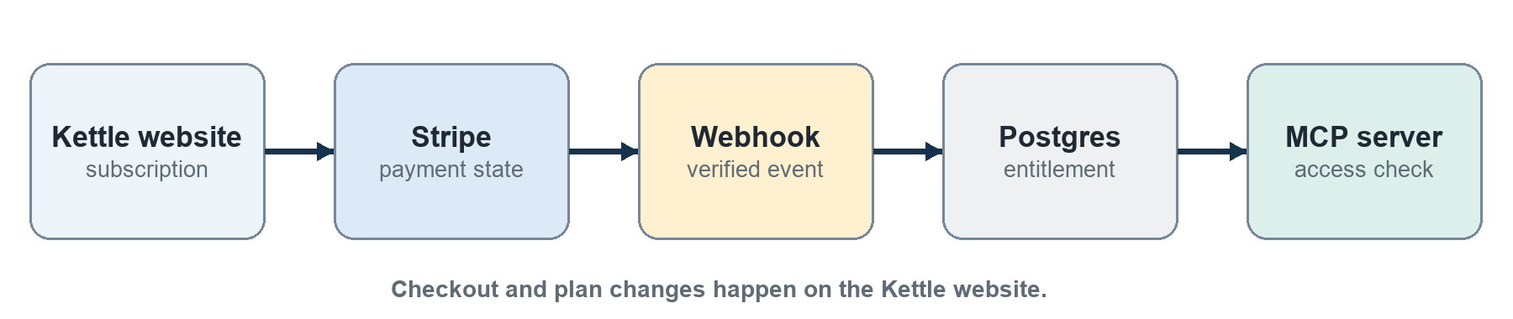
Figure 5 Stripe changes access through a verified webhook; the MCP server reads that access.

Payment boundary
Kettle’s website creates Stripe Checkout sessions and provides subscription management. Signed Stripe webhooks update the entitlement record, with event IDs used to prevent duplicate processing. ChatGPT may use features included in an existing paid account, but the plugin should not initiate or promote a digital subscription purchase.

Build order
Stage | Exit condition
1 Foundation | OAuth works in ChatGPT; a project can be saved and read back.
2 Reference pilot | Permissions, coverage, evidence quality, latency, and cost are acceptable.
3 Product flow | A user can get ideas, create and revise a script, and save it to Vault.
4 Billing | Stripe webhooks update access correctly after payment changes.
5 Directory review | Production MCP endpoint, privacy pages, test account, and review cases are ready.

Source notes
OpenAI Build an MCP server https://developers.openai.com/plugins/build/mcp-server
OpenAI Authentication https://developers.openai.com/plugins/build/auth
OpenAI Plugin guidelines https://developers.openai.com/plugins/plugin-guidelines
OpenAI Upload and submit your plugin https://developers.openai.com/plugins/deploy/submission
Stripe Subscription webhooks https://docs.stripe.com/billing/subscriptions/webhooks
Supabase Database overview https://supabase.com/docs/guides/database/overview
Lightreel API documentation and terms https://lightreel.ai/docs https://lightreel.ai/terms
TikTok Display API overview https://developers.tiktok.com/docs/en/display-api-overview

