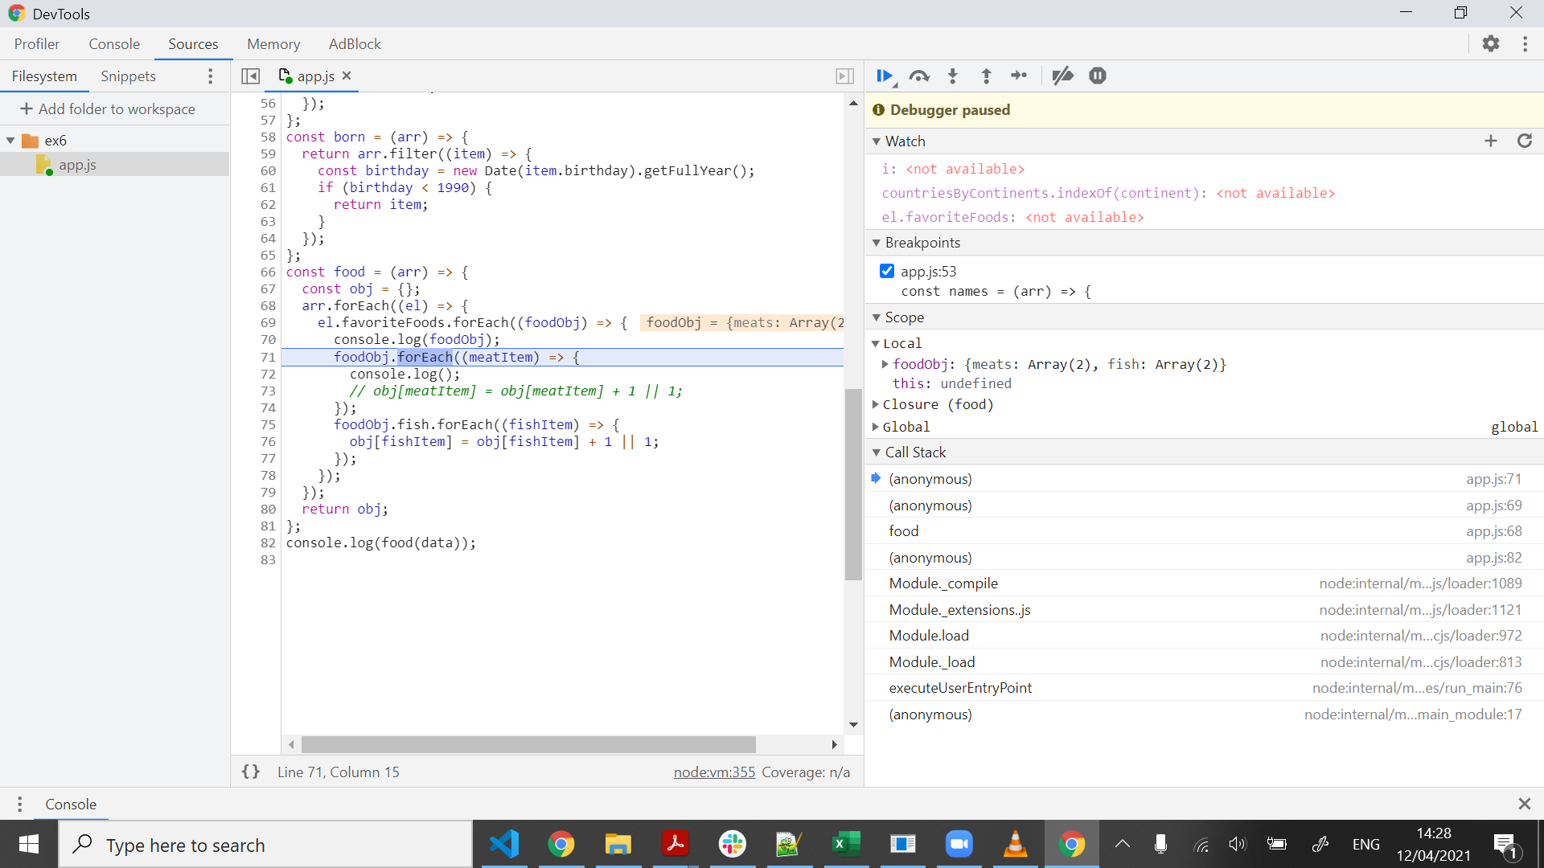

the bug – calling foreach for an object. fix – either take array.entries as an array, of use another looping function.