**adonisjs**

 is an MVC framework. MVC stands for Model, Views, and Controllers.

Every AdonisJS project ships with a set of folders and files.

type of routes.

Adonis gives us the option to bind routes to controllers, group routes, create REST resources with them.

AdonisJS  has its own ORM (Object Relational Mapping) called Lucid. that provide data modeling can run seeds and factories can build queries.

has its own templating engine called Edge. You can use loops, add conditions, create layouts, create components, and a few more.

Edge also provides a tool to inspect and debug templates with it.

**fast!!!**

Benaya:

Koa

דומה לאקספרס,

- משתמש בES6.

- אין צורך בcallbacks בכלל, במקום כל זה יש שימוש ישיר בפונקציות async ובהבטחות.

- שליטה יותר גדולה בניהול שגיאות.

- אין תוכנית אמצע – middleware, אז זה אומר שמפתחים שולטים על כל התהליך מהליבה, אבל מצד שני היא לא תעבוד עם שום middleware של NODE.

- המפתחים של EXPRESS בנו אותה(!) כדי ליצור משהו קליל יותר ויותר robust.

- בשורה התחתונה -  KOA היא בעצם הפשטה של מודול HTTP, הכי פשוט וישיר, בעוד EXPRESS היא ממש framework מלאה עבור NODEJS.

- יותר עבודה – צריך לבנות הכל מההתחלה, כי בניגוד לEXPRESS, KOA לא עושה בשבילך את הדברים הבסיסיים, כמו שכתוב למטה:

- 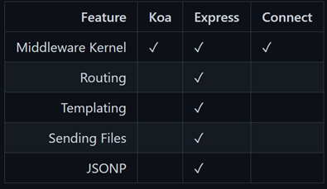

Total.js

Total.js is a Node.js framework targeted at creating server-side web applications,

REST services, real-time applications

you can use any database like PostgreSQL, MongoDB, Firebase, Redis, etc., or you can use most of the NPM dependencies besides.

the basis of the platform is a server-side framework called Total.js framework and client-side library called jComponent.

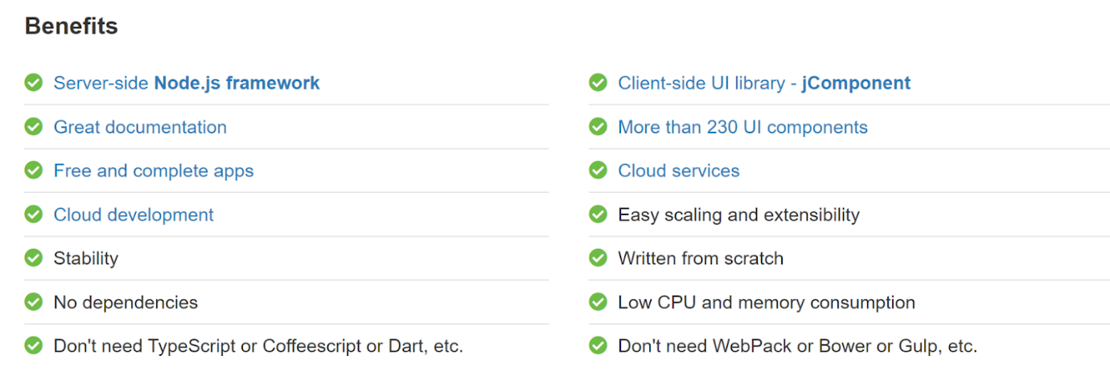



**Meteorjs**

**Advantage:**

- mongodb is the default db for meteor.

- there is some good features in it like code splitting and dynamic import with zero configuration.

- can upload server very very fast.

- you can make your own meteor methods and call them in your frontend framework without hit API. with meteor the

  client and the server can merge together.

- support react and angular

- easy to learn.

**Disadvantage:**

-sql is not that good with meteor.

- no official testing framework

- you can do pretty much whatever you want with the meteor structur, witch can be very confusing.

**Express.js**

**built on Node.js, asynchronous**

**middleware to help manage our servers and routes**

**supports a lot of other packages**

**can process more than a single request seamlessly**

**Some of the numerous advantages of Express.js includes:**

**Almost the standard for Node.js web middleware**

**Fully customisable**

**Low learning curve**

**Majorly focused on browsers, making templating and rendering an almost out of the box feature.**